SAMPLE DATA

FILE1

0

1

1

2

2

3

4

5

6

7

8

18

19

19

29

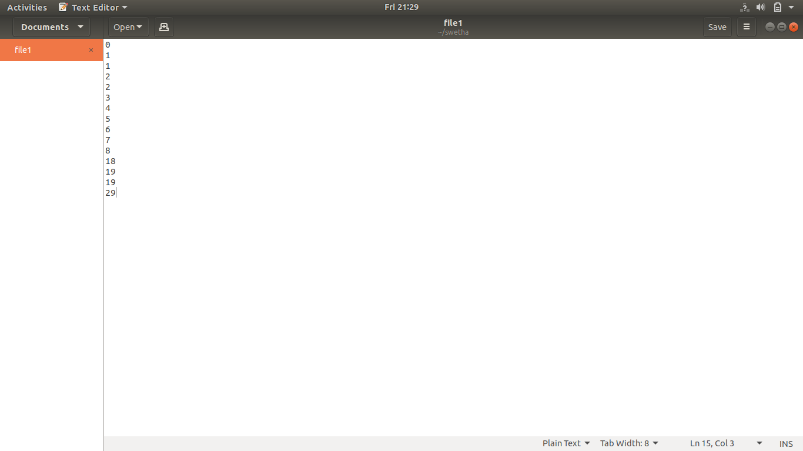

FILE2

-3

-3

0

1

2

3

15

16

18

18

18

19

20

25

29

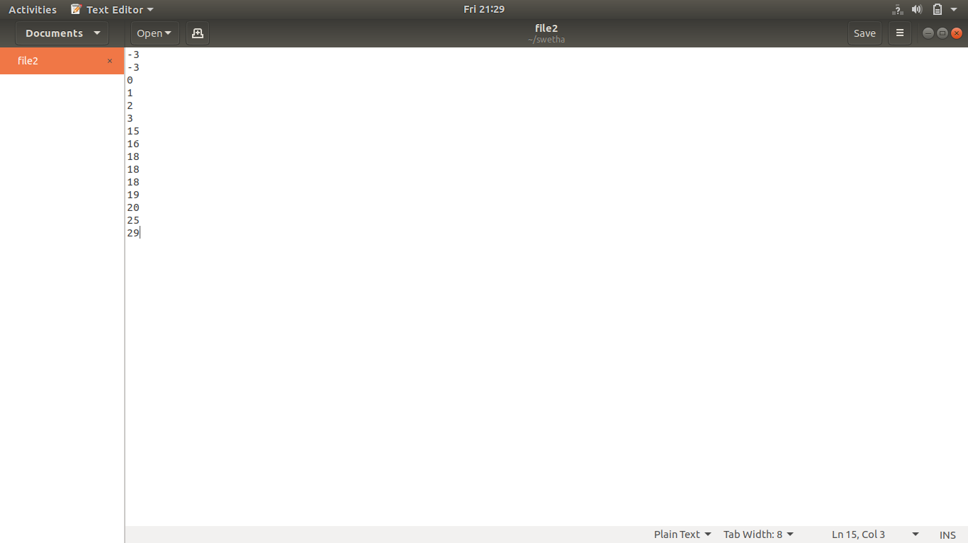

OUTPUT

AUB: {-3,0,1,2,3,4,5,6,7,8,15,16,18,19,20,25,29}

A^B: {0,1,2,3,18,19,29}

A-B: {4,5,6,7,8}

No. of comparisons for AUB are 16

No. of comparisons for A^B are 8

No. of comparisons for A-B are 16

Total no. of comparisons are 40

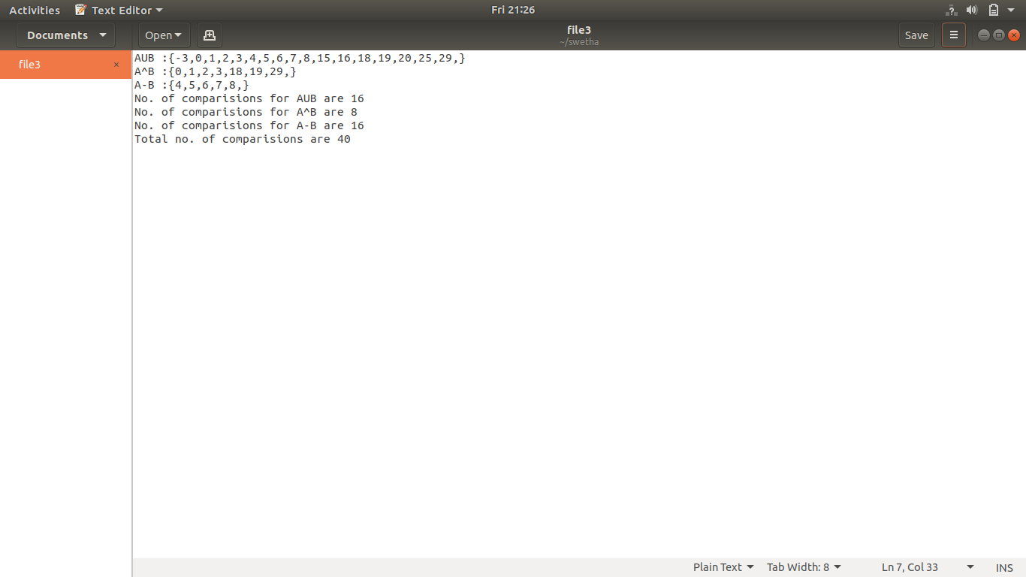

**Time complexity** is **O(m,k1).**