SOIL WHISPERS
A Strategic Plan for an Agribusiness Data Visualization Platform
Week 1 Deliverable: Strategic Planning Task
Prepared for: YuvaIntern Internship Program
Prepared by: Yogitha J

Executive Summary
Soil Whispers is a proposed agribusiness data visualization platform. It helps farmers, agronomists, and agricultural stakeholders turn scattered field data (satellite imagery, weather records, soil sensor readings, and market prices) into a single, easy-to-read decision dashboard. The goal is simple: replace guesswork with a clear, visual picture of what is happening in the field right now, and what is likely to happen next.
Modern farms already generate far more data than any one person can read in raw form. Industry research shows a clear shift toward IoT sensors, satellite monitoring, and AI-assisted analytics. Large farms, in particular, are increasingly expected to adopt advanced analytics tools to manage crops and resources.
Source: Farmonaut, “Precision Agriculture Data Analysis: Top 2025 Trends” (2025); market.us, “Agriculture Analytics Market Size Report” (2025).
The sections that follow lay out the strategic plan for that platform: its objectives, background, scope, methodology, KPIs, and risks. A forward-looking innovation module, plant bioacoustic monitoring, is also included as a Year 2+ research track. It is kept clearly separate from the core Year 1 deliverable, since the underlying science, while promising, is still early-stage.

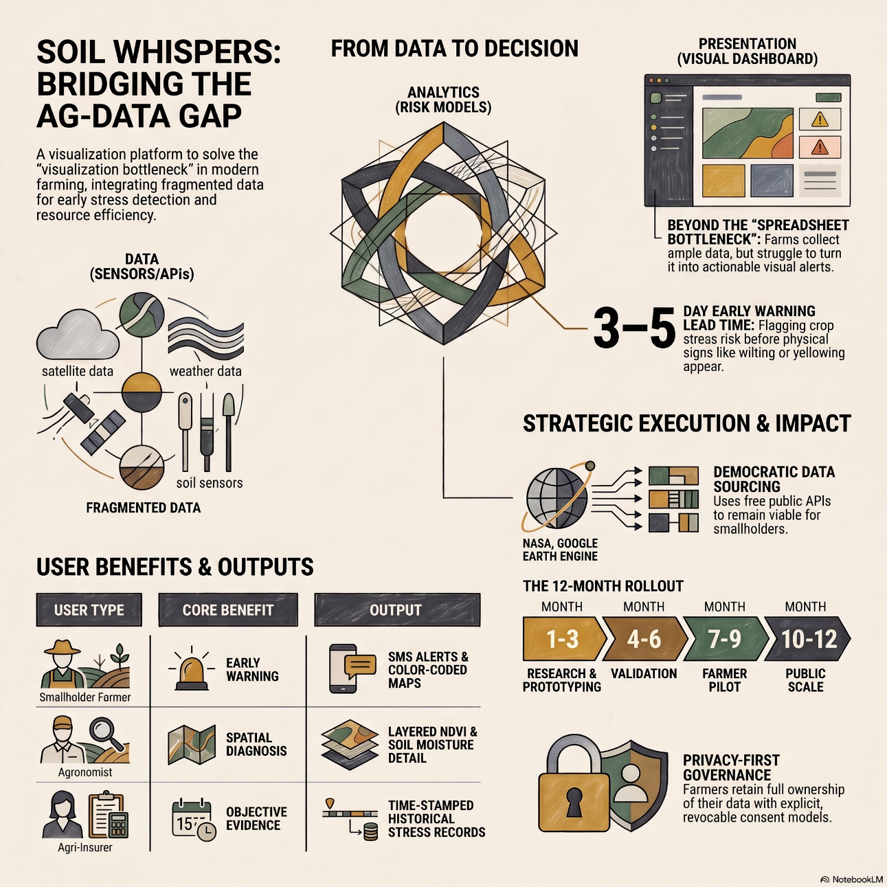

1. Project Background

1.1 The Problem
Climate variability, rising input costs, and shrinking margins mean farmers can no longer afford to manage fields by intuition alone. Visible signs of stress (wilting, yellowing, stunted growth) typically appear only after some yield damage has already occurred. Data-driven, visual tools that surface problems earlier give farmers a real window to act.

1.2 What the Research Shows
Three points stand out from current industry and market research:
- Adoption is accelerating. Large farms are increasingly expected to adopt advanced data analytics for crop management, and the U.S. precision farming market is projected to keep expanding through the early 2030s as sensors, drones, and software costs fall.
- Visualization is the bottleneck, not data collection. Farms already collect large volumes of sensor, imagery, and weather data. The harder problem is turning it into a format (maps, dashboards, alerts) that a busy farmer can act on in seconds, rather than spreadsheets that require an analyst to interpret.
- Data ownership and trust matter as much as accuracy. As precision-agriculture platforms scale, questions of who owns farm data, and how it is shared with agribusinesses or technology vendors, are becoming a real barrier to adoption. Sections 3.5 and 6 address this concern directly.

Source | Key Finding | Relevance to This Project
Farmonaut, “Precision Agriculture Data Analysis: Top 2025 Trends” (2025) | IoT sensors, satellite imagery, and analytics are converging into modular, app-accessible farm platforms. | Confirms multi-source data fusion (sensor + satellite + weather) is the industry standard architecture.
Omdena, “Precision Agriculture: Strategies, Tech & Future Trends” (2025) | Modern farm platforms increasingly add predictive analytics for yield forecasting and pest/disease risk. | Validates the KPI and forecasting features proposed in Section 3.4.
MarketsAndMarkets, “U.S. Precision Farming Market Outlook” (2025) | High upfront cost and unresolved data-privacy questions remain the two biggest adoption barriers, especially for smaller farms. | Directly informs the cost model and data governance safeguards in Sections 3.3 and 6.
Full citation details appear in Section 8, References.

1.3 Project Objectives
In priority order, the objectives below define what the project aims to achieve:
- Integrate multi-source agricultural data (satellite imagery, weather, soil, and optional field-sensor data) into a single, unified visualization framework.
- Develop an accessible decision-support interface that lets farmers and agronomists understand field conditions without needing advanced technical expertise.
- Identify emerging crop stress and environmental risk through visual analysis of temporal and spatial data patterns.
- Support irrigation and resource-management decisions by combining environmental and field-level indicators.
- Establish measurable performance indicators for early warning, alert precision, adoption, and resource efficiency.
- Create a scalable foundation for future bioacoustic integration once the underlying technology is validated in real-world agricultural environments (Section 5).

2. Project Scope

2.1 In Scope (Year 1)
- Satellite-based vegetation monitoring (NDVI/EVI trends)
- Weather and climate data integration and analysis
- Public soil-characteristic data integration
- Optional low-cost IoT soil sensor integration
- Field-level visualization: maps, trend charts, dashboards
- Stress-risk indicators and irrigation-adequacy analysis
- Historical (multi-season) trend comparison
- KPI monitoring and SMS/push alerting

2.2 Out of Scope (Year 1)
- Autonomous irrigation control (system recommends; it does not act on hardware)
- Guaranteed crop-disease diagnosis (alerts are risk indicators, not medical-grade diagnostics)
- Fully automated agricultural recommendations without human review
- Commercial bioacoustics deployment or real-time field-wide acoustic monitoring (Year 2+ research track only, see Section 5)
- Automated financial/investment decision-making on the farmer's behalf

2.3 Target Users
User Type | Core Need | How the Platform Helps
Smallholder farmer | Simple, early warning of problems | Color-coded dashboard + SMS alerts, no technical training required
Agronomist / farm advisor | Spatial detail, cause diagnosis | Layered maps (NDVI, soil moisture, weather) with drill-down detail
Agricultural cooperative / insurer | Objective evidence of stress events | Time-stamped sensor + satellite records to support claims and planning
Researcher / agri-tech partner | Access to structured field data | Exportable, anonymized historical datasets for analysis

2.4 Business Questions the Platform Should Answer
- Why did yield drop in a specific field or season, when it looked fine from the road?
- Is the current irrigation schedule matched to what the soil and weather data actually show?
- Which fields are trending toward stress this week, and which need attention first?
- How does this season compare to the same point in prior seasons for the same field?
- Which fields are delivering the best return relative to input cost, based on the data?
Note on the last question: answering it requires cost and revenue data that is not naturally captured by satellite, weather, or soil sources. Section 3.3 addresses that gap explicitly, rather than leaving the question unsupported.

2.5 Public / Low-Cost Data Sources
A core design principle: the platform should run on data that is free or low-cost and publicly accessible, so the model works for smallholders, not just large operations. Paid satellite subscriptions or private weather feeds would quietly price out the very farmers this platform is meant to serve, which is why every primary source below is either free or available under an open data license.
Data Type | Public Source | What It Provides
Satellite vegetation indices (NDVI, EVI) | Google Earth Engine / Sentinel-2, Landsat; ISRO Bhuvan (India-specific) | Crop health and vigor trends over time, at no sensor cost
Weather & climate | NOAA, OpenWeather API, NASA POWER; IMD (India, currently limited; see note below) | Rainfall, temperature, humidity, and forecast data
Soil characteristics | USDA NRCS Soil Survey / SoilGrids (ISRIC) | Baseline soil type, texture, and organic matter
Crop production & yield benchmarks | USDA NASS QuickStats, FAOSTAT; data.gov.in (India, Ministry of Agriculture) | Regional yield and production benchmarks for comparison
Market / commodity prices | Agmarknet via data.gov.in (India, daily mandi prices, NDSAP license) | Real revenue-side pricing to partially support the ROI business question
Field-level sensor data (optional, paid tier) | Low-cost IoT soil moisture / temperature sensors | Ground-truth data to calibrate the free satellite/weather layers
Because this project is grounded in an Indian context, its India-specific sources deserve a closer look. Data.gov.in's agriculture datasets and Agmarknet's commodity price feeds were verified as publicly accessible under the National Data Sharing and Accessibility Policy. ISRO's Bhuvan portal provides free NDVI and agriculture thematic layers, though downloading them requires a free registration. IMD's API is real, but as of this writing it is not accepting new registrations while a new usage and pricing policy is finalized. For that reason, it is listed here as a planned Year 1 source pending that update, not one already confirmed usable today.

3. Strategic Framework

3.1 Platform Architecture (Three Layers)
The platform is organized into three layers, a pattern consistent with current smart-farming system designs:
- Data layer: satellite feeds, weather APIs, and (optional) field sensors, standardized into a common time-series format.
- Analytics layer: models that turn raw data into indices: crop stress risk, irrigation adequacy, and yield-trend estimates.
- Presentation layer: the dashboard itself: field maps, trend charts, and SMS/push alerts, designed for a non-technical user.
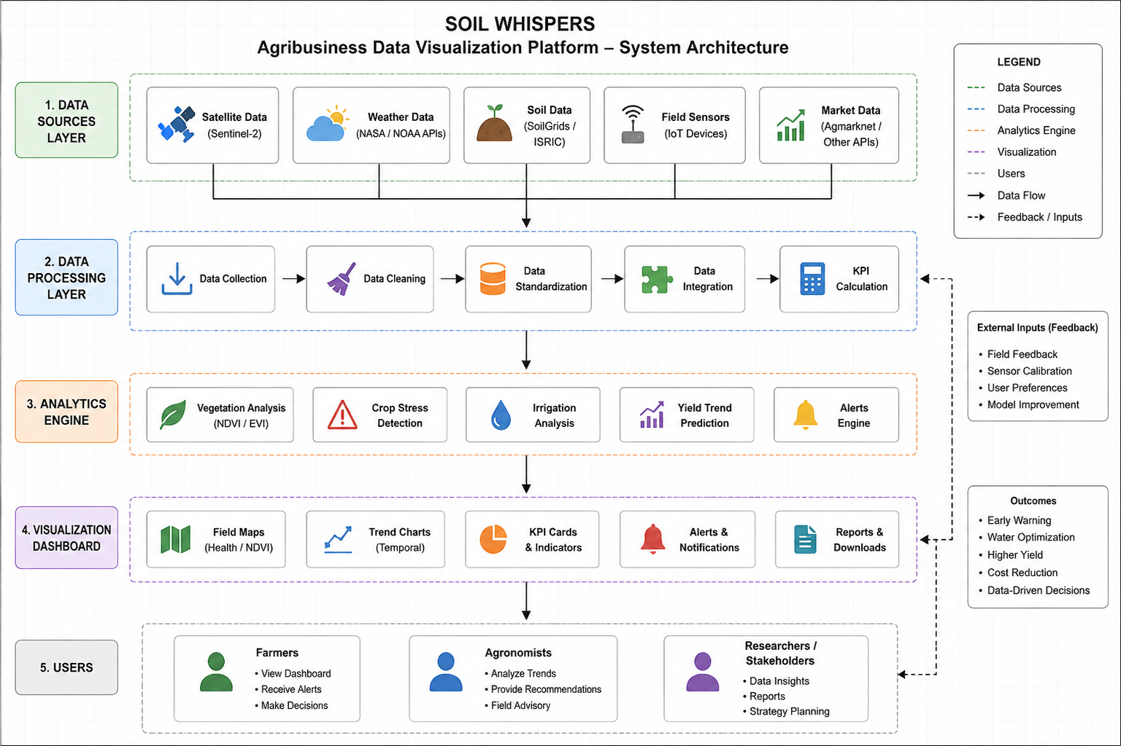

3.2 Proposed Methodology
Architecture describes what the system looks like; methodology describes how it will actually be built. Twelve stages make up the linear-with-feedback methodology used here:
- Data Source Identification: confirm which public APIs/datasets are genuinely accessible (not just theoretically available) for the chosen pilot region.
- Data Acquisition: pull raw data on a fixed schedule (e.g. daily weather, biweekly satellite passes).
- Data Profiling: examine each source's structure, coverage, and known gaps before writing any cleaning logic.
- Data Cleaning: handle missing values, structural zeros, duplicates, and outliers, with every decision documented (see Week 2 report for a worked example).
- Data Standardization: convert all sources to a common time/location key so they can be joined.
- Data Integration: merge satellite, weather, soil, and market layers into one working dataset per field.
- Exploratory Data Analysis: descriptive statistics and correlation check to validate assumptions before building models.
- Feature / KPI Engineering: derive the indices defined in Section 6 (stress risk, irrigation adequacy) from raw fields.
- Visualization Development: design and build the dashboard views (Week 3 of this internship).
- User Testing: pilot with a small farmer group; collect structured feedback on clarity and usefulness.
- KPI Validation: measure whether alerts and indices actually perform against the targets in Section 6.
- Iterative Refinement: adjust thresholds, visuals, and data sources based on Stage 11 findings, then repeat from Stage 7.
This creates a direct bridge into the rest of the internship: Stages 1–6 map to Week 2 (data gathering, cleaning, analysis), Stages 8–9 map to Week 3 (visualization design), and Stages 10–12 map to Week 4 (evaluation and refinement).

3.3 Addressing the ROI / Input-Cost Data Gap
The business question “which fields deliver the best return relative to input cost” cannot be answered by satellite, weather, or soil data alone. It requires cost and revenue information as well. Rather than dropping the question, a two-part approach resolves the gap:
- Revenue side: Agmarknet's public daily mandi price data (Section 2.5) gives a real, verifiable proxy for crop revenue by commodity and region.
- Cost side: input costs (seed, fertilizer, labor) are not available as public data and would need to be farmer-provided and anonymized, on an explicit opt-in basis, with the same consent model described in Section 6.
Until a meaningful sample of farmers opt in to share cost data, this KPI should be treated as a Year 1–2 target requiring real user data, not a capability the platform has on day one.

3.4 Key Performance Indicators (KPIs)
The KPIs below combine technical, business, product, and operational metrics. Targets marked as hypotheses are proposed goals to validate during the Year 1 pilot (Section 4), not measured results of an existing system.
KPI | Type | What It Measures | Target (hypothesis, pending validation)
Early-warning lead time | Technical | Days between the platform flagging risk and a visible symptom appearing | 3–5 days advance notice
Stress-alert precision | Technical | Share of “high risk” alerts that reflect a real, actionable issue | >80% precision after pilot tuning
Dashboard adoption rate | Product | % of enrolled farmers actively checking the dashboard weekly | >60% within 3 months of onboarding
Irrigation efficiency gain | Business | Reduction in water use for the same or better yield vs. baseline season | 10–15% reduction
Data cost per hectare | Operational | Total data + infrastructure cost to monitor one hectare per season | Kept low enough for smallholder viability

3.5 Anticipated Challenges & Data Quality Concerns
One of these challenges is not hypothetical. While researching this report, IMD’s own registration portal was found to be closed to new sign-ups, a live example of the access risk the table below describes.
Challenge | Why It Matters | Mitigation
Cloud cover blocking satellite imagery | NDVI and similar indices can go missing for days during rainy periods | Blend satellite data with weather-model estimates to fill short gaps
Sparse or noisy field sensor data | Cheap sensors drift and fail in field conditions | Cross-check sensor readings against satellite and weather trends; flag outliers
Low-connectivity rural areas | Real-time dashboards need consistent data upload | Edge processing on-device; batch-sync summaries when connectivity resumes
Farmer trust / data ownership concerns | Documented as a top adoption barrier industry-wide | Farmers retain ownership of their own field's data; clear opt-in/opt-out policy
Uneven data quality across regions | Public data resolution varies by country/region | Start with a pilot region with strong data coverage, expand once validated
Government API access changes (e.g. IMD registration hold) | Public infrastructure policy can shift without notice, as seen with IMD's current pricing-policy pause | Design the data layer so any single government source can be swapped for an equivalent (e.g. NASA POWER) without a platform redesign

4. Implementation Timeline
Phase | Duration | Key Activities
1. Research & Validation | Months 1–2 | Confirm data sources, pilot region, and user needs
2. Data Pipeline & Prototype | Months 3–5 | Build data ingestion (satellite + weather); first dashboard prototype
3. Pilot with Farmers | Months 6–8 | Test with a small farmer group; collect feedback; refine alerts
4. KPI Validation | Months 9–10 | Measure alert precision and lead time against real outcomes
5. Launch & Scale | Months 11–12 | Public rollout in pilot region; plan expansion
This 12-month timeline describes the hypothetical full-scale rollout a real company would follow. Section 7 maps how this internship's own 4-week schedule compresses the same lifecycle into a small-scale proof of concept.

5. Innovation Roadmap: Plant Bioacoustic Monitoring (Exploratory, Year 2+)
Plant bioacoustics is a genuinely exciting, scientifically real research direction. Peer-reviewed work has shown that stressed plants emit airborne sounds carrying information about their physiological state. Machine learning can even distinguish drought-stressed, cut, and healthy plants from those sounds alone.
Source: Khait, I. et al., “Sounds emitted by plants under stress are airborne and informative,” Cell (2023).
This is a real and exciting finding, but it comes from controlled laboratory/greenhouse conditions, not open-field deployments. Before building bioacoustic monitoring into the core product, the plan treats it as a Year 2+ research track:
- Year 1: Ship the core visualization platform using satellite, weather, and (optional) low-cost soil sensors. All are field-proven, publicly available data sources.
- Year 2: Pilot a small acoustic-sensor test plot in partnership with a university lab, to see whether lab-scale findings hold up under real field noise (wind, insects, machinery).
- Year 3+: If validated, fold acoustic stress indicators into the main dashboard as an additional, optional signal not a replacement for the proven data layer.
This staged approach keeps the report ambitious and forward-looking. It avoids resting the core deliverable on unverified or overstated claims, an important distinction for a professional strategy document.

6. Ethical Considerations
- Data privacy: field data is owned by the farmer; the platform only uses it with explicit, revocable consent.
- Equity of access: pricing and a free/basic tier are designed so smallholders are not priced out of the core safety features.
- Avoiding over-claiming: alerts are framed as risk indicators with stated confidence levels, not guarantees, to avoid farmers over-trusting an imperfect model.
- Transparency: any experimental feature (like the bioacoustics module) is clearly labeled as experimental to users.
- Cost data sensitivity: farmer-provided input-cost data (Section 3.3) is treated as commercially sensitive and is anonymized and opt-in, never a condition of using the core dashboard.

7. Project Continuity Across the Internship
Four connected deliverables make up this internship, and this document is the first of them. Each week builds directly on the last, compressing the Section 4 timeline into a small-scale, real-data proof of concept:
Week | Focus | Soil Whispers Output
Week 1 | Strategic Planning | Project objectives, scope, methodology, KPIs, and data strategy (this document)
Week 2 | Data Preparation | Real public datasets sourced, cleaned, and statistically profiled
Week 3 | Visualization | Dashboard mockups built from the Week 2 findings
Week 4 | Evaluation | Usability review, benchmarking against best practice, and refinement plan

8. References
1. Farmonaut. (2025). Precision Agriculture Data Analysis: Top 2025 Trends. https://farmonaut.com/precision-farming/precision-agriculture-data-analysis-top-2025-trends
2. Omdena. (2025). Precision Agriculture: Strategies, Tech & Future Trends. https://www.omdena.com/blog/precision-agriculture-2025-key-strategies-trends
3. MarketsAndMarkets. (2025). U.S. Precision Farming Market Outlook: Data-Driven Agriculture Trends Through 2032. https://www.marketsandmarkets.com/ResearchInsight/us-precision-farming-market.asp
4. market.us. (2025). Agriculture Analytics Market Size, Share Report. https://market.us/report/agriculture-analytics-market/
5. Khait, I., Lewin-Epstein, O., Sharon, R. et al. (2023). Sounds emitted by plants under stress are airborne and informative. Cell, 186(7). https://www.cell.com/cell/fulltext/S0092-8674(23)00262-3
6. Folio3 AgTech. (2025). How Data Visualization in Agriculture Drives Smarter Farming. https://agtech.folio3.com/blogs/data-visualization-in-agriculture/
7. Open Government Data (OGD) Platform India: Agriculture Sector. https://www.data.gov.in/sector/agriculture
8. Open Government Data (OGD) Platform India: Current Daily Price of Various Commodities from Various Markets (Agmarknet). https://www.data.gov.in/catalog/current-daily-price-various-commodities-various-markets-mandi
9. India Meteorological Department: IMD API Management. https://api.imd.gov.in/ (registration currently on hold pending a new usage/pricing policy, verified August 2026).
10. Indian Space Research Organisation: Bhuvan Geoportal (NDVI and agriculture thematic data). https://bhuvan.nrsc.gov.in/

