SOIL WHISPERS
Data Gathering, Cleaning, and Preliminary Analysis
Week 2 Deliverable: YuvaIntern Internship Program
Prepared by: Yogitha J
Date: 05 August 2026

1. Introduction
The Week 1 strategic plan proposed Soil Whispers, a decision dashboard that fuses satellite, weather, soil, and market data for farmers and agronomists. Putting that plan into practice starts here, at small scale. Two real, publicly available agribusiness datasets are identified below, a genuine cleaning process is documented for each, and the preliminary statistics that follow would seed the Year 1 dashboard's data layer described in the strategic plan.
Both datasets were sourced from public repositories rather than simulated. That choice matters: it means the cleaning decisions and findings below reflect the actual messiness of real agricultural data, including inconsistent records, structural zeros, and skewed distributions, rather than a tidy synthetic stand-in.
One practical note on sourcing: both datasets were retrieved from GitHub mirrors of the original government and research data, rather than pulled live from an API. Widely used public agribusiness datasets are frequently mirrored this way, and using a mirror sidesteps API registration and key-management friction without changing the underlying data.

2. Methodology
This section covers two things: which datasets were used and why, and the step-by-step process applied to clean each one before any analysis began.

2.1 Data Source Identification

2.1.1 Source A: Crop Recommendation Dataset (Soil & Climate)
This is a record-level dataset of 2,200 samples. Each row describes the soil nutrient levels (Nitrogen, Phosphorus, Potassium), temperature, humidity, soil pH, and rainfall associated with 22 different crops. It mirrors exactly the kind of soil-sensor and weather-API data the Week 1 plan proposes to fuse (Section 2.5 of the strategic plan).
- Type of data: numeric soil and climate features, plus a categorical crop label.
- Potential use in visualization: scatter plots and box plots showing which rainfall and nutrient ranges suit which crops. This directly supports the “is my irrigation schedule matched to the data” business question from Week 1.

2.1.2 Source B: District-Level Crop Yield Dataset, India (2010–2017)
This is a district-year panel covering 20 states and 8 years. It records area, production, and yield for rice, wheat, cotton, sugarcane, and other crops.
- Type of data: time-series, structured by district and year, across multiple crop-specific metrics.
- Potential use in visualization: trend lines and state comparison charts. These support both the “how does this season compare to prior seasons” and the “which fields deliver the best return” business questions from Week 1.

2.2 Data Cleaning Plan

2.2.1 Source A: Crop Recommendation Dataset
- Checked for exact duplicate rows. None were found (0 of 2,200).
- Checked for structurally impossible values: negative nutrient levels, humidity outside 0–100%, pH outside 0–14, and negative rainfall. None were found, which suggests a pre-vetted source.
- Flagged, but did not drop, statistical outliers in rainfall and temperature using the IQR method. Agronomically real extremes, like very high rainfall for rice, are meaningful signal rather than errors. About 100 rainfall values and several temperature values fell outside the 1.5×IQR band, mostly concentrated in high-rainfall crops such as rice and coffee.

2.2.2 Source B: District Crop Yield Dataset
- Checked for duplicate district-year rows. None were found.
- Identified a genuine data-quality issue: 6 rows record nonzero rice-growing area but zero rice yield. That combination is agronomically inconsistent, since land under cultivation should produce some yield. These rows were flagged for exclusion from yield averages rather than silently kept, to avoid understating true yield.
- Distinguished true missing data from structural zeros. A “0” in a crop's area or production column usually just means that crop is not grown in that district. Treating those as missing values would have wrongly dragged down national averages, so zero-area rows were excluded before computing yield statistics.
- Checked yield outliers via IQR, after first excluding the structural zeros above. 46 rice-yield values and a smaller number of wheat-yield values were flagged as unusually high or low. These were kept in the dataset but noted for review, since they may reflect real high-performing districts, such as Punjab or Tamil Nadu, rather than data errors.

3. Analysis
With both datasets cleaned, this section reports preliminary descriptive statistics, the kind of mean, spread, and correlation checks that should always come before building anything more complex.

3.1 Soil & Climate Profile by Crop
Mean nutrient and climate values for a sample of common crops show clear, distinct profiles. This is exactly the kind of differentiation a recommendation or stress-detection model would rely on:
Crop | N | P | K | Temp (°C) | Humidity (%) | pH | Rainfall (mm)
Rice | 79.9 | 47.6 | 39.9 | 23.7 | 82.3 | 6.4 | 236.2
Maize | 77.8 | 48.4 | 19.8 | 22.4 | 65.1 | 6.2 | 84.8
Cotton | 117.8 | 46.2 | 19.6 | 24.0 | 79.8 | 6.9 | 80.4
Coffee | 101.2 | 28.7 | 29.9 | 25.5 | 58.9 | 6.8 | 158.1
Banana | 100.2 | 82.0 | 50.0 | 27.4 | 80.4 | 6.0 | 104.6
Chickpea | 40.1 | 67.8 | 79.9 | 18.9 | 16.9 | 7.3 | 80.1

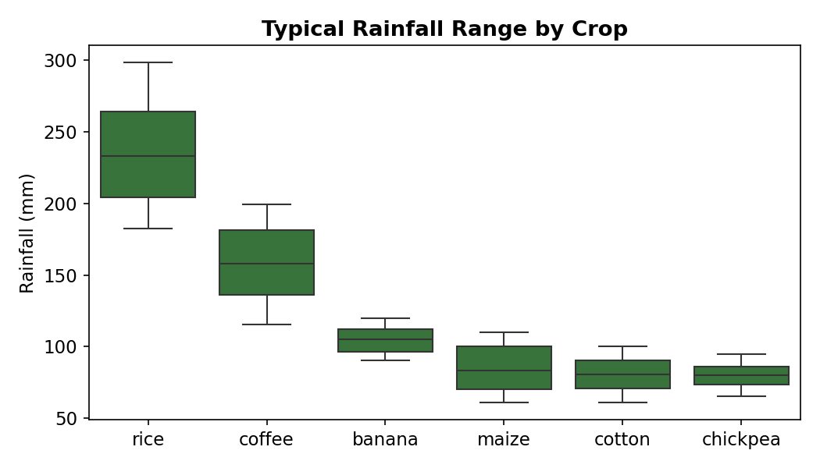
Figure 1. Rice and coffee require substantially more rainfall than chickpea or cotton, confirming these datasets can meaningfully differentiate irrigation needs by crop.
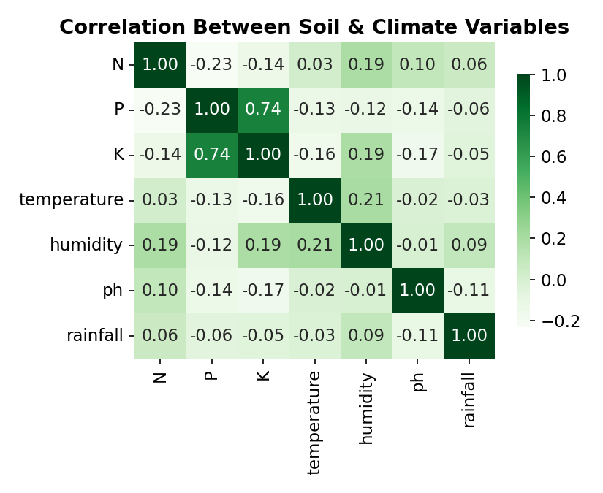
Figure 2. Correlation matrix of soil and climate variables. N, P, and K show weak correlation with each other, all under 0.25 in magnitude, meaning each nutrient carries independent signal rather than duplicating information. That is useful to know before feeding these into a future prediction model.

3.2 National Yield Trends, 2010–2017
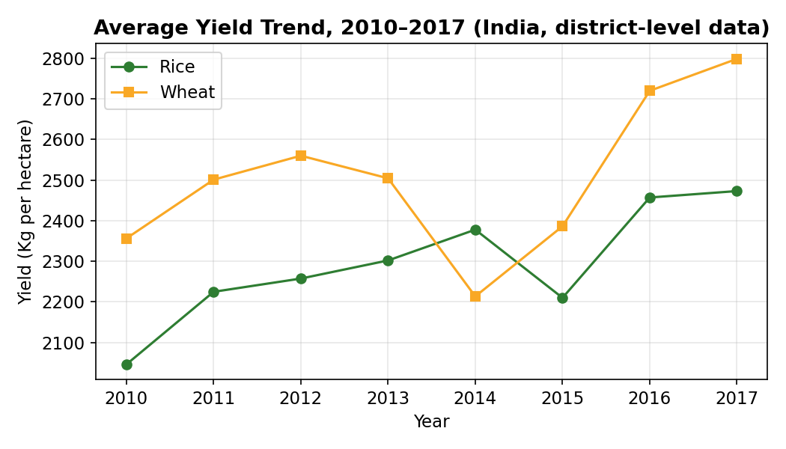
Figure 3. Average rice yield rose from ~2,046 to ~2,473 Kg/ha (+20.9%), and wheat from ~2,356 to ~2,799 Kg/ha (+18.8%), over the eight-year window. This is consistent with the broader precision-agriculture adoption trend cited in the Week 1 report.
This upward trend holds despite year-to-year dips, such as in 2015. It supports the Week 1 business question of how a season compares to prior seasons: a dashboard user would want exactly this kind of multi-year baseline to judge whether the current season is under- or over-performing.

3.3 State-Level Variation
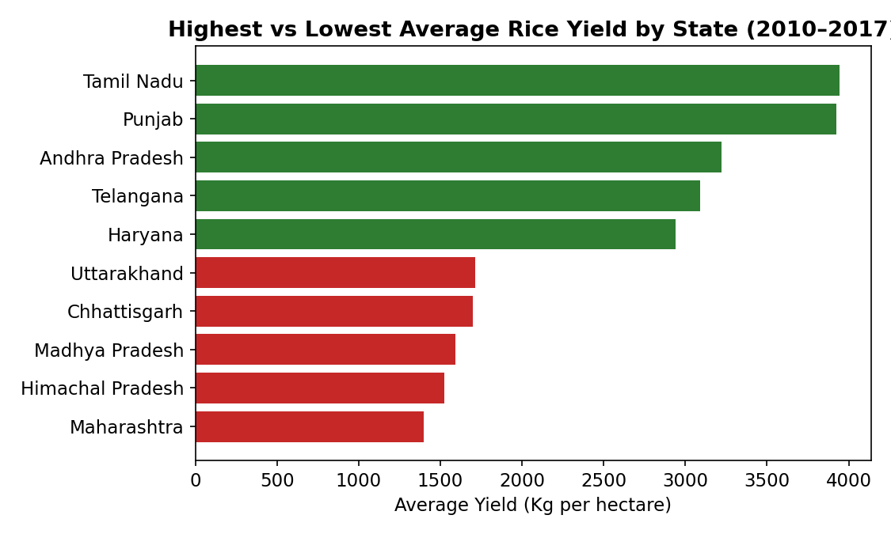
Figure 4. Tamil Nadu and Punjab lead in average rice yield (~3,940 and ~3,920 Kg/ha), more than double Maharashtra's ~1,400 Kg/ha. That is nearly a 3× gap between the highest- and lowest-yield states in the same eight-year window.
This spread is the clearest evidence in the data for the Week 1 KPI on which fields deliver the best return relative to input cost. Geography alone explains a large share of yield variation. Any dashboard benchmarking a farmer's yield should therefore compare against a regional baseline, not a flat national average.

4. Conclusions
- Both datasets are usable as-is with minor, well-documented cleaning steps. No destructive data loss was required at this stage.
- The main data-quality risk in agribusiness datasets is not missing values in the conventional sense. It is structural zeros and area/yield inconsistencies that require domain judgment to handle correctly.
- Rainfall and nutrient profiles differ meaningfully by crop, and yield varies more by region than by year. Both findings directly inform which visualizations will be most useful in Week 3: crop-specific rainfall charts, state-benchmarked yield comparisons, and multi-year trend lines.
- These two real datasets are not identical to the live satellite and IoT feeds described in the Week 1 architecture, but they are structurally analogous. That makes them sufficient to prototype the analytics and presentation layers before investing in live data pipelines.

5. Data Source References
1. Crop Recommendation Dataset. Compiled agricultural dataset (soil nutrients, climate, crop label), mirrored at: https://github.com/AbhishekKandoi/Crop-Yield-Prediction-based-on-Indian-Agriculture
2. Crop Datasets for All Indian States (2010–2017), district-level area/production/yield by crop: https://github.com/nileshely/Crop-Datasets-for-All-Indian-States

