SOIL WHISPERS
Evaluation, Refinement, and Presentation of Visual Analytics
Week 4 Deliverable: YuvaIntern Internship Program
Prepared by: Yogitha J
Date: 20 August 2026

Introduction
This report closes the internship loop by critically evaluating the Soil Whispers deliverables from Weeks 1 through 3, benchmarking the Week 3 dashboards against documented accessibility and visualization guidance, and setting out a concrete, prioritized refinement plan. It also documents two real pieces of external feedback received on the Week 2 and Week 3 submissions and the specific revisions made in response to each, providing evidence of an iterative feedback-and-improvement process.

1. Evaluation: Self-Assessment of Weeks 1–3

1.1 Week 1: Strategic Plan
Strengths: the plan defines explicit objectives, an in-scope/out-of-scope boundary, and a 12-stage methodology, which gave every later week a clear stage to map its work onto. KPI targets are labeled as hypotheses pending validation rather than stated as settled facts, which avoided a common overclaiming problem in early-stage project plans.
Weaknesses: the original data source table leaned heavily on U.S. and global sources (NASA POWER, USDA NASS) despite the project's Indian context. This was corrected in a revision that added data.gov.in, Agmarknet, ISRO Bhuvan, and a documented caveat about IMD's API registration hold, but the fact that it needed correcting at all is itself worth noting here: the first draft of a data source list should be checked for geographic fit before, not after, it is treated as final.

1.2 Week 2: Data Gathering, Cleaning, and Preliminary Analysis
This deliverable received external evaluator feedback, reproduced here in full since it is the most concrete evidence available of where the work fell short:
“Your report is thorough and well-structured. Enhance clarity by including figures or charts to visually support your analysis. Provide more detailed explanations for handling outliers to deepen the analytical depth.” — Score: 59.8/100 (minimum 30 required)
Both points were valid, even though the submitted report already contained four charts. The real issue was not the absence of visuals but their placement and framing: charts appeared after their related paragraph with only a passive caption, so a reader skimming the document could miss the connection between a claim and its supporting figure. The outlier explanation had the same shape of problem: it stated that outliers were checked using the IQR method and reported a count, but never explained why IQR was the right method, why 1.5 was the right multiplier, or what was actually done with a flagged value once found.
The revised Week 2 report (submitted alongside this one) makes four specific changes in response:
- Every chart is now introduced by a sentence stating what it shows before the figure appears, so the figure confirms a claim rather than sitting in isolation.
- A fifth chart was added specifically to visualize the outlier fences themselves (Q1, Q3, and the 1.5×IQR boundaries) on the rainfall data, rather than only describing them in text.
- The outlier section now explains the statistical reasoning: why IQR is more robust to skewed data than a mean±3SD rule (a 25% breakdown point versus effectively 0%), and why 1.5 specifically is the standard multiplier rather than an arbitrary choice.
- The decision to flag rather than delete outliers is now justified with a concrete case (a high-rainfall rice sample is real agronomic signal, not an error) and cross-checked against an independent variable (state) for the yield dataset, rather than treated as a purely mechanical filtering step.
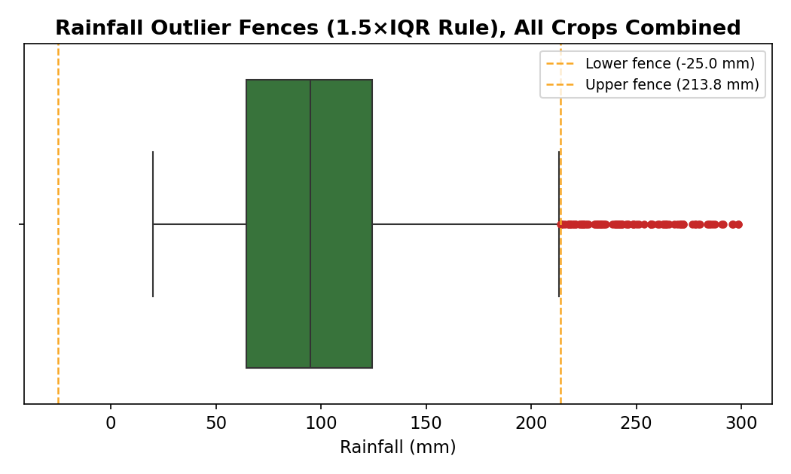
Figure 1. The outlier-fence chart added to the revised Week 2 report. Q1 = 64.6mm, Q3 = 124.3mm, giving fences at −25.0mm and 213.8mm; every flagged point (red) sits above the upper fence, visualizing the 1.5×IQR method rather than only describing it in text.
This is the clearest example available of the feedback loop this Week 4 task asks about: specific, external feedback, tied to a specific score, followed by a specific, verifiable change to the artifact itself, not just a promise to do better next time.

1.3 Week 3: Visualization Design and Dashboard Development
Strengths: two dashboards were built for two different users (Farmer View and Agronomist View), matching the Week 1 target-user table rather than designing one generic dashboard for everyone. The primary dashboard was first created in Tableau Public, as required by the internship task. The completed Tableau design was then extended into a standalone HTML implementation using Plotly.js, preserving the same analytical structure while providing a more interactive web-based presentation.
This deliverable also received external evaluator feedback, a second real case study alongside Week 2's:
“While the report is comprehensive and well-structured, it lacks specific examples and concrete numbers to support some claims. Consider adding more worked examples or calculations to demonstrate the depth of your analysis.”
This was accurate. The original submission justified each chart choice in general terms (“a box plot shows the full spread”) without ever showing that spread calculated from the actual data. The revised Week 3 report (submitted alongside this one) adds a full Worked Examples subsection with three calculations traceable to the real dataset:
- The Pearson correlation between Phosphorus and Potassium (r = 0.74) derived by hand on a 5-row sample, showing the mean, the deviation products, and the full formula, then confirmed against the full 2,200-row calculation.
- The rainfall box plot's quartiles and fences computed explicitly (Q1 = 64.55mm, Q3 = 124.27mm, IQR = 59.72mm, fences at −25.02mm and 213.84mm), with the resulting outlier count (100 of 2,200, or 4.5%) stated rather than implied.
- A full dashboard-action trace for a real filter click (State = Punjab, Crop = Wheat), showing the national average (2,504.3 kg/ha), Punjab's average (4,723.1 kg/ha), the resulting delta (+88.6%), and Punjab's rank (1st of 19 states), so the interaction is demonstrated with its actual output rather than only described.
Weaknesses identified independently of external feedback, since not every gap will be caught by an evaluator: the Farmer View's field-stress grid encodes risk level using color alone (green, yellow, orange, red) with no secondary encoding such as an icon or text label. The Agronomist View's diverging state-comparison bars use green-versus-red, a combination that is difficult to distinguish for the most common forms of color blindness. Both issues are addressed in Section 3.
Read together, the Week 2 and Week 3 feedback point at the same underlying habit: a tendency to describe an analytical method correctly without also showing it operate on real numbers. Both revisions fix that by adding the arithmetic itself back into the document, which is the pattern carried into the recommendations in Section 3.

2. Benchmarking Against Documented Best Practices
Four external accessibility/design benchmarks were used to evaluate the Week 3 dashboards. These were selected because they provide specific, checkable criteria rather than relying only on general design opinions.
Standard | What It Requires | Soil Whispers Status
WCAG 2.1 (Level AA), color contrast | Text needs a 4.5:1 contrast ratio against its background; non-text graphical elements (bars, chart lines, markers) need 3:1. | Verified by hand (Section 2.1): text pairs pass with wide margin (7.6:1 to 15.9:1). The state-chart's green/red bar pair fails badly at 1.10:1.
WCAG 2.1, Use of Color (SC 1.4.1) | Information must not be conveyed by color alone; a second encoding such as an icon, pattern, or text label should be provided. | Fails as currently designed. The field-stress grid relies on color alone with no text or icon fallback.
Color-universal design guidance | Use color combinations that remain distinguishable for people with common color-vision deficiencies; avoid relying on red/green alone where possible. | Fails as currently designed. The state-comparison bar chart uses a straight green/red diverging scheme.
Dashboard component-density heuristic | A practical UX heuristic used in this evaluation recommends roughly five to nine key components per view before cognitive load increases. | Agronomist View is above the selected heuristic: 4 KPI cards + 5 charts + 1 detail table = 10 components. Farmer View has 8.
Sources: W3C WCAG 2.1 Success Criteria 1.4.3 (Contrast, Minimum), 1.4.11 (Non-text Contrast), and 1.4.1 (Use of Color); Okabe-Ito color-universal-design guidance; Machado, Oliveira & Fernandes (2009) for color-vision-deficiency simulation. Component density is treated as a practical UX heuristic, not as a formal WCAG requirement.
Two of the accessibility/design checks identify clear issues requiring remediation, while the remaining checks provide verified evidence about contrast and component density. Naming those findings plainly, rather than only listing strengths, is the point of a benchmarking section: it is useful only when it produces concrete findings that can drive specific fixes.

2.1 Worked Example: Calculating the Contrast Ratios by Hand
Rather than assert that a color pair “should” pass or fail, WCAG's relative luminance formula was applied directly to the actual hex colors used in the Soil Whispers dashboards. For an sRGB channel value c (0–1), the linearized channel is c/12.92 if c ≤ 0.03928, otherwise ((c+0.055)/1.055)²⁴. Relative luminance L = 0.2126R + 0.7152G + 0.0722B, and the contrast ratio between two colors is (L₁+0.05)/(L₂+0.05), using the lighter color as L₁.
Worked for the failing case, state-comparison green (#2E7D32) against red (#C62828):
- Green #2E7D32 → R=0.180, G=0.490, B=0.196 (0–1 scale) → L = 0.1548
- Red #C62828 → R=0.776, G=0.157, B=0.157 → L = 0.1368
- Contrast ratio = (0.1548+0.05) / (0.1368+0.05) = 0.2048 / 0.1868 = 1.10:1
That 1.10:1 is far below even the 3:1 graphical minimum, let alone the 4.5:1 text minimum. The same formula applied to the header (white on dark green), the KPI cards (dark green on off-white), and body text (near-black on white) gives 7.87:1, 7.59:1, and 15.91:1 respectively, all comfortably passing. Figure 2 shows all four side by side against both thresholds.
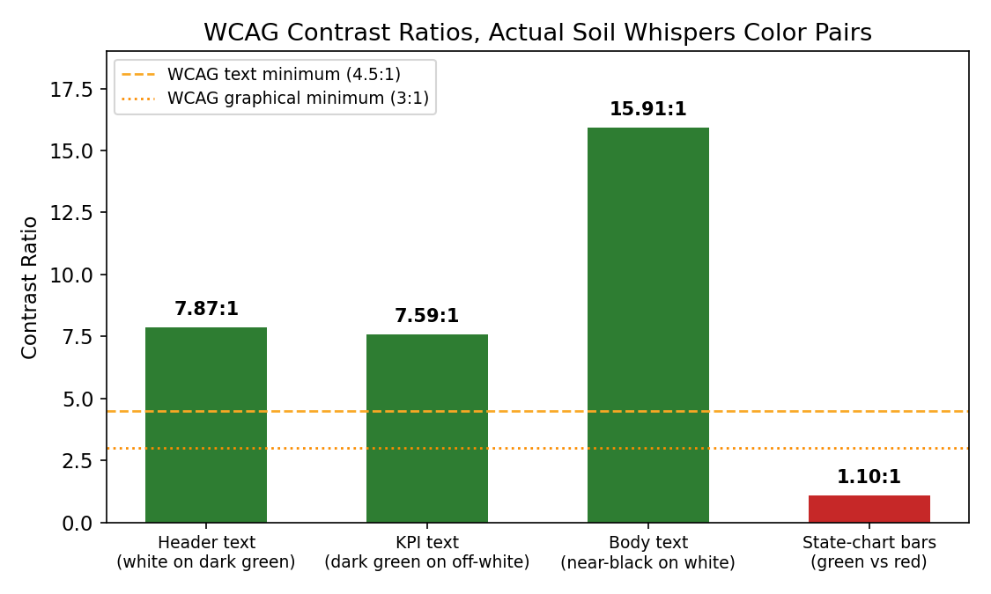
Figure 2. WCAG contrast ratios for every color pair actually used in the Soil Whispers dashboards. Three pairs pass with wide margin; the state-comparison chart's green/red bars fail both thresholds outright.
The 1.10:1 result also explains why the color pair fails for colorblind users specifically, not just in the abstract. Applying the deuteranopia and protanopia simulation matrices published by Machado, Oliveira & Fernandes (2009) to the same two hex colors shows what a colorblind viewer would actually see:
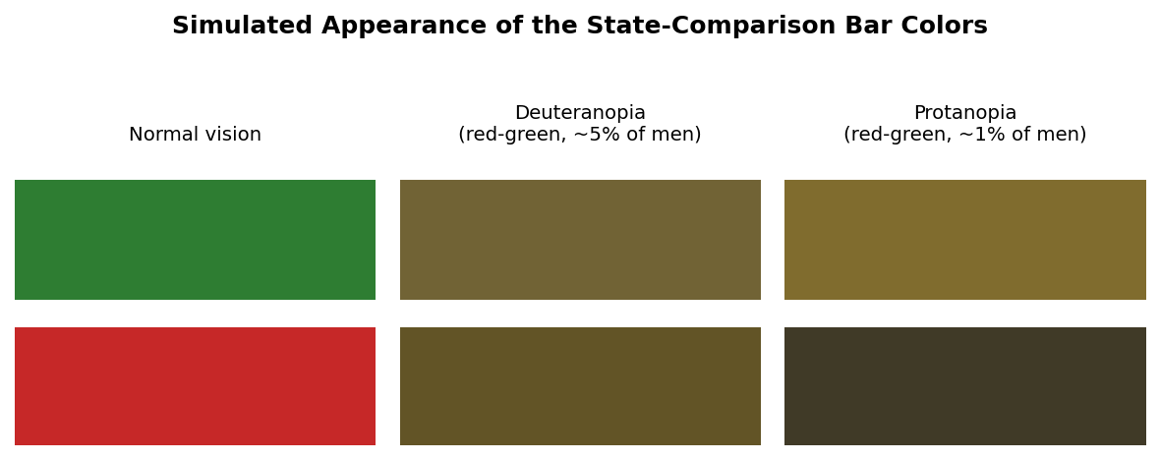
Figure 3. The same green and red bar colors, simulated under deuteranopia and protanopia. Both conditions collapse the pair into two very similar olive/brown tones, confirming the low contrast ratio is not just a luminance technicality but a real perceptual problem.

2.2 Worked Example: Dashboard Component Density
The Agronomist View's component count was counted directly rather than estimated: 4 KPI cards, plus 5 charts (yield trend, correlation heatmap, state bars, rainfall box plot, area-vs-yield scatter), plus 1 drill-down table, totals 10. The Farmer View, by contrast, holds 4 KPI cards, the field-stress grid, an alerts panel, and 2 charts, totaling 8, inside the recommended band.
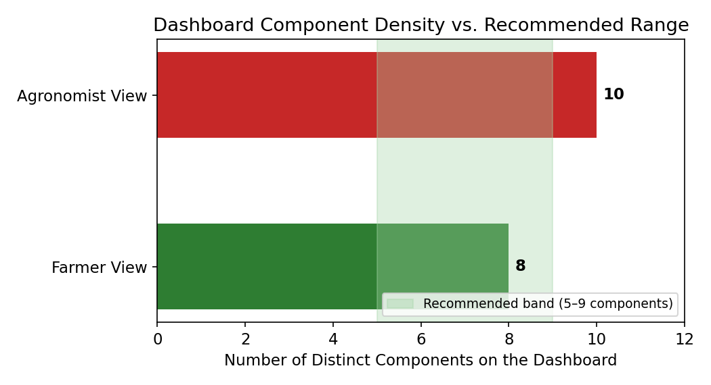
Figure 4. Component counts for both dashboard views against the 5–9 practical UX heuristic used in this evaluation. The Farmer View fits the heuristic; the Agronomist View exceeds it by one component.

3. Improvement Recommendations

3.1 Accessibility
- Add a text label or small icon inside each cell of the Farmer View's field-stress grid (e.g. a checkmark for healthy, an exclamation mark for urgent), so status is never conveyed by color alone, directly addressing the WCAG 2.1 Use of Color issue identified in Section 2.
- Replace the state-comparison bar chart's green/red diverging scheme with navy (#1A237E) for above-average and gold (#FFC107) for below-average. This pair was checked, not assumed: a first candidate, blue #1565C0 against orange #E65100, was tested with the same formula from Section 2.1 and still only reached 1.52:1, failing outright. Navy against gold reaches 8.12:1, clearing even the stricter 4.5:1 text threshold, and remains distinguishable under both the deuteranopia and protanopia simulations used in Figure 3.
- The broader lesson from testing that first candidate and rejecting it: a replacement color pair is only safe once it is run through the same contrast formula as the pair it replaces. Choosing colors that merely look distinct to typical vision, without recalculating luminance, would have quietly reintroduced the same failure under a different pair of hex codes.

3.2 User Experience
- Split the Agronomist View's 10 components across two linked dashboards, or add a drill-down interaction so the detail table only appears after a chart is clicked, bringing the default view back within the 5–9 component heuristic used in Section 2.
- Add a persistent “last updated” timestamp to both dashboards. The current Tableau and HTML implementations do not display one, and a decision-support tool that a farmer or agronomist is meant to trust should make data freshness visible rather than assumed.

3.3 Data Clarity
- Extend the Week 2 outlier-flagging approach (flag with a documented reason, cross-check against an independent variable, never silently delete) to the dashboard layer itself: flagged points should render with a distinct marker in the Tableau scatter and box plot views, so a viewer can see which points were flagged during cleaning without having to cross-reference the Week 2 report separately.
- Add a visible data-source and vintage footer to both dashboards (e.g. “District yield panel, 2010–2017, India; soil/climate sample, N=2,200”), since neither current mockup states how current or how large the underlying data is, information a stakeholder needs before trusting a KPI.

4. Action Plan
Action | Priority | Effort | Status
Add non-color encoding to field-stress grid | High | Low | Not started
Implement navy/gold replacement palette in Tableau (contrast verified, 8.12:1) | High | Low | Verified; not yet implemented
Reduce Agronomist View to ≤9 components via drill-down | Medium | Medium | Not started
Add data freshness timestamp to both dashboards | Medium | Low | Not started
Render flagged outliers with a distinct marker on charts | Medium | Medium | Not started
Add data-source/vintage footer to both dashboards | Low | Low | Not started
Priority was assigned by accessibility impact first (a dashboard that fails WCAG excludes real users, not a hypothetical edge case), then by how directly an item was raised by external or self-identified evaluation versus a general nice-to-have.

5. Conclusion
The most useful finding in this report is not any individual chart or color fix. It is that two separate feedback loops, on Week 2 and on Week 3, both closed the same way: specific feedback led to a specific, checkable revision, documented in Sections 1.2 and 1.3 and visible in the resubmitted reports. The Week 3 dashboard was first implemented in Tableau Public as the primary internship deliverable and was subsequently extended into an interactive HTML/Plotly implementation. The benchmarking in Section 2 applies the same evidence-based approach to the remaining accessibility, usability, and data-clarity gaps before further external feedback arrives. The action plan in Section 4 provides a concrete mechanism for applying those improvements in the next iteration.

References
1. W3C Web Content Accessibility Guidelines (WCAG) 2.1, Success Criterion 1.4.3 (Contrast, Minimum) and 1.4.11 (Non-text Contrast). https://www.w3.org/TR/WCAG21/
2. Tukey, J. W. (1977). Exploratory Data Analysis. Addison-Wesley. Origin of the 1.5×IQR outlier convention referenced in the revised Week 2 report.
3. Okabe, M., & Ito, K. (2008). Color Universal Design (CUD): How to Make Figures and Presentations That Are Friendly to Colorblind People. Widely cited as the standard colorblind-safe categorical palette referenced in Section 2.
4. Machado, G. M., Oliveira, M. M., & Fernandes, L. A. F. (2009). A Physiologically-based Model for Simulation of Color Vision Deficiency. IEEE Transactions on Visualization and Computer Graphics. Source of the deuteranopia and protanopia simulation matrices used in Figure 3.
5. Component-density note. The 5–9 component range is used in this report as a practical dashboard UX heuristic for internal evaluation, not as a formal WCAG success criterion.

