SMART PUBLIC RESTROOM   
DEVELOPMENT PART-1

Abstract — Public sanitation in many parts of India and slums is

sadly inadequate, with frequent urination and outflow due to

public toilets that may be very dirty or poorly maintained. Many

governments spend a lot of money and effort in keeping these

public toilets clean and tidy. All of these efforts to keep public

restrooms clean are in futile because there is no centralized

mechanism in place to monitor their cleanliness and cleaner

quality. In many regions of India and slums, public sanitation is

woefully inadequate, with rampant public urinating and

incontinence caused by overpopulation or poorly maintained

public toilets. Because of this issue, a system that allows

monitoring in one place of all public toilets and a cleaner

connection will be helpful in overcoming the problem of

pollution. The major goal of this project is to show how an

Internet of Things-based toilet monitoring system may be simple

to use. The web server and the mobile cleaner application are

used in this project. This technology allows the toilet cleaner and

the administrator to monitor multiple cleaning metrics and

inform the cleaner about the condition of the toilet based on user

input.

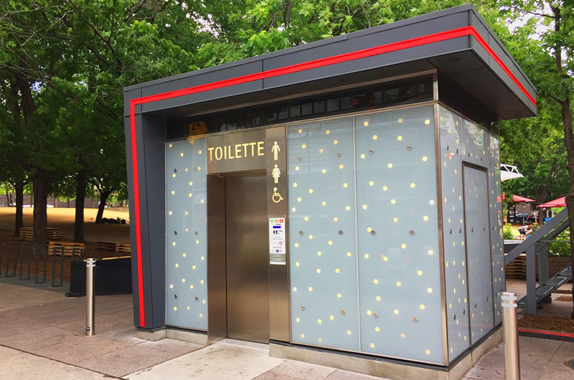

Despite the fact that our country has plenty of public

toilets, there is no other way to check and maintain their

cleanliness. There is no procedure in place to ensure that the

workers allocated to these restrooms are clean. Toilets should

be inspected in person to keep track of their state, which is harmful to employees. As a result of these causes, the quality

of public toilets has dropped dramatically, endangering the

health of the general public.

**The goal of this proposal is-**

to make it easier for people to maintain track of their health,

especially diabetes. The data acquired in this study will be

used to compare the data obtained in the urine of a diabetic

and a healthy person. Data pre-processing is a stage in which

data is separated into multiple categories. The information in

this study is presented in the form of numbers obtained from

the urine's RGB value. The k- means are used to process data

using the clustering approach. The steps below must be

followed in order to cluster using k-means.

In this research, we propose to use an IoT system to

collect data on many aspects of toilets to solve the problem of

toilet monitoring and maintenance, including air quality,

water availability, water closure, and vacant toilets. Using a

well-defined web interface, this software may provide

centralized data visualization. The system is sophisticated

enough to follow the cleaner's work and alert authorities if

they do not pay attention.

The authors suggest an IoT system to increase

restroom safety for the elderly and women. The system

employs sensors such as a leak detection sensor, a digital

nLight/Lux sensor, a voice detection sensor, and a pressure

sensor. This research examines the integration of a wireless

sensor local network system. The restroom is one of the most

dangerous locations, particularly for the elderly. Older

persons often have more difficulty with mobility and

balance, leaving them more vulnerable to restroom falls and

slips, as well as major health problems in the short and long

term. There is presently no IoT application for a bathroom.

Bathrooms, unlike other applications, have several distinct

characteristics, such as privacy and a wet environment. This

study proposes a holistic conceptual approach to the

development and deployment of an Internet-of-Things (IoT)

system to improve toilet safety. The idea is to employ a

major nursing care facility as a pilot testing bed for the

concept.

The sensor is utilised by placing it near the soap. The

cleaner is informed when the soap goes missing via the

mobile app. The Water Sensor is used to monitor the water

level in the tank that delivers water to the toilet. It is the most

appropriate sensor and the threshold status as well as an

action done for the same .A luminosity sensor detects the

brightness of the toilet and determines whether it is well lit

or not. The lights switch on automatically when the toilet's

brightness falls below the chosen threshold. The RFID

Scanner was chosen since it is ideal for this task. The RFID

Scanner is used to keep track of cleaners' attendance so they

don't forget to clean. Outside the toilet, there is an RFID

scanner. Every toilet has a rating system with rating buttons

where users may offer feedback after using the toilet so that

the toilets can be altered based on the feedback status. Using

the Node MCU, which allows them to connect to the internet

through Wi-Fi, all the sensors send data to the cloud every five minutes

. 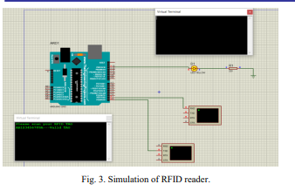

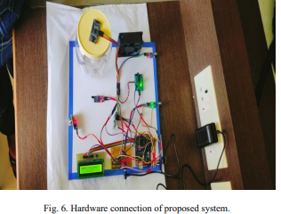

IoT Device to Monitor the Toilet:-

The MQ-135 sensor detects the stench of the toilet. The

presence of ammonia gas in the atmosphere is detected by

this sensor. The presence of Ammonia is responsible for the

toilet's foul odour. Ammonia has a pungent odour that can

only be perceived at a concentration of 5 parts per million

(parts per million).Fans automatically turn on when the

ammonia content in the toilet exceeds the set threshold of 5

ppm, while levels below 5 ppm have no impact. Moving on

to the next component, an infrared sensor is used to check

for the presence of soap in the toilet.

Data Processing is done over the cloud:-

To begin, data from IoT devices is pre-processed

depending on the sensor parameters' values. There might be

gaps in this data, as well as false measurements. Erroneous

readings are removed from the data, which is then

normalized and recorded with a timestamp in Thingspeak

database storage. This Thingspeak is a suitable choice for a

system that requires real-time data updates.

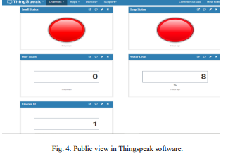

Thingspeak website where all the data

are stored. It shows Smell status, Soap status, user count,

water level, cleaner id. Soap and smell status is determined

using red light as shown in Fig. 4. If the soap is present in

the container then the red LED will turn on, similarly if there

is smell in the toilet then the red LED for smell status will

turn on. Water level is determined using percentages in water

level block. It also counts number of people entering the toilet in user count block.

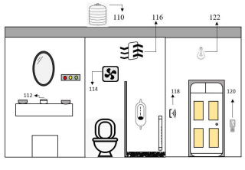

110- Water Tank.

120- Odour detection MQ-135.

112- Soap detector.

122- Automatic lights.

116- Ventilation fan 124- Frequency counter.

126- Cleaners attendance.

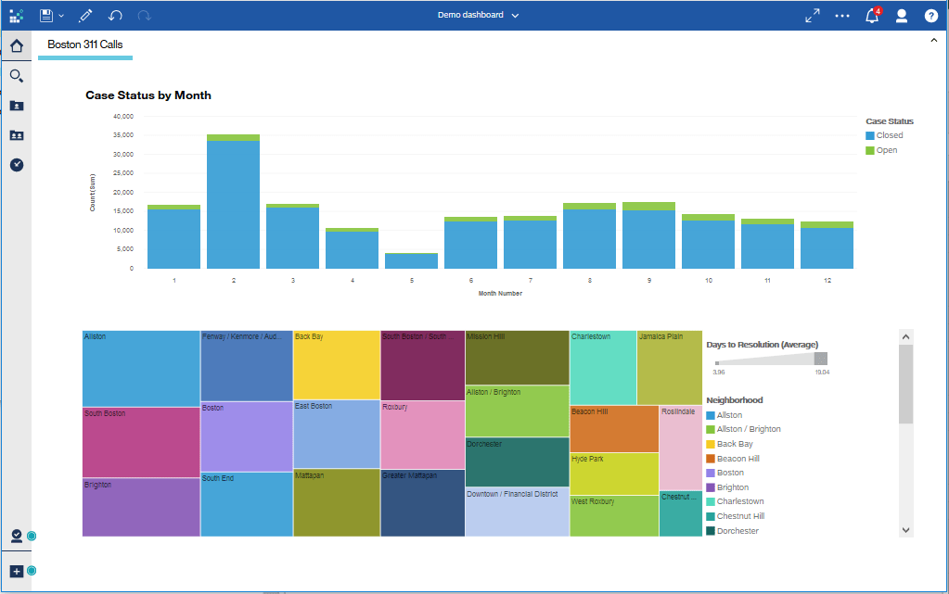

For water level detection we have used ultrasonic sensor

to measure the level of the water in the tank. In our hardware

we have used small container to store the water so based on

the distance, the ultrasonic sensor can detect the water level

which in turn displays the results on the LCD display as well

as in Thingspeak in percentage format.