SMART PUBLIC RESTROOM  
DEVELOPMENT PART-2

**ABSTRACT:**

In the cutting edge world, the advances are definitely grown, yet at the same time the cleanliness in our nation is under risk. The abstract of this paper is to deliver clean and hygiene toilets. All the public toilets should be clean and hygiene. In our country, our government has introduced the scheme called “Swachh Bharat” (Clean India). Keeping the toilets uncontaminated is the one of the objective of Clean India scheme. This can be helpful to encourage the clean India project. In future, it can show the major part in clean India scheme. In an Existing system, they are focused only on identifying the dirt in the toilets. In our proposed system, we have determined on keeping clean toilets, observing the sweeper’s working activities. It can dodge many syndromes. It may create the consciousness amongst people about the toilet management. Therefore, our development is to use safe and hygienic toilets. This paper is based on IOT and image-processing concepts using different sensors like smell sensor, IR sensor, sonic sensor, RFID reader. By using these sensors, we can create the smart toilets.

**INTRODUCTION:**

In India it is estimated that on an average about 60% of the population have no toilets in their homes. The number is still higher in rural areas at about 72%. The condition of the limited number of existing public toilets being pathetic people prefer to defecate in the open thereby compromising themselves to dreadful diseases like cholera, typhoid, hepatitis, jaundice etc. It is estimated that there are above 25 lakh women in Delhi who go for their necessary functions before dawn every morning in the open fields putting their lives to risk in view of the high level of crimes against women. The Commission has always believed that adequate civic amenities help in enhancing the aesthetics of a city. In view of the unsatisfactory situation relating to public toilets in the city of Delhi, the Commission felt that it is high time that an initiative was taken for developing high tech self sustaining public toilets which could be put up in slums, unauthorized colonies, market places and in other places like gardens and parks where foot fall is high. After receiving approval from the Government in the year 2012 on a proposal mooted by it ,the Commission on the basis of a design competition developed a prototype for a low cost self sustaining High-Tech Public Toilets which has been installed at various locations around New Delhi.

**SCOPE OF THE PROJECT:**

In this we are going to provide the clean toilet. This paper can create the awareness among the people about the clean and hygienic toilets. This paper can ensure the responsibilities of the sweeper. Finally, this concept is the one of the stepping stone to the “Clean and disease free India”.

There are two part are involved here. They are,

1. Automatic Flusher Part (AFP)

2. Server part

In an existing system, they concentrate more on organizing sewages from the railway system. They are trying to taking all the medical tests through the usage of toilets. They are concentrated on reducing water wastage on toilets, by the implementation of automatic flusher.

**WORKING PRINCIPLE:**

• In the first phase, IR sensor is used to discover the dirt present in the toilet. • Here the set of sample images are given as input. • After using the toilet, the sensor senses the basin of the toilet. • Then it relates the sensed image with the input image. • If the dirt present, it increases the alarm. • Then the user wants to be clean the waste. Through this activity, people can get the awareness about the toilet management. • In the second phase, Figaro sensor is used to perceive the unwanted gases present in the toilet. • In the Figaro sensor, a particular range is to be stable earlier manner. If the range gets extended, it can send the alert message to the sweeper. Then they cleaned it by using proper fragrant. • In the third phase, RFID reader (Radio Frequency Identification) is used to observe the sweeper’s activities (absence and presence in the toilet cleaning). • Initially, the sweeper wants to show his/her individuality tag in front of RFID reader. It can be shown before and after cleaning the toilet. • Then the first phase gets initiated and senses for the dirt presence in the toilet. • If the dirt gets noticed, it raises the alarm. • Through this monitoring activity, the sweeper can realize their roles and responsibilities. Then they protect the people by disposing all the unwanted materials (dirt, unwanted gases) present in the toilet. • In the final phase, the sonic sensor is used to detect the depth of the septic tank. • Here, the range of septic tank is fixed prior manner. • If the sewage reached with the range, then it directs message to an organization. • All the message transfer can be done by the GSM (Global System for Communication).

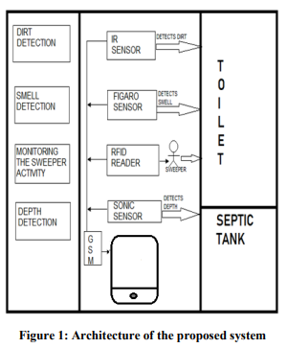

**DESCRIPTION OF ARCHITECTURE HARDWARE REQUIREMENTS:**

• Microcontroller

• Power supply

• LCD display

• Buzzer

• Infrared sensor

• Sonic sensor

• Gas sensor

• RFID

• GSM modem

**SOFTWARE REQUIREMENTS:**

• Embedded C.

MICROCONTROLLER:

A microcontroller is a small computer on a single combined circuit holding a processor core, memory and programmable input/output peripherals. Program memory in the form of Ferroelectric RAM, NOR flash or OTP ROM is also often included on chip, as well as a typically small amount of RAM. Microcontrollers are designed for embedded applications, in contrast to the microprocessors used in personal computers or other general-purpose applications.

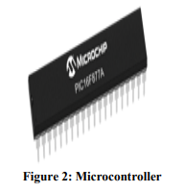

**BUZZER Buzzer:**

is also called as Beeper. It is a sound signaling mechanical device.

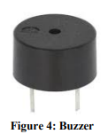

**INFRARED SENSOR:**

The IR sensor is used to detect the dirt present in the toilet. Here we nourish the image models into the sensor. It can perceive the dirt by comparing the images we feed into it, after using the toilet. If it can detect the dirt, it raises the alarm, and the users may get embraced and they clean it. This system can create the responsiveness among the people.

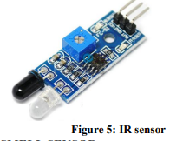

**SMELL SENSOR**

The Smell Sensor is used to detect the unwanted smell and gases in the toilet.

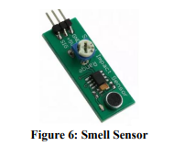

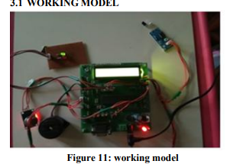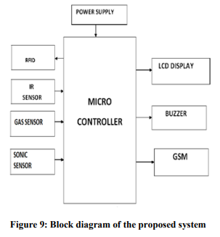

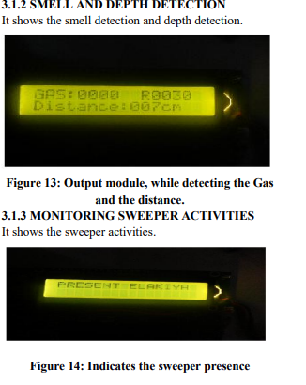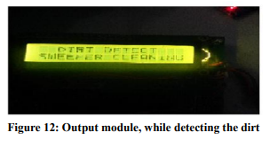

**ADVANTAGES :**

• It can creates an awareness among the people about the proper toilet management

• It can prevents the many contagious diseases like malaria, typhoid, cholera, streptococcus, asthma, etc..

• It can promotes the “Swachhbharat” scheme.

**CONCLUSION:**

Our proposed project will create awareness among the people about the proper sanitation. It makes use of Internet of things, which is a rapidly growing technology. Our proposed system will make everyone to strictly follow the cleanliness and proper sanitation in the toilets. It prevents the many new contagious diseases that spread due to improper sanitation of the toilets. Thus by using technologies in the smarter way, we can maintain the cleanliness which is next to the godliness. Keep Clean, Be Safe.

**SAMPLE DESIGN:**

(Size of the unit - 6.90m X 2.75m) (Internal height - 2.20m)

INTERNAL LAYOUT OPTIONS:

Option 01:

With Two Ladies WCs, One Universal Toilet as per CPWD specifications, three gents WCs, three urinals and three washbasins.

Combination of:

a. One universal

b. Two ladies WCs

c. Three gents WCs and four urinals

d. Three washbasins

