Symbiosis Skills and Professional University



Skill Journal

**Name: Yograj Anant Gadekar** **Date:15-12-2021**

**PRN:**

**School:** School of Data Science

**Course:** Data Associate (Data Science)

**Module Name:** Python for Data Analysis **/** Managing with Data **/** Analyzing Data from Disparate Sources **(tick any one)**

1. **Skill Activity Number: 10**
2. **Title:** BusinessAnalytics with Tableau on PUBG Game Data Analysis
3. **Skills / Competencies to be acquired:**

Tableau

1. **Duration:** 2 day
2. **What is the purpose of the activity?**

How to analyse, explore a data with Tableau

1. **Steps Performed in this activity?**
2. **What resources / materials / equipment / tools did you use for this activity?**

Tableau, MS word

1. **What skills did you acquire?**

Visualization with Tableau

1. **Time taken to complete this activity?**

1 Hours

**Business Analytics with Tableau**

**Assignment on Project Data**

**Project: PUBG Game Data Analysis**

1. **Age wise check Do u play game Pie chart**

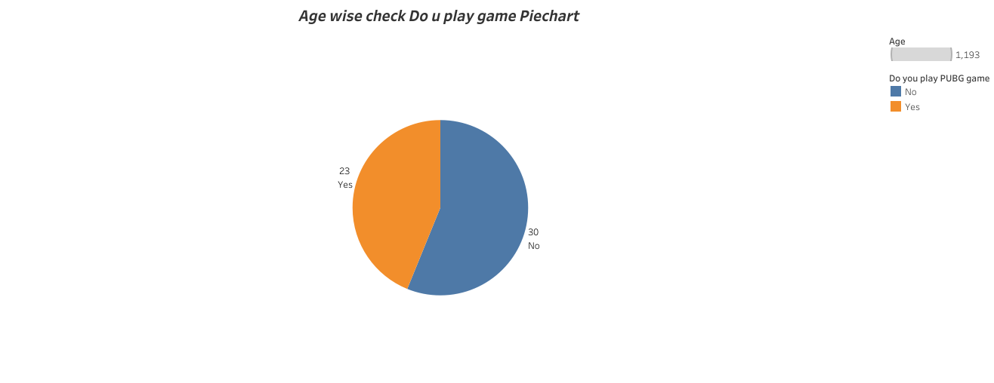

1. **Age wise Positive Effect**

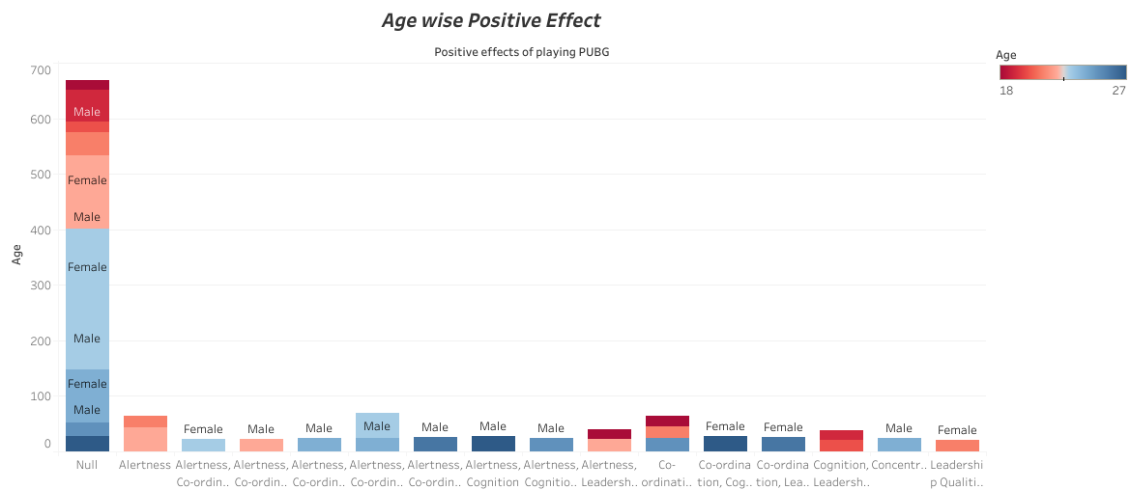

1. **Sum of Kills in particular Match Type**

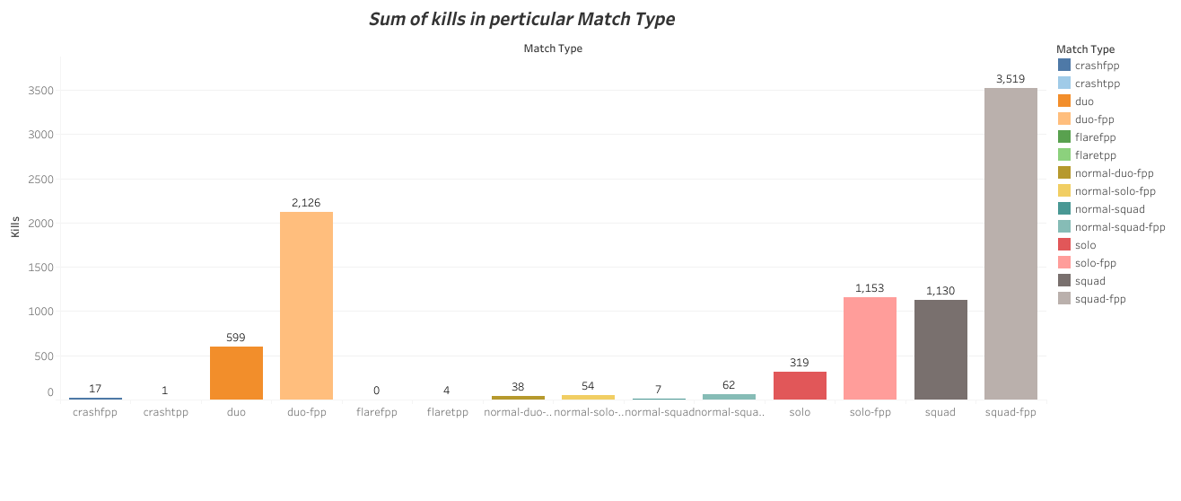

1. **Headshot Kills with Id**

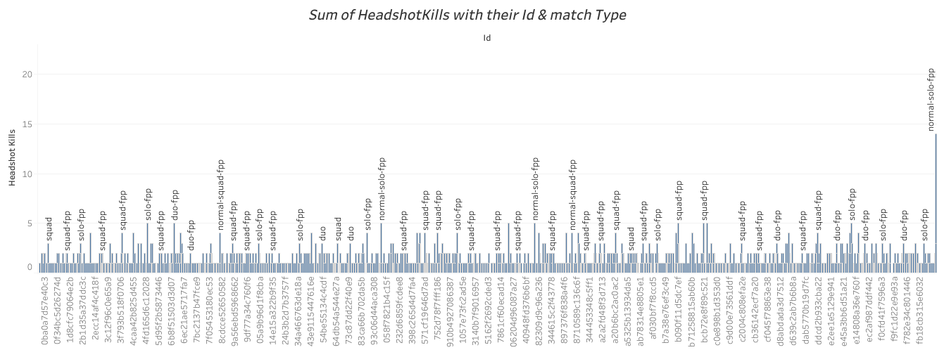

1. **Piechart for matchtype and sum of revives**

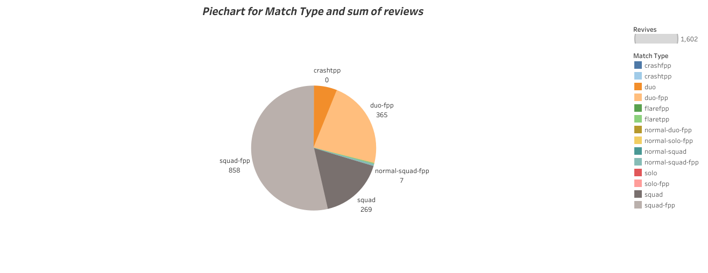

1. **Reasons_Why_dont_play Game**



1. **Total RankPoints**

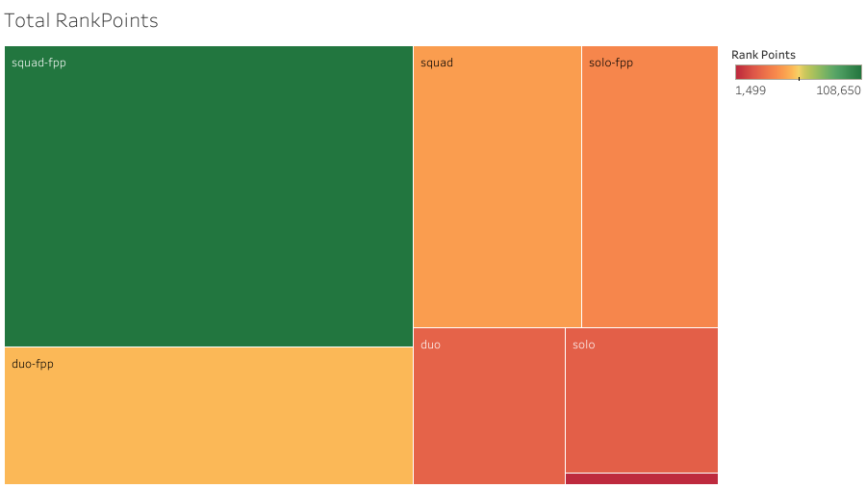

1. **Total_heals in Match_duration**

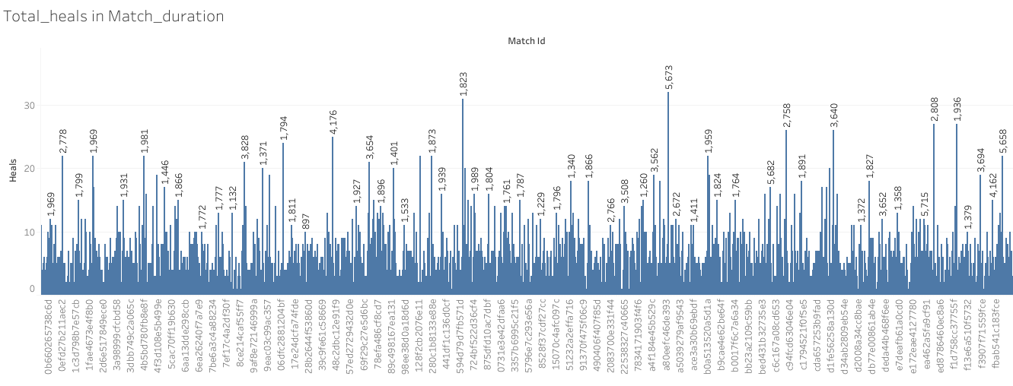

1. **Dashboard 1- Barchart and Piechart**

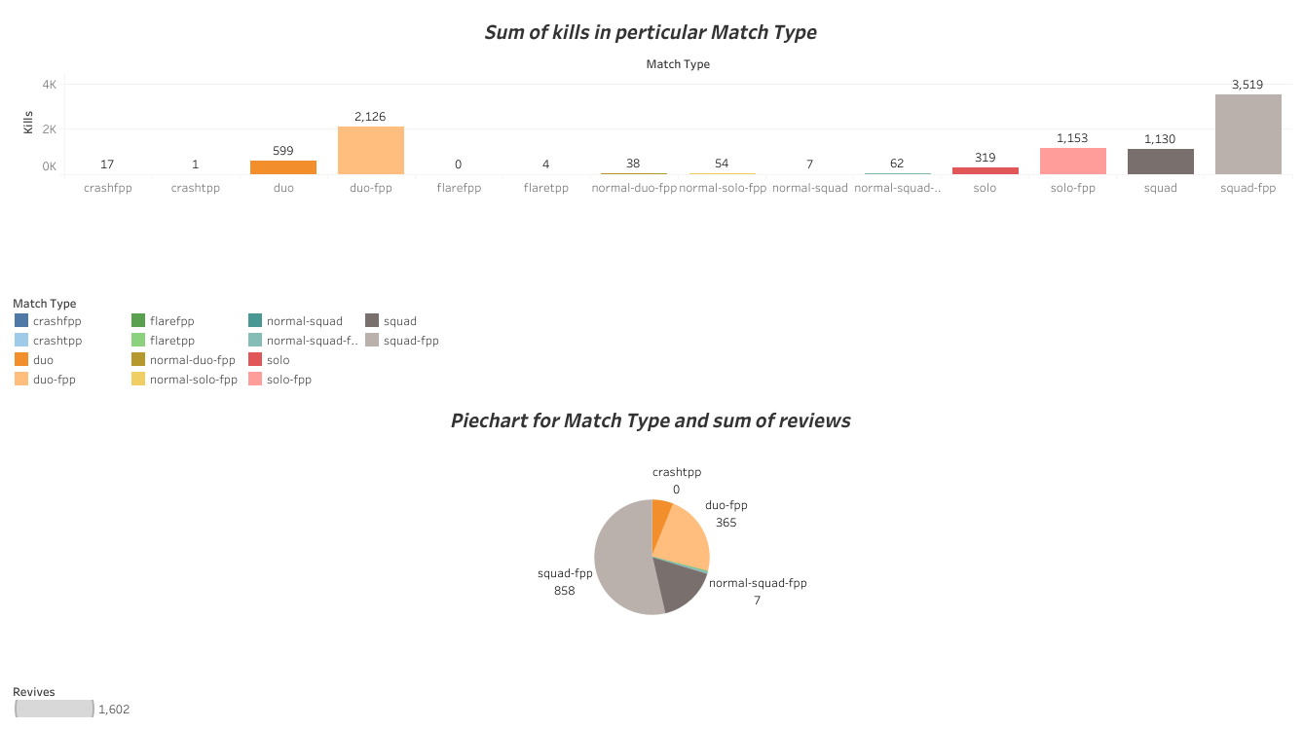

1. **Dashboard 2 – Tree maps and sum of headshot kill**

