Symbiosis Skills and Professional University



Skill Journal

**Name: Yograj Anant Gadekar** **Date: 20/11/2021**

**PRN:**

**School:** School of Data Science

**Course:** Data Associate (Data Science) DA13

**Module Name:** HDFS_import, HDFS_export, HIVE_import

1. **Skill Activity Number :** 06
2. **Title:** Create DB, Tables, import and export file in HDFS by using SQOOP.
3. **Skills / Competencies to be acquired :** Linux, MYSQL, HDFS, HIVE, SQOOP
4. **Duration: 2 days.**
5. **What is the purpose of the activity?**

Purpose of this activity is to understand how to import and export files in HDFS / HIVE using SQOOP

1. **Steps Performed in this activity?**

1) Create Database and tables.

2) Load file into MYSQL.

3) Describe & select table in MYSQL.

4) Open new terminal and import MYSQL table into HDFS using SQOOP.

5) Show file using hdfs dfs –cat command.

6) Export HDFS file into MYSQL using SQOOP.

7) Rename file HDFS_import to HIVE_import in MYSQL.

8) Import renamed file in HIVE using SQOOP.

9) Check imported file in HIVE.

1. **What resources / materials / equipment / tools did you use for this activity?**

VM-Ware, MYSQL, HIVE, Hadoop, MS-word.

1. **What skills did you acquire?**

Linux, Hive, Hadoop, MYSQL, SQOOP Commands and Learn concepts of SQOOP.

1. **Time taken to complete this activity?**

1 hrs

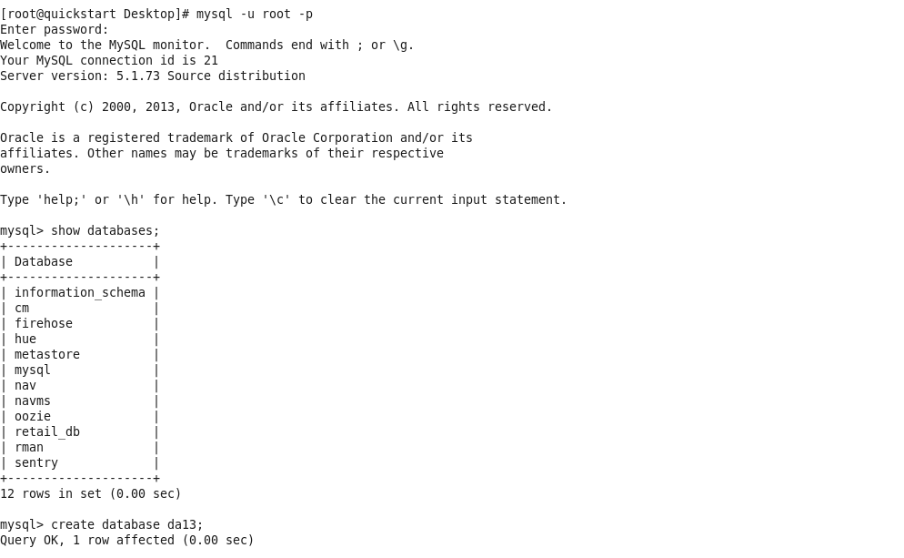

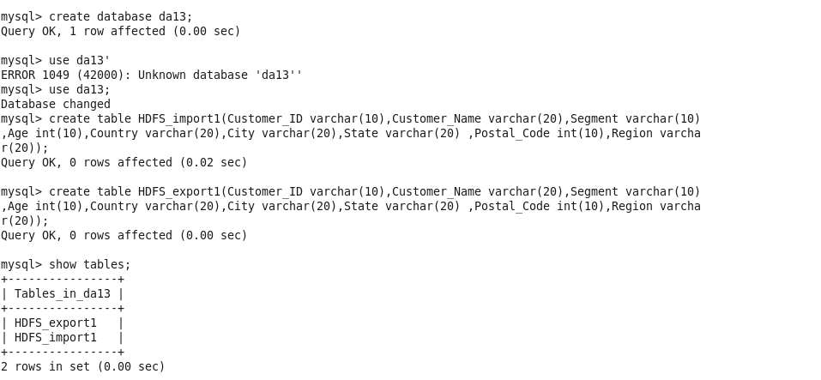

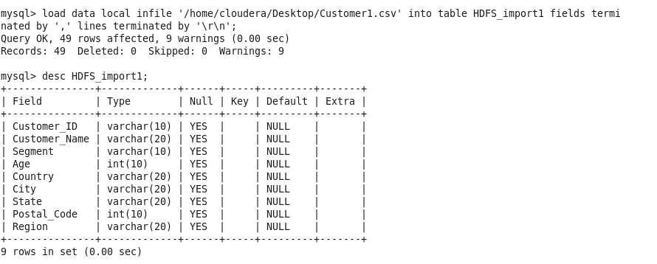

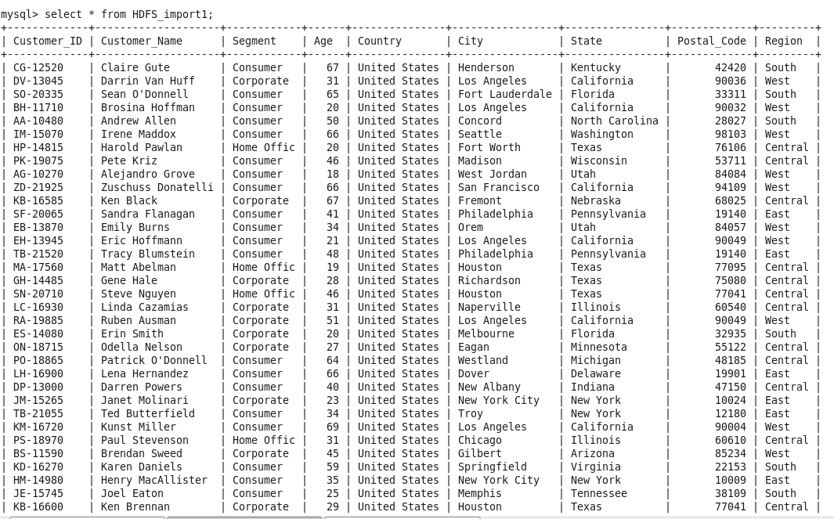

**[cloudera@quickstart Desktop]$ sudo su**

**[root@quickstart Desktop]# cd /**

**[root@quickstart /]# sqoop import --connect jdbc:mysql://quickstart/da13 --table HDFS_import1 --username root -password cloudera -m 1**

Warning: /usr/lib/sqoop/../accumulo does not exist! Accumulo imports will fail.

Please set $ACCUMULO_HOME to the root of your Accumulo installation.

21/11/20 02:23:22 INFO sqoop.Sqoop: Running Sqoop version: 1.4.6-cdh5.13.0

21/11/20 02:23:22 WARN tool.BaseSqoopTool: Setting your password on the command-line is insecure. Consider using -P instead.

21/11/20 02:23:23 INFO manager.MySQLManager: Preparing to use a MySQL streaming resultset.

21/11/20 02:23:23 INFO tool.CodeGenTool: Beginning code generation

21/11/20 02:23:24 INFO manager.SqlManager: Executing SQL statement: SELECT t.* FROM `HDFS_import1` AS t LIMIT 1

21/11/20 02:23:24 INFO manager.SqlManager: Executing SQL statement: SELECT t.* FROM `HDFS_import1` AS t LIMIT 1

21/11/20 02:23:24 INFO orm.CompilationManager: HADOOP_MAPRED_HOME is /usr/lib/hadoop-mapreduce

Note: /tmp/sqoop-root/compile/9fff4bd5bbe0557460bf457add8ed07a/HDFS_import1.java uses or overrides a deprecated API.

Note: Recompile with -Xlint:deprecation for details.

21/11/20 02:23:32 INFO orm.CompilationManager: Writing jar file: /tmp/sqoop-root/compile/9fff4bd5bbe0557460bf457add8ed07a/HDFS_import1.jar

21/11/20 02:23:32 WARN manager.MySQLManager: It looks like you are importing from mysql.

21/11/20 02:23:32 WARN manager.MySQLManager: This transfer can be faster! Use the --direct

21/11/20 02:23:32 WARN manager.MySQLManager: option to exercise a MySQL-specific fast path.

21/11/20 02:23:32 INFO manager.MySQLManager: Setting zero DATETIME behavior to convertToNull (mysql)

21/11/20 02:23:32 INFO mapreduce.ImportJobBase: Beginning import of HDFS_import1

21/11/20 02:23:32 INFO Configuration.deprecation: mapred.job.tracker is deprecated. Instead, use mapreduce.jobtracker.address

21/11/20 02:23:33 INFO Configuration.deprecation: mapred.jar is deprecated. Instead, use mapreduce.job.jar

21/11/20 02:23:35 INFO Configuration.deprecation: mapred.map.tasks is deprecated. Instead, use mapreduce.job.maps

21/11/20 02:23:36 INFO client.RMProxy: Connecting to ResourceManager at /0.0.0.0:8032

21/11/20 02:23:39 WARN hdfs.DFSClient: Caught exception

java.lang.InterruptedException

at java.lang.Object.wait(Native Method)

at java.lang.Thread.join(Thread.java:1281)

at java.lang.Thread.join(Thread.java:1355)

at org.apache.hadoop.hdfs.DFSOutputStream$DataStreamer.closeResponder(DFSOutputStream.java:967)

at org.apache.hadoop.hdfs.DFSOutputStream$DataStreamer.endBlock(DFSOutputStream.java:705)

at org.apache.hadoop.hdfs.DFSOutputStream$DataStreamer.run(DFSOutputStream.java:894)

21/11/20 02:23:39 WARN hdfs.DFSClient: Caught exception

java.lang.InterruptedException

at java.lang.Object.wait(Native Method)

at java.lang.Thread.join(Thread.java:1281)

at java.lang.Thread.join(Thread.java:1355)

at org.apache.hadoop.hdfs.DFSOutputStream$DataStreamer.closeResponder(DFSOutputStream.java:967)

at org.apache.hadoop.hdfs.DFSOutputStream$DataStreamer.endBlock(DFSOutputStream.java:705)

at org.apache.hadoop.hdfs.DFSOutputStream$DataStreamer.run(DFSOutputStream.java:894)

21/11/20 02:23:39 WARN hdfs.DFSClient: Caught exception

java.lang.InterruptedException

at java.lang.Object.wait(Native Method)

at java.lang.Thread.join(Thread.java:1281)

at java.lang.Thread.join(Thread.java:1355)

at org.apache.hadoop.hdfs.DFSOutputStream$DataStreamer.closeResponder(DFSOutputStream.java:967)

at org.apache.hadoop.hdfs.DFSOutputStream$DataStreamer.endBlock(DFSOutputStream.java:705)

at org.apache.hadoop.hdfs.DFSOutputStream$DataStreamer.run(DFSOutputStream.java:894)

21/11/20 02:23:39 WARN hdfs.DFSClient: Caught exception

java.lang.InterruptedException

at java.lang.Object.wait(Native Method)

at java.lang.Thread.join(Thread.java:1281)

at java.lang.Thread.join(Thread.java:1355)

at org.apache.hadoop.hdfs.DFSOutputStream$DataStreamer.closeResponder(DFSOutputStream.java:967)

at org.apache.hadoop.hdfs.DFSOutputStream$DataStreamer.endBlock(DFSOutputStream.java:705)

at org.apache.hadoop.hdfs.DFSOutputStream$DataStreamer.run(DFSOutputStream.java:894)

21/11/20 02:23:39 WARN hdfs.DFSClient: Caught exception

java.lang.InterruptedException

at java.lang.Object.wait(Native Method)

at java.lang.Thread.join(Thread.java:1281)

at java.lang.Thread.join(Thread.java:1355)

at org.apache.hadoop.hdfs.DFSOutputStream$DataStreamer.closeResponder(DFSOutputStream.java:967)

at org.apache.hadoop.hdfs.DFSOutputStream$DataStreamer.endBlock(DFSOutputStream.java:705)

at org.apache.hadoop.hdfs.DFSOutputStream$DataStreamer.run(DFSOutputStream.java:894)

21/11/20 02:23:39 WARN hdfs.DFSClient: Caught exception

java.lang.InterruptedException

at java.lang.Object.wait(Native Method)

at java.lang.Thread.join(Thread.java:1281)

at java.lang.Thread.join(Thread.java:1355)

at org.apache.hadoop.hdfs.DFSOutputStream$DataStreamer.closeResponder(DFSOutputStream.java:967)

at org.apache.hadoop.hdfs.DFSOutputStream$DataStreamer.endBlock(DFSOutputStream.java:705)

at org.apache.hadoop.hdfs.DFSOutputStream$DataStreamer.run(DFSOutputStream.java:894)

21/11/20 02:23:40 WARN hdfs.DFSClient: Caught exception

java.lang.InterruptedException

at java.lang.Object.wait(Native Method)

at java.lang.Thread.join(Thread.java:1281)

at java.lang.Thread.join(Thread.java:1355)

at org.apache.hadoop.hdfs.DFSOutputStream$DataStreamer.closeResponder(DFSOutputStream.java:967)

at org.apache.hadoop.hdfs.DFSOutputStream$DataStreamer.endBlock(DFSOutputStream.java:705)

at org.apache.hadoop.hdfs.DFSOutputStream$DataStreamer.run(DFSOutputStream.java:894)

21/11/20 02:23:40 WARN hdfs.DFSClient: Caught exception

java.lang.InterruptedException

at java.lang.Object.wait(Native Method)

at java.lang.Thread.join(Thread.java:1281)

at java.lang.Thread.join(Thread.java:1355)

at org.apache.hadoop.hdfs.DFSOutputStream$DataStreamer.closeResponder(DFSOutputStream.java:967)

at org.apache.hadoop.hdfs.DFSOutputStream$DataStreamer.endBlock(DFSOutputStream.java:705)

at org.apache.hadoop.hdfs.DFSOutputStream$DataStreamer.run(DFSOutputStream.java:894)

21/11/20 02:23:41 WARN hdfs.DFSClient: Caught exception

java.lang.InterruptedException

at java.lang.Object.wait(Native Method)

at java.lang.Thread.join(Thread.java:1281)

at java.lang.Thread.join(Thread.java:1355)

at org.apache.hadoop.hdfs.DFSOutputStream$DataStreamer.closeResponder(DFSOutputStream.java:967)

at org.apache.hadoop.hdfs.DFSOutputStream$DataStreamer.endBlock(DFSOutputStream.java:705)

at org.apache.hadoop.hdfs.DFSOutputStream$DataStreamer.run(DFSOutputStream.java:894)

21/11/20 02:23:41 WARN hdfs.DFSClient: Caught exception

java.lang.InterruptedException

at java.lang.Object.wait(Native Method)

at java.lang.Thread.join(Thread.java:1281)

at java.lang.Thread.join(Thread.java:1355)

at org.apache.hadoop.hdfs.DFSOutputStream$DataStreamer.closeResponder(DFSOutputStream.java:967)

at org.apache.hadoop.hdfs.DFSOutputStream$DataStreamer.endBlock(DFSOutputStream.java:705)

at org.apache.hadoop.hdfs.DFSOutputStream$DataStreamer.run(DFSOutputStream.java:894)

21/11/20 02:23:41 WARN hdfs.DFSClient: Caught exception

java.lang.InterruptedException

at java.lang.Object.wait(Native Method)

at java.lang.Thread.join(Thread.java:1281)

at java.lang.Thread.join(Thread.java:1355)

at org.apache.hadoop.hdfs.DFSOutputStream$DataStreamer.closeResponder(DFSOutputStream.java:967)

at org.apache.hadoop.hdfs.DFSOutputStream$DataStreamer.endBlock(DFSOutputStream.java:705)

at org.apache.hadoop.hdfs.DFSOutputStream$DataStreamer.run(DFSOutputStream.java:894)

21/11/20 02:23:43 WARN hdfs.DFSClient: Caught exception

java.lang.InterruptedException

at java.lang.Object.wait(Native Method)

at java.lang.Thread.join(Thread.java:1281)

at java.lang.Thread.join(Thread.java:1355)

at org.apache.hadoop.hdfs.DFSOutputStream$DataStreamer.closeResponder(DFSOutputStream.java:967)

at org.apache.hadoop.hdfs.DFSOutputStream$DataStreamer.endBlock(DFSOutputStream.java:705)

at org.apache.hadoop.hdfs.DFSOutputStream$DataStreamer.run(DFSOutputStream.java:894)

21/11/20 02:23:44 INFO db.DBInputFormat: Using read commited transaction isolation

21/11/20 02:23:44 INFO mapreduce.JobSubmitter: number of splits:1

21/11/20 02:23:45 INFO mapreduce.JobSubmitter: Submitting tokens for job: job_1637398850950_0001

21/11/20 02:23:49 INFO impl.YarnClientImpl: Submitted application application_1637398850950_0001

21/11/20 02:23:50 INFO mapreduce.Job: The url to track the job: http://quickstart.cloudera:8088/proxy/application_1637398850950_0001/

21/11/20 02:23:50 INFO mapreduce.Job: Running job: job_1637398850950_0001

21/11/20 02:24:27 INFO mapreduce.Job: Job job_1637398850950_0001 running in uber mode : false

21/11/20 02:24:27 INFO mapreduce.Job: map 0% reduce 0%

21/11/20 02:24:44 INFO mapreduce.Job: map 100% reduce 0%

21/11/20 02:24:44 INFO mapreduce.Job: Job job_1637398850950_0001 completed successfully

21/11/20 02:24:45 INFO mapreduce.Job: Counters: 30

File System Counters

FILE: Number of bytes read=0

FILE: Number of bytes written=170598

FILE: Number of read operations=0

FILE: Number of large read operations=0

FILE: Number of write operations=0

HDFS: Number of bytes read=87

HDFS: Number of bytes written=3995

HDFS: Number of read operations=4

HDFS: Number of large read operations=0

HDFS: Number of write operations=2

Job Counters

Launched map tasks=1

Other local map tasks=1

Total time spent by all maps in occupied slots (ms)=14386

Total time spent by all reduces in occupied slots (ms)=0

Total time spent by all map tasks (ms)=14386

Total vcore-milliseconds taken by all map tasks=14386

Total megabyte-milliseconds taken by all map tasks=14731264

Map-Reduce Framework

Map input records=49

Map output records=49

Input split bytes=87

Spilled Records=0

Failed Shuffles=0

Merged Map outputs=0

GC time elapsed (ms)=126

CPU time spent (ms)=1710

Physical memory (bytes) snapshot=122990592

Virtual memory (bytes) snapshot=1510187008

Total committed heap usage (bytes)=60882944

File Input Format Counters

Bytes Read=0

File Output Format Counters

Bytes Written=3995

21/11/20 02:24:45 INFO mapreduce.ImportJobBase: Transferred 3.9014 KB in 69.5436 seconds (57.446 bytes/sec)

21/11/20 02:24:45 INFO mapreduce.ImportJobBase: Retrieved 49 records.

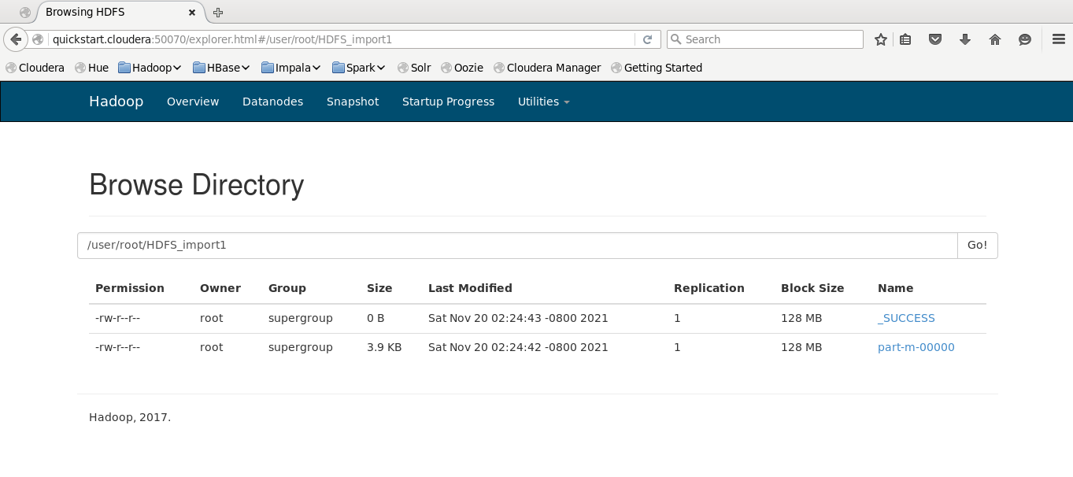

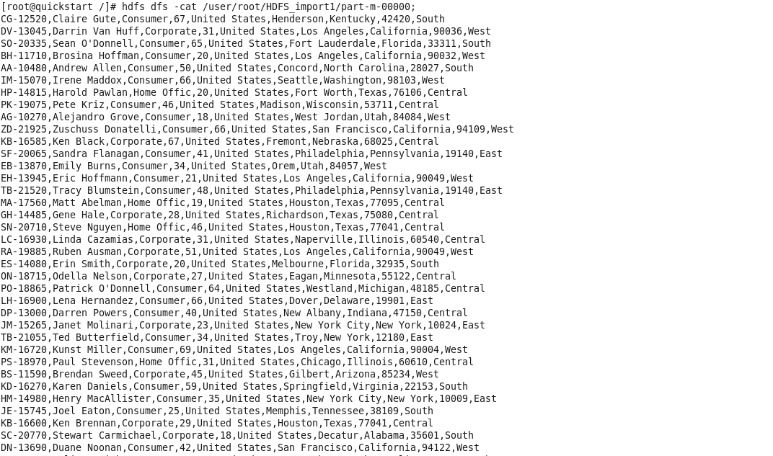

**Step : export HDFS File into MySQL (HDFS_export1)**

**[root@quickstart /]# sqoop export --connect jdbc:mysql://quickstart/da13 --export-dir /user/root/HDFS_import1 --table HDFS_export1 --username root -password cloudera -m 1**

Warning: /usr/lib/sqoop/../accumulo does not exist! Accumulo imports will fail.

Please set $ACCUMULO_HOME to the root of your Accumulo installation.

21/11/20 02:39:20 INFO sqoop.Sqoop: Running Sqoop version: 1.4.6-cdh5.13.0

21/11/20 02:39:20 WARN tool.BaseSqoopTool: Setting your password on the command-line is insecure. Consider using -P instead.

21/11/20 02:39:21 INFO manager.MySQLManager: Preparing to use a MySQL streaming resultset.

21/11/20 02:39:21 INFO tool.CodeGenTool: Beginning code generation

21/11/20 02:39:22 INFO manager.SqlManager: Executing SQL statement: SELECT t.* FROM `HDFS_export1` AS t LIMIT 1

21/11/20 02:39:22 INFO manager.SqlManager: Executing SQL statement: SELECT t.* FROM `HDFS_export1` AS t LIMIT 1

21/11/20 02:39:22 INFO orm.CompilationManager: HADOOP_MAPRED_HOME is /usr/lib/hadoop-mapreduce

Note: /tmp/sqoop-root/compile/0476476a7e9d868e4393bcd9c00e0456/HDFS_export1.java uses or overrides a deprecated API.

Note: Recompile with -Xlint:deprecation for details.

21/11/20 02:39:27 INFO orm.CompilationManager: Writing jar file: /tmp/sqoop-root/compile/0476476a7e9d868e4393bcd9c00e0456/HDFS_export1.jar

21/11/20 02:39:27 INFO mapreduce.ExportJobBase: Beginning export of HDFS_export1

21/11/20 02:39:27 INFO Configuration.deprecation: mapred.job.tracker is deprecated. Instead, use mapreduce.jobtracker.address

21/11/20 02:39:28 INFO Configuration.deprecation: mapred.jar is deprecated. Instead, use mapreduce.job.jar

21/11/20 02:39:30 INFO Configuration.deprecation: mapred.reduce.tasks.speculative.execution is deprecated. Instead, use mapreduce.reduce.speculative

21/11/20 02:39:30 INFO Configuration.deprecation: mapred.map.tasks.speculative.execution is deprecated. Instead, use mapreduce.map.speculative

21/11/20 02:39:30 INFO Configuration.deprecation: mapred.map.tasks is deprecated. Instead, use mapreduce.job.maps

21/11/20 02:39:31 INFO client.RMProxy: Connecting to ResourceManager at /0.0.0.0:8032

21/11/20 02:39:32 WARN hdfs.DFSClient: Caught exception

java.lang.InterruptedException

at java.lang.Object.wait(Native Method)

at java.lang.Thread.join(Thread.java:1281)

at java.lang.Thread.join(Thread.java:1355)

at org.apache.hadoop.hdfs.DFSOutputStream$DataStreamer.closeResponder(DFSOutputStream.java:967)

at org.apache.hadoop.hdfs.DFSOutputStream$DataStreamer.endBlock(DFSOutputStream.java:705)

at org.apache.hadoop.hdfs.DFSOutputStream$DataStreamer.run(DFSOutputStream.java:894)

21/11/20 02:39:32 WARN hdfs.DFSClient: Caught exception

java.lang.InterruptedException

at java.lang.Object.wait(Native Method)

at java.lang.Thread.join(Thread.java:1281)

at java.lang.Thread.join(Thread.java:1355)

at org.apache.hadoop.hdfs.DFSOutputStream$DataStreamer.closeResponder(DFSOutputStream.java:967)

at org.apache.hadoop.hdfs.DFSOutputStream$DataStreamer.endBlock(DFSOutputStream.java:705)

at org.apache.hadoop.hdfs.DFSOutputStream$DataStreamer.run(DFSOutputStream.java:894)

21/11/20 02:39:32 WARN hdfs.DFSClient: Caught exception

java.lang.InterruptedException

at java.lang.Object.wait(Native Method)

at java.lang.Thread.join(Thread.java:1281)

at java.lang.Thread.join(Thread.java:1355)

at org.apache.hadoop.hdfs.DFSOutputStream$DataStreamer.closeResponder(DFSOutputStream.java:967)

at org.apache.hadoop.hdfs.DFSOutputStream$DataStreamer.endBlock(DFSOutputStream.java:705)

at org.apache.hadoop.hdfs.DFSOutputStream$DataStreamer.run(DFSOutputStream.java:894)

21/11/20 02:39:32 WARN hdfs.DFSClient: Caught exception

java.lang.InterruptedException

at java.lang.Object.wait(Native Method)

at java.lang.Thread.join(Thread.java:1281)

at java.lang.Thread.join(Thread.java:1355)

at org.apache.hadoop.hdfs.DFSOutputStream$DataStreamer.closeResponder(DFSOutputStream.java:967)

at org.apache.hadoop.hdfs.DFSOutputStream$DataStreamer.endBlock(DFSOutputStream.java:705)

at org.apache.hadoop.hdfs.DFSOutputStream$DataStreamer.run(DFSOutputStream.java:894)

21/11/20 02:39:32 WARN hdfs.DFSClient: Caught exception

java.lang.InterruptedException

at java.lang.Object.wait(Native Method)

at java.lang.Thread.join(Thread.java:1281)

at java.lang.Thread.join(Thread.java:1355)

at org.apache.hadoop.hdfs.DFSOutputStream$DataStreamer.closeResponder(DFSOutputStream.java:967)

at org.apache.hadoop.hdfs.DFSOutputStream$DataStreamer.endBlock(DFSOutputStream.java:705)

at org.apache.hadoop.hdfs.DFSOutputStream$DataStreamer.run(DFSOutputStream.java:894)

21/11/20 02:39:33 WARN hdfs.DFSClient: Caught exception

java.lang.InterruptedException

at java.lang.Object.wait(Native Method)

at java.lang.Thread.join(Thread.java:1281)

at java.lang.Thread.join(Thread.java:1355)

at org.apache.hadoop.hdfs.DFSOutputStream$DataStreamer.closeResponder(DFSOutputStream.java:967)

at org.apache.hadoop.hdfs.DFSOutputStream$DataStreamer.endBlock(DFSOutputStream.java:705)

at org.apache.hadoop.hdfs.DFSOutputStream$DataStreamer.run(DFSOutputStream.java:894)

21/11/20 02:39:33 WARN hdfs.DFSClient: Caught exception

java.lang.InterruptedException

at java.lang.Object.wait(Native Method)

at java.lang.Thread.join(Thread.java:1281)

at java.lang.Thread.join(Thread.java:1355)

at org.apache.hadoop.hdfs.DFSOutputStream$DataStreamer.closeResponder(DFSOutputStream.java:967)

at org.apache.hadoop.hdfs.DFSOutputStream$DataStreamer.endBlock(DFSOutputStream.java:705)

at org.apache.hadoop.hdfs.DFSOutputStream$DataStreamer.run(DFSOutputStream.java:894)

21/11/20 02:39:33 WARN hdfs.DFSClient: Caught exception

java.lang.InterruptedException

at java.lang.Object.wait(Native Method)

at java.lang.Thread.join(Thread.java:1281)

at java.lang.Thread.join(Thread.java:1355)

at org.apache.hadoop.hdfs.DFSOutputStream$DataStreamer.closeResponder(DFSOutputStream.java:967)

at org.apache.hadoop.hdfs.DFSOutputStream$DataStreamer.endBlock(DFSOutputStream.java:705)

at org.apache.hadoop.hdfs.DFSOutputStream$DataStreamer.run(DFSOutputStream.java:894)

21/11/20 02:39:33 WARN hdfs.DFSClient: Caught exception

java.lang.InterruptedException

at java.lang.Object.wait(Native Method)

at java.lang.Thread.join(Thread.java:1281)

at java.lang.Thread.join(Thread.java:1355)

at org.apache.hadoop.hdfs.DFSOutputStream$DataStreamer.closeResponder(DFSOutputStream.java:967)

at org.apache.hadoop.hdfs.DFSOutputStream$DataStreamer.endBlock(DFSOutputStream.java:705)

at org.apache.hadoop.hdfs.DFSOutputStream$DataStreamer.run(DFSOutputStream.java:894)

21/11/20 02:39:33 WARN hdfs.DFSClient: Caught exception

java.lang.InterruptedException

at java.lang.Object.wait(Native Method)

at java.lang.Thread.join(Thread.java:1281)

at java.lang.Thread.join(Thread.java:1355)

at org.apache.hadoop.hdfs.DFSOutputStream$DataStreamer.closeResponder(DFSOutputStream.java:967)

at org.apache.hadoop.hdfs.DFSOutputStream$DataStreamer.endBlock(DFSOutputStream.java:705)

at org.apache.hadoop.hdfs.DFSOutputStream$DataStreamer.run(DFSOutputStream.java:894)

21/11/20 02:39:33 WARN hdfs.DFSClient: Caught exception

java.lang.InterruptedException

at java.lang.Object.wait(Native Method)

at java.lang.Thread.join(Thread.java:1281)

at java.lang.Thread.join(Thread.java:1355)

at org.apache.hadoop.hdfs.DFSOutputStream$DataStreamer.closeResponder(DFSOutputStream.java:967)

at org.apache.hadoop.hdfs.DFSOutputStream$DataStreamer.endBlock(DFSOutputStream.java:705)

at org.apache.hadoop.hdfs.DFSOutputStream$DataStreamer.run(DFSOutputStream.java:894)

21/11/20 02:39:33 WARN hdfs.DFSClient: Caught exception

java.lang.InterruptedException

at java.lang.Object.wait(Native Method)

at java.lang.Thread.join(Thread.java:1281)

at java.lang.Thread.join(Thread.java:1355)

at org.apache.hadoop.hdfs.DFSOutputStream$DataStreamer.closeResponder(DFSOutputStream.java:967)

at org.apache.hadoop.hdfs.DFSOutputStream$DataStreamer.endBlock(DFSOutputStream.java:705)

at org.apache.hadoop.hdfs.DFSOutputStream$DataStreamer.run(DFSOutputStream.java:894)

21/11/20 02:39:33 WARN hdfs.DFSClient: Caught exception

java.lang.InterruptedException

at java.lang.Object.wait(Native Method)

at java.lang.Thread.join(Thread.java:1281)

at java.lang.Thread.join(Thread.java:1355)

at org.apache.hadoop.hdfs.DFSOutputStream$DataStreamer.closeResponder(DFSOutputStream.java:967)

at org.apache.hadoop.hdfs.DFSOutputStream$DataStreamer.endBlock(DFSOutputStream.java:705)

at org.apache.hadoop.hdfs.DFSOutputStream$DataStreamer.run(DFSOutputStream.java:894)

21/11/20 02:39:33 WARN hdfs.DFSClient: Caught exception

java.lang.InterruptedException

at java.lang.Object.wait(Native Method)

at java.lang.Thread.join(Thread.java:1281)

at java.lang.Thread.join(Thread.java:1355)

at org.apache.hadoop.hdfs.DFSOutputStream$DataStreamer.closeResponder(DFSOutputStream.java:967)

at org.apache.hadoop.hdfs.DFSOutputStream$DataStreamer.endBlock(DFSOutputStream.java:705)

at org.apache.hadoop.hdfs.DFSOutputStream$DataStreamer.run(DFSOutputStream.java:894)

21/11/20 02:39:33 WARN hdfs.DFSClient: Caught exception

java.lang.InterruptedException

at java.lang.Object.wait(Native Method)

at java.lang.Thread.join(Thread.java:1281)

at java.lang.Thread.join(Thread.java:1355)

at org.apache.hadoop.hdfs.DFSOutputStream$DataStreamer.closeResponder(DFSOutputStream.java:967)

at org.apache.hadoop.hdfs.DFSOutputStream$DataStreamer.endBlock(DFSOutputStream.java:705)

at org.apache.hadoop.hdfs.DFSOutputStream$DataStreamer.run(DFSOutputStream.java:894)

21/11/20 02:39:34 WARN hdfs.DFSClient: Caught exception

java.lang.InterruptedException

at java.lang.Object.wait(Native Method)

at java.lang.Thread.join(Thread.java:1281)

at java.lang.Thread.join(Thread.java:1355)

at org.apache.hadoop.hdfs.DFSOutputStream$DataStreamer.closeResponder(DFSOutputStream.java:967)

at org.apache.hadoop.hdfs.DFSOutputStream$DataStreamer.endBlock(DFSOutputStream.java:705)

at org.apache.hadoop.hdfs.DFSOutputStream$DataStreamer.run(DFSOutputStream.java:894)

21/11/20 02:39:34 WARN hdfs.DFSClient: Caught exception

java.lang.InterruptedException

at java.lang.Object.wait(Native Method)

at java.lang.Thread.join(Thread.java:1281)

at java.lang.Thread.join(Thread.java:1355)

at org.apache.hadoop.hdfs.DFSOutputStream$DataStreamer.closeResponder(DFSOutputStream.java:967)

at org.apache.hadoop.hdfs.DFSOutputStream$DataStreamer.endBlock(DFSOutputStream.java:705)

at org.apache.hadoop.hdfs.DFSOutputStream$DataStreamer.run(DFSOutputStream.java:894)

21/11/20 02:39:34 WARN hdfs.DFSClient: Caught exception

java.lang.InterruptedException

at java.lang.Object.wait(Native Method)

at java.lang.Thread.join(Thread.java:1281)

at java.lang.Thread.join(Thread.java:1355)

at org.apache.hadoop.hdfs.DFSOutputStream$DataStreamer.closeResponder(DFSOutputStream.java:967)

at org.apache.hadoop.hdfs.DFSOutputStream$DataStreamer.endBlock(DFSOutputStream.java:705)

at org.apache.hadoop.hdfs.DFSOutputStream$DataStreamer.run(DFSOutputStream.java:894)

21/11/20 02:39:34 WARN hdfs.DFSClient: Caught exception

java.lang.InterruptedException

at java.lang.Object.wait(Native Method)

at java.lang.Thread.join(Thread.java:1281)

at java.lang.Thread.join(Thread.java:1355)

at org.apache.hadoop.hdfs.DFSOutputStream$DataStreamer.closeResponder(DFSOutputStream.java:967)

at org.apache.hadoop.hdfs.DFSOutputStream$DataStreamer.endBlock(DFSOutputStream.java:705)

at org.apache.hadoop.hdfs.DFSOutputStream$DataStreamer.run(DFSOutputStream.java:894)

21/11/20 02:39:34 WARN hdfs.DFSClient: Caught exception

java.lang.InterruptedException

at java.lang.Object.wait(Native Method)

at java.lang.Thread.join(Thread.java:1281)

at java.lang.Thread.join(Thread.java:1355)

at org.apache.hadoop.hdfs.DFSOutputStream$DataStreamer.closeResponder(DFSOutputStream.java:967)

at org.apache.hadoop.hdfs.DFSOutputStream$DataStreamer.endBlock(DFSOutputStream.java:705)

at org.apache.hadoop.hdfs.DFSOutputStream$DataStreamer.run(DFSOutputStream.java:894)

21/11/20 02:39:34 WARN hdfs.DFSClient: Caught exception

java.lang.InterruptedException

at java.lang.Object.wait(Native Method)

at java.lang.Thread.join(Thread.java:1281)

at java.lang.Thread.join(Thread.java:1355)

at org.apache.hadoop.hdfs.DFSOutputStream$DataStreamer.closeResponder(DFSOutputStream.java:967)

at org.apache.hadoop.hdfs.DFSOutputStream$DataStreamer.endBlock(DFSOutputStream.java:705)

at org.apache.hadoop.hdfs.DFSOutputStream$DataStreamer.run(DFSOutputStream.java:894)

21/11/20 02:39:35 WARN hdfs.DFSClient: Caught exception

java.lang.InterruptedException

at java.lang.Object.wait(Native Method)

at java.lang.Thread.join(Thread.java:1281)

at java.lang.Thread.join(Thread.java:1355)

at org.apache.hadoop.hdfs.DFSOutputStream$DataStreamer.closeResponder(DFSOutputStream.java:967)

at org.apache.hadoop.hdfs.DFSOutputStream$DataStreamer.endBlock(DFSOutputStream.java:705)

at org.apache.hadoop.hdfs.DFSOutputStream$DataStreamer.run(DFSOutputStream.java:894)

21/11/20 02:39:35 INFO input.FileInputFormat: Total input paths to process : 1

21/11/20 02:39:35 INFO input.FileInputFormat: Total input paths to process : 1

21/11/20 02:39:35 WARN hdfs.DFSClient: Caught exception

java.lang.InterruptedException

at java.lang.Object.wait(Native Method)

at java.lang.Thread.join(Thread.java:1281)

at java.lang.Thread.join(Thread.java:1355)

at org.apache.hadoop.hdfs.DFSOutputStream$DataStreamer.closeResponder(DFSOutputStream.java:967)

at org.apache.hadoop.hdfs.DFSOutputStream$DataStreamer.endBlock(DFSOutputStream.java:705)

at org.apache.hadoop.hdfs.DFSOutputStream$DataStreamer.run(DFSOutputStream.java:894)

21/11/20 02:39:35 WARN hdfs.DFSClient: Caught exception

java.lang.InterruptedException

at java.lang.Object.wait(Native Method)

at java.lang.Thread.join(Thread.java:1281)

at java.lang.Thread.join(Thread.java:1355)

at org.apache.hadoop.hdfs.DFSOutputStream$DataStreamer.closeResponder(DFSOutputStream.java:967)

at org.apache.hadoop.hdfs.DFSOutputStream$DataStreamer.endBlock(DFSOutputStream.java:705)

at org.apache.hadoop.hdfs.DFSOutputStream$DataStreamer.run(DFSOutputStream.java:894)

21/11/20 02:39:35 INFO mapreduce.JobSubmitter: number of splits:1

21/11/20 02:39:35 INFO Configuration.deprecation: mapred.map.tasks.speculative.execution is deprecated. Instead, use mapreduce.map.speculative

21/11/20 02:39:35 INFO mapreduce.JobSubmitter: Submitting tokens for job: job_1637398850950_0002

21/11/20 02:39:36 INFO impl.YarnClientImpl: Submitted application application_1637398850950_0002

21/11/20 02:39:36 INFO mapreduce.Job: The url to track the job: http://quickstart.cloudera:8088/proxy/application_1637398850950_0002/

21/11/20 02:39:37 INFO mapreduce.Job: Running job: job_1637398850950_0002

21/11/20 02:39:55 INFO mapreduce.Job: Job job_1637398850950_0002 running in uber mode : false

21/11/20 02:39:55 INFO mapreduce.Job: map 0% reduce 0%

21/11/20 02:40:09 INFO mapreduce.Job: map 100% reduce 0%

21/11/20 02:40:10 INFO mapreduce.Job: Job job_1637398850950_0002 completed successfully

21/11/20 02:40:10 INFO mapreduce.Job: Counters: 30

File System Counters

FILE: Number of bytes read=0

FILE: Number of bytes written=170539

FILE: Number of read operations=0

FILE: Number of large read operations=0

FILE: Number of write operations=0

HDFS: Number of bytes read=4146

HDFS: Number of bytes written=0

HDFS: Number of read operations=4

HDFS: Number of large read operations=0

HDFS: Number of write operations=0

Job Counters

Launched map tasks=1

Data-local map tasks=1

Total time spent by all maps in occupied slots (ms)=11871

Total time spent by all reduces in occupied slots (ms)=0

Total time spent by all map tasks (ms)=11871

Total vcore-milliseconds taken by all map tasks=11871

Total megabyte-milliseconds taken by all map tasks=12155904

Map-Reduce Framework

Map input records=49

Map output records=49

Input split bytes=148

Spilled Records=0

Failed Shuffles=0

Merged Map outputs=0

GC time elapsed (ms)=353

CPU time spent (ms)=1350

Physical memory (bytes) snapshot=114774016

Virtual memory (bytes) snapshot=1508089856

Total committed heap usage (bytes)=60882944

File Input Format Counters

Bytes Read=0

File Output Format Counters

Bytes Written=0

21/11/20 02:40:10 INFO mapreduce.ExportJobBase: Transferred 4.0488 KB in 39.9864 seconds (103.6853 bytes/sec)

21/11/20 02:40:10 INFO mapreduce.ExportJobBase: Exported 49 records.

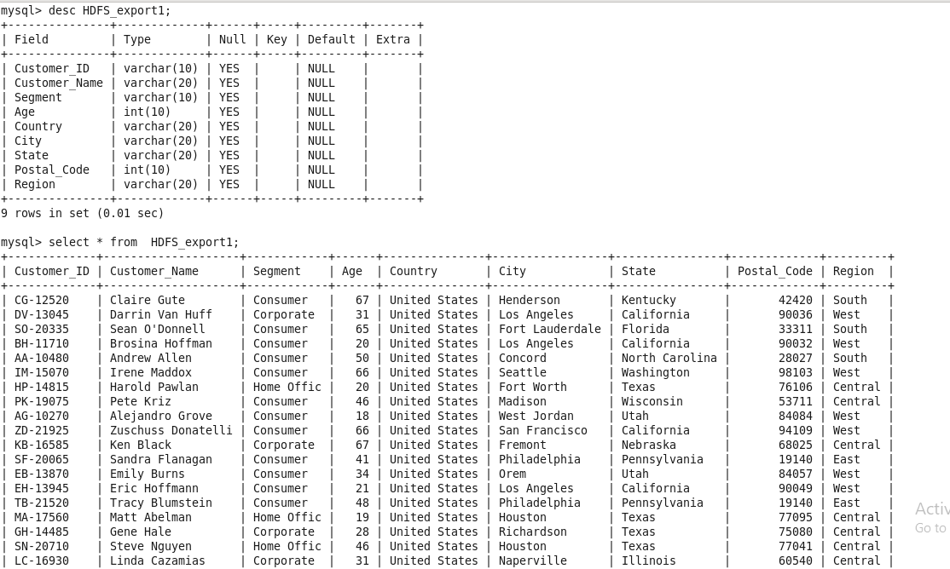

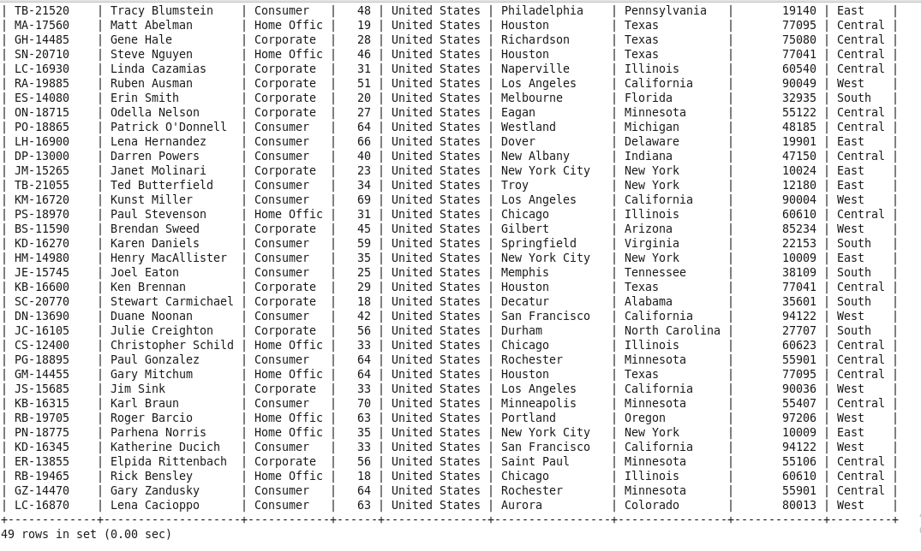

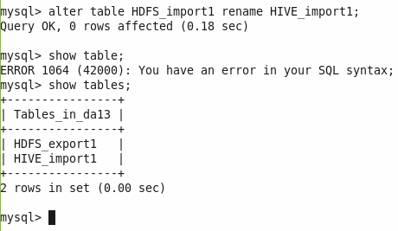

**[root@quickstart /]# sqoop import --connect jdbc:mysql://quickstart/da13 --table HIVE_import1 --create-hive-table --hive-import --username root -password cloudera -m 1**

Warning: /usr/lib/sqoop/../accumulo does not exist! Accumulo imports will fail.

Please set $ACCUMULO_HOME to the root of your Accumulo installation.

21/11/20 03:43:28 INFO sqoop.Sqoop: Running Sqoop version: 1.4.6-cdh5.13.0

21/11/20 03:43:28 WARN tool.BaseSqoopTool: Setting your password on the command-line is insecure. Consider using -P instead.

21/11/20 03:43:28 INFO tool.BaseSqoopTool: Using Hive-specific delimiters for output. You can override

21/11/20 03:43:28 INFO tool.BaseSqoopTool: delimiters with --fields-terminated-by, etc.

21/11/20 03:43:29 INFO manager.MySQLManager: Preparing to use a MySQL streaming resultset.

21/11/20 03:43:29 INFO tool.CodeGenTool: Beginning code generation

21/11/20 03:43:32 INFO manager.SqlManager: Executing SQL statement: SELECT t.* FROM `HIVE_import1` AS t LIMIT 1

21/11/20 03:43:32 INFO manager.SqlManager: Executing SQL statement: SELECT t.* FROM `HIVE_import1` AS t LIMIT 1

21/11/20 03:43:32 INFO orm.CompilationManager: HADOOP_MAPRED_HOME is /usr/lib/hadoop-mapreduce

Note: /tmp/sqoop-root/compile/853d544b8241c6e87ea9328ceb50fb2d/HIVE_import1.java uses or overrides a deprecated API.

Note: Recompile with -Xlint:deprecation for details.

21/11/20 03:43:41 INFO orm.CompilationManager: Writing jar file: /tmp/sqoop-root/compile/853d544b8241c6e87ea9328ceb50fb2d/HIVE_import1.jar

21/11/20 03:43:42 WARN manager.MySQLManager: It looks like you are importing from mysql.

21/11/20 03:43:42 WARN manager.MySQLManager: This transfer can be faster! Use the --direct

21/11/20 03:43:42 WARN manager.MySQLManager: option to exercise a MySQL-specific fast path.

21/11/20 03:43:42 INFO manager.MySQLManager: Setting zero DATETIME behavior to convertToNull (mysql)

21/11/20 03:43:42 INFO mapreduce.ImportJobBase: Beginning import of HIVE_import1

21/11/20 03:43:42 INFO Configuration.deprecation: mapred.job.tracker is deprecated. Instead, use mapreduce.jobtracker.address

21/11/20 03:43:43 INFO Configuration.deprecation: mapred.jar is deprecated. Instead, use mapreduce.job.jar

21/11/20 03:43:46 INFO Configuration.deprecation: mapred.map.tasks is deprecated. Instead, use mapreduce.job.maps

21/11/20 03:43:46 INFO client.RMProxy: Connecting to ResourceManager at /0.0.0.0:8032

21/11/20 03:43:52 WARN hdfs.DFSClient: Caught exception

java.lang.InterruptedException

at java.lang.Object.wait(Native Method)

at java.lang.Thread.join(Thread.java:1281)

at java.lang.Thread.join(Thread.java:1355)

at org.apache.hadoop.hdfs.DFSOutputStream$DataStreamer.closeResponder(DFSOutputStream.java:967)

at org.apache.hadoop.hdfs.DFSOutputStream$DataStreamer.endBlock(DFSOutputStream.java:705)

at org.apache.hadoop.hdfs.DFSOutputStream$DataStreamer.run(DFSOutputStream.java:894)

21/11/20 03:43:53 WARN hdfs.DFSClient: Caught exception

java.lang.InterruptedException

at java.lang.Object.wait(Native Method)

at java.lang.Thread.join(Thread.java:1281)

at java.lang.Thread.join(Thread.java:1355)

at org.apache.hadoop.hdfs.DFSOutputStream$DataStreamer.closeResponder(DFSOutputStream.java:967)

at org.apache.hadoop.hdfs.DFSOutputStream$DataStreamer.endBlock(DFSOutputStream.java:705)

at org.apache.hadoop.hdfs.DFSOutputStream$DataStreamer.run(DFSOutputStream.java:894)

21/11/20 03:43:53 WARN hdfs.DFSClient: Caught exception

java.lang.InterruptedException

at java.lang.Object.wait(Native Method)

at java.lang.Thread.join(Thread.java:1281)

at java.lang.Thread.join(Thread.java:1355)

at org.apache.hadoop.hdfs.DFSOutputStream$DataStreamer.closeResponder(DFSOutputStream.java:967)

at org.apache.hadoop.hdfs.DFSOutputStream$DataStreamer.endBlock(DFSOutputStream.java:705)

at org.apache.hadoop.hdfs.DFSOutputStream$DataStreamer.run(DFSOutputStream.java:894)

21/11/20 03:43:53 WARN hdfs.DFSClient: Caught exception

java.lang.InterruptedException

at java.lang.Object.wait(Native Method)

at java.lang.Thread.join(Thread.java:1281)

at java.lang.Thread.join(Thread.java:1355)

at org.apache.hadoop.hdfs.DFSOutputStream$DataStreamer.closeResponder(DFSOutputStream.java:967)

at org.apache.hadoop.hdfs.DFSOutputStream$DataStreamer.endBlock(DFSOutputStream.java:705)

at org.apache.hadoop.hdfs.DFSOutputStream$DataStreamer.run(DFSOutputStream.java:894)

21/11/20 03:43:53 WARN hdfs.DFSClient: Caught exception

java.lang.InterruptedException

at java.lang.Object.wait(Native Method)

at java.lang.Thread.join(Thread.java:1281)

at java.lang.Thread.join(Thread.java:1355)

at org.apache.hadoop.hdfs.DFSOutputStream$DataStreamer.closeResponder(DFSOutputStream.java:967)

at org.apache.hadoop.hdfs.DFSOutputStream$DataStreamer.endBlock(DFSOutputStream.java:705)

at org.apache.hadoop.hdfs.DFSOutputStream$DataStreamer.run(DFSOutputStream.java:894)

21/11/20 03:43:53 WARN hdfs.DFSClient: Caught exception

java.lang.InterruptedException

at java.lang.Object.wait(Native Method)

at java.lang.Thread.join(Thread.java:1281)

at java.lang.Thread.join(Thread.java:1355)

at org.apache.hadoop.hdfs.DFSOutputStream$DataStreamer.closeResponder(DFSOutputStream.java:967)

at org.apache.hadoop.hdfs.DFSOutputStream$DataStreamer.endBlock(DFSOutputStream.java:705)

at org.apache.hadoop.hdfs.DFSOutputStream$DataStreamer.run(DFSOutputStream.java:894)

21/11/20 03:43:53 WARN hdfs.DFSClient: Caught exception

java.lang.InterruptedException

at java.lang.Object.wait(Native Method)

at java.lang.Thread.join(Thread.java:1281)

at java.lang.Thread.join(Thread.java:1355)

at org.apache.hadoop.hdfs.DFSOutputStream$DataStreamer.closeResponder(DFSOutputStream.java:967)

at org.apache.hadoop.hdfs.DFSOutputStream$DataStreamer.endBlock(DFSOutputStream.java:705)

at org.apache.hadoop.hdfs.DFSOutputStream$DataStreamer.run(DFSOutputStream.java:894)

21/11/20 03:43:53 WARN hdfs.DFSClient: Caught exception

java.lang.InterruptedException

at java.lang.Object.wait(Native Method)

at java.lang.Thread.join(Thread.java:1281)

at java.lang.Thread.join(Thread.java:1355)

at org.apache.hadoop.hdfs.DFSOutputStream$DataStreamer.closeResponder(DFSOutputStream.java:967)

at org.apache.hadoop.hdfs.DFSOutputStream$DataStreamer.endBlock(DFSOutputStream.java:705)

at org.apache.hadoop.hdfs.DFSOutputStream$DataStreamer.run(DFSOutputStream.java:894)

21/11/20 03:43:53 WARN hdfs.DFSClient: Caught exception

java.lang.InterruptedException

at java.lang.Object.wait(Native Method)

at java.lang.Thread.join(Thread.java:1281)

at java.lang.Thread.join(Thread.java:1355)

at org.apache.hadoop.hdfs.DFSOutputStream$DataStreamer.closeResponder(DFSOutputStream.java:967)

at org.apache.hadoop.hdfs.DFSOutputStream$DataStreamer.endBlock(DFSOutputStream.java:705)

at org.apache.hadoop.hdfs.DFSOutputStream$DataStreamer.run(DFSOutputStream.java:894)

21/11/20 03:43:54 WARN hdfs.DFSClient: Caught exception

java.lang.InterruptedException

at java.lang.Object.wait(Native Method)

at java.lang.Thread.join(Thread.java:1281)

at java.lang.Thread.join(Thread.java:1355)

at org.apache.hadoop.hdfs.DFSOutputStream$DataStreamer.closeResponder(DFSOutputStream.java:967)

at org.apache.hadoop.hdfs.DFSOutputStream$DataStreamer.endBlock(DFSOutputStream.java:705)

at org.apache.hadoop.hdfs.DFSOutputStream$DataStreamer.run(DFSOutputStream.java:894)

21/11/20 03:43:54 WARN hdfs.DFSClient: Caught exception

java.lang.InterruptedException

at java.lang.Object.wait(Native Method)

at java.lang.Thread.join(Thread.java:1281)

at java.lang.Thread.join(Thread.java:1355)

at org.apache.hadoop.hdfs.DFSOutputStream$DataStreamer.closeResponder(DFSOutputStream.java:967)

at org.apache.hadoop.hdfs.DFSOutputStream$DataStreamer.endBlock(DFSOutputStream.java:705)

at org.apache.hadoop.hdfs.DFSOutputStream$DataStreamer.run(DFSOutputStream.java:894)

21/11/20 03:43:54 WARN hdfs.DFSClient: Caught exception

java.lang.InterruptedException

at java.lang.Object.wait(Native Method)

at java.lang.Thread.join(Thread.java:1281)

at java.lang.Thread.join(Thread.java:1355)

at org.apache.hadoop.hdfs.DFSOutputStream$DataStreamer.closeResponder(DFSOutputStream.java:967)

at org.apache.hadoop.hdfs.DFSOutputStream$DataStreamer.endBlock(DFSOutputStream.java:705)

at org.apache.hadoop.hdfs.DFSOutputStream$DataStreamer.run(DFSOutputStream.java:894)

21/11/20 03:43:55 WARN hdfs.DFSClient: Caught exception

java.lang.InterruptedException

at java.lang.Object.wait(Native Method)

at java.lang.Thread.join(Thread.java:1281)

at java.lang.Thread.join(Thread.java:1355)

at org.apache.hadoop.hdfs.DFSOutputStream$DataStreamer.closeResponder(DFSOutputStream.java:967)

at org.apache.hadoop.hdfs.DFSOutputStream$DataStreamer.endBlock(DFSOutputStream.java:705)

at org.apache.hadoop.hdfs.DFSOutputStream$DataStreamer.run(DFSOutputStream.java:894)

21/11/20 03:43:55 WARN hdfs.DFSClient: Caught exception

java.lang.InterruptedException

at java.lang.Object.wait(Native Method)

at java.lang.Thread.join(Thread.java:1281)

at java.lang.Thread.join(Thread.java:1355)

at org.apache.hadoop.hdfs.DFSOutputStream$DataStreamer.closeResponder(DFSOutputStream.java:967)

at org.apache.hadoop.hdfs.DFSOutputStream$DataStreamer.endBlock(DFSOutputStream.java:705)

at org.apache.hadoop.hdfs.DFSOutputStream$DataStreamer.run(DFSOutputStream.java:894)

21/11/20 03:43:55 WARN hdfs.DFSClient: Caught exception

java.lang.InterruptedException

at java.lang.Object.wait(Native Method)

at java.lang.Thread.join(Thread.java:1281)

at java.lang.Thread.join(Thread.java:1355)

at org.apache.hadoop.hdfs.DFSOutputStream$DataStreamer.closeResponder(DFSOutputStream.java:967)

at org.apache.hadoop.hdfs.DFSOutputStream$DataStreamer.closeInternal(DFSOutputStream.java:935)

at org.apache.hadoop.hdfs.DFSOutputStream$DataStreamer.run(DFSOutputStream.java:931)

21/11/20 03:43:55 WARN hdfs.DFSClient: Caught exception

java.lang.InterruptedException

at java.lang.Object.wait(Native Method)

at java.lang.Thread.join(Thread.java:1281)

at java.lang.Thread.join(Thread.java:1355)

at org.apache.hadoop.hdfs.DFSOutputStream$DataStreamer.closeResponder(DFSOutputStream.java:967)

at org.apache.hadoop.hdfs.DFSOutputStream$DataStreamer.endBlock(DFSOutputStream.java:705)

at org.apache.hadoop.hdfs.DFSOutputStream$DataStreamer.run(DFSOutputStream.java:894)

21/11/20 03:43:57 WARN hdfs.DFSClient: Caught exception

java.lang.InterruptedException

at java.lang.Object.wait(Native Method)

at java.lang.Thread.join(Thread.java:1281)

at java.lang.Thread.join(Thread.java:1355)

at org.apache.hadoop.hdfs.DFSOutputStream$DataStreamer.closeResponder(DFSOutputStream.java:967)

at org.apache.hadoop.hdfs.DFSOutputStream$DataStreamer.endBlock(DFSOutputStream.java:705)

at org.apache.hadoop.hdfs.DFSOutputStream$DataStreamer.run(DFSOutputStream.java:894)

21/11/20 03:43:57 INFO db.DBInputFormat: Using read commited transaction isolation

21/11/20 03:43:58 WARN hdfs.DFSClient: Caught exception

java.lang.InterruptedException

at java.lang.Object.wait(Native Method)

at java.lang.Thread.join(Thread.java:1281)

at java.lang.Thread.join(Thread.java:1355)

at org.apache.hadoop.hdfs.DFSOutputStream$DataStreamer.closeResponder(DFSOutputStream.java:967)

at org.apache.hadoop.hdfs.DFSOutputStream$DataStreamer.endBlock(DFSOutputStream.java:705)

at org.apache.hadoop.hdfs.DFSOutputStream$DataStreamer.run(DFSOutputStream.java:894)

21/11/20 03:43:58 WARN hdfs.DFSClient: Caught exception

java.lang.InterruptedException

at java.lang.Object.wait(Native Method)

at java.lang.Thread.join(Thread.java:1281)

at java.lang.Thread.join(Thread.java:1355)

at org.apache.hadoop.hdfs.DFSOutputStream$DataStreamer.closeResponder(DFSOutputStream.java:967)

at org.apache.hadoop.hdfs.DFSOutputStream$DataStreamer.endBlock(DFSOutputStream.java:705)

at org.apache.hadoop.hdfs.DFSOutputStream$DataStreamer.run(DFSOutputStream.java:894)

21/11/20 03:43:58 INFO mapreduce.JobSubmitter: number of splits:1

21/11/20 03:43:58 INFO mapreduce.JobSubmitter: Submitting tokens for job: job_1637398850950_0003

21/11/20 03:44:00 INFO impl.YarnClientImpl: Submitted application application_1637398850950_0003

21/11/20 03:44:00 INFO mapreduce.Job: The url to track the job: http://quickstart.cloudera:8088/proxy/application_1637398850950_0003/

21/11/20 03:44:00 INFO mapreduce.Job: Running job: job_1637398850950_0003

21/11/20 03:44:27 INFO mapreduce.Job: Job job_1637398850950_0003 running in uber mode : false

21/11/20 03:44:27 INFO mapreduce.Job: map 0% reduce 0%

21/11/20 03:44:58 INFO mapreduce.Job: map 100% reduce 0%

21/11/20 03:44:58 INFO mapreduce.Job: Job job_1637398850950_0003 completed successfully

21/11/20 03:44:59 INFO mapreduce.Job: Counters: 30

File System Counters

FILE: Number of bytes read=0

FILE: Number of bytes written=170595

FILE: Number of read operations=0

FILE: Number of large read operations=0

FILE: Number of write operations=0

HDFS: Number of bytes read=87

HDFS: Number of bytes written=3995

HDFS: Number of read operations=4

HDFS: Number of large read operations=0

HDFS: Number of write operations=2

Job Counters

Launched map tasks=1

Other local map tasks=1

Total time spent by all maps in occupied slots (ms)=28158

Total time spent by all reduces in occupied slots (ms)=0

Total time spent by all map tasks (ms)=28158

Total vcore-milliseconds taken by all map tasks=28158

Total megabyte-milliseconds taken by all map tasks=28833792

Map-Reduce Framework

Map input records=49

Map output records=49

Input split bytes=87

Spilled Records=0

Failed Shuffles=0

Merged Map outputs=0

GC time elapsed (ms)=274

CPU time spent (ms)=1870

Physical memory (bytes) snapshot=116572160

Virtual memory (bytes) snapshot=1510162432

Total committed heap usage (bytes)=60882944

File Input Format Counters

Bytes Read=0

File Output Format Counters

Bytes Written=3995

21/11/20 03:44:59 INFO mapreduce.ImportJobBase: Transferred 3.9014 KB in 73.6229 seconds (54.263 bytes/sec)

21/11/20 03:44:59 INFO mapreduce.ImportJobBase: Retrieved 49 records.

21/11/20 03:44:59 INFO manager.SqlManager: Executing SQL statement: SELECT t.* FROM `HIVE_import1` AS t LIMIT 1

21/11/20 03:45:00 INFO hive.HiveImport: Loading uploaded data into Hive

Logging initialized using configuration in jar:file:/usr/lib/hive/lib/hive-common-1.1.0-cdh5.13.0.jar!/hive-log4j.properties

OK

Time taken: 19.855 seconds

Loading data to table default.hive_import1

Table default.hive_import1 stats: [numFiles=1, totalSize=3995]

OK

Time taken: 1.663 seconds

