Digital Computer Logic

Technical Document
of
MINI-CPU
(Multi cycle processor)

Presented By

Group Triple BAKA
6833123021 Thiraphat Pholboon
6833025121 Komsant Perkpiboon
6833115021 Thanisara Satalalai

2110252 Semester 1/2025
Department of Computer Engineering,
Faculty of Engineering, Chulalongkorn University

Table of content
CPU Design Concepts 2
Detailed explanation of states 3
FSM Chart 5
Design and Development of the Data Path / Control Unit

CPU Design Concepts

Overall and purpose
Our main goal is to make the CPU with harvard architecture with pRAM having size of 256*14 bits and rRAM having size of 256*8bits . We chose a multi-cycle processor because it is much easier to build , detect bugs , develop under time constraint and lastly , we don’t want to deal with hazards in pipelined processors. This approach may be seen as a less efficient way for computing time , but we decided to compensate for lost speed by not only considering the state in the FSM of the present but also precomputing the next state; we do this to prepare data for the next clock. Therefore, speeds are considerably faster.

Instruction and Opcode handling

Our CPU uses 14-bit instructions, split into a 6-bit opcode and an 8-bit operand. We handle decoding by using a small decoder logic that converts the opcode into control signals for the datapath.
For unconventional instruction in ISA such as LCM, factorial and max.
These instuction use more time than easy-to-compute arithmetic operations. Therefore,
we decided that we need dedicated state for these types of operations
We can easily implement the Jump instructions by checking the equal, greater, and lesser flags. In the multi-cycle setup, the CPU evaluates the flags in one cycle and then updates the program counter in the next cycle if the condition is met.
Lastly with the complicated instructions like pow LCM and isPrime . we encounter a tradeoff. Do we implement a function normally to have this mini-cpu as a scaleable with bit size?, Or a second choice, we hardcode the result in ROM . Since we don't have to be dealing with scaling bits , we came to the conclusion that the second choice is more suitable for us.

Detailed explanation of states

State 0: IDLE (000)
This is both the initial state of the system (when the program starts) and the final state (after results have been sent).
In this state, the system keeps the done, valid, and result the same to indicate that it is either ready to receive a new command or has just finished processing.
From this state, the FSM transitions to other states depending on the input signals:
- If reset == 1, the FSM moves to State 1 (RESET).
- If progLoad == 1, the FSM moves to State 2 (LOAD_PROG).
- If start == 1, the FSM moves to State 3 (FETCH).
- If valid == 1 and result == 1, the FSM moves to State 6 (SEND).

State 1: RESET (001)
In this state, the system clears all 16 positions of rRAM to 0 as specified, and resets all internal registers, accumulator, and flags to 0.
The system sets done = 0 and valid = 0.
The FSM remains in this state until all 16 rRAM locations have been cleared and the StopReset signal becomes 1.
After that, it returns to State 0 (IDLE).

State 2: LOAD (010)
(If reset == 1, the FSM moves to State 1 (RESET) )
In this state, the system loads the program from progIn (14 bits) into pRAM, one instruction per clock cycle. The FSM remains in this state as long as progLoad == 1.
When progLoad == 0 (indicating that program loading is complete), the FSM returns to State 0 (IDLE).

State 3: FETCH (011)
(If reset == 1, the FSM moves to State 1 (RESET) )
When entering this state (after start == 1 or after finishing the previous instruction), the system begins fetching instructions from pRAM.
The instruction is read from pRAM[PC] and stored into the Instruction Register (IR).
After fetching the instruction,
- If STOP-CODE == 1, the FSM moves to State 5 (WAIT).
- If STOP-CODE == 0, the FSM moves to State 4 (EXECUTE).

State 4: EXECUTE (100)
(If reset == 1, the FSM moves to State 1 (RESET) )
In this state, the system decodes and executes the instruction stored in IR.
The Control Unit operates according to the decoded Opcode — for example, it may command the ALU to perform addition, write data to accA, or read/write rRAM.
- If the Opcode is 51, the FSM moves to State 7 (LCM)
The FSM remains in this state until AfterExecute == 1, at which point it goes back to State 3 (FETCH).

State 5: WAIT (101)
(If reset == 1, the FSM moves to State 1 (RESET) )
In this state, the system has finished executing the program (after encountering STOP-CODE) and is ready to output the results.
The system keeps valid = 1 active, waiting for an external result signal.
The FSM remains in this state until result == 1, at which point it transitions to State 6 (SEND).

State 6: SEND (110)
(If reset == 1, the FSM moves to State 1 (RESET) )
When entering this state, the system begins sending the first 16 result values (Address 0x00–0x0F) from rRAM to the output.
The FSM remains in this state until all 16 values have been sent, indicated by StopSend == 1, the FSM returns to State 0 (IDLE).

State 7: LCM (111)
(If reset == 1, the FSM moves to State 1 (RESET) )
In this state, the system finds the LCM as instructed from the IR
The FSM remains in this state until Q_LCM == 1, at which point it transitions to State 3 (FETCH).

FSM Chart

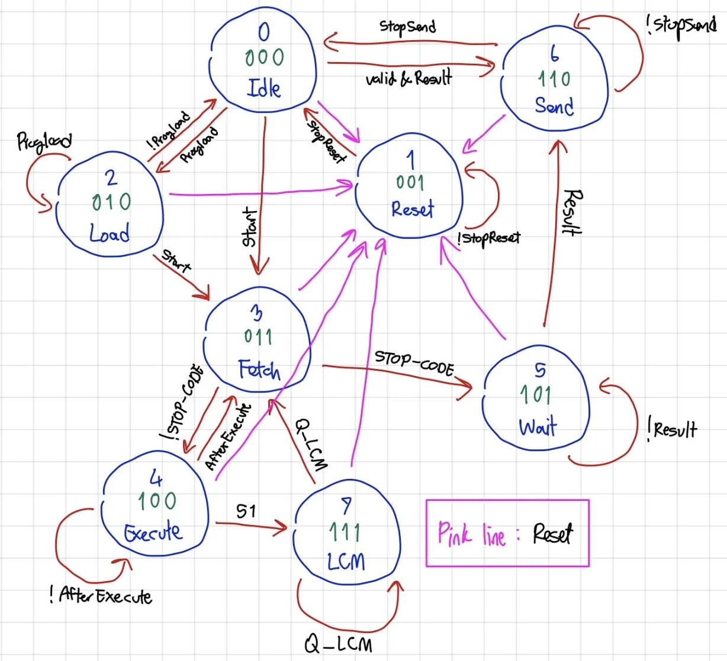

Notes : in state 3 Fetch , we implemented the “decode” state right after the IR is fetched. This preserves the normal fetch-decode-execute cycle.

Design and Development of the Data Path / Control Unit
Design of Data Path
The datapath is the core part of the CPU where actual data processing takes place.
It’s responsible for executing arithmetic and logic operations, loading and storing data, and moving values between registers and memory.
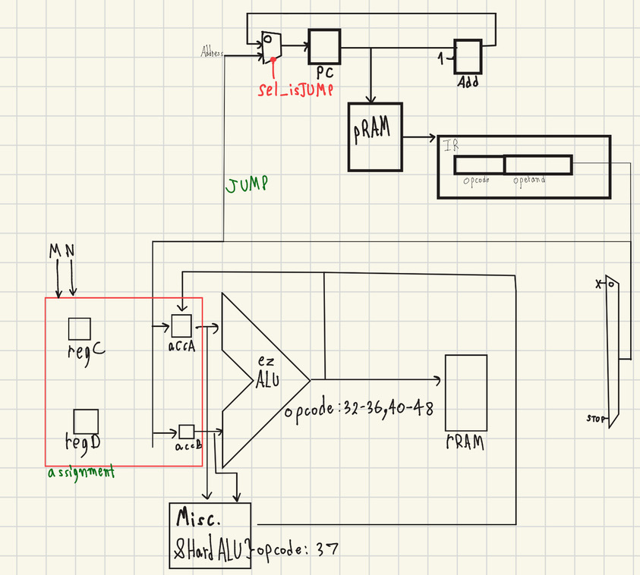
Note : ez ALU means typical arithmetic operation that is not a pow(exponent) operations
Component
Our datapath consists of the following main components:
- Registers and Accumulator (Acc):
We implemented the general-purpose registers and the accumulator separately instead of using a register file, since each register and the accumulator has its own dedicated opcode.
The accumulator mainly handles arithmetic and logic results from the ALU.
- ALU (Arithmetic Logic Unit):
The ALU performs all the core arithmetic and logic operations, including ADD, SUB, MUL, DIV, and CMP.
It takes inputs from the accumulator and registers, then outputs the result back to the accumulator or rRAM.
The Flags unit is connected to the ALU to store status information such as zero, negative, or overflow conditions.
- rRAM (Register RAM / Dual-Port RAM):
This serves as the data memory of the CPU.
We used dual-port RAM so the CPU can perform read and write operations simultaneously, improving overall execution speed.
- pRAM (Program RAM):
Holds the program instructions that the CPU executes.
The Program Counter (PC) fetches instructions from this memory.
- Program Counter (PC):
Keep track of the current instruction address.
It increments sequentially for normal execution, or jumps to a specific address when executing jump or branch instructions.
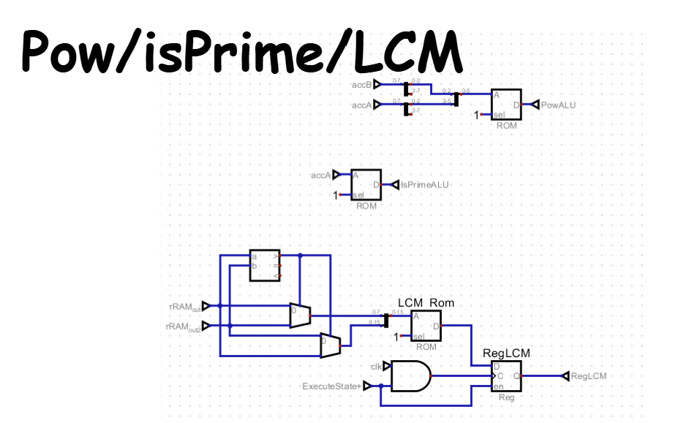
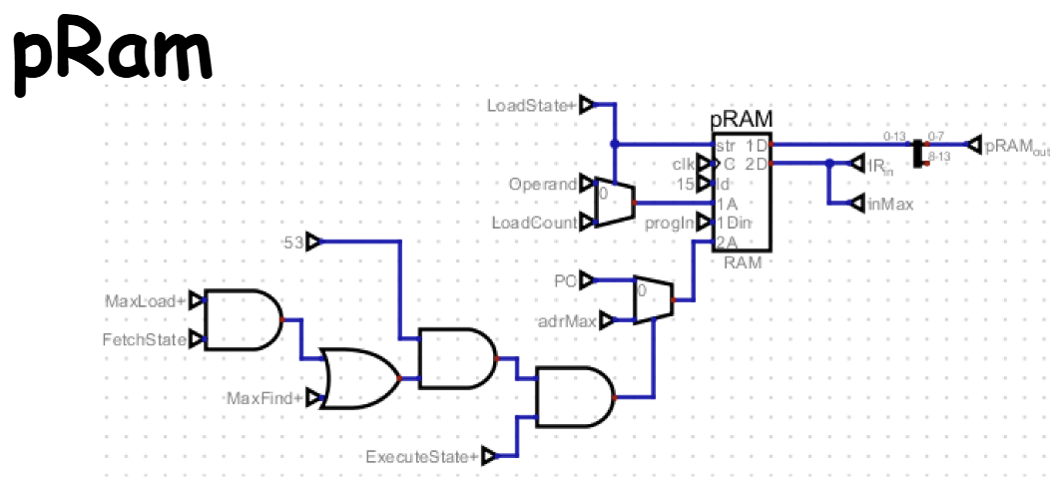
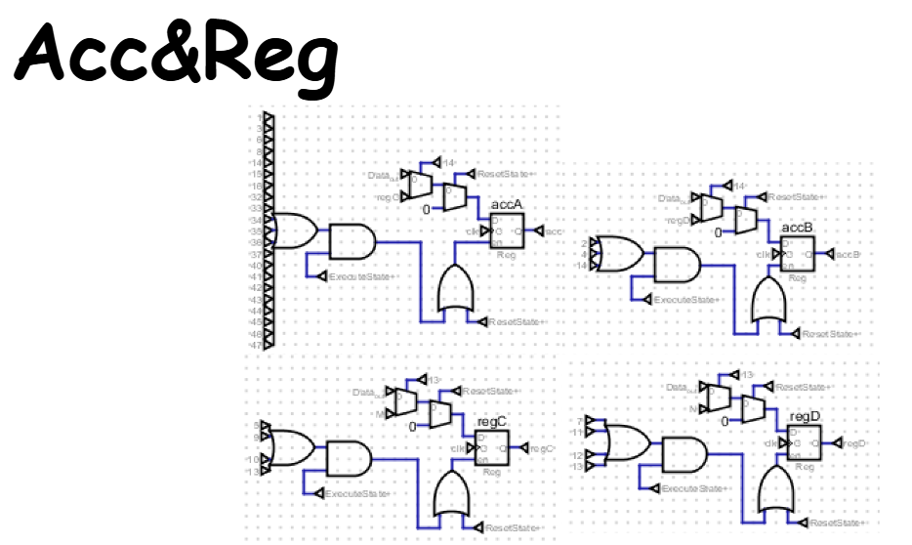
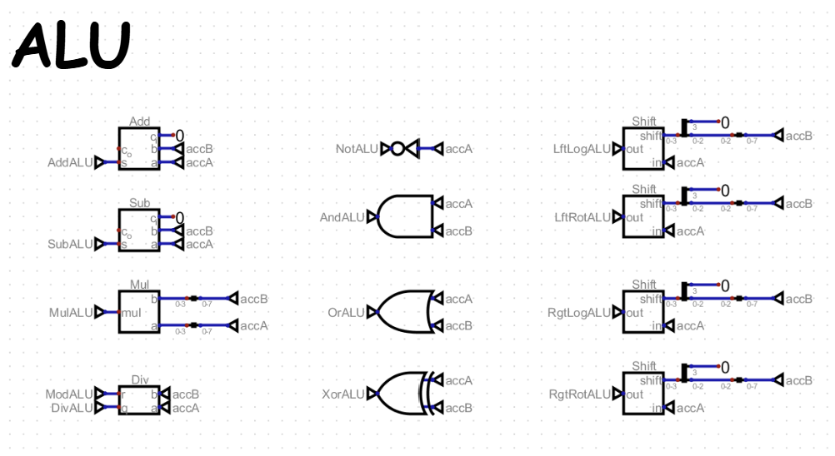
- MUX (Multiplexer) and Decoder:
The MUX is used to select which data source is sent to the ALU, memory, or registers at any given moment.
The Decoder interprets the instruction opcode and generates control signals that guide how the datapath operates during each clock cycle.
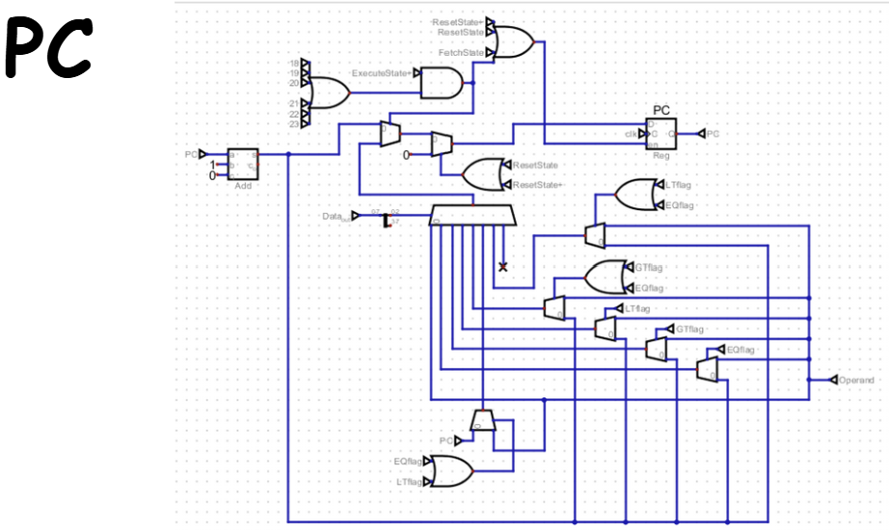
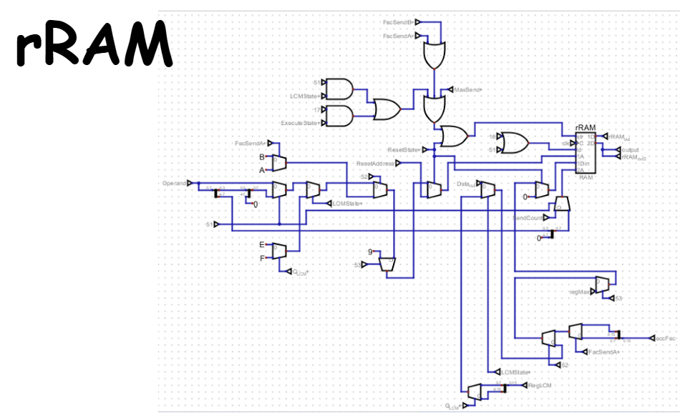
Design of Control Unit
The control unit manages the timing and coordination of the entire CPU.
It sends control signals that tell each part of the datapath when to perform operations and what to do.
Our control unit is divided into two main parts:
- State Control
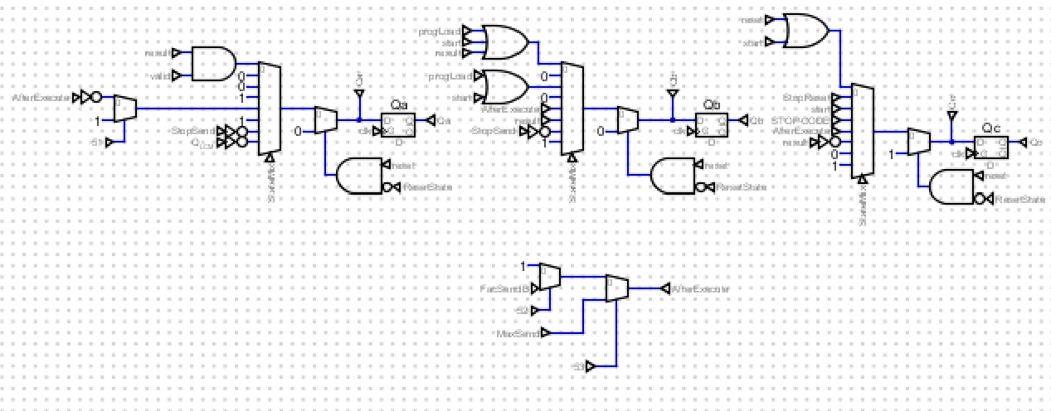
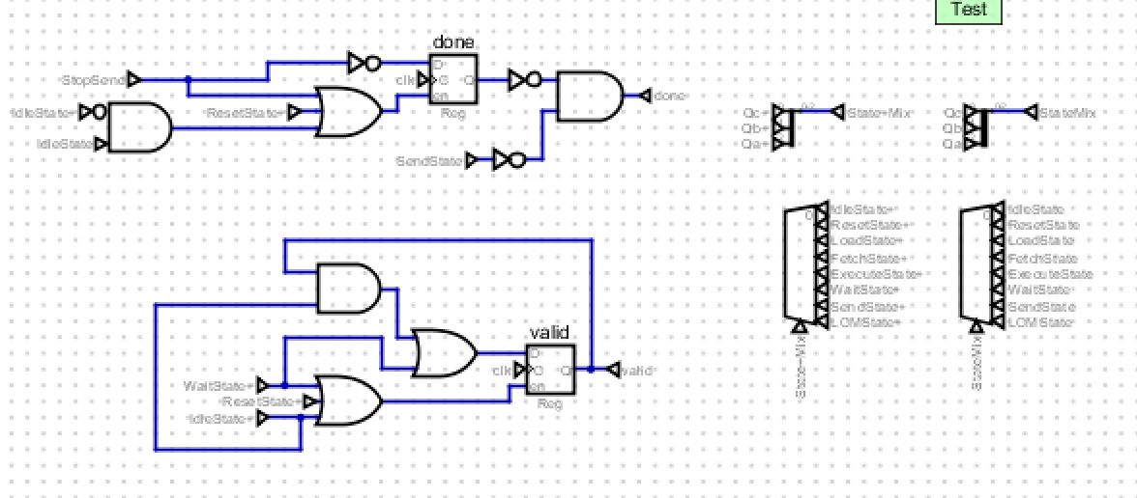
Consist of : Progload , Reset , StopReset , Start , STOP-CODE , AfterExecute , Result , valid , done and StopSend.
- Valid&Done Control
Consist of :Stopreset StopSend Maxsend , FacsendB, StopFacCal.
There are not many Control paths because we mostly use opcode and state to control the direction of our CPU instead.

The data path and control unit are developed together and are closely connected.

