一：数据流图

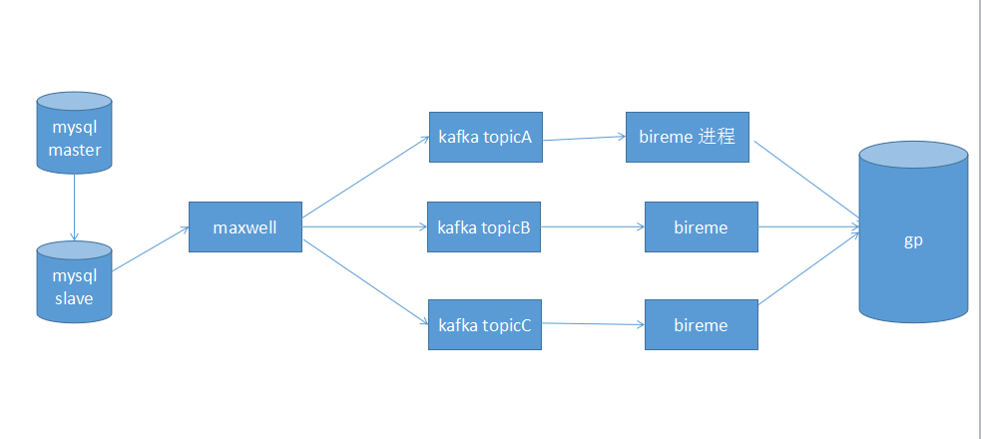

二：测试环境情况

10.1.75.27

1：Mysql 主从集群

启动 docker start mysql_master5.7

docker start mysql_slave5.7

连接

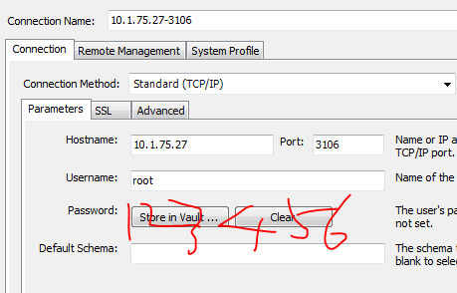

2：kafka 单机部署

目录

/home/user/maxwell/kafka_2.11-2.0.0

启动

nohup bin/zookeeper-server-start.sh config/zookeeper.properties &

bin/kafka-server-start.sh config/server.properties

3：maxwell

/home/user/maxwell/maxwell-1.18.0

文档指引

http://maxwells-daemon.io/config/

4：bireme

/home/user/maxwell/bireme

5：GP

target.url = jdbc:postgresql://10.1.75.27:5432/postgres

target.user = gpadmin

target.passwd = gpadmin

三：测试步聚：

四：生产环境部署

1：目前同步了css-dsds.

2：Maxwell,bireme,kafka目前都是单进程

3：目录：/uCloudlink/realTimeSteam/

apache-tomcat-8.5.34 --bireme用到一个jsvc ，除此没有其他的WEB部署

bireme-2.0.0-alpha-1

dumpData 开始全量同步时放dump文件的

jdk1.8.0_141 bireme，maxwell用的1.8JDK

kafka_2.11-2.0.0

maxwell-1.18.0

4:环境变量

export JAVA_HOME=/uCloudlink/realTimeSteam/jdk1.8.0_141

export JRE_HOME=${JAVA_HOME}/jre

export CLASSPATH=.:${JAVA_HOME}/lib:${JRE_HOME}/lib

export PATH=${JAVA_HOME}/bin:$PATH

export PATH=$PATH:/uCloudlink/realTimeSteam/apache-tomcat-8.5.34/bin/commons-daemon-1.1.0-native-src/unix

5：启动顺序 zk,kafka,maxwell,bireme

su - realTimeUser 切换用户

分别Cd到各自目录

nohup bin/zookeeper-server-start.sh config/zookeeper.properties &

nohup bin/kafka-server-start.sh config/server.properties &

--以上一般不需要启停，除非进程挂了

maxwell --config=/uCloudlink/realTimeSteam/maxwell-1.18.0/config/config-css-dsds.properties

./bin/bireme start file=./etc/config.properties

./bin/bireme stop file=./etc/config.properties

五：CSS_DSDS上线过程

10.7.5.27

1:导出数据

cd /uCloudlink/realTimeSteam/dumpData/css_dsds

mysqldump --databases glocalme_css_dsds --skip-lock-tables -t -h ukl-devtest-mysql01-read02.cqfpzr9uaqnr.ap-southeast-1.rds.amazonaws.com -u gpuser2 -p'SrRtZoiQjnY9uhiS' --default-character-set=utf8 --result-file=glocalme_css_dsds.sql

mysqldump -h ukl-devtest-mysql01-read02.cqfpzr9uaqnr.ap-southeast-1.rds.amazonaws.com -u gpuser2 -p'Sr' -R -E --triggers --single-transaction --default-character-set=utf8 -B glocalme_css_dsds

2：进入MYSQL,记下Position

Mysql -Aglocalme_css_dsds-h ukl-devtest-mysql01-read02.cqfpzr9uaqnr.ap-southeast-1.rds.amazonaws.com -u gpuser2 -p'SrR

show master status

MySQL [glocalme_css_dsds]> show master status

-> ;

+----------------------------+----------+--------------+------------------+-------------------+

| File | Position | Binlog_Do_DB | Binlog_Ignore_DB | Executed_Gtid_Set |

+----------------------------+----------+--------------+------------------+-------------------+

| mysql-bin-changelog.037417 | 74090037 | | | |

more config-css-dsds.properties |grep init

init_position=74090037init_position=74090037

3：打包

tar -czvf css_dsds.sql_gp.tar.gz css_dsds.sql_gp

4：ssh 10.7.1.18

远程复制先到18，再从18传到5.16

scp -P 22 dengwangsheng@10.7.5.27:/home/dengwangsheng/css_dsds.sql_gp.tar.gz /home/dengwangsheng/exportdata/css_dsds/

scp -P 22 /home/dengwangsheng/exportdata/css_dsds/css_dsds.sql_gp.tar.gz dengwangsheng@10.7.5.16:/home/dengwangsheng/css_dsds.sql_gp.tar.gz

5：ssh 10.7.5.16

cd /home/dengwangsheng/ && tar -xzvf css_dsds.sql_gp.tar.gz

chmod 777 /home/dengwangsheng/css_dsds.sql_gp

mv /home/dengwangsheng/css_dsds.sql_gp /home/gpadmin/

导入dump数据

psql -d bigdata -f /home/dengwangsheng/css_dsds.sql_gp

6:启动maxwell

7:启动bireme

8:对比数据

select count(1) from glocalme_css_dsds.t_dsds_softsim_online_log;

select count(1) from ods.ods_css_dsds_t_dsds_softsim_online_log