Author: Yohan Bopearatchy

ISU Netid [yohanb@iastate.edu](mailto:yohanb@iastate.edu)

Date: March 4, 2023

3)

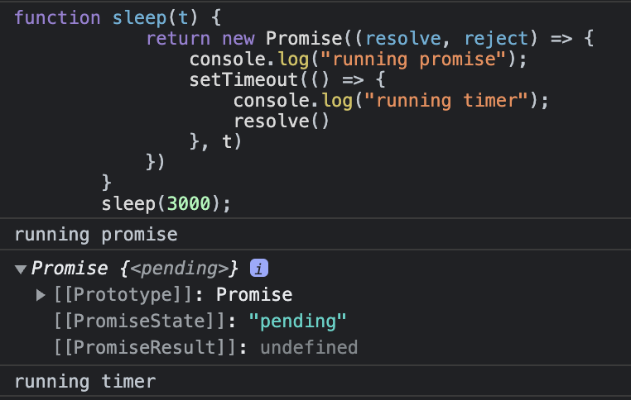

The code ran for 3000ms. During the process, the promise function goes into pending phase. Because the 3000ms, the operation completed successfully and the value was placed.

4)

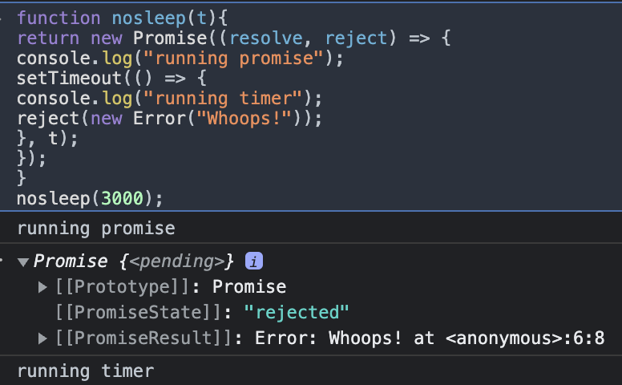

The code ran for 3000ms. During the process, the promise function goes into pending phase. Because the 3000ms, the operation completed successfully and an error we created is printed.

5.1) A new function was created called myresolve which returned a success prompt with the amount of time set. We then use promise.then to set the value of the results and errors given by myresolve.

5.2)

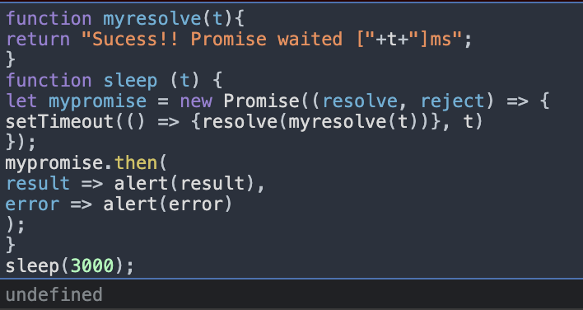

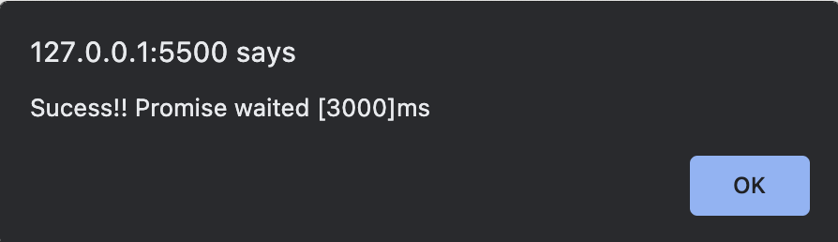

6.1) A new function was created called myreject which returned an error prompt with the amount of time set. We then use promise.then to set the value of the results and errors given by myreject.

6.2)

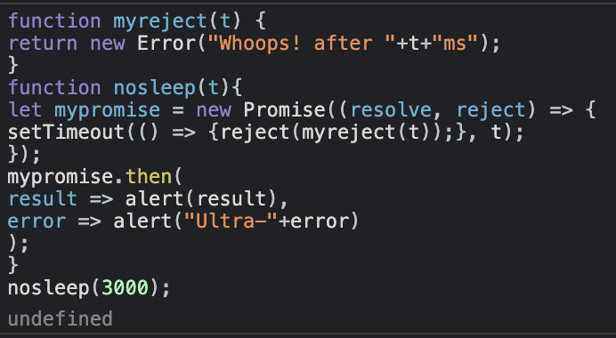

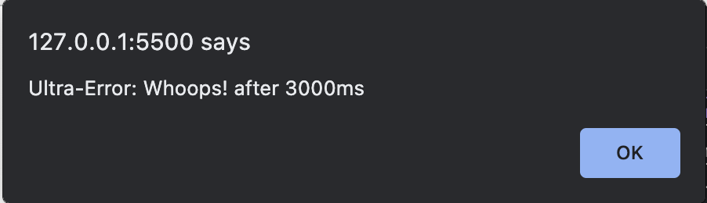

7)



function myresolve(t){  
return "Sucess!! Promise waited ["+t+"] ms";  
}  
function sleep (t) {  
let mypromise = new Promise((resolve, reject) => {  
setTimeout(() => {resolve(myresolve(t))}, t)  
});  
mypromise.then(  
result => {  
let container = document.getElementById("promisehere");  
let div = document.createElement("div");  
div.innerHTML= result;  
container.appendChild(div);  
},  
error => alert(error)  
);  
}  
sleep(3000);