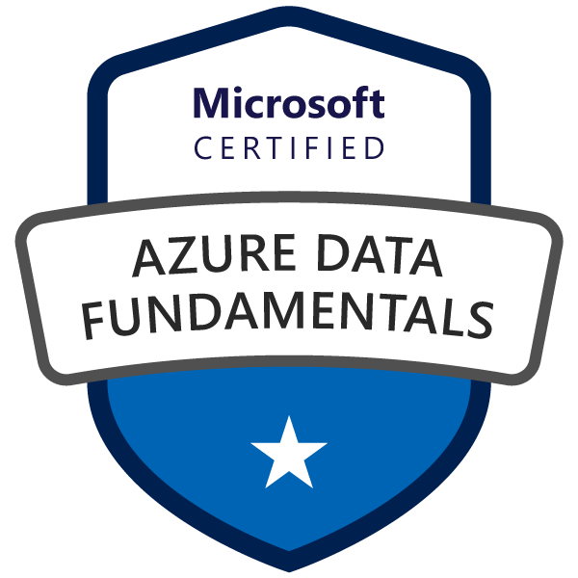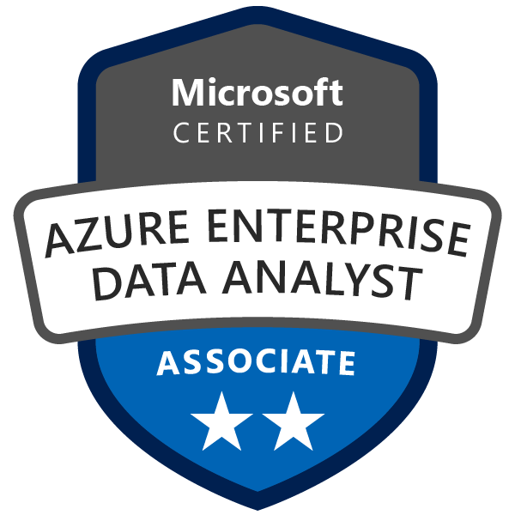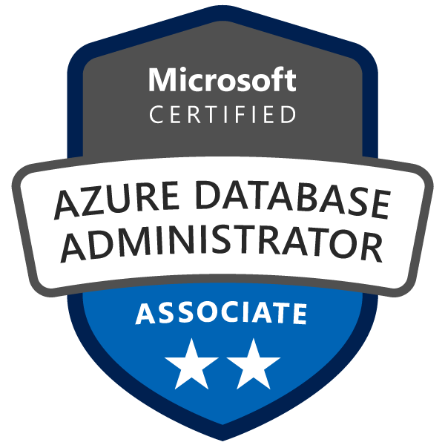

Summary:

Over 17 years of experience in analytics and business intelligence development environment database administration Azure Data Factory, Azure Data Lake Analytics, Azure Analysis Services, Azure Stream Analytics, Azure Synapse Analytics, Azure Data Explorer, Azure Data Bricks, SQL SERVER, MSBI (SSAS, SSIS, SSRS), Power BI.

Comprehensive data warehouse analysis and design experience, with full knowledge of data warehouse methodologies and data modeling for performance. Strong understanding of relational database structures, theories, principles, and practices, recognized by managers, colleagues, and peers as a dedicated performer who demonstrates innovation, communication, and teamwork to ensure quality, and timely project completion.

Experienced in using Financial Planning and modeling tools such as Anaplan and TM1

Onsite working experience on offshore/onshore model

Skill Set
Programming | TSQL, MDX, DAX, C#, KQL
Database | Azure SQL DB, SQL Server 2019,2017/2014/2012/2008/2005
Reporting Tools | SQL Server Reporting Services, Power BI
Data warehouse | Data Vault Model and Kimball Design
BI Development | MSBI (SSIS, SSAS, and SSRS).
OLAP | SSAS Multidimensional/Tabular Model
Big Data Analytics | Azure Synapse Analytics, Azure Data Explorer (Kusto Cluster), Azure Data Lake, Azure Data Factory, Azure Data Bricks
Source Safe | SVN, TFS 2010, DevOps
Database Administration | Replication, Mirroring, User administration, backup/restore.
Other | SharePoint 2013, Change Data Capture and Master Data Services in SQL Server 2017/2014.
SDLC | All phases of the software development life cycle (requirements, design, development, testing, release, support), utilizing multiple development methodologies.

Happiest Minds Technologies 10 April 2023- till date
Sr Data Architect

Responsibilities:
- Handling Data Engineering projects – data modernization/migration. Using Azure Data Stack (ADF, Synapse, Databricks, ADLS). DevOps and CI/CD
- Working with Business Intelligence or Data warehousing or Analytics projects.
- Provide data lake and data warehouse solutions including ETL pipelines.
- Efforts estimation, create project plan, planning milestones, activities and track the progress.
- Identify risks and issues. Come up with mitigation plan.
- Status reporting to both internal and external stakeholders.
- Manage end-to-end project lifecycle - requirements gathering, design, development, testing and go-live.
- Running Agile-based project development.
Husco Hydraulics Pvt. Ltd – Control Focused, Technology Driven. 14 Mar 2019 – 7 April 2023
Manager-Data Engineering (Azure Data Architect)

Responsibilities:
- Work with the leadership to set the standards for Data engineering practices within the team and support across other disciplines.
- Implementing data pipeline (ingestion, transformation, cleansing) using Microsoft Stack.
- Designing & building data architectures including the design & set-up of scalable data lakes, scheduled transformations & data governance.
- Analyze DW/BI migration strategy.
- Power BI, Azure Data Factory, Azure Data Lake Analytics, Azure Analysis Services, Azure Stream Analytics, Azure Synapse Analytics, Azure Data Explorer.
Projects:
Modern Data Warehouse Implementation:
Ship Frequency Optimization: Optimized ship frequency solution will provide these features.
- Components for basic data collection including size, and weight; ​Find out information about shipment documents.
- Measure physical parts one by one in the warehouse.​
- Ask support from a supplier and let the supplier fill in the ship frequency in Baan ERP system.
- Figure out freight for each weight /volume range via different shipping method from different location.
- Analysis of historical shipment records.
- Evaluate, Track, Verify and Update into Baan ERP system to reflect MRP calculation.
- Comparing the difference between stable programs and big fluctuation programs.

Azure Data Lake:
Create Data Lake for Auto and Off Highway. For different locations (US, China, India, UK)

Bravura Solutions India Pvt. Ltd – 4 Nov 2013 –12 Mar 2019
Associate Technical Consultant (MSBI Architect)

Responsibilities:
- Technical design of all BI systems including ETL, data warehousing, reporting, and analysis services.
- Design and implement relational, multidimensional, and tabular data models.
- Design dashboard using Power BI desktop.
- Work with business analysts and others to translate BI requirements into technical solutions.
- Design and lead Business Intelligence technology proof of concepts
- Perform and advise/assist BI developers with performance tuning and query optimization.
- Design Row-level Security and Role-based security using SSAS tabular model.
- Optimized queries using SQL Profiler and Database engine tuning advisor.
- Analyze DW/BI migration strategy.

Projects:
Wildfire Enterprise Data Warehouse and reporting solution:
Bravura Solutions has implemented Enterprise Project Management (Microsoft Project) to manage their project and portfolios to improve visibility and control across varied portfolios and projects, align spending with strategic priorities, and drive team collaboration to deliver projects on time and within budget.

The objective of the Bravura Enterprise Data Warehouse (EDW) is to provide a consolidated data source as a single source of truth for corporate reporting. The EDW will provide end-user self-service reporting, and data repository for business objects.

Bravura DWH data staging solution is developed using Data Vault Data Modelling techniques. Data Vault modelling was selected as it is most compelling when applied to an Enterprise Data Warehouse program (EDW). The data vault principles are specifically well suited for EDW program and when applied consistently will provide the organization with very compelling benefits. These include auditability, agility, adaptability, alignment with the business, and support for operational data warehousing.

Performance Reporting: Team Members complete and submit timesheets by CoB Friday. Schedule Managers process task updates, update Project Codes and Billing Basis codes, and publish schedules by CoB Monday. PMO produces Performance Reports by CoB Tuesday.

GWM Reporting: The forecasting model began with key business drivers brought about the need to re-implement the bottom-up forecast model.

The changing nature of the overall GWM program; Sonata and related programs and ramp down of the Asia long-term implementations. Do we still have the right skill types to support the evolving program? Artifacts to support effective resource management and the new structure. Financial year Budget planning commenced.

Line Management reporting: The purpose of line management reporting is to describe the various Global Wealth Management line manager reports, their purpose, source, and the requirements for production and review.

QTO Admin Tool - Project Code Creation
All tasks in MS Project schedules that have work or actual work recorded against them must have a project code. Project codes and all their associated information are held in the Project Register. Project codes are generated using the QTO Admin Tool and then uploaded to EPM to make them available for use in MS Project schedules. Different workflow in QTO.
Project Code Creation Workflow.
Project Code Creation Process
Create New Engagement Sub-Process
Create New Work Contract Sub-Process
Create New Finance Project Sub-Process
Link JIRA issues Sub-Process
Publish Project Code Sub-Process

Migration EPM to 2016 and DW/Repotting solution to SQL Server 2017
As such the decision was made to establish a new EPM 2016 server and move the whole business onto that platform. This would then (along with other existing corporate and new bespoke systems) become the basis for the downstream creation of a new Data Warehouse and Business Information portal.
Existing licenses for EPM 2013, the underlying SharePoint software, database and operating systems are near/or at end of license.
So, the decision has been made to review the existing solution and migration to a new EPM 2016/SQL 2017 platform.

Cost Apportionment
The purpose of Cost Apportionment module is to allocate calculated indirect cost to clients based on a set of drivers and assumptions. The drivers and assumptions are maintained inside CostApp MDS(Master Data Services) tables in a mapping table which would be available to the users to make any changes or modifications when required.

Cubes:
EPM Detail
EPM Summary
Invoice
Cost Apportionment
GL Finance

Technologies: SQL Server 2017/2014, SSIS 2017/2014, SSRS 2014 integrated with SharePoint 2013, SSAS 2017/2014 Tabular Model, SSRS 2017, Master Data Services 2017/2014(MDS), MS Power BI, Data Vault design, SQL Replication, Mirroring and Change data capture, .NET 4.0.

HCL Technologies – Transformational Global Service for IT and Engineering. 16 Jan 2012 – 1 Nov 2013

Responsibilities:
- Creating\Modifying Cubes, Designing and populating data warehouse, generating reports using MSBI (SSAS, SSRS).
- Experience in BI Development and Deployment of SSIS packages from MS SQL Server, Excel, Oracle, and flat file.
- Designing and Deployment of Reports for the End-User requests using Web Interface &SSRS.
- Creating\Modifying objects such as stored procedures, views & T-SQL queries (DDL and DML) Etc.
- Handling SQL Server Production Issues
- Managing User Creations, assigning Roles to SQL Databases

Projects:
Operational Dashboard: It’s a near real-time refresh of the operational dashboard, which contains two dashboards - Manager dashboard and Service Centre dashboard. It gives real-time information about the service Centre and clients, having SLA for 15 minutes. Client: Insurance domain IT company Technologies: SQL Server Analysis Services 2008, SQL Server Integration Services 2008, and SQL Server Reporting Services 2008.

Integrated Scorecards: Integrated scorecard functionality will enable the distribution of scorecards for defined roles within insurance carrier claims workflow. Though this is intended for the AAA IE rollout, the requirements are intended to apply to general market applications for configuring and delivering scorecards to end users. Technologies: SQL Server Analysis Services 2008, SQL Server Integration Services 2008, and SQL Server Reporting Services 2008

Codex Software Pvt. Ltd (CXI) – Advanced solutions for changing world. 4 Sept 2006 – 13 Jan 2012
Team Lead (BI)

Responsibilities:
- Creating\Modifying Cubes, Designing and populating data warehouse, and generating reports using MSBI (SSAS, SSRS).
- Involved in Huge data migrations, and transfers using utilities like SSIS and Bulk Insert.
- Experience in BI Development and Deployment of SSIS packages from MS SQL Server, Excel, Oracle, and flat file.
- Designing and Deployment of Reports for the End-User requests using Web Interface & SSRS.
- Expertise in Performance tuning and optimization by removing unnecessary columns, redundant and inconsistent data, and using SQL Profiler. Query performance is improved by normalizing tables, establishing necessary joins, and creating useful indexes wherever necessary.
- Experience in solving Database issues with Index fragmentation, DBCC checks, Optimization of Query, Data Integrity, Index tuning, Update Statistics, Error and Event Handling.
- SQL Server Development/DBA Activities
- Creating\Modifying objects such as stored procedures, views & T-SQL queries (DDL and DML) Etc.
- Handling SQL Server Production Issues.
- Managing User Creations, assigning Roles to SQL Databases
- Website development and maintenance.
Projects:
Invoice Integration: It is data transformation ETL services using SQL server integration services (SSIS), and Web services to exporting/Importing of VMS Inc. data in the staging database. It loads dimensional data from multiple production databases to generate reports. MS deliver roadway and facility asset management services for interstates, primaries, bridges, tunnels, toll facilities, rest areas, welcome centers, public buildings, canals, and airport infrastructure and systems. Client: VMS Inc. Trans Services NA, Transportation Infrastructure, Richmond, VA, USA Technologies: SQL Server 2008, TSQL, And SQL Server Integration Services 2008
Virginia Farm Base (Data warehouse): Design SSIS Solution for Countryway that will move from the Indiana Farm Bureau to the Virginia Farm Bureau. And load their Data warehouse from different sources (e.g. COBOL flat file source (Fixed width& coma delimited, SQL server, Excel file). Created SSRS reports as per specifications given by the client in an Excel sheet.

B-Prompt (Business Performance Optimization): B-Prompt is the solution for the performance optimization in process. This is a BI solution for the BPO process linked with the agents and their employees. It’s an extremely useful tool to support the management to analyze the data with multi-dimensions, trend analysis, and forecast, etc. It gives them insight into the whole process and help them make decisions based on reports generated through OLAP. Technologies: -SQL Server 2008, TSQL, SQL Server Analysis Services 2008, SQL Server Integration Services 2008 and SQL Server Reporting Services 2008.

Global Raw Material Specification: Participated in the development, database design and release of this intranet web application module that provides an interface to generate raw material specifications for our New Market client. Implemented features and solutions to satisfy the requirements, along with fixing numerous software defects identified by SQA and Customer Integration. Technologies: -SQL Server 2008, TSQL, .Net Framework 3.5, SQL Server Integration Services 2008, SQL Server Reporting Services 2008.

SAIL: Participated in the application development, database design development and release of this intranet web application. SAIL is a secure online information exchange system with a collection and maintenance portal for Afton Chemical and Suppliers to share and maintain product details and company information, and view data on demand. Suppliers will be able to maintain their company and product information used by Afton to ensure accuracy and assign a point of contact for a particular functionality. The project is developed for US Client New Market (Richmond VA). Technologies: -SQL Server 2008, TSQL, .Net Framework 2.0, SQL SERVER Reporting Services 2005.

New Market Timekeeping System: Participated in the application development, database design development, and release of this intranet web application. Users can directly enter and modify the records of the current week and of the previous week if it is not submitted. The administrator can see and modify the time entry of any Employee. Employee registration, Vacation tracking, Supervisor Approval Process, Automated Email Notification Technologies: -SQL Server 2008, TSQL, .Net Framework 2.0, SQL Reporting Services 2005.

Home Guidance: The client offers Home Counseling to US citizens and provides Loans for purchasing or renting houses. The entire data of the customers are captured and processed to evaluate the extent of loan to be granted plus the data becomes markers for further research to housing related problems and sends information to HUD using the HUD web service. Technologies: SQL Server 2008, TSQL, SQL Server Integration Services 2008, SQL Server Reporting Services 2008, SQL Server Analysis Services 2008.

CXI Monitoring Tool: Participated in the Architecture design and development of this Smart Client Application. It handles numerous operations in a company like Project Development management, Recruitment process management, and Time Tracking management. Technologies: -SQL Server 2008, TSQL, .Net Framework 2.0, C#, Web Services, ADO.NET, XML, SQL Server 2005, SQL Reporting Services 2005.

Business Card Builder: Architected and developed this online card builder web application that provides the facility to the customer to customize the design of their business card, make online orders, and make payment online. Created dozens of custom Excel reports and used the GDI+ facility of.net to provide custom design of business cards. Tools utilized – Net Framework 2.0, C#, ASP.NET, ADO, SQL Server 2005, CSS. AJAX, Payment Gateway, XML.

Education

- Master of Computer Applications, M.D. University, Rohtak (2004).
- Microsoft Certified: Azure Data Engineer Associate
- Microsoft Certified: Data Analyst Associate
- AZ-900 Microsoft Certified: Azure Fundamentals
- DP-900: Microsoft Azure Data Fundamentals
- SC-900 Microsoft Certified: Security, Compliance, and Identity Fundamentals
- DP-500 Microsoft Certified: Azure Enterprise Data Analyst Associate
- DP-300 Administering Microsoft Azure SQL Solutions
- Microsoft Certified Professional in Implementing a Data warehouse with Microsoft SQL SERVER 2012.
- Microsoft Certified Technology Specialist in Microsoft® SQL Server™ 2005- Implementation and Maintenance.

Personal Profile

Passport: T9651286
Languages known: English, Hindi

