MANTLE RESEARCH CHALLENGE · TRACK 1 · INTERIM

Stable by Design
Tokenized SpaceX put Mantle's fees to a real-world stress test the day of history's biggest IPO. They didn't move, and the reason rewrites the story everyone repeats.
On-chain census: 362 SPCXx swaps · 113 trading-hours · 2026-06-12 → 2026-07-01 · collected through the campaign window (deadline 3 Jul 2026)

TL;DR
- Mantle's fee barely moved through the entire event, and statistically it is unrelated to BOTH network demand and Ethereum's gas price (differenced OLS R² ≈ 0.019; fee CV 0.32).
- The reason isn't L1 pass-through. The L1 data fee is only ~2.4% of the total; the dominant L2 fee sits on a fixed 50 Gwei base with no priority-fee auction. Stability is structural.
- Massive headroom: across a 13,312-block census the network averages ~0.19% of its 60,000,000-gas block limit (~99.8% unused; even the single busiest block hit only 8.2%), so an asset-level demand shock like SPCXx can't move fees or block time (fixed 2.000 s).
- SPCXx broadly tracks its Nasdaq parent: daily prices co-move (r = 0.905) in the same range, but with several-percent day-to-day dispersion (median |premium| ~2.11%) from thin on-chain liquidity. We make no tight-peg or convergence claim.

THE SETUP

The shift: capital markets are moving on-chain
The market move at the center of this piece is the arrival of tokenized equities on-chain. On 12 June 2026, SpaceX completed the largest IPO in history (ticker SPCX, $135/share, ~$75B raised). Within hours, a tokenized version (SPCXx, issued by xStocks) went live for 24/7 trading on Mantle via Fluxion and Merchant Moe. Days of chaos followed: Binance, Bybit and Bitget cancelled pre-IPO tokenized campaigns after xStocks couldn't secure shares, leaving >$1B in orders unfilled against >$100B of retail demand. The lesson was blunt. Tokenizing a stock is easy; sourcing the real shares and hosting the demand is the hard part.
Why it happened: tokenized equities promise what traditional rails can't: 24/7, borderless, intermediary-light access to high-demand assets. SPCXx is not a one-off; it sits in a visible pipeline (xStocks issuance, Fluxion/Bybit execution) on a chain explicitly positioning itself as the settlement layer for on-chain finance. But the move only sticks if the infrastructure can absorb real, spiky demand without the cost and performance blowing up. That is the question we test, and SPCXx is the natural experiment that lets us test it with live data.
Mantle markets itself as a reliability layer with low, predictable fees. The usual explanation is that its fee is dominated by the Ethereum L1 data fee, so on-chain congestion doesn't push it up. We tested that, and found the explanation is outdated, while the conclusion is actually stronger.
The objective, in one line: use the SPCXx listing as a natural experiment to test whether, and why, Mantle's cost and performance stay stable under a real, sudden surge in on-chain demand.
This is one stimulus→response study, not four separate questions. SPCXx is the stimulus; Mantle's stability is the response. Two probes establish the shock is real: SPCXx is a live asset tracking its Nasdaq parent (price) with a genuine volatility event (the allocation failure). The core probe asks whether the fee responds (it doesn't), and the last probe explains why (capacity headroom).
WHAT WE FOUND

Finding 1: The fee is flat, and not for the reason people say
Across the swap census, the L1 data fee is a rounding error: ~2.4% of total fees. The L2 execution fee dominates, and it sits on an administratively fixed 50 Gwei base fee with zero priority-fee auction (Mantle is non-EIP-1559, FIFO). So the volatile part everyone assumes dominates (L1) has gone negligible post-EIP-4844 (blobs), and the dominant part (L2) is fixed by design.
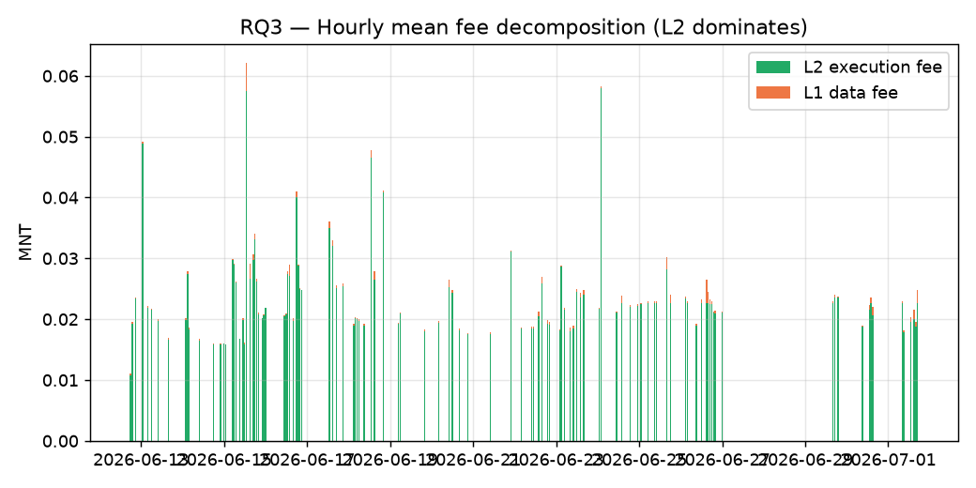
Figure 1. Hourly fee decomposition: the L2 execution fee dwarfs the L1 data fee.

Finding 2: Fee doesn't respond to demand OR to L1 gas
We regressed the hourly fee on both candidate drivers. Even before any correction, both correlations are weak: fee vs L1 gas r = 0.098, and fee vs volume r = 0.101. Because level correlations on trending time-series can be spurious, we first-difference everything (after ADF testing) to be safe. The differenced result is unambiguous:
Relationship (first-differenced) | Pearson r | n
Δ fee vs Δ Ethereum L1 gas | 0.037 | 112
Δ fee vs Δ SPCXx volume | 0.134 | 112
L1 component vs L1 gas (sanity) | 0.546 | 113
OLS (Δfee ~ Δgas + Δvolume), Newey–West HAC errors: R² = 0.019, VIF ≈ 1.0 for both drivers (no multicollinearity). Neither driver explains the fee. The L1 component does track Ethereum gas (the sanity check passes), but it is too small a slice of the total to matter.
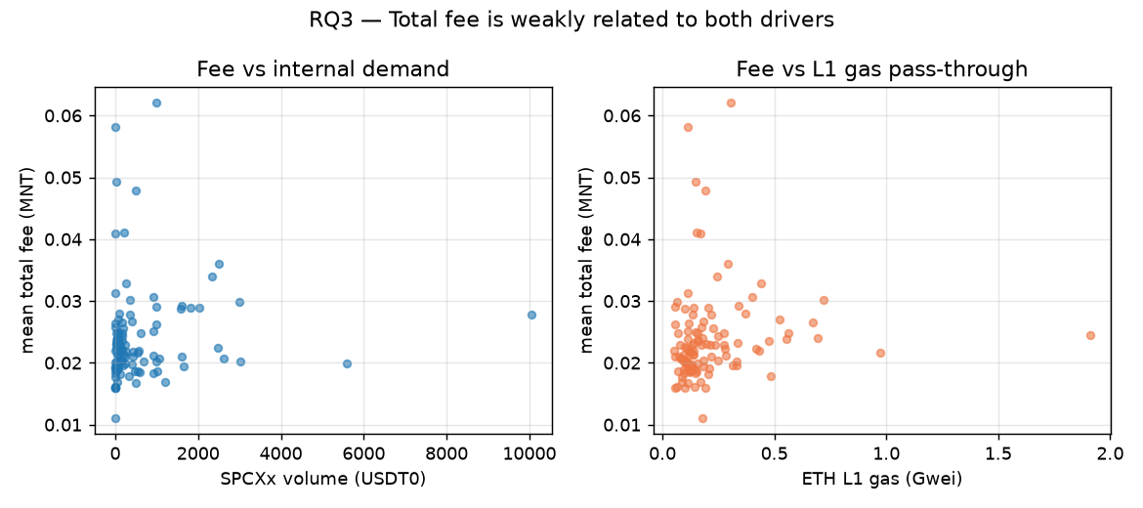
Figure 2. Total fee vs internal demand (left) and vs L1 gas (right). Both flat.

Finding 3: There's room to spare (a lot of it)
Mantle's block gas limit is a constant 60,000,000 gas and block time is a constant 2.000 s. Across a 13,312-block census (via eth_feeHistory gasUsedRatio, so no sampling can hide a full block), utilization averaged ~0.19% with the single busiest block reaching only 8.2%, roughly 99.8% headroom on average, and still ~91.8% at the peak. SPCXx demand vs block fullness correlates at r = -0.097 (≈ null). That null isn't a failure; it's evidence the network has orders of magnitude more capacity than this asset needs. (Caveat: TPS ceilings are bounded by the gas limit here; sequencer/L1-DA throughput may bind first, so we report utilization %, not a headline TPS.)
A natural objection: isn't all that idle capacity over-provisioned overhead? It is not. Unlike reserved cloud compute, a block gas limit is a cap, not provisioned hardware. Empty block space is essentially free, blocks are produced every 2 s regardless of fullness, and an L2's real costs (data availability and settlement to Ethereum, sequencer operation) scale with actual usage or are fixed, not with the ceiling. So the headroom is cheap to keep; if anything the economic tension runs the other way (low utilization means modest gas revenue, a monetization question, not an overhead one). [Qualitative argument from how L2s operate, outside what this study's on-chain data directly measures.]
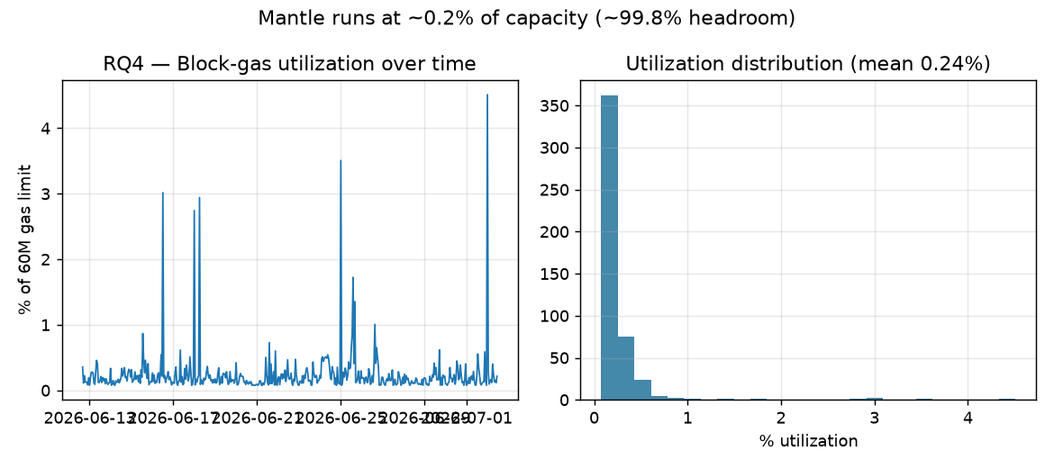
Figure 3. Block-gas utilization over time and its distribution. About 0.2% used.

Finding 4: The token broadly tracks its parent (with real dispersion)
Across 13 trading days, SPCXx and SPCX move together. Their daily prices co-move with a correlation of r = 0.905, both sitting in the same ~$150–210 band. So the on-chain token is a faithful directional mirror of the real equity.
But it is not a tight peg. Day to day, the on-chain daily VWAP sits a median of ~2.11% away from the Nasdaq close (mean ~3.39%), ranging from -7.97% to 10.54% on individual days, the fingerprint of thin on-chain liquidity. We deliberately make no claim of a tight premium or a statistically significant convergence trend: an earlier intraday-aligned estimate proved unreliable (Nasdaq hourly bars are timestamped in US/Eastern with end-of-bar prices, which misaligns against 24/7 UTC on-chain data during fast moves), so we report only the robust daily co-movement.
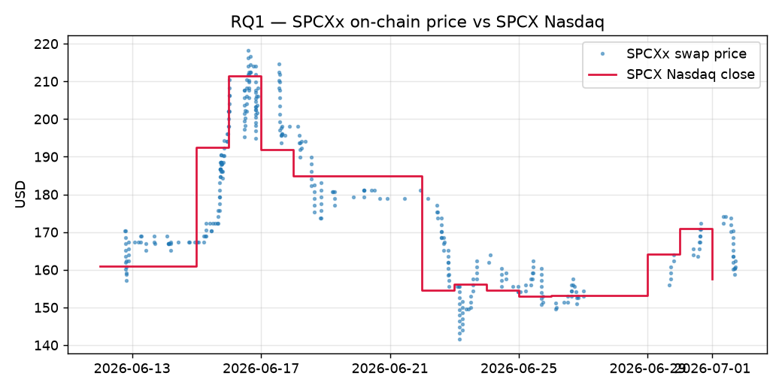
Figure 4. SPCXx on-chain price vs SPCX Nasdaq close. Same range, moving together.
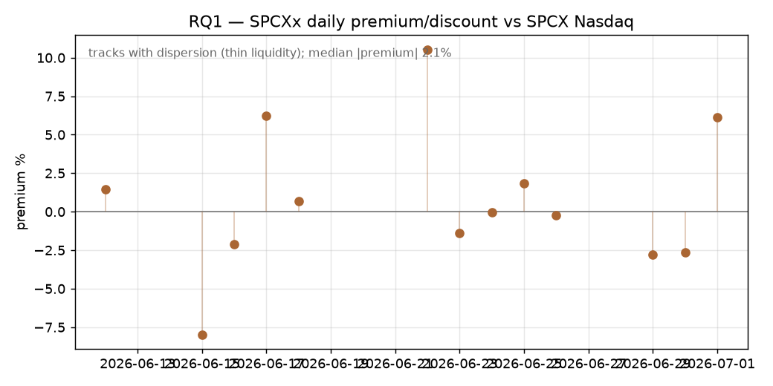
Figure 5. SPCXx daily premium/discount. Tracks with several-percent dispersion.
One more thing worth flagging: some users pay above the 50 Gwei floor (up to ~149 Gwei) even though Mantle's FIFO ordering gives overpayment no advantage, a small UX inefficiency (likely wallet gas defaults) that Mantle and wallet teams could trivially fix.
WHY IT MATTERS FOR MANTLE

A structural claim beats a contingent one
- Independent, on-chain proof of the core 'stable fees' claim, more credible than self-reported marketing.
- An upgraded narrative: 'stable by design' (fixed base fee + negligible post-blob L1) is more durable than 'L1 pass-through is quiet right now', which depends on Ethereum staying calm.
- Evidence for the RWA / distribution-layer thesis: predictable settlement cost is exactly what high-value tokenized assets need.
- Capacity headroom (~99.8%) reassures institutions evaluating Mantle for scale.
- An actionable product signal (the gas-overpayment quirk) and a reusable, open measurement pipeline for every future tokenized listing.
WHAT COMES NEXT

The infrastructure question is now answered, so the pipeline can scale
The SPCXx experiment resolves the open question from the setup: can an L2 host a real, spiky demand shock for a high-value tokenized asset without the cost or performance degrading? On this evidence, the answer is yes, and it holds structurally, not by luck. That changes the forward outlook for tokenized equities on Mantle in three concrete ways.
- More listings, less friction. SPCXx is one node in an existing pipeline (xStocks issuance, Fluxion/Bybit execution, Merchant Moe liquidity). With fees fixed by design and ~99.8% capacity headroom, each new tokenized listing inherits the same predictable-cost guarantee on day one; the infrastructure assembled for SPCXx is built to repeat.
- RWA momentum has the wind behind it. Mantle's own Q1 2026 ecosystem report puts RWA TVL up 27% to $247.5M; a structurally stable cost base is exactly the precondition that lets that curve keep compounding as larger, more cost-sensitive institutional assets come on-chain.
- The moat is durability, not just price. Because stability is structural (fixed 50 Gwei base + negligible post-blob L1), it survives Ethereum gas spikes that would ripple through pass-through-dependent designs, a meaningful edge as tokenized equities, prediction markets (InsightX), and other RWAs compete for a reliable settlement home.
The near-term test to watch: a genuinely large demand event (a blue-chip tokenized listing or a volatility spike that pushes volume orders of magnitude above SPCXx's current thin volumes). Our pipeline is built to measure exactly that as it happens, using the same census method, re-run on the next shock.
HOW WE DID IT: METHODOLOGY & RIGOR

Census data, on-chain ground truth
This is a quantitative, observational study on the full population (census) of SPCXx swaps, not a sample, reconstructed directly from Merchant Moe Liquidity Book Swap events on Mantle. Per-transaction fees are decomposed from receipts as gasUsed × effectiveGasPrice (L2) + l1Fee (L1). Block fullness and the Ethereum L1 gas series come from sampled block headers and receipt l1GasPrice; the SPCX baseline is from Nasdaq daily closes. The entire pipeline is deterministic from block numbers and reproducible from public RPC.
Statistical approach: (1) ADF stationarity tests; (2) first-difference / log-returns to defeat spurious correlation; (3) Pearson and Spearman correlations for robustness; (4) OLS with Newey–West (HAC) standard errors and VIF diagnostics, run separately for the L2 and L1 components; (5) an event-study volatility comparison around the 12–13 June cluster; (6) a daily co-movement analysis for RQ1 (price tracking; no convergence claimed). Because volume is thin, we lean on effect sizes rather than p-values alone.
CAVEATS

What could still move
- Short window and thin volume mean limited statistical power; a null can mean 'not enough data', not 'no effect'. These numbers are interim and finalize near the deadline.
- The listing (Event A) and the allocation failure (Event B) overlap within ~24h and can't be cleanly separated; we treat them as one event cluster.
- Correlation isn't causation. The structural facts (fixed 50 Gwei base, ~2% L1 share) are stable; the regression coefficients will tighten as data grows.
- Price tracking (RQ1) is reported at daily granularity only. Intraday premium/convergence is NOT claimed: matching 24/7 on-chain UTC prices to Nasdaq hourly bars (US/Eastern, end-of-bar) misaligns by up to an hour and manufactures spurious premiums during fast moves. Thin liquidity also limits any peg/convergence inference. This is a scope limit, not a finding.
REPRODUCIBILITY
All swaps, fees, blocks and capacity metrics are reconstructed from Mantle public RPC (chainId 5000) and Nasdaq data; scripts and raw CSVs accompany this report. Re-running the pipeline on the latest blocks reproduces every figure and statistic. Cited context: SpaceX IPO and tokenized-stock allocation coverage (CoinDesk, CNBC, The Block, Chainwire); Mantle fee mechanism (Mantle Docs); RWA TVL +27% to $247.5M (Mantle Q1 2026 ecosystem report). Full links in the companion repository.
Auto-generated from the research data pipeline. Re-run scripts/make_docx.py to refresh with the latest data.

