RB-204: PostgreSQL Primary Failover
Field | Value
Service | orders-db (PostgreSQL 16, Patroni)
Severity | SEV-1
Owner | Data Platform team
Last reviewed | 2026-08-30

1. When to use this runbook
- Alert PostgresPrimaryDown fires for more than 2 minutes.
- Writes fail with: FATAL: the database system is in recovery mode.
- Patroni did not promote a replica automatically.

2. Topology
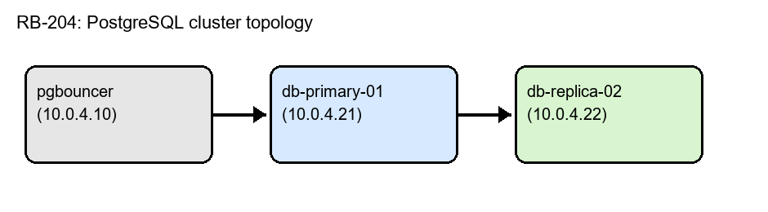
Figure 1: orders-db cluster topology.

3. Pre-checks
Confirm the primary is really down and that the replica is healthy:
patronictl -c /etc/patroni.yml list
psql -h 10.0.4.22 -c "SELECT pg_last_wal_replay_lsn();"
Replication lag must be under 16 MB before promoting.

4. Failover procedure

4.1 Promote the replica
- Pause automatic failover: patronictl pause orders-db
- Promote the replica: patronictl failover orders-db --candidate db-replica-02 --force
- Point pgbouncer at the new primary and reload it: systemctl reload pgbouncer
- Resume automatic failover: patronictl resume orders-db

4.2 Fence the old primary
Stop PostgreSQL on db-primary-01 so it cannot accept writes (split-brain risk):
ssh db-primary-01 'sudo systemctl stop patroni && sudo systemctl mask patroni'

5. Rollback
Step | Command | Expected result
Rebuild old primary as replica | patronictl reinit orders-db db-primary-01 | Member state: streaming
Switch back (optional) | patronictl switchover orders-db --candidate db-primary-01 | Leader: db-primary-01
Unmask service | sudo systemctl unmask patroni | Unit loaded

6. Escalation
Level | Who | Contact
L1 | On-call SRE | #ops-oncall
L2 | Data Platform on-call | PagerDuty: data-platform
L3 | DBA lead | Phone tree in the on-call wiki

