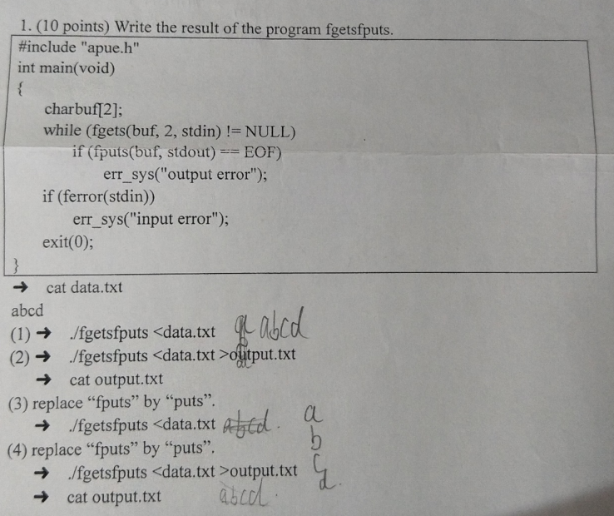

源程序：puts，fputs，gets，fgets：P123

#include "apue.h"

int main(void)

{

/*

* puts与fputs：puts每次输出的时候带有换行符

* gets与fgets：gets不安全，没有指定输入长度，会发生内存溢出问题；fgets每次 *只读取n-1个字符，本道题n=2，每次只读取一个字符

*/

char buf[2];

while(fgets(buf,2,stdin)!=NULL){

if(fputs(buf,stdout)==EOF)

printf("%s","error");

}

if(ferror(stdin))

printf("%s","error");

exit(0);

}

1. abcd
2. abcd
3. a

b

c

d

1. a

b

c

d

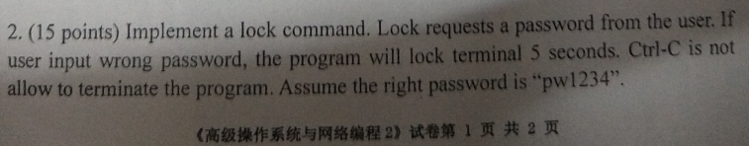

#include"myerr.h"

#include"apue.h"

#include<stdio.h>

volatile sig_atomic_t quitflag;

static void sig_int(int signo)

{

if(signo==SIGINT)

printf("\ninterrupt\n");

}

int main(void)

{

if(signal(SIGINT,sig_int)==SIG_ERR)

err_sys("signal (SIGINT) error");

char c[1024];

sigset_t newmask,oldmask;

while(scanf("%s",c)==1)

{

if(strcmp(c,"pw1234")==0)

{

printf("login success!");

}

else{

if(signal(SIGINT,sig_int)==SIG_ERR)

err_sys("signal (SIGINT) error");

sigemptyset(&newmask);

sigaddset(&newmask,SIGINT);

if(sigprocmask(SIG_BLOCK,&newmask,&oldmask)<0)

err_sys("SIG_BLOCK error");

sleep(5);

}

exit(0);

}

}

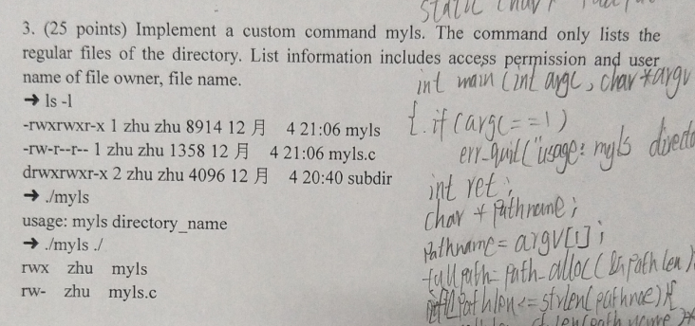

参考：

#include"myerr.h"

#include"apue.h"

#include<stdio.h>

#include<dirent.h>

#include<pwd.h>

#include<fcntl.h>

int main(int argc,char *argv[])

{

DIR *dp;

struct dirent *dirp;

struct stat buf;

char mode[4];

struct passwd *ptr;

if(argc==1)

{

err_quit("usage: ls directory_name");

}

if((dp = opendir(argv[1]))==NULL)

err_sys("can't open %s",argv[1]);

int fd = open(argv[1],O_RDONLY);

while((dirp=readdir(dp))!=NULL)

{

// stat(dirp->d_name,&buf);

fstatat(fd,dirp->d_name,&buf,AT_SYMLINK_NOFOLLOW);

if(S_ISREG(buf.st_mode))//判断其是否为普通文件

{

memset(mode,'-',sizeof(mode)-1);

if(buf.st_mode&S_IRUSR)

mode[0] = 'r';

if(buf.st_mode&S_IWUSR)

mode[1] = 'w';

if(buf.st_mode&S_IXUSR)

mode[2] = 'x';

ptr = getpwuid(buf.st_uid);//获得用户id

printf("%s %s %s\n",mode,ptr->pw_name,dirp->d_name);

}

}

closedir(dp);

exit(0);

}

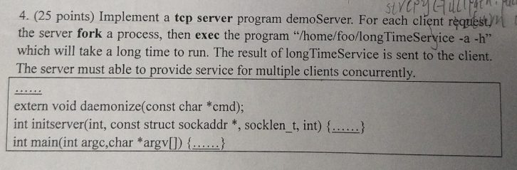

参考：p497

#include <stdio.h>

#include <arpa/inet.h>

#include <syslog.h>

#include <signal.h>

#include <errno.h>

#include <fcntl.h>

#include <netdb.h>

#include <string.h>

#include <stdlib.h>

#include <unistd.h>

#include <sys/wait.h>

#include <sys/socket.h>

#define QLEN 10

#ifndef HOST_NAME_MAX

#define HOST_NAME_MAX 128

#endif

extern void daemonize(const char * cmd);

int initserver(int ,struct sockaddr * ,socklen_t ,int );

void server(int sockfd);

void set_cloexec(int);

int main(int argc,char *argv[])

{

struct addrinfo hint, *ailist, *aip;

int err, sockfd, n;

char *host;

struct sockaddr_in *sinp;

const char *addr;

char abuf[INET_ADDRSTRLEN];

if(argc != 1)

{

fprintf(stderr,"usage:longTimeServer\n");

exit(1);

}

if((n=sysconf(_SC_HOST_NAME_MAX)) < 0)

n = HOST_NAME_MAX;

if((host=malloc(n)) == NULL)

{

perror("malloc");

exit(1);

}

if(gethostname(host,n) < 0)

{

perror("gethostname");

exit(1);

}

//hint内存空间分配

memset(&hint,0,sizeof(hint));

hint.ai_flags = AI_PASSIVE;

hint.ai_socktype = SOCK_STREAM;

hint.ai_canonname = NULL;

hint.ai_addr = NULL;

hint.ai_next = NULL;

if((err=getaddrinfo(host,"ruptime",&hint,&ailist)) != 0)

{

fprintf(stderr,"getaddrinfo : %s\n",gai_strerror(err));

exit(1);

}

for(aip=ailist; aip!=NULL; aip=aip->ai_next)

{

if((sockfd=initserver(SOCK_STREAM,aip->ai_addr,aip->ai_addrlen,QLEN)) >= 0)

{

server(sockfd);

exit(0);

}

}

exit(1);

}

/*

* 初始化服务:

* (1)创建套接字socket()

* (2)socket绑定地址bind()

* (3)监听listen()

* 返回：socket文件描述符

*/

int initserver(int type, struct sockaddr *addr,socklen_t alen,int qlen)

{

int fd;

int err;

if((fd=socket(addr->sa_family,type,0)) < 0)

return -1;

if(bind(fd,addr,alen) < 0)

{

perror("bind");

close(fd);

return -1;

}

if(type==SOCK_STREAM || type==SOCK_SEQPACKET)

{

if(listen(fd,qlen) < 0)

{

close(fd);

return -1;

}

}

return fd;

}

void server(int sockfd)

{

int clfd,status;

pid_t pid;

set_cloexec(sockfd);

while(1){

if((clfd=accept(sockfd,NULL,NULL))){

printf("%s","accept error");

exit(1);

}

if((pid==fork())<0){

printf("%s","fork error");

exit(1);

}else if(pid==0){

//fork()两次，防止僵尸进场

if((pid==fork())<0){

printf("%s","fork error");

exit(1);

}else if(pid>0){

//防止第一代孩子进程不退出

exit(1);

}

//执行longTimeServer

int result=execl("/home/foo/longTimeServer","longTimeServer","-a","-h",(char *)0);

//发送运行结果到客户端

send(clfd,&result,sizeof(result),0);

close(clfd);

exit(1);

}else{//父亲进程

close(clfd);

waitpid(pid,&status,0);

}

}

}

//关闭文件描述符

void set_cloexec(int sockfd)

{

int val;

val = fcntl(sockfd,F_GETFD);

val |= FD_CLOEXEC;

fcntl(sockfd,F_SETFD,val);

}

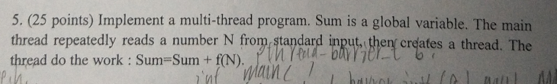

参考:p321互斥变量

#include <apue.h>

#include <stdio.h>

#include <pthread.h>

int total=0;

pthread_mutex_t mutex;

void *tfn(void * arg){

int num=*((int *)arg);

while(1){

//尝试锁住

if(pthread_mutex_trylock(&mutex)==0){

total+=num;

printf("%s","total:");

printf("%d\n",total);

//解锁

pthread_mutex_unlock(&mutex);

//退出循环

break;

}

}

}

int main(int argc, char *argv[])

{

pthread_t tid;

void * tret;

int num;

//初始化

pthread_mutex_init(&mutex,NULL);

while(scanf("%d",&num)==1){

pthread_create(&tid,NULL,tfn,(void *)&num);

}

//摧毁互斥变量

pthread_mutex_destroy(&mutex);

}