***FILE HANDLING IN C#***

**Part 1: Basic File Operations**  
**Task:** *Create and Write to a File*  
Create a method CreateAndWriteToFile(string filePath) that:

Creates a text file named sample.txt.

Writes "Welcome to File Handling in C#" into it.

Use StreamWriter or File.WriteAllText.

**Task**: *Read from a File*  
Create a method ReadFromFile(string filePath) that:

Reads content using StreamReader.

Prints each line on the console.

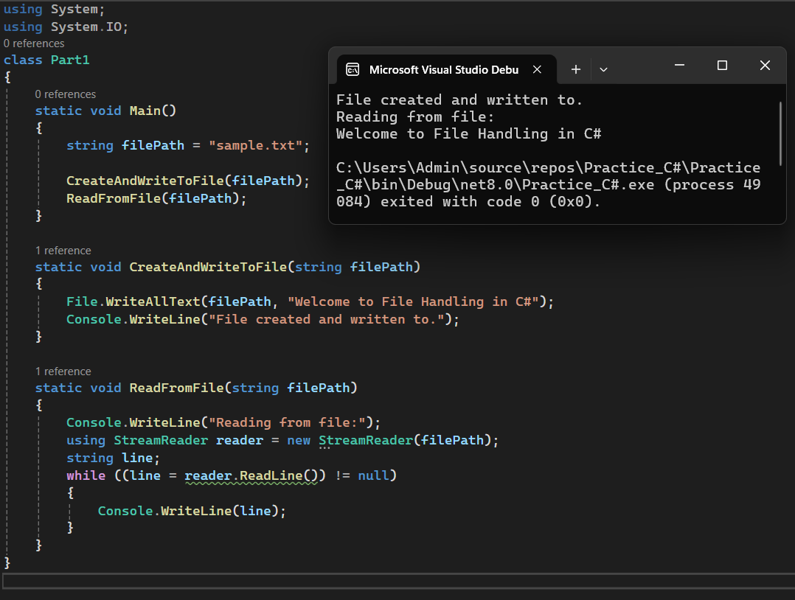

**Part 2: Append and Copy Files**  
**Task:** *Append Content to File*Create a method AppendToFile(string filePath) that:

Appends a new line: "This is an appended line."

**Task:** *Copy a File*Create a method CopyFile(string source, string destination) that:

Copies the file sample.txt to copy_sample.txt.

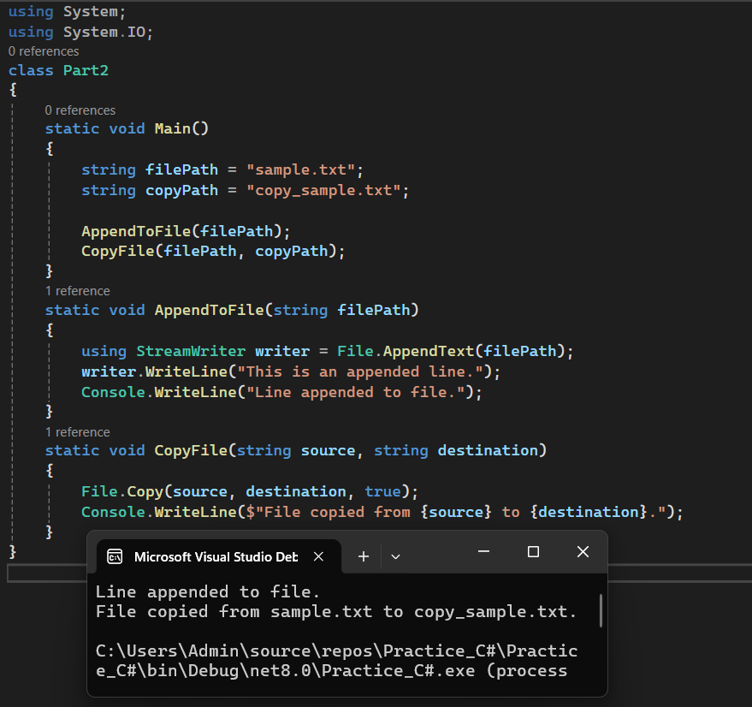

**Part 3: FileInfo Class Use  
Task*:*** *Get File Details*Using FileInfo:

Display file name, size, creation time, and last access time for sample.txt.

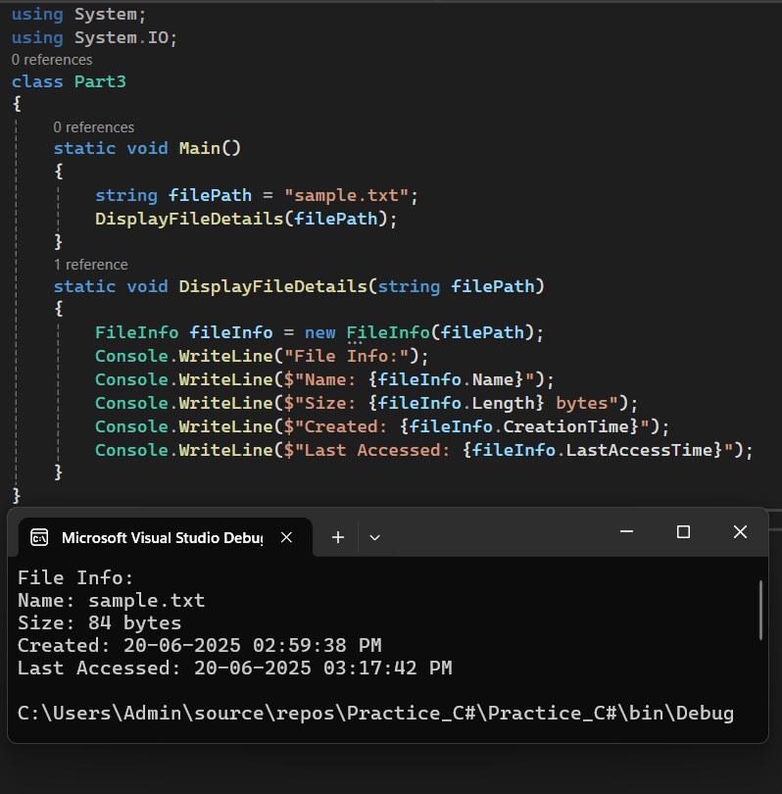

**Part 4: Directory Handling**  
**Task:** *Create a Directory and List Files*Create a directory TestFolder and write 3 text files in it (a.txt, b.txt, c.txt).

Then display the list of all files in that folder.

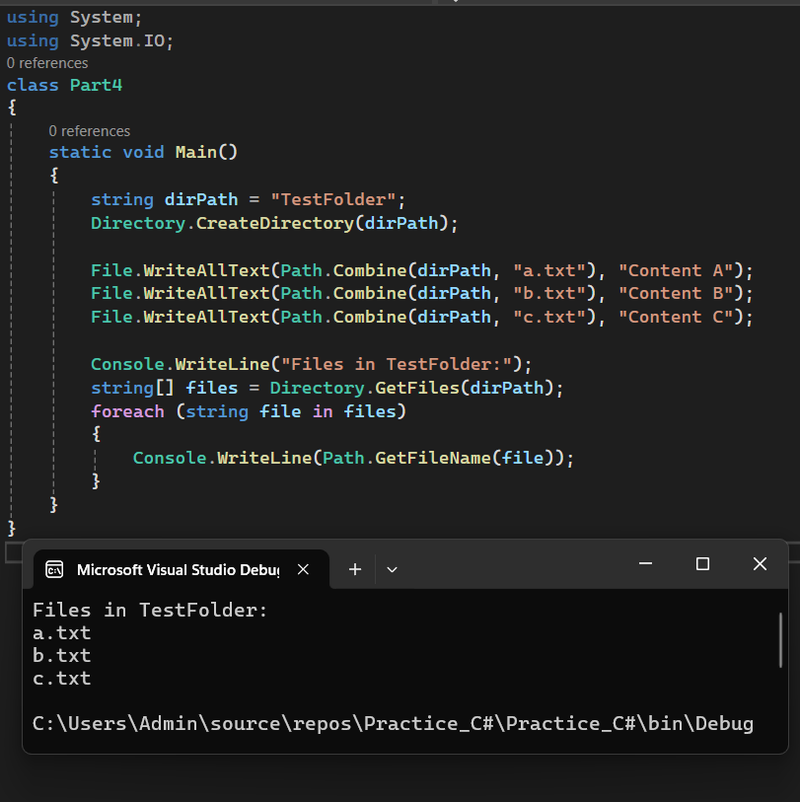

**Part 5: Exception Handling in File Operations**  
**Task:** *Handle Missing File*Try to open a non-existent file using StreamReader and catch the FileNotFoundException.

Display a custom message: "File not found. Please check the path."

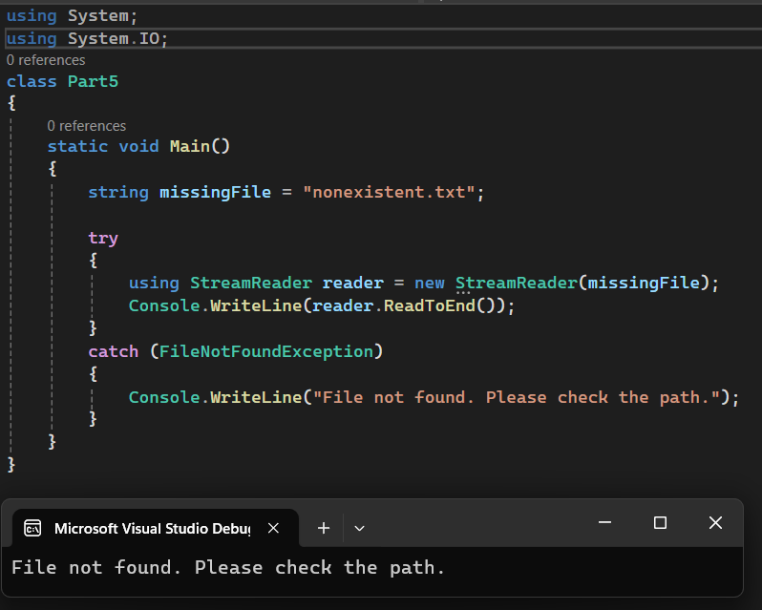 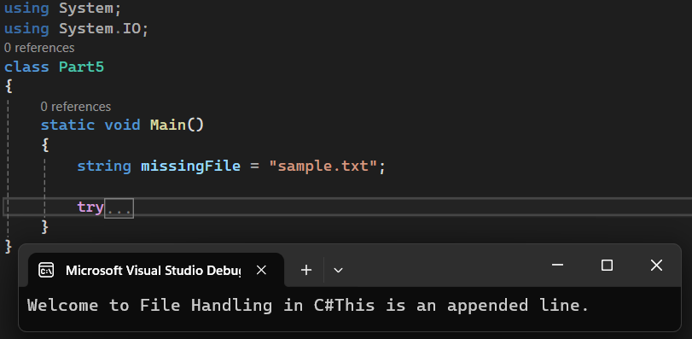

**Part 6: Mini Project – Student Record System (File Based)**  
**Scenario:** Store student records in a file and retrieve them when needed.

**Requirements:** Create a file students.txt.

Each student record should be: Name, RollNo, Marks

**Add a menu:** Add Student, View All Students, Search by Roll Number, Delete File, Exit.

**Concepts to use:** StreamWriter, StreamReader, File.Delete, File.Exists, Exception Handling

