***CAREERHUB – The Job Board***

(SQL Queries and Data Handling)

**Description:**

The CareerHub database is a relational database designed to manage a job board system, connecting companies, job listings, applicants, and applications through four core tables: Companies, Jobs, Applicants, and Applications.

The Companies table stores organization details (CompanyID, CompanyName, Location), while the Jobs table lists roles (JobID, JobTitle, JobDescription, Salary, JobType, PostedDate) linked to Companies via a foreign key. The Applicants table holds candidate data (ApplicantID, FirstName, LastName, Email, Phone, Resume, ExperienceYears, City, State), and the Applications table links applicants to jobs (ApplicationID, JobID, ApplicantID, ApplicationDate, CoverLetter) with referential integrity. Initialized by a script that drops existing databases to avoid errors, it creates tables with constraints and inserts 10 records each, featuring companies like Tata Consultancy Services, diverse roles like Software Engineer, and candidates with emails like [aaradhyasharma@example.com](mailto:aaradhyasharma@example.com).

Modifications ensure full column names (e.g., Jobs.JobTitle), correct "Salary" spelling, and date formats without time (e.g., '2023-02-15'). Supporting 16 queries, it enables functionalities like counting applications per job (including unapplied jobs via LEFT JOIN), retrieving jobs within salary ranges ($30,000–$90,000), tracking applicant histories, calculating average salaries (excluding zeros), identifying top job-posting companies, and listing applicants with 3+ years of experience in cities like Chennai. Using SQL features like JOINs, GROUP BY, and subqueries, CareerHub provides robust insights for recruitment analysis, salary benchmarking, and applicant tracking.

**Tasks:**

1. Provide a SQL script that initializes the database for the Job Board scenario “CareerHub”.

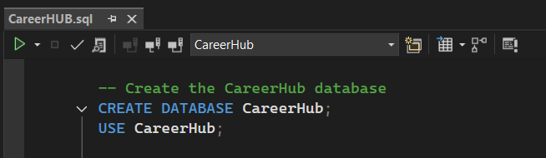

2. Create tables for Companies, Jobs, Applicants and Applications.

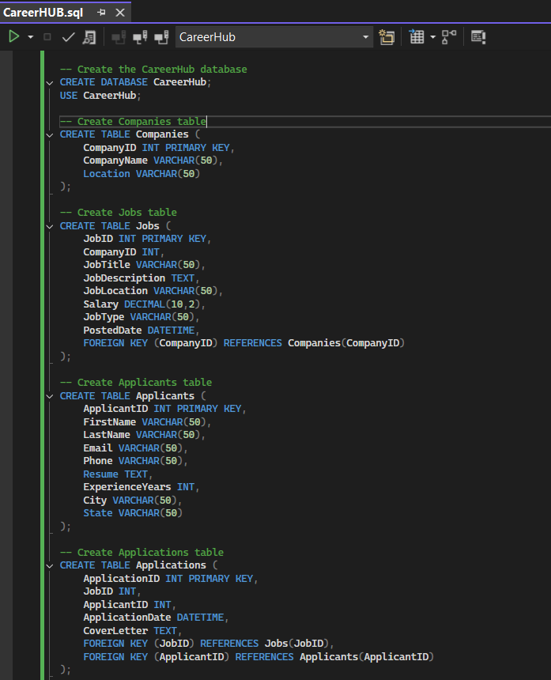

3. Define appropriate primary keys, foreign keys, and constraints.

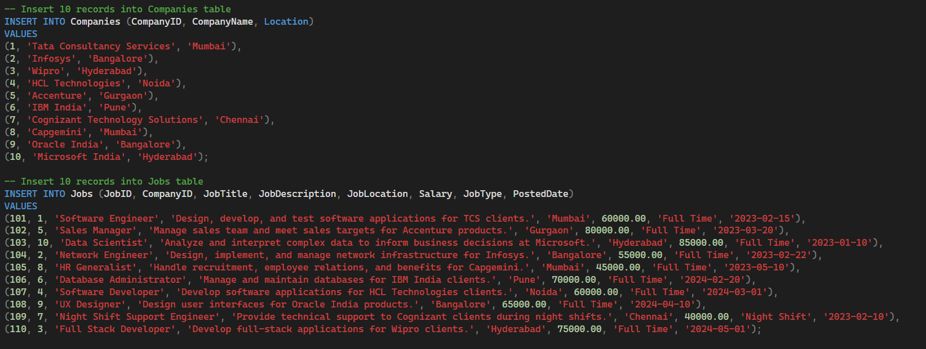

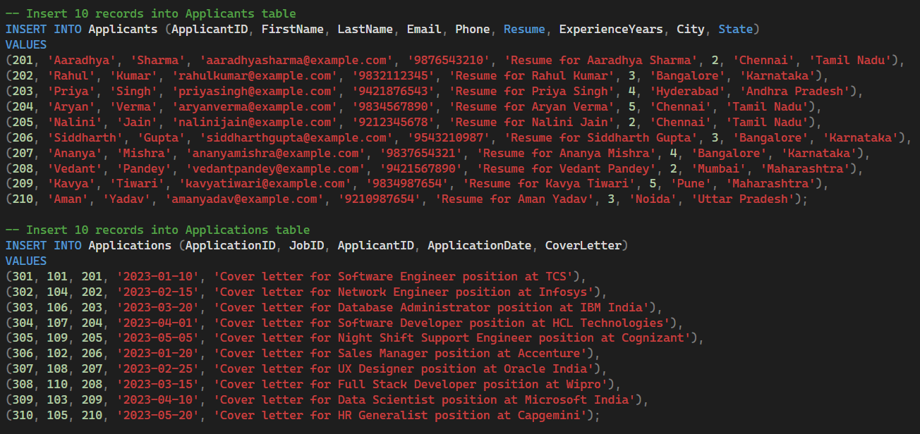

4. Ensure the script handles potential errors, such as if the database or tables already exist.

To ensure all queries produce valid results, additional records have been inserted where necessary to account for jobs with no applications, filtering, and company-wise grouping.

SELECT * FROM Companies;

SELECT * FROM Jobs;

SELECT * FROM Applicants;

SELECT * FROM Applications;

This set of queries retrieves all records from the core tables of the CareerHub system. It provides a comprehensive view of companies, job listings, applicants, and applications, and helps validate relationships and data integrity for downstream analysis.

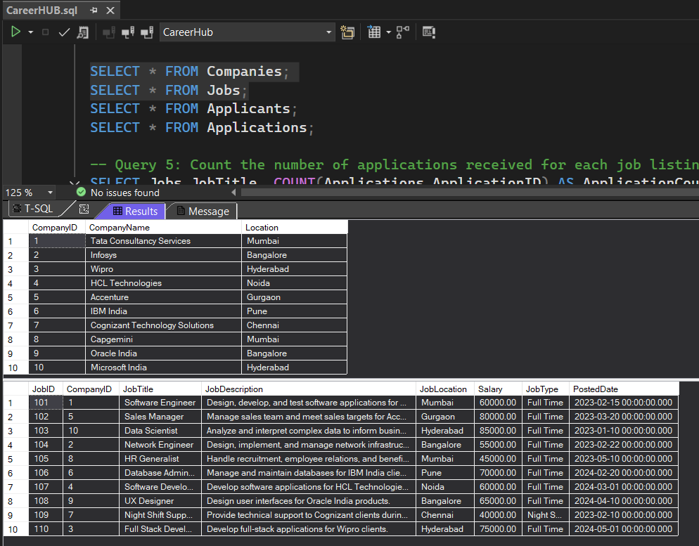

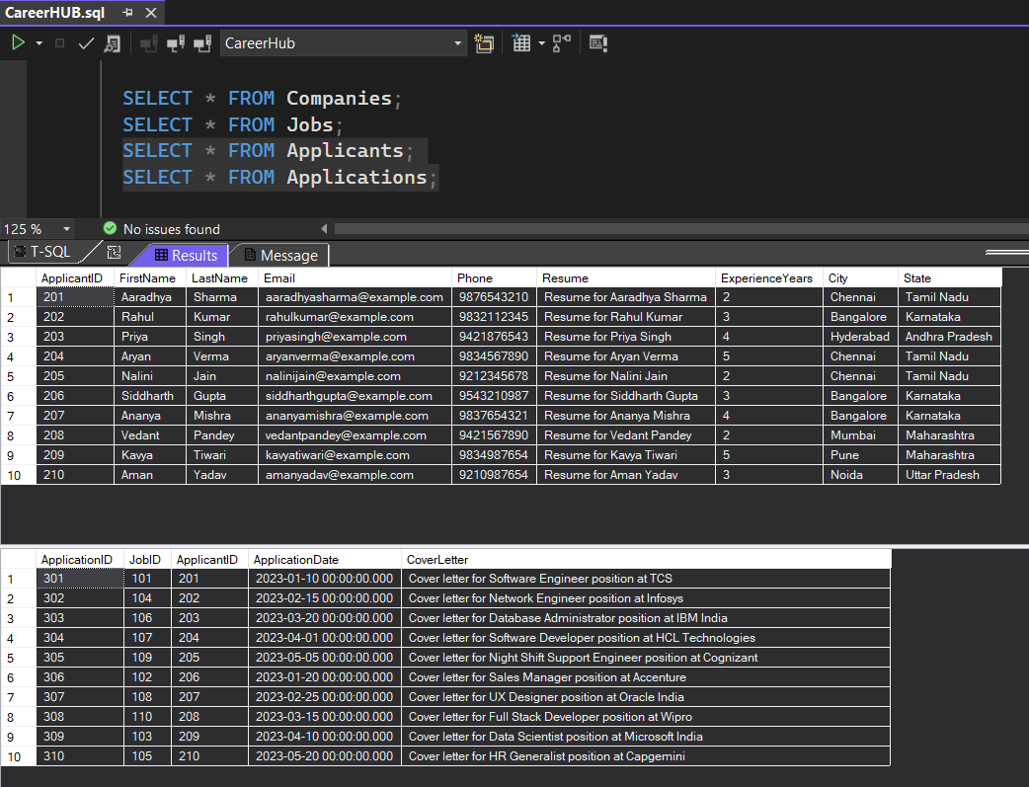

5. Write an SQL query to count the number of applications received for each job listing in the

"Jobs" table. Display the job title and the corresponding application count. Ensure that it lists

all jobs, even if they have no applications.

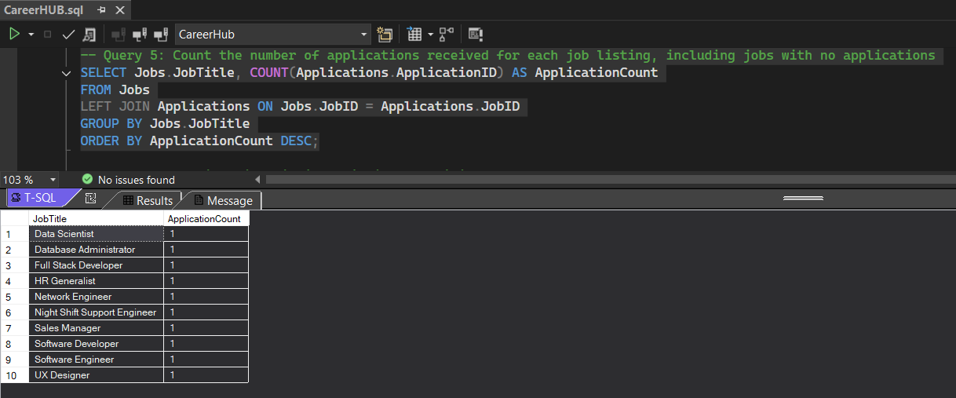

6. Develop an SQL query that retrieves job listings from the "Jobs" table within a specified salary range. Allow parameters for the minimum and maximum salary values. Display the job title, company name, location, and salary for each matching job.

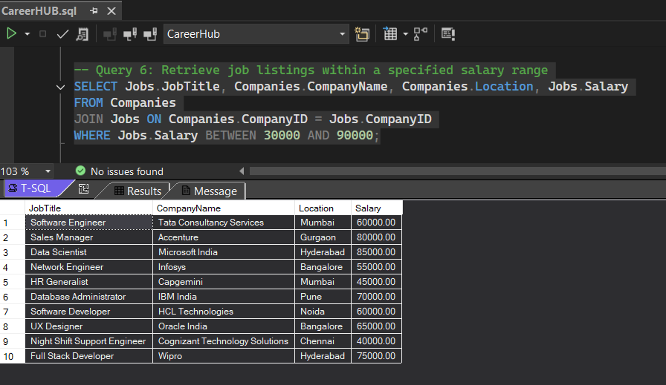

7. Write an SQL query that retrieves the job application history for a specific applicant. Allow a parameter for the ApplicantID, and return a result set with the job titles, company names, and application dates for all the jobs the applicant has applied to.

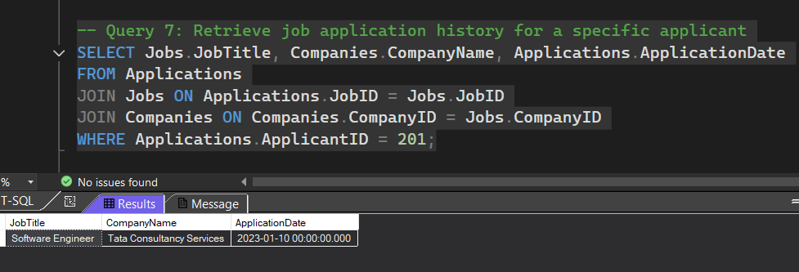

8. Create an SQL query that calculates and displays the average salary offered by all companies for job listings in the "Jobs" table. Ensure that the query filters out jobs with a salary of zero.

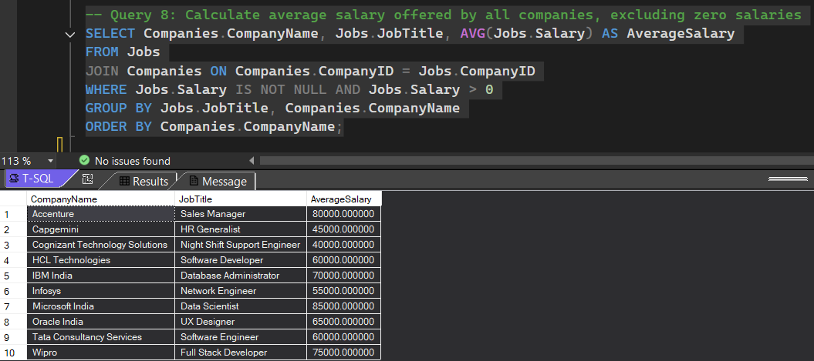

9. Write an SQL query to identify the company that has posted the most job listings. Display the company name along with the count of job listings they have posted. Handle ties if multiple companies have the same maximum count.

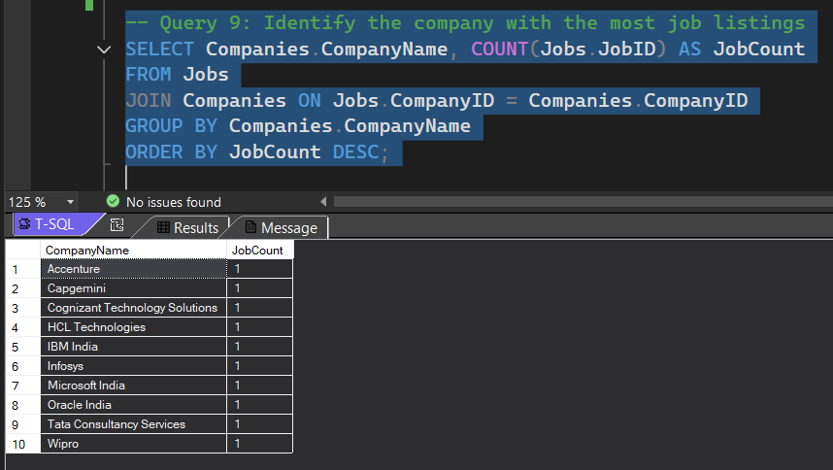

10. Find the applicants who have applied for positions in companies located in 'CityX' and have at least 3 years of experience.

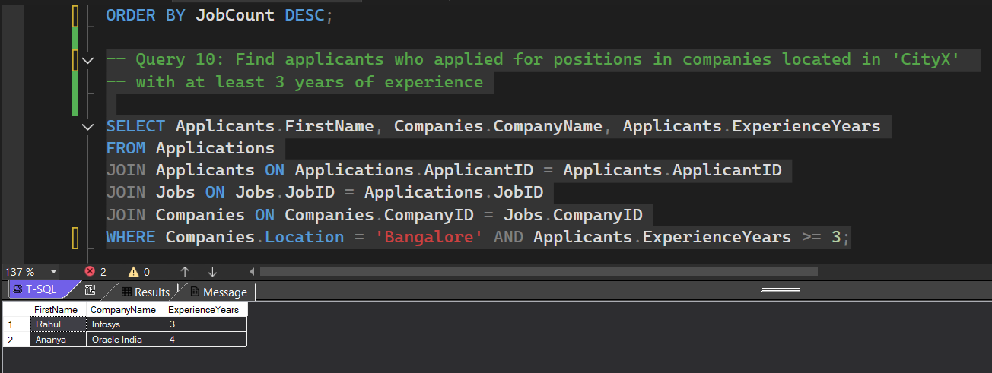

11. Retrieve a list of distinct job titles with salaries between $60,000 and $80,000.

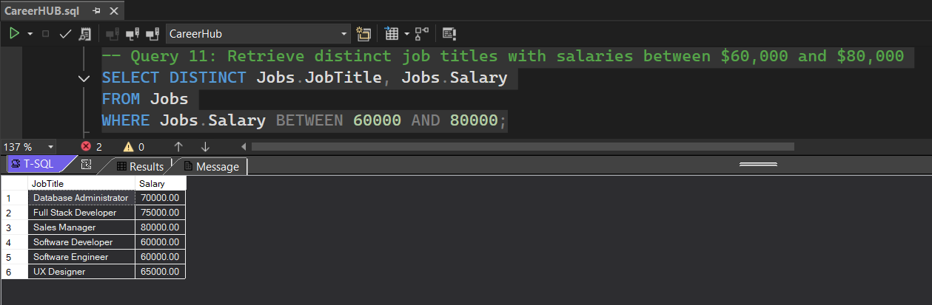

12. Find the jobs that have not received any applications.

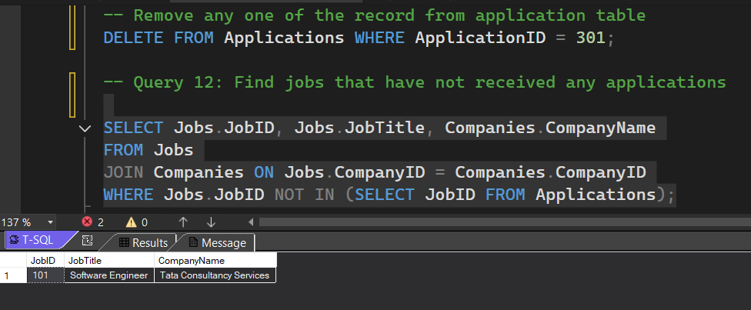

13. Retrieve a list of job applicants along with the companies they have applied to and the positions they have applied for.

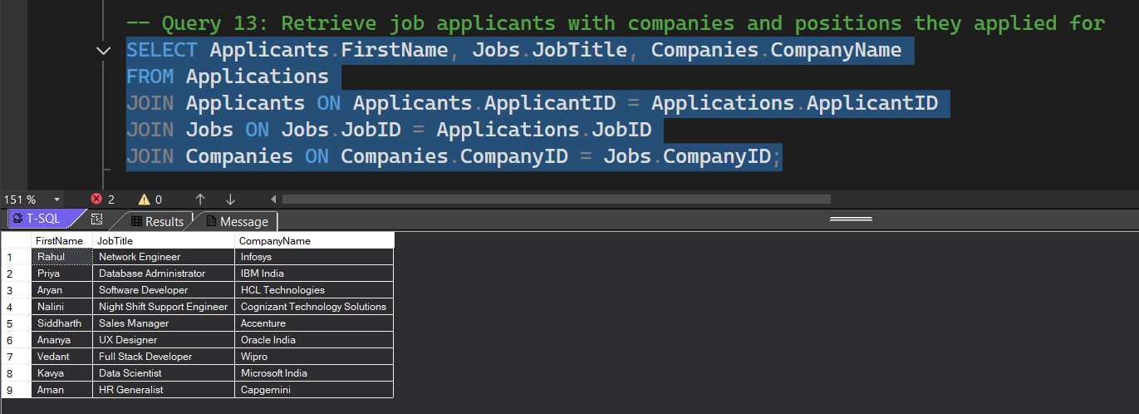14. Retrieve a list of companies along with the count of jobs they have posted, even if they have not received any applications.

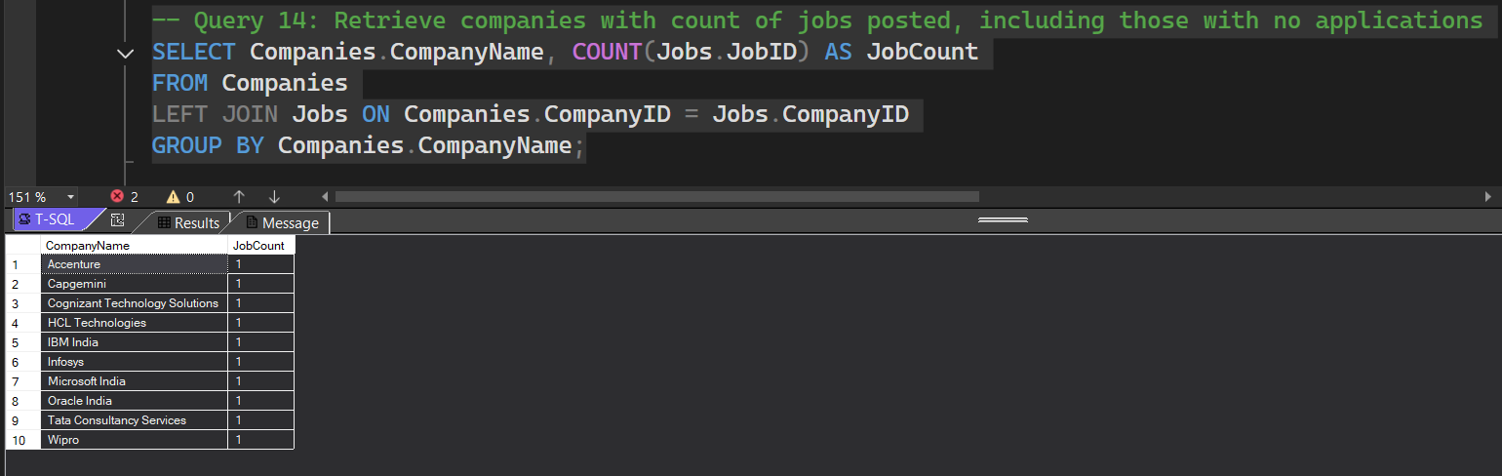

15. List all applicants along with the companies and positions they have applied for, including those who have not applied.

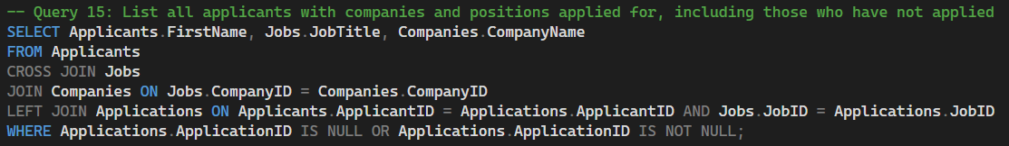

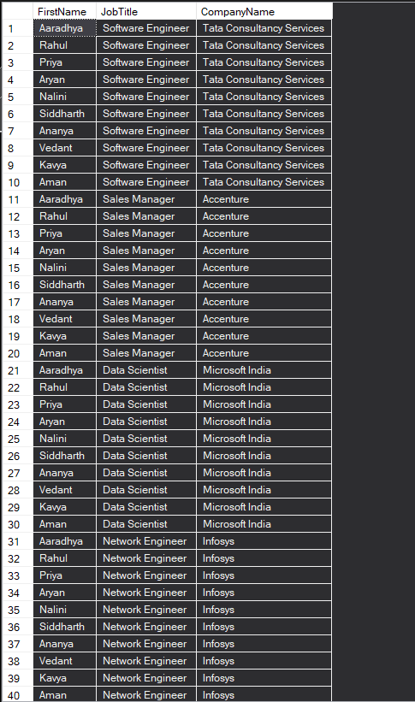 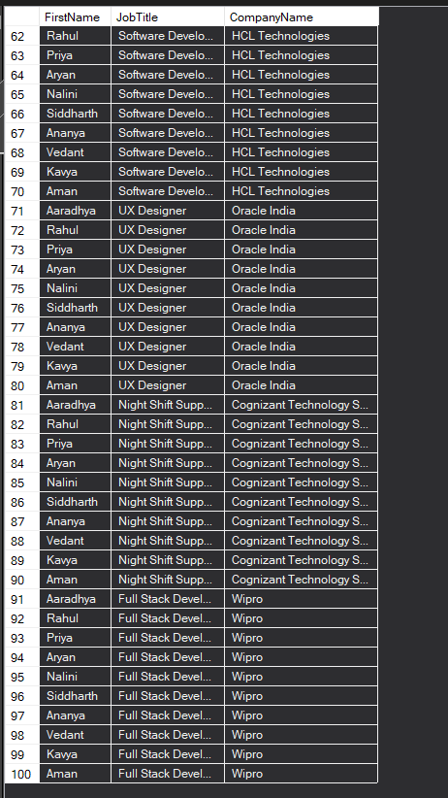

16. Find companies that have posted jobs with a salary higher than the average salary of all jobs.

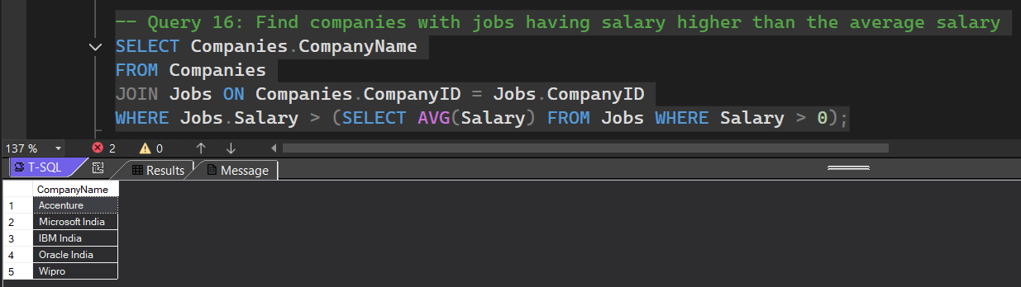

17. Display a list of applicants with their names and a concatenated string of their city and state.

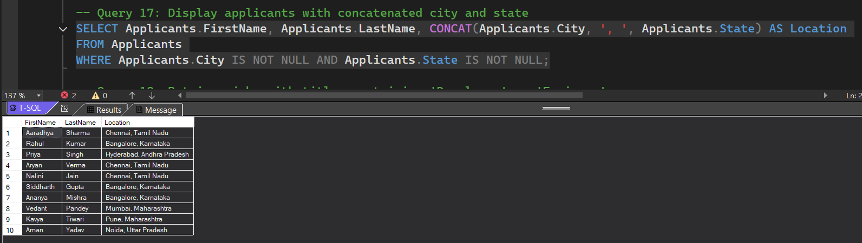

18. Retrieve a list of jobs with titles containing either 'Developer' or 'Engineer'.

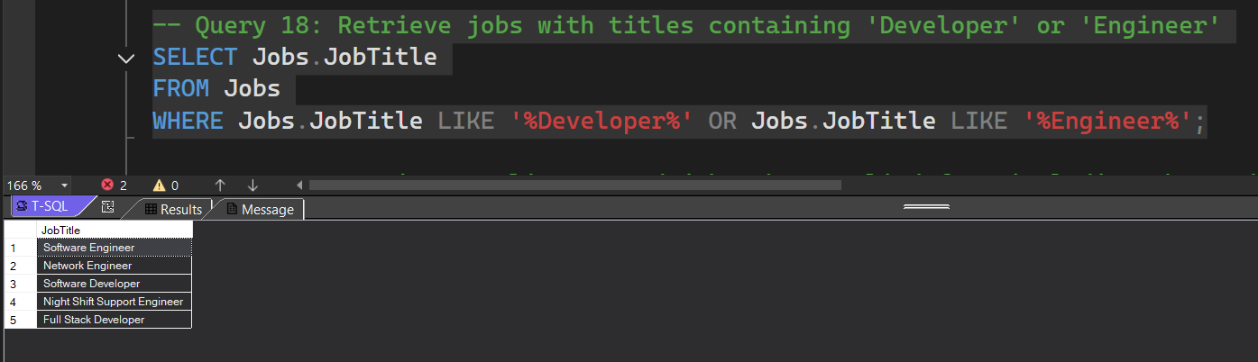

19. Retrieve a list of applicants and the jobs they have applied for, including those who have not applied and jobs without applicants.

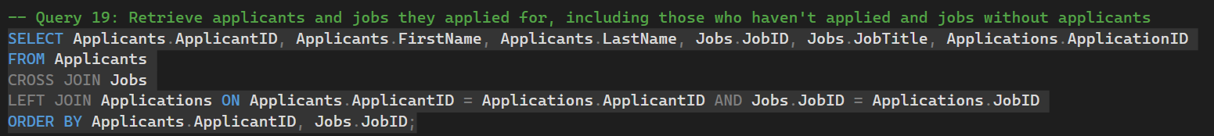

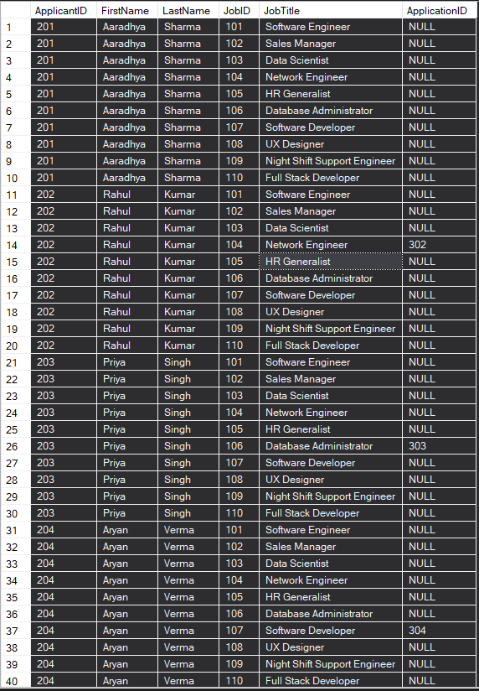 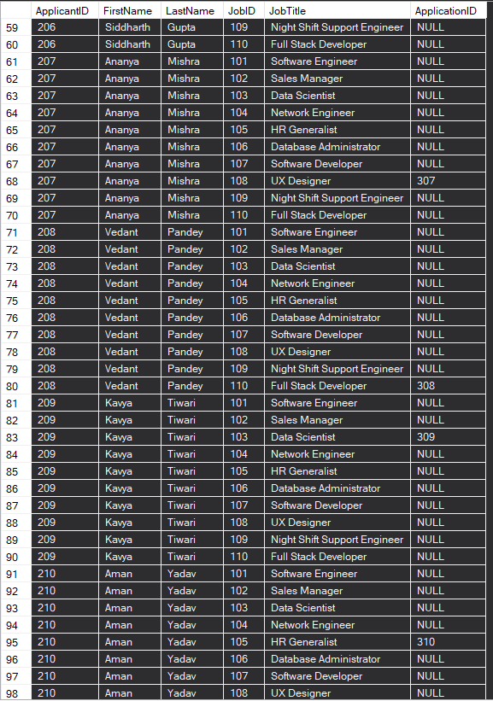

20. List all combinations of applicants and companies where the company is in a specific city and the applicant has more than 2 years of experience. For example: city=Chennai

