University of Huddersfield& Fujian Normal University

School of Computing and Engineering
Group Report

Active and Passive filters experiments

NFE2158-FNW

Electrical Principles 1
Tutor: Waled Gheth，Dr Ali Farzamnia

Group 7
Chair: JIAKUN PI (U2389501)
PEIYUN WANG ( U2389514)
CHANGHAO LI（U2389488)
RUIHAN HUANG (U2389388)
BOHAN LI (U2389509)
KUNYANG PAN (U2389396)
ZIHENG YAN (U2389492)
YIREN ZHAN (U2389376)
Summary
This project investigates and contrasts active and passive filter techniques through two structured laboratory experiments that integrate theory with hands-on measurement, which is the active filters experiment and passive filters experiment. As these two types of filters are widely used, so in this paper, the principle of these two types of filters will be discussed in detail, from the first experiment, the objective is to analyze the performance of high-pass, low-pass, and band-pass filters through a circuit mainly built up by UA741 and some capacities and resistors. The second one will be researched from a circuit mainly built up by resistor and capacitors and inductor. From these two experiments, one will deepen the understanding of the shapes of high-pass, low-pass and bandpass response curves and the meaning of "slope", learn about resonance phenomena, enhance the mastery of laboratory instruments and oscilloscope interpretation, as well as the sweep frequency techniques of function signal elements, and master the ability of data processing and error analysis.

Keywords: active filters, passive filters, high-pass filters, low-pass filters, band-pass filters, resonance phenomenon, cut-off frequency
Contents
- Introduction...................................................................................................P1
- Methodology..................................................................................................P2
2.1.Theoretical research............................................................................P2
2.2.Active filters............................................................................................P7
2.2.1.Instruments preparation A.......................................................P7
2.2.2.Working process A.....................................................................P9
2.2.3. Working Result A and analysis............................................P10
2.3.Passive filters........................................................................................P16
2.3.1.Instruments preparation B.....................................................P16
2.3.2.Working Process B...................................................................P17
2.3.3.Working Result B and analysis.............................................P19
5. Conclusion.....................................................................................................P22
6. Reference.......................................................................................................P25
7. Appendices....................................................................................................P26
7.1.Data Images Appendix...................................................................P26
7.2.Group meeting Appendix..............................................................P41

Introduction
Filters are fundamental building blocks in various electronic systems, performing the crucial task of selectively passing desired frequencies in a signal while attenuating unwanted ones. This selective processing allows for extracting specific information or protecting sensitive circuits from harmful noise. There exist two main categories of filters: active and passive!(Jadhav, 2022)

In this project, these two categories of filters will be discussed, since nowadays, with the surging demand for high-fidelity and wideband signal processing, filters have become indispensable basic modules in analog and mixed-signal links. In low-frequency or small-signal scenarios, traditional inductors are often large in size and have high losses, which prompts the operational amplifier - RC topology to rapidly replace the LC scheme and form an "inductance-free" active filter. This not only achieves controllable gain and steep roll-off, but also simplifies the multi-stage connection design. In RF and high-power links, pure passive RLC still occupies a key position due to its advantages such as no need for power supply, high linearity and large resonant Q value. Correctly understanding and weighing the performance boundaries of the two types of filters is one of the core capabilities for electronic engineers in system architecture and front-end signal conditioning. This project focus on these two types of filters and designed two experiments to help us consolidate the frequency domain concepts like: cut-off frequency, bandwidth, quality factor and roll-off rate, understand the physical differences of devices, learn about the limitations of operational amplifier GBW and RC constants on active/passive performance, master instrument skills like: function generator sweep frequency and multi-channel oscilloscope measurement

Methodology

Theoretical research
Active filters: A network that uses active devices such as operational amplifiers (OP-AMP), transconductance amplifiers (OTA), or transistors to jointly achieve the required frequency selection characteristics with R and C components. Since the amplifier itself can provide gain and isolation, the bulky inductors in the low-frequency band can be completely eliminated. Active filters contains 4 kinds of circuits: Low pass filters, high pass filters and band pass filters and band stop filters. It have a lot of advantages, like: inductance-free, miniaturized and easy to cascade Built-in gain is available, with a high roll-off rate (≥ -24 dB/oct per stage) Easily tune the center frequency and bandwidth through resistors, potentiometers, SC clocks or OTA biasing.
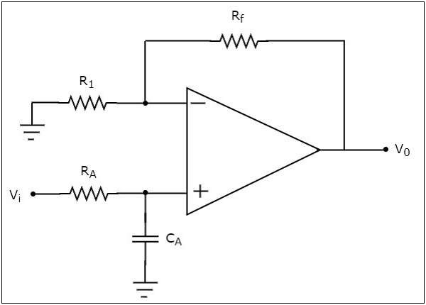
Fig.1: The circuit diagram of an active low pass filter(points, n.d.)
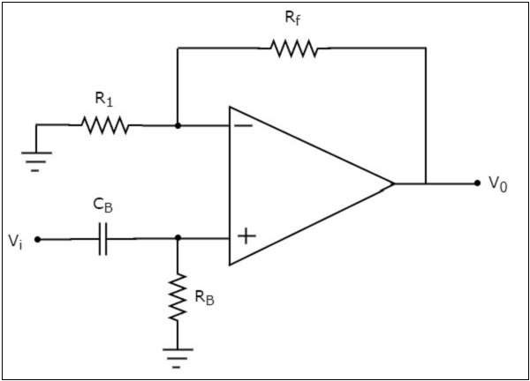
Fig.2: The circuit diagram of an active High pass filter(points, n.d.)
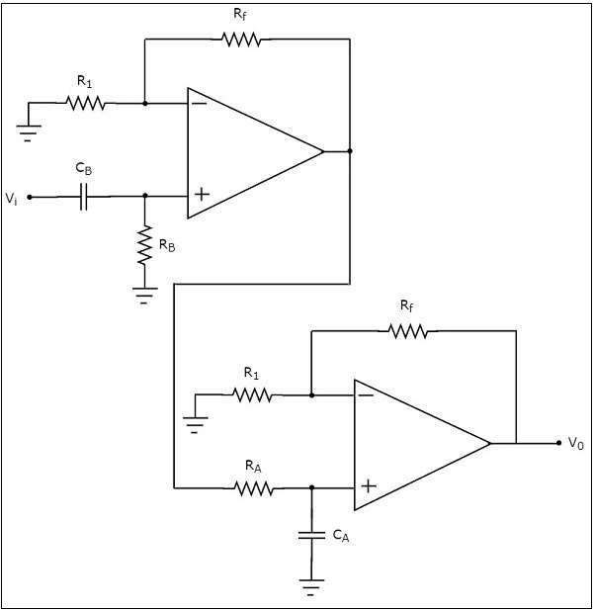
Fig.3: The circuit diagram of an active Band pass filter(points, n.d.)
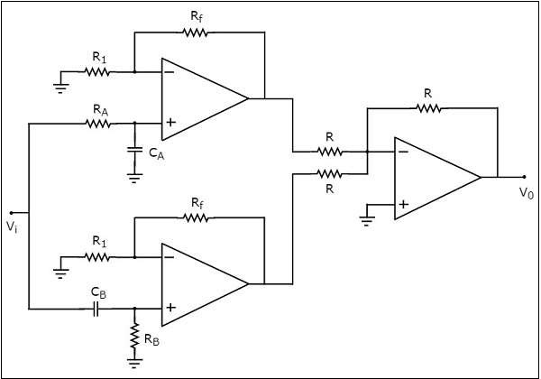
Fig.4: The circuit diagram of an active Band stop filter(points, n.d.)

But it also have some limitations, like: power supply is required, and noise/distortion is dominated by active devices Due to the limitations of the operational amplifier gain-bandwidth product (GBW) and the conversion rate, high Q is difficult to achieve in radio frequency.

Passive filters: the selection network composed only of R, L, C (or quartz, ceramic resonators) is completely dependent on the energy storage and dissipation characteristics of the components and does not require external bias.
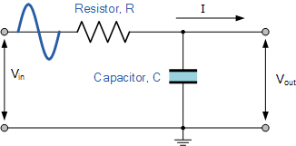
Fig.5: The circuit of passive low pass filters (Electronics Tutorials, 2018)
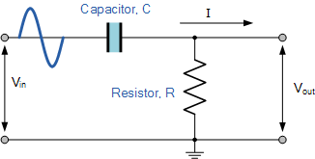
Fig.6: The circuit of passive high pass filters (Electronics Tutorials, 2018)
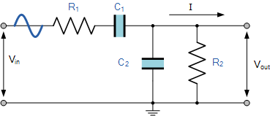
Fig.7: The circuit of passive band pass filters (Electronics Tutorials, 2018)

The basic circuit is RC first order (tone control), series/parallel RLC resonators (band-pass or notch), LC trapezoidal networks (telephone splitters, RF matching). The passive filters also have some advantages like: No power supply, high linearity and strong power handling capacity, and it is readily available with the aid of crystal/ceramic resonators to reach Q>103 Narrow band pass. And the limitations is that the inductors are large in volume, high in cost and vulnerable to parasitic influences, and its gain < 1, its insertion loss requires additional amplification stage compensation, and the tuning range is limited and it is sensitive to load impedance.

So in a brief summary, active topology "synthesizes" inductance and gain through amplifiers, making it suitable for low - and medium frequency small-signal systems that require precise adjustability or high integration. Passive networks maintain an irreplaceable advantage in the high-power or high-frequency (radio frequency, microwave) segments due to their outstanding linearity and high Q.

Active filters

Instruments preparation A
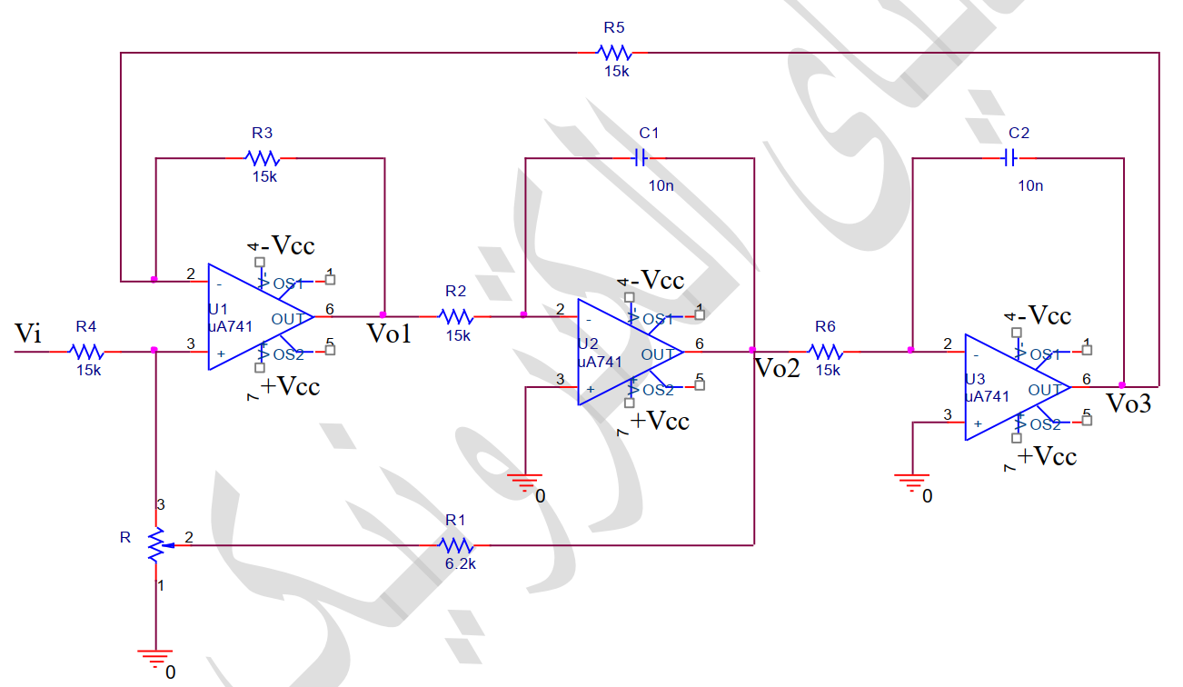
Fig8. the schematic of the experiment 1 active filters

In the first experiment, the necessary tools and instruments should be prepared based on the schematic diagram which is given, the detailed lists are as follow:
1- oscilloscope
2- power supply
3- three IC of 741
4- two capacitors 10 nF
5- five resistors 15 kΩ
6- four resistors 10 kΩ
7- one resistor 6.2 kΩ
8- one potentiometer of 30 kΩ
Next, the effect of these instruments and tools will be introduced. First, the oscilloscope is used to display and measure the amplitudes and waveforms of Vo1, Vo2 and Vo3,and determine the upper and lower cut-off frequencies through the cursor or the -3 dB reading value, and record the screenshots of the square wave transient (rising edge, overshoot). Then, the power supply is used to provide a stable ± 15V rail voltage to the three 741 operational amplifiers to ensure that the amplifiers have sufficient swing amplitude and linear operating area. Thirdly, the 3 741 ICs is used to comprise the high pass band pass and low pass filters, and provide gain and buffering after each level of RC network to prevent inter-stage loading, then the capacitors are used to set the RC time constant together with a 15 kΩ resistor, C1 is located at the Qualcomm input (forming the zero point); C2 is located in the low-pass feedback (forming the pole), and the resistors with capacitors decide the characteristic of frequency, and the potentiometer is used to provide adjustable gain.

Working process A
The first job following the experiment document is to assemble the circuit on the breadboard.
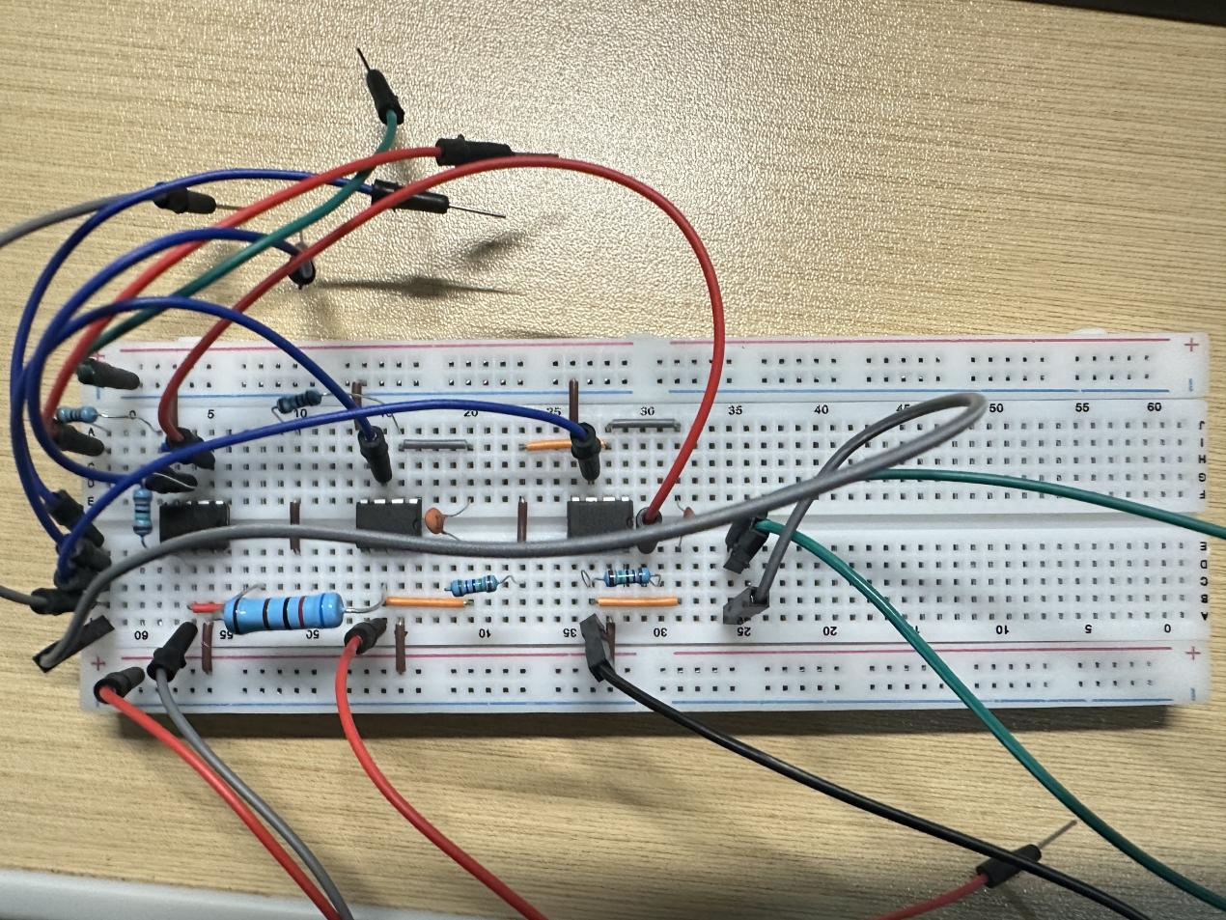
Fig.9. The breadboard connection of the circuit without the potentiometer

Based on the requirements of the document, the circuit should connect without the potentiometer, and connect one end of the 6.2k resistor to the positive terminal of the first OP-Amp. Then the circuit will be apply a sine wave with an amplitude of 1v to the Vi. After testing the Vo1 Vo2 Vo3 in 100Hz 1kHz 2kHz 1MHz, and observe and record the result of different frequency. Next we will test the cut off frequency (3dB) of this circuit. Then the experiment will be carried out to next step,which is to connect the 30k potentiometer in the circuit and apply a square wave with an amplitude of 1V and a frequency of 100Hz, during this steps, the data will be recorded by adjusting the range of the potentiometer from low to median and high. And also, record the output waveform. After doing these steps, the experiment of active filters is finished, then the result will be displayed and analyzed below.

Working Result A and analysis
During the section of measuring the Vo1 Vo2 Vo3 outputs with different frequencies without the potentiometer, the result will be shown below in table

Table 1

Frequency (Hz) | Vo1 | Vo2 | Vo3
100 Hz | 14.8mv | 84mv | 600mv
1 kHz | 504mv | 376mv | 288mv
2 kHz | 592mv | 220mv | 90mv
1 MHz | 252mv | 22.0mv | 5.6mv

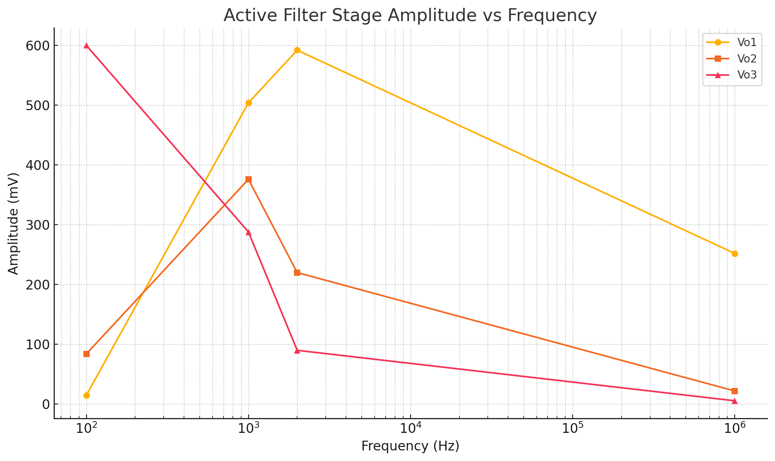
The observation picture of the oscilloscope will be attached to the appendix, then why this the circuit outputs this result, the analysis will be shown below:
Under the state of removing 30 kΩ potentiometer, the Q fix it in the "low damping" state, 6.2 kΩ resistor R1 is connected to the + terminal of U1 . In 100Hz, vo1 is 14.8mv, The coupling capacitor in the first stage forms a high pass, with a cut-off frequency fc≈ several hundred Hz. When it is lower than fc, it is greatly attenuated, vo2 is 84mv, Bandpass is also limited by the high-pass end, vo3 is 600mv, The final stage is low-pass. At 100 Hz, it is far below its upper limit, so it almost passes through the entire range and comes with a certain low-frequency gain. In 1kHz, the vo1 is 504mv, it has passed the Qualcomm fc and is far from the op-amp GBW, almost at full scale, Vo2 is 376mv, The gain is the greatest when it falls near the center of the bandpass, and Vo3 is 288mv, approaching the low-pass inflection point, it begins to decay by approximately -3 dB. In2kHz, Vo1 is 592mV, Still within the first-level passband, Vo2 is 220mV, it has exceeded the bandpass upper limit and the amplitude has dropped, Vo3 is 90mV, the low-pass roll-off (~-20 dB/dec) is obvious. In 1MHz, vo1 is 252mV, it is no longer the filter itself, but the GBW/SR (slew rate) limitation of the operational amplifier that causes the closed-loop gain to reverse with the frequency, Vo2 is 22mv, it is both suppressed by the high end of the bandpass and restricted by GBW. Vo3 is 5.6mv, The dual influence of low-pass roll-off and device bandwidth. The function of U1 is reversing buffering/pre-amplification, whose gain varies with the "cross-stage" feedback current of C1 and C2. The U2 is active first-order low-pass (-R5/R2=-1), and the high-frequency band is short-circuited by C1 to the global feedback. The U3 is lowpass filter.

After testing the Vout without the potentiometer, the upper and lower cut off frequency(-3dB) will be tested. The cutoff frequency is Vpp/ $\sqrt{2}$ = Vrms ,then use the Vrms*0.707 =Vout(-3dB). Based on the test, the Vo1 High pass filter: the lower cut off frequency is 700Hz, and the Vo2: band-pass filter: the lower cut off frequency is 400Hz, the upper cut off frequency is about 1.6kHz. The Vo3 low-pass filter: the upper cut off frequency is about 730Hz.
After testing the cut off frequency, the next step is to connect the 30K potentiometer to see what would it happen to the output if the potentiometer is adjusted from low to high, and the output are been recorded, the detailed pictures can be seen in the appendix.
In Vo1 (High pass):
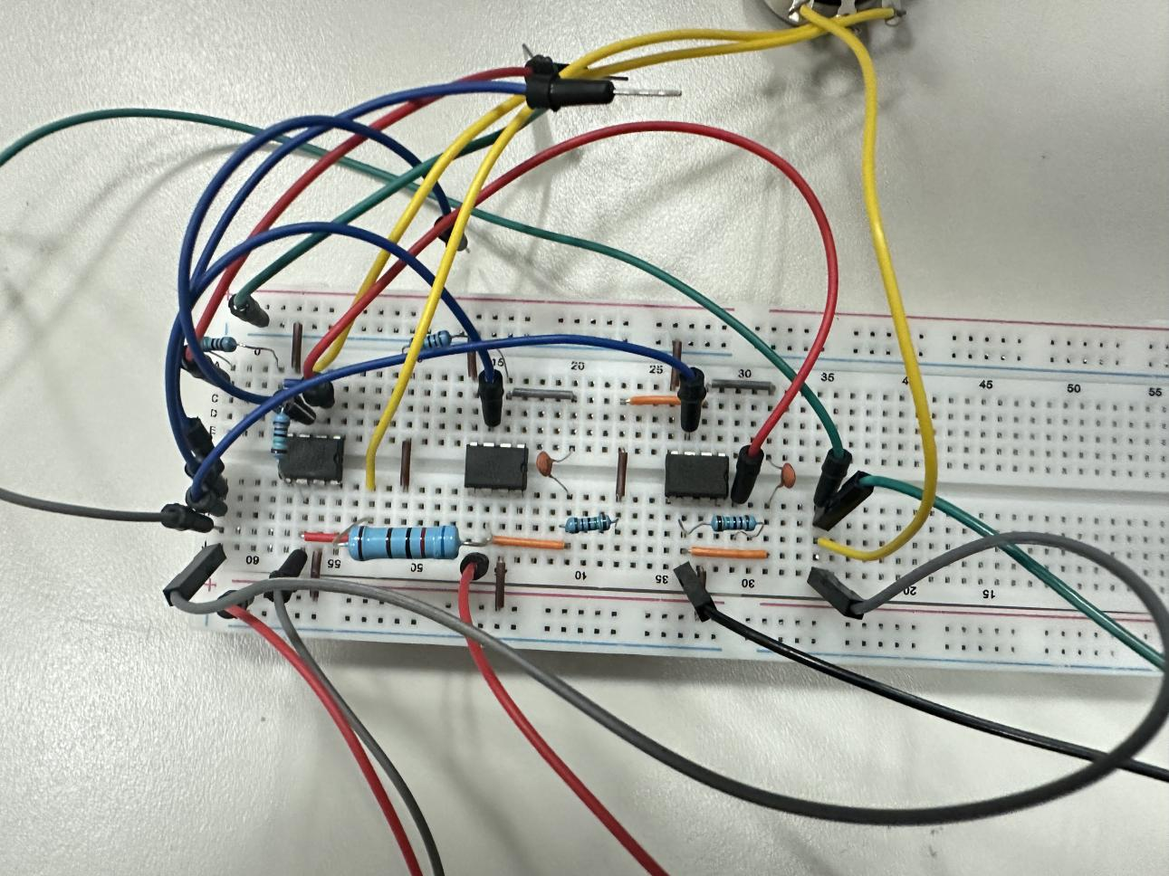
Fig.10. The breadboard connection of the circuit with the potentiometer

In the low gear, The feedback is very strong, with obvious underdamping and the pulse amplitude increases and there is a distinct ringing at the tail, featuring multi-period attenuated oscillation
In the median gear, The feedback is moderate, with slight underdamping and only 1-2 cycles of micro-ringing occur after the pulse
In the high gear, The feedback is very weak, and the system is over-damped and the pulse is extremely narrow and decays rapidly; There is no ringing.
This is because qualcomm equivalent differentiator, output ≈dVi/dt; Potentiometer regulation of non-inverting feedback affects the damping ratio of the closed-loop pole, thereby changing the transition response and ringing characteristics of the pulse.
In Vo2 (band Pass):
In the low gear, High Q and The wave packet ringing is significant and lasts for multiple cycles. The peak is higher.
In the median gear, Q medium and The duration of the wave packet is slightly longer, and 1-2 period damped oscillations can be observed.
In the high gear, Low Q, extremely wide bandwidth and The wave packet is very short, with only one narrow peak appearing. The subsequent oscillations are hardly visible.
This is because bandpass is equivalent to the frequency spectrum of the opposite wave "selective" near f0. Increasing Q by the potentiometer is to give greater gain and lower damping at the center frequency, so the edge impulse response is transformed into a wave packet with attenuated ringing
In Vo3( low pass):
In the low gear, High Q and strong underdamping, after the square wave jumps, the output shows obvious ringing and overshoot, and the waveform is close to the superimposed damping oscillation with a ramp wave.
In the median gear, In the middle of Q, there is a slight overshoot (overshoot/ringing) at the edge, and the waveform slightly jitter at the turning point.
In the high gear, Q low and over-damping, smooth edge integration yields approximately linear ramp rise/ramp fall, with almost no overshoot.
This is because Cascaded low-pass equivalent integrator, output = ∫Vi dt; The higher the Q is, the smaller the damping of the integral loop is, resulting in a more obvious "underdamped" oscillation when responding to the jump.

Finally, to answer the question 8 of the document.Based on the results of the table 1, the trend of the Op-Amp output changes with frequency. Some keys were summarized: Firstly, the very low Q, set by the feedback network after removing the 30 kΩ potentiometer, stretches the -3 dB points so widely that all three outputs remain essentially unity-gain across most of the table. Secondly, Bandwidth ultimately limited by the op-amp, not the RC network. Once the test frequency approaches the 741’s GBW, the closed-loop gain of every stage collapses, so even the nominal “high-pass” output no longer holds its level.

Passive filter

Instruments preparation B
After finishing the first experiment, the second experiment will be carried out which is the passive filters experiment. Before conducting this experiment, the instruments for the circuits and some tools should be prepared. The detailed instruments list will be shown below based on the schematic provided in the documents.
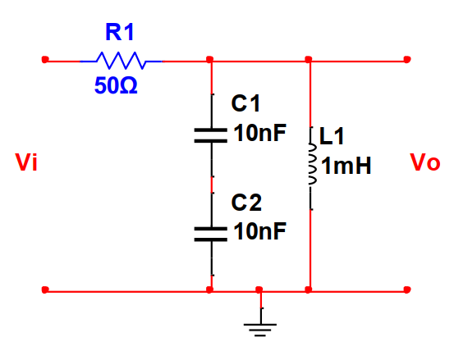
Fig.11. The schematic of the passive filters experiment
- A signal generator
- An oscilloscope
- 50 Ω resistor
- 2 X 10nF capacitors
- 1mH inductors
- Multimeter

The signal generator will provide swept-frequency sine or square wave excitation. And the experiment result can be observed and recorded by using the oscilloscope. And the 50Ω resistor, 2X10nF capacitors and 1mH inductor comprised the passive series resonant RLC bandpass filter. C1 and C2 are grounded in series and are equivalent to 5nF.

Working process B
Firstly, to start this experiment, the circuit of the passive filter should connect on the breadboard.
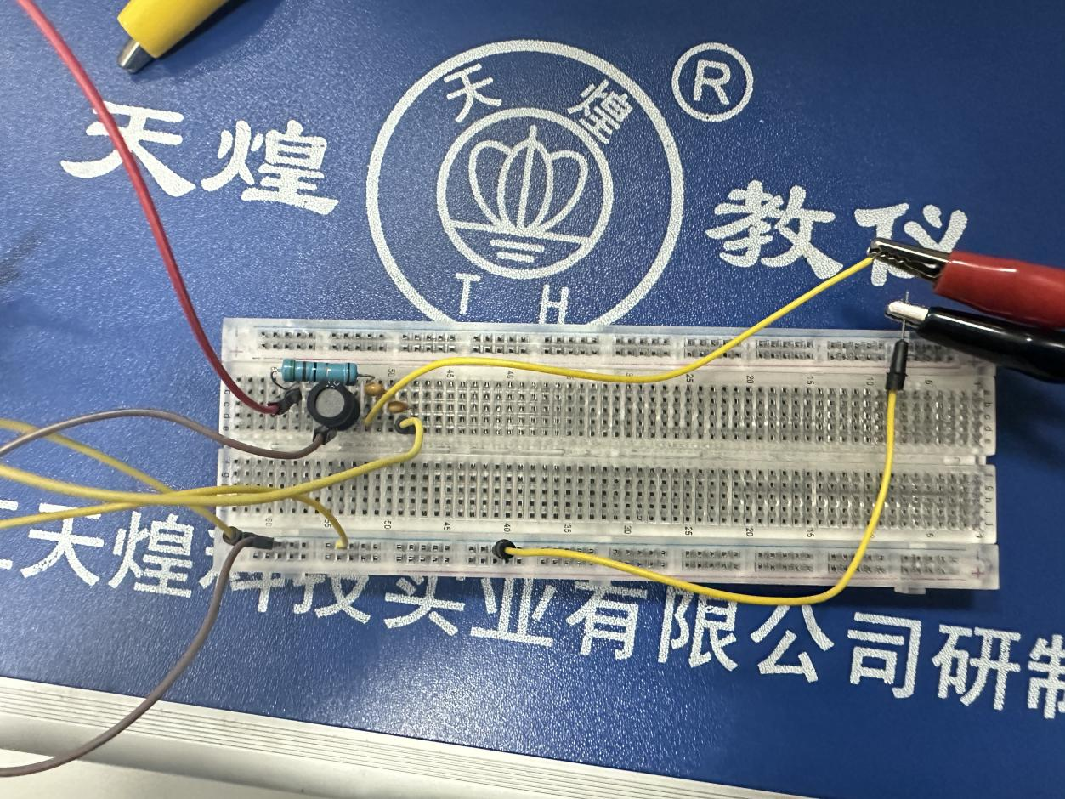
Fig.12. breadboard of the passive filter.

Then, the next stage of the experiment is to calculate the resonant frequency fr, based on the formula $f_{r}=\frac{1}{2π\sqrt{LC}}$ , in order to compare the fr in theoretical and in practical, the actual inductance and capacity of the inductor and capacitor will be measured by multimeter. The next step is to measure the lower cut off frequency and upper cut off frequency.(3dB) Finally, some specified frequencies will be measured by oscilloscope from 20kHz to 250kHz. After doing all these steps, the experiment of passive filter in this project is finished.
Working Result B and analysis
The fr in this circuit is calculated, since two capacitors are in series, so the equivalent capacitor is $C_{eq}=\frac{C_{1}C_{2}}{C_{1}+C_{2}}=\frac{10 nF×10 nF}{20 nF}=5 nF$, and based on the formula of calculating resonant frequency $f_{0}=\frac{1}{2π\sqrt{LC_{eq}}}=\frac{1}{2π\sqrt{1 mH×5 nF}}≈71 kHz$. By doing this, the theoretical resonant frequency is calculated, then the actual fr also should be measured. By testing the actual value of the capacitor and inductor utilizing the multimeter, the real value of capacitors are 9.5nF and 9.7nF, and the actual value of inductor is 1.01mH. So the $C_{eq}=\frac{C_{1}C_{2}}{C_{1}+C_{2}}=\frac{9.7 nF×9.5 nF}{(9.7+9.5) nF}= 4.79nF$, So $f_{0}=\frac{1}{2π\sqrt{LC_{eq}}}=\frac{1}{2π\sqrt{1.01 mH×4.79 nF}}≈72.4kHz$. The next step of this experiment is to measure the cut off frequency both upper and lower, to find the cutoff frequency, the definition should be known. Cutoff frequency is defined as the point in a frequency response at which the signal begins to be attenuated rather than fully passing through. (Muthukrishnan, 2022)
Fig13. The cutoff frequency (Muthukrishnan, 2022)
So, in order to measure the -3dB cutoff frequency of this RCL circuit, we utilize the oscilloscope in two channels, one is used to test the Vin, and another is to test the Vout. By measuring both Vin and Vout, and calculate the ratio of it, when the ratio comes to 70.7%, it reaches -3dB. The picture of measurement will attached to the appendix. The data shows when the frequency comes to 630kHz, it reaches the upper cutoff frequency, the Vin is 1.28mV, the Vout is 900mV, the ratio( Vin/Vout ) is approximately 70.3%, and when the frequency comes to 8.8KHz, the frequency reaches the lower cutoff frequency, which the Vin is 1.32V, the Vout is 940mV, the ratio is approxiately 71.2%. Since this is a high-q series L-C notch (or band-stop) filter. The f0 is about 71.3kHz series with a resistor of 50Ω the quality factor $Q=\frac{ω_{0}L}{R_{1}},ω_{0}=\frac{1}{\sqrt{LCeq}}$ so take the 1mH and 5nF into the formula which calculate the result is Q $≈$ 8.9, then calculate the Calculate the half-power point based on the formula fL $≈$ f0/R , so fL $≈$ 71/8.9 $≈$ 8.0KHz, and fH $≈$ 71*8.9 $≈$ 630kHz. So in theoretically, the cutoff frequency is basically consistent with the actual measurement. Finally, some specified frequencies will be measured by using points below the table.

Input frequency | 20  kHz | 30  kHz | 50  kHz | 65  kHz | 71  kHz | 80  kHz | 100 kHz | 150 kHz | 250 kHz
Output amplitude (Vo) | 1.56 | 1.76 | 1.92 | 1.96 | 1.96 | 1.92 | 1.92 | 1.84 | 1.60

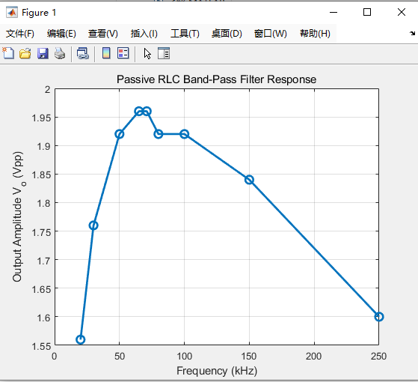
Fig14. passive RLC bandpass filter response.
By recording the data, the data diagram is made by matlab. Gaining a result like this has some reasons will be introduced below.
Firstly, In the low frequency range (20 kHz → 50 kHz): The branch circuit was short-circuited by the inductor, The capacitance impedance is large.
Secondly, near resonance (65 kHz to 71 kHz): near the f0(71kHz), X_L ≈ X_C, the impedance of the series branch is the smallest, the current is the largest, and the Vo reaches the peak value of approximately 1.96 Vpp. Here is also the center frequency of the -3 dB cut-off, and the output is closest to the input amplitude.
Finally, at high frequency range (80kHz-250kHz): the frequency is higher than the f0, the inductance impedance X L = 2πfL increases, the branch circuit is short-circuited by the capacitance, so finally the output has been pulled down again. The whole trend of the output voltage is increasing first then at f0 reaches the peak value, then decreasing when the frequency is higher than the f0. So after finishing analyzing all these results and data. The passive filter experiment is conducted successfully.

Conclusion
Through these two experiment, some skills are learned and some abilities are obtained.
Firstly, the definitions and measurement methods of the -3 dB cut-off frequency, bandwidth (BW), and quality factor Q are mastered. Secondly, through sweeping the frequency of the oscilloscope and the reading of the vernier, we learn about analyzing the amplitude changes of different filters in the passband, transition band and stopband.
Thirdly, the advantages and shortages of active filters and passive filters are learned, the advantages of the active filters have no inductance required, it’s in small size, its adjustable gain can be cascaded; However, due to the limitations of the operational amplifier GBW and noise, the high-frequency expansion is limited. The passive filters need no external power supply, it has great quality factor, it is suitable for high frequency/high power; However, the inductor has a large volume and a gain of less than 1, so a post-stage amplifier is required.
What’s more, it helps us proficient in using the Sweep frequency and Log-Sweep functions of the function signal source, and we have mastered the method of powering the operational amplifier with ±15 V dual power supplies. And this experiment has further enhanced our application of the oscilloscope.
In the active filter experiment, through changing the potentiometer, and adjusting the damping ratios ζ and Q, the overdamped and underdamped ringing under square wave excitation was observed, which help us verifying the influence of damping on the transient characteristics of the filter.
This experiment helped us cultivate the ability to analyze errors and the ability to develop experimental thinking,and it helps us learn to attribute errors, conduct quantitative analysis and propose improvement plans.
Finally, The two experiments not only consolidated the basic theory of filters but also strengthened the complete engineering practice process from design → construction → measurement → analysis → reporting, laying a solid foundation for more complex analog and digital signal processing in the future.

Reference
Jadhav, A. (2022, October 15). Difference between active and passive filters? Wevolver. https://www.wevolver.com/article/difference-between-active-and-passive-filters
points, tutorial. (n.d.). Active Filters - Tutorialspoint. Www.tutorialspoint.com. https://www.tutorialspoint.com/linear_integrated_circuits_applications/linear_integrated_circuits_applications_active_filters.htm
Electronics Tutorials. (2018, May 15). Low Pass Filter - Passive RC Filter Tutorial. Basic Electronics Tutorials. https://www.electronics-tutorials.ws/filter/filter_2.html
Muthukrishnan, V. (2022, November 19). Cutoff Frequency: What is it? Equation & How To Find it | Electrical4U. https://www.electrical4u.com/cutoff-frequency/

Appendices

Data Images Appendix
Experiment 1 without the potentiometer:
Blue lines are inputs, yellow lines are outputs

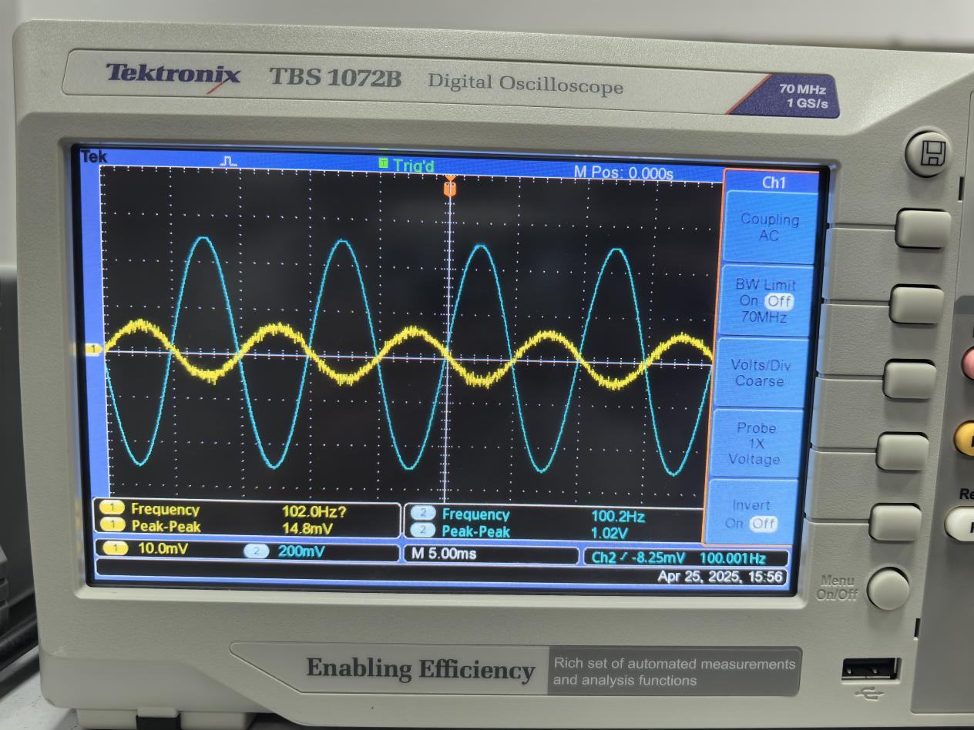
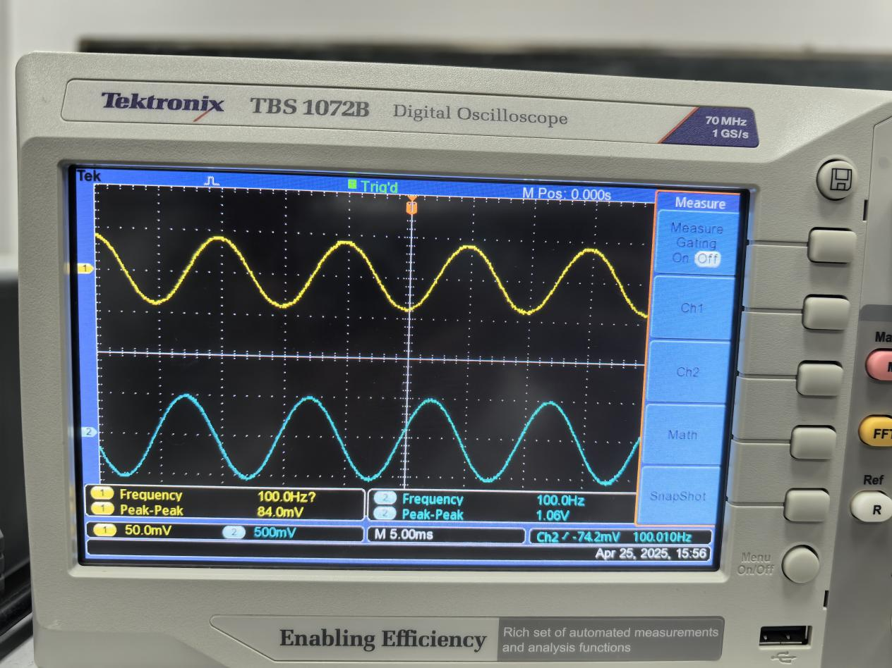
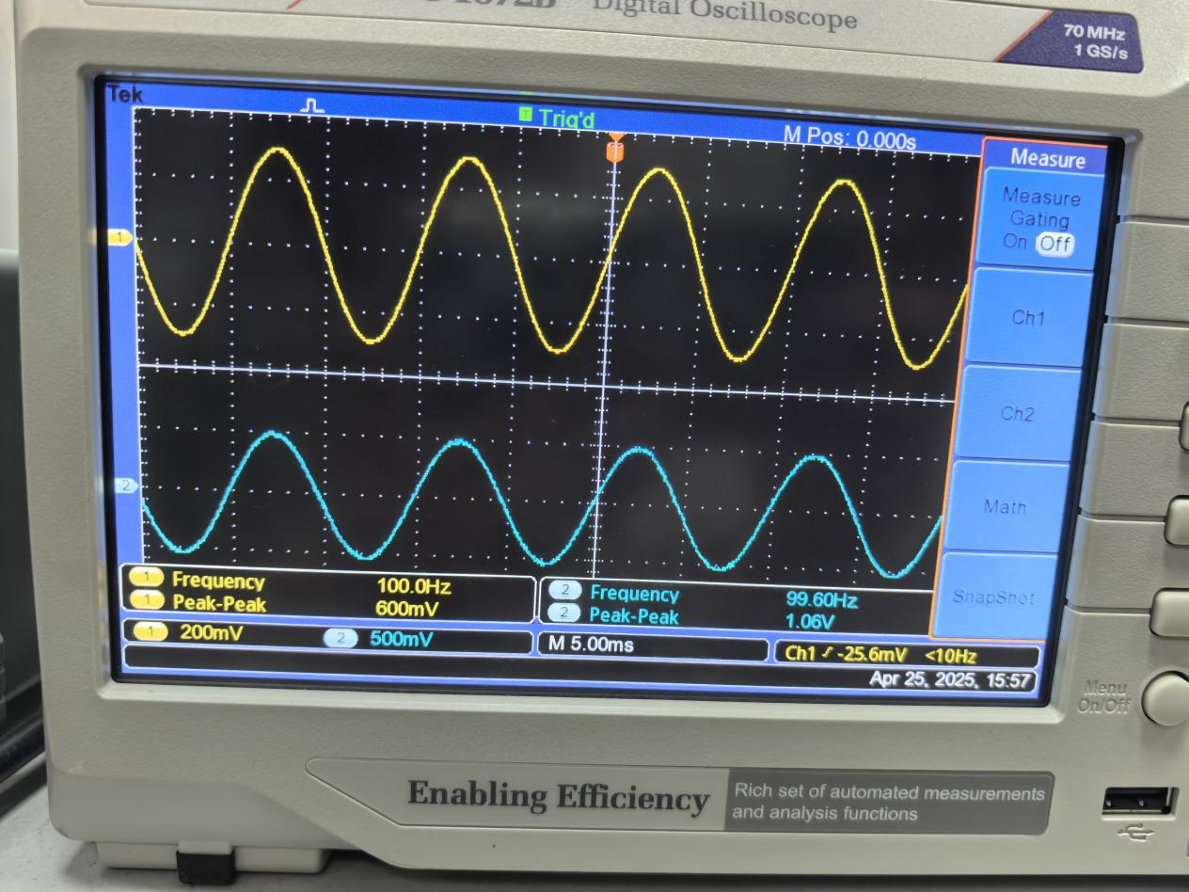
Vo1 Vo2 Vo3 at 100Hz

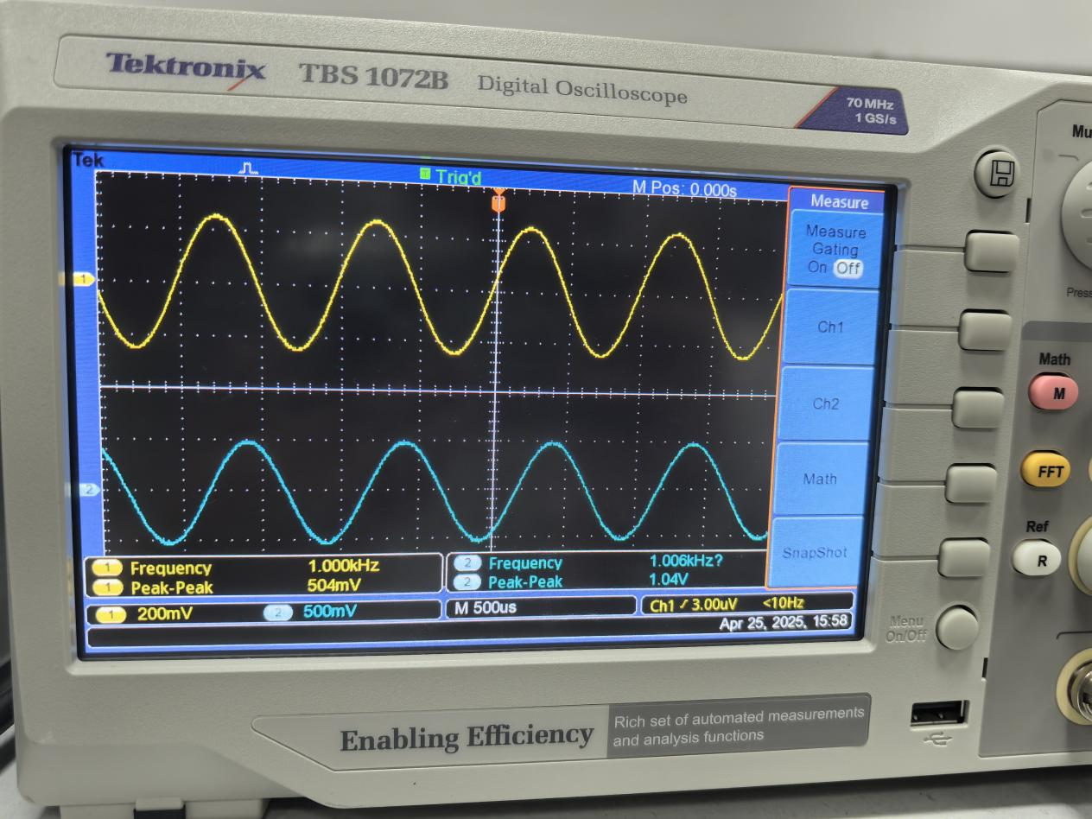
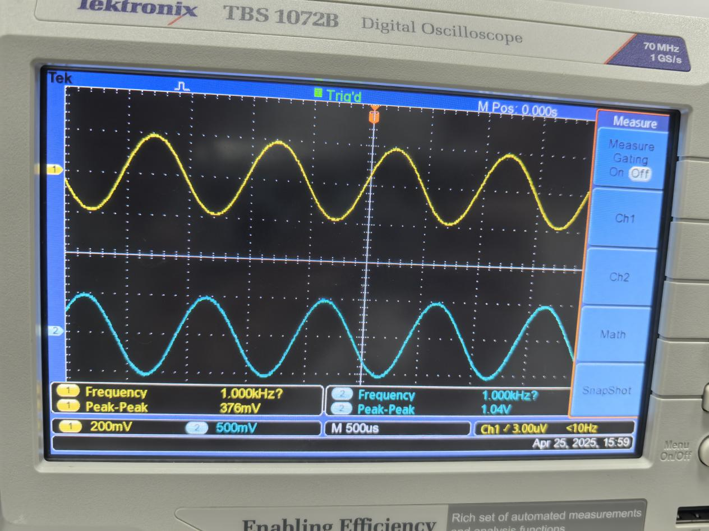
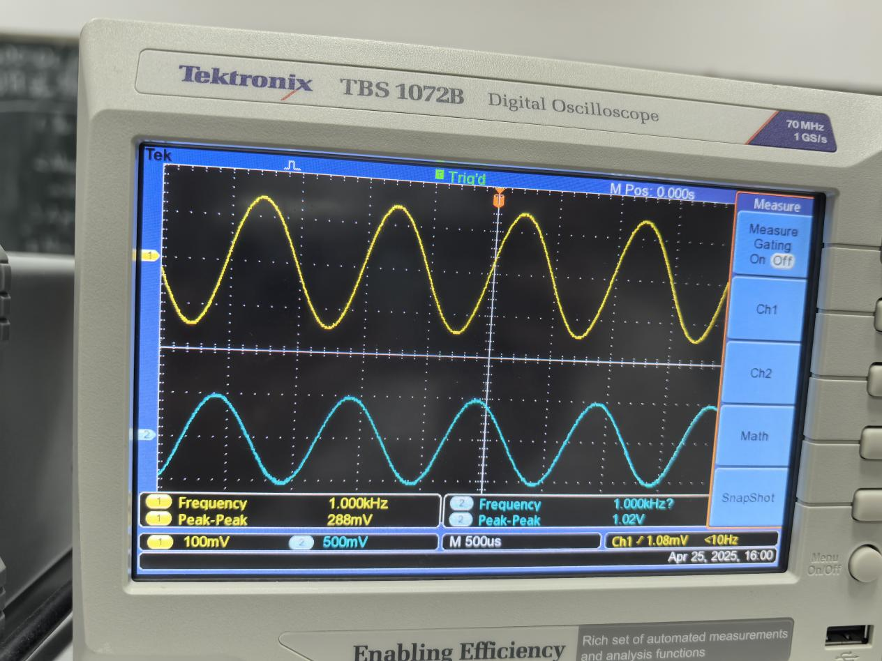
Vo1 Vo2 Vo3 at 1kHz
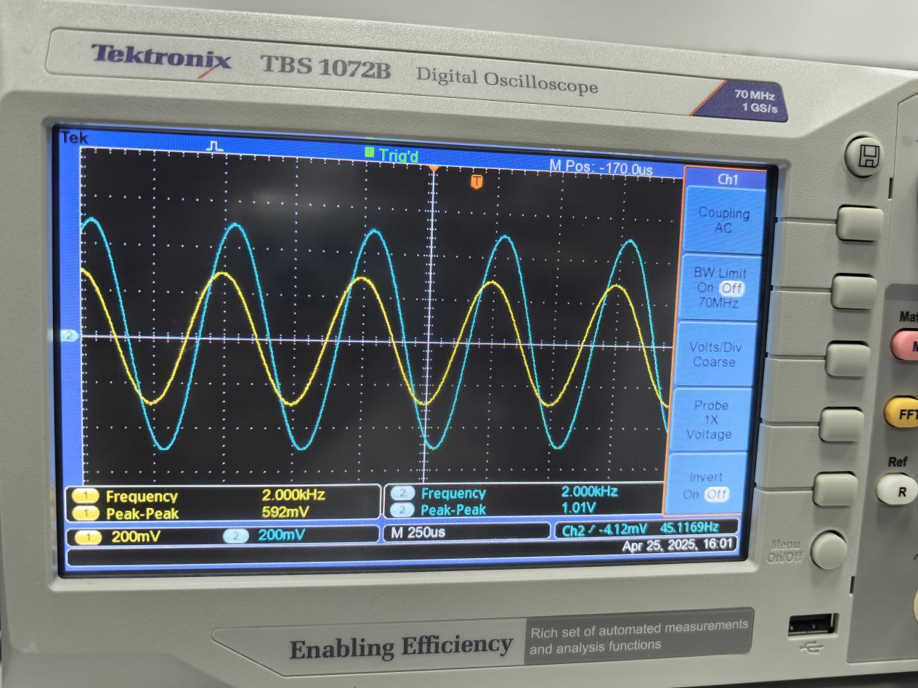
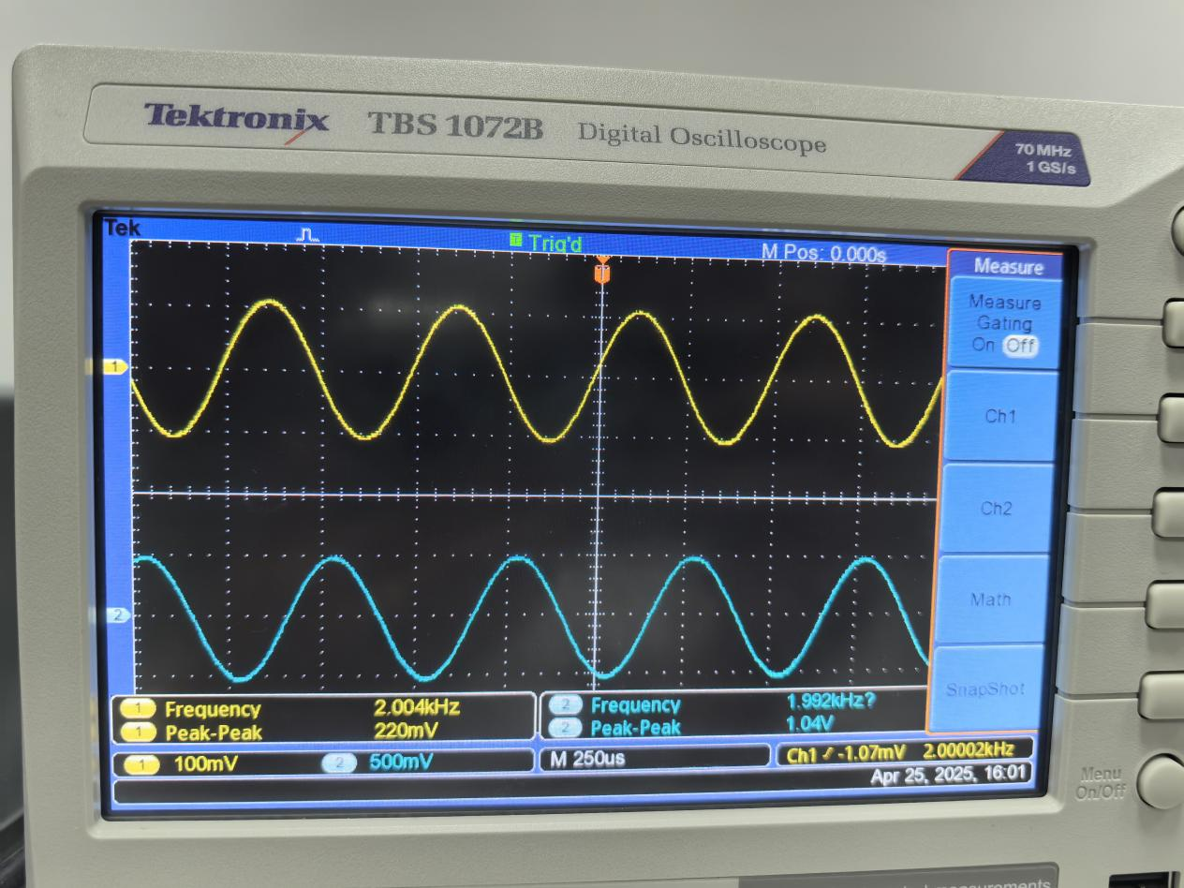
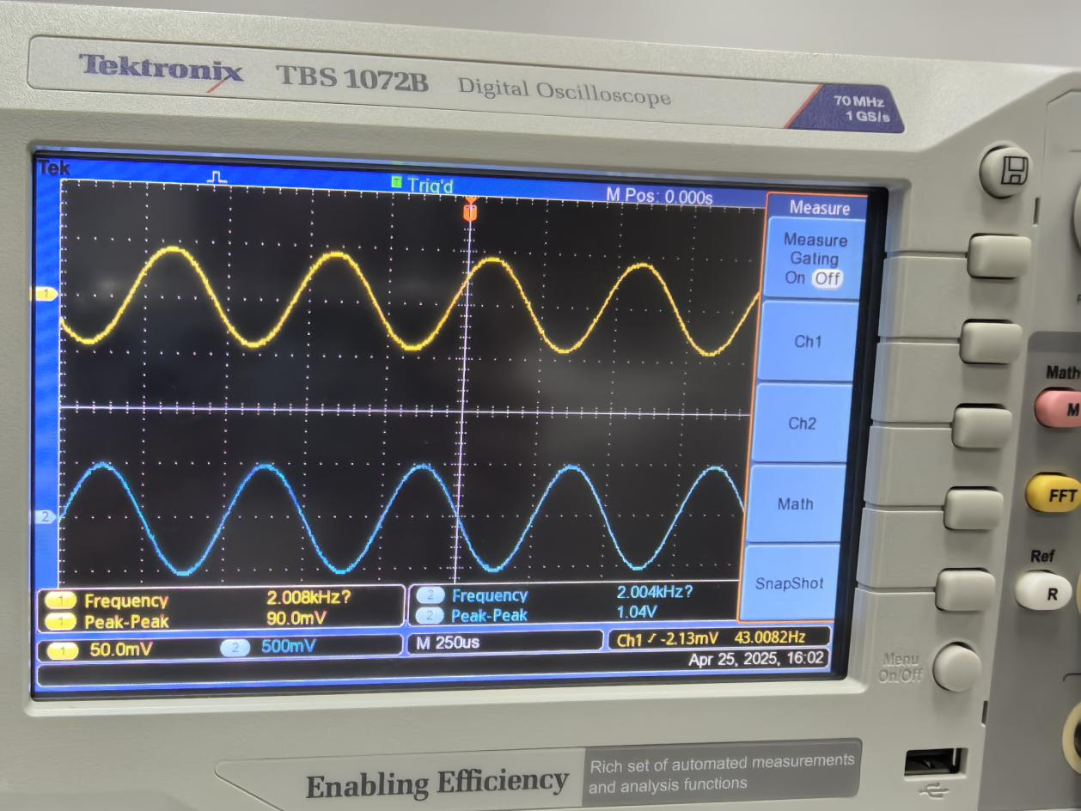

Vo1 Vo2 Vo3 at 2kHz
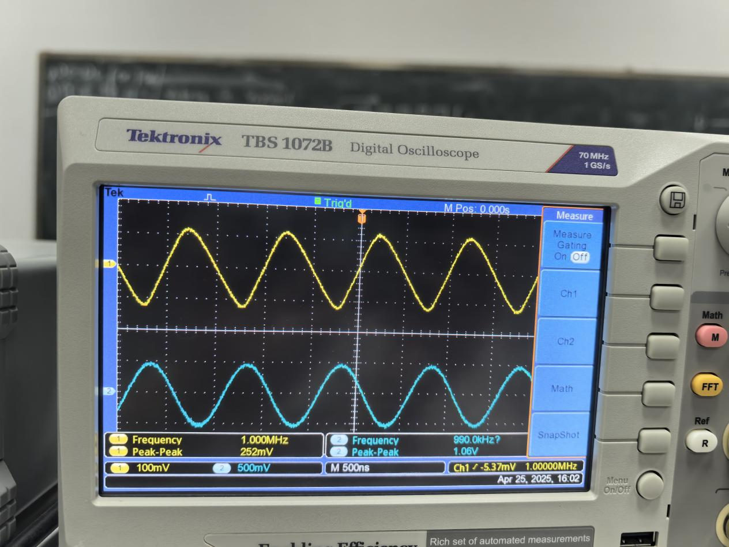
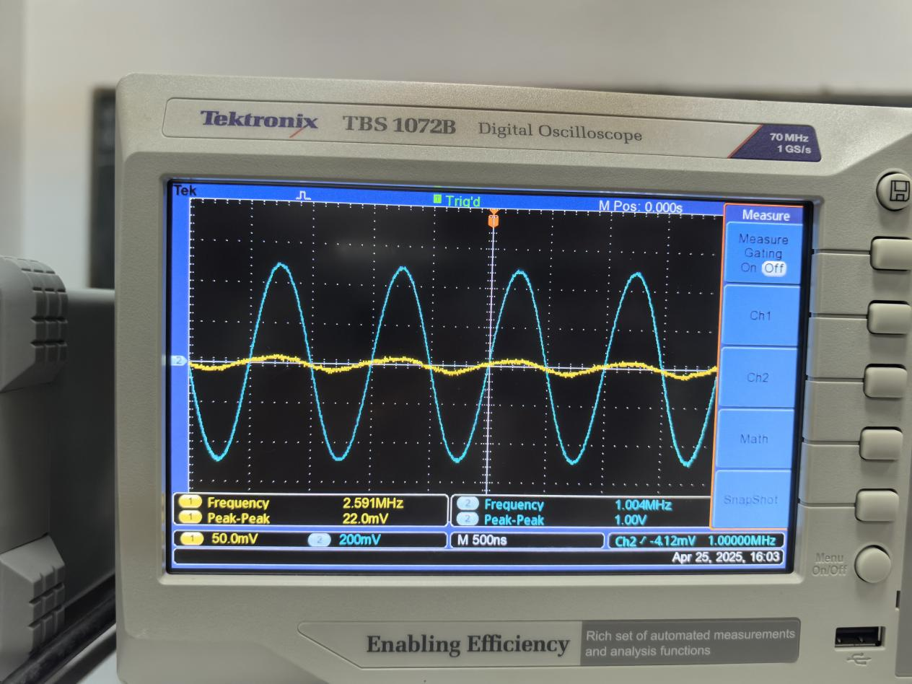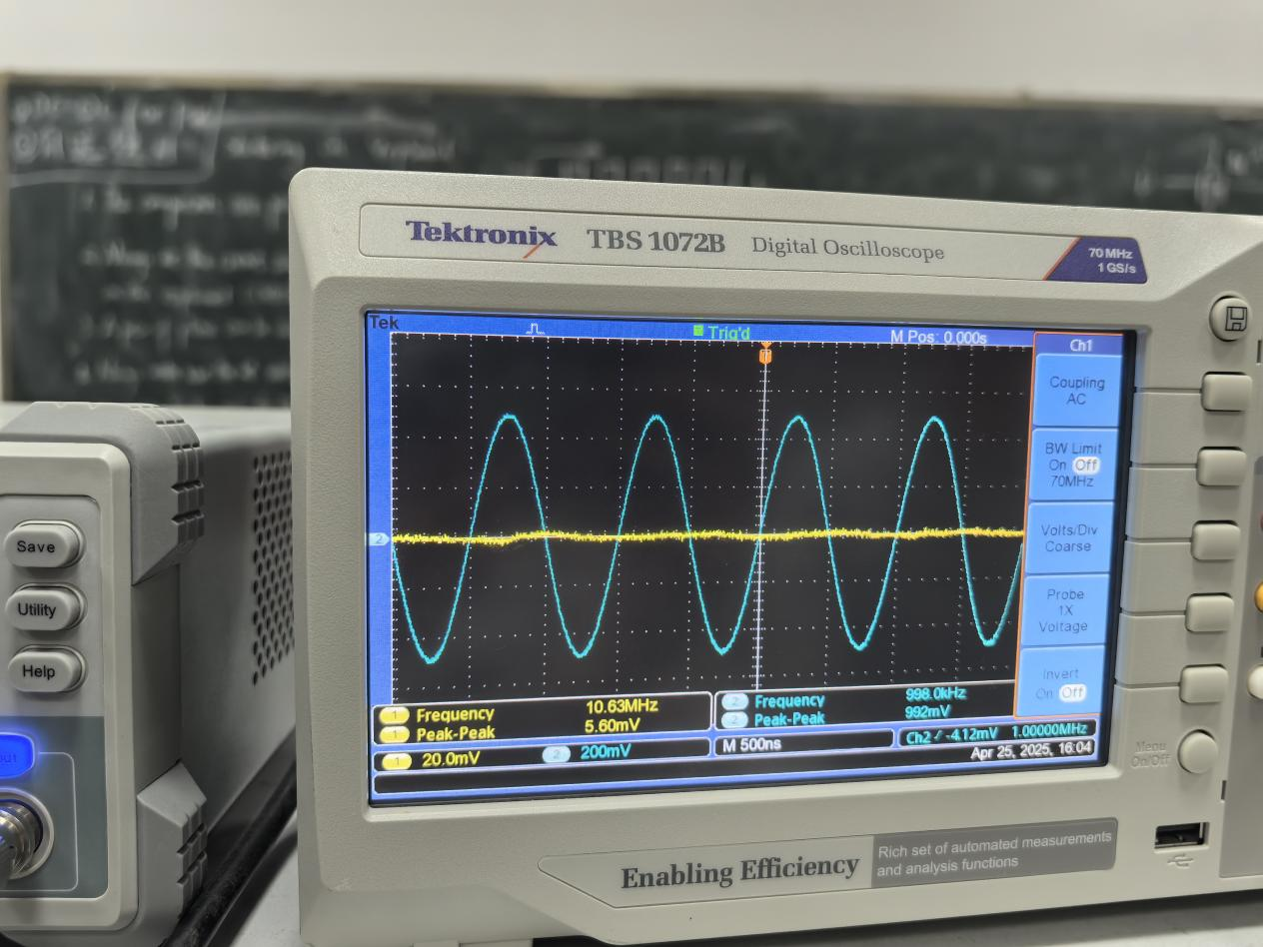
Vo1 Vo2 Vo3 at 1MHz
Experiment 1 Cutoff frequency(3db):
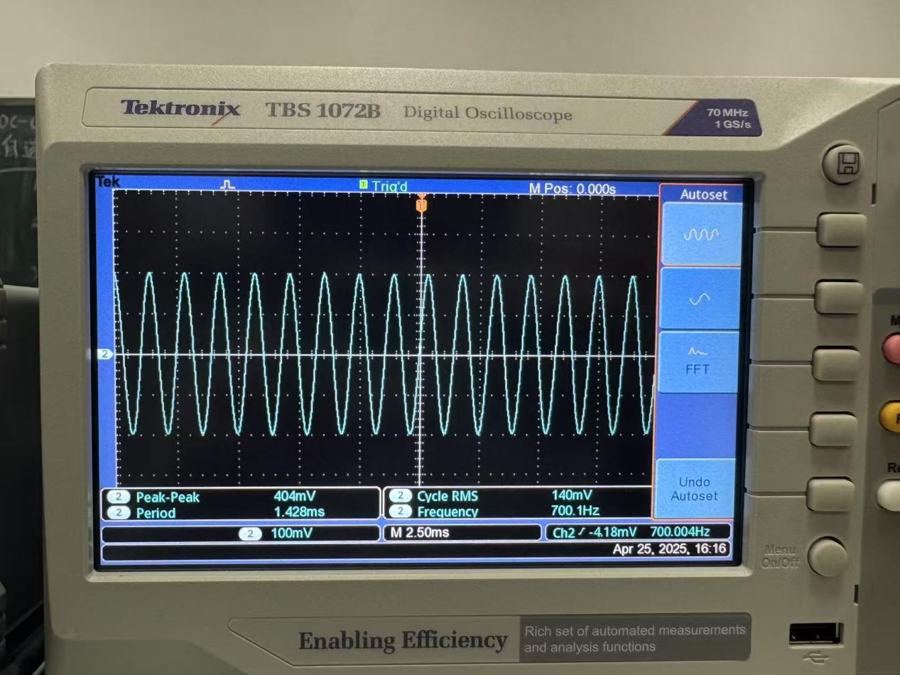
Vo1 High_pass:Lower cut off frequency
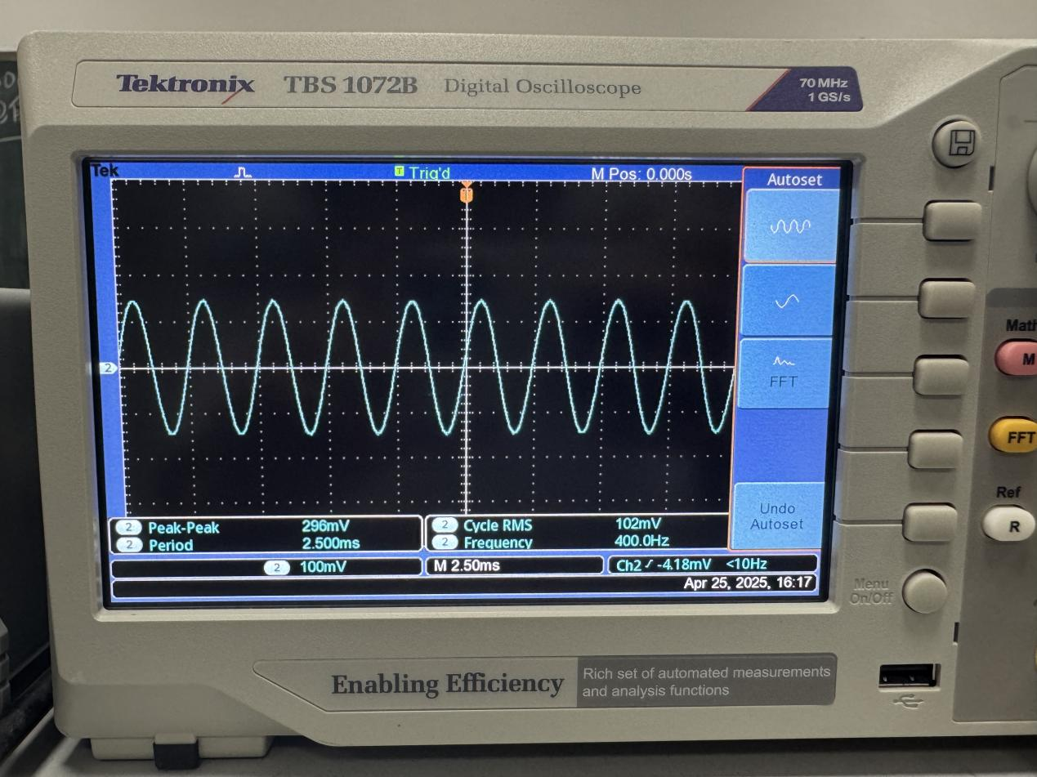
Vo2 Band-pass:Lower cut off frequency
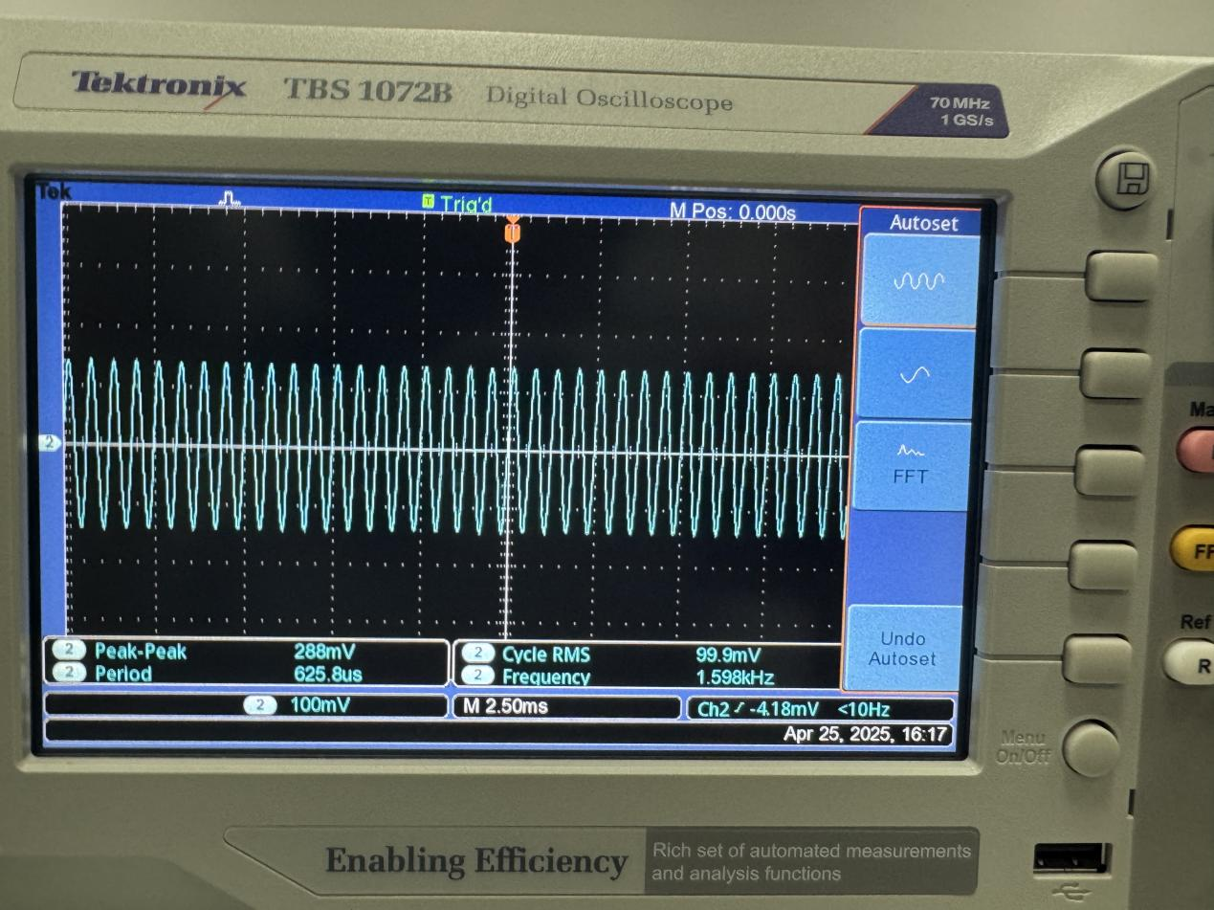
Vo2 Band-pass: Upper cut off frequency
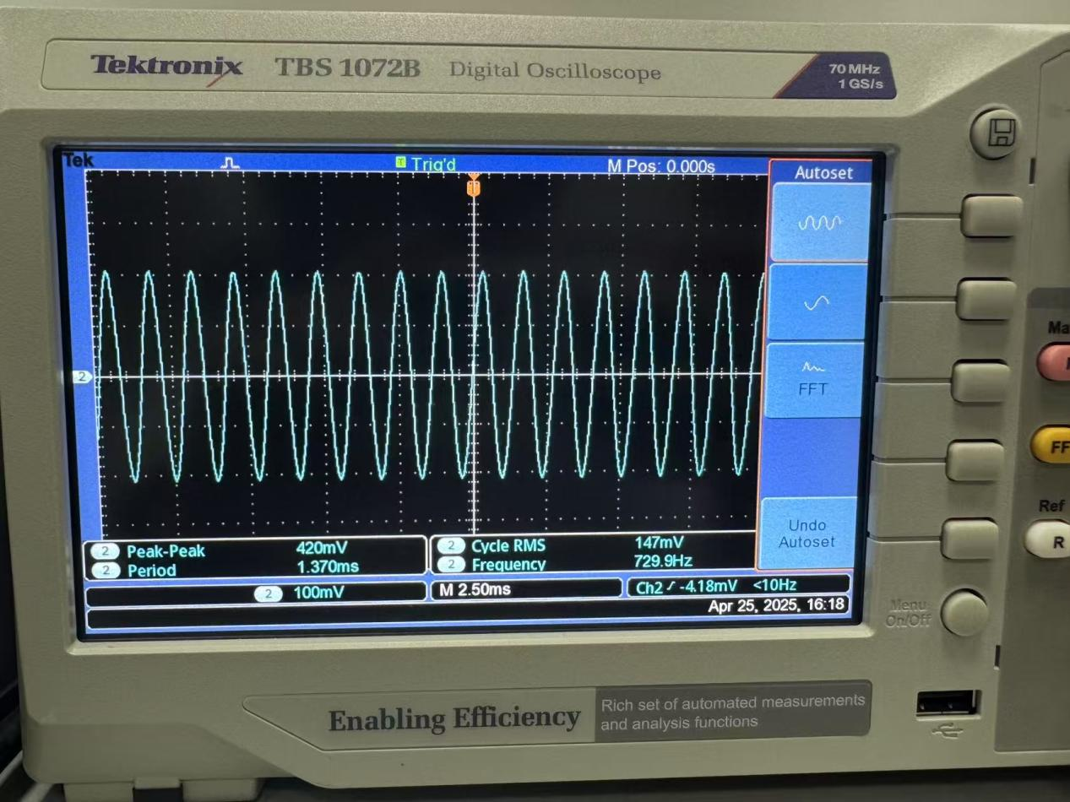
Vo3Low-pass: Upper cut off frequency

Experiment 1 with the potentiometer:
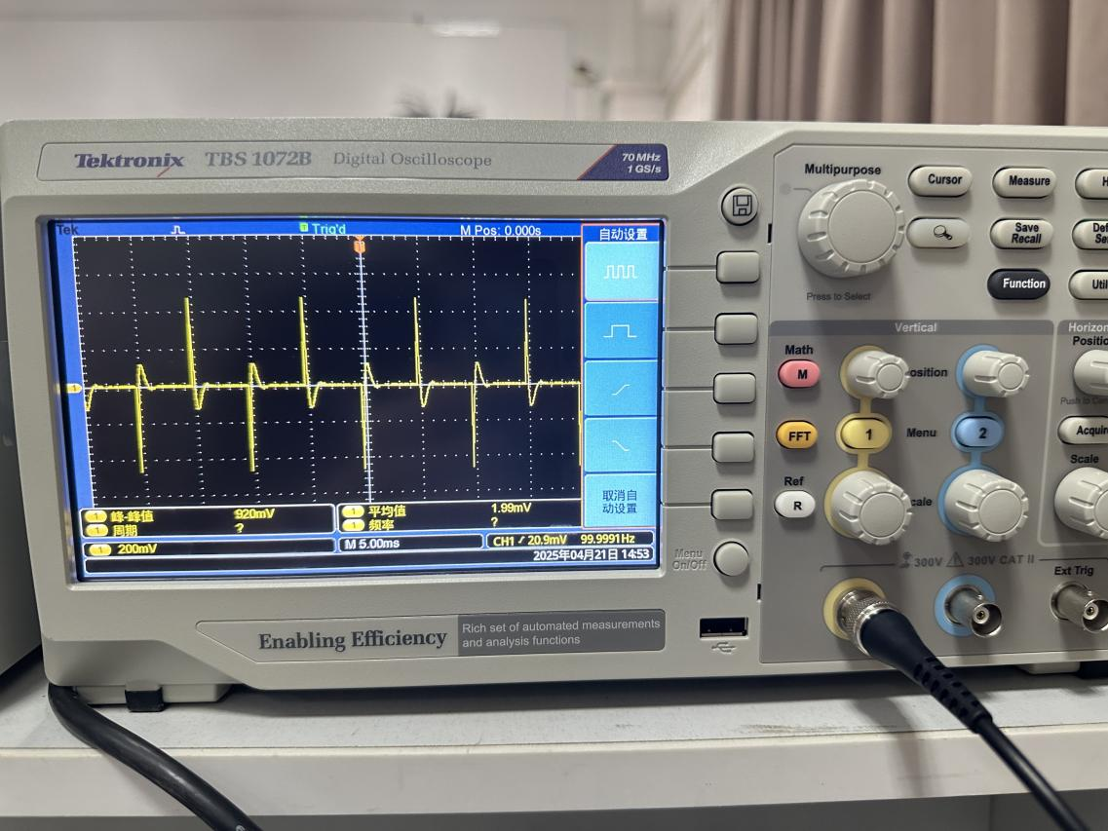
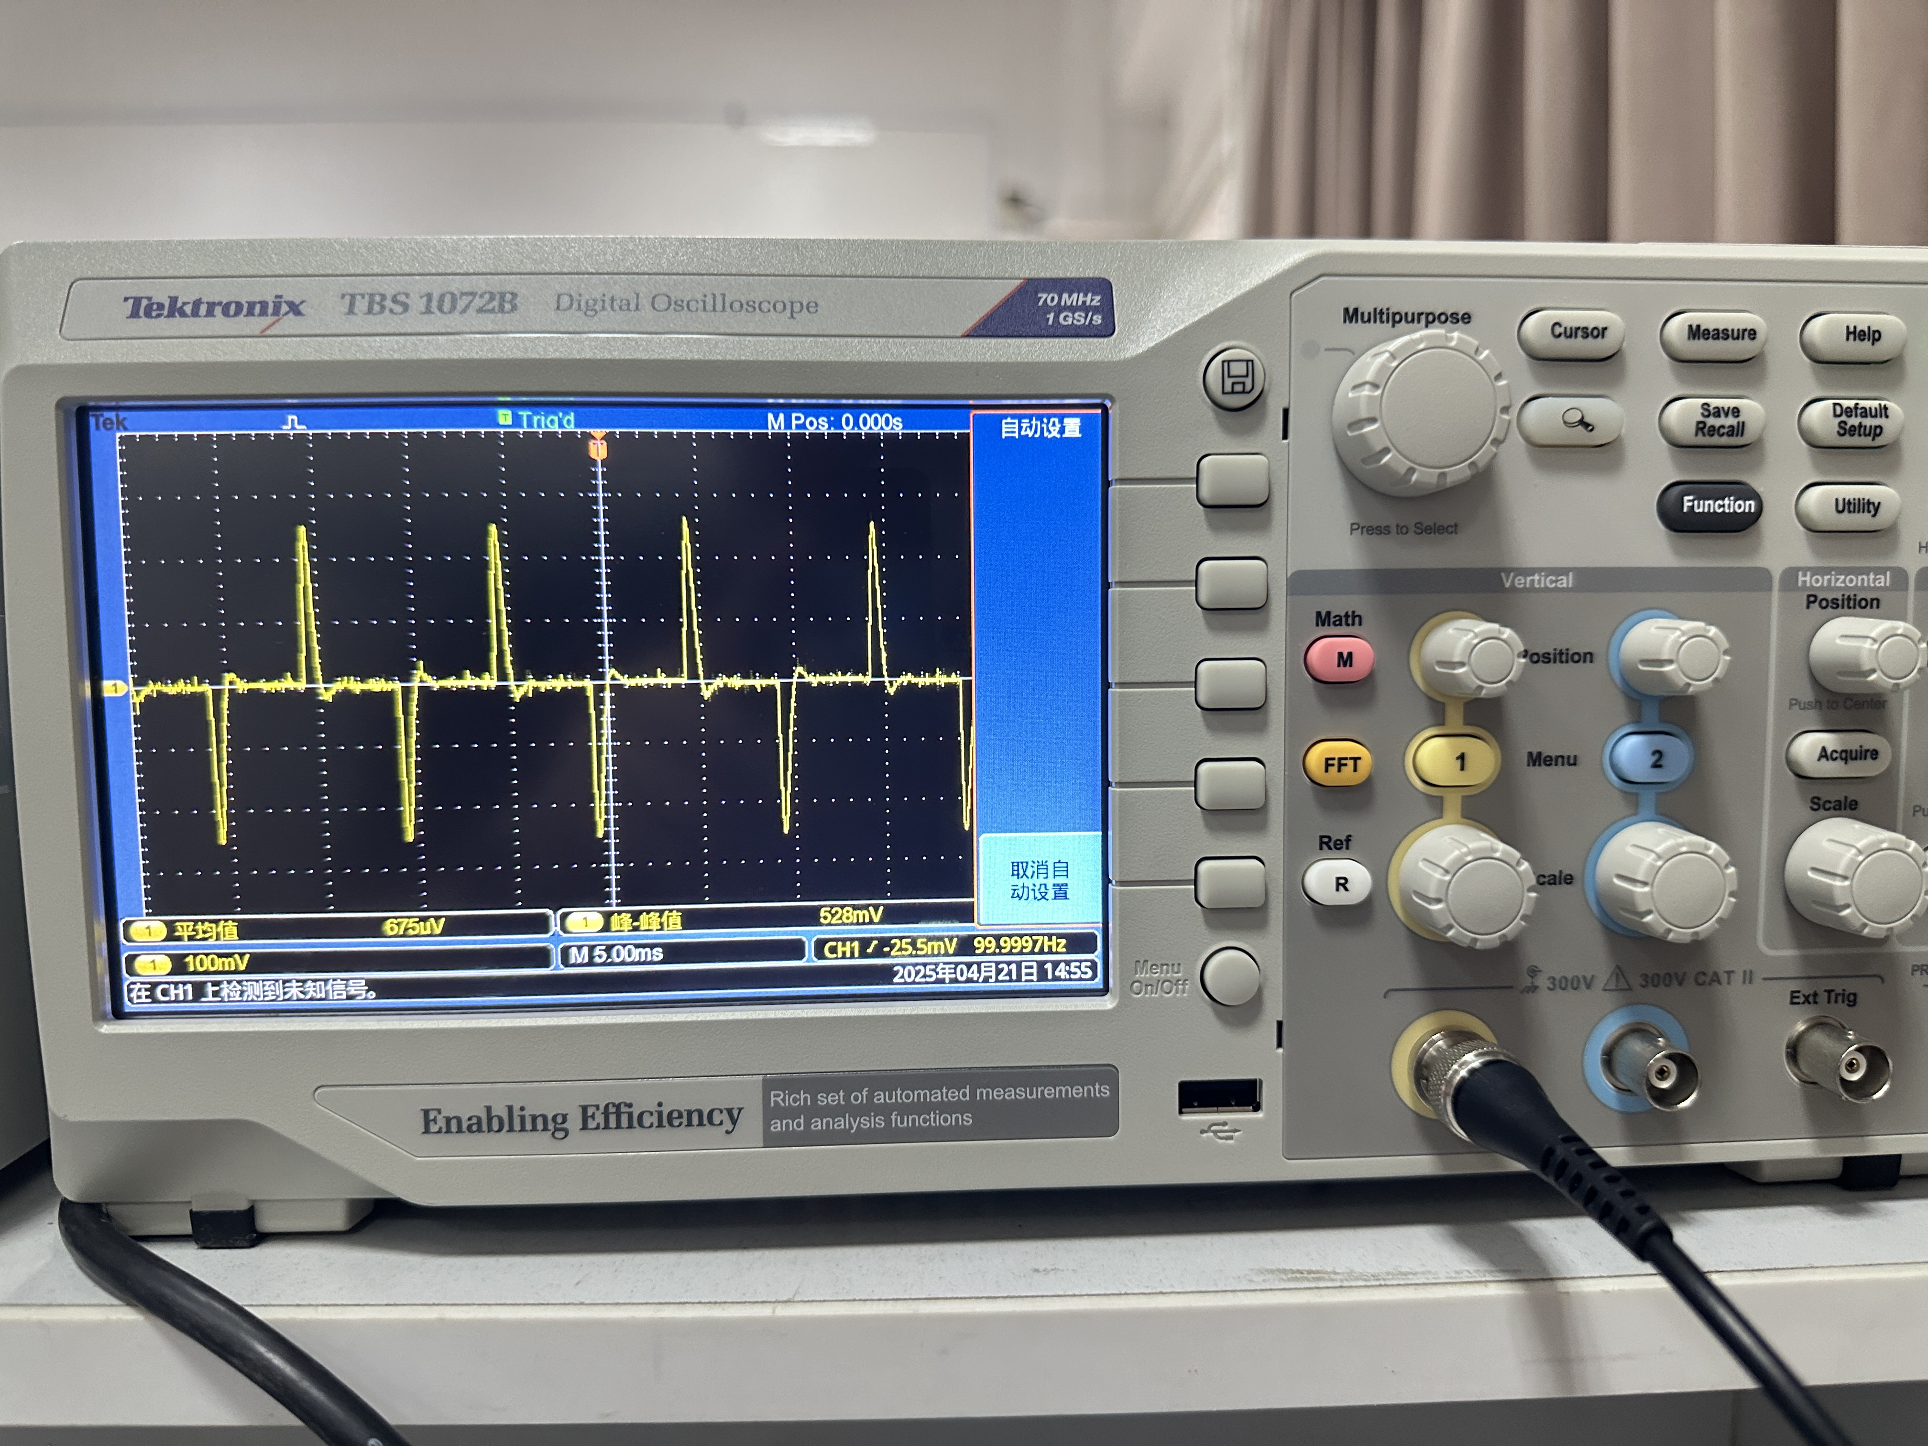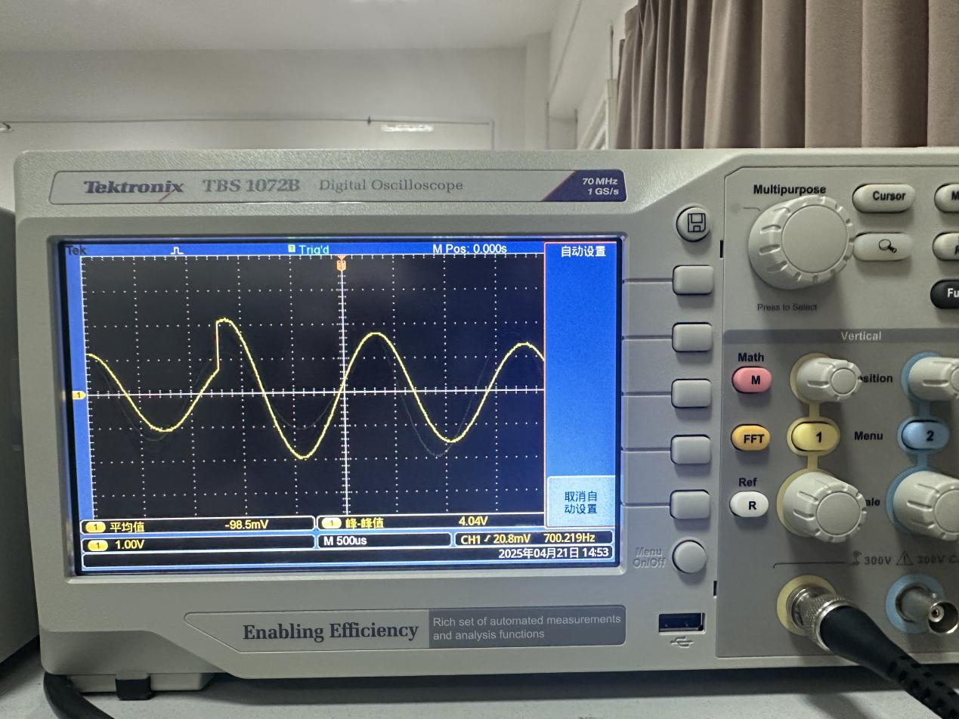
Vo1: High Median Low

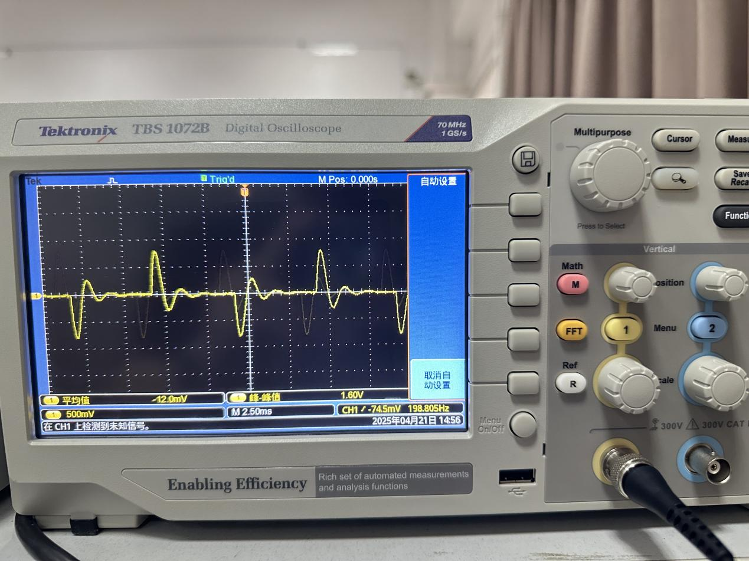
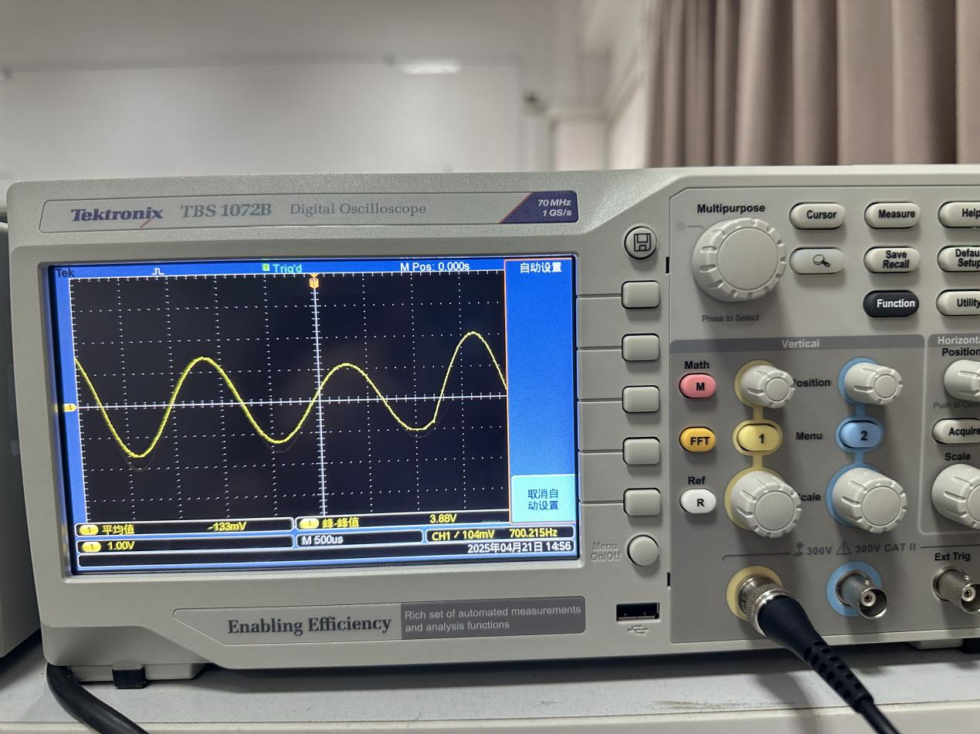
Vo2: High median low
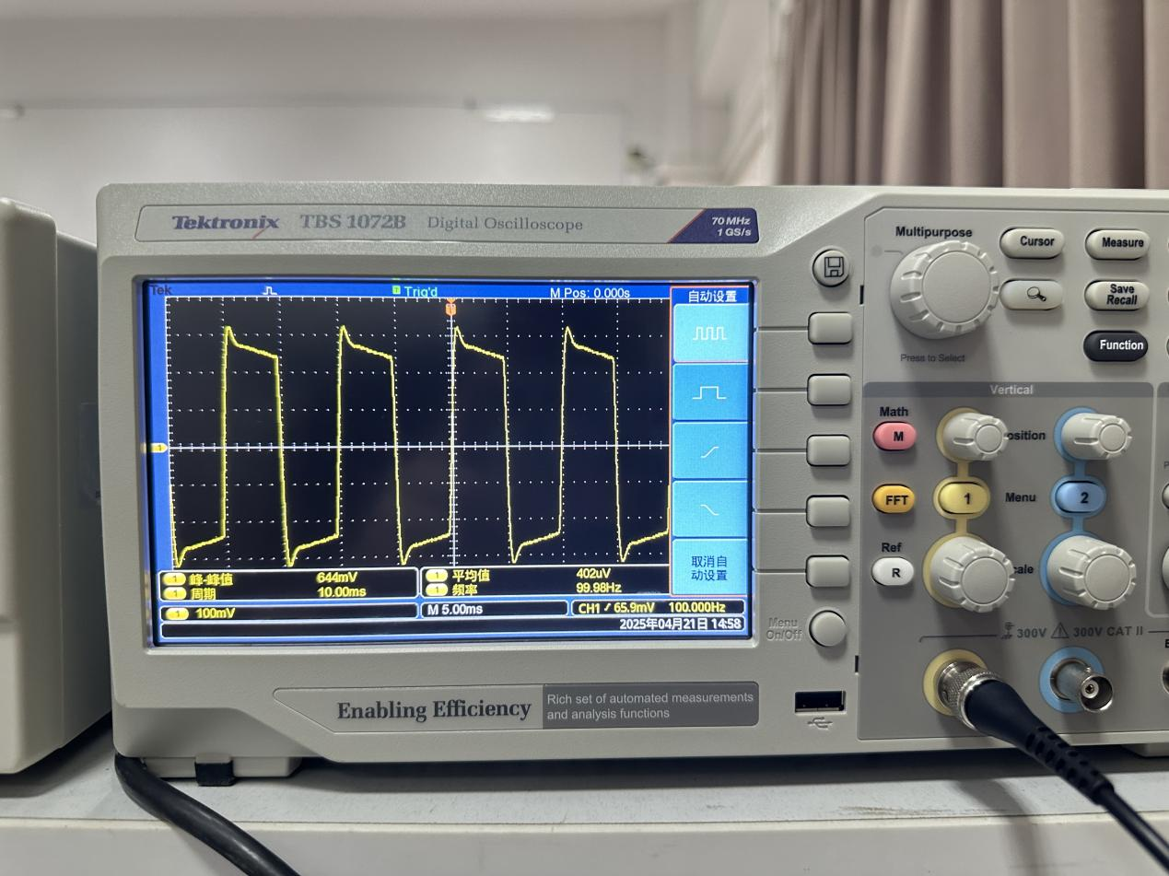
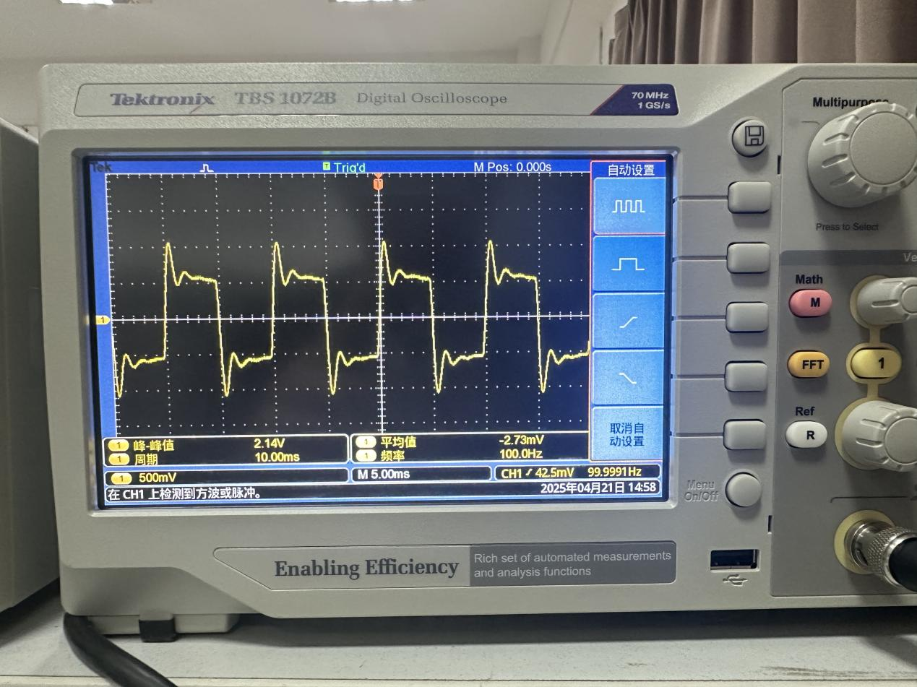
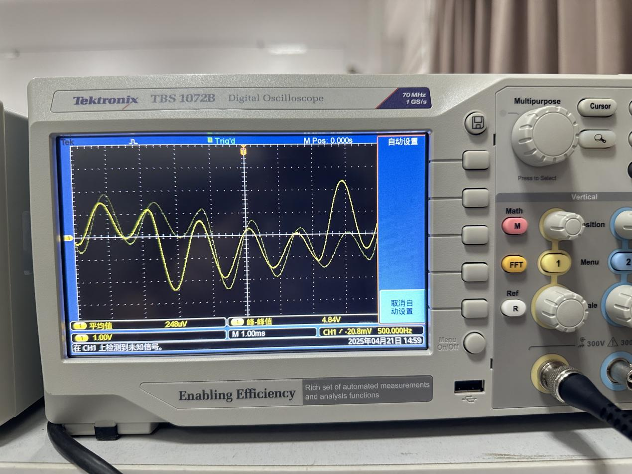
Vo3: High median low
The cut off frequency(-3dB) of the passive filter:
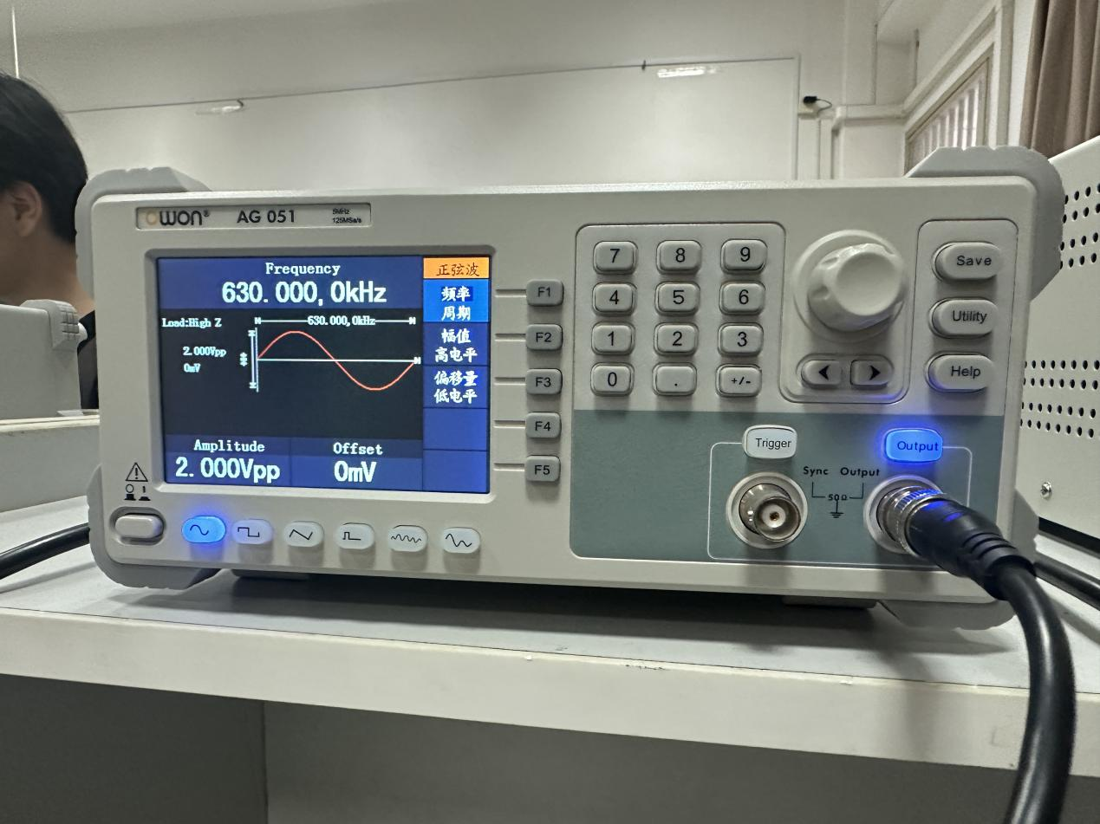
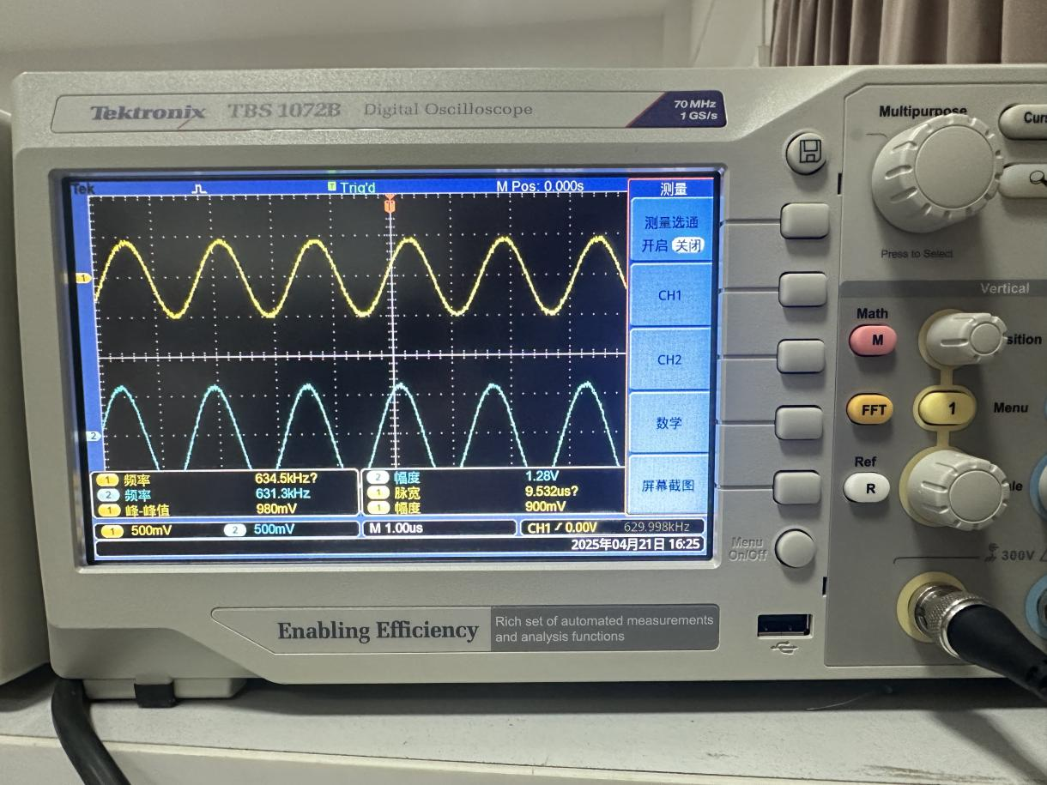
The upper cutoff frequency (-3dB)
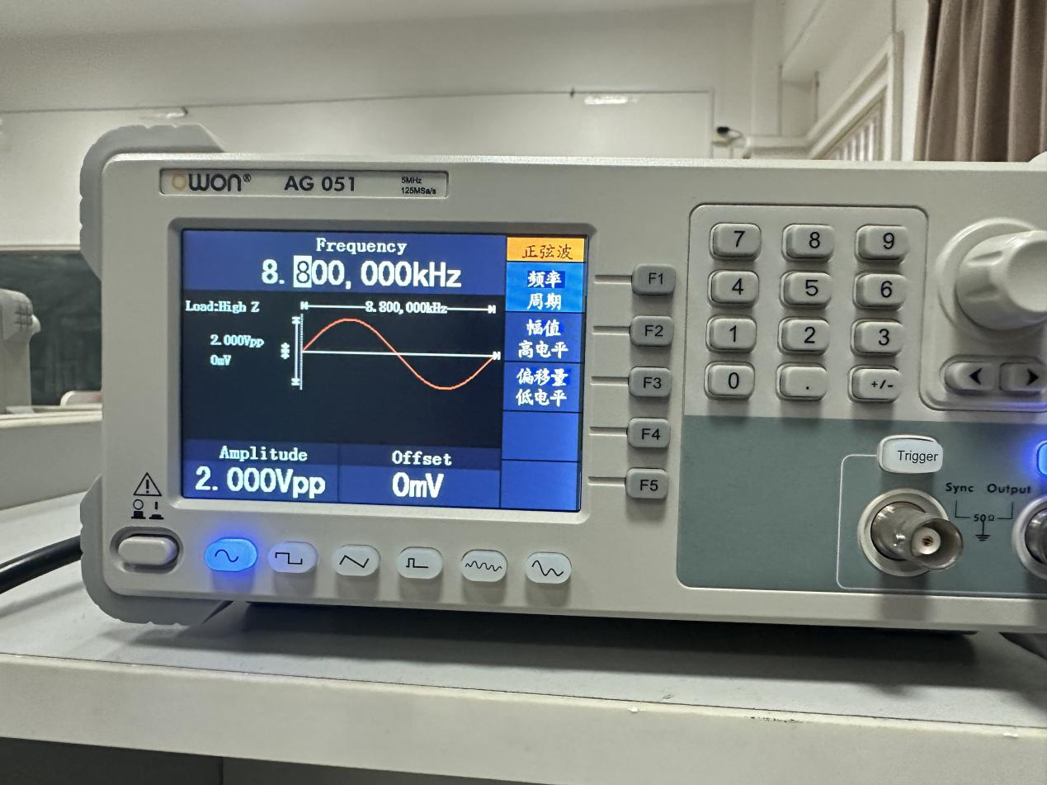
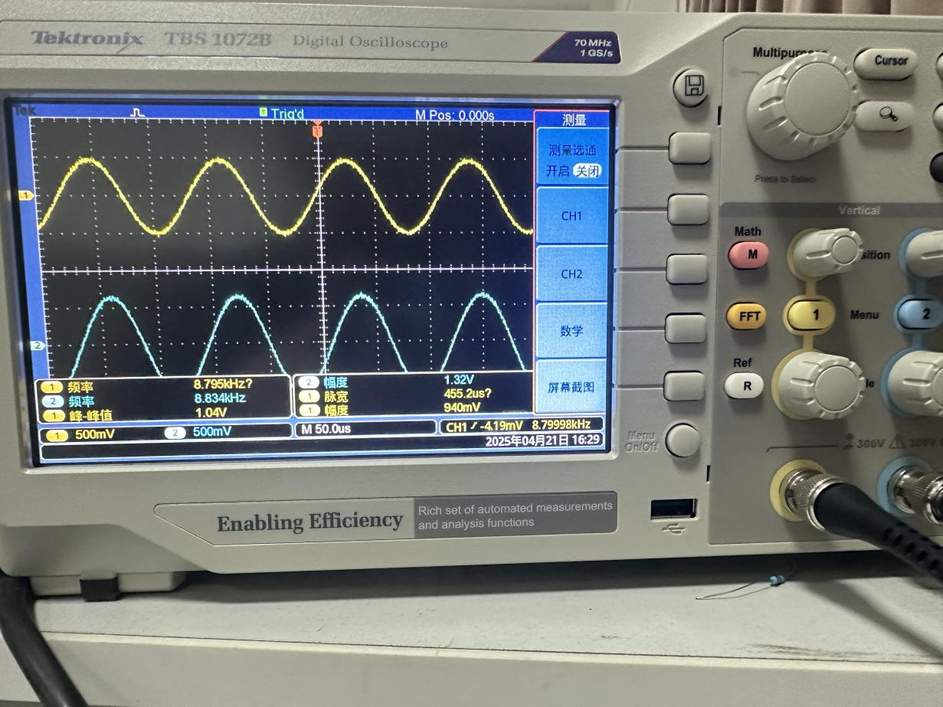
The Lower cutoff frequency.(-3dB)

Group meeting Appendix
2025/4/14 First group meeting for half hour : discussing the first experiment, and assemble the circuit
2025/4/16 Second group meeting for 40 minutes: testing and recording the experiment result and photographing the oscilloscope.
2025/4/17 Third group meeting for 1 hour: Discussing the principle of the active filter, sharing information which every group member searched online on the meeting about the characteristics of the active filters.
2025/4/18 Fourth group meeting for 30 minutes: talking about the second passive filter experiment. Assemble the passive filter circuit.
2025/4/21 Fifth group meeting for 2 hours: finishing the passive filter experiment

Work of division:

First experiment:
JIAKUN PI (U2389501)
PEIYUN WANG ( U2389514)
CHANGHAO LI（U2389488)
RUIHAN HUANG (U2389388)

Second experiment:
JIAKUN PI (U2389501)
BOHAN LI (U2389509)
KUNYANG PAN (U2389396)
ZIHENG YAN (U2389492)
YIREN ZHAN (U2389376)

The writing of the report:
JIAKUN PI (U2389501)

