**Task 1**

1. Download Git from here <https://git-scm.com/> (Version 2.26.2)

Done✅

1. Install Git (Installation Guide: <https://www.youtube.com/watch?v=SWYqp7iY_Tc>)

Done✅

1. Check git version

* *git –version*

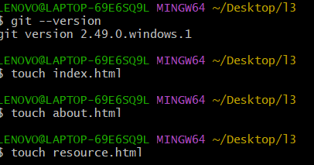

1. Now add files with this Command:

* *touch index.html*
* *touch about.html*
* *touch resources.txt*

1. Check your Folder, you will see these files

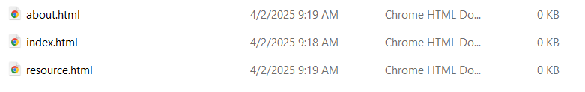

1. Open your file index.html in notepad or notepad++. Add these lines of code & save

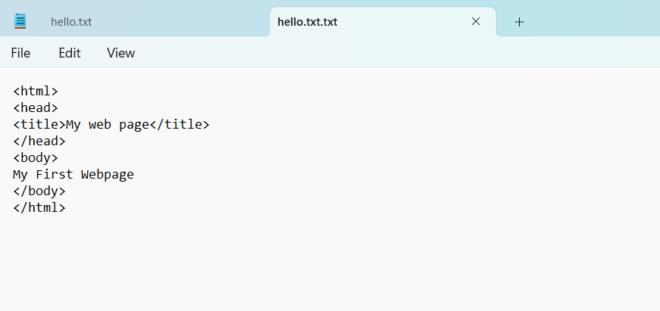

1. Open resources.txt and write your name and save this file

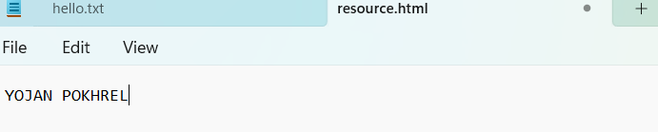

1. Initialize a Git repository/working directory
   * *git init*

• Check your Folder, you will see .git folder. And within this folder you will find Git Related Folders and files.

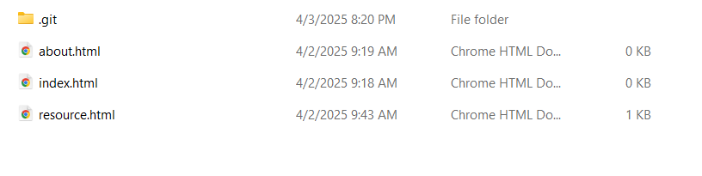

1. Configure user name and email
   * git config --global user.name ‘Your Name’
   * git config --global user.email ‘youremail@gmail.com’

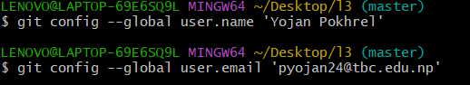

1. Check Status of Working directory
   * *git status*

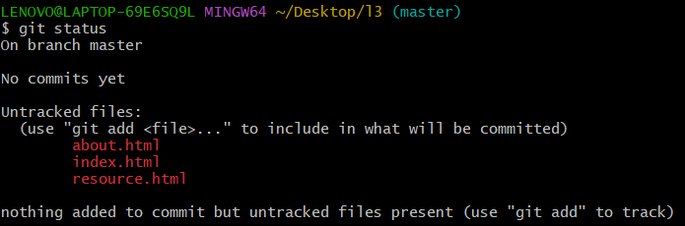

1. Add file or files
   * *git add index.html / git add .*
   * *git add .*

13.Check Status of Working directory

* + *git status*

14.Commit changes in your working directory

* + *git commit*
  + *git commit –m “Some git commit message”*

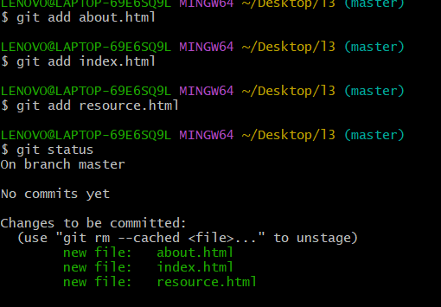

15.After all commit, Check Status of Working directory (This will show you message like nothing to commit, working tree clean)

* + *git status*

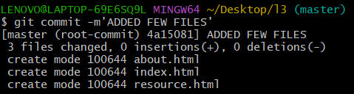

16.Make changes to resources.txt. Add few names of your friends

17.Check with git status, it will show (changes not staged for commit)

* + *git status*

18.Add file or files

* + *git add .*

19.Commit changes in your working directory with commit message

* + *git commit -m ‘Changed resouces.txt’*

20.Check with git status, it will show (changes not staged for commit)

* + *git status*

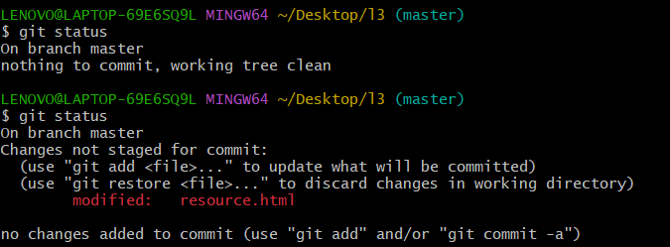

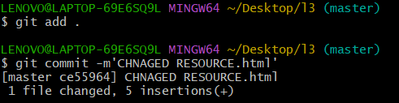

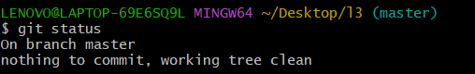

21.View commit history

* + *git log*

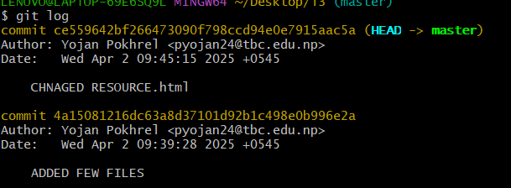

**Task 2 – Git & GitHub**

* + - 1. Create an account on Github.com

Created✅

* + - 1. Use Git Bash and Follow these commands:
         * *git remote*
         * *git remote add origin* <URL>
  + *git push -u origin master*

Enter your GitHub username/email and password

Then in github.com, reload your repository page & see your added files

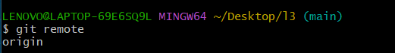

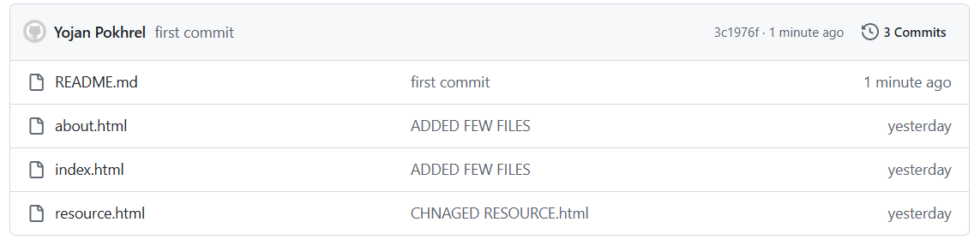

3. Clone GitHub Repository

* + - * + *git clone* <URL>

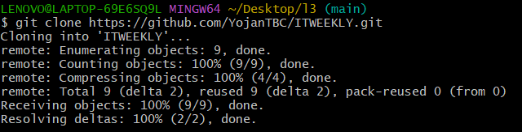

TASK -3

CREATE A NEW BRANCH AND MERGE IT.

