**Task 1 - Getting started with moqups.com account setup and tools overview**

1. Create a free account in moqups.com. Follow with the click on the Create a Free Account. You can get this screen. Let’s go with Sign up with Google.

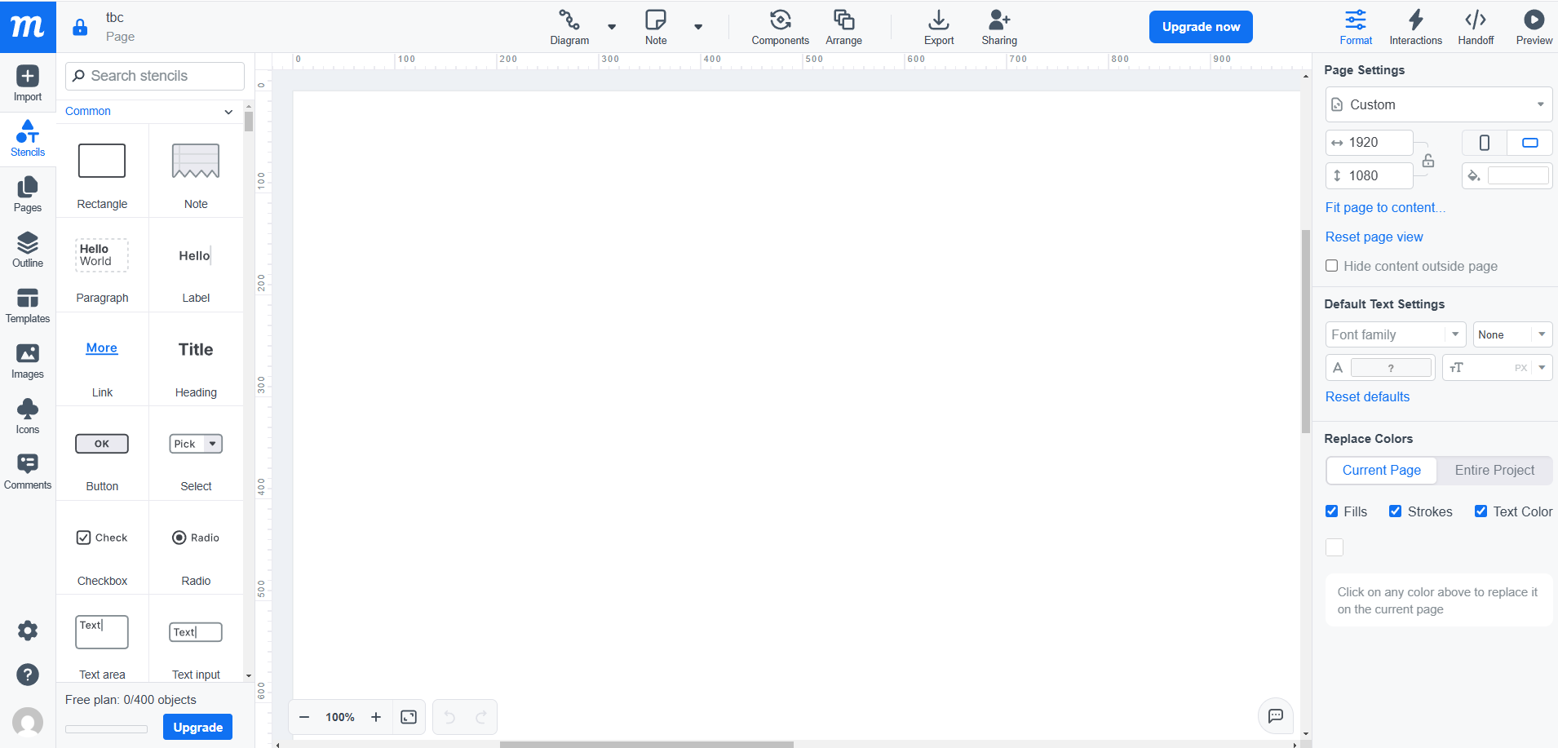

Task 2 – Design the below like wireframe structure. Use your own creativity.

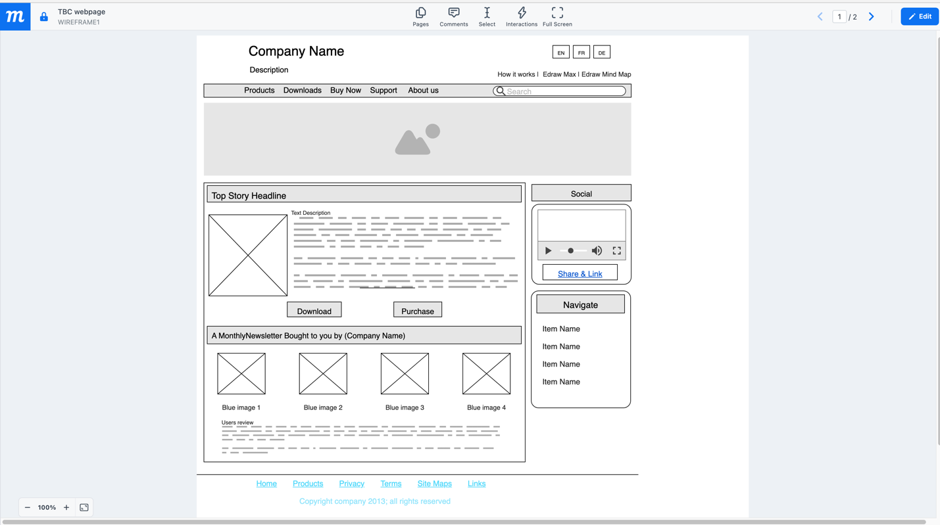

**Task 3 – Create a mockup design like your college website’s contact us page. Use your own creativity for this design.**

