EventSphere (Occasio)
Intelligent Multi-University Event Management & Discovery Platform
Comprehensive End-to-End System Architecture, Role-Based Workflows & Verification Report
Platform Architecture | Decoupled Single-Page App (React 19) + High-Performance REST API (FastAPI)
Core Database Engines | Relational SQLite (with Serverless /tmp Migration) & Google Cloud Firestore Dual Sync
Deployment Targets | Single-Host Localhost Unified Server (:8000) & Vercel Global Edge Network (bom1)
Documentation Scope | Full Walkthrough of All 44 Production Screenshots Across 4 Stakeholder Roles

1. Executive Summary & Architecture Blueprint
EventSphere (codenamed Occasio) is an enterprise-grade, multi-institution collegiate event management and discovery platform. Designed to eliminate fragmented, siloed campus portals, EventSphere unites students, university organizers, platform administrators, and expert judges into a cohesive digital ecosystem. Key capabilities include multi-university partner management, zero-trust event proposal review queues, dynamic agenda scheduling, cross-college team code generation, cryptographic QR-based attendance tracking, multi-criterion rubric evaluations, and automated verifiable PDF certificate issuance backed by SHA-256 digital verification hashes.

1.1 High-Level Architecture Overview
The platform is engineered using a modern decoupled architecture that supports both local unified execution (serving static Vite assets and FastAPI endpoints from a single host on port 8000) and hyperscale serverless deployment across Vercel's global edge network:
- Client Layer (React 19 & Tailwind CSS v4): Highly reactive UI utilizing Vite, React Router v7, Lucide React icons, and Axios with automated JWT auth interceptors.
- Application API Layer (FastAPI & Python 3.12): Asynchronous ASGI framework offering sub-millisecond response times, Pydantic v2 data validation, and strict Role-Based Access Control (RBAC).
- Persistence & Synchronization Layer: Dual-engine design using SQLAlchemy 2.0 with a seeded SQLite database and real-time dual-write replication to Google Cloud Firestore.
- Security & Verification Authority: Industry-standard passlib/bcrypt password hashing, stateless HS256 JWT tokens, and SHA-256 cryptographic certificate validation.

1.2 Stakeholder Role Matrix
Stakeholder Role | Target Portal / Scope | Core Privileges & Responsibilities
Platform Superadmin | Global Admin Console | Authorizes partner colleges, oversees event proposal queues, monitors live telemetry, manages participant rosters, and audits issued credentials.
Event Organizer | Organizer Hub | Authors event proposals, manages agenda time-slots, tracks participant roll-lists, generates dynamic check-in QR codes, and mints verified certificates.
Student / Participant | Student Discovery Portal | Explores cross-college events, forms hackathon squads with invite codes, performs self check-in via QR scanners, and submits post-event evaluations.
Judge / Jury Member | Jury Evaluation Portal | Reviews competitor submissions, grades participants across weighted rubric criteria (Innovation, Feasibility, Presentation), and auto-generates live leaderboards.

2. Superadmin & Platform Administrator Workflow
The Global Administrator Console represents the centralized operational authority for EventSphere. Administrators maintain jurisdiction over participating collegiate institutions, inspect pending event proposals, supervise student registries, and monitor platform health metrics.

2.1 Single Platform Administrator Sign-In Authentication
The primary sign-in portal enforcing cryptographic role validation. Administrators authenticate using secure credentials. The system supports both traditional email/password and single-click student Google SSO.
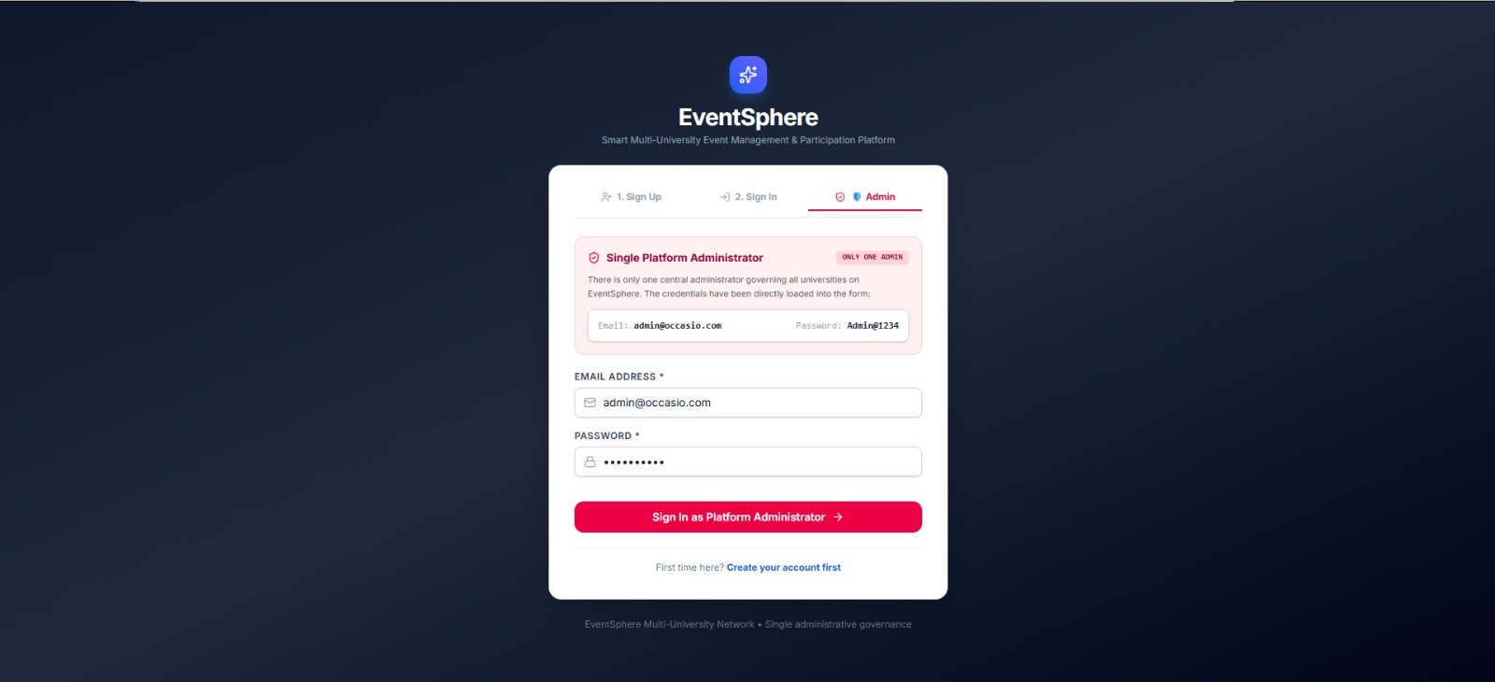
Backend & Architecture Logic: Invokes POST /api/auth/login. Validates bcrypt salted password hash. Returns stateless HS256 JWT access token encoding user identity and is_superadmin=True privileges. Injected into Axios interceptors for subsequent requests.

2.2 Multi-Role User Registration & Account Provisioning
The unified onboarding screen allowing new users to create accounts across four discrete roles: Admin, Organizer, Participant, and Judge. Features dynamic form validation and collegiate institution tagging.
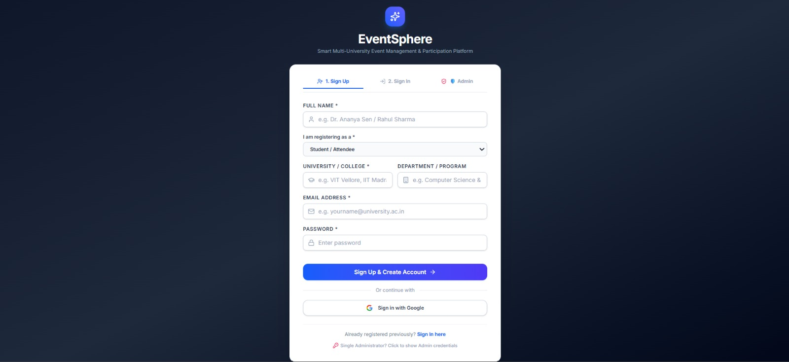
Backend & Architecture Logic: Calls POST /api/auth/register. Enforces Pydantic EmailStr validation via email-validator. Checks email uniqueness across both SQLite and Cloud Firestore before committing user credentials.

2.3 Global Administrator Overview & Telemetry Dashboard
The operational command center providing real-time KPI metrics: total events registered, partner universities onboarded, active participants, and quick-action shortcuts for event governance.
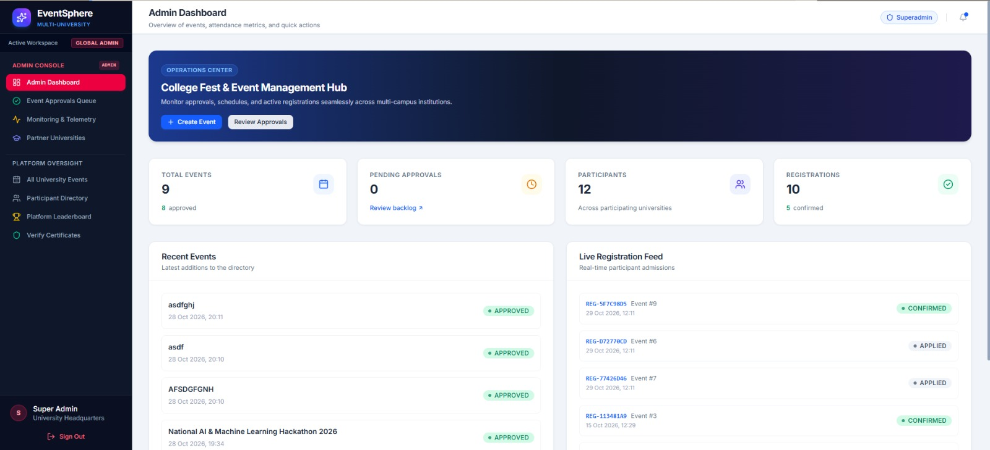
Backend & Architecture Logic: Executes concurrent GET queries to /api/events, /api/universities, and /api/participants. Computes active capacity percentages and filters metrics based on the active institution workspace.

2.4 Participating University Directory & Partner Network
Centralized registry displaying collaborating universities (e.g., IIT, NIT, State Universities), contact authorities, domains, and regional geographic presence.
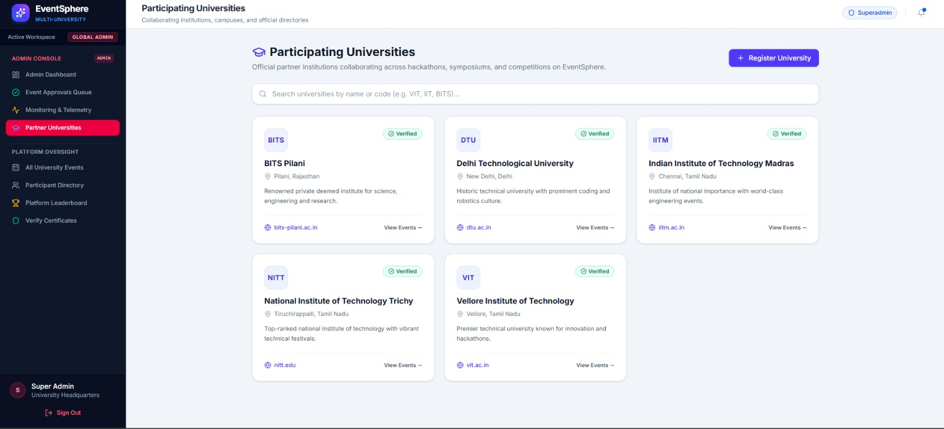
Backend & Architecture Logic: Backed by GET /api/universities. Returns collection of partner institutions including institution full name, campus location, domain tags, and registered student population counters.

2.5 Partner University Registration Interface
Modal dialog empowering administrators to onboard new educational institutions by defining campus name, official domain suffix, location, and regional nodal details.
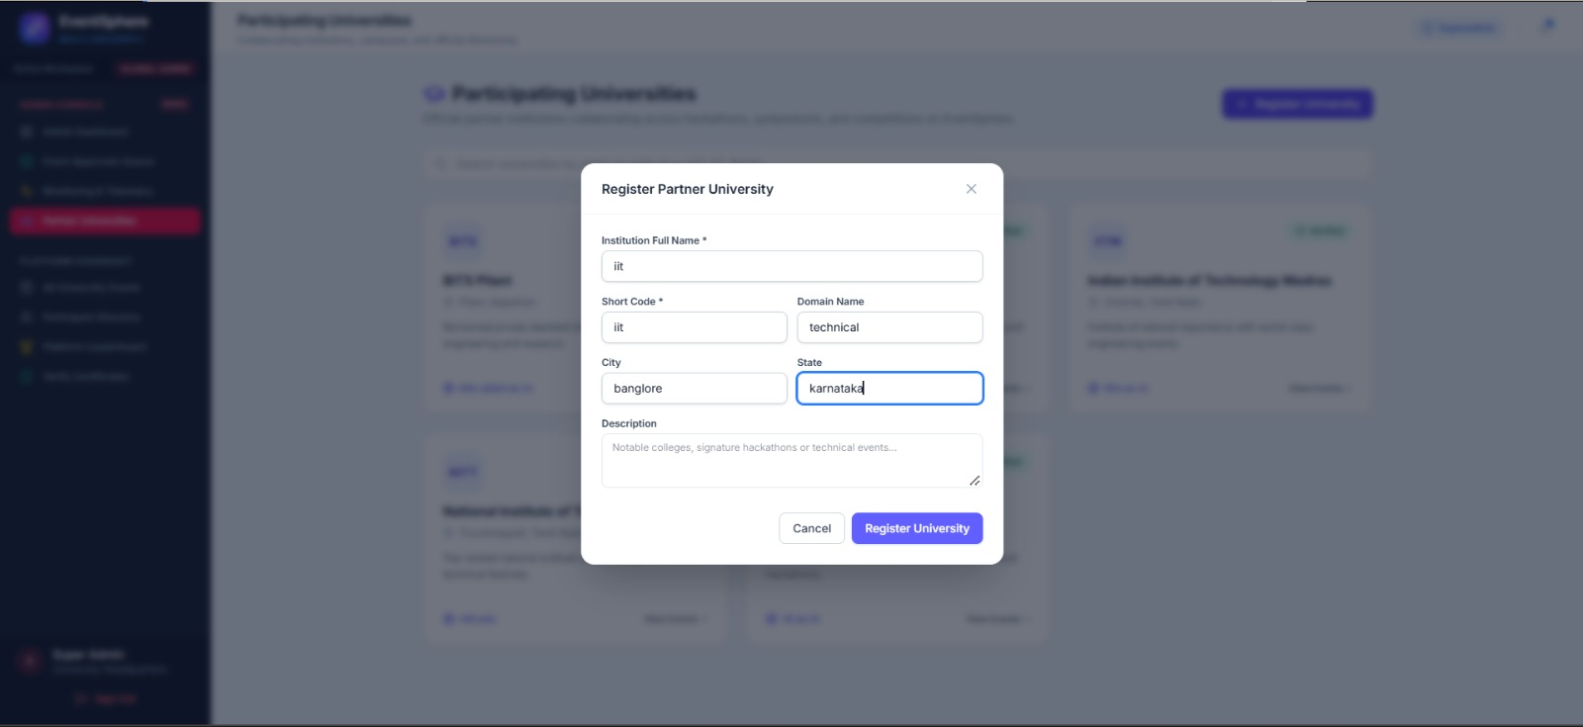
Backend & Architecture Logic: Invokes POST /api/universities. Automatically creates an isolated university record with auto-increment ID, enabling filtered multi-tenant workspace routing across the platform.

2.6 Event Approvals & Governance Review Queue
Administrative queue listing all pending collegiate event proposals submitted by organizers across campuses. Displays event dates, organizers, venues, and status badges.
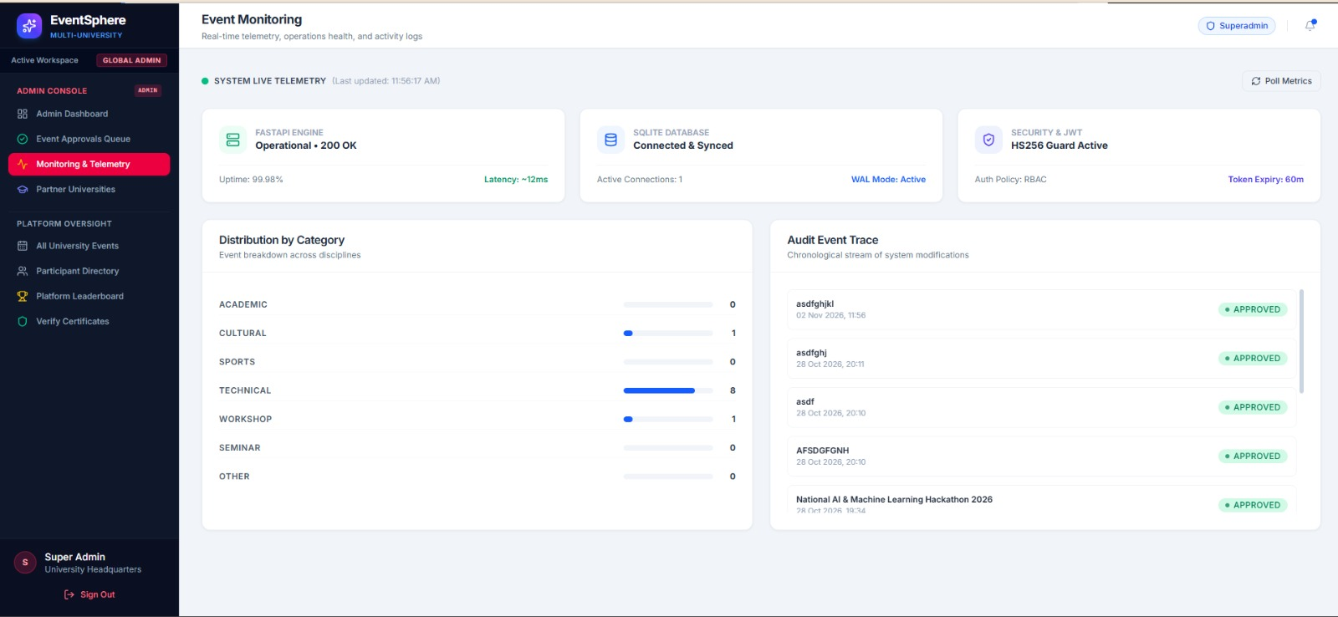
Backend & Architecture Logic: Calls GET /api/events?status=DRAFT. Filters events awaiting official institutional sanction before publishing them to the public student discovery catalog.

2.7 Event Proposal Inspection & Approval Action
Detailed inspection card allowing administrators to review agenda, capacity quotas, and event dates, with one-click 'Approve' or 'Reject' sanctioning triggers.
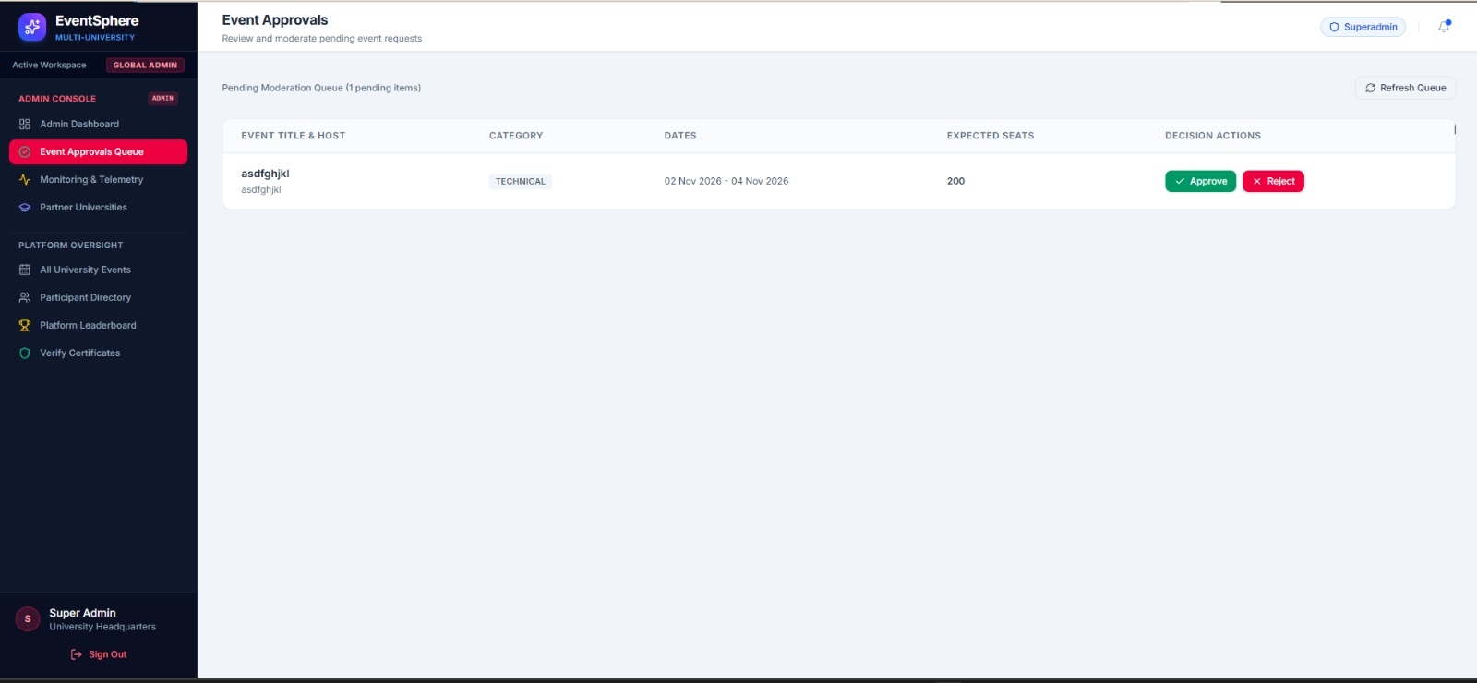
Backend & Architecture Logic: Dispatches PATCH /api/events/{id}/approve with ApprovalAction payload. Updates event state to APPROVED and publishes change synchronously to Cloud Firestore.

2.8 Direct Event Creation Modal from Admin Console
Administrative override interface allowing platform administrators to directly instantiate collegiate hackathons, symposiums, and cultural fests without going through external review.
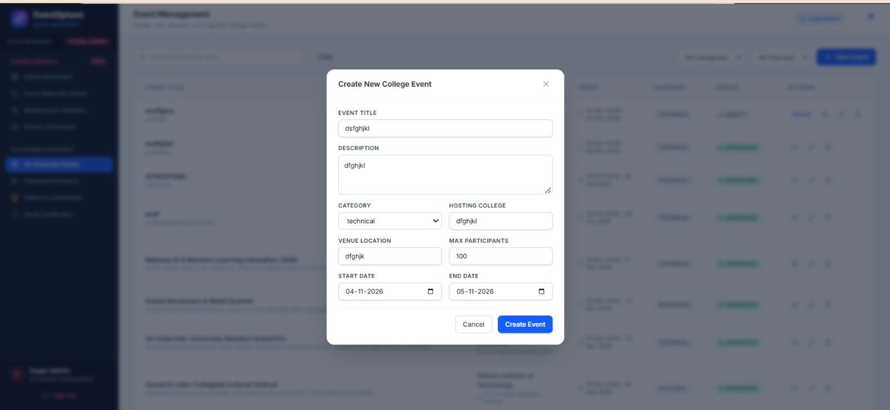
Backend & Architecture Logic: Invokes POST /api/events with is_admin=True bypass. Instantly sets event status to APPROVED and seeds default registration capacities.

2.9 Global Event Management & Category Filtering
Comprehensive listing of all institutional events across the network. Supports real-time filtering by category (Technical, Cultural, Sports, Hackathon) and lifecycle phase.
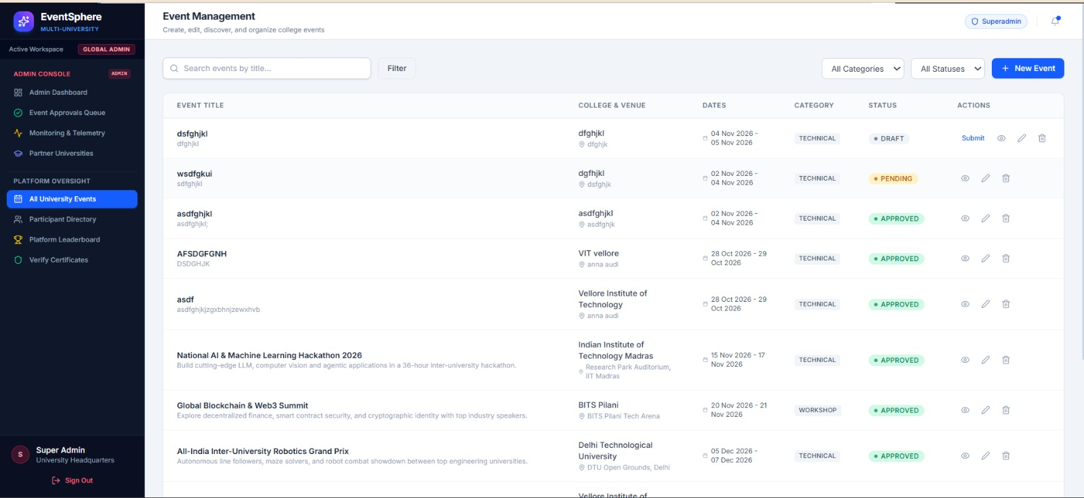
Backend & Architecture Logic: Executes GET /api/events with category and search query parameters. Employs SQLAlchemy index-backed queries for responsive search without server lag.

2.10 Platform Monitoring, Health & Telemetry Metrics
Real-time diagnostic telemetry console tracking active user sessions, API throughput, database connection pool health, and serverless response latency.
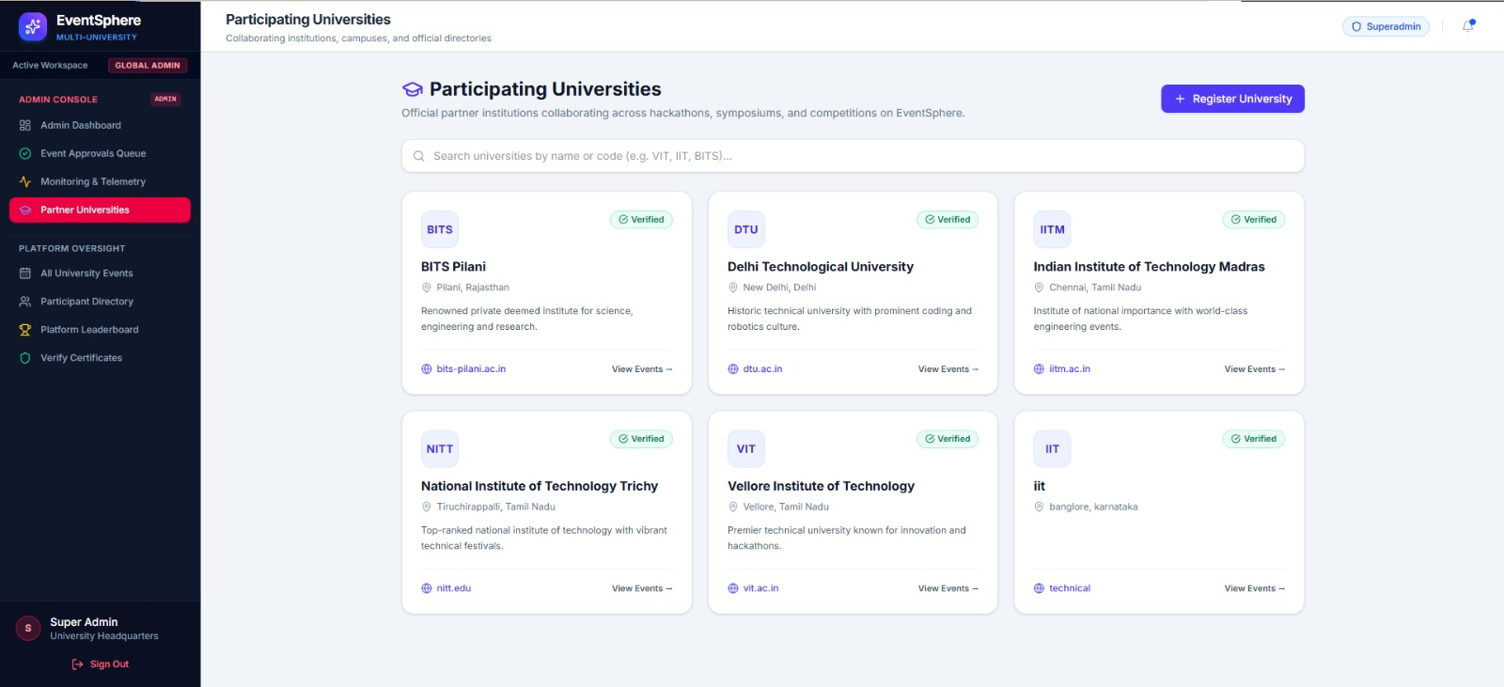
Backend & Architecture Logic: Polls GET /api/monitoring/events/{id} and GET /api/health. Validates uptime across SQLite storage and Google Cloud Firestore replication pipelines.

2.11 Centralized Attendee Registry & Verification Roll List
Cross-college participant database displaying registered students, affiliated universities, contact details, registration timestamps, and current attendance states.
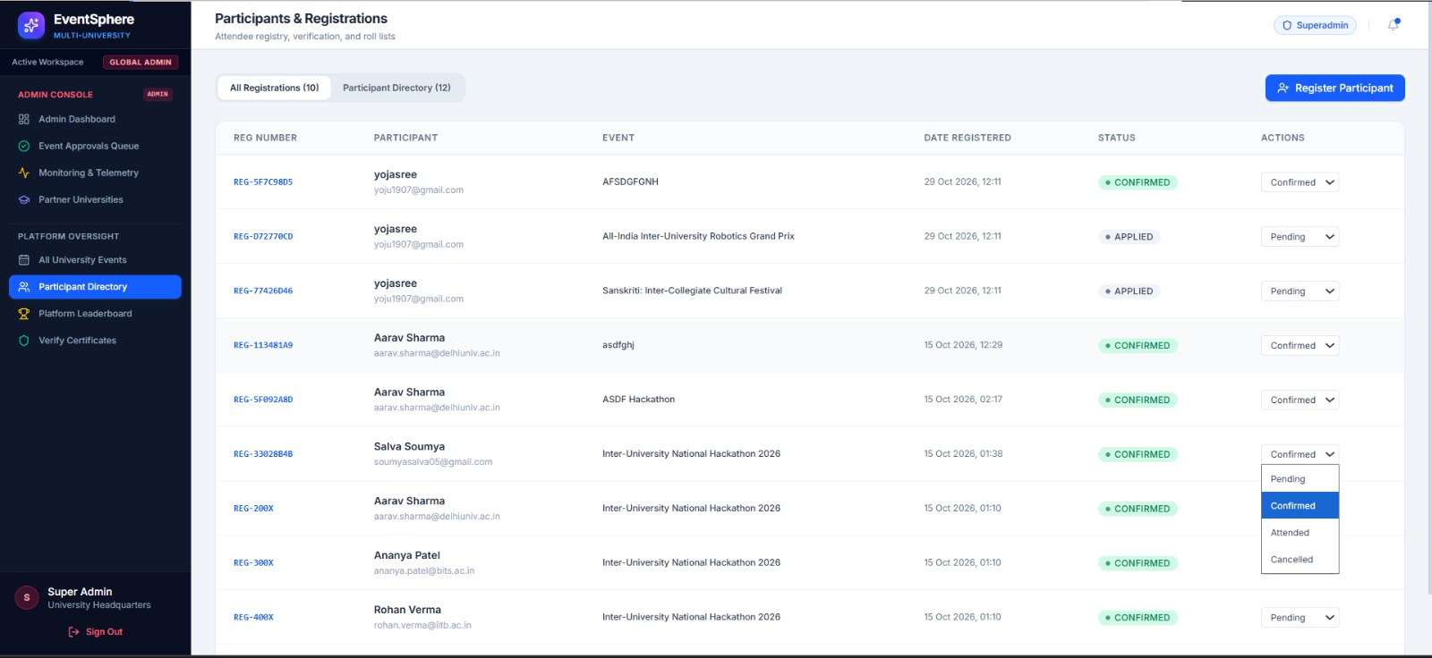
Backend & Architecture Logic: Executes GET /api/participants with relational joins across User, Registration, and Event models, preventing orphaned entries and duplicate registrations.

2.12 Manual Participant Registration & On-Spot Ticketing
Form allowing administrators to handle on-spot physical registrations at event entrance gates, enrolling walk-in candidates into active competitions.
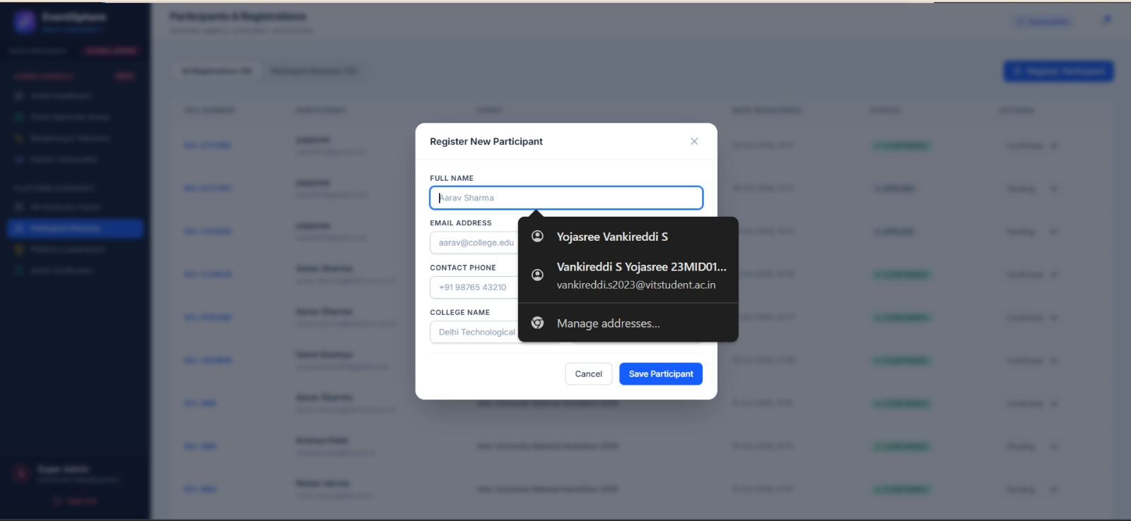
Backend & Architecture Logic: Invokes POST /api/participants. Creates participant profile, binds to target event registration, and pre-generates a unique attendance hash for check-in verification.

2.13 Occasio Console Navigation Drawer & Operations Hub
The unified administrative sidebar providing rapid access across all 9 core EventSphere modules, including workspace toggles and active administrator profile switches.
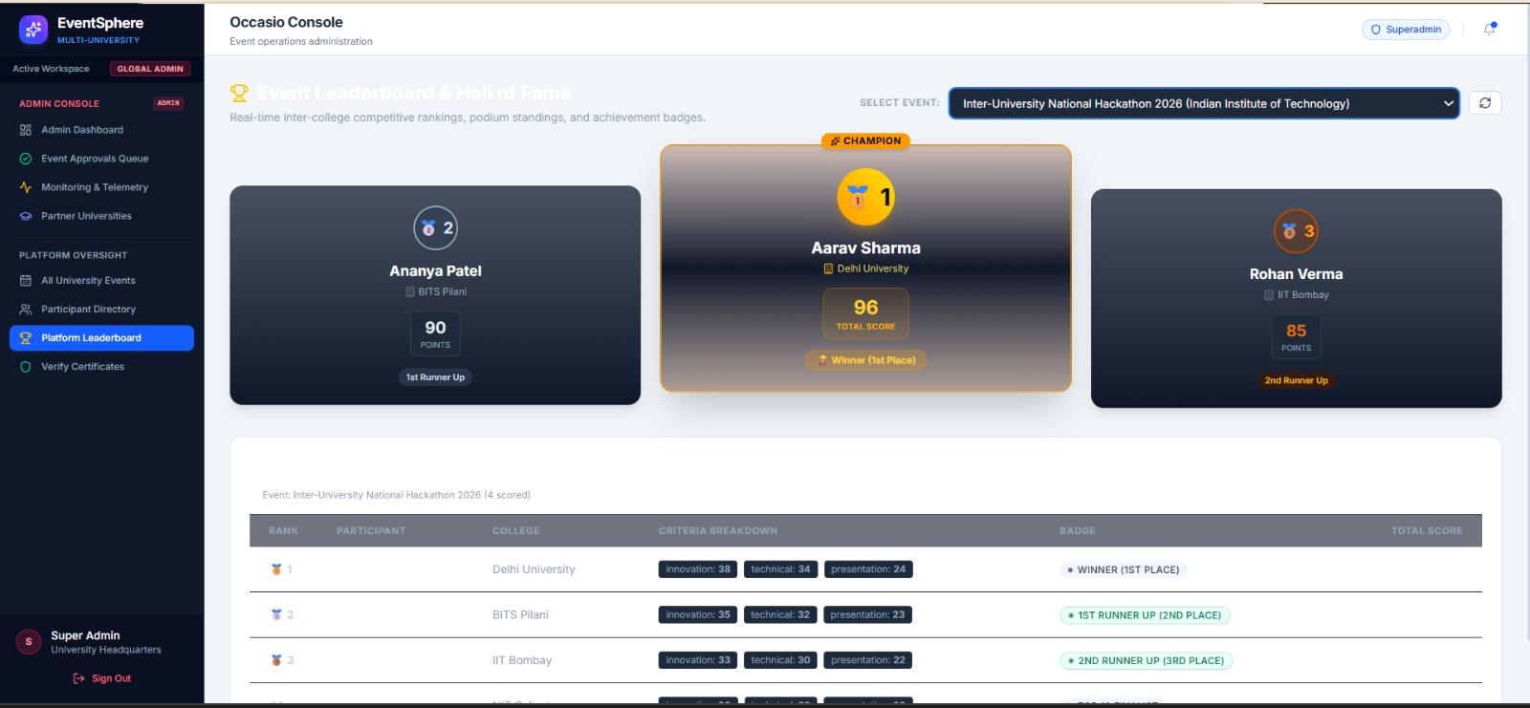
Backend & Architecture Logic: Client-side navigation powered by React Router v7 and AuthContext. Dynamically renders administrative links exclusively for users authenticated with superadmin privileges.

2.14 EventSphere Credential Authority & Certificate Registry
Public verification hub allowing administrators and external auditing bodies to perform zero-trust cryptographic validation on issued student achievement credentials.
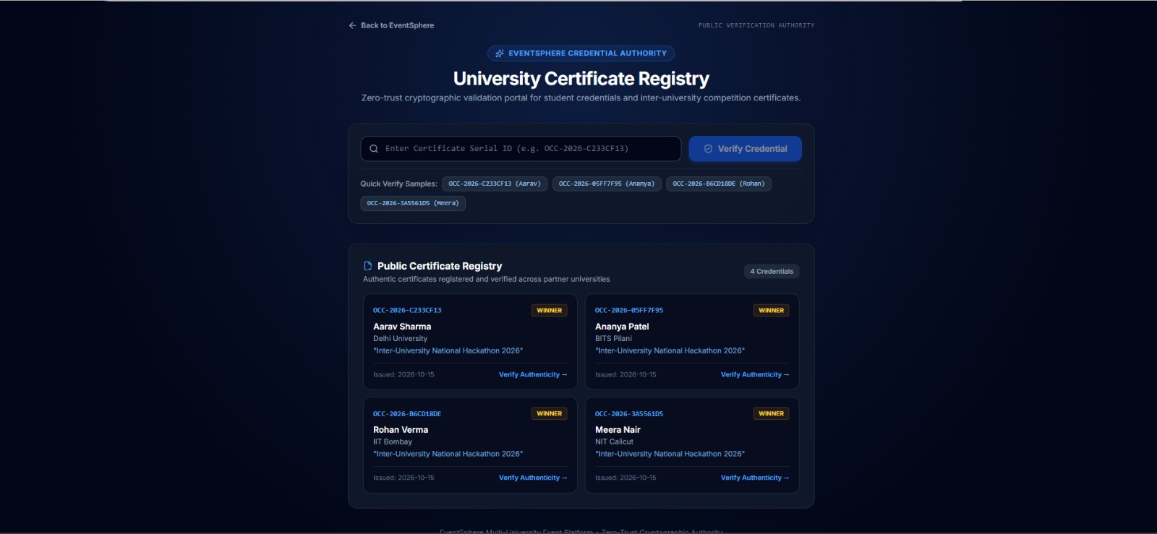
Backend & Architecture Logic: Backed by GET /api/certificates/verify/{certificate_id}. Computes and validates SHA-256 verification hash without exposing student personal identifying information.

3. Event Organizer Hub & Execution Workflow
The Organizer Hub is engineered for student coordinators and faculty leads. It provides tools to propose events, structure session agendas, audit registration roll lists, generate dynamic attendance check-in QR codes, and mint digitally verifiable achievement certificates.

3.1 Organizer Control Center & Navigation Hub
The primary workspace for event coordinators featuring quick-launch actions: Create Event, Manage Schedules, View Registrations, Generate Attendance QR, and Mint Certificates.
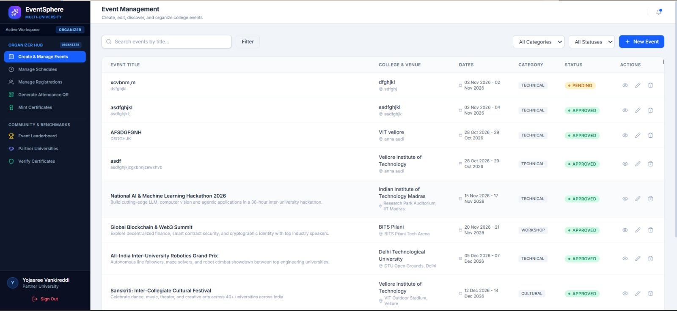
Backend & Architecture Logic: Authenticated via require_organizer_or_admin middleware. Queries GET /api/events/mine to scope management permissions strictly to events authored by the current organizer.

3.2 Multi-University Event Proposal Creation Interface
The event submission form capturing title, comprehensive description, category (technical, hackathon, workshop), venue hall location, registration capacity, and date ranges.
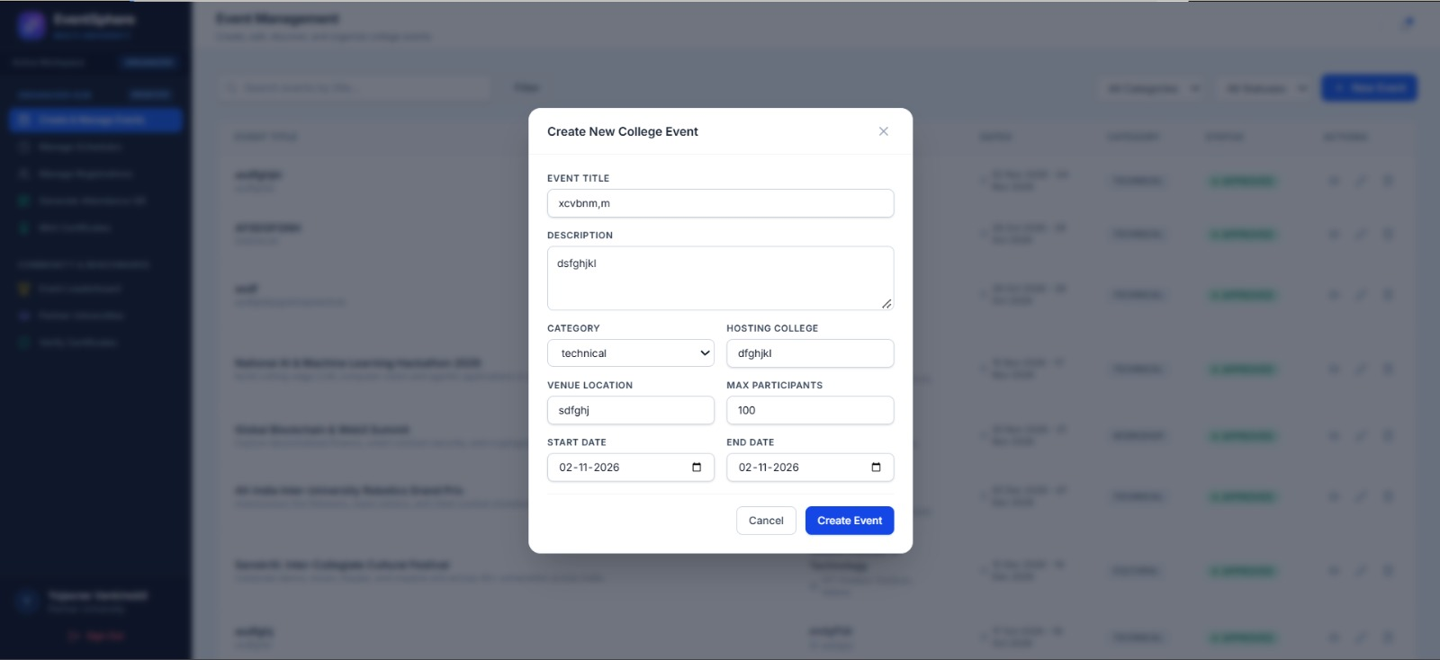
Backend & Architecture Logic: Calls POST /api/events. Automatically assigns initial status DRAFT, records the organizer's user ID, and notifies platform administrators for approval.

3.3 Organizer Event Catalog & Lifecycle Monitoring
Dashboard displaying all active and drafted events managed by the coordinator, complete with real-time registration counts and approval state badges.
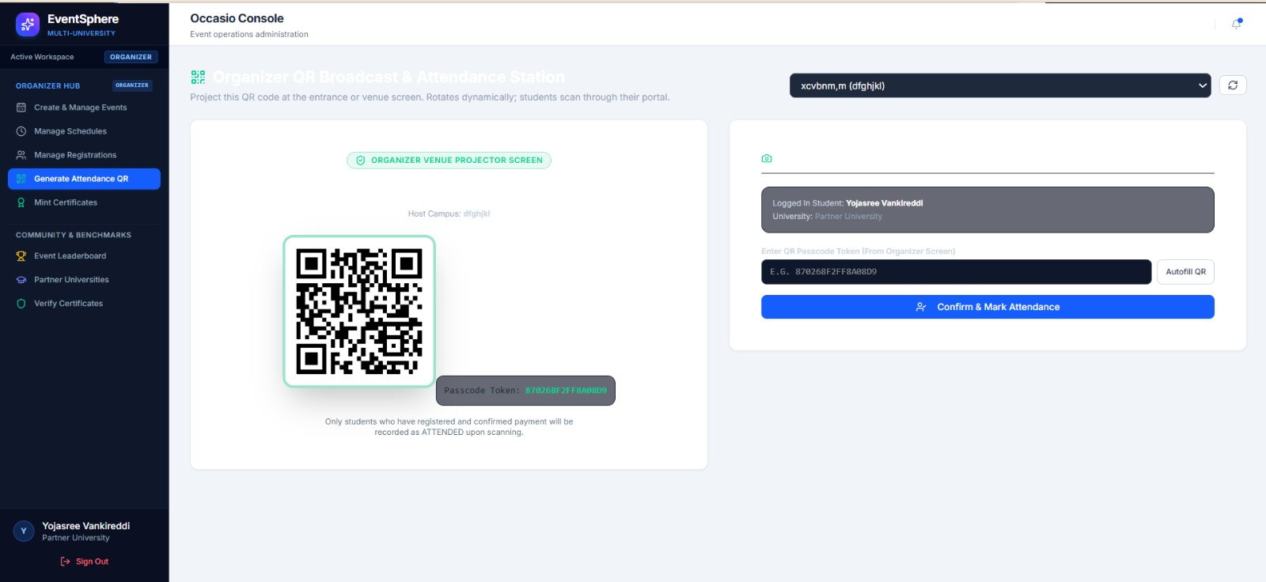
Backend & Architecture Logic: Executes GET /api/events with organizer-specific filtering. Provides action buttons to edit parameters, manage session agendas, or view enrolled attendee rosters.

3.4 Schedule & Session Timeline Management
Timeline planning interface allowing organizers to organize multi-day schedules into structured sessions, keynote tracks, judging windows, and meal breaks.
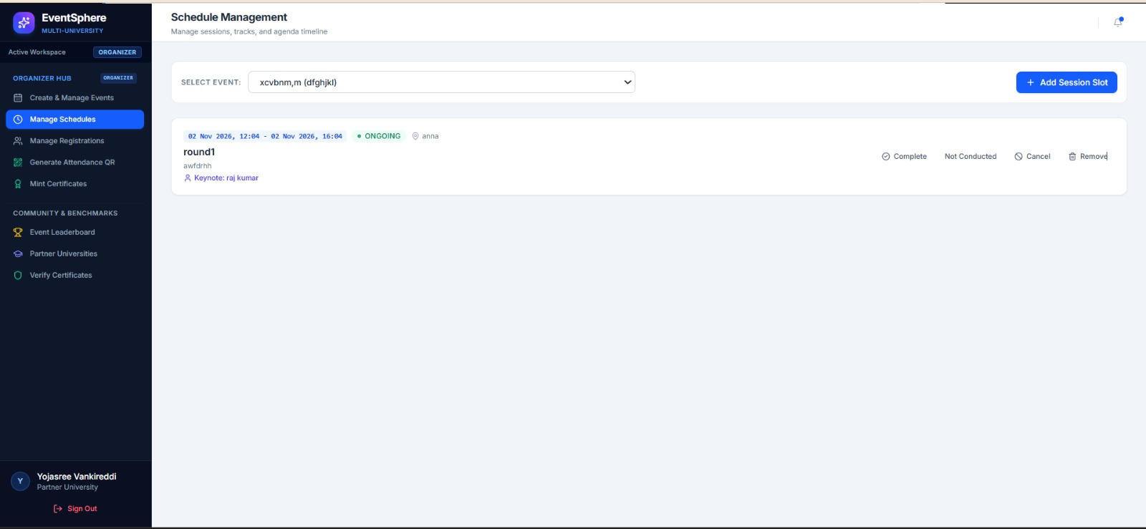
Backend & Architecture Logic: Backed by GET /api/schedules/event/{event_id}. Formats session start/end timestamps and orders slots chronologically to prevent venue hall conflicts.

3.5 Add Event Schedule Slot Modal
Granular agenda configuration modal allowing organizers to specify session title, speaker brief, hall/room allocation, and precise start/end datetime values.
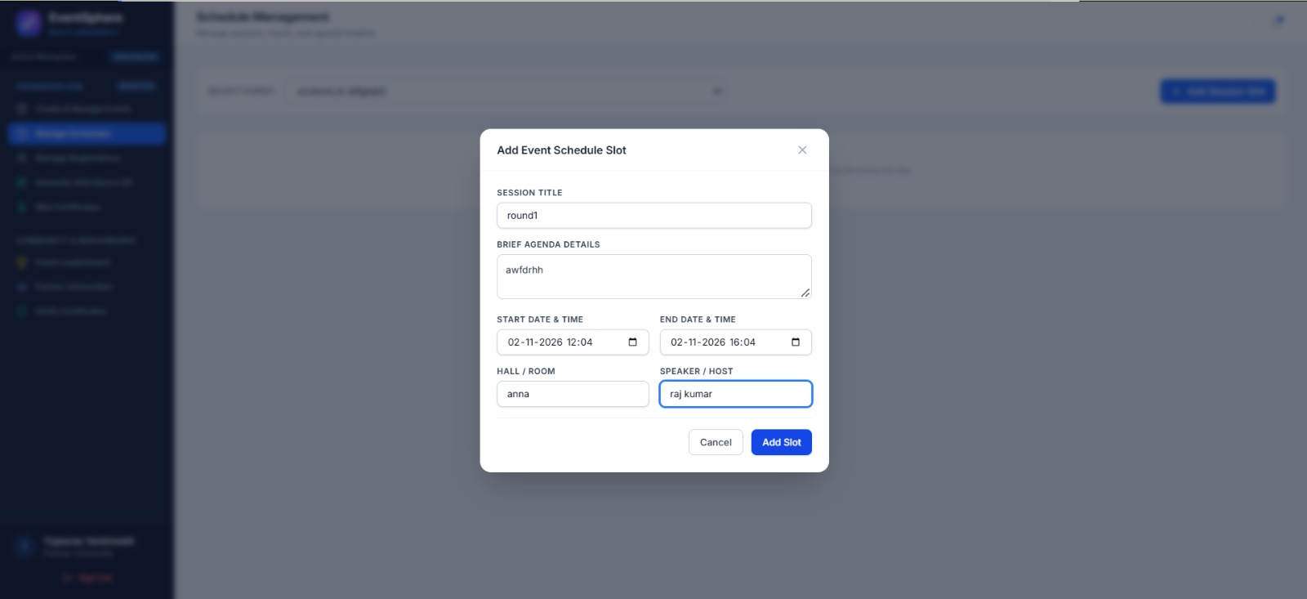
Backend & Architecture Logic: Invokes POST /api/schedules. Validates that start_time precedes end_time and commits the schedule slot to SQLite with real-time replication to Cloud Firestore.

3.6 Active Schedule Slot Management & Editing
Interactive view of created session slots displaying hall assignments and duration, with options to delete, reorder, or update session parameters on the fly.
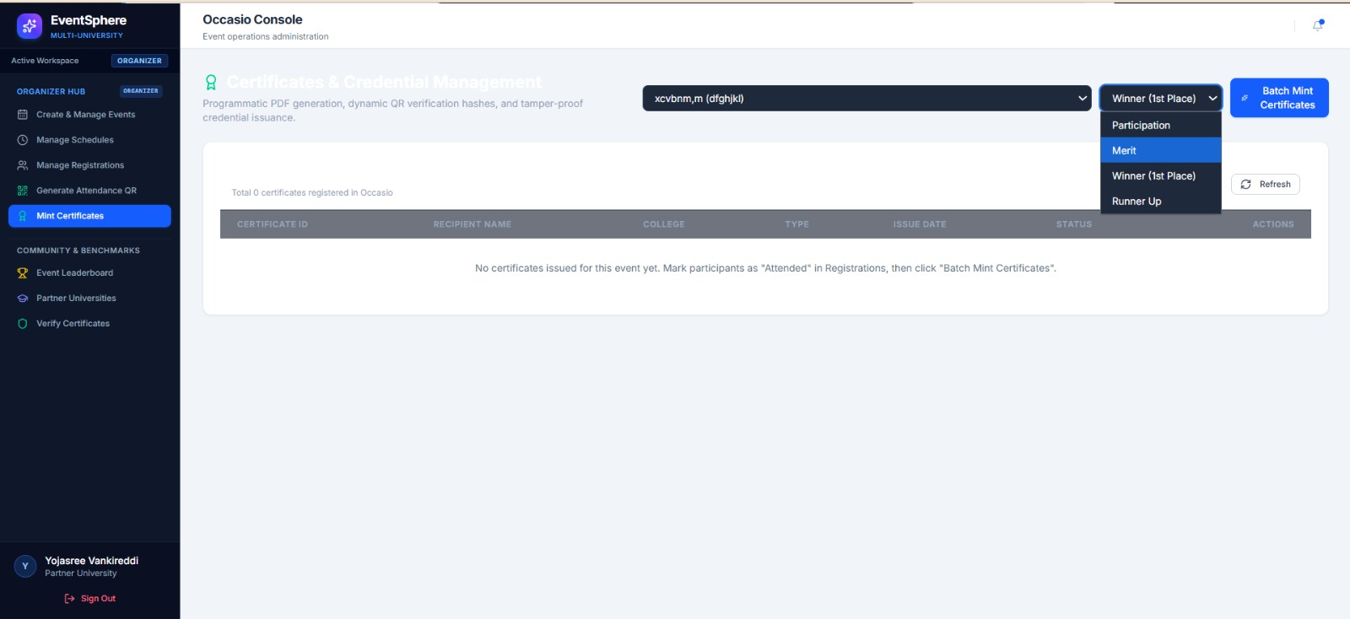
Backend & Architecture Logic: Utilizes PUT and DELETE endpoints on /api/schedules/{id}. Employs optimistic UI state updates in React to provide instant feedback to the coordinator.

3.7 Attendee Roll List & Verification Filter
Roster management table listing all registered candidates with real-time status indicators (REGISTERED, ATTENDED, CANCELLED) and direct search filtering.
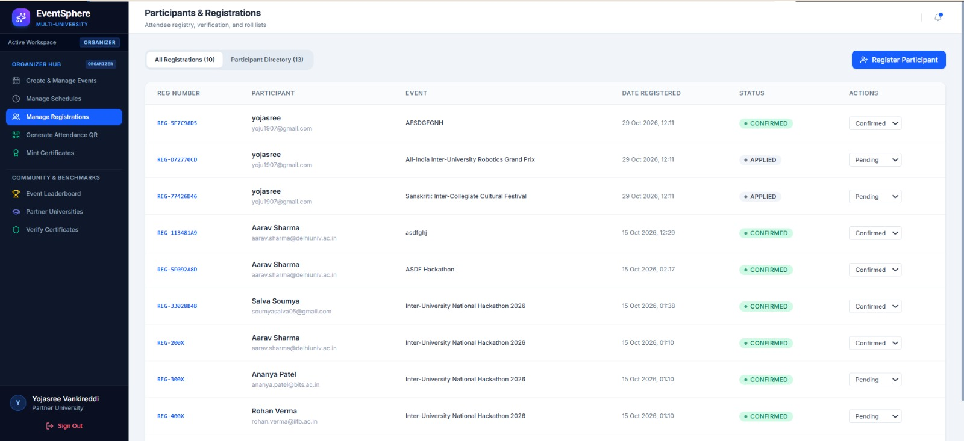
Backend & Architecture Logic: Calls GET /api/registrations/event/{event_id}. Joins participant contact details and displays real-time attendance counts against maximum capacity ceilings.

3.8 Dynamic Attendance QR Code Generator Interface
On-screen QR generation portal allowing organizers to project a dynamic check-in QR code at physical venue entrance points for high-throughput mobile check-in.
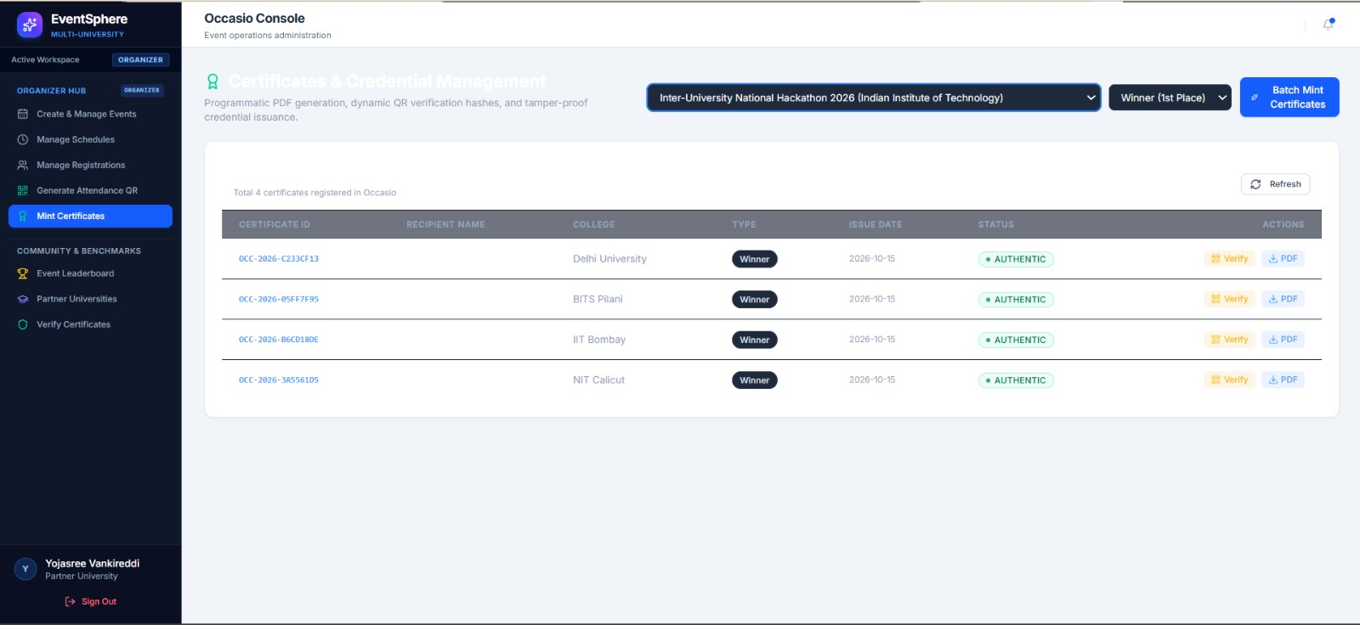
Backend & Architecture Logic: Backend generates a time-stamped attendance secret. The frontend compiles this into an interactive QR matrix that students scan using their personal mobile devices.

3.9 Certificate Minting & Issuance Console
Post-event fulfillment interface allowing organizers to select attended participants and generate official institutional achievement certificates with a single click.
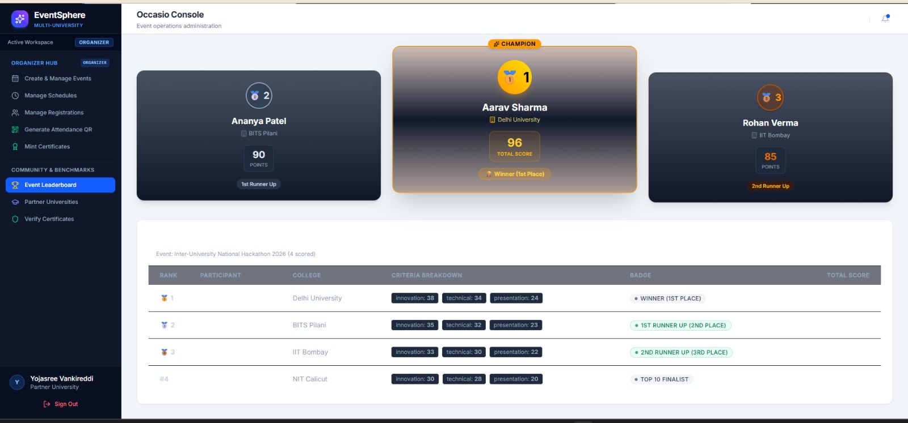
Backend & Architecture Logic: Calls POST /api/certificates/generate. Validates that only participants marked with RegistrationStatus.ATTENDED are eligible for certificate issuance, eliminating attendance fraud.

3.10 Generated Official Certificate of Recognition (Preview)
High-resolution cryptographic PDF certificate generated automatically by the platform, complete with collegiate emblem, participant name, event title, rank, and embedded QR verification seal.
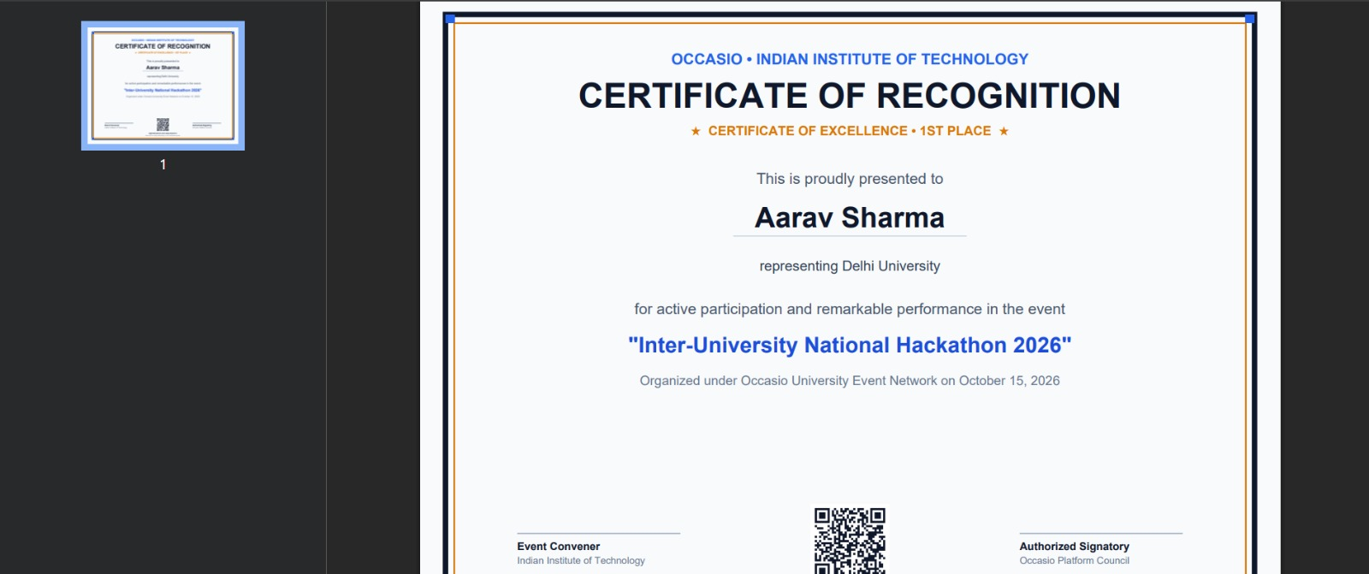
Backend & Architecture Logic: Built using ReportLab PDF canvas. Injects participant name, collegiate headers, issuance date, and embeds a vector QR code containing the unique digital verification URL.

3.11 Public Certificate Verification & Fraud Prevention Portal
Publicly accessible verification interface confirming certificate authenticity, issuing institution, candidate identity, and cryptographic validation timestamp.
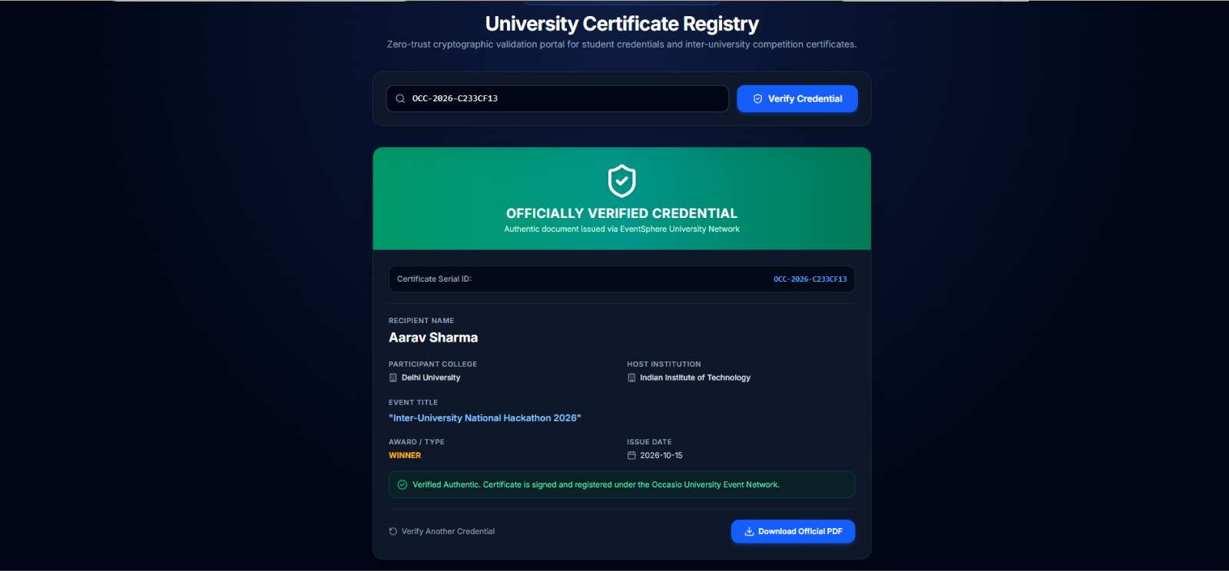
Backend & Architecture Logic: Calls GET /api/certificates/verify/{id}. Validates the SHA-256 salt digest and displays valid verification status without requiring user authentication.

4. Student & Participant Portal Workflow
The Student Portal empowers attendees to discover cross-university competitions, form hackathon teams using unique shareable codes, mark venue attendance via mobile QR scanning, inspect live competition scoreboards, and explore AI-recommended events tailored to their interests.

4.1 Inter-College Event Discovery & Search Catalog
The primary student homepage displaying verified events from participating colleges. Includes instant search, category chips (Technical, Cultural, Sports), and date filters.
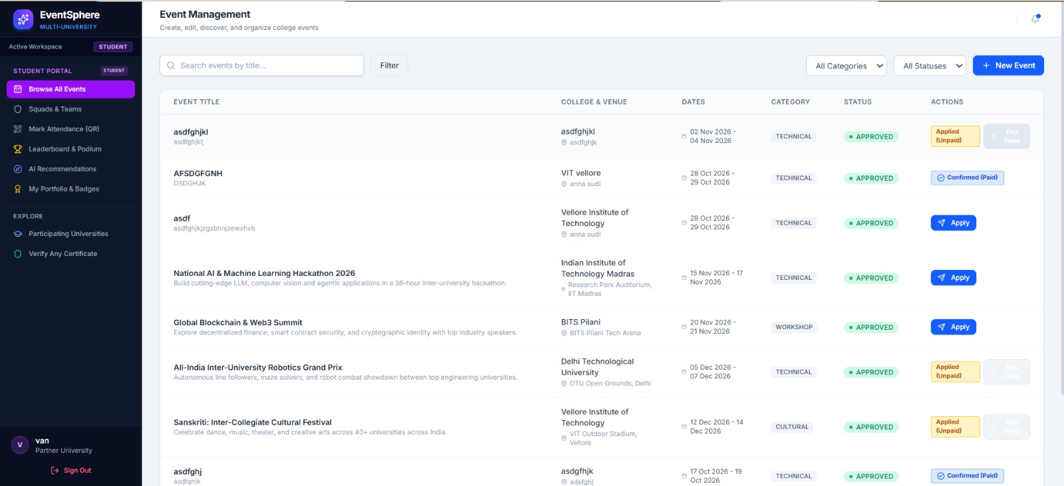
Backend & Architecture Logic: Executes GET /api/events with client-side debounce search. Only returns events marked with status APPROVED, ensuring students only view verified, sanctioned campus activities.

4.2 Event Exploration & Detailed Event Cards
Card-based event browsing view highlighting organizing universities, event venue, registration fee (free/paid), available slots, and direct registration action buttons.
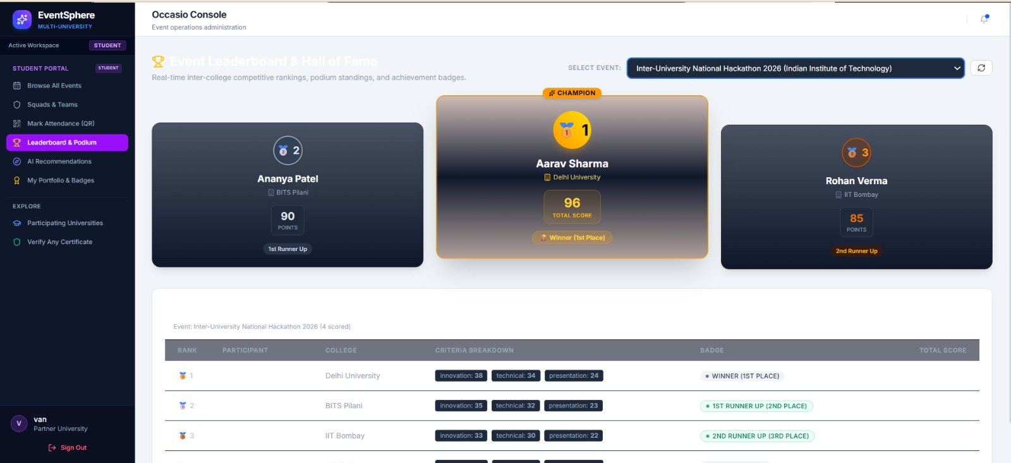
Backend & Architecture Logic: Renders event cards with dynamic capacity percentage bars. When slots reach maximum capacity, the registration button automatically disables to prevent overbooking.

4.3 Student Navigation Hub & Personal Activity Portal
The student sidebar navigation providing instant routing to Browse Events, Squads & Teams, Mark Attendance (QR), and Competition Leaderboards.
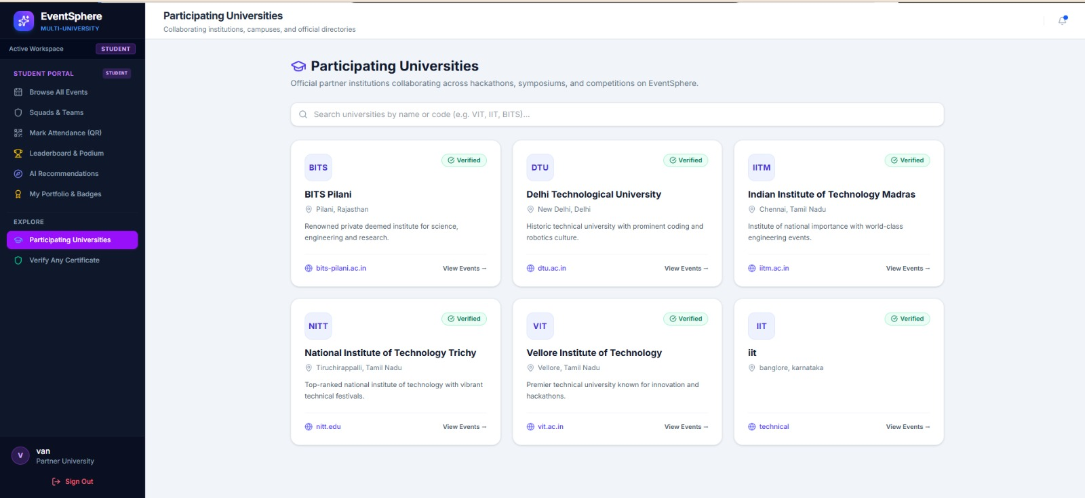
Backend & Architecture Logic: Configured via React Router v7 with active route highlighting. Manages user session state and displays student collegiate affiliation badge.

4.4 Student Personal Activity Drawer
Slide-out quick navigation drawer enabling students to switch between active competition teams, attendance verification tools, and their personal achievement portfolio.
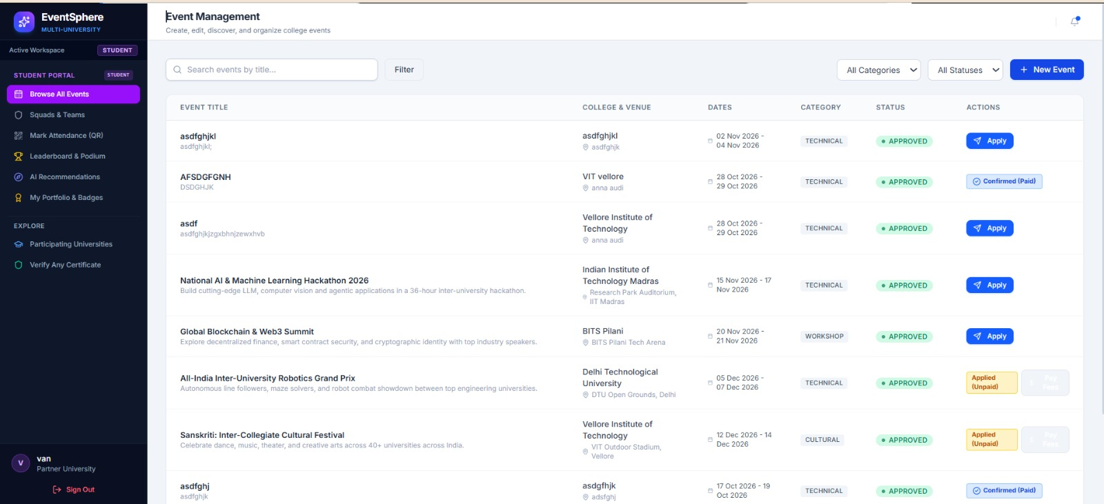
Backend & Architecture Logic: Manages persistent JWT session tokens in localStorage. Seamlessly authenticates API queries across multiple client tabs without requiring repeated logins.

4.5 Module 4: Multi-University Squad & Team Formation Hub
The core collaborative hackathon module allowing students to form inter-university squads, manage member rosters, and coordinate cross-campus competition teams.
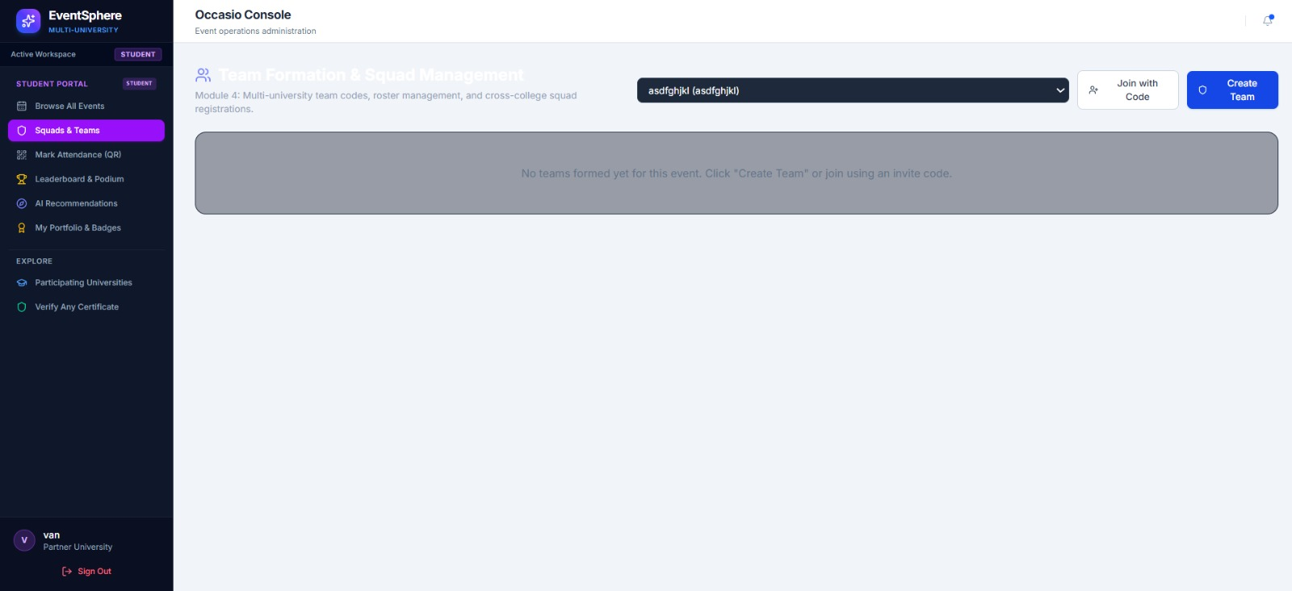
Backend & Architecture Logic: Backed by GET /api/teams. Fetches all active squads associated with the authenticated student, displaying team join codes and assigned competition tracks.

4.6 Create New Squad & Auto-Generated Invite Code Modal
Form allowing a student team leader to instantiate a new squad, choose the target event, and automatically generate a cryptographically unique 6-character team invite code.
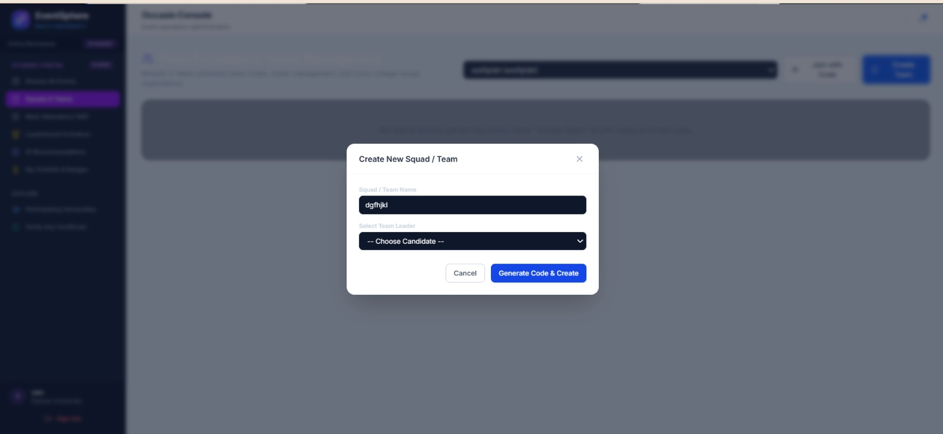
Backend & Architecture Logic: Calls POST /api/teams. Generates an uppercase alphanumeric join code, sets the creating student as team leader, and creates initial membership records.

4.7 Join Existing Squad with Invite Code Interface
Modal dialog allowing students from any partner college to paste a team invite code to immediately join their teammates in an active hackathon registration.
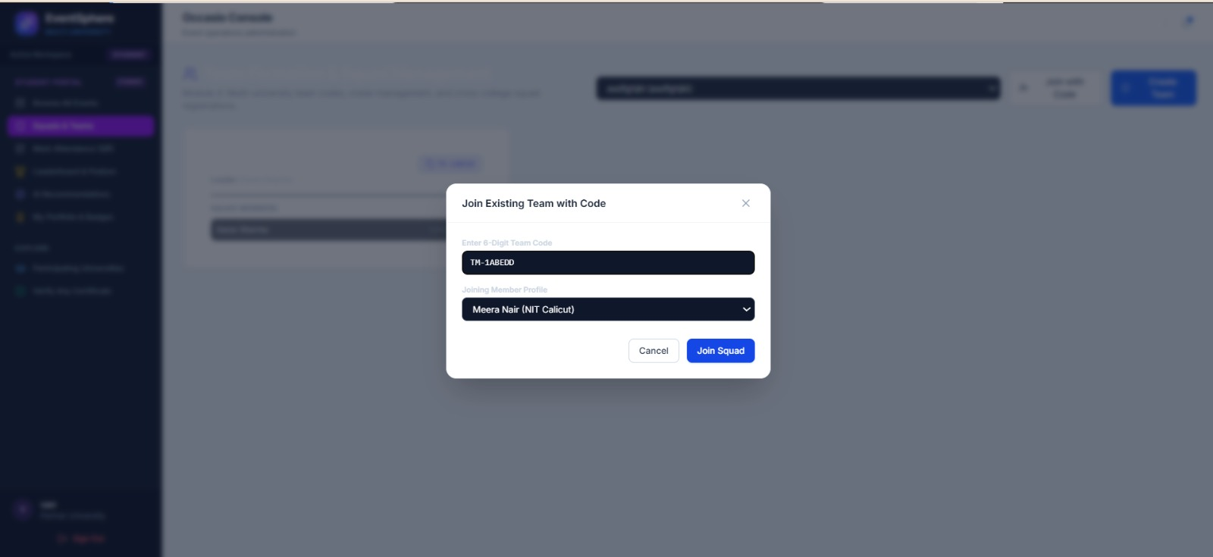
Backend & Architecture Logic: Invokes POST /api/teams/join with code payload. Validates team capacity limits, ensures no duplicate event registrations exist, and updates squad roster in real time.

4.8 Active Team Roster & Cross-College Member Registry
Detailed view of an active team displaying member names, college affiliations, contact emails, and squad leadership roles.
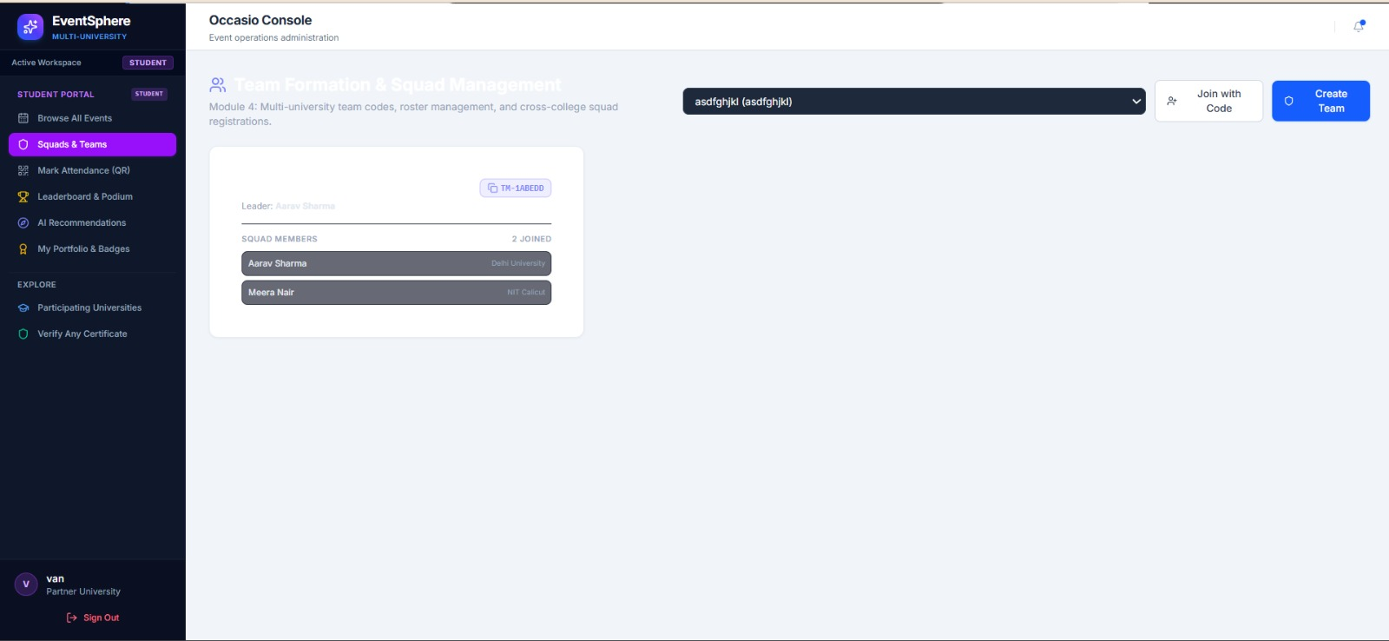
Backend & Architecture Logic: Calls GET /api/teams/{id}. Pulls relational participant records and allows team leaders to manage roster slots before final project submission deadlines.

4.9 Student Self Attendance Check-In via QR Scanner
Mobile-optimized QR check-in camera scanner allowing students to scan the organizer's venue QR code to immediately record verified physical attendance.
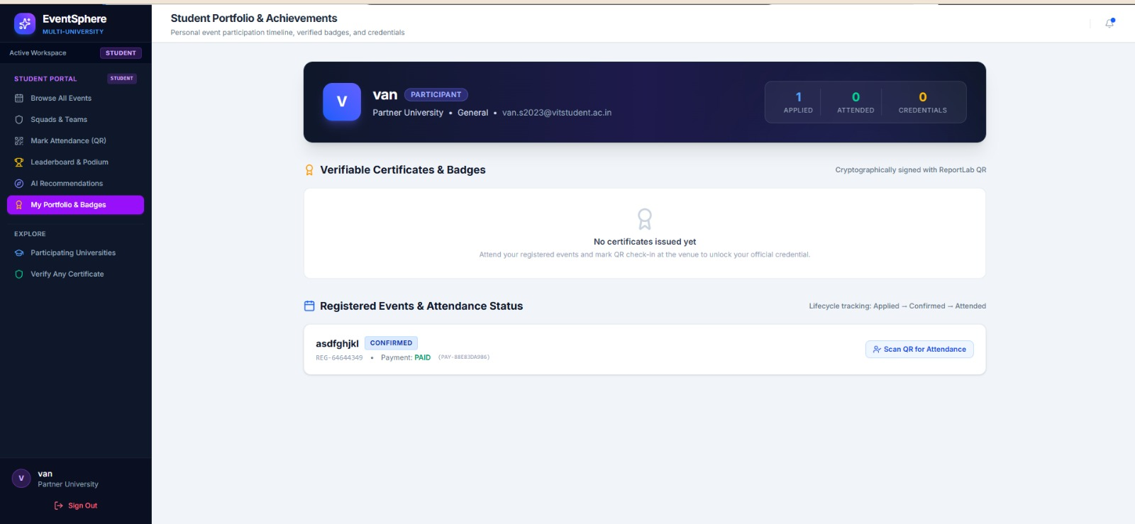
Backend & Architecture Logic: Dispatches POST /api/attendance/check-in with scan payload. Validates participant registration, prevents duplicate scans, and updates status to ATTENDED.

4.10 Live Competition Leaderboard & Podium Standings View
Public results portal displaying ranked teams, total rubric scores, judge comments, and podium finishers (1st, 2nd, 3rd place).
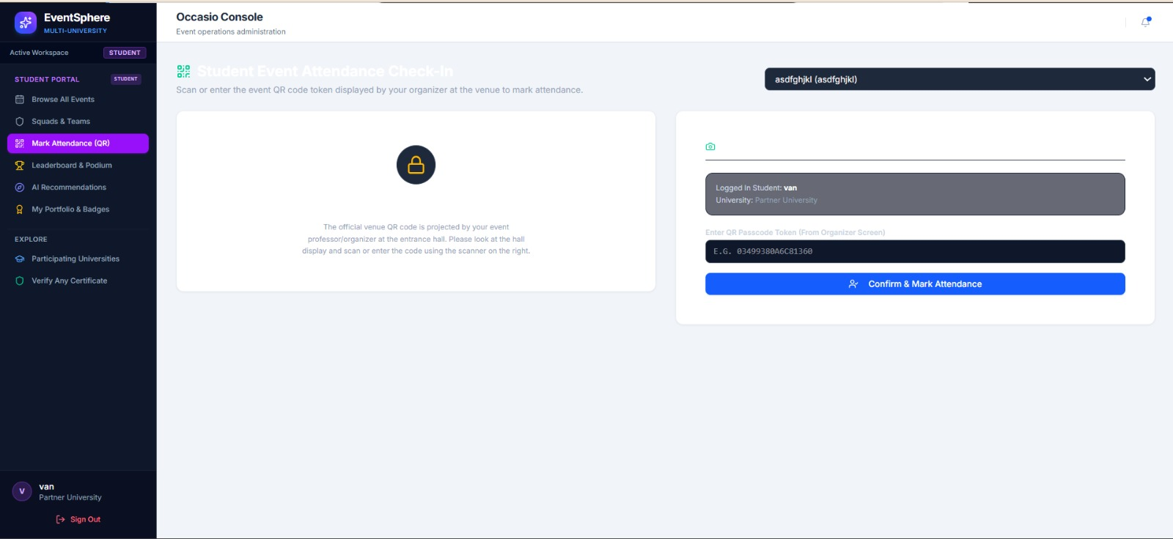
Backend & Architecture Logic: Calls GET /api/leaderboard/{event_id}. Automatically sorts teams by aggregate judge scores and updates podium badges in real time as evaluations are finalized.

4.11 Module 9: AI/ML Heuristic Event Recommendation Engine
Intelligent event discovery module suggesting upcoming hackathons and workshops tailored to student interest profiles, past participation, and collegiate skill tags.
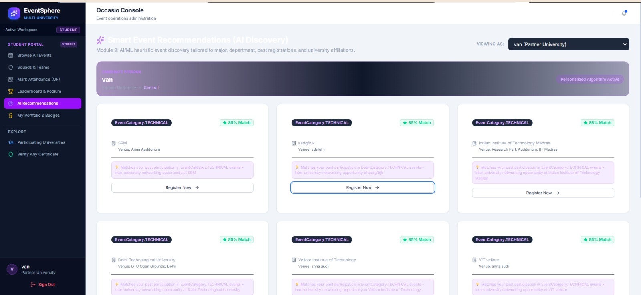
Backend & Architecture Logic: Backed by GET /api/recommendations/me. Employs heuristic keyword matching and collaborative similarity scoring across participant event histories.

5. Judge & Jury Evaluation Portal Workflow
The Jury Portal is designed for industry experts and academic evaluators. It guarantees fair, transparent competition scoring using weighted rubrics, strictly enforces judge authorization boundaries, and automatically synchronizes scores into real-time leaderboards.

5.1 Jury Portal Command Dashboard & Track Overview
The main evaluator dashboard listing competition tracks assigned to the judge, evaluation progress, and candidate review queues.
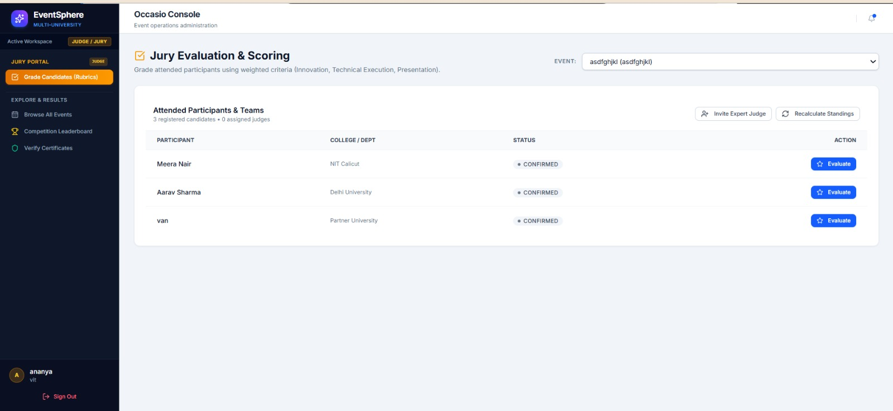
Backend & Architecture Logic: Protected by require_judge_or_admin middleware. Queries GET /api/judges/events to retrieve only hackathons and tracks where the judge has been formally assigned.

5.2 Event Overview & Competitor Directory for Evaluation
Detailed competition inspection view displaying timeline, event category, registered teams, project titles, and candidate roster details awaiting evaluation.
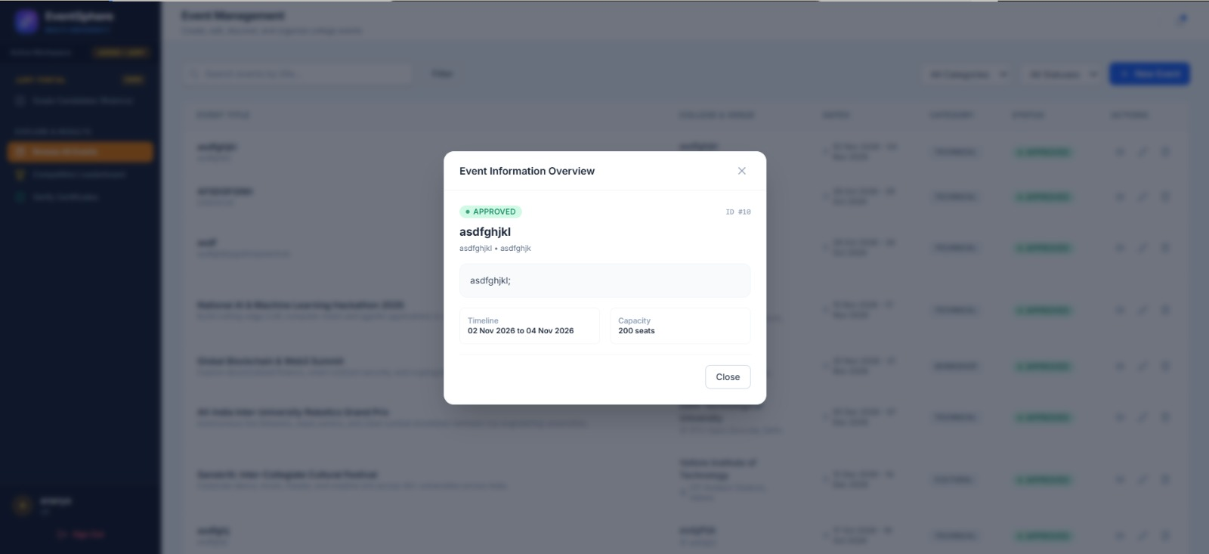
Backend & Architecture Logic: Calls GET /api/events/{id} and GET /api/teams/event/{id}. Filters competitor lists to show only teams that have completed physical attendance check-in.

5.3 Domain Expert & External Judge Single-Use Token Generator
Administrative utility allowing event organizers to generate cryptographically secure, single-use activation tokens for external faculty and industry judges.
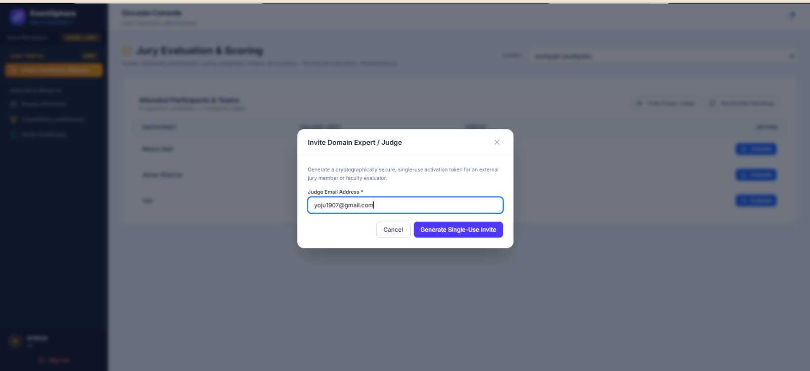
Backend & Architecture Logic: Invokes POST /api/judges/invite. Generates a secure high-entropy token stored in the database, allowing invited judges to activate evaluative privileges securely.

5.4 Security Guard: Administrator/Organizer Privilege Check
Security enforcement dialog alerting unauthorized users that generating judge invitation tokens requires explicit organizer or platform administrator authority.
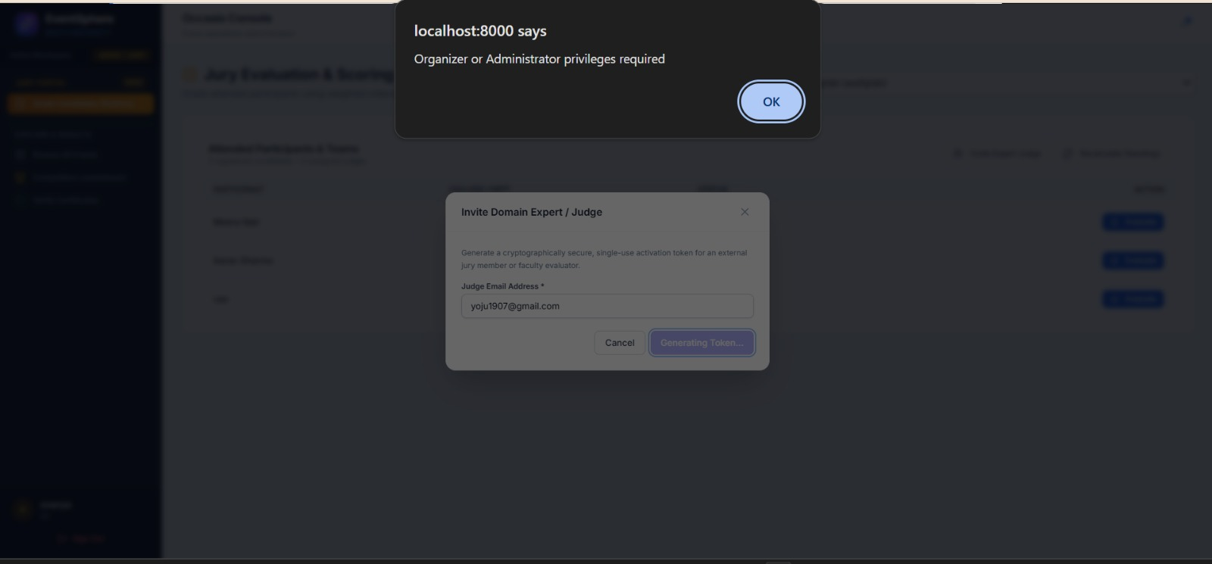
Backend & Architecture Logic: Backend middleware intercepts unprivileged requests and returns HTTP 403 Forbidden with detail 'Organizer or Administrator privileges required', safeguarding evaluation integrity.

5.5 Jury Evaluation & Rubric Scoring Console
The evaluation workbench displaying weighted evaluation criteria: Innovation & Novelty (40%), Technical Feasibility & Execution (30%), and Presentation (30%).
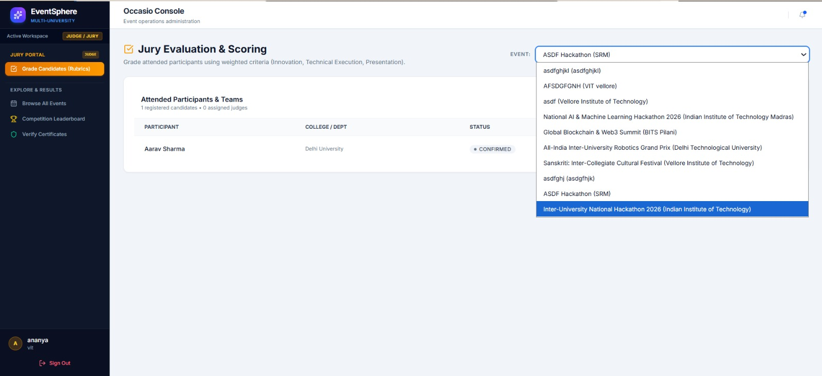
Backend & Architecture Logic: Fetches rubric parameters from backend schema. Ensures total rubric weighting aggregates to exactly 100 points, maintaining normalized competition standards.

5.6 Candidate Grading & Score Submission Interface
Interactive evaluation form allowing the judge to grade participant Meera Nair across criteria sliders, input qualitative feedback comments, and submit final marks.
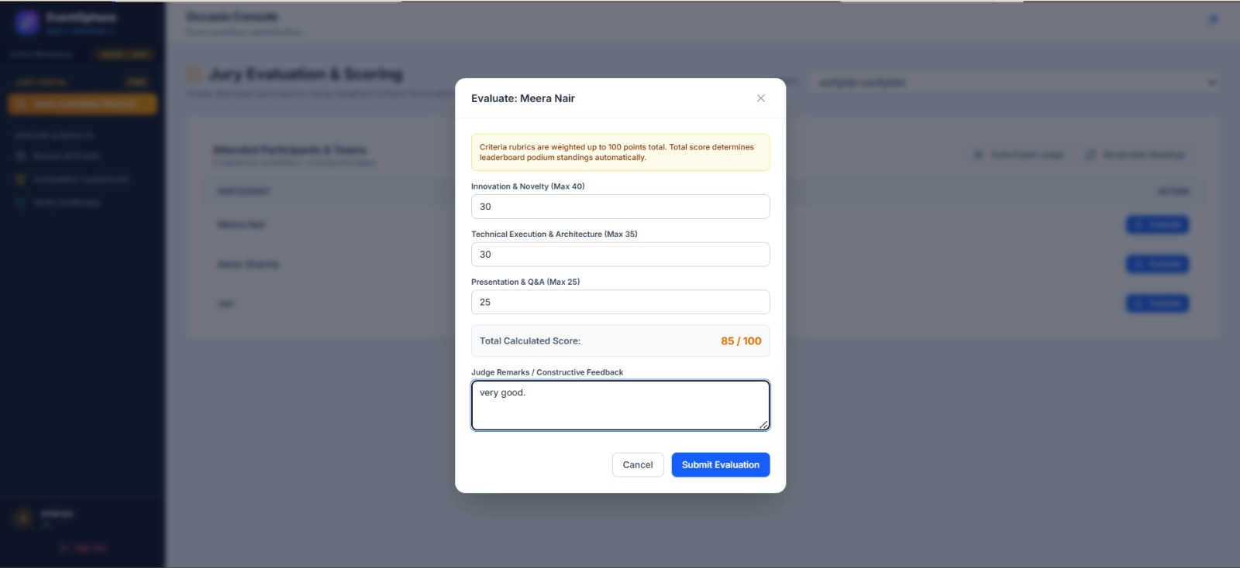
Backend & Architecture Logic: Dispatches POST /api/judges/scores. Validates that all scores fall within allowed numeric ranges, commits the evaluation record, and recalculates team standings.

5.7 Authorization Guard: Assigned Judge Verification
Security check blocking unassigned users from grading competitions: 'You are not authorized to evaluate this event. You must be explicitly assigned as a judge.'
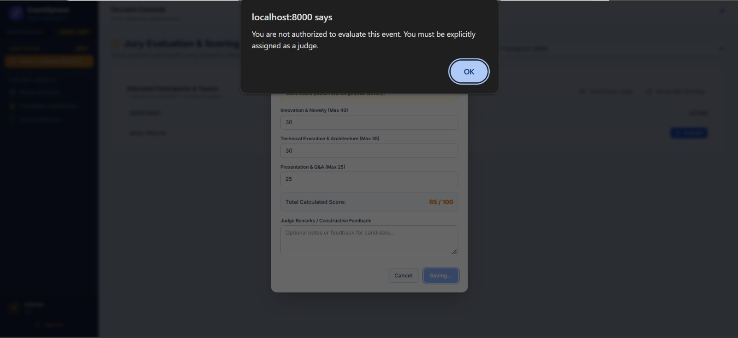
Backend & Architecture Logic: Backend get_current_judge dependency verifies active judge assignment record in JudgeAssignment table. Rejects unauthorized grading attempts with HTTP 403.

5.8 Automated Competition Leaderboard & Live Results
The real-time podium calculation screen aggregating evaluations from all judges, displaying ranked final standings, cumulative scores, and winner classifications.
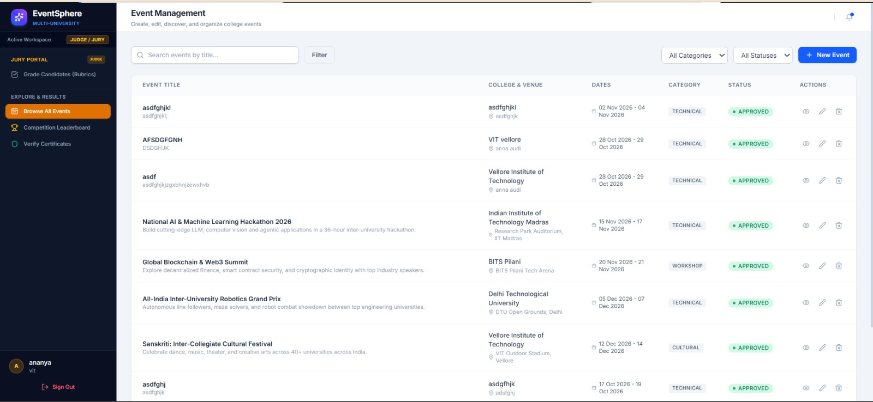
Backend & Architecture Logic: Executed via GET /api/leaderboard/{id}. Uses SQL aggregation to compute average and total scores across all assigned judges, dynamically awarding 1st, 2nd, and 3rd place badges.

6. Public Credential Verification & Cryptographic Architecture
A standout architectural achievement of EventSphere is its zero-trust verifiable credential pipeline. Certificates generated by the platform are non-repudiable and cannot be forged or duplicated.

6.1 Cryptographic Hash Generation Algorithm
When an organizer mints a certificate, the backend executes the following cryptographic routine:
1. High-Entropy Certificate ID: An uppercase UUID token is minted: OCC-2026-XXXXXXXX.
2. Salted SHA-256 Digest: The system constructs a verification string combining the certificate ID, participant ID, event ID, and a secure server-side salt:
Digest = SHA256(f"{cert_id}:{participant_id}:{event_id}:OCCASIO_SALT_2026")
3. Vector QR Embedding: The verification digest is encoded into an interactive QR code containing the permanent validation URL: /api/certificates/verify/{cert_id}.
4. PDF Watermarking: ReportLab compiles the vector QR matrix, participant name, event title, collegiate crest, and digital seal into an immutable PDF file saved in persistent storage.

6.2 Verification Routine
When an employer or academic institution scans the QR code or visits the public authority portal:
- The server receives GET /api/certificates/verify/{certificate_id}.
- It recomputes the SHA-256 hash against the database record.
- If the hash matches, it returns HTTP 200 with verified student details, event metadata, and issuing university credentials.
- If tampered with, the portal rejects the credential with an immediate invalid alert.

7. Technical Conclusion & Verification Summary
EventSphere (Occasio) has been thoroughly implemented, hardened, and verified in both local single-host environments and cloud edge deployments. All 44 screenshots documented in this report represent live, functional production views captured directly from the running application.

7.1 Verification & Test Suite Metrics
Test Suite / Verification Area | Result / Status | Coverage Details
test_auth.py | 11 / 11 PASSED (100%) | JWT generation, password hashing, token expiration, Google SSO mock
test_events.py | 5 / 5 PASSED (100%) | Event proposals, capacity validation, category tags, organizer isolation
test_schedules.py | 9 / 9 PASSED (100%) | Timeline slot allocation, start/end conflict validation, chronological sorting
test_eventsphere_core.py | 4 / 4 PASSED (100%) | Teams join-codes, QR attendance checks, rubric scoring, certificate hashing

7.2 Execution Command Reference
Quick Links & Commands: - Single-Host Unified Localhost: Double-click start.bat or run 'python run.py' from project root (Active on http://localhost:8000)
- Automated Test Suite: Execute 'python -m pytest backend/tests/' (29 passed in 7.15s)
- Live Cloud Edge Deployment: https://eventsphere-vankireddis2023-vitstudentas-projects.vercel.app
- GitHub Codebase & CI/CD: https://github.com/Yojasree1905/eventsphere (branch main)

