REPORT
ON

1-MONTH SOFTWARE DEVELOPMENT INTERNSHIP

Submitted To
School of Computer Science and Engineering
IILM University, Greater Noida, U.P.

In partial fulfilment of the requirement for the degree of
B.Tech (CSE)



By

Roll Number of Student: 2410031104
Name of Student: Yojit Bhatt
Batch: 2024-28

CANDIDATE'S DECLARATION

I, Yojit Bhatt, do hereby declare that the internship report titled "1-Month Software Development Internship at Cognifyz IT Solutions" has been completed by me to fulfil the requirement for the award of the degree of Bachelor of Technology in CSE. All the references have been quoted and I have not taken as such any material from any other source. I affirm that this report is my own work and has not been submitted to any other institute for any degree/diploma requirement, and I shall be solely responsible for any kind of copyright violation in this regard.

Student Name: Yojit Bhatt
Roll No.: 2410031104

ACKNOWLEDGEMENT

I am using this opportunity to express my gratitude to everyone who supported me throughout the 1-Month Software Development Internship Program at Cognifyz IT Solutions. I am thankful for their aspiring guidance, invaluably constructive criticism and friendly advice during this work. I am sincerely grateful to the mentors and the entire team at Cognifyz IT Solutions Pvt. Ltd. for sharing their truthful and illuminating views on a number of issues related to software development and project implementation.
I would also like to thank the School of Computer Science and Engineering, IILM University, for providing me the opportunity and continuous support to undertake this internship as a part of my academic curriculum.
I express my gratitude to my parents for their blessings.

Student Name: Yojit Bhatt
Roll No.: 2410031104

INTERNSHIP COMPLETION CERTIFICATE

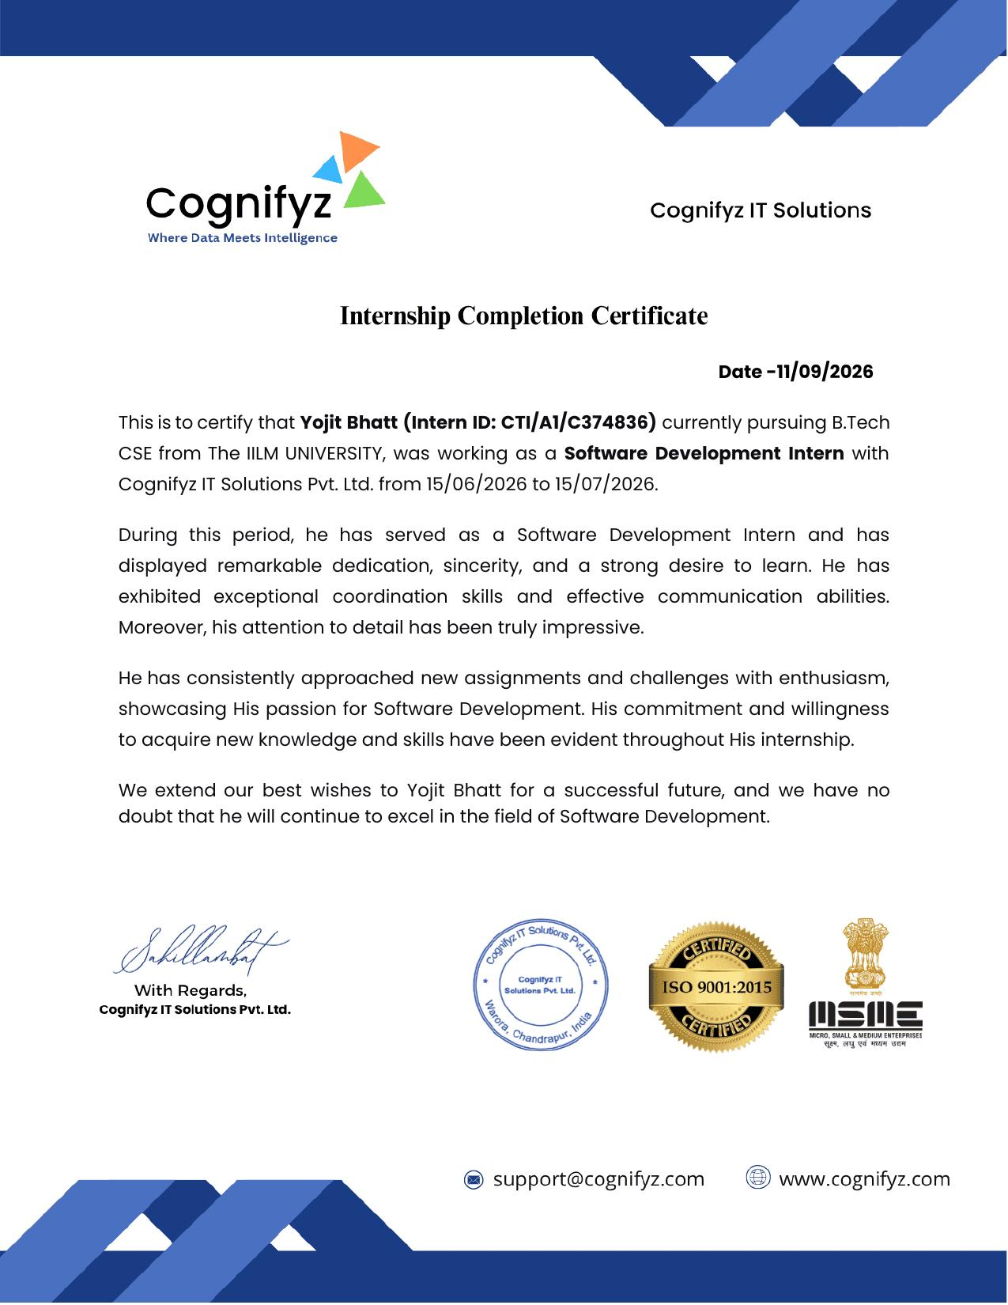

TABLE OF CONTENTS

Chapter No. | Chapter Name
 | Cover Page
1. | Candidate's Declaration
2. | Acknowledgement
3. | Internship Completion Certificate
4. | Project Description
 | 4.1 Introduction
 | 4.2 Organization Profile
 | 4.3 Problem Statement
 | 4.4 Project Objectives
 | 4.5 Scope of the Project
 | 4.6 Technologies and Tools Used
 | 4.7 System Architecture
 | 4.8 Methodology
 | 4.9 Expected Outcomes
 | 4.10 Certificate of Completion
5. | Bibliography/References

CHAPTER 4: PROJECT DESCRIPTION

4.1 Introduction
This report presents a summary of the work carried out during the 1-Month Software Development Internship undertaken at Cognifyz IT Solutions Pvt. Ltd. The internship, spanning the period from 15/06/2026 to 15/07/2026, was designed to build a strong foundation in software development practices while providing hands-on exposure to building a real-world, web-based application. Over the course of four weeks, the program combined structured learning with practical assignments, culminating in the development of a web-based software project built using Python and the Django framework.
The internship provided exposure to the complete software development lifecycle, from requirement analysis, environment setup, and coding to testing and deployment of a functional web application, thereby bridging the gap between academic learning and industry-oriented practical skills.

4.2 Organization Profile
Cognifyz IT Solutions Pvt. Ltd. is an IT solutions and technology training organization, headquartered in Warora, Chandrapur, India, that operates under the tagline "Where Data Meets Intelligence." The organization is ISO 9001:2015 certified and registered under the Micro, Small and Medium Enterprises (MSME) scheme, and provides internship and training programs in domains such as Software Development, Data Analytics, and related emerging technologies.
Cognifyz IT Solutions offers structured internship programs that combine practical, project-based assignments with mentorship, and issues verifiable internship completion certificates to interns upon successful completion of their assigned duration and deliverables.

4.3 Problem Statement
Beginners entering the field of software development often struggle to translate theoretical programming knowledge into a complete, deployable web application. There is a need for a structured, guided learning path that introduces web application development fundamentals using Python and Django, and gradually builds up to a functional, real-world software solution. Specifically, the internship addressed the following problem:
- Manually managing and presenting information through static or ad-hoc means is inefficient and does not scale; there is a need for a dynamic, database-backed web application that can store, process, and present data through a structured interface.
- New developers require practical exposure to the full web-development workflow — from designing the data model to building the backend logic and rendering a usable front end — which is best learned through an applied mini-project rather than isolated exercises.

4.4 Project Objectives
- To gain a strong foundation in Python programming, including data structures, control flow, functions, and error handling.
- To learn the Django web framework, including its Model-View-Template (MVT) architecture, URL routing, and templating engine.
- To understand how to design and integrate a relational database (e.g., SQLite/MySQL) with a Django-based backend.
- To design and implement a generic, web-based software application demonstrating create, read, update, and delete (CRUD) functionality.
- To gain hands-on experience with front-end integration using HTML, CSS, and Django templates.
- To learn the use of version control (Git/GitHub) for tracking and managing project code.
- To gain practical, hands-on experience in building, testing, and presenting a functional web-based software project.

4.5 Scope of the Project
The scope of the internship was limited to the Software Development curriculum offered by Cognifyz IT Solutions over a duration of one month, covering Python fundamentals, the Django web framework, database integration, and a final project component. Within this scope, a generic web-based software application was developed to demonstrate applied learning.
The project covers designing the data model, implementing backend logic using Django's MVT architecture, connecting the application to a relational database, building basic front-end templates for user interaction, and testing the application's core functionality locally. It does not extend to large-scale production deployment, load testing, or integration with third-party payment or cloud-hosting services.

4.6 Technologies and Tools Used
- Programming Language: Python 3
- Web Framework: Django
- IDE/Editor: Visual Studio Code / PyCharm
- Front-End: HTML, CSS, and Django Template Language (DTL)
- Database: SQLite (development) / MySQL
- Version Control: Git and GitHub
- Other Tools: Django Admin interface, virtual environments (venv), pip package manager

4.7 System Architecture
The application follows Django's Model-View-Template (MVT) architecture, summarized below:
- Model Layer: Defines the application's data structures using Django ORM models, mapped to underlying database tables.
- View Layer: Contains the business logic that processes incoming HTTP requests, interacts with the models, and prepares data for display.
- Template Layer: Renders the final HTML pages presented to the user, using Django's templating engine to display dynamic data.
- URL Routing Layer: Maps incoming request URLs to the appropriate view functions.
- Database Layer: Stores persistent application data, accessed and manipulated through the Django ORM.

4.8 Methodology
The internship was carried out over four structured weeks, following the official Software Development Internship curriculum of Cognifyz IT Solutions:
- Week 1 – Python and Web Development Fundamentals: Introduction to Python, setting up the development environment, understanding Python syntax and basic constructs, control structures, functions, and an introduction to the Django framework.
- Week 2 – Django Framework and Database Integration: Learning Django's MVT architecture, creating models and migrations, configuring and connecting a relational database, and working with the Django Admin interface.
- Week 3 – Views, Templates, and Front-End Integration: Building views and URL routing, designing templates using HTML/CSS and the Django Template Language, and implementing CRUD functionality.
- Week 4 – Final Project: Application of all concepts learned in Weeks 1–3 to design, build, test, and present a complete, generic web-based software project.
Building on this curriculum, the project was developed using an iterative methodology: requirement understanding, data model design, backend implementation, front-end integration, testing on sample data, and refinement based on results.

4.9 Expected Outcomes
- A solid working knowledge of core Python programming concepts and the Django web framework.
- Practical proficiency in designing and integrating a relational database with a web application.
- A functional, generic web-based software application demonstrating CRUD operations and basic front-end rendering.
- Improved problem-solving, debugging, and project-documentation skills, along with exposure to an industry-style internship workflow.
- A verifiable internship completion certificate from Cognifyz IT Solutions Pvt. Ltd. upon successful completion.

4.10 Certificate of Completion

CHAPTER 5: BIBLIOGRAPHY/REFERENCES
1. Cognifyz IT Solutions. "Internship Programs." Available at: https://www.cognifyz.com
2. Django Software Foundation. "Django Documentation." Available at: https://docs.djangoproject.com/
3. Python Software Foundation. "The Python Tutorial." Available at: https://docs.python.org/3/tutorial/
4. Git Documentation. Available at: https://github.com/YojitBhatt/2024-28_YOJIT-BHATT_2410031104_5TH_3CSE7

