Project Description
Wireshark Traffic Analysis is about capturing, filtering, and interpreting network packets to understand communication between hosts, diagnose issues, and study protocols. Using Wireshark, you can visualize traffic flows such as DNS queries, HTTP requests, ICMP pings, and TLS handshakes.
- Basic connectivity checks (ping in Kali Linux).
- Live packet captures in Wireshark.
- Applying filters (DNS, ICMP, HTTP, TCP streams).
- Inspecting protocol layers (Ethernet, IP, TCP/UDP, TLS, HTTP).
Steps to Follow
1. Setup & Capture
- Open Wireshark and select the correct interface (e.g., eth0).

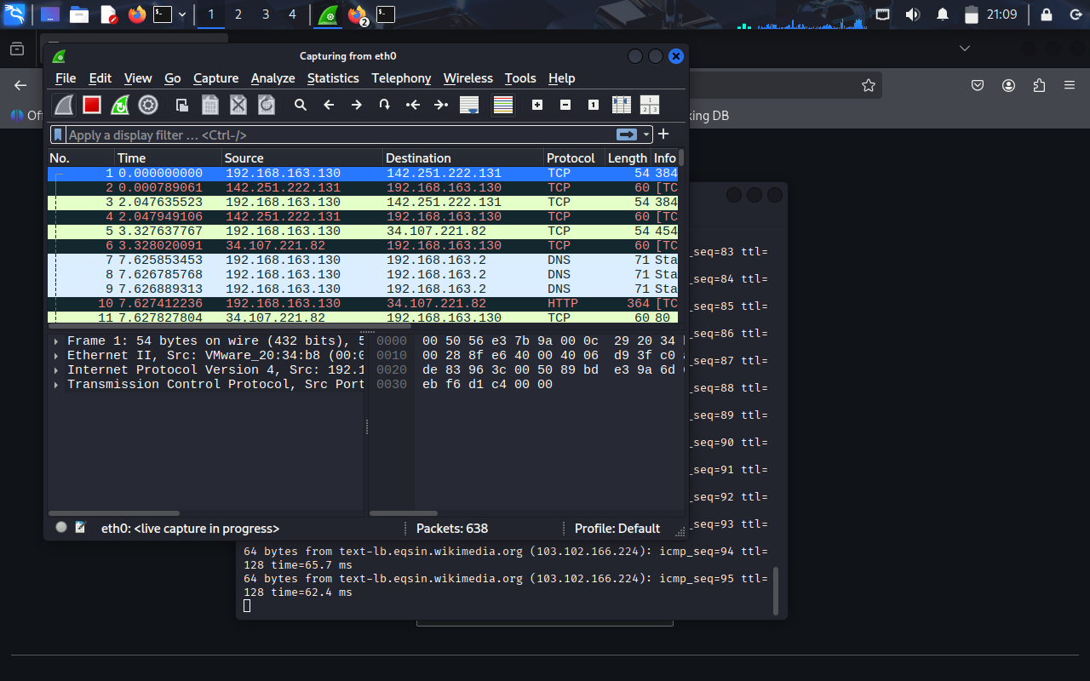

- Start live capture to record traffic.
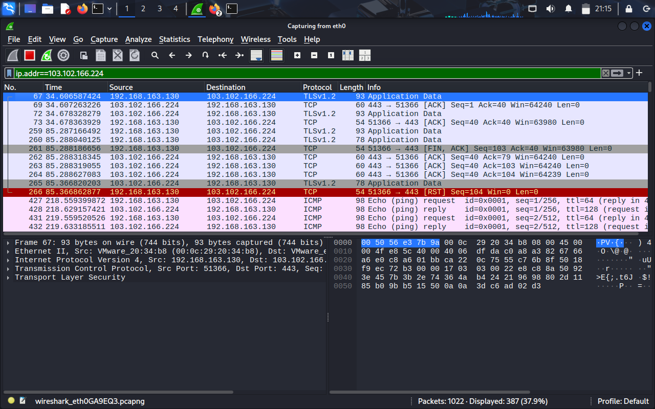

- Run test commands (ping, curl, browsing Wikipedia) to generate traffic.

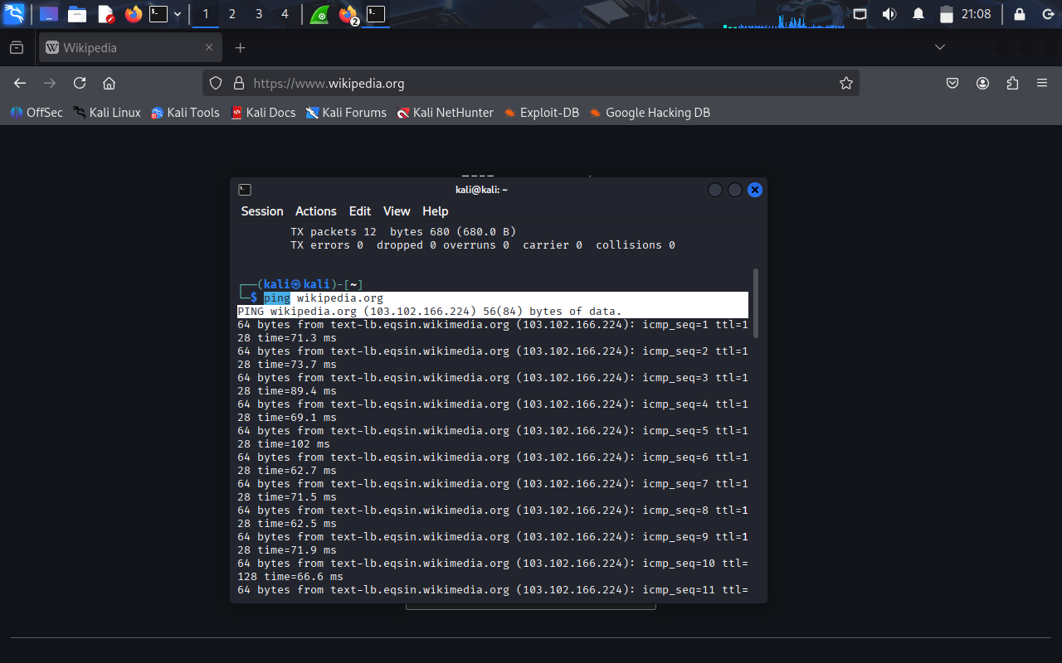

2. Apply Filters:

Use display filters to focus on specific traffic:

- icmp → Show ping requests/replies.

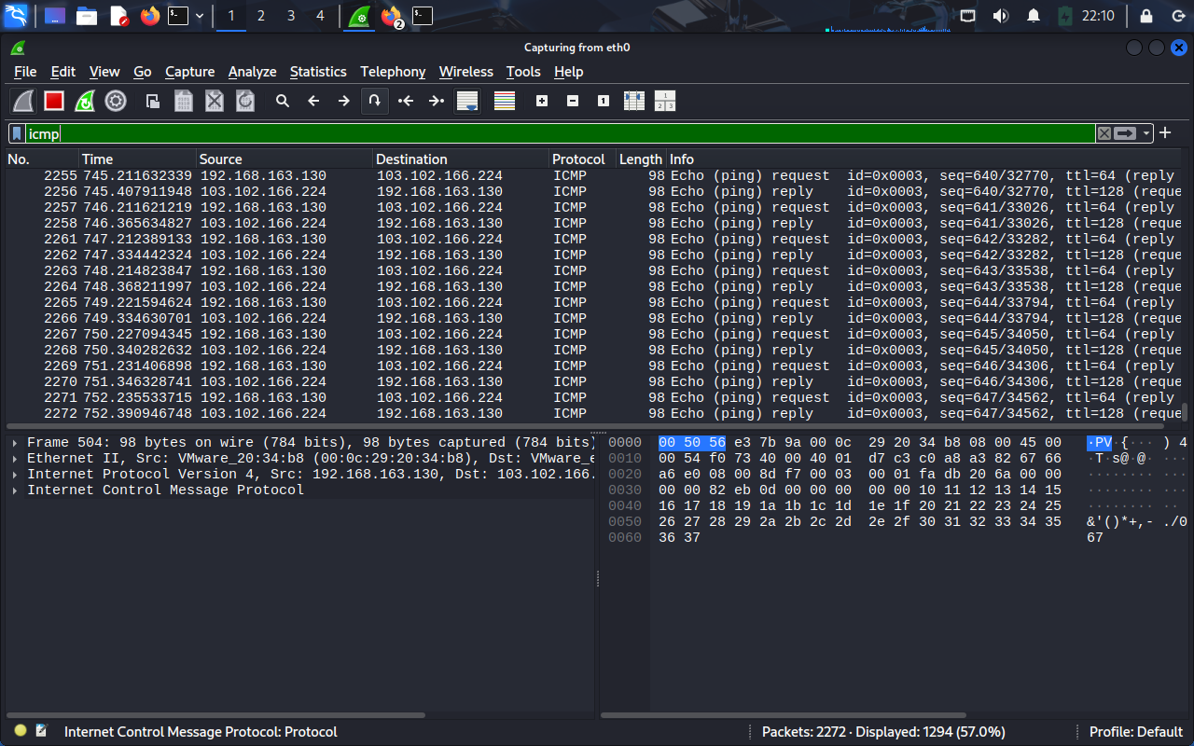

- dns.qry.name == "wikipedia.org" → Show DNS lookup

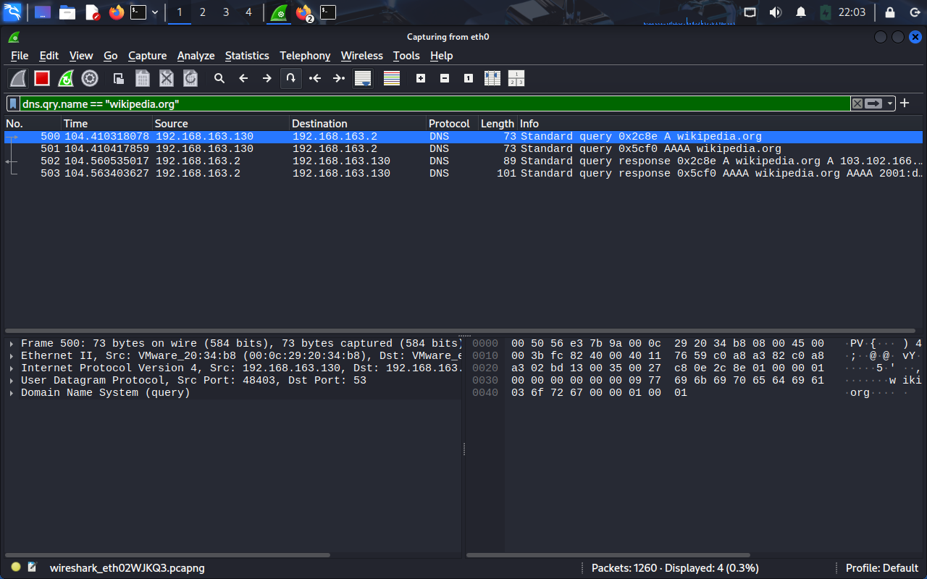

- http.request → Show HTTP GET requests.

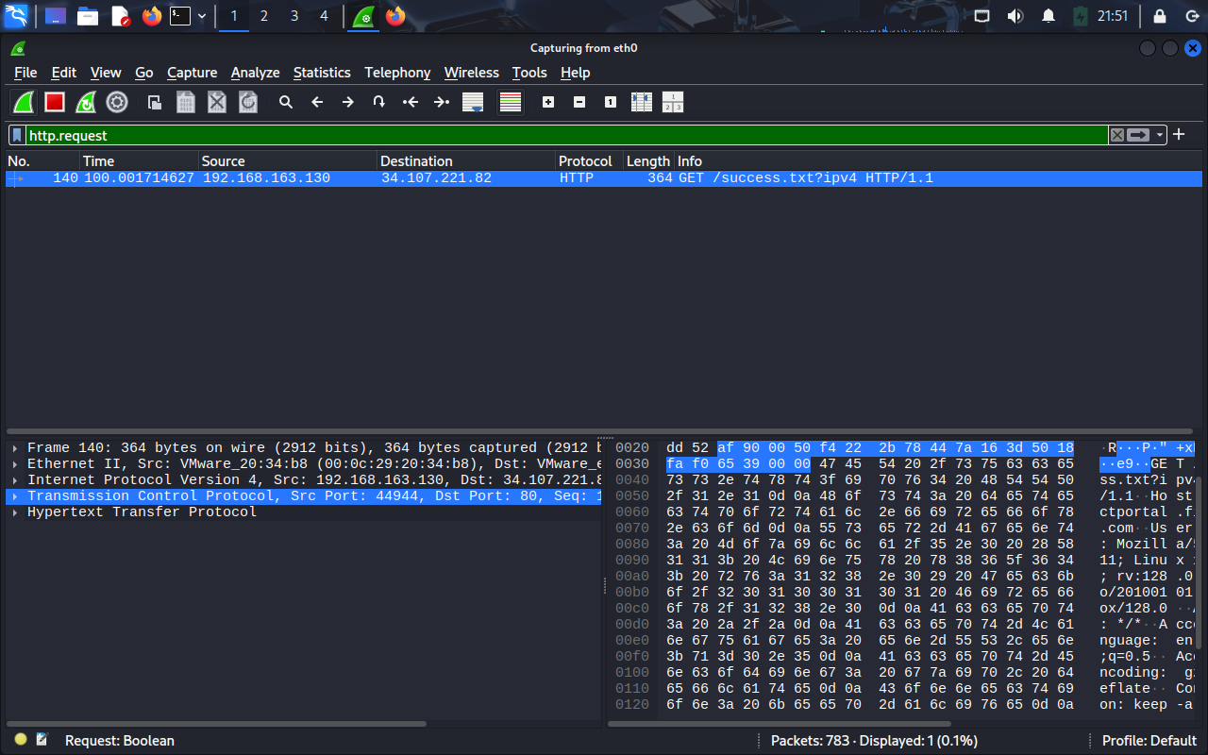

- tcp.stream eq 1 → Follow a single TCP/TLS session.

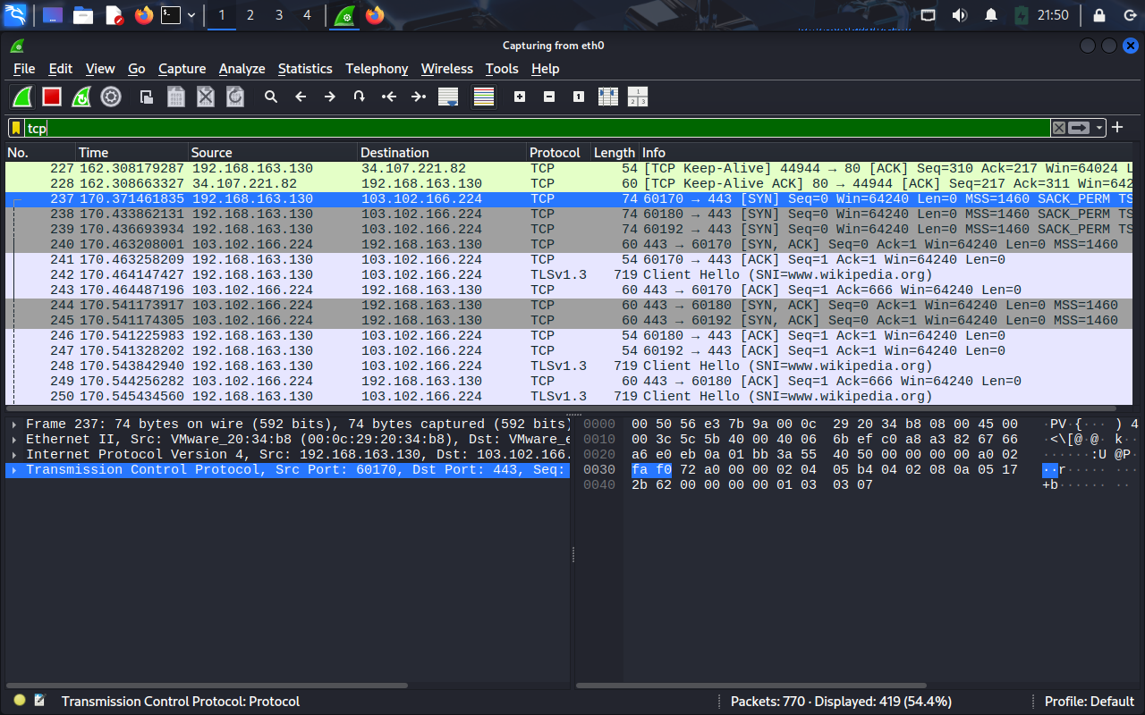
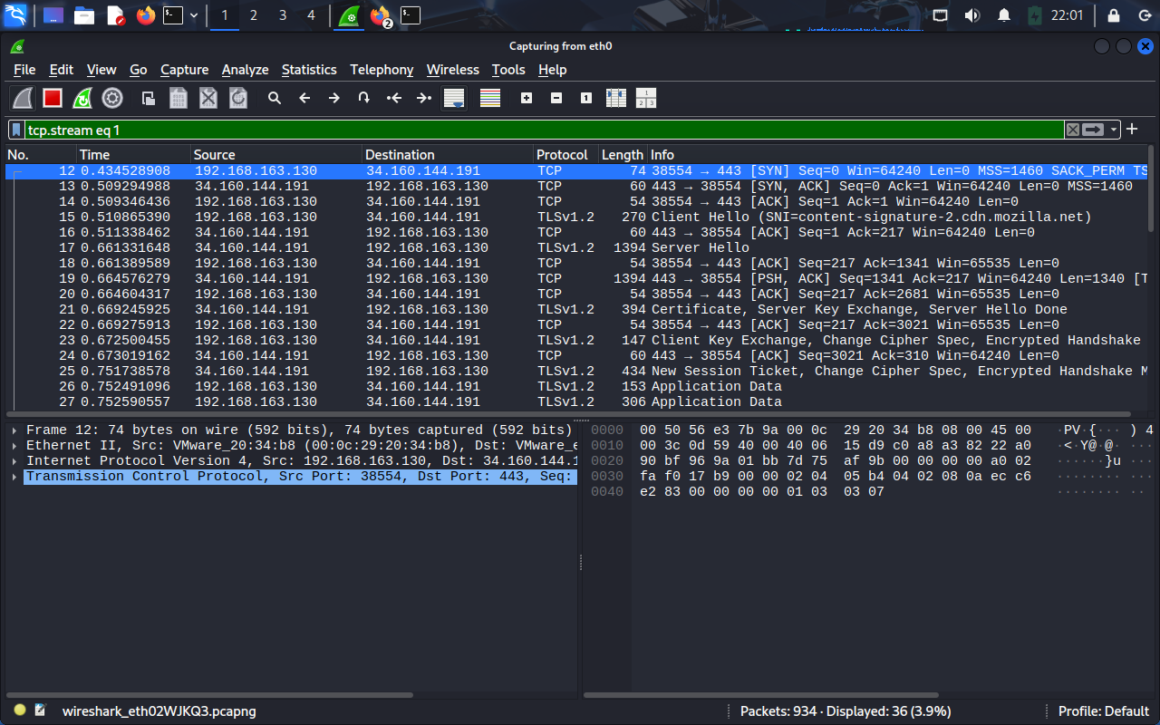

3. Analyze Protocols
- Expand packet details to see Ethernet, IP, TCP/UDP layers.
- Look at flags (SYN, ACK, RST) for TCP handshakes.
- Inspect TLS handshake (Client Hello, Server Hello, Certificate).
- Review HTTP requests/responses (GET, 200 OK).
4. Interpret Results
- Connectivity: ICMP replies confirm reachability.
- DNS: Queries resolve wikipedia.org to IP 103.102.166.224.
- HTTP: Shows request/response exchange with servers.
- TLS: Demonstrates encrypted communication setup.
5. Document Findings
- Summarize each screenshot with context:
  - Ping output → Connectivity check.
  - Wireshark ICMP view → Echo request/reply.
  - DNS filter → Domain resolution.
  - HTTP filter → Web request captured.
  - TLS stream → Secure session establishment.

Final Outcome:
By the end of this project, you have:
- Captured live traffic on the eth0 interface using Wireshark.
- Applied targeted filters (icmp, dns.qry.name, http.request, tcp.stream) to isolate specific communication flows.
- Analyzed multiple protocols:
  - ICMP → Verified connectivity with ping requests/replies.
  - DNS → Observed domain resolution for wikipedia.org.
  - HTTP → Inspected GET requests and server responses.
  - TCP/TLS → Followed handshakes and secure session establishment.
- Interpreted packet details at each layer (Ethernet, IP, TCP/UDP, TLS, HTTP).
- Documented findings with screenshots showing connectivity checks, filtered traffic views, and protocol breakdowns.
Key Learning Outcomes:
- Gained practical experience in network diagnostics.
- Understood how protocols interact (DNS → TCP → HTTP/TLS).
- Learned to filter and focus on relevant traffic in Wireshark.
- Built a step-by-step workflow for analyzing real network communication.
Conclusion:
This project demonstrates how Wireshark can be used not just to capture packets, but to interpret network behavior, troubleshoot issues, and study security protocols. The screenshots provide clear evidence of each stage, making the analysis reproducible and educational.

