# Image Processing Report

Name: Ethan Hebblewhite

Student Number: HEB16608921

Module Name: Image Processing

Module Code: CMP3108M

Date: 06/12/2018

Contents

Task 1 3

Task 2 7

Task 3 9

Task 4 14

# Task 1

This task is to enlarge an image from 556 x 612 to 1668 x 1836 this is an enlarge meant by a factor of 3. Firstly, we are going to see the nearest neighbour image and a zoomed in version of the image at the zebra’s head. Then we are going to see the bilinear image and a zoomed in version at the zebra’s head. Then under the four images will be a small comparison of the images.

Below is the nearest neighbour image. (fig.1)

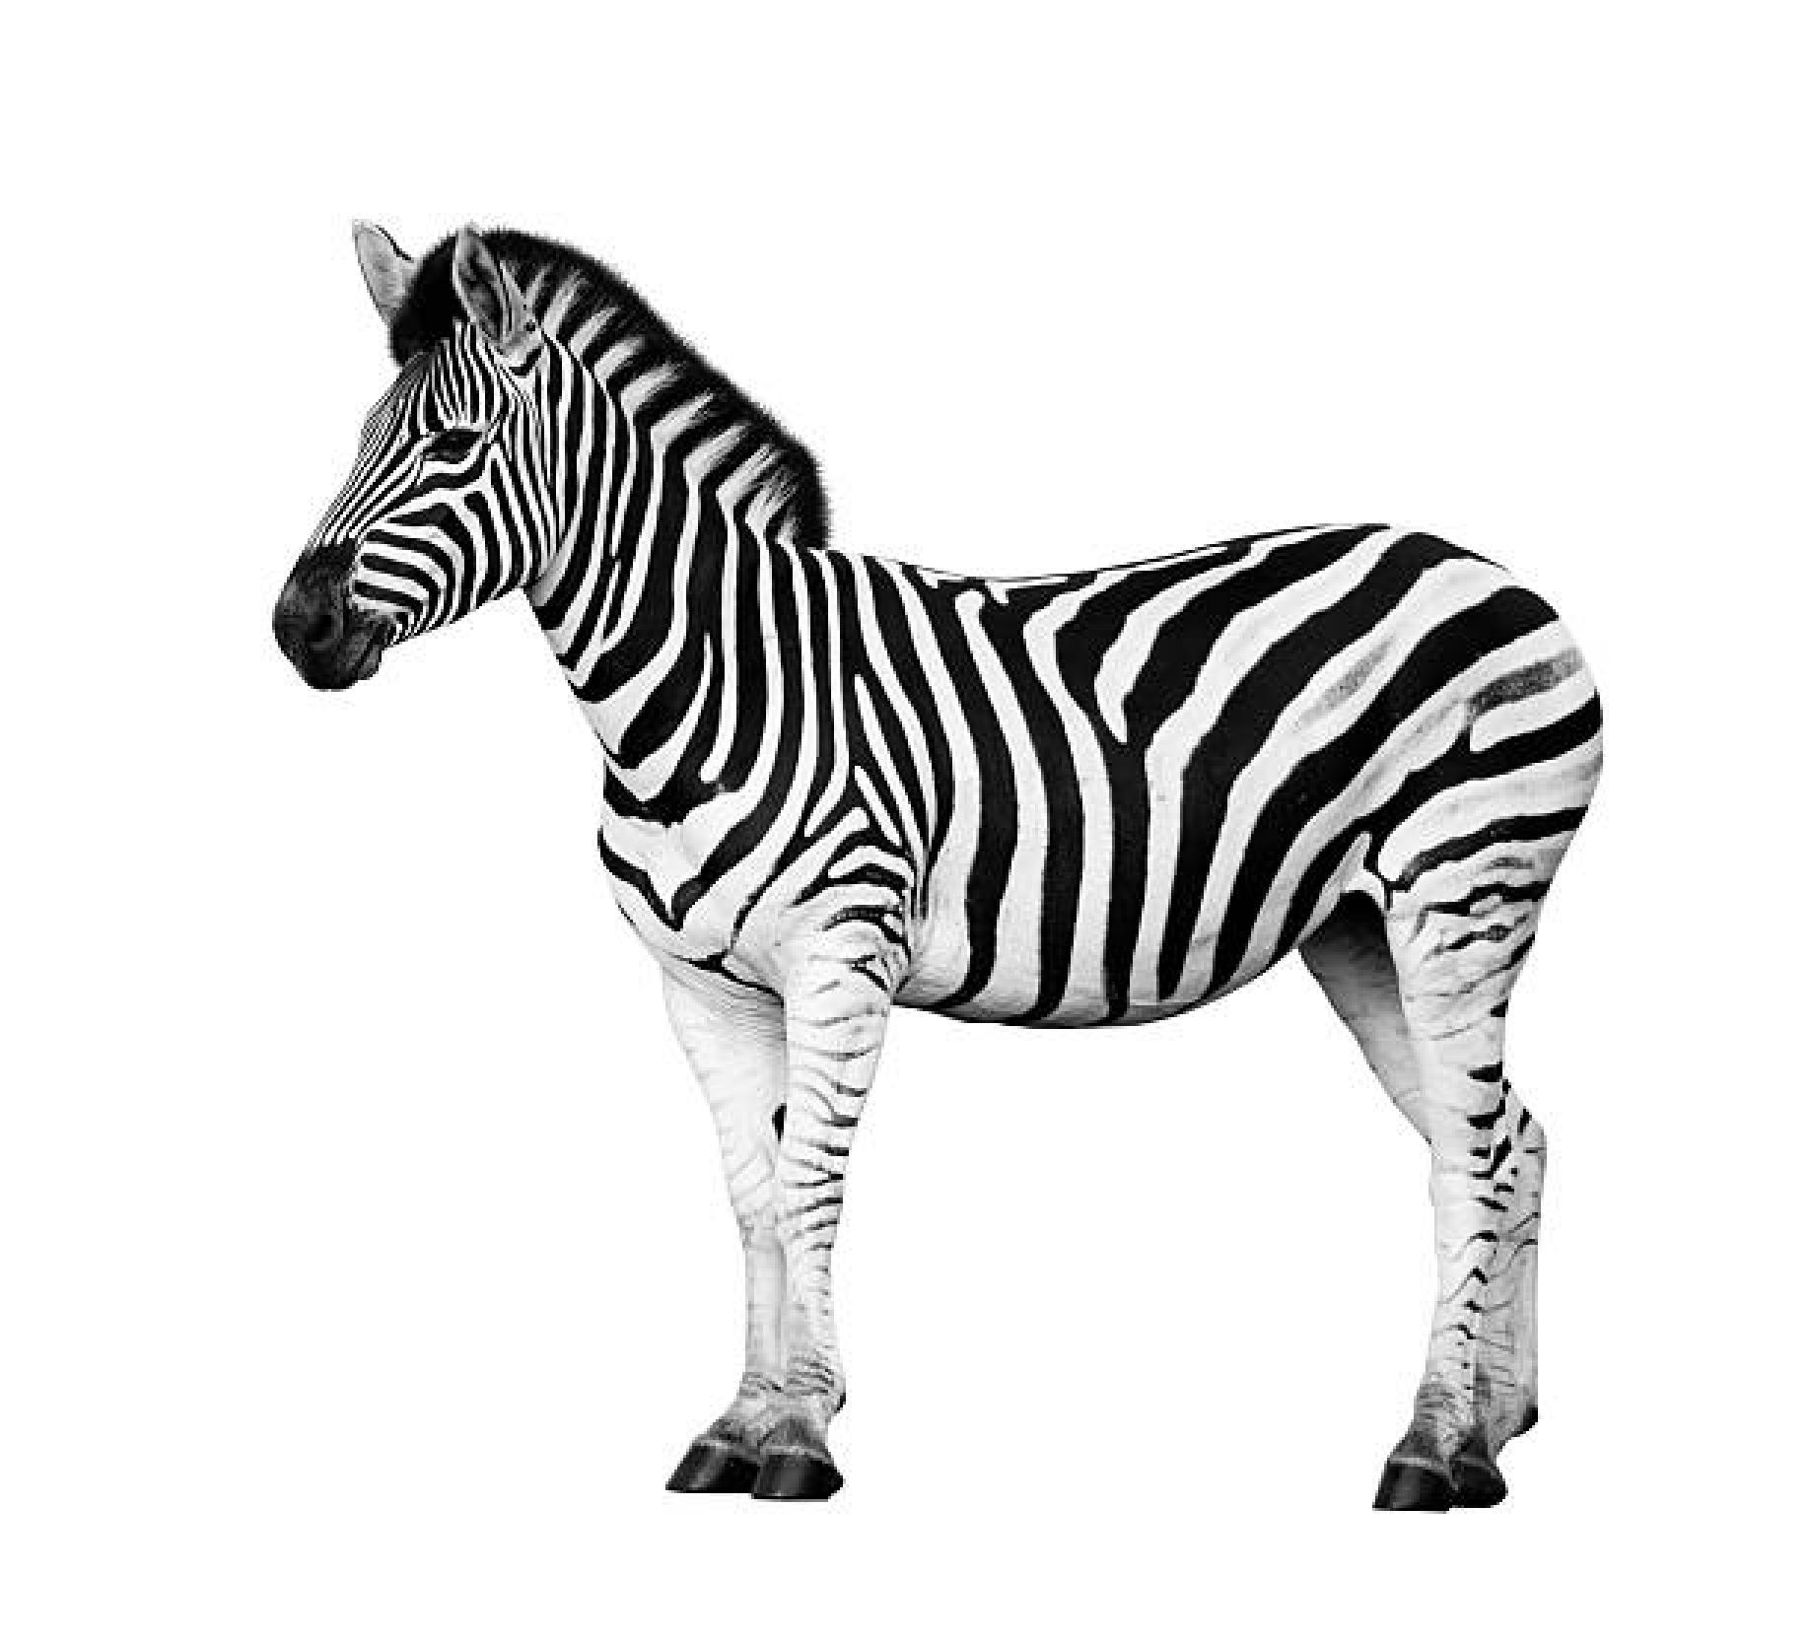

Below is a zoomed in version of the nearest neighbour image. (fig.2)



Below is the bilinear image. (fig.3)

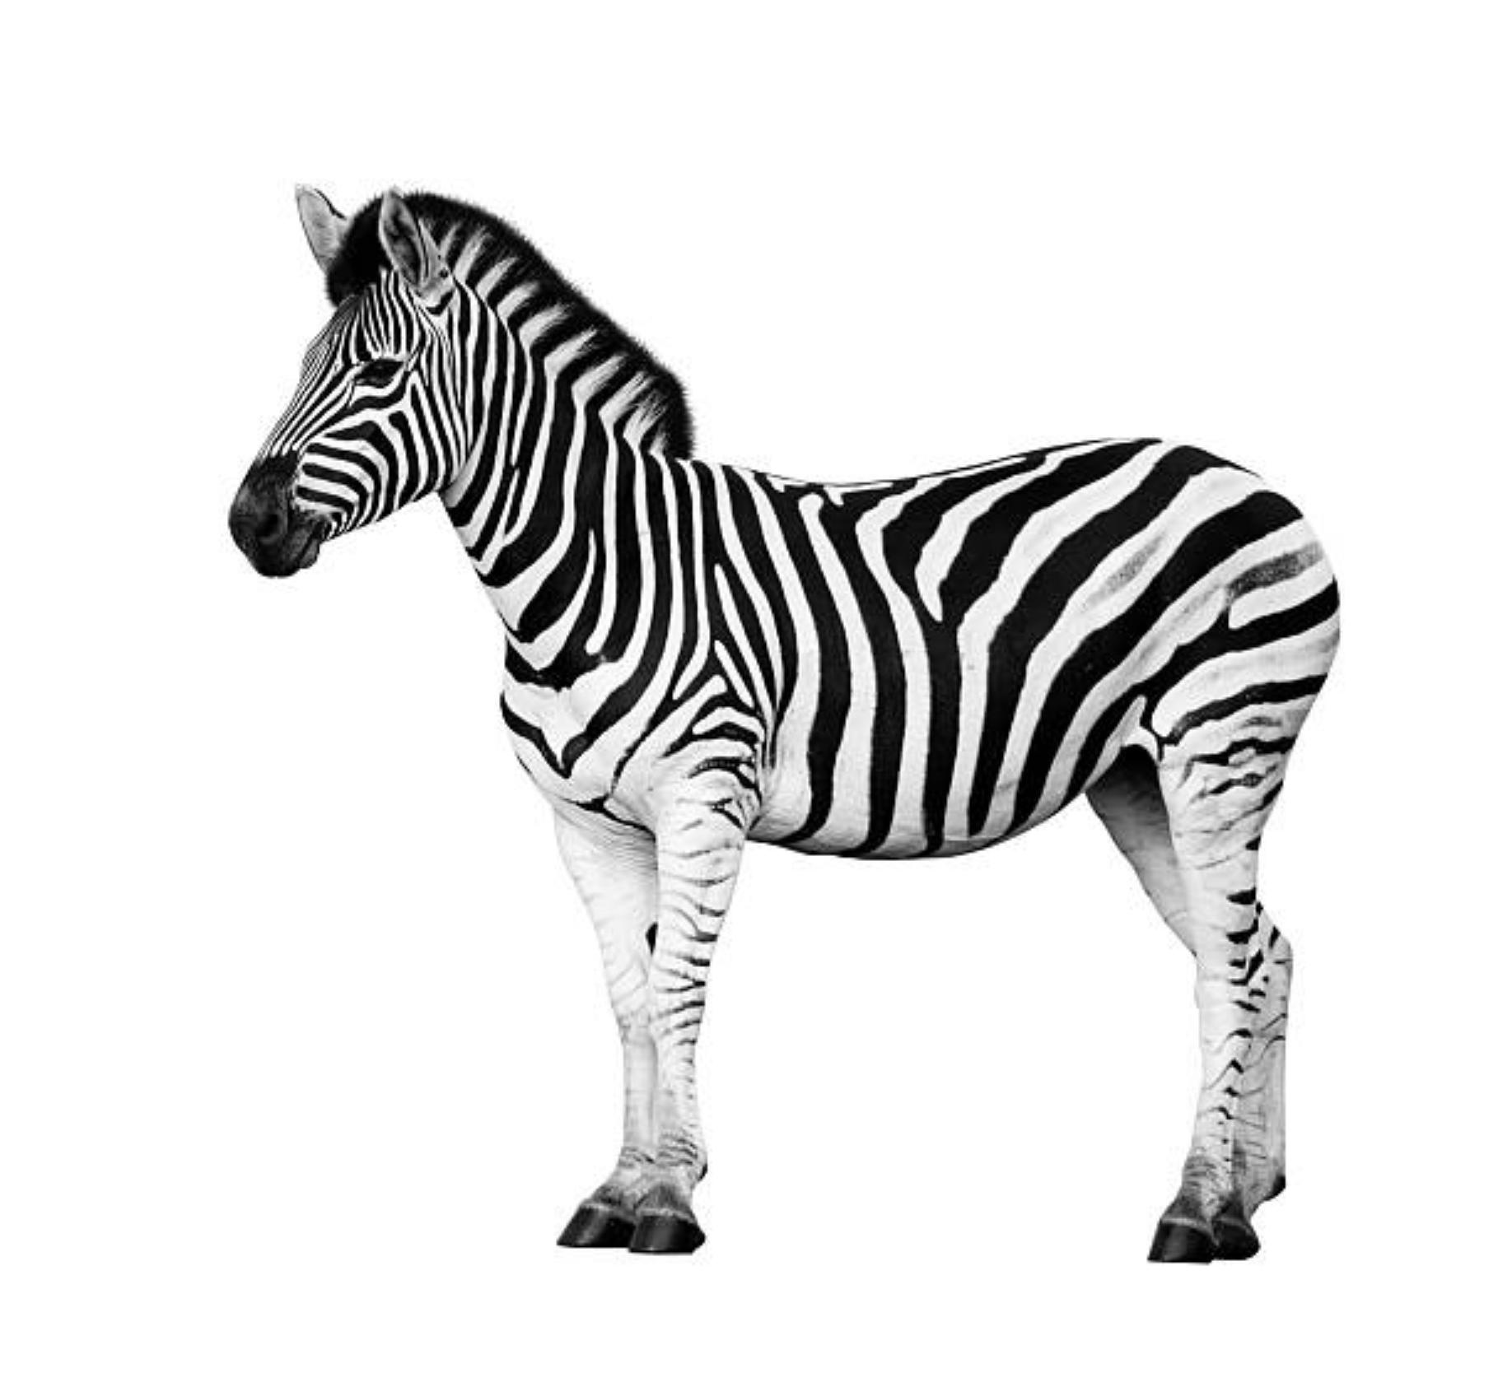

Below is the bilinear zoomed in version. (fig.4)



Now we have seen all 4 images we can compare them. At first if we compare fig.1 and fig.3 we can’t see any differences from the algorithms the images are basically identical. But when we zoom into the image at the head, we can now begin to see a difference between these algorithms. If we look at fig.2 it is very pixelated, this makes the edges very sharp or blocky. It also makes it hard to see the detail in the image when you start to zoom in. When we look at fig.4 the result is completely different. When you zoom into the image, it has very smooth edges but appears blurry, again making the detail hard to see. If you were to zoom into enlarge and image and want to zoom in then I would recommend bilinear interpolation, because then you aren’t going to have an ‘ugly’ photo. This is because even though the image is slightly blurry personally it is better to have an image like this rather than a pixelated one. But the bilinear interpolation is harder to program and in my own use takes longer for certain photos as it has more to do when creating the image.

# Task 2

In this task we were asked to create two images. One image that uses a mean algorithm (averaging algorithm) and an image that uses a median algorithm. The original image had salt and pepper noise, our aim was to implement the algorithms and see if we can eliminate the noise or mask it as best as possible. We also used a kernel with these algorithms of 5 x 5. We will see the mean image first then the median image, after we have seen the images, we will discuss the differences between the images.

Below is the mean image. (fig.5)

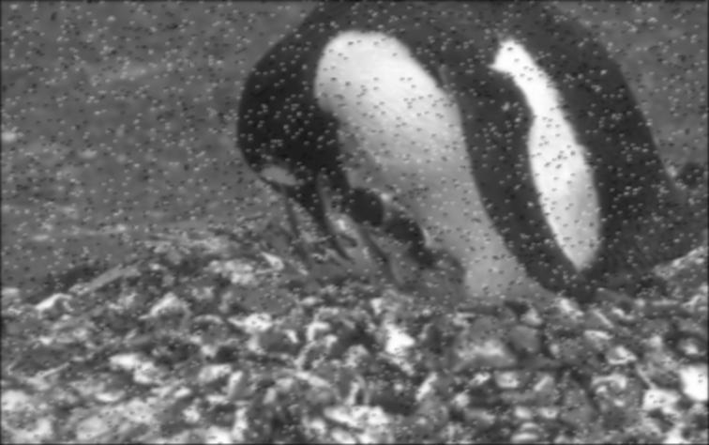

Below is the median image. (fig.6)

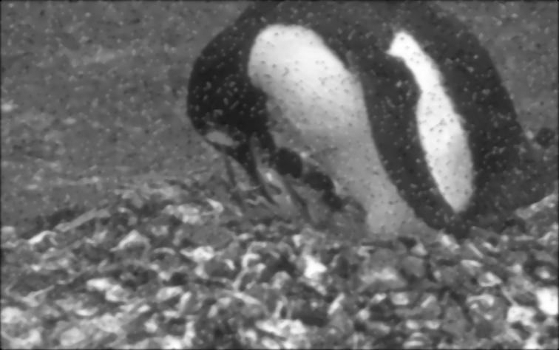

Now we have seen the images we can instantly see a difference between them. The mean image has masked the noise a little, but you can clearly still see the noise. I don’t believe it could’ve gotten rid of the noise completely as it was very severe. But the median image has masked the salt and pepper noise a lot, at some points I would say it is even gone, but you can still see the noise as it was so severe. I used the median algorithm in task 3, as I believed it would give me the best results due to the results from task 2.

# Task 3

In this task we were asked to take an image and remove shapes that weren’t a starfish. So, in this task we are going to look at all the images saved and use them to show how we got to the end image. After the images we are going to discuss them and how they link together.

Below is step one, loading the original image. (fig.7)



Below is step two, turning the image grey. (fig.8)



Below is the grey image without the salt and pepper noise. (fig.9)



Below is the grey image without salt and pepper noise turned into a binary image. (fig.10)



Below is the binary image without some of the larger objects. (fig. 11)



Below is a filter used to remove some of the small objects. (fig.12)



Below is the image but the filter is applied to it. (fig.13)



Below is a filter that was used to keep just the starfish. (fig.14)



Below is an image of just the starfish left. (fig.15)



Below is an image of just the starfish but now it has been converted into the correct binary numbers. (fig.16)



So, from these images we can see the evolution of the image to get the result. Fig.7 is just the original image that is given to us for this task. Fig.8 is just the original image but turned into greyscale version, so there are only values from 0 – 255 but only one value per pixel. Fig.9 is fig.8 but has the median algorithm from task 2 applied to it, this removes the salt and pepper noise that we could see from fig.8. Fig.10 is the same as fig.9 but just a binary version so the image only has 1 or 0 values at a pixel.

Fig.11 has just removed some large objects from the image using imclose and imerode. Fig.12 is the filter that is applied to the image without the big objects, this filter removes anything from the image that is black in the filter. Fig.13 is just results from the filter, showing us what happened when it was applied. Fig.14 is the filter that was applied to fig.13 that allowed us to keep just the starfish as anything in the filter would remain. This filter was created by using imclose and then imerode. Fig.15 shows us the result of the filter and what has happened when the filter is applied to fig.13. Fig.16 is just fig.15 but now the binary values represent the correct things as the brief stated that 0 is no starfish and 1 is a starfish and throughout the task it was the other way around for us.

# Task 4

In this task we were asked to make shape signatures and compare them to a one another. in this section we are going to see a shape signature for a starfish, see the image that it has been selected in and the shape that has been selected outlined in a different colour. We are also going to see the image that the other 4 objects have been taken from, we are going to see each image outlined in a different colour and that colour corresponds to the object. Then we are going to see an image signature with all the signatures on it

Below is the starfish image. (fig.17)



Below is the image where all the other objects have been taken from. (fig.18)



Below is the starfishes shape signature. (fig.19)



Below is the shape signature of shape A. (fig.20)



Below is the shape signature for object B. (fig.21)



Below is the shape signature for object C. (fig.22)



Below is the shape signature for object D. (fig.23)



Below is the shape signature for all the objects and the starfish. (fig.24)



So, fig.17 shows us the image that the starfish was taken from and the starfish data we are gathering from as it is outlined in green at the bottom left hand side of the screen. Fig.18 shows us the image where all the data is getting gathered from. All the objects used are outlined in different colours. Fig.19 shows us the starfishes shape signature, this signature can be used to compare it to other objects to see how alike they are. Fig.20 to fig.23 show us various shape signatures from fig.18. The colours from all the images represent the shapes. Fig.24 shows all the shape signatures together, this is a little harder to see and compare but this is a diagram that has all the shape signatures on allowing us to compare them. As we can see from the shape signatures the shapes are very different and some of the shapes have similarities to the starfish but most of them do not. The closest shape to the starfish from the shape signature is probably fig.21 object b, as it has a similar boarder according to the shape signature.