1


PROJECT TITLE

WEATHERWISE
AI-Powered Weather API Project

Node.js • Express • MongoDB
OpenWeather API • Google AI Studio / Gemini AI
API testing with Thunder Client

2
TEAM ID
SWTID-2026-1094

TEAM LEADER | MAIL ID
YOGESH J | yokeeyokee18@gmail.com

TEAM MEMBERS | MAIL ID
KUMARAN S | kumarans02102006@gmail.com
BHARATH R | bharathmonish40@gmail.com
BHUVANESH P | bhuvanesh2007solai@gmail.com

Introduction
3

  - WeatherWise is a web-based weather application with a RESTful backend.
  - The project combines weather data with AI-generated summaries and recommendations.
  - Users can register, log in and access protected API features.
  - The backend is built with Node.js and Express, with MongoDB used for data storage.
  - Weather and AI services are connected through API integrations.

Objectives
4

- Provide weather information for selected cities.

- Enable secure user registration and login.

- Manage favorite locations.

- Generate AI-based weather summaries.

- Display real-time weather conditions.

- Use OpenWeather API for weather data.

- Integrate Google AI Studio for AI features.

- Demonstrate REST API development and testing.

Technologies & Tools Used
5

  - Node.js – server-side JavaScript runtime.
  - Express.js – REST API and route handling.
  - MongoDB with Mongoose – database and data modelling.
  - Google Generative AI / Gemini – AI weather insights.
  - OpenWeather – weather data source.
  - JWT and bcryptjs – authentication and password security.
  - Thunder Client – API request and response testing.
  - VS Code – development environment.

System Architecture & Workflow
6



User / Frontend
Express REST API
MongoDB

OpenWeather

Gemini AI

1. User sends a request → 2. Express processes the request → 3. Database/service is accessed → 4. JSON response is returned. Weather data is obtained from the weather service, while AI endpoints use weather values to generate human-readable insights.


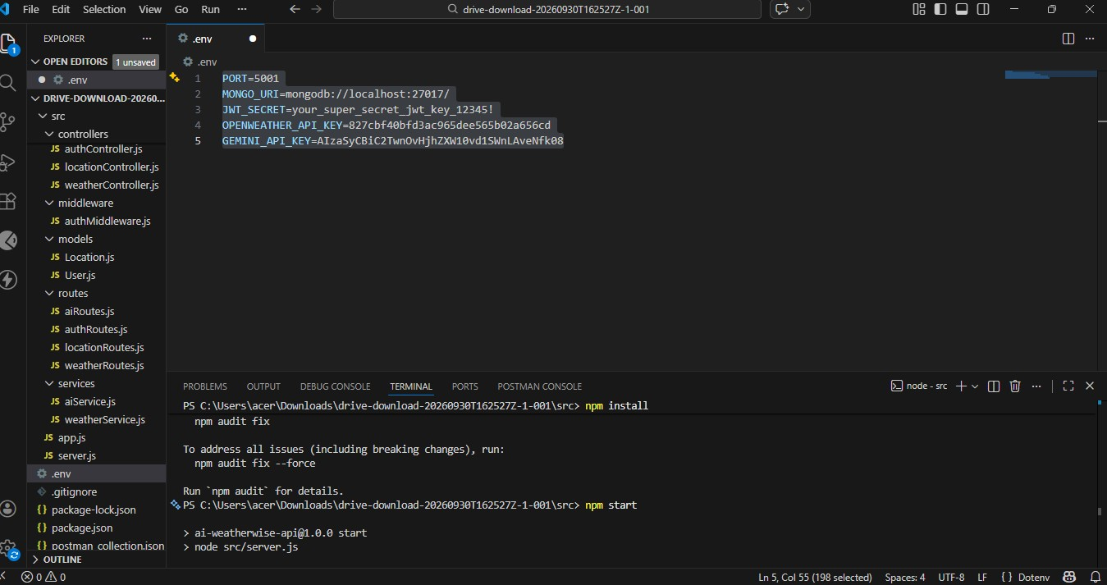
Run and Connecting server to mongodb


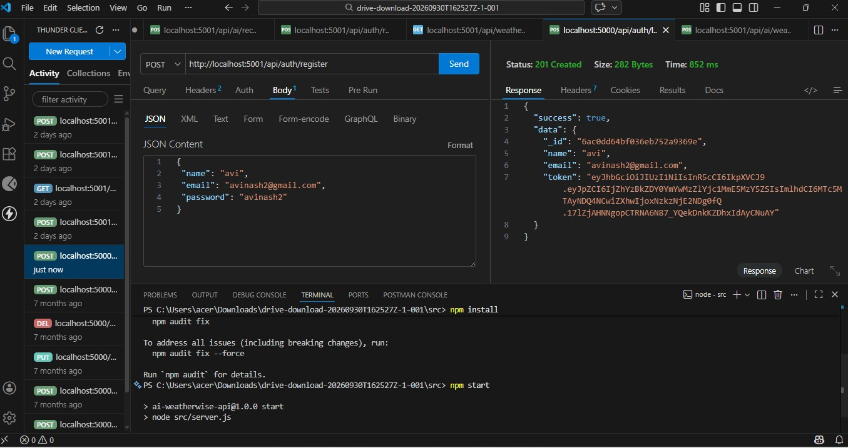
User Authentication – REGISTER API
Thunder Client test result

7


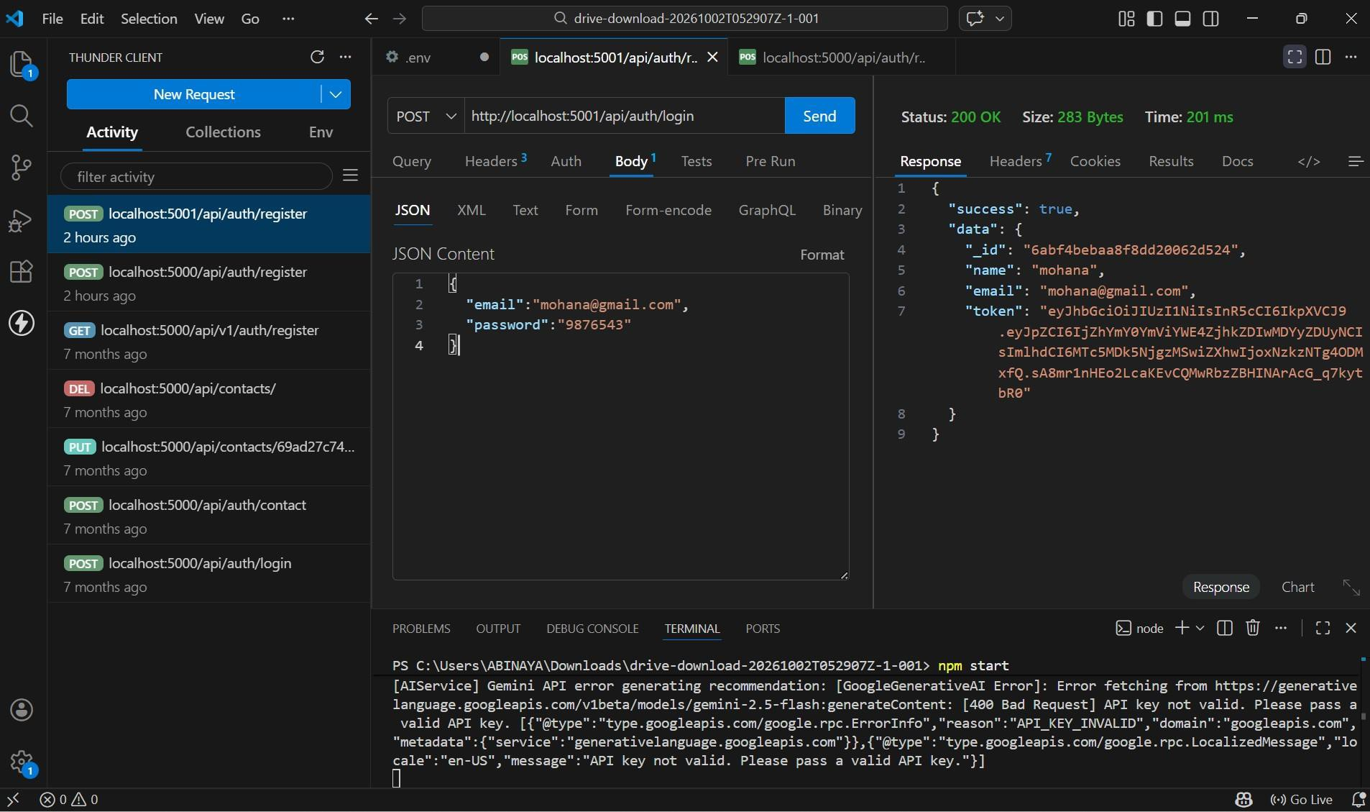
User Authentication – LOGIN-API
Thunder Client test result

8


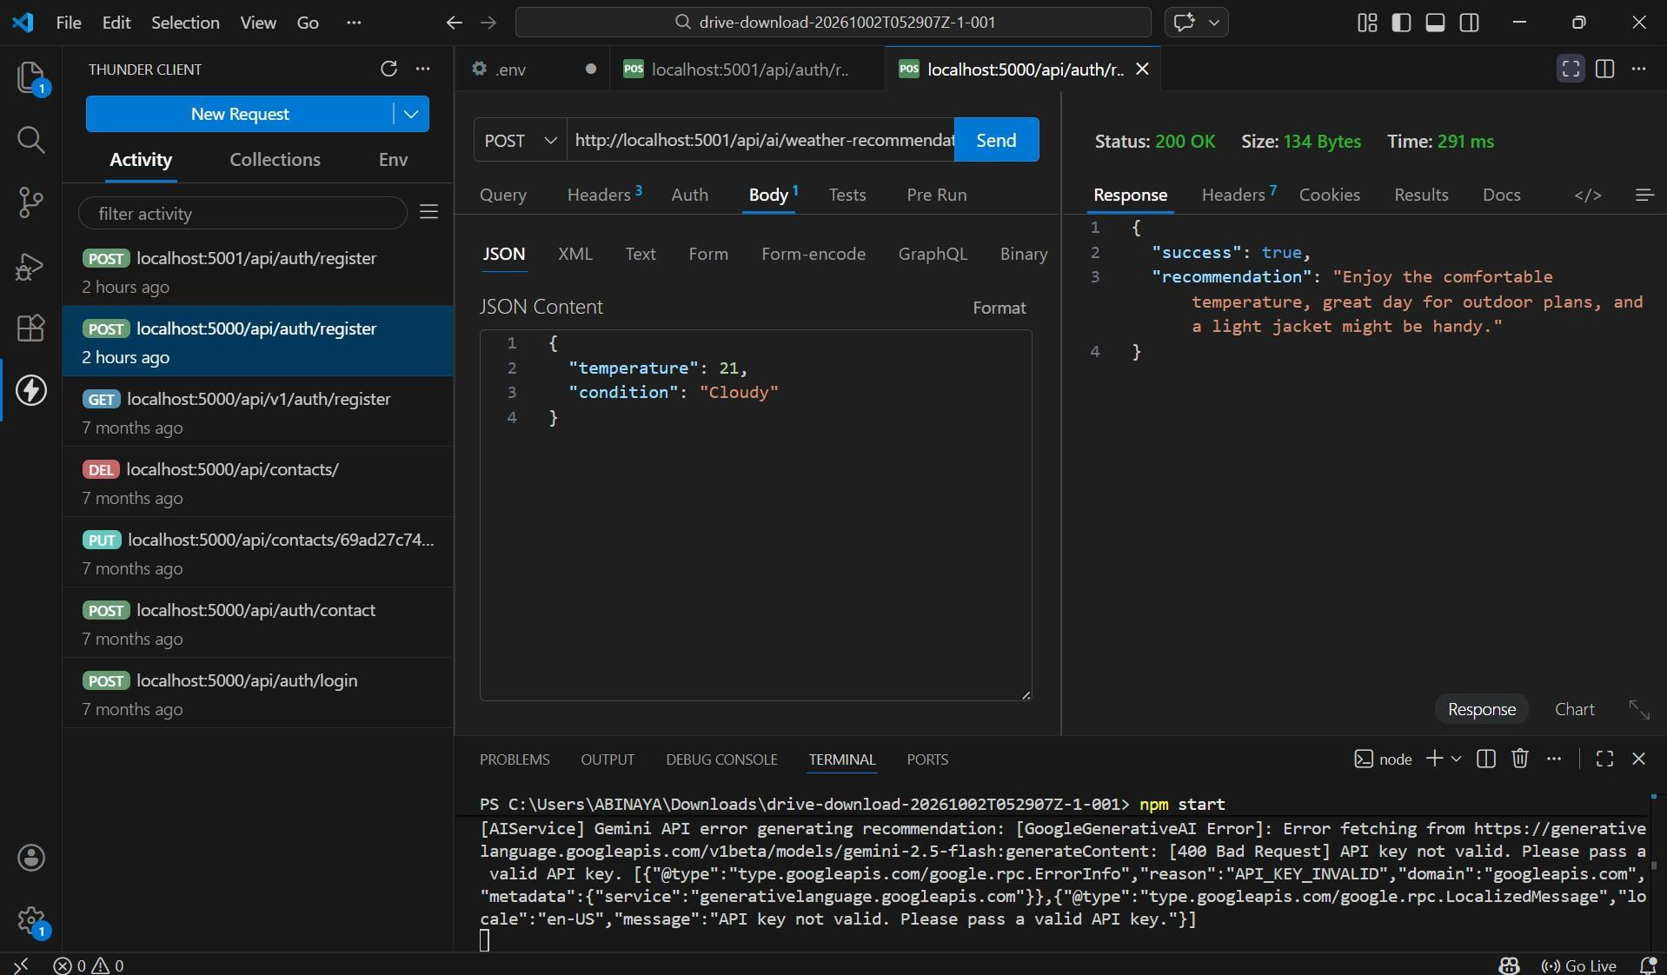
AI Weather Recommendation
Thunder Client test result

9

Main API Modules
10

  - Authentication: Register User, Login User and Get User Profile.
  - Locations: Add, View, Update and Delete favorite locations.
  - Weather: Get current weather for a city.
  - AI Insights: Generate AI weather summary and AI weather recommendation.
  - Protected endpoints use bearer-token authentication where required.

API Testing & Results
11

  - Thunder Client is used to send HTTP requests and inspect JSON responses.
  - The Login API screenshot shows a successful 200 OK response with user data and an
authentication token.
  - The AI recommendation test shows a successful 200 OK response containing a generated recommendation.
  - The screenshots represent the current project testing stage.
  - The terminal also shows a Gemini API-key error message in the captured run, indicating that the AI configuration needs a valid key for reliable AI generation.

Features & Future Enhancements
12

  - Current features: authentication, favorite locations, current weather, AI summary and AI
recommendation.
  - Future enhancement: add multi-day forecast and hourly forecast views.
  - Future enhancement: add automatic location detection and weather maps.
  - Future enhancement: improve AI prompts and provide more personalized recommendations.
  - Future enhancement: add a polished responsive frontend dashboard.

Conclusion
13

  - WeatherWise demonstrates practical REST API development with weather and AI integrations.
  - The project combines authentication, database operations, external weather data and Gemini-
based insights.
  - API testing confirms successful authentication and AI recommendation responses in the captured tests.
  - The project can be extended into a complete AI-assisted weather dashboard.

14

