WEEK-1

MANDATORY HANDS-ON

Design principles & Patterns

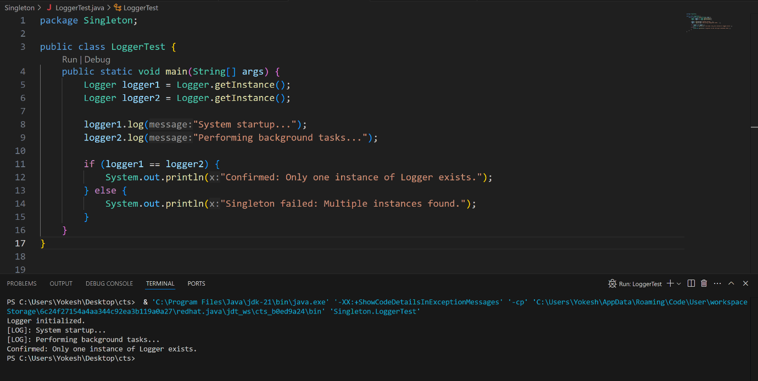
Exercise 1: Implementing the Singleton Pattern

Exercise 2: Implementing the Factory Method Pattern
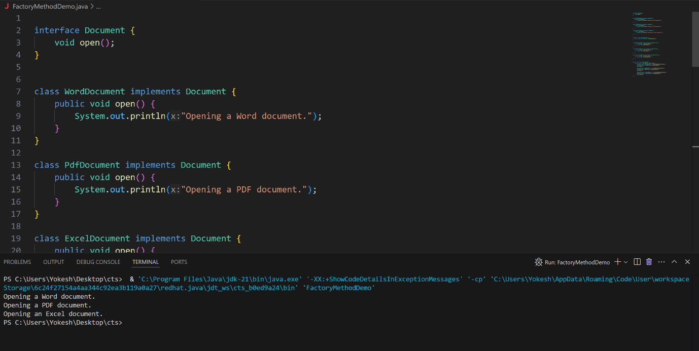

Data structures and Algorithms:

Exercise 2: E-commerce Platform Search Function

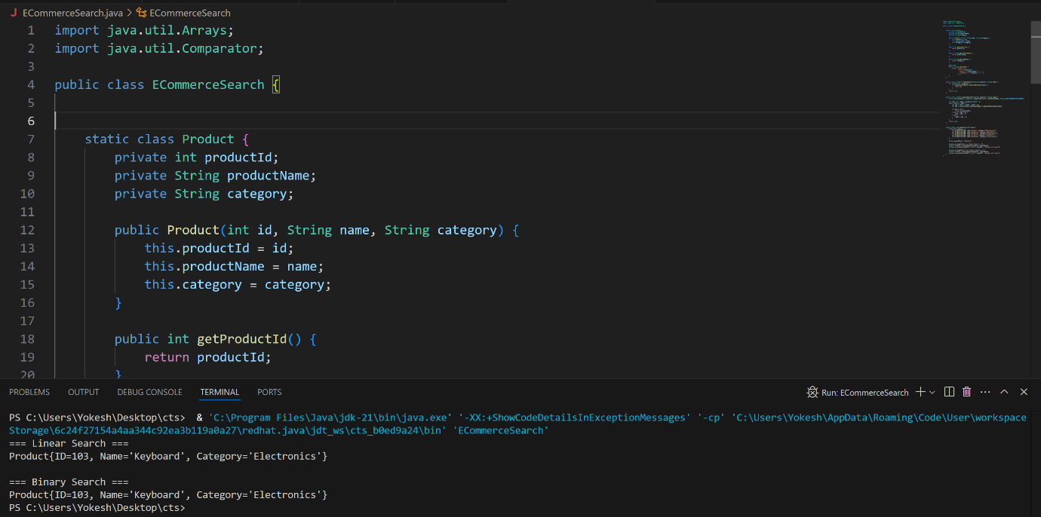

Exercise 7: Financial Forecasting

