PET Engineering College, Vallioor
Department of Computer Science & Engineering
Internal Assessment Test – II

CS6302-Database Management Systems
Date:18.09.17 Marks : 50
Semester : III Answer ALL Questions Time : 90 mts
LEVEL:L
PART A: (2 * 5=10) LEVEL
- What is normalization? State the need for normalization. (R)
- Find the difference between the terms serial schedule and serializable schedule. (L)
- What do you mean by a transaction? Write the properties of a transaction. (R)
- What is ‘dirty read’ in a concurrent processing? (U)
- Define recoverability. (R)

PART B: (2*15=30)
6.a) What is deadlock? Describe about the deadlock handling schemes. (15) (U)
(or)
b) Explain relational algebra operations with example. (15) (L)

7.a.i) Illustrate query processing in detail. (10) (U)
ii)Represent states of a transaction.(5) (U)
(or)
b) Explain concurrency control techniques. (15) (U)

PART C: (1*10=10)

8) Consider the following schedules. The actions are listed in the order they are scheduled, and prefixed (A)
with the transaction names.
S1: T1:R(x) T2:R(x) T1:W(y) T2:W(y) T1:R(y) T2:R(y)
S2: T3:W(x) T1:R(x) T1:W(y) T2:R(z) T2:W(z) T3:R(z)

For each of the schedules, answer the following questions: (10)
i)What is the precedence graph for the schedule?
ii)Is the schedule conflict serializable? If so, what are the conflict equivalent serial schedules?
------------------------------------------------------------
Question Type | Weightage | Percentage
R | 2m(3) | 7.5
U | 2m(1),5m(1),10m(1),15m(2) | 58.75
A | 10m(1) | 12.5
L | 2m(1),15m(1) | 21.25
E | Nil | 0
C | Nil | 0

ANSWER KEY
PART A: (2 * 5=10)
- What is normalization? State the need for normalization. Normalization is the process of analyzing the relational schema based on primary key and the functional dependencies to reduce data redundancy and avoid null values.
Need:
Normalization is a method to remove all the anomalies and bring the database to a consistent state.

- Find the difference between the terms serial schedule and serializable schedule. Serial schedule: A serial schedule is a schedule that executes all of the operations from one transaction before moving on to the transaction.
Serializable schedule: A serializable schedule is a concurrent schedule that has the same effect on the database as a serial schedule.

3. What do you mean by a transaction? Give the properties of a transaction.
Collections of operations that form a single logical unit of a work is called a transaction.
Eg: Transferring amount from an account
The properties of transactions are:
- Atomicity
- Consistency
- Isolation
- Durability
.
4. What is ‘dirty read’ in a concurrent processing?
Dirty read is a problem that may occur in a concurrent schedule at which a transaction reads a nonexistent value.

5. Define recoverability.
It is a database system recovery scheme that can restore database to the consistent state that existed before failure.

PART B: (2*15=30)
6.a) What is deadlock? Describe about the deadlock handling schemes. (15)
- Deadlock Definition: 2m
- Deadlock handling schemes: 13m
i)Deadlock prevention:5m
Wait - Die algorithm
Wound - wait
ii) Deadlock detection :4m
wait - for graph (WFG) .
iii)Recovery:4m
roll back
(or)
6.b) b) Explain relational algebra operations with example. (15)
Definition & purpose: 2m
Types of operations: 3m
Example for each type:10m
It is a procedural query language that forms basis for “high level” query languages ( SQL)
- Set Operations:
  - union, intersection, Cartesian product, set difference
- Algebric Operations:
  - selection, projection, join, division
7.a.i)Illustrate query processing in detail. (10)
Defintion:2m
Steps:2m
Diagram:3m
Explanation:3m
1. Parsing and translation
2. Optimization
3. Evaluation
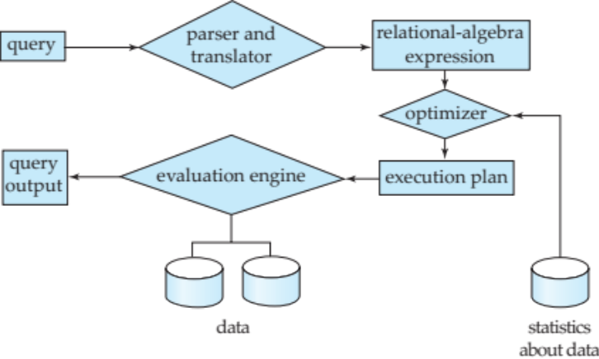
.
7.b) Explain concurrency control techniques. (15)
Description of concurrency control:2m
Listing concurrency control techniques:1m
Lock based protocol: 6m
Timestamp based protocol: 6m

PART C:(1*10=10)
8) Consider the following schedules. The actions are listed in the order they are scheduled,
and prefixed with the transaction names.
S1: T1:R(x) T2:R(x) T1:W(y) T2:W(y) T1:R(y) T2:R(y)
S2: T3:W(x) T1:R(x) T1:W(y) T2:R(z) T2:W(z) T3:R(z)
For each of the schedules, answer the following questions: (10)
i)What is the precedence graph for the schedule?
ii)Is the schedule conflict serializable?If so, What are the conflict equivalent serial schedules?

Schedule diagram: 2m
Precedence graph: 3m
Testing serializability: 3m
Equivalent serial schedule: 2m

