AD3002 - HEALTH CARE ANALYTICS
ASSIGNMENT-2

Clinical Prediction Models- Apply any one DL alg

INPUT:
import numpy as np
import pandas as pd
import matplotlib.pyplot as plt

import tensorflow as tf
from tensorflow import keras
from tensorflow.keras import layers
from tensorflow.keras.models import Sequential
from tensorflow.keras.layers import Conv2D, MaxPooling2D, Dense, Flatten
from tensorflow.keras.metrics import BinaryAccuracy, Precision, Recall
import warnings
warnings.filterwarnings("ignore")
tf.keras.backend.clear_session()

INPUT:
from google.colab import drive
drive.mount('/content/drive')

OUTPUT:

INPUT:
data = keras.utils.image_dataset_from_directory("../content/drive/MyDrive/HEALTH CARE ANALYTICS/brain_tumor_dataset")

OUTPUT:

INPUT:
batch = data.as_numpy_iterator().next()

INPUT:
fig, ax = plt.subplots(3, 5, figsize=(15,10))
ax = ax.flatten()
for idx, img in enumerate(batch[0][:15]):
ax[idx].imshow(img.astype(int))
ax[idx].title.set_text(batch[1][idx])

OUTPUT:
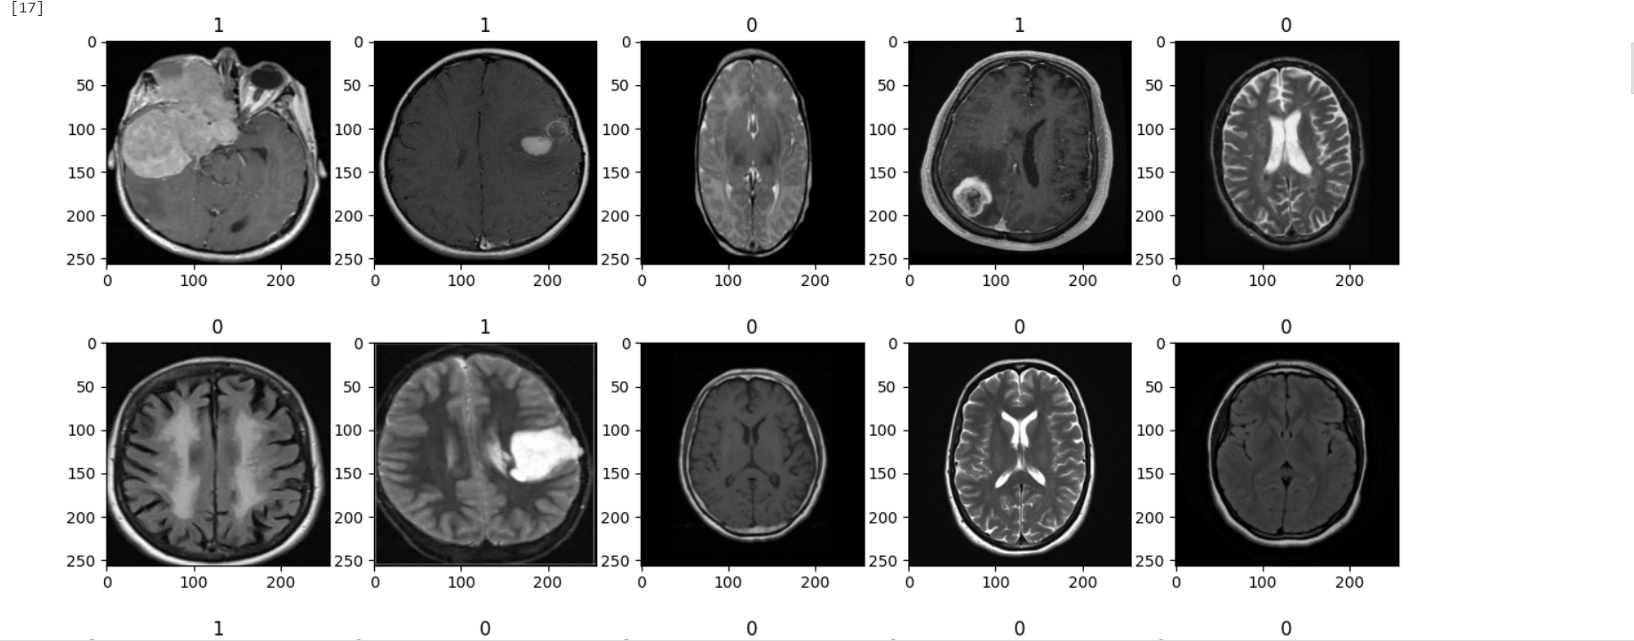
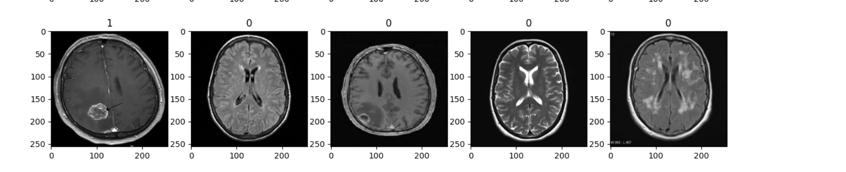

INPUT:
data = data.map(lambda x,y: (x/255, y))
batch = data.as_numpy_iterator().next()

INPUT:
print("Minimum value of the scaled data:", batch[0].min())
print("Maximum value of the scaled data:", batch[0].max())

OUTPUT:

INPUT:
print("There are", len(data), "batches in our data")

OUTPUT:


INPUT:
train_size = int(len(data)*0.6)
val_size = int(len(data)*0.2)+1
test_size = int(len(data)*0.2)+1
print("Train Size:", train_size)
print("Validation Size:", val_size)
print("Test Size:", test_size)

print("Sum of Train, Validation and Test sizes is equal to:", train_size + val_size + test_size)

OUTPUT:
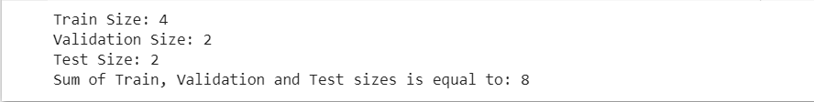
INPUT:
train = data.take(train_size)
val = data.skip(train_size).take(val_size)
test = data.skip(train_size + val_size).take(test_size)
batch = data.as_numpy_iterator().next()

INPUT:
data_augmentation = Sequential([
layers.RandomFlip("horizontal_and_vertical", input_shape=(256,256,3)),
layers.RandomZoom(0.1),
layers.RandomContrast(0.1),
layers.RandomRotation(0.2)
])

image = batch[0]

plt.figure(figsize=(10, 10))
for i in range(9):
augmented_image = data_augmentation(image)
ax = plt.subplot(3, 3, i + 1)
plt.imshow(augmented_image[0])
plt.axis("off")

OUTPUT:

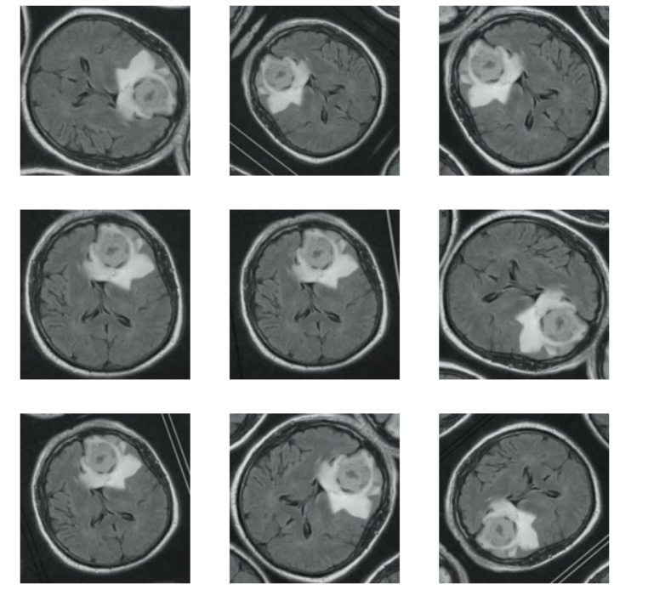

INPUT:
model = Sequential([
data_augmentation,
Conv2D(16, (3,3), 1, activation="relu", padding="same"),
Conv2D(16, (3,3), 1, activation="relu", padding="same"),
MaxPooling2D(),
Conv2D(32, (5,5), 1, activation="relu", padding="same"),
Conv2D(32, (5,5), 1, activation="relu", padding="same"),
MaxPooling2D(),
Conv2D(16, (3,3), 1, activation="relu", padding="same"),
Conv2D(16, (3,3), 1, activation="relu", padding="same"),
MaxPooling2D(),

Flatten(),
Dense(128, activation="relu"),
Dense(1, activation="sigmoid")
])
model.compile(optimizer="adam", loss=keras.losses.BinaryCrossentropy(), metrics=["accuracy"])
model.summary()

OUTPUT:
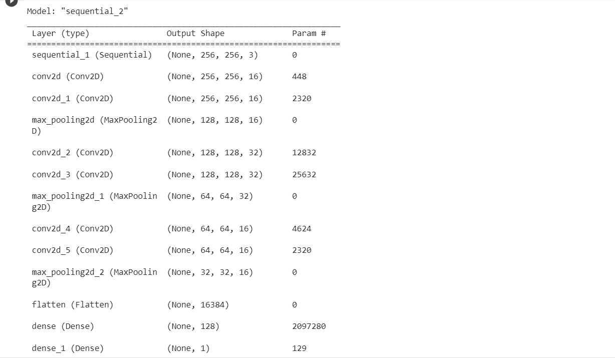

INPUT:
history = model.fit(train, epochs=5, validation_data=val)

OUTPUT:
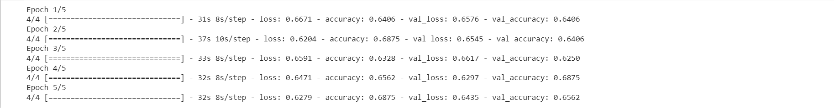
INPUT:
fig, ax = plt.subplots(2, 1, figsize=(10,8))

ax[0].plot(history.history["loss"], label="Train")
ax[0].plot(history.history["val_loss"], label="Validation")
ax[0].title.set_text("Loss")
ax[0].legend()

ax[1].plot(history.history["accuracy"], label="Train")
ax[1].plot(history.history["val_accuracy"], label="Validation")
ax[1].title.set_text("Accuracy")
ax[1].legend()

plt.show()

OUTPUT:
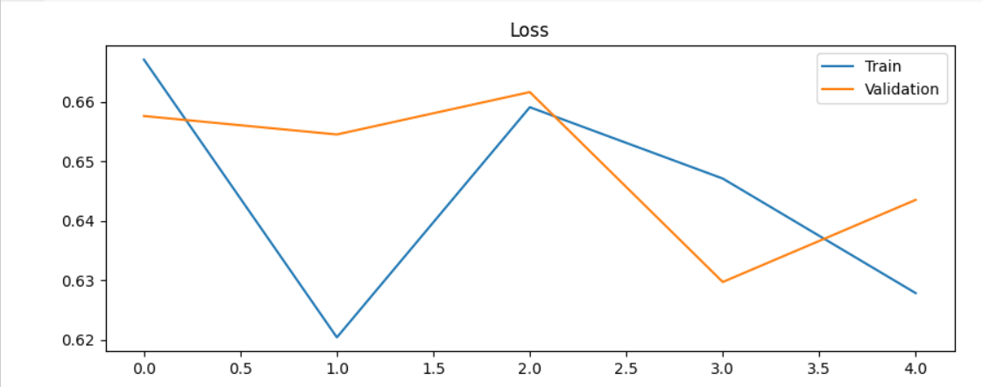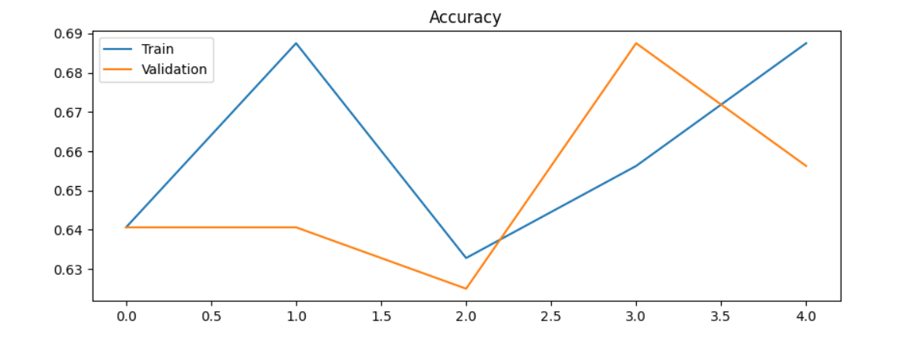
INPUT:

bin_acc = BinaryAccuracy()
recall = Recall()
precision = Precision()

for batch in test.as_numpy_iterator():
X, y = batch
yhat = model.predict(X)
bin_acc.update_state(y, yhat)
recall.update_state(y, yhat)
precision.update_state(y, yhat)

print("Accuracy:", bin_acc.result().numpy(), "\nRecall:", recall.result().numpy(), "\nPrecision:", precision.result().numpy())

OUTPUT:

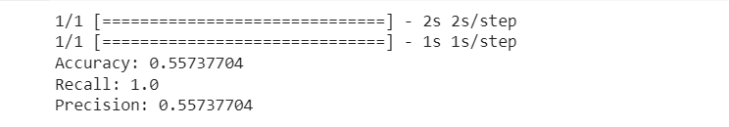

INPUT:
batch = test.as_numpy_iterator().next()
img, label = batch[0][15], batch[1][15]
plt.imshow(img)
if label==1:
plt.title("Brain with Tumor")
else:
plt.title("Brain with No Tumor")
plt.show()

OUTPUT: 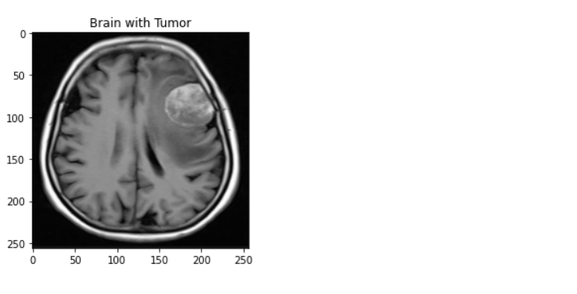

INPUT:

y_hat = model.predict(np.expand_dims(img, 0))
y_hat

OUTPUT:
INPUT:
if y_hat < 0.5:
print("No tumor detected")
else:
print("Tumor detected")

OUTPUT:

