ER – Diagram
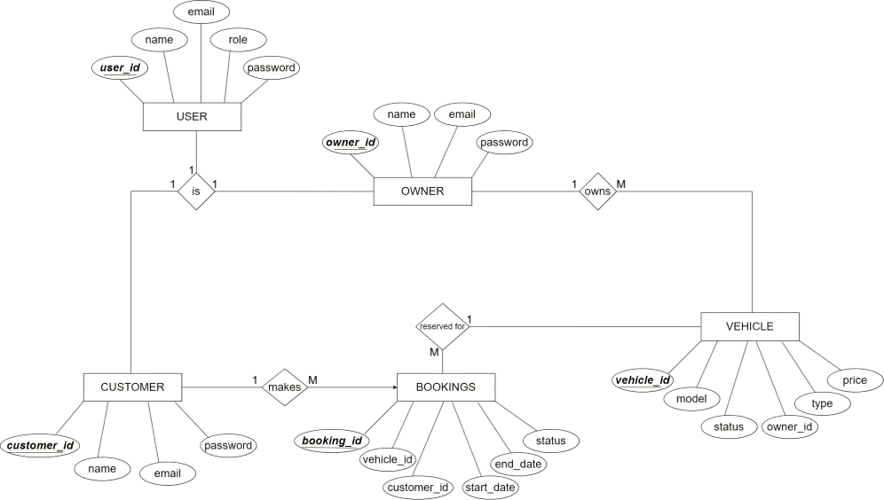

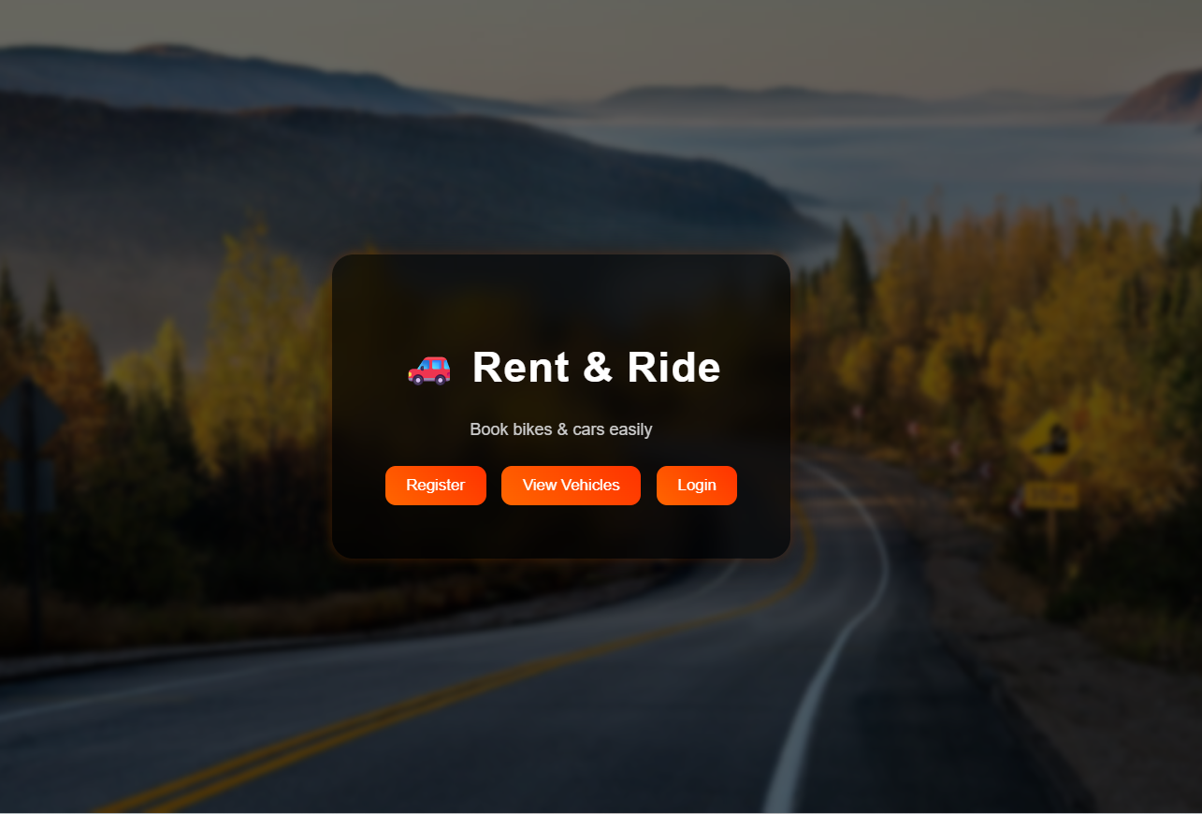

EX:NO:10 | Design and Implementation of Vehicle Rental Management System Using (Oracle SQL & Flask)
Objective:
To design and implement database operations such as Insert, Update, Delete, and Display for managing users, vehicles, and bookings using PL/SQL in Oracle Database.

Before Execution
SET SERVEROUTPUT ON;

Task 1: User Interface Design
- Design web pages using HTML and CSS
- Create pages for Login, Register, Dashboard, and Booking

Task 2: User Registration Page
- Input fields: Name, Email, Password, Role
- Validate user input
- Send data to backend

Task 3: Login Page
- Authenticate users using email and password
- Redirect users based on role (Admin/Owner/Customer)

Task 4: Vehicle Display Page
- Show list of available vehicles
- Display details like model, type, price, and status

Task 4: Booking Page
- Allow customers to select vehicle and dates
- Submit request to backend

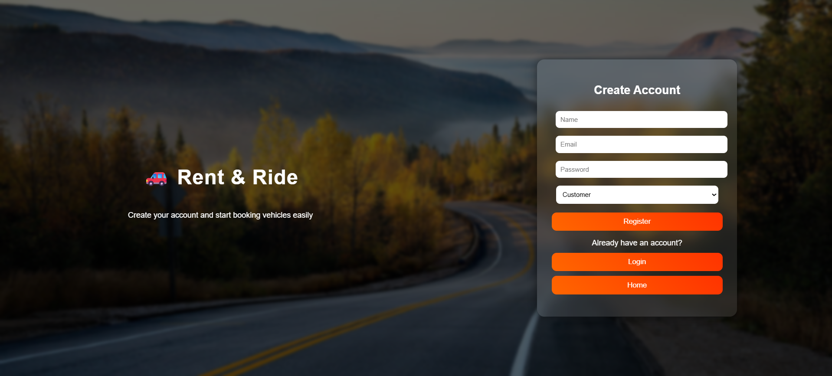

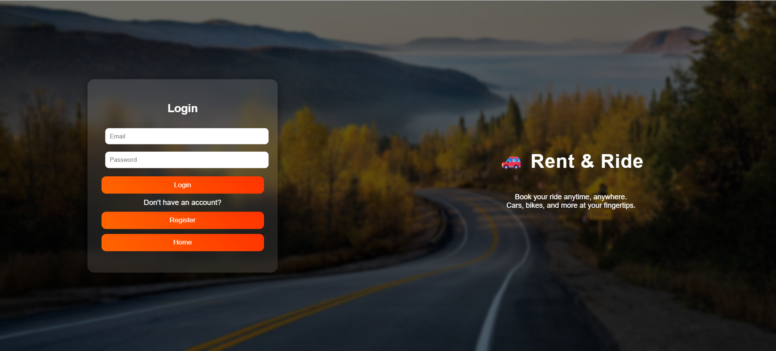

Task 5: Database Connection
connection = oracledb.connect(
user="username",
password="password",
dsn="localhost:1521/XEPDB1"
)

Task 6:User Login Query
SELECT * FROM users
WHERE LOWER(email) = LOWER(:email)

AND password = :password;

Task 7: Insert New User
INSERT INTO users(name, email, password, role)

VALUES(:name, :email, :password, :role);

Task 8: Insert Customer
INSERT INTO users(name, email, password, role)

VALUES(:name, :email, :password, :role);

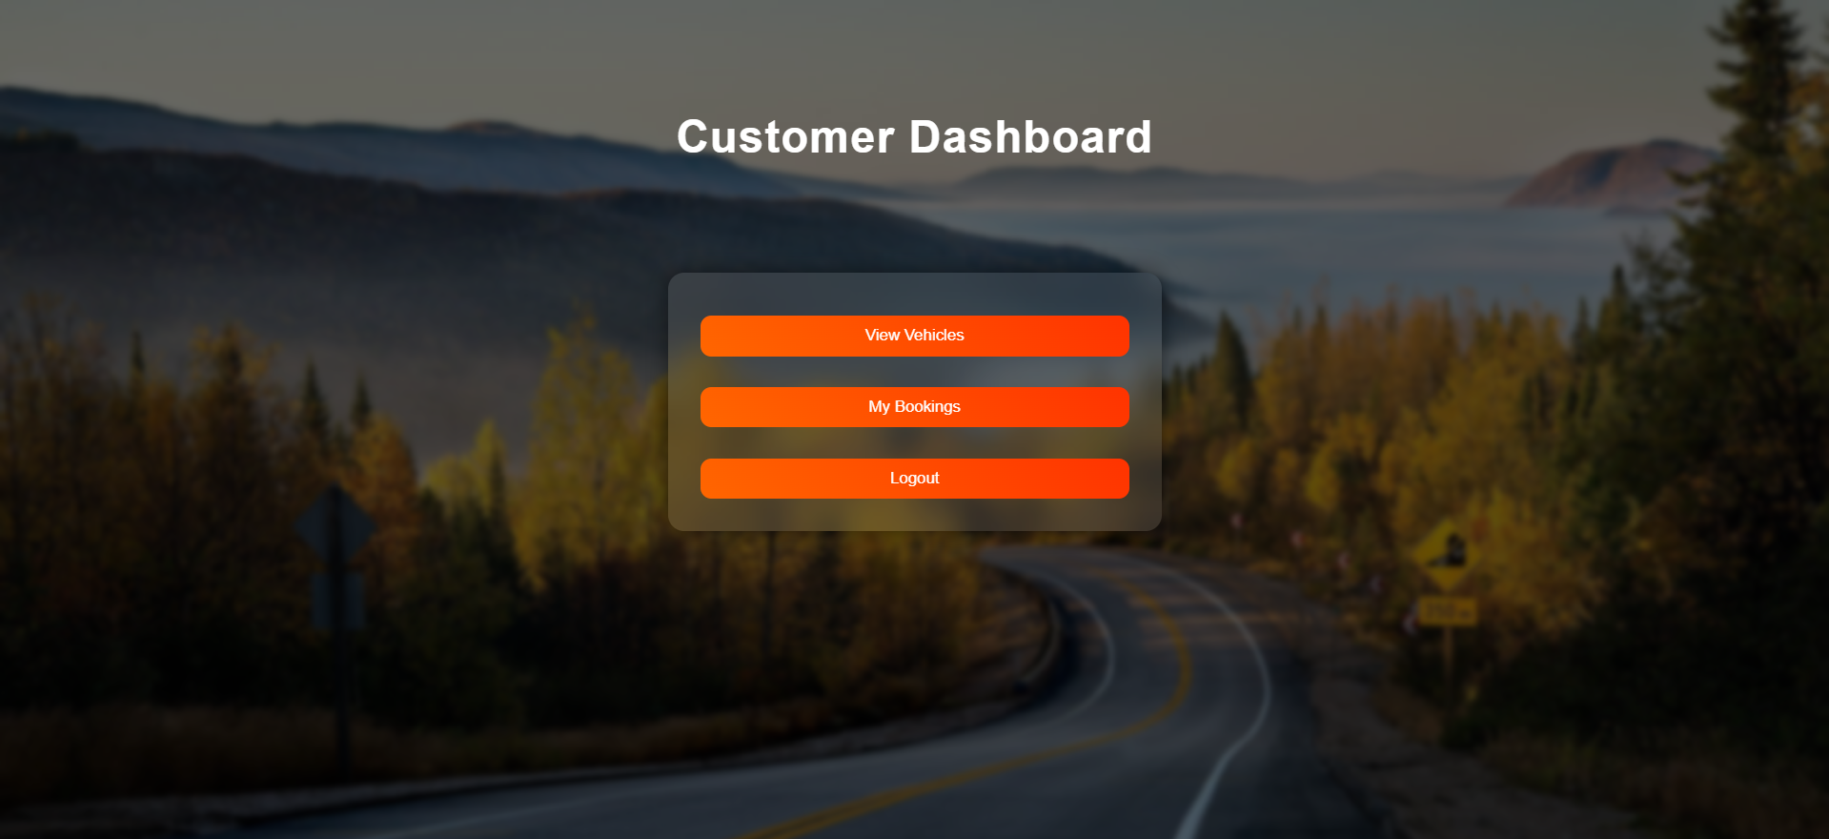

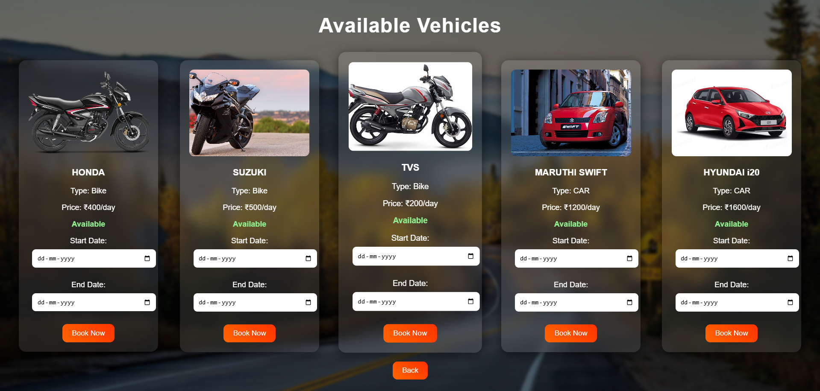

Task 9: Insert Owner
INSERT INTO owners(name, email)

VALUES(:name, :email);

Task 10: View All Vehicles
SELECT * FROM vehicles;

Task 11: Add Vehicle
INSERT INTO vehicle (model, type, price, status, owner_id)

VALUES (:model, :type, :price, 'AVAILABLE', :owner_id);

Task 12: Check Vehicle Availability

SELECT status FROM vehicle

WHERE vehicle_id = :vehicle_id

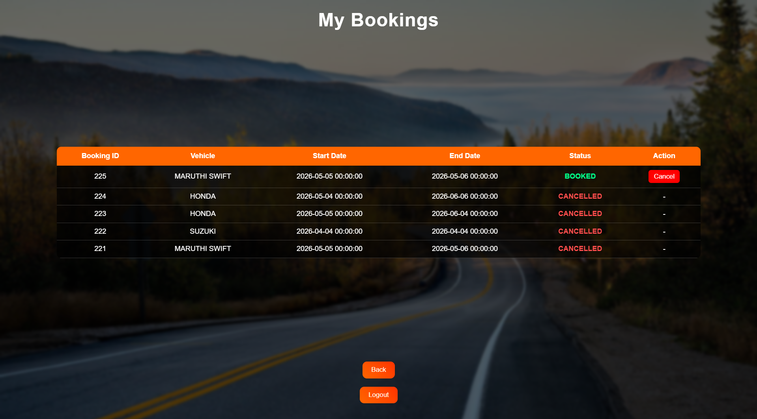

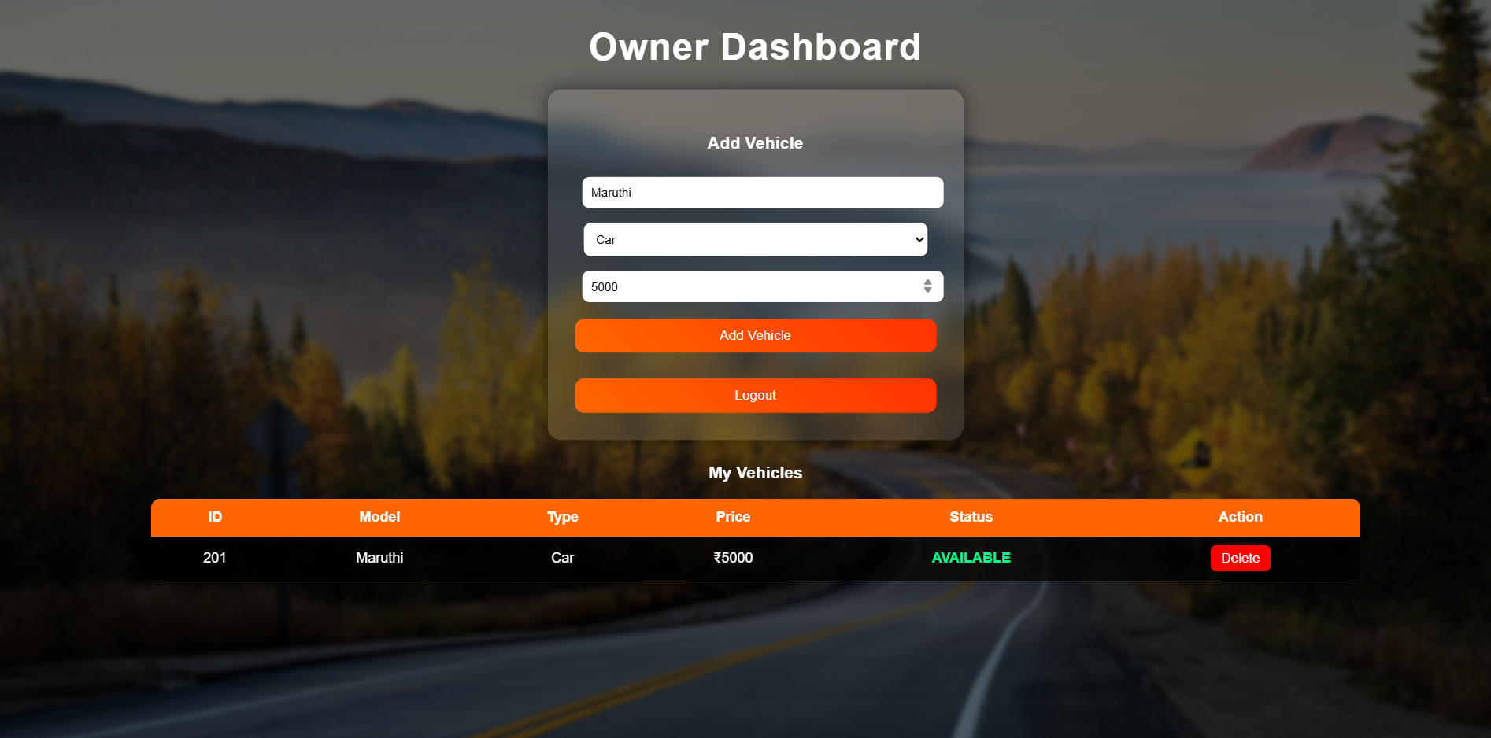

Task 13: Insert Booking

INSERT INTO bookings (customer_id, vehicle_id, start_date, end_date, status)

VALUES (:customer_id, :vehicle_id,

TO_DATE(:start_date,'YYYY-MM-DD'),

TO_DATE(:end_date,'YYYY-MM-DD'), 'BOOKED');

Task 14: Update Vehicle Status

UPDATE vehicle

SET status = 'NOT AVAILABLE'

WHERE vehicle_id = :vehicle_id;

Task 15: View Customer Booking

SELECT b.booking_id, v.model, b.start_date, b.end_date, b.status

FROM bookings b
JOIN vehicle v ON b.vehicle_id = v.vehicle_id

WHERE b.customer_id = :customer_id

ORDER BY b.booking_id DESC;

Task 16: Most Booked Vehicle
SELECT v.model, COUNT(b.booking_id) AS total

FROM vehicle v

LEFT JOIN bookings b ON v.vehicle_id = b.vehicle_id

GROUP BY v.model
ORDER BY total DESC;

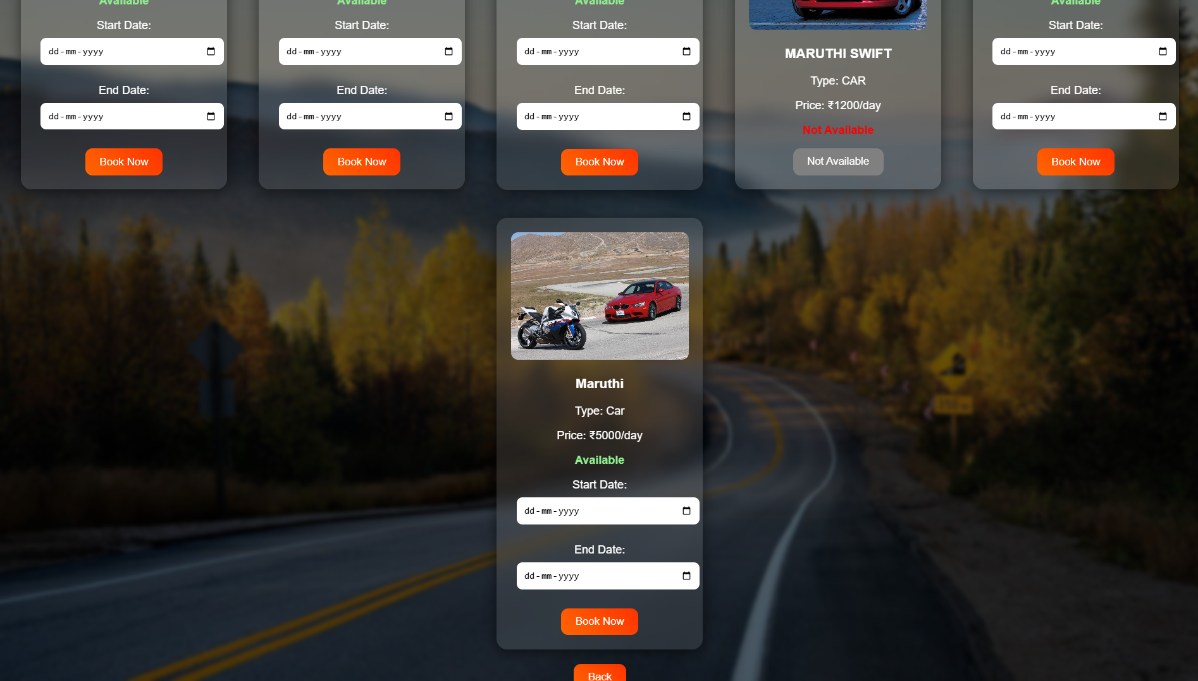

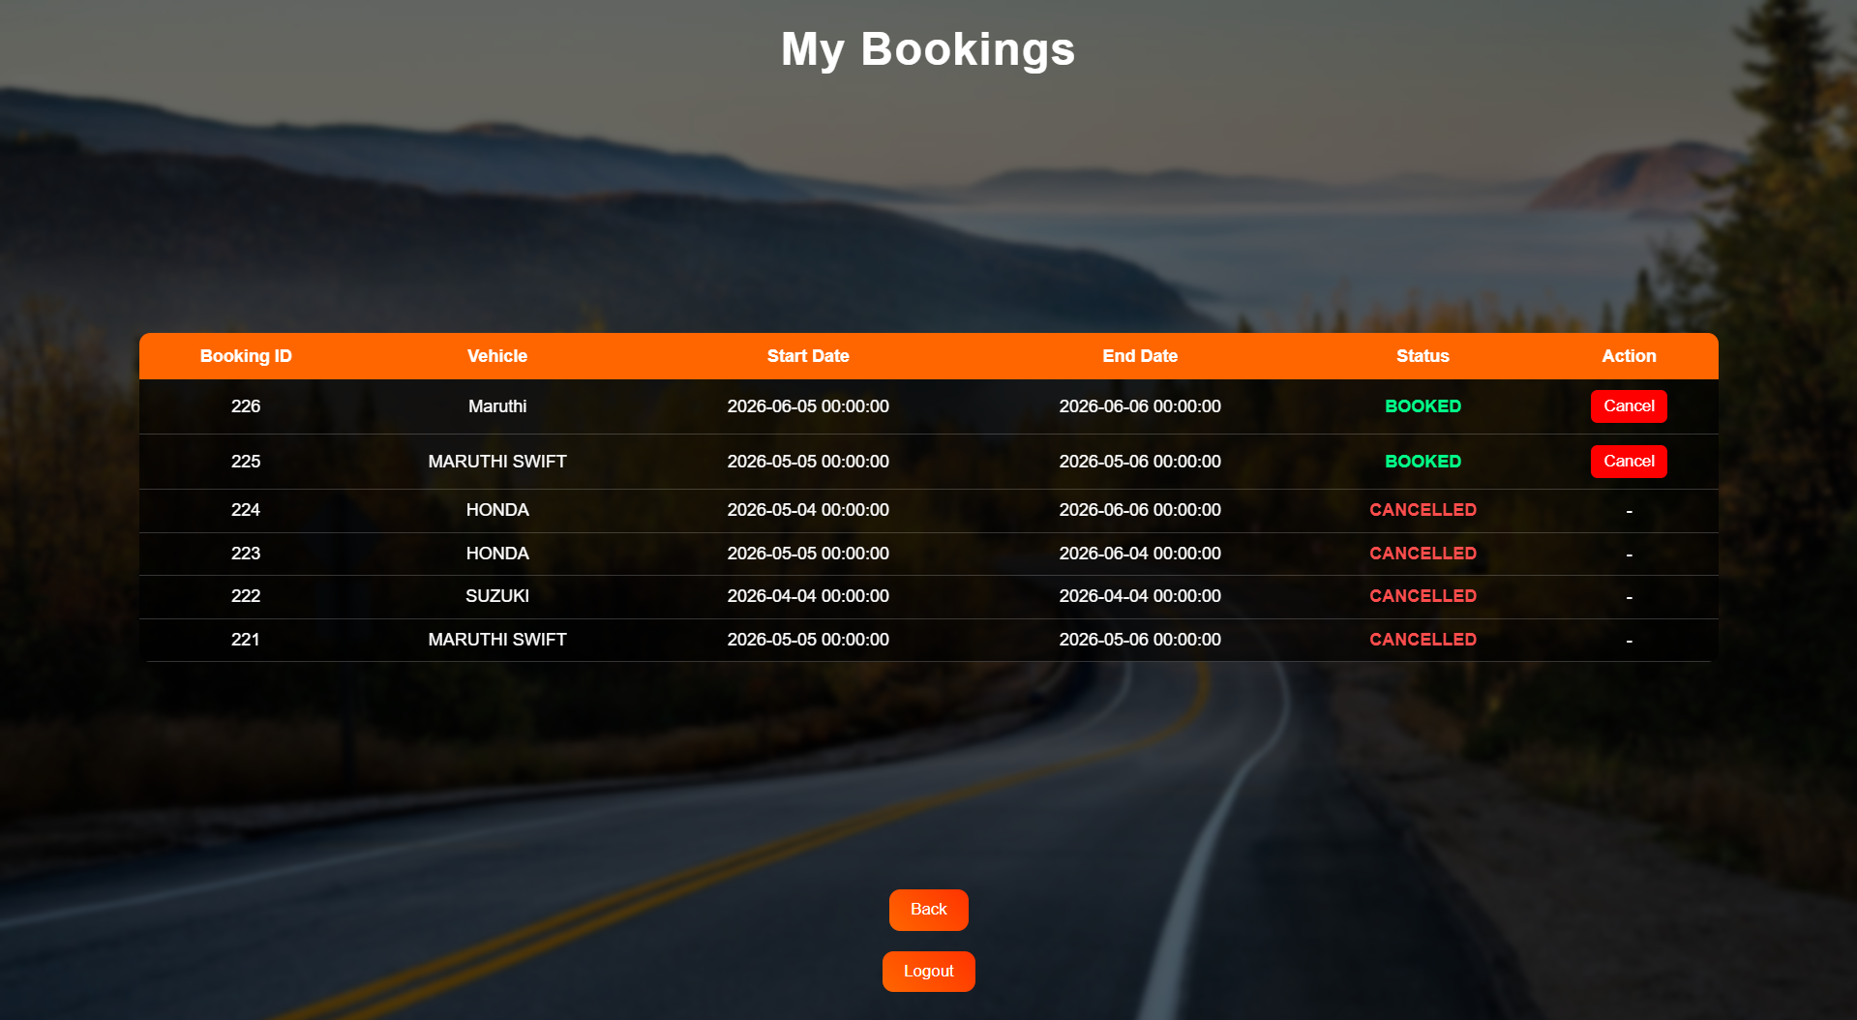

Task 17: Most Cancelled Vehicle

SELECT v.model, COUNT(b.booking_id) AS total

FROM vehicle v

JOIN bookings b ON v.vehicle_id = b.vehicle_id

WHERE b.status = 'CANCELLED'

GROUP BY v.model

ORDER BY total DESC;

Task 18: View All Bookings

SELECT b.booking_id, u.name, v.model,

b.start_date, b.end_date, b.status

FROM bookings b

JOIN users u ON b.customer_id = u.user_id

JOIN vehicle v ON b.vehicle_id = v.vehicle_id

ORDER BY b.booking_id DESC;

Task 19: Customer Bookings Views

CREATE VIEW customer_bookings_view AS

SELECT b.booking_id, v.model, b.start_date, b.end_date, b.status

FROM bookings b

JOIN vehicle v ON b.vehicle_id = v.vehicle_id;

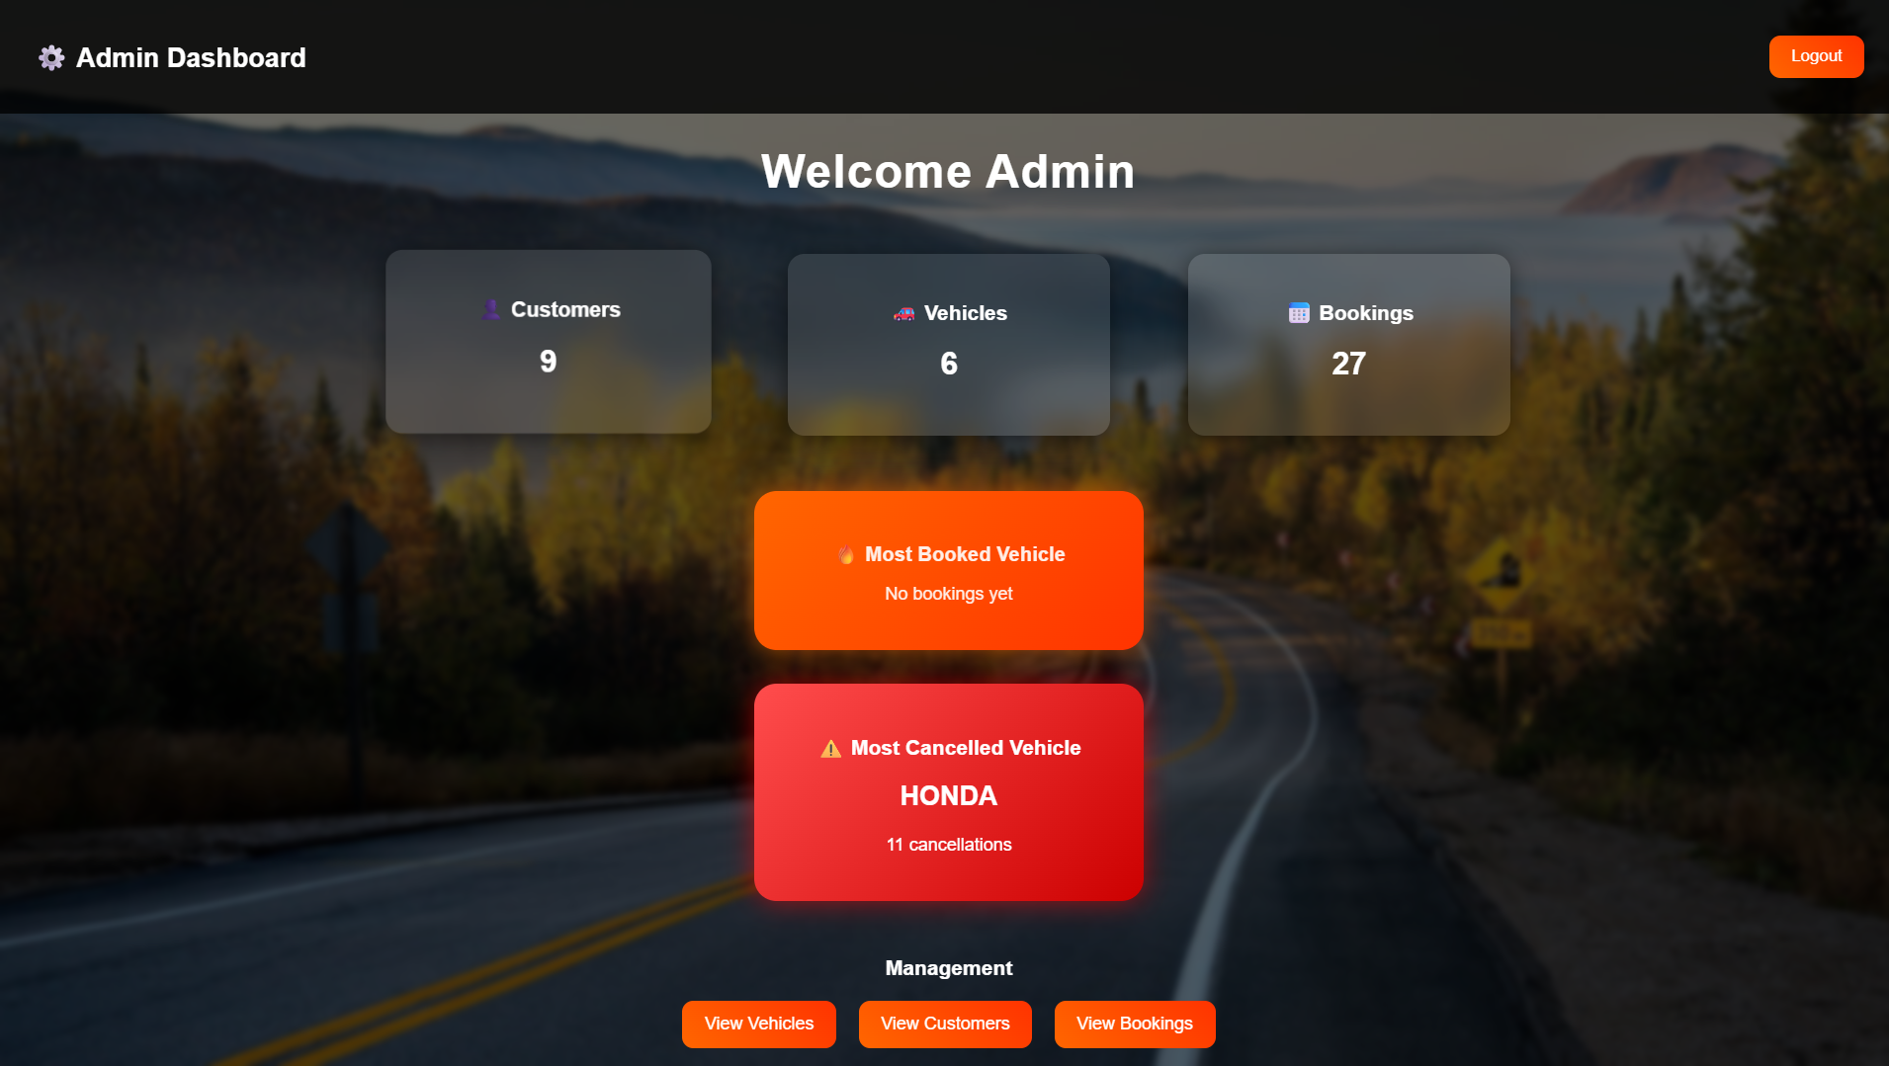

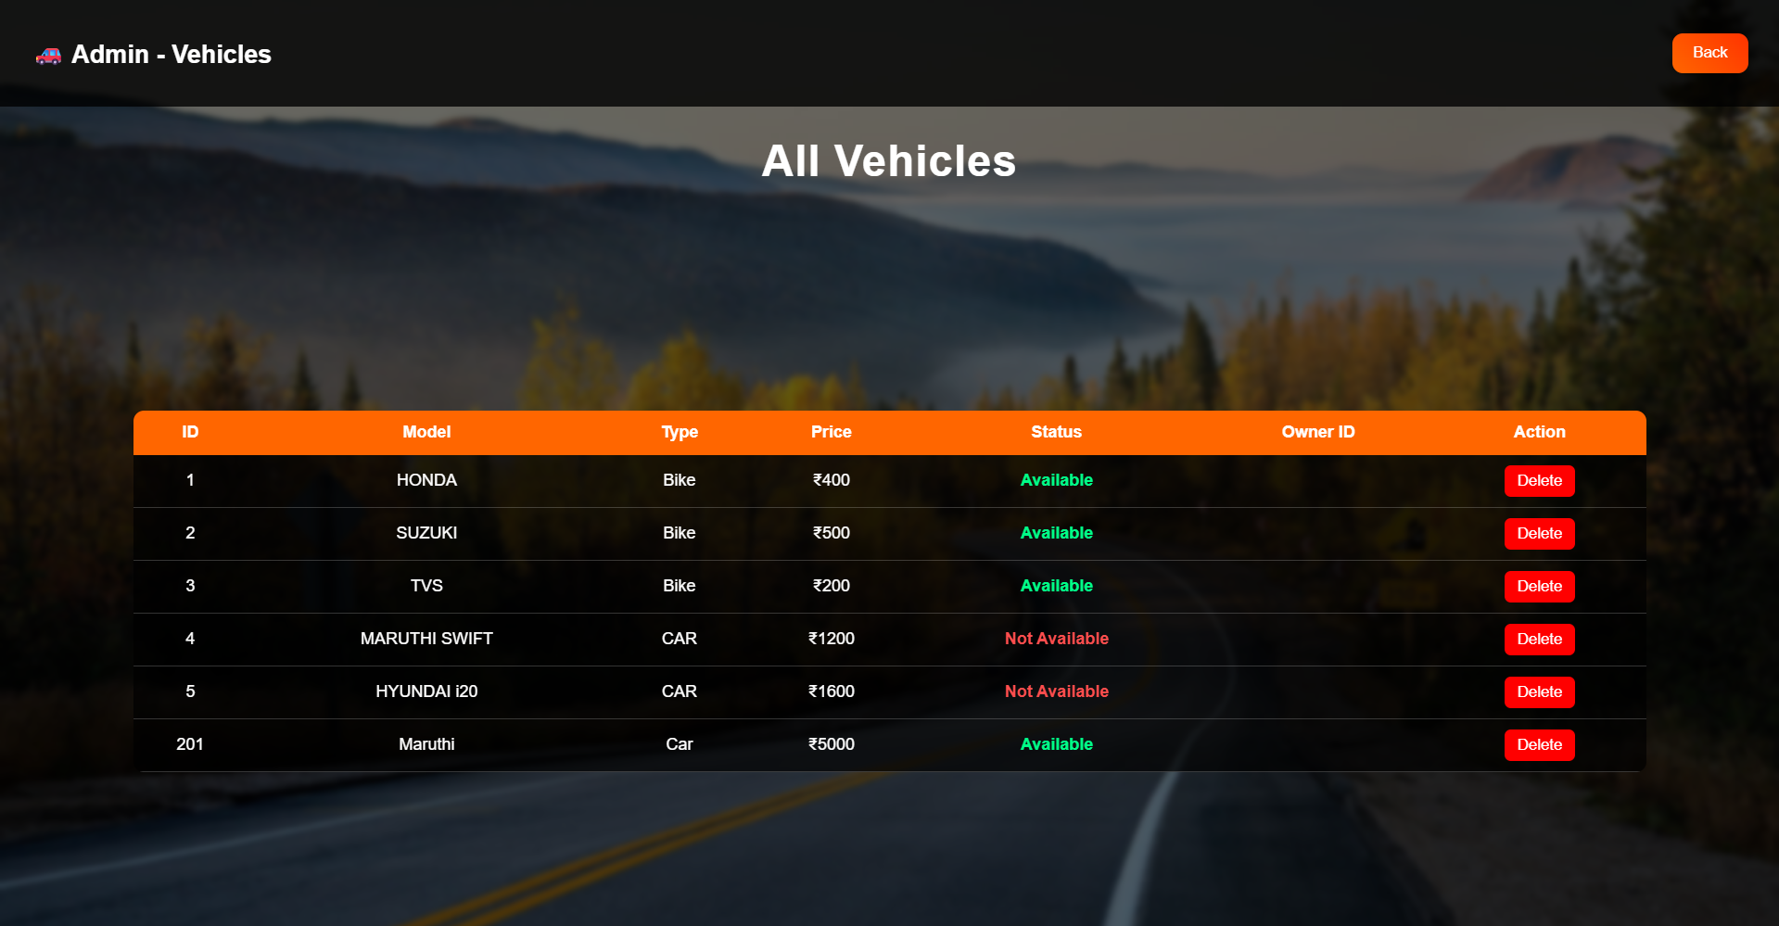

Task 20: Admin Booking View

CREATE VIEW admin_booking_view AS

SELECT b.booking_id, u.name AS customer_name, v.model,

b.start_date, b.end_date, b.status

FROM bookings b

JOIN users u ON b.customer_id = u.user_id

JOIN vehicle v ON b.vehicle_id = v.vehicle_id;

Task 21: Auto Update Vehicles Status After Booking

CREATE OR REPLACE TRIGGER trg_book_vehicle

AFTER INSERT ON bookings

FOR EACH ROW

BEGIN

UPDATE vehicle

SET status = 'NOT AVAILABLE'

WHERE vehicle_id = :NEW.vehicle_id;

END;

/

Result
The Vehicle Rental Management System was successfully implemented using Flask and Oracle Database. The system efficiently manages users, vehicles, and bookings, ensuring accurate data handling, smooth operations, and improved user experience.

