1. Create a simple functional component named Greeting that returns “Hello, World!” within a tag.

**Greeting.jsx:**

export function Greeting(){

    return(

        <h1>Hello World</h1>

    );

}

**Main.jsx:**

import { StrictMode } from 'react'

import { createRoot } from 'react-dom/client'

import './index.css'

import { Greeting } from './Greeting.jsx'

createRoot(document.getElementById('root')).render(

  <StrictMode>

    <Greeting />

  </StrictMode>,

)

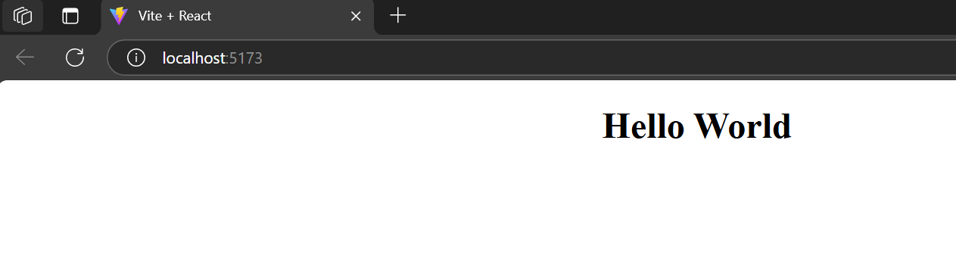

1. Modify the Greeting component to display “Hello, React!”

**Greeting.jsx:**

export function Greeting(){

    return(

        <h1>Hello, React!”</h1>

    );

}

**Main.jsx:**

import { StrictMode } from 'react'

import { createRoot } from 'react-dom/client'

import './index.css'

import { Greeting } from './Greeting.jsx'

createRoot(document.getElementById('root')).render(

  <StrictMode>

    <Greeting />

  </StrictMode>,

)

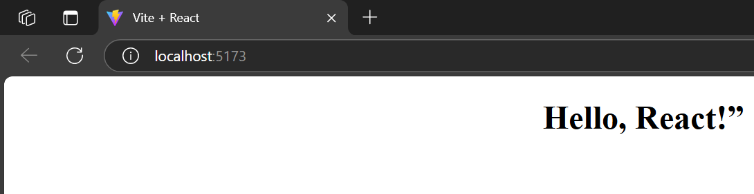

1. Create a Gallery functional component to display an image.

**App.jsx:**

import reactLogo from './assets/react.svg'

import viteLogo from '/vite.svg'

import './App.css'

import.meta.env.BASE_URL

function Gallery(){

    return(

    <div><img src="/download.jpg" alt="greetings">

    </img>

    </div>

    );

}

export default Gallery;

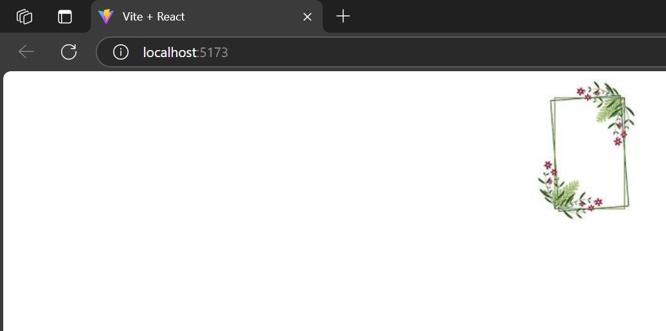

1. Add Greeting to the Gallery component and display the image and greeting.

**App.jsx:**

import { useState } from 'react'

import reactLogo from './assets/react.svg'

import viteLogo from '/vite.svg'

import './App.css'

import { Greeting } from './Greeting.jsx'

import.meta.env.BASE_URL

function Gallery(){

return(

<div><img src="/download.jpg" alt="greetings">

</img>

<Greeting />

</div>

);

}

export default Gallery;

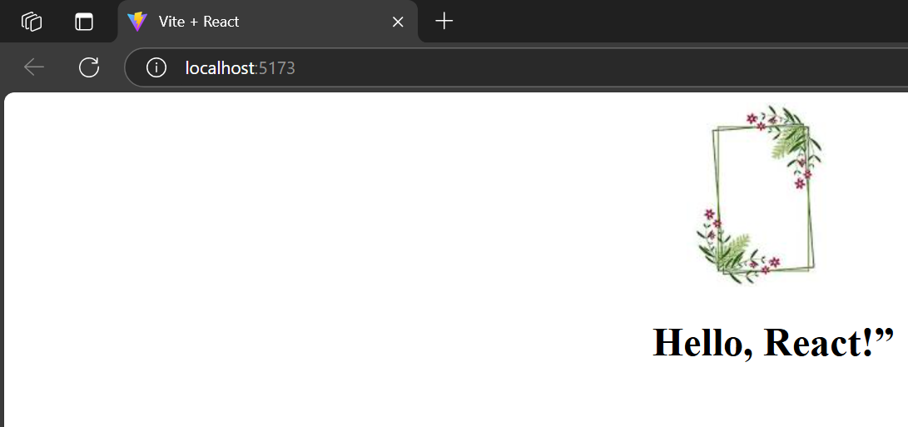

1. Write a component called Profile which displays a hardcoded user’s name and age.

**Profile.jsx:**

import './Profile.css'

export default function Profile(){

    return(

        <div>

        <h3>UserName: Yokey</h3>

        <h3>Age:21</h3>

        </div>

    );

}

