Train Journey Management System

AIM OF SOFTWARE
Journey management system is used by operation manager to manage the tourist trains that are serving a number of routes in a specific area. Two subsystems naming customer system and InTrain System read information from the management system respectively.
Customer system is designed for the tourists who are located in train station while InTrain system is useful for those on-board driver or customers.

SOFTWARE FUNCTIONS
I. Management System (Operation Manager)
1. Manage the route
1.1 Add a new route
1.2 Delete an existed route
1.3 Search for a route containing certain stations
1.4 Find the detailed journey information of each route
1.5 Operate on the journeys information in a specific route
1.6 Find the train location of a particular journey by the progress bar
1.7 Send stop information to a train if facing some state of emergency
2. Manage the driver
2.1 Add a new driver
2.2 Delete an existed driver
2.3 Find the free time of each driver
2.4 Look for the information about journeys that the driver operates on
3. Manage the train
3.1 Add a new locomotive
3.2 Delete an existed locomotive
3.3 Find the free time of each locomotive
3.4 Look for the information about journeys that the train operates on
4. Manage the station
3.1 Add a new station
3.2 Delete an existed station
3.3 Look for the journeys that go through this station
II. Customer System (tourists in station)
- Look for the journeys that go through a particular station
- Find the train location of each journey arriving this station
- Ascertain the arrival / start time of each train passing this station

- InTrain system
- Look for the station information that this train would pass
- Find the train location of each journey arriving this station
- Find the train’s location in real time by the percentage of the journey that the train passes by
- Know the driver’s information

HOW TO OPERATE ON OUR SYSTEM?
1. Start the simulation process
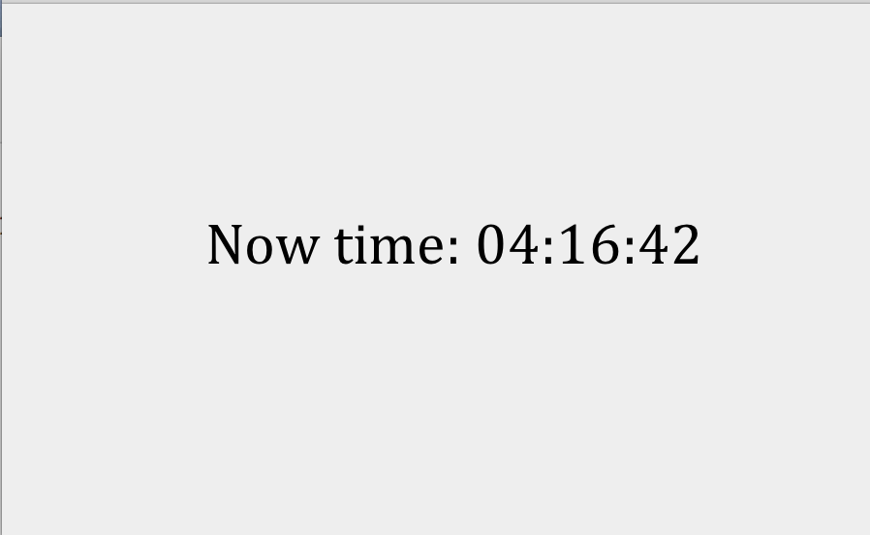
2. Choose a system to enter based on your identity
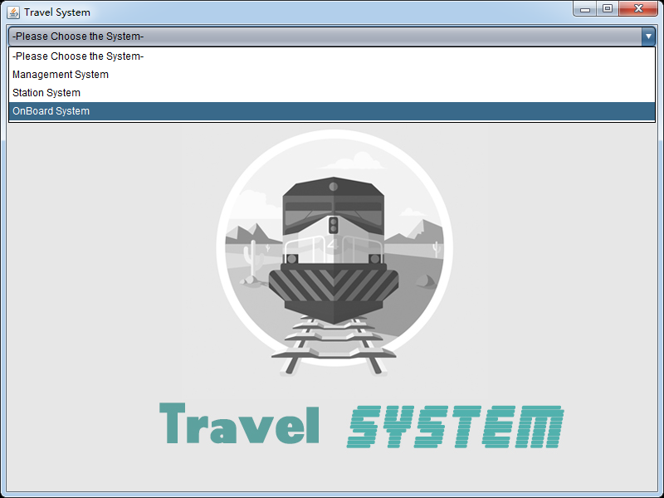
3. Management System
You can operate on the route, driver, train and station in this system.
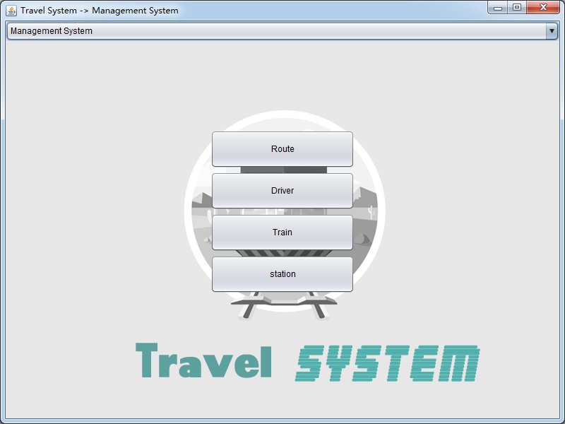
3.1 Manage the route
Click the “route” button, you can find, add or delete the route in this interface.
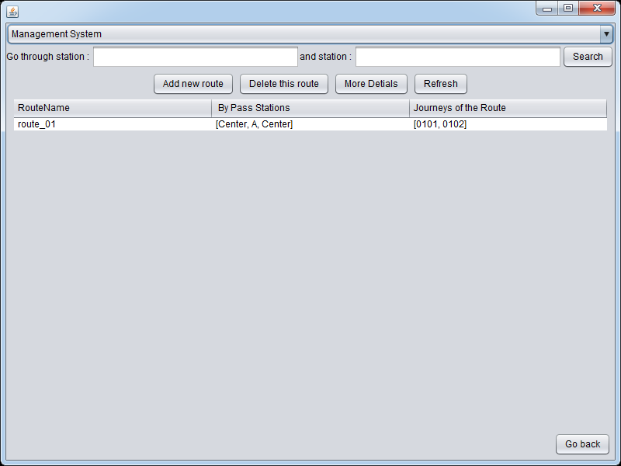
3.1.1 Search for the route
Write the station you want to go to in the label, then click the button. You can find the route you need.
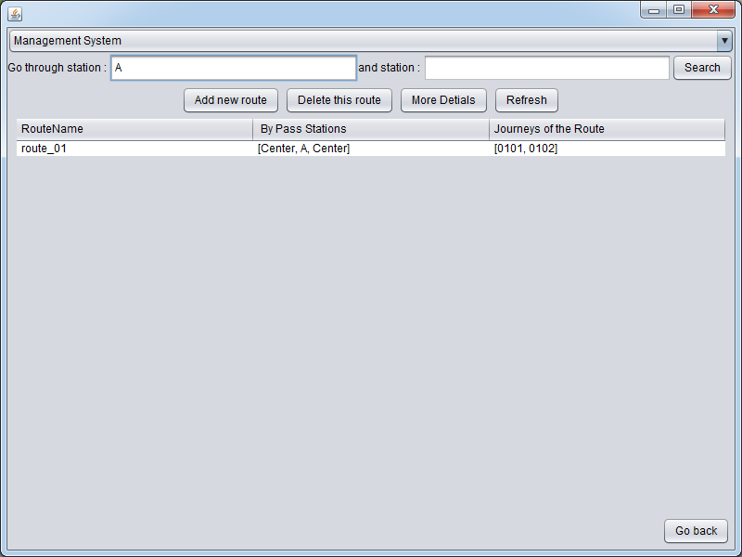

Outcome of the searching:
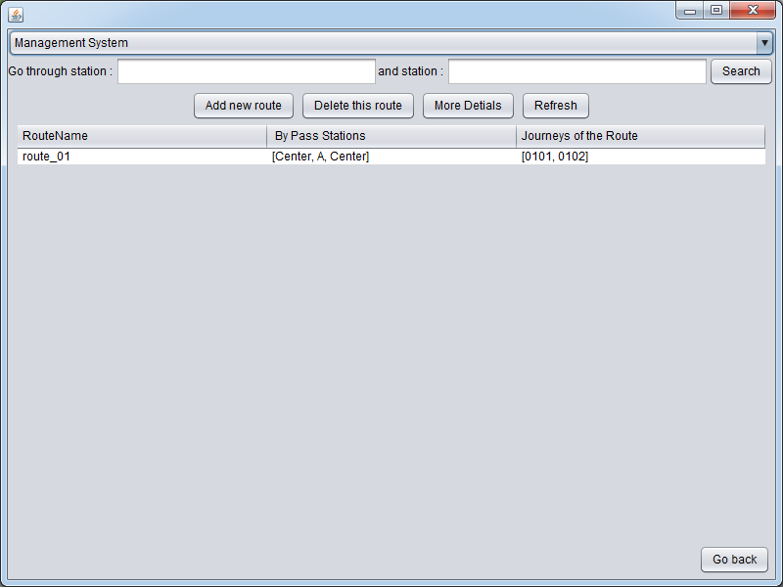
3.1.2 Add a new route
Click the “add new route” button.
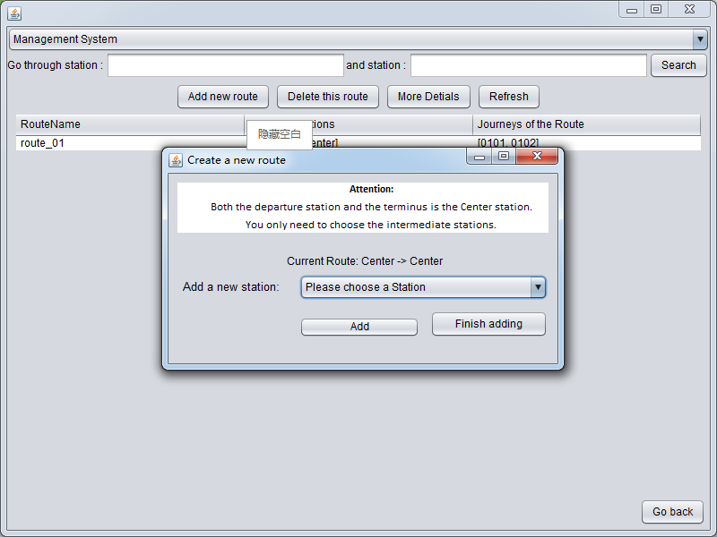

Choose a station you want to add, and click “add” button for another station. When stations in the route are enough for you, click “Finish adding” button. (Both of the departure and the terminus is center station)

Next, coding the route within the number of 01-99
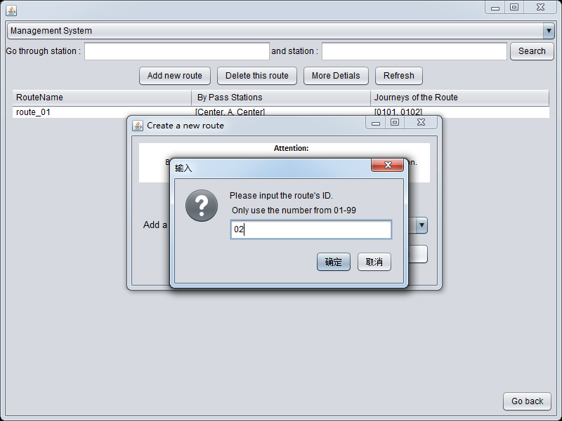
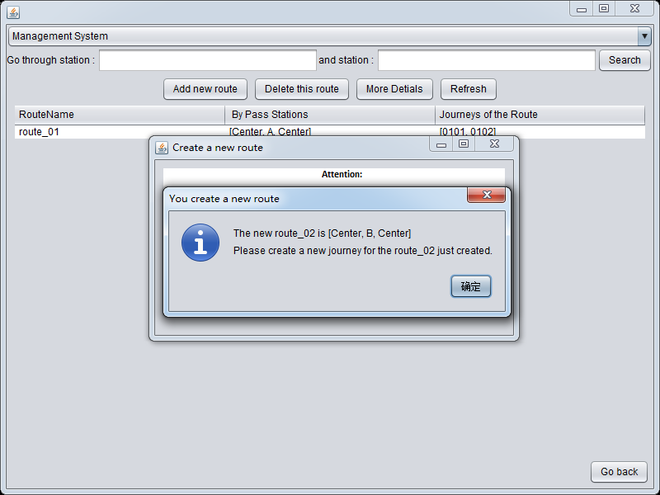
Allocate time for each station in the route.
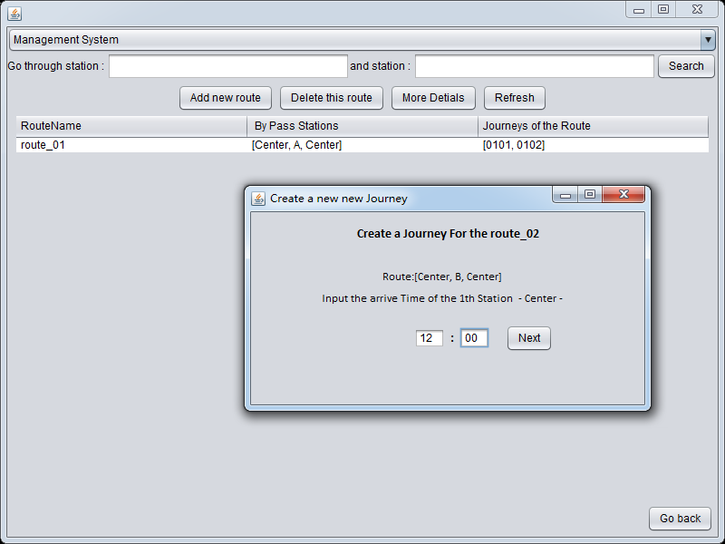
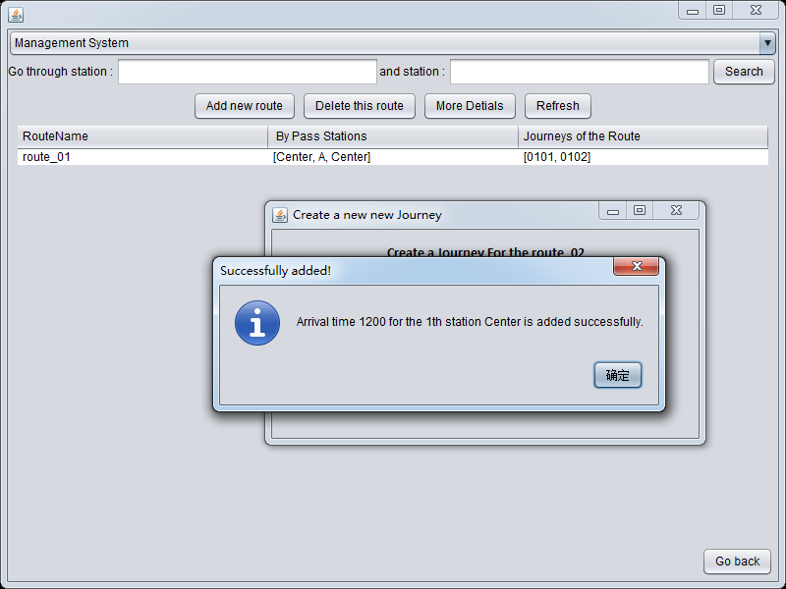
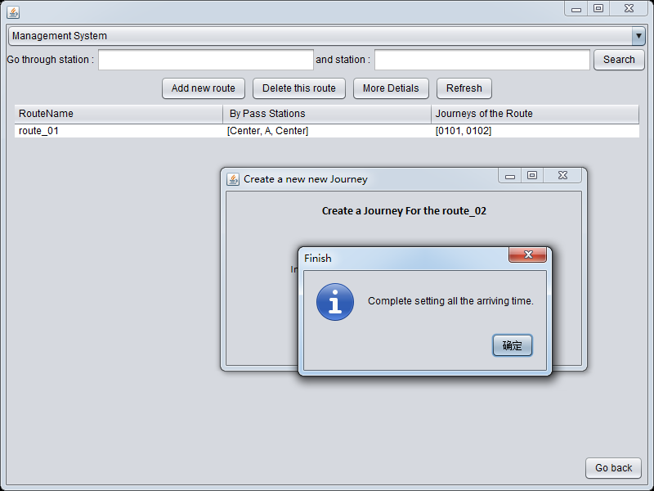
Warning: the time of the later station must be larger than the former one.
Allocate the number of the journey
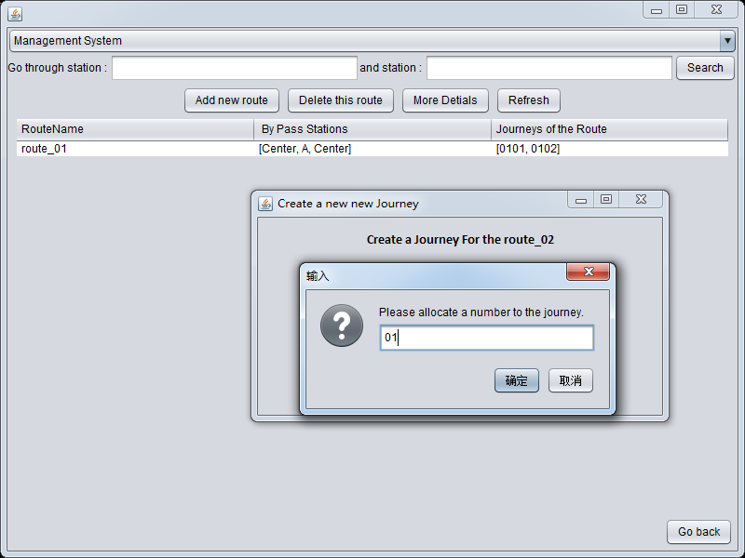

Choose a train in its spare time
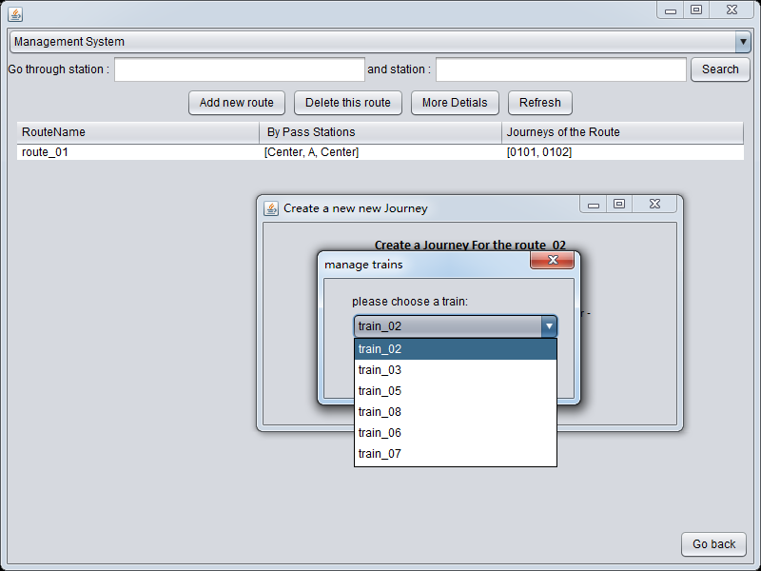
Choose a driver in his leisure time
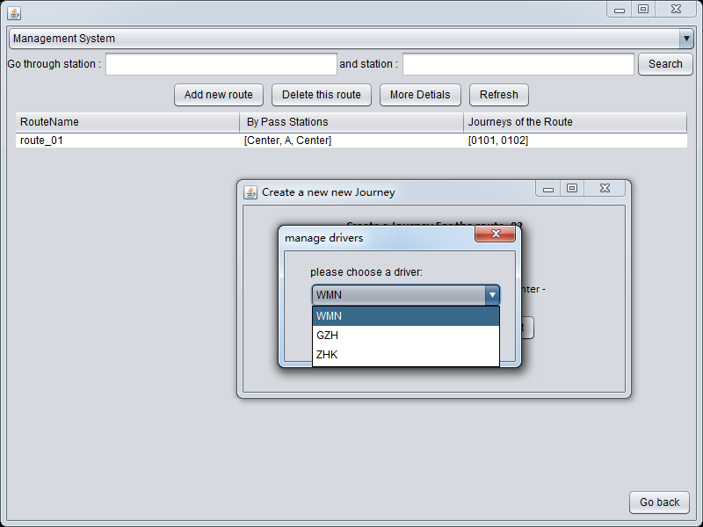
Finish adding the route.
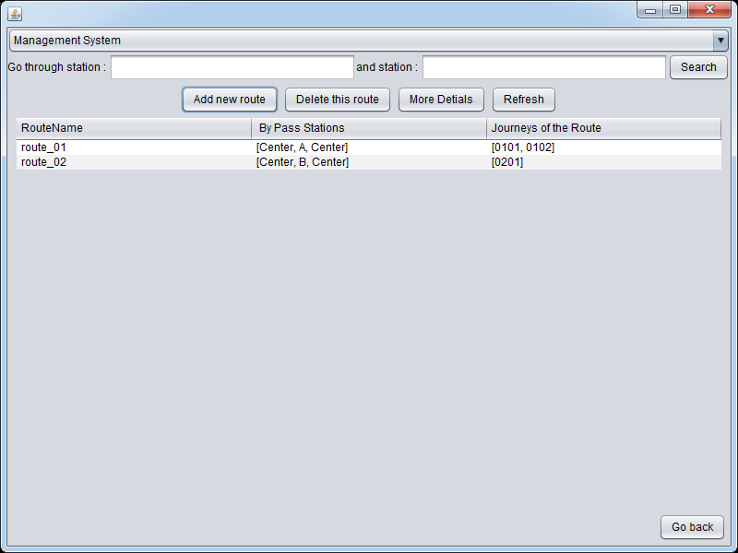
Journey number of the route is formed by route number and journey number.
3.1.3 Delete a route
Choose a route and click “Delete this route” button.
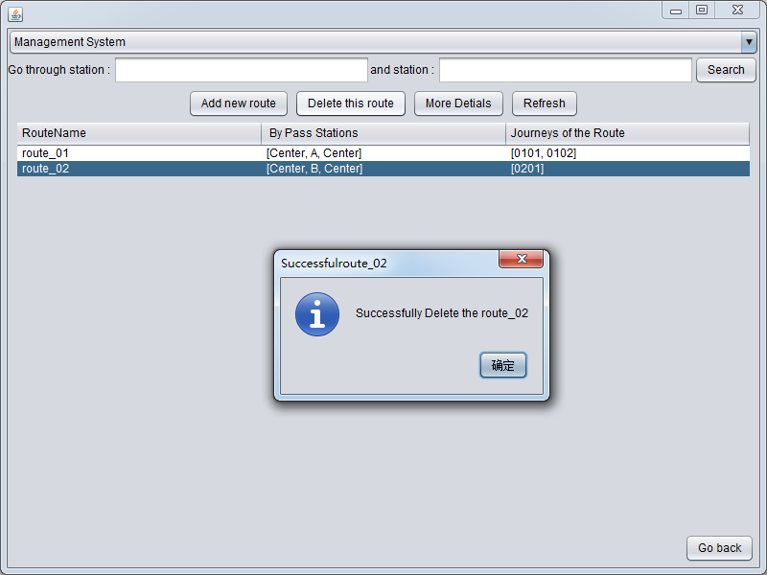
    - Manage the trips of the route
Choose a route which you want more details, click “More Details” button.
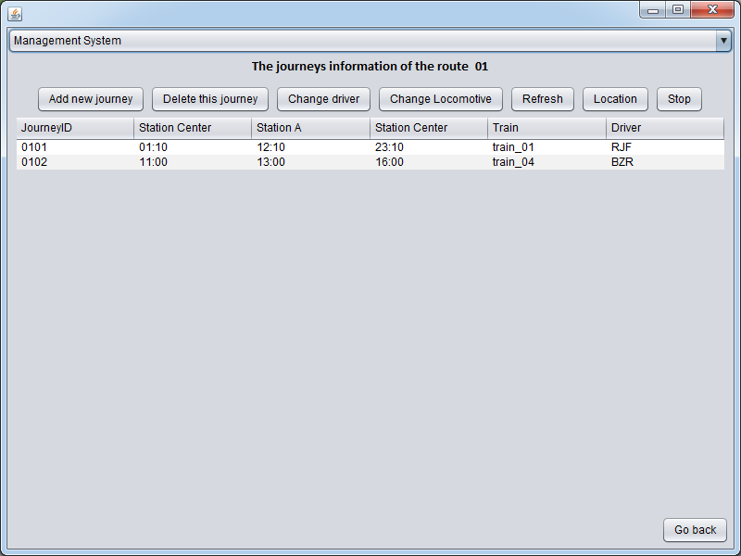
In this interface, you manage the journeys in the route.

3.1.4.1 Add a new journey
Click the “Add new trip” button. Then allocate time, trip number, driver and train like adding the route.
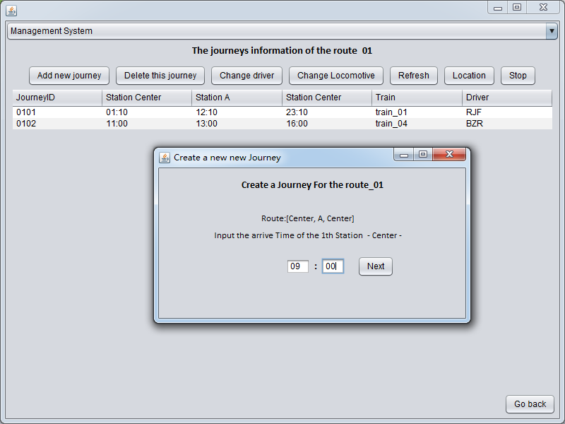
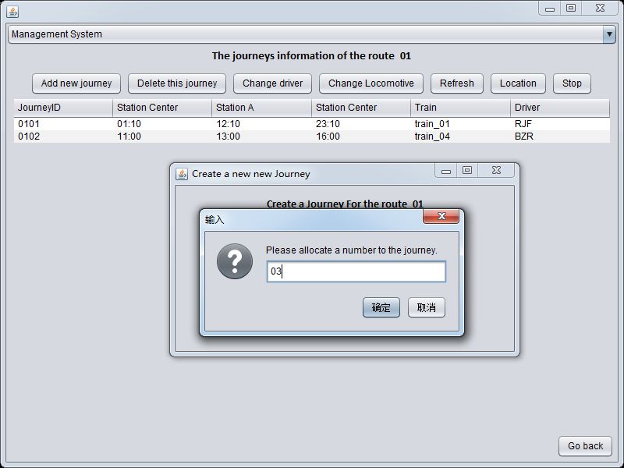
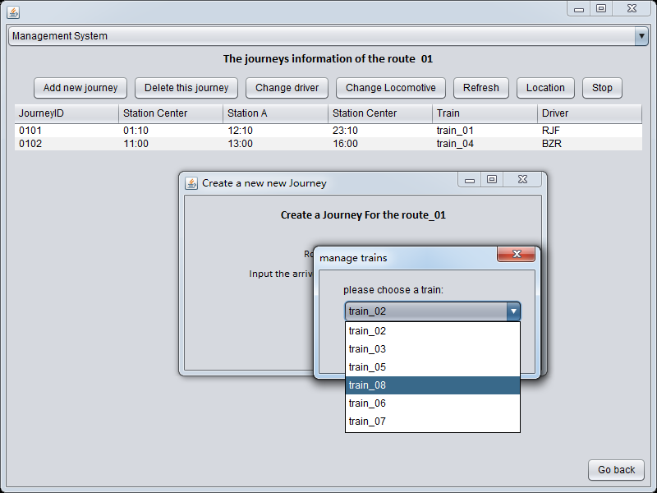
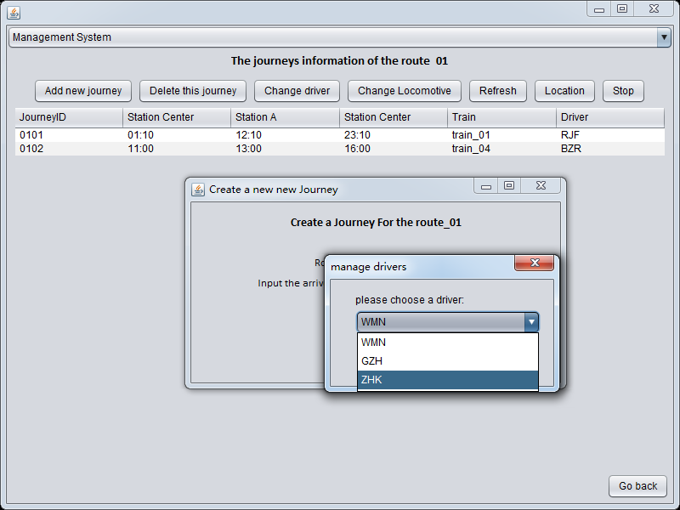
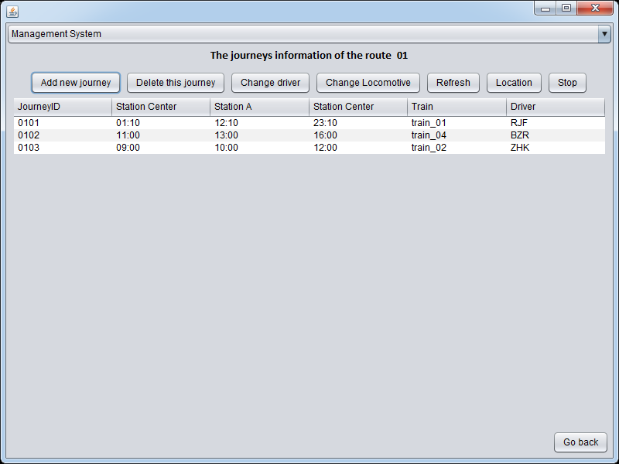
3.1.4.2 Delete a trip
Choose a trip and click the “Delete this trip” button.
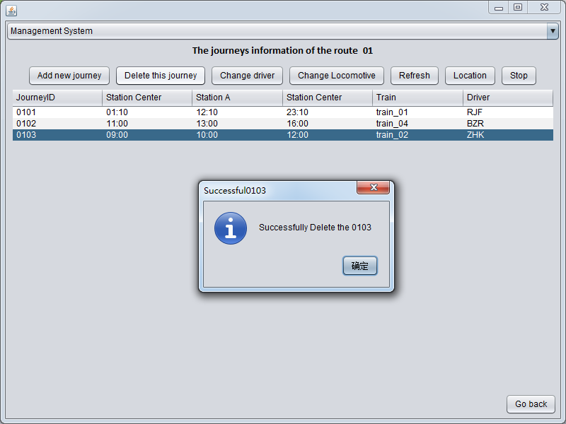
3.1.4.3 Change the driver
Choose a trip and click the “Change driver” button to choose a driver
who is available at that moment.
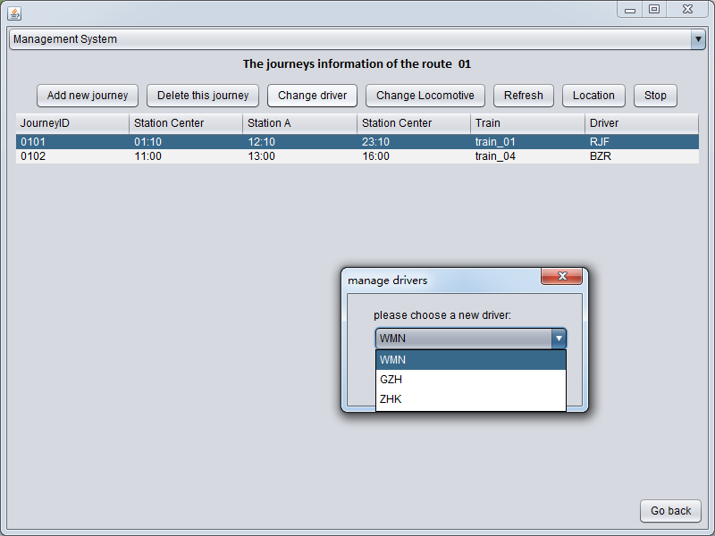
3.1.4.4 Change the locomotive
Choose a trip and click the “Change Locomotive” button to select a spare train.
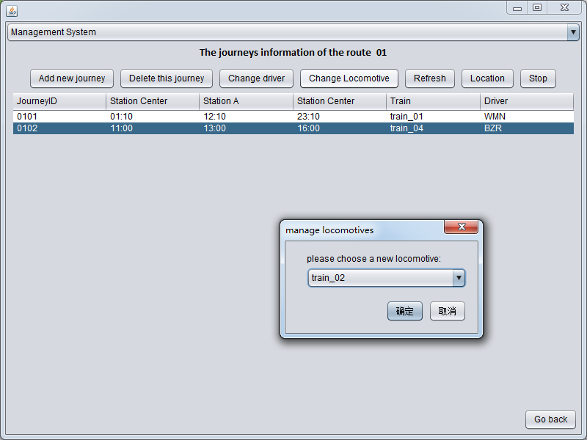
3.1.4.5 Location of the journey
Choose a trip and click the “Location” button
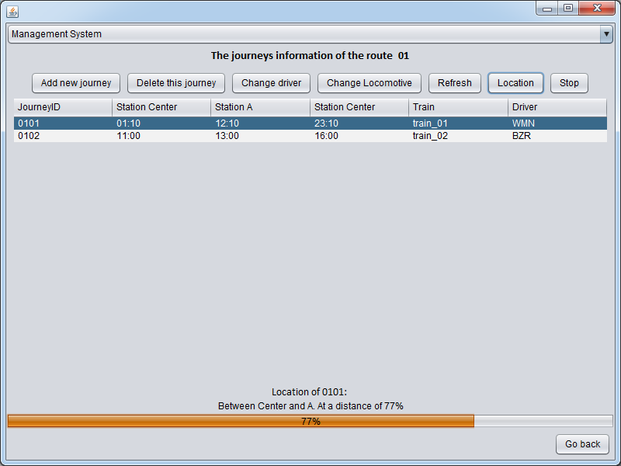
3.1.4.6 Stop journey
Choose a trip and click the “Stop” button
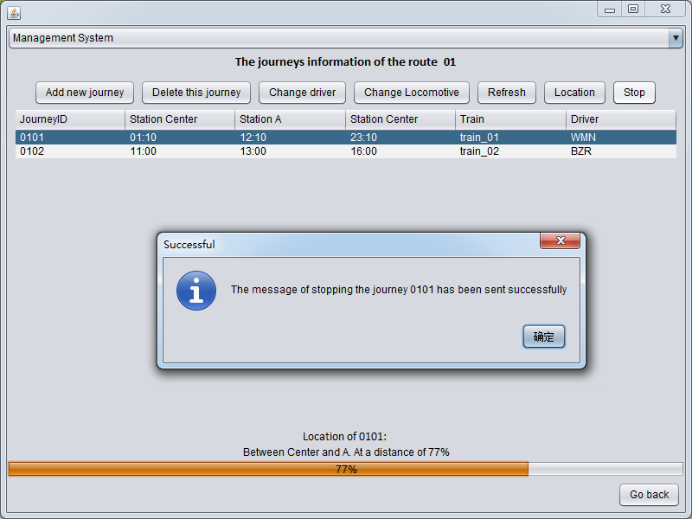
3.2 Manage the driver
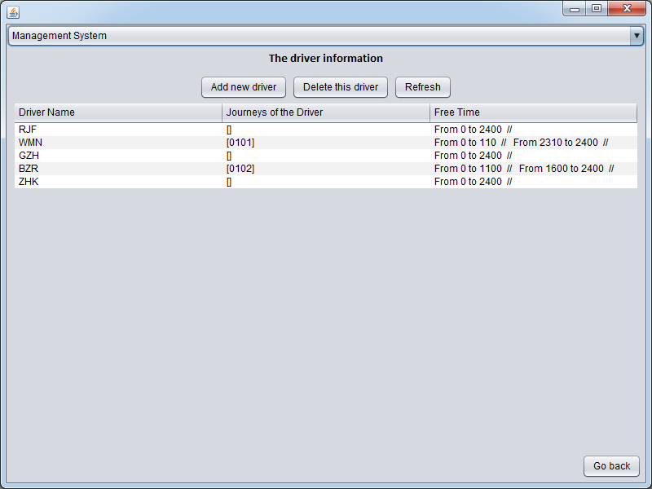
3.2.1 Add a new driver
Click the “Add new driver” button and input a new driver name.
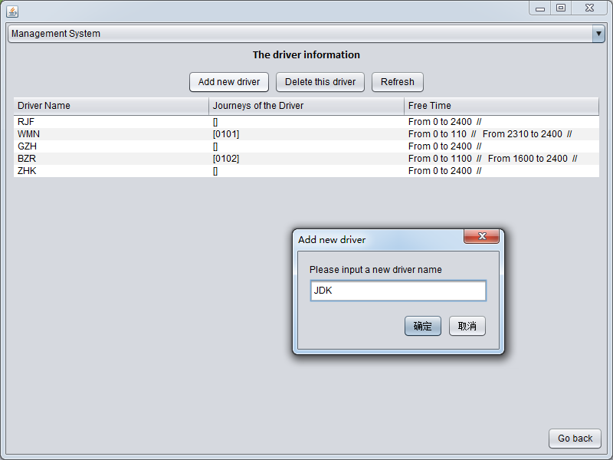
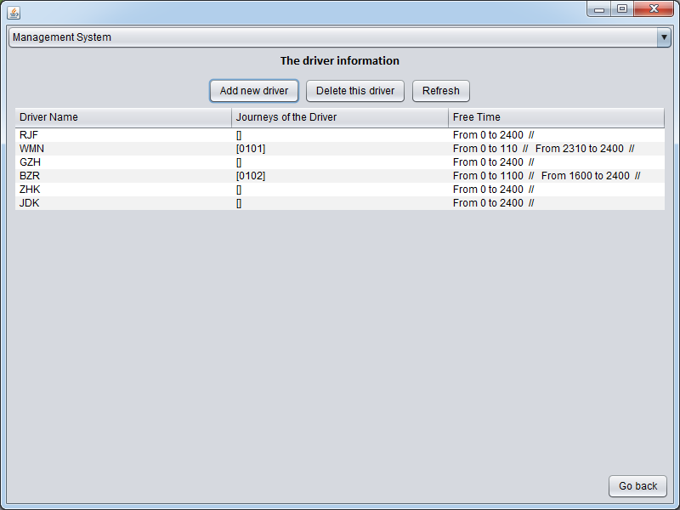

Refresh and you will find it’s added successfully.
3.2.2 Delete a driver.
Choose a driver and click the “Delete this driver” button.
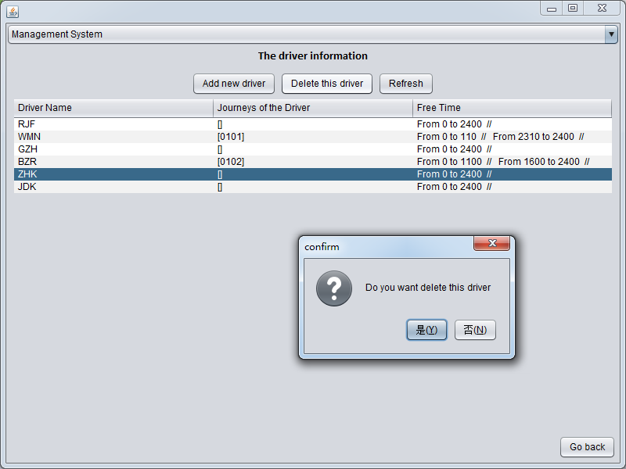
Warning: Can’t delete the driver who has been allocated journeys.
3.3 Manage the train
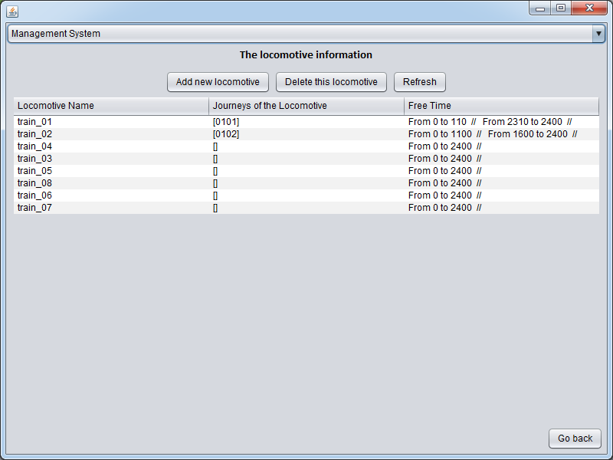
You can add or delete the train like the driver.
Warning: Can’t delete the train which has been allocated journeys.
3.4 Manage the station
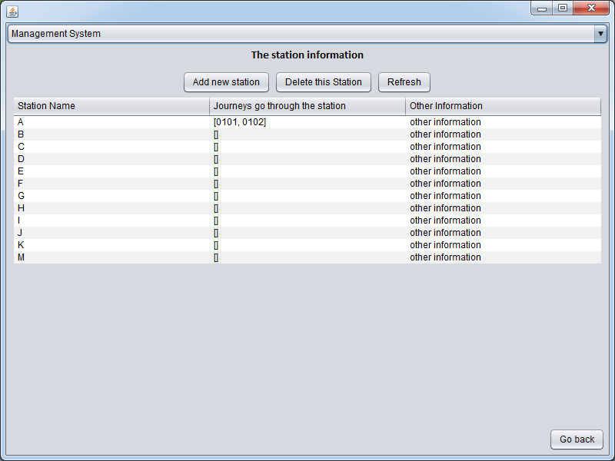
You can add or delete new stations like the driver.
Warning: Can’t delete the stations which are already in certain routes.
- Station System
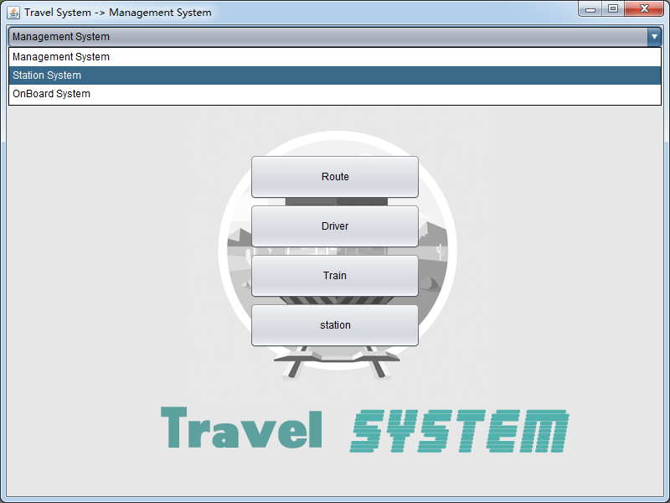
Customers can find the routes through the selected station.
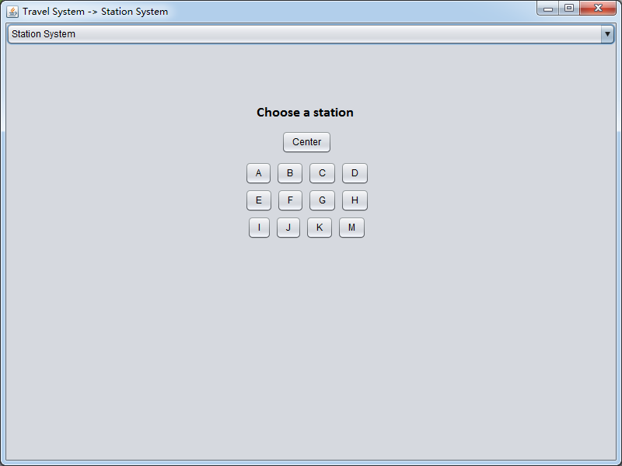
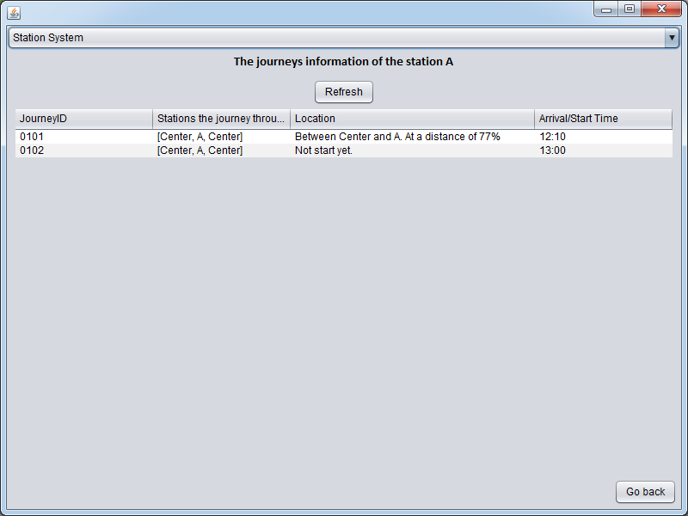
- OnBoard System
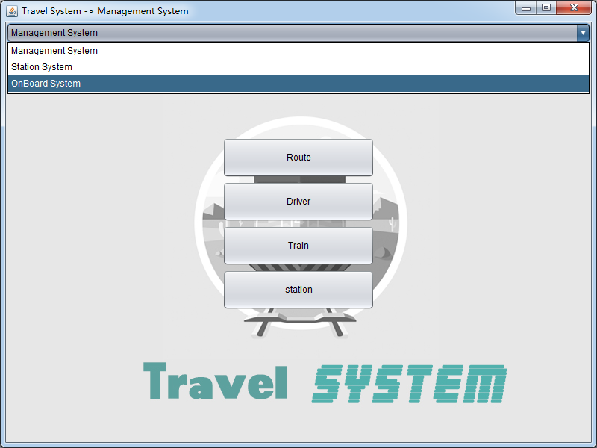
You can know the information showed in the train by choosing the train.
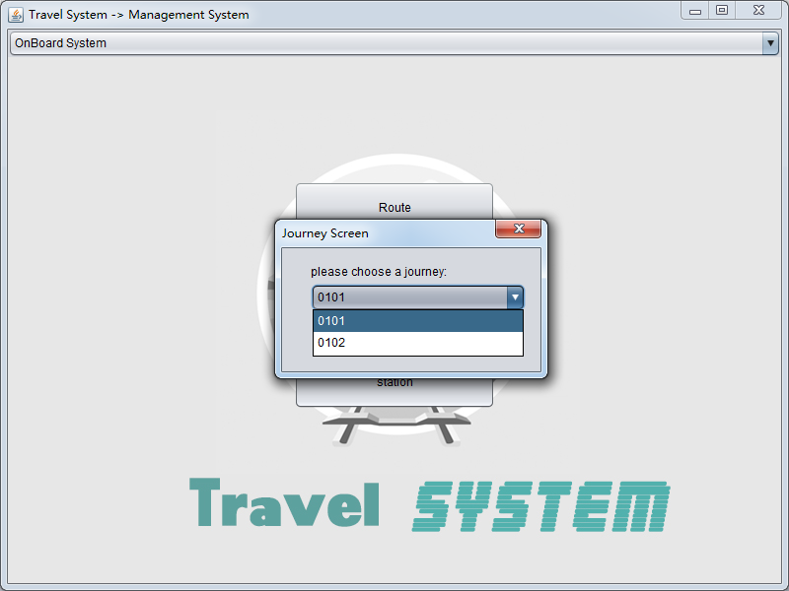
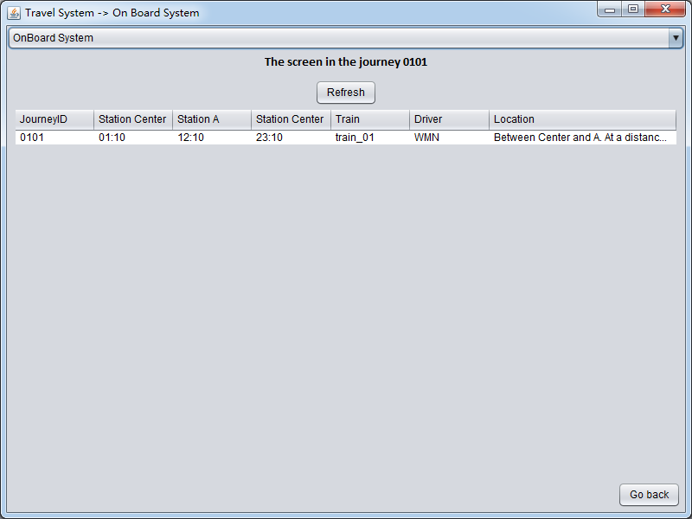
NOTICE
- Notice the input format.
- Can’t delete drivers, trains and stations which has already been
allocated to certain journeys.
- There is no bug when sometimes the system doesn’t show the
information you add. Just click the “Refresh” button.

