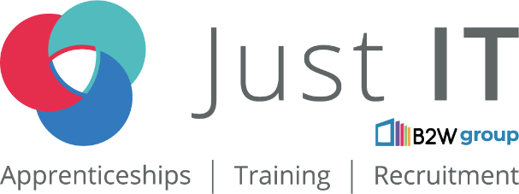

**Data Technician**

|  |
| --- |
|  |

|  |
| --- |
| **Name:** |
| **Course Date:** |
|  |

**Table of contents**

Day 1: Task 1 3

Day 1: Task 2 3

Day 1: Task 3 4

Day 2: Task 1 5

Day 3: Task 1 9

Day 3: Task 2 10

Day 3: Task 3 11

Day 4: Task 1 12

Day 4: Task 2 13

1. Scenario Background 13

2. Data Laws and Regulations 14

3. Azure Service Recommendations 14

4. Data Types and Data Modelling 14

5. Data Storage Formats and Structures in Azure 14

6. Additional Considerations 15

Submission Guidelines: 15

Course Notes 17

Additional Information 17

# Day 1: Task 1

Please research and complete the below questions relating to key concepts of cloud.

Be prepared to discuss the below in the group following this task.

|  |  |
| --- | --- |
| **What can cloud computing do for us in the real-world?** | Cloud computing helps us in many simple and practical ways in everyday life. It allows you to store your files, photos, and videos online instead of on your devices, so you can access them from anywhere and keep them safe if something happens to your phone or computer. It makes working with others much easier by letting people share and edit files in real time, even if they are in different locations. For example, tools like Google Docs or Zoom make it simple to collaborate on projects or hold meetings remotely.  You can also use apps and programs directly from the internet without needing to download or update them yourself—things like email, banking, or even photo editing tools. For businesses, cloud computing helps process and analyze large amounts of information quickly, making it easier to make better decisions. It also connects smart devices, like fitness trackers or home assistants, so they can work together.  Cloud services are built to be very secure and can recover your information quickly if something goes wrong, like a computer crash or power outage. They are also widely used in industries such as healthcare, where doctors can access patient records online, or education, where students can learn from online classes. In short, cloud computing helps us work smarter, stay organized, and save money while staying connected to the things we need. |
| **How can it benefit a business?** | Cloud computing helps businesses save money, work more efficiently, and grow faster. It reduces the need for expensive hardware by letting businesses store and access data online and only pay for what they use. Employees can work from anywhere, making teamwork easier and boosting productivity. It keeps data safe with strong security and automatic backups, ensuring businesses can recover quickly from problems. With the cloud, businesses can easily scale up or down as needed, access advanced tools like data analysis and AI, and stay updated with the latest software. Overall, it’s a cost-effective way to stay competitive and run smoothly. |
| **What’s the alternative to cloud computing?** | The main alternative to cloud computing is using your own physical servers and equipment, known as on-premises computing. This gives businesses full control over their data and systems, but it can be expensive to set up and maintain. Other options include renting space in data centers (colocation), combining cloud and in-house systems (hybrid solutions), or using edge computing, where data is processed locally instead of in the cloud. Traditional web hosting is also an option but offers less flexibility. While these alternatives work well for specific needs, they usually require more time, money, and technical expertise compared to the convenience of cloud computing. |
| **What cloud providers can we use, what are their features and functions?** | **Amazon Web Services (AWS)**  **Features:** Wide range of services including computing (EC2), storage (S3), databases (RDS), AI/ML, IoT, and analytics.  Global presence with data centers worldwide for low-latency performance.  Pay-as-you-go pricing model with free-tier options for beginners.  **Functions:** Scalable infrastructure for hosting websites, applications, and large-scale data processing.  Tools for machine learning, big data analytics, and IoT integration.  Popular for startups, enterprises, and developers needing flexibility and customization.  **Microsoft Azure**  **Features:** Integration with Microsoft tools like Office 365, Windows Server, and Dynamics 365.  Services for virtual machines, app hosting, AI, IoT, and analytics.  Hybrid cloud solutions that connect on-premises infrastructure with the cloud.  **Functions:** Great for businesses already using Microsoft products.  Offers seamless development, testing, and deployment environments.  Tools for data management, machine learning, and cybersecurity.  **Google Cloud Platform (GCP)**  **Features:** Specializes in machine learning and AI with TensorFlow and BigQuery.  Services for storage, app hosting, data analysis, and developer tools.  Strong focus on sustainability and green energy in its data centers.  **Functions:** Ideal for businesses needing advanced data analysis and AI tools.  Reliable for hosting websites, mobile apps, and gaming applications.  Offers seamless integration with Google’s ecosystem (e.g., Google Workspace).  **IBM Cloud**  **Features:** Known for enterprise-level solutions and AI tools like Watson.  Offers hybrid cloud capabilities and support for open-source technologies.  Security-focused with tools for compliance and encryption.  **Functions:** Commonly used in industries like healthcare, finance, and government.  Supports AI-driven insights and custom application development.  Provides blockchain services for secure digital transactions.  **Oracle Cloud**  **Features:** Specializes in database services and business applications.  Provides computing, storage, AI, and analytics services.  Focus on enterprise resource planning (ERP) and customer relationship management (CRM) tools.  **Functions:** Best suited for businesses needing advanced database management.  Ideal for large enterprises using Oracle’s ERP or CRM systems.  Supports analytics and AI for business intelligence.  **Alibaba Cloud**  **Features:** Leading provider in Asia with global reach.  Services include computing, storage, databases, and big data analytics.  AI, IoT, and e-commerce-specific tools.  **Functions:** Popular for businesses operating in or targeting the Asian market.  Supports e-commerce platforms, logistics, and AI-driven solutions.  Offers robust security and compliance features. |

# Day 1: Task 2

Please research the below cloud offerings, explain what they are and examples of use cases.

|  |  |  |
| --- | --- | --- |
| **Cloud Offerings** | Explain what it is | When / how might you use this service in the real-world? |
| **IaaS (Infrastructure as a service)** | IaaS provides virtualized computing resources over the internet. It is the most basic cloud service model, offering infrastructure like servers, storage, and networking hardware that you can rent on-demand. Users have control over the operating systems, storage, and deployed applications, but they don’t need to manage the physical hardware. | **When to Use:** IaaS is ideal when you need flexible, scalable infrastructure (e.g., hosting websites, disaster recovery, or cloud storage).  -Need for Virtualized Infrastructure: If you need to scale your infrastructure quickly without the burden of maintaining physical servers, IaaS is ideal.  -Cost-Effective Scaling: When you need to expand your computing resources temporarily, IaaS provides the flexibility to do so without large upfront costs.  **How You Might Use It:**  -Running Virtual Machines: A startup needs to host a website but doesn’t have the resources to buy physical servers. They can use IaaS providers to rent virtual machines that can be easily scaled up or down as needed.  -Cloud Storage: A business needs secure and scalable storage for data backups, customer records, or media files. With Microsoft Azure Blob Storage, they can store massive amounts of data without maintaining physical storage devices.  -Disaster Recovery: A large enterprise wants to ensure business continuity in case of an outage or natural disaster. Using IaaS for cloud-based disaster recovery allows them to replicate critical systems and data in the cloud, ensuring that operations can resume quickly if something goes wrong. |
| **PaaS (Platform as a service)** | PaaS provides a platform that allows developers to build, run, and manage applications without worrying about the underlying infrastructure (servers, storage, networking). It provides tools and services such as databases, development tools, and middleware, making it easier for developers to focus on writing code and deploying apps. | **When to Use:** PaaS is the best option when you focus on building and deploying applications quickly, without worrying about the underlying infrastructure.  -Focus on Development: When your primary goal is to build and deploy applications without worrying about the underlying infrastructure (e.g., servers, networks, and storage).  -Fast Deployment: If you need to rapidly develop and launch web applications or mobile apps with minimal setup and maintenance of infrastructure.  **How You Might Use It:**  -Web Application Development: A software company is building a new web app and needs a platform that allows quick coding, testing, and deployment without dealing with server management. They might use Heroku or Google App Engine to quickly deploy their app in a cloud environment.  -Mobile App Backend: A startup is developing a mobile app and needs a reliable backend without managing its own servers. By using Firebase, they can take advantage of real-time databases, authentication services, and cloud functions to power the app with minimal setup.  -Data Processing and Analytics: A company needs to process large sets of data for analytics but doesn’t want to deal with server management. They might use Google Cloud Dataflow or Azure App Services to easily build and run scalable data processing pipelines in the cloud. |
| **SaaS (Software as a service)** | SaaS delivers fully functional software applications over the internet on a subscription basis. These applications are hosted, managed, and maintained by the service provider, and users access them through a web browser. SaaS eliminates the need for businesses to install and run software on their own computers or data centers. | **When to Use:** SaaS is for using ready-made software over the internet, especially when you want to avoid installing or maintaining applications yourself.  -Software Access Without Installation: When you need ready-to-use software applications that can be accessed via the internet with no installation required, such as email, collaboration tools, or CRM systems.  -Subscription-Based Software: If you need business-critical software but prefer paying for it as a service (subscription), which saves you from upfront software purchase costs and maintenance.  **How You Might Use It:**  -Email and Collaboration: A company needs a suite of tools for email, calendar, document creation, and collaboration. They might use Google Workspace or Microsoft 365 to handle these tasks, allowing employees to access everything through their browsers with automatic updates and cloud storage.  -Customer Relationship Management (CRM): A sales team needs a CRM to track customer interactions, manage leads, and monitor sales progress. Salesforce provides a cloud-based platform that allows the sales team to access customer data from anywhere, on any device.  -Accounting and Finance: A small business needs an easy way to manage its finances without buying expensive software. They might use QuickBooks Online to track expenses, send invoices, and generate financial reports — all accessible online.  -File Sharing and Storage: A team needs to store and collaborate on documents and files. They can use Dropbox or Google Drive to store files in the cloud, share them with colleagues, and edit documents in real time without worrying about hardware or software updates. |

# Day 1: Task 3

Please research the below terms and explain what they are, when they would be appropriate and a real-world example of where it could be implemented (i.e. what type of organisation).

|  |  |
| --- | --- |
| **Public Cloud** | **What it is:** A public cloud is a cloud computing model where services (e.g., storage, computing power, applications) are provided over the internet by third-party providers. These services are shared among multiple organizations or individuals and hosted on the provider's infrastructure. Users pay for what they use without owning or managing physical hardware.  **When it’s appropriate:**  Scalability: For businesses that need flexible, scalable resources to handle fluctuating workloads (e.g., e-commerce platforms during peak seasons).  Cost-Effectiveness: Ideal for startups or small businesses that want to avoid the high costs of owning and maintaining infrastructure.  Speed: When quick deployment of resources or applications is necessary.  **Real-world example:**   1. commerce Startup: A small online store could use Amazon Web Services (AWS) or Google Cloud to host their website and handle traffic spikes during sales events. They don’t need to invest in expensive infrastructure and can scale their usage up or down based on demand. |
| **Private Cloud** | **What it is:** A private cloud is a dedicated cloud environment used by a single organization. The infrastructure can be hosted on-premises or by a third-party provider, but the resources are not shared with others, offering greater control and customization.  **When it’s appropriate:**  High Security and Compliance: For organizations handling sensitive data or operating in heavily regulated industries (e.g., finance, healthcare).  Customization Needs: When businesses require tailored solutions and control over their infrastructure.  Consistent Workloads: For organizations with predictable workloads and a steady demand for computing resources.  **Real-world example:**  Healthcare Provider: A hospital could use a private cloud to store and process patient data securely, complying with regulations like HIPAA, while maintaining full control over access and data management. |
| **Hybrid Cloud** | **What it is:** A hybrid cloud combines public and private cloud infrastructures, allowing data and applications to move between them. This setup provides flexibility, enabling businesses to keep sensitive data in the private cloud while using the public cloud for less critical workloads.  **When it’s appropriate:**  Balancing Security and Cost: When businesses want the cost efficiency of a public cloud for general tasks but need the security of a private cloud for sensitive data.  Dynamic Workloads: For organizations with varying demands, such as seasonal spikes, that can benefit from the scalability of the public cloud.  Legacy Systems: For businesses looking to integrate cloud computing with existing on-premises infrastructure.  **Real-world example:**  Retail Chain: A large retailer could store customer data and transaction history in a private cloud for security but use a public cloud to handle traffic surges during holiday sales. |
| **Community Cloud** | **What it is:** A community cloud is a shared cloud infrastructure designed for use by multiple organizations with common needs, such as regulatory compliance or data security. It can be managed by the organizations themselves or by a third party.  **When it’s appropriate:**  Shared Interests and Goals: When organizations in the same industry or sector (e.g., government agencies, research institutions) need to collaborate or share data.  Cost Sharing: For organizations that want to share the costs of infrastructure and maintenance while meeting similar requirements.  Compliance: When businesses in regulated industries want to collectively meet compliance standards.  **Real-world example:**  Research Consortium: Universities collaborating on a large-scale research project could use a community cloud to share computing resources, store data, and analyze results in a secure environment. |

# Day 2: Task 1

Describe, with examples, the **three** major areas that the Computer Misuse Act deals with.

|  |  |  |
| --- | --- | --- |
| **Area** | Description | Example |
| Unauthorized Access to Computer Material | This offense occurs when someone gains access to a computer or system without permission. The intent does not have to be malicious; simply accessing the system without authorization is illegal. | An employee using a colleague’s credentials to read private emails without permission. |
| Unauthorized Access with Intent to Commit or Facilitate a Crime | This offense involves accessing a computer without authorization and intending to commit further crimes, such as fraud or theft. The motive to misuse the accessed information or system elevates the severity of the crime. | Hacking into a bank's system to steal customer account details and commit fraud. |
| Unauthorized Modification of Computer Material | This offense involves altering, deleting, or damaging computer data or systems without permission. It includes activities like spreading viruses, ransomware, or other malicious software. | Deleting critical files from a government database without authorization. |

The computer misuse act 1990 is an act where an individual can be criminalised because of computer related offense. Describe three extra powers that the Police and Justice Act 2006 (Computer Misuse) has added.

|  |
| --- |
| **Description** |
| Making and Distributing Tools for Cybercrime  The Act criminalizes the creation, possession, or distribution of tools or programs designed to commit offenses under the Computer Misuse Act, such as hacking software, viruses, or keyloggers. |
| Increased Penalties for Serious Offenses  The maximum penalty for unauthorized access with intent to commit or facilitate further crimes (Section 2 of the original Act) was increased from 5 years to 10 years in prison. |
| Criminalization of Denial-of-Service (DoS) Attacks  The Act specifically criminalizes Denial-of-Service attacks, where offenders overload a network or website to disrupt its operations. Such attacks were not explicitly covered under the original Computer Misuse Act. |

Look at the below website to answer the questions:

<https://www.gov.uk/personal-data-my-employer-can-keep-about-me>

|  |
| --- |
| **Write down three items of data which a company can store about an employee.** |
| personal information: Name, Date of Birth |
| Employment details: Job title, Start Date |
| Performance and development records: training records, certifications |

|  |
| --- |
| **Give three more examples of data that an employer can only store if they first get the employee’s permission.** |
| Biometric Data: Fingerprints |
| Health information: information about specific illnesses |
| Criminal Record Information: Results from a criminal background check |

Conduct further research to answer the below questions.

|  |  |
| --- | --- |
| **Question** | Answer |
| **Provide one example of: Copyright infringement** | if an individual downloads a movie from a torrent website, which is copyrighted, and shares it with others without the consent of the movie's creators or the distribution company, this is a clear violation of copyright law. The original creators or copyright holders (like the film studio or production company) own the rights to the movie and are entitled to control how it is distributed and used. Sharing or downloading copyrighted content without permission is considered infringement. |
| **Provide one example of: Plagiarism** | a student finds a well-written paragraph on a topic from an online article, copies it verbatim, and includes it in their paper without quotation marks or citing the source, this is plagiarism. The student is presenting someone else’s intellectual property as their own, which violates academic integrity and copyright laws |
| **What are two consequences of copyright infringement and software piracy?** | -Copyright Infringement and software piracy can lead to legal actions taken by the copyright holder or software publisher. This could result in substantial fines, court costs, and even criminal charges.  -Companies or individuals involved in copyright infringement or software piracy risk significant damage to their reputation. This can lead to a loss of trust from customers, clients, and business partners. |
| **Give three possible consequences for individuals when using pirated software** | -Using pirated software is illegal and can lead to significant legal consequences, including fines and potential criminal charges.  -Pirated software often comes from untrusted sources and can contain hidden viruses, malware, or ransomware that can infect the user's computer.  -Pirated software does not receive official updates, patches, or technical support, leaving the user vulnerable to bugs, security vulnerabilities, and performance issues. |

Listed below are some laws which we have covered today:

1. Computer Misuse Act 1990

2. Police and Justice Act 2006 (Computer Misuse)

3. Copyright, Designs and Patents Act 1988

4. Copyright (Computer Programs) Regulations 1992

5. The Health and Safety (Display Screen Equipment) Regulations 1992

6. Data Protection Act 2018

7. Consumer Rights Act 2015

* Insert a number in the first column of each row to match each of the statements with one of the above Acts.
* One of statements is incorrect and not illegal. For this statement, write ‘Not illegal’.

|  |  |
| --- | --- |
| **Act number** | **Clause** |
| 4 | With some exceptions, it is illegal to use unlicensed software |
| 7 | Any product, digital or otherwise, must be fit for the purpose it is supplied for |
| 1 | Unauthorised modification of computer material is illegal |
| not illegal | It is illegal to create or use a hacking tool for penetration testing |
| 6 | Personal data may only be used for specified, explicit purposes |
| 5 | Employers must provide their computer users with adequate health and safety training for any workstation they work at |
| 1 | It is illegal to distribute hacking tools for criminal purposes |
| 3 | It is illegal to distribute an illicit recording |
| 6 | Personal data may not be kept longer than necessary |
| 1 | Gaining unauthorised access to a computer system is illegal |
| 5 | Employers must ensure that employees take regular and adequate breaks from looking at their screens |
| 1 | It is illegal to prevent or hinder access (e.g. by a denial-of-service attack) to any program or data held in any computer |
| 6 | Personal data must be accurate and where necessary kept up to date |

# 

# Day 3: Task 1

Please complete the below lab (3) *‘Explore relational data in Azure’* and paste evidence of the completed lab in the box provided.

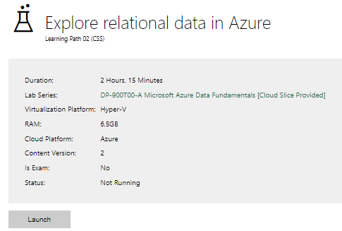

|  |  |
| --- | --- |
| **Completed lab** |  |

# Day 3: Task 2

Please complete the below lab (4) *‘Explore non-relational data in Azure’* and paste evidence of the completed lab in the box provided.

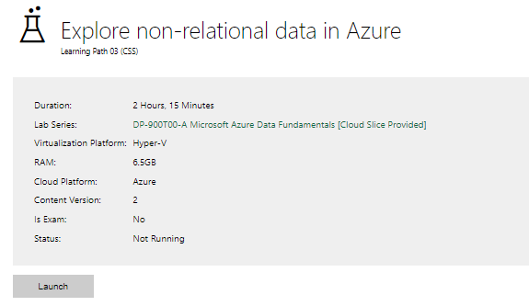

|  |  |
| --- | --- |
| **Completed lab** |  |

# Day 3: Task 3

Please complete the below lab (5) ‘Explore data analytics in Azure’ and paste evidence of the completed lab in the box provided.

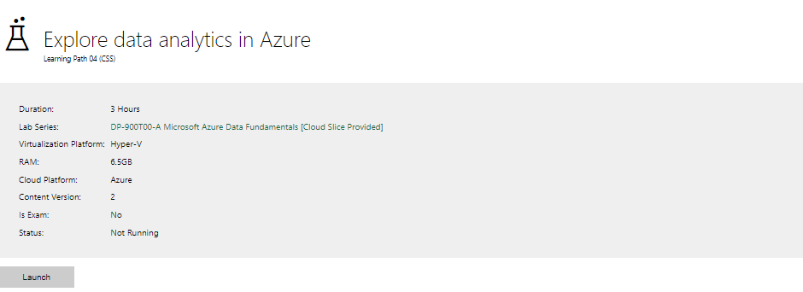

|  |  |
| --- | --- |
| **Completed lab** |  |

# Day 4: Task 1

In your teams, complete the Azure DP-900 practice exam and paste your result below – this is open book and please research and discuss your answers as a team.

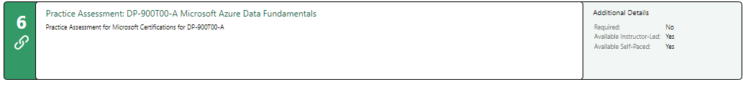

|  |  |
| --- | --- |
| **Result** |  |

# Day 4: Task 2

#### **1. Scenario Background**

"Paws & Whiskers" is a growing pet shop that aims to improve its business by analysing sales, customer information, and inventory data. Currently, the data is collected manually or stored in spreadsheets. Management is interested in transitioning to Microsoft Azure to streamline data storage, analysis, and reporting, enabling them to make data-driven decisions.

#### **2. Data Laws and Regulations**

Identify and explain the data laws and regulations relevant to handling customer data within the proposal. Ensure you cover the following points:

* **GDPR Compliance**: Highlight the importance of adhering to the General Data Protection Regulation (GDPR), particularly as it relates to storing and processing customer information.
* **Data Protection Act (DPA) 2018**: Outline how the DPA 2018 may affect the way "Paws & Whiskers" collects and stores data, ensuring compliance with UK laws on data privacy.
* **Other Industry Standards**: Research any additional data protection standards or regulations that may apply to pet shop data, particularly if they involve sensitive or payment information.

#### **3. Azure Service Recommendations**

Recommend Microsoft Azure services that would suit the company’s data analysis needs and explain why these services are suitable. Your recommendations should include:

* **Data Storage**: Identify suitable storage options, such as **Azure Blob Storage** or **Azure SQL Database**, and discuss the benefits of each for storing large datasets, including inventory, sales transactions, and customer details.
* **Data Analysis Tools**: Recommend tools such as **Azure Machine Learning** for customer behaviour analysis or **Azure Synapse Analytics** for analysing sales trends.
* **Data Integration and Automation**: Explain how services like **Azure Data Factory** could automate data collection and integration processes, improving efficiency.

#### **4. Data Types and Data Modelling**

Define the types of data "Paws & Whiskers" will need to work with and describe your approach to data modelling:

* **Data Categories**: Identify key data types, such as customer demographics, transaction history, pet inventory, and product categories.
* **Data Modelling Approach**: Outline how you would structure this data using a relational model or a data warehouse approach, considering factors like tables, entities, relationships, and primary keys.

#### **5. Data Storage Formats and Structures in Azure**

Discuss how you would store data within Azure and the formats you would recommend:

* **Data Formats**: Specify recommended formats (e.g., CSV for raw data imports, JSON for structured data, Parquet for analytics) and explain why these formats are suitable for specific data types.
* **Data Security and Encryption**: Include recommendations for securing data using Azure’s built-in encryption features and access controls to ensure compliance with data privacy regulations.

#### **6. Additional Considerations**

Provide any other considerations that might enhance data handling and efficiency in Azure, such as:

* **Backup and Disaster Recovery**: Outline a backup plan using **Azure Backup** or **Azure Site Recovery** to safeguard against data loss.
* **Data Visualisation**: Discuss potential use of **Power BI** within Azure for creating dashboards that provide management with real-time insights into sales and customer trends.
* **Future Scalability**: Comment on how Azure services can scale as the business grows, accommodating larger datasets and more complex analyses.

### **Submission Guidelines:**

1. **Structure**: Ensure your report is well-organised, with sections for each task (e.g., Data Laws, Azure Services, Data Types, etc.).
2. **Formatting**: Include headings, bullet points where appropriate, and any visuals or diagrams that support your explanations.
3. **References**: Cite any resources or regulations referenced in the report.
4. **Length**: Aim for 1500-2000 words.

|  |
| --- |
| **Data Laws and Regulations**  Ensuring compliance with data protection laws is essential when handling customer information. Below are the key regulations relevant to "Paws & Whiskers."  The General Data Protection Regulation (GDPR) applies to businesses handling the personal data of individuals within the EU. Key considerations include:  **Lawful Processing:** Customer data must be collected and processed with consent or a legitimate business interest.  **Data Minimisation:** Only necessary customer data should be stored.  Right to Access & Deletion: Customers have the right to request access to their data or have it deleted.  **Security Measures:** Data must be encrypted and protected against breaches.  As a UK-based regulation, the DPA 2018 aligns with GDPR but includes additional provisions. Compliance involves:  **Fair Processing:** Transparent handling of personal data.  **Data Security:** Ensuring customer data is not misused, lost, or accessed without authorisation.  **Retention Policies:** Limiting data storage duration to only what is necessary.  Other Industry Standards  **PCI DSS** (Payment Card Industry Data Security Standard): If "Paws & Whiskers" processes payments, it must comply with PCI DSS to protect customer payment details.  **ISO 27001:** Adopting this security standard ensures a structured approach to data security management.  **Azure Service Recommendations**  ***Data Storage***  **Azure SQL Database:** This is a fully managed relational database service that provides high availability and security. It is ideal for storing structured business data, such as customer details, sales records, and inventory levels. The built-in automatic tuning and scalability ensure optimal performance as the business grows. For example, Azure SQL Database allows querying real-time stock levels, preventing over-selling or stock shortages.  **Azure Blob Storage:** This service is excellent for unstructured data, such as invoices, customer receipts, and pet product images. It provides cost-effective scalability and integrates well with Azure Content Delivery Network (CDN) to ensure quick access to images on the company’s website.  ***Data Analysis Tools***  **Azure Synapse Analytics:** This tool enables advanced analytics, helping management identify sales trends. For instance, it can analyze historical sales data to determine the best-selling products during holiday seasons, helping with better stock planning.  **Azure Machine Learning:** Helps in customer behavior prediction. For example, by analyzing purchase history, the company can use AI-driven insights to recommend personalized promotions for pet owners.  ***Data Integration and Automation***  **Azure Data Factory:** Automates data collection from multiple sources, such as POS systems and online sales platforms, reducing manual data entry errors. For example, it can pull daily sales data from different branches and consolidate it into the Azure SQL Database for unified reporting.  **Azure Logic Apps:** Streamlines workflows like automatic reordering of low-stock items. If inventory data shows that dog food stock falls below a threshold, an automatic purchase order can be created and sent to suppliers.  **Data Types and Data Modelling**  ***Data Categories***  **Customer Data:** Names, contact details, purchase history, loyalty program status.  **Transaction Data:** Sales receipts, payment methods, order details.  **Inventory Data:** Product categories, stock levels, supplier details.  ***Data Modelling Approach***  **Relational Model (SQL Database):**  Customers Table (CustomerID, Name, Email, Phone, LoyaltyPoints)  Products Table (ProductID, Name, Category, Price, Stock)  Sales Table (SaleID, CustomerID, SaleDate, PaymentMethod)  SaleItems Table (SaleItemID, SaleID, ProductID, Quantity)  ***Data Warehouse Approach (Synapse Analytics):***  Aggregates sales, customer behavior, and inventory data for analytics.  **Data Storage Formats and Structures in Azure**  ***Data Formats***  **CSV (Comma-Separated Values):** Suitable for bulk data imports and exports, such as uploading inventory data from suppliers or exporting sales reports for offline analysis. CSV is widely supported across various applications.  **JSON (JavaScript Object Notation):** Best for structured data exchanges via APIs. For example, if "Paws & Whiskers" integrates with an online store, JSON can be used to send customer orders and product details between the website and Azure.  ***Data Security and Encryption***  **Azure Security Center:** Monitors data security risks.  **Encryption at Rest & In Transit:** Using Azure Key Vault to manage encryption keys.  **Role-Based Access Control (RBAC):** Restricts data access based on user roles.  **Additional Considerations**  ***Backup and Disaster Recovery***  Azure Backup: Regular backups of critical data.  Azure Site Recovery: Ensures business continuity in case of system failures.  Data Visualisation  PowerBI: Creates interactive dashboards for real-time insights into sales trends and customer behavior.  ***Future Scalability***  Azure Autoscale: Adjusts resources based on demand.  **Conclusion**  By transitioning to Microsoft Azure, "Paws & Whiskers" can efficiently manage sales, customer, and inventory data while ensuring compliance with data protection laws. The recommended Azure services will enhance data security, automation, and analytics, enabling data-driven business decisions. Future scalability ensures that the solution grows alongside the business, maintaining efficiency and competitiveness. |

|  |
| --- |
| **Course Notes** |

|  |
| --- |
| **Additional Information** |

It is recommended to take notes from the course, use the space below to do so, or use the revision guide shared with the class:

We have included a range of additional links to further resources and information that you may find useful, these can be found within your revision guide.

**END OF WORKBOOK**

**Please check through your work thoroughly before submitting and update the table of contents if required.**

**Please send your completed work booklet to your trainer.**