Customer base
- How many customers does the bank have per province, and what share of the total does each province represent?
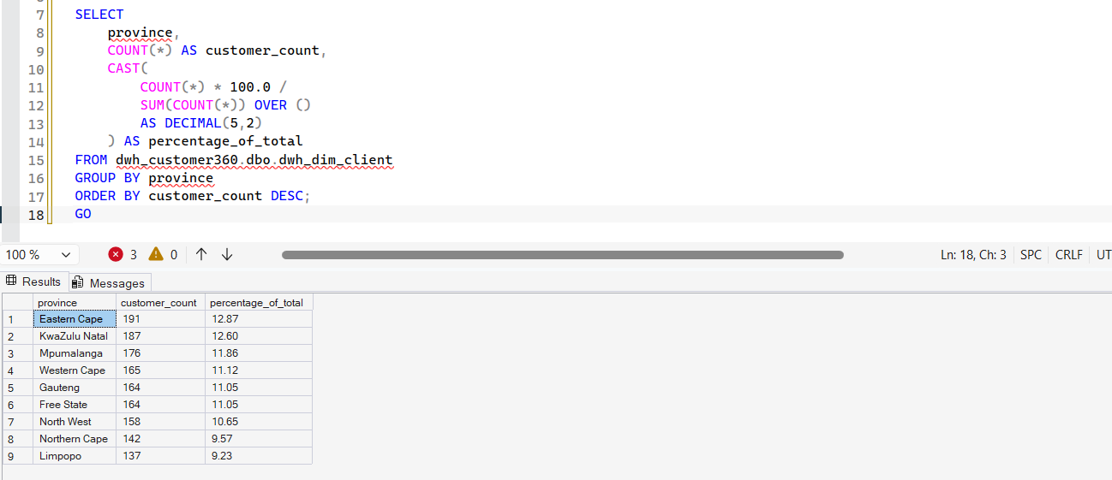
- What is the age distribution of the customer base? Present it in age bands of your own choosing and justify the bands.
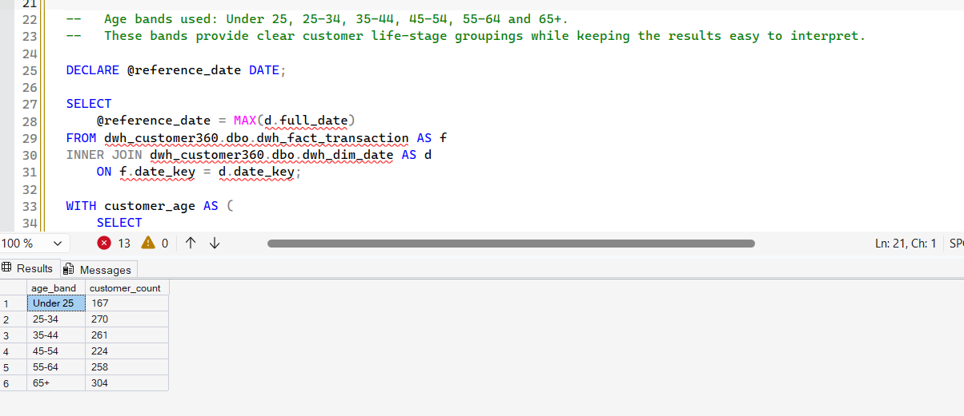
- How many customers have signed up per month over the last two years? Is signup growth trending up, flat, or down?
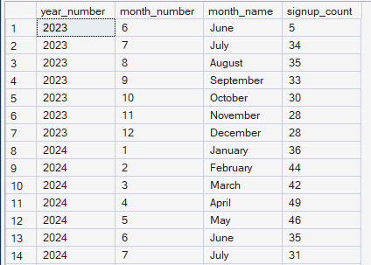
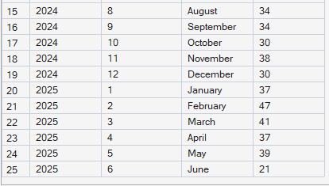
- How many customer records look like data quality problems (e.g. missing contact details, duplicate identity)? Report the count and what you count as a "problem".
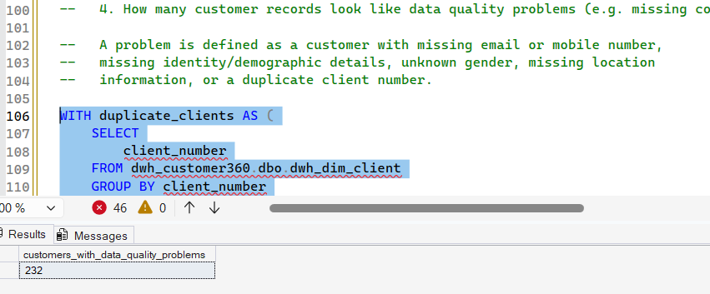

Products
- How many customers hold each product type, and how many hold more than one product (cross-holding)?
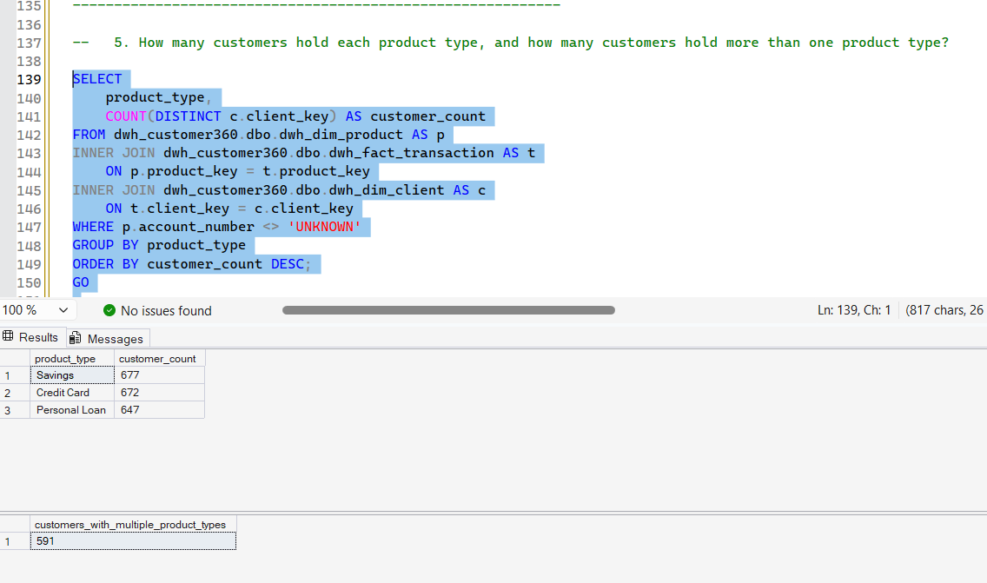
- What is the total and average account balance by product type?
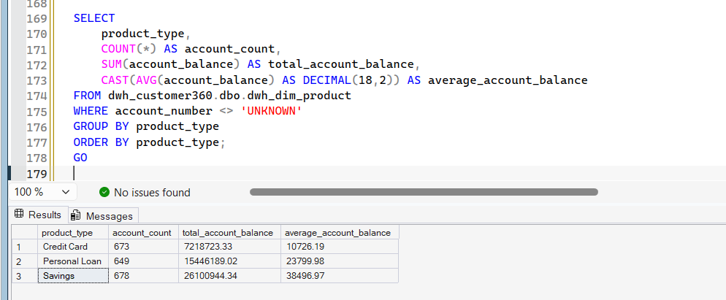
- Which customers hold a Savings account but no Credit Card? Report the count, this is a cross-sell list.
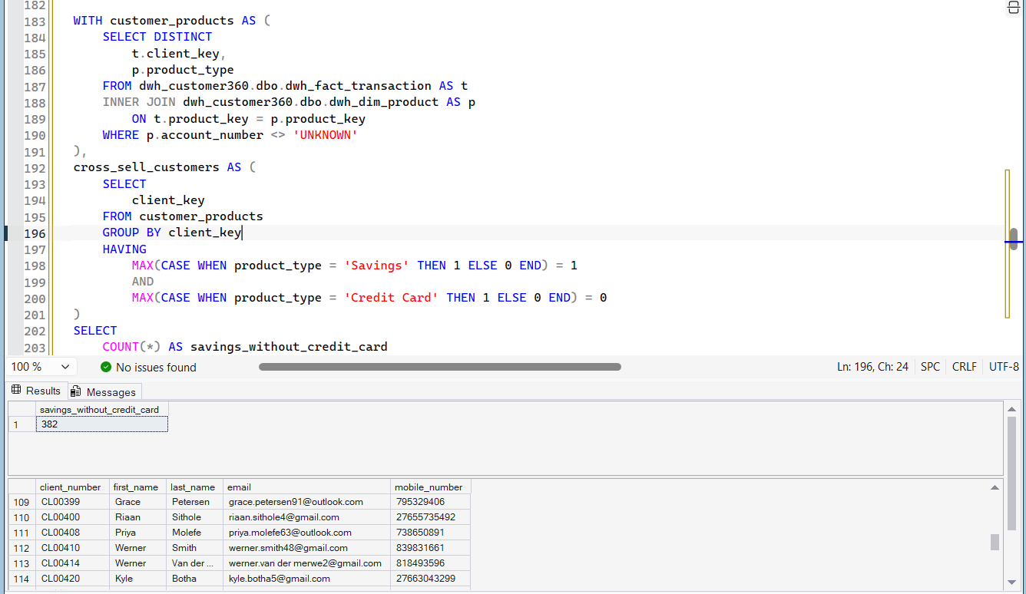
- What proportion of Credit Card accounts are within 90% of their credit limit?
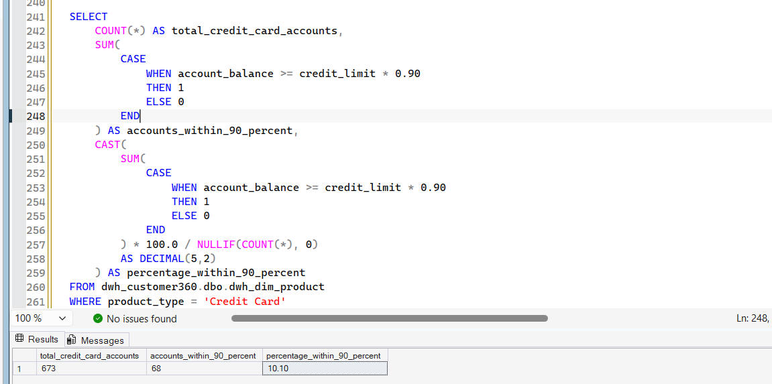

Transactions
- What is total transaction value by month, split by transaction type? Are there seasonal patterns?
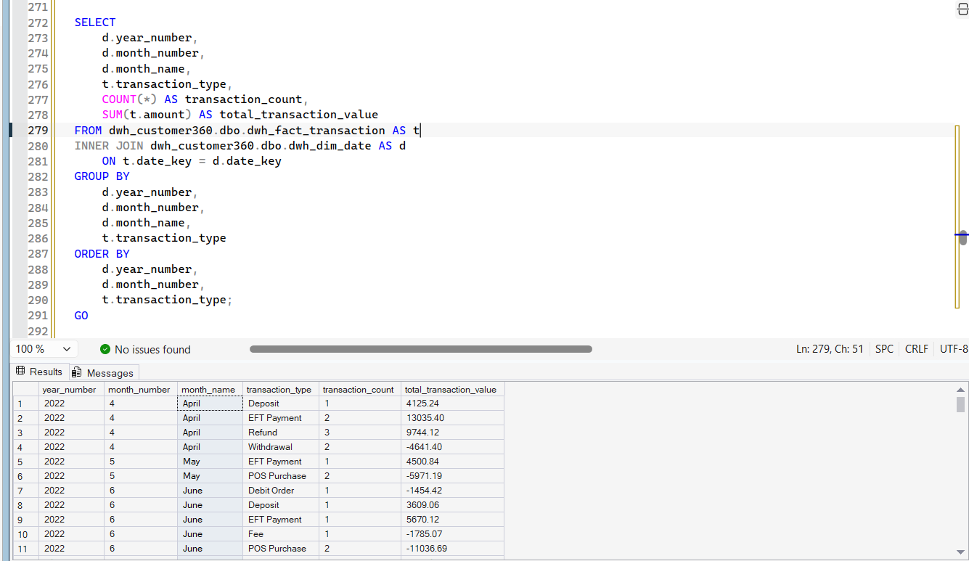
- Which transaction channel handles the most transactions, and which handles the highest total value? (These may not be the same channel, explain why, if so.)
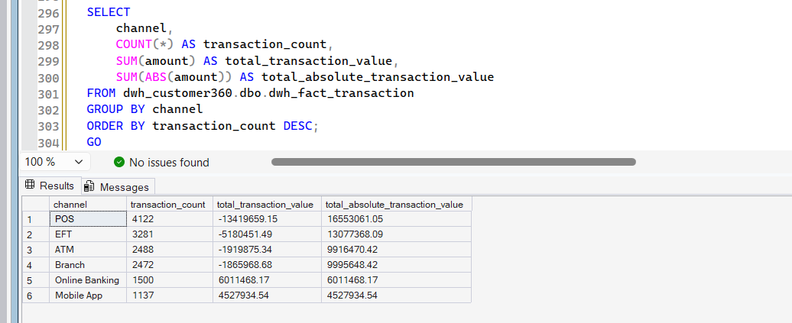
- Define "active customer" using transaction and/or interaction recency, state your definition, and report how many customers are active vs not, as of the latest date in the data.
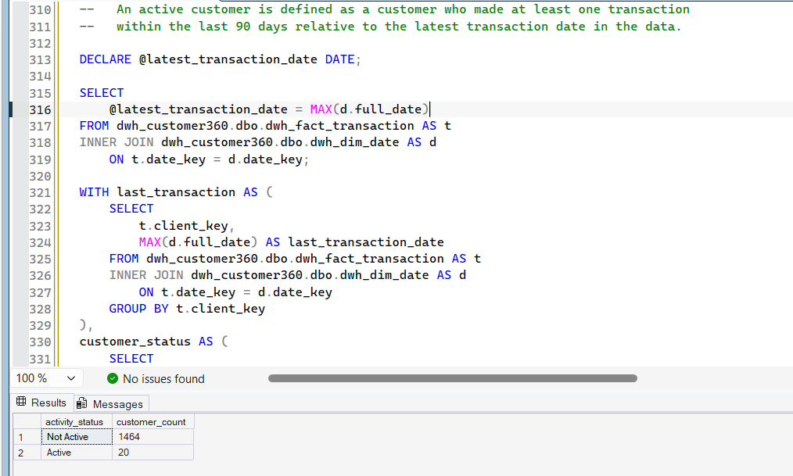
- Who are the top 20 customers by total transaction value in the last 12 months of data? (Use the latest transaction date in the data as your reference point, not today's date, this is a static extract.)
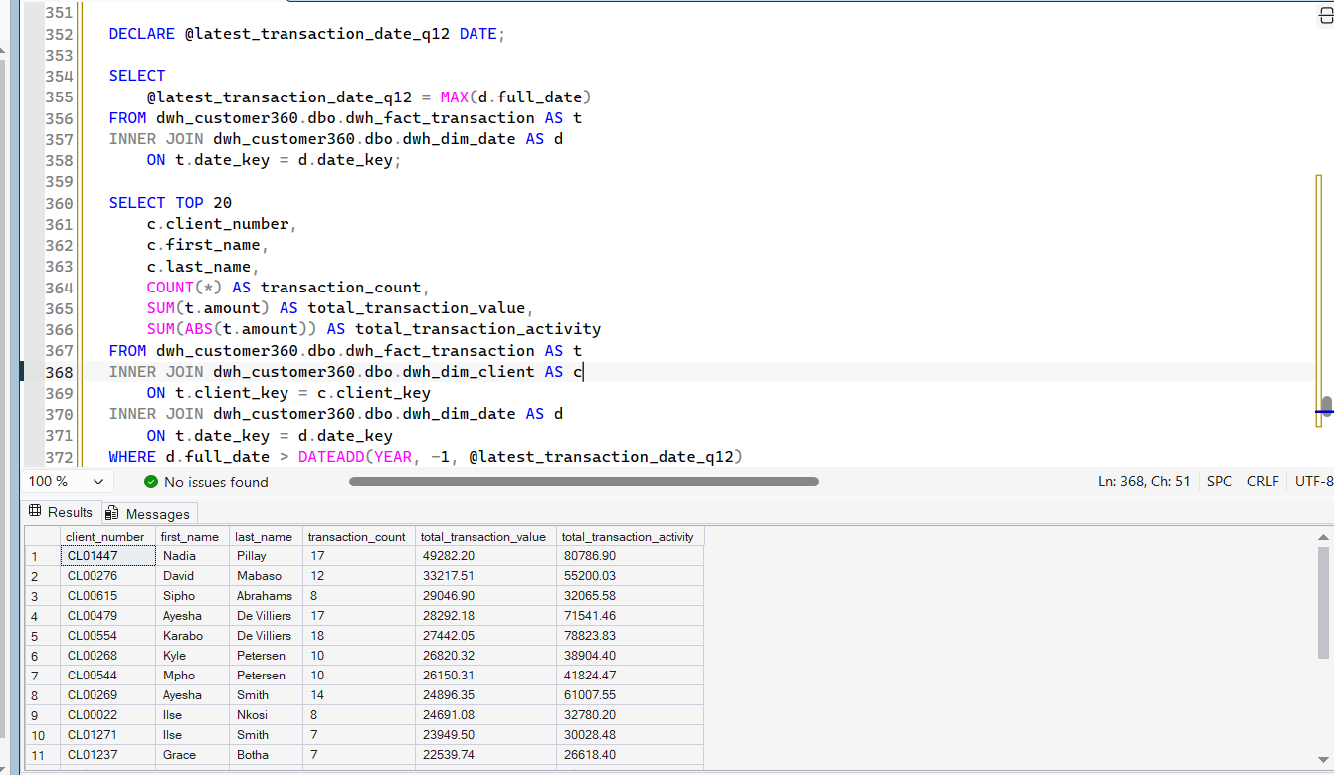

CRM / engagement
- What is the average number of interactions per customer, split by interaction type
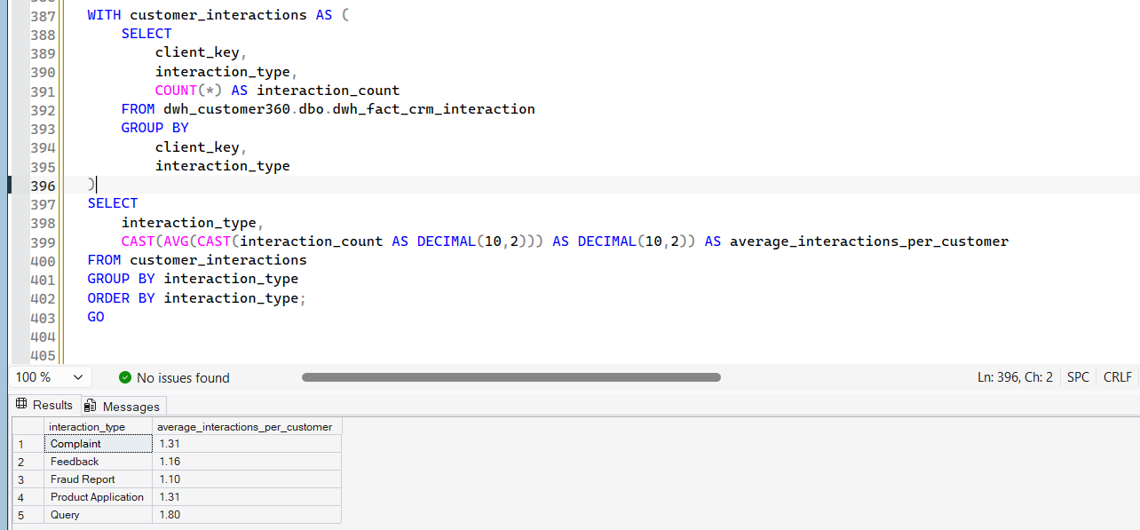
- Which channel is most used for complaints specifically, versus other interaction types?
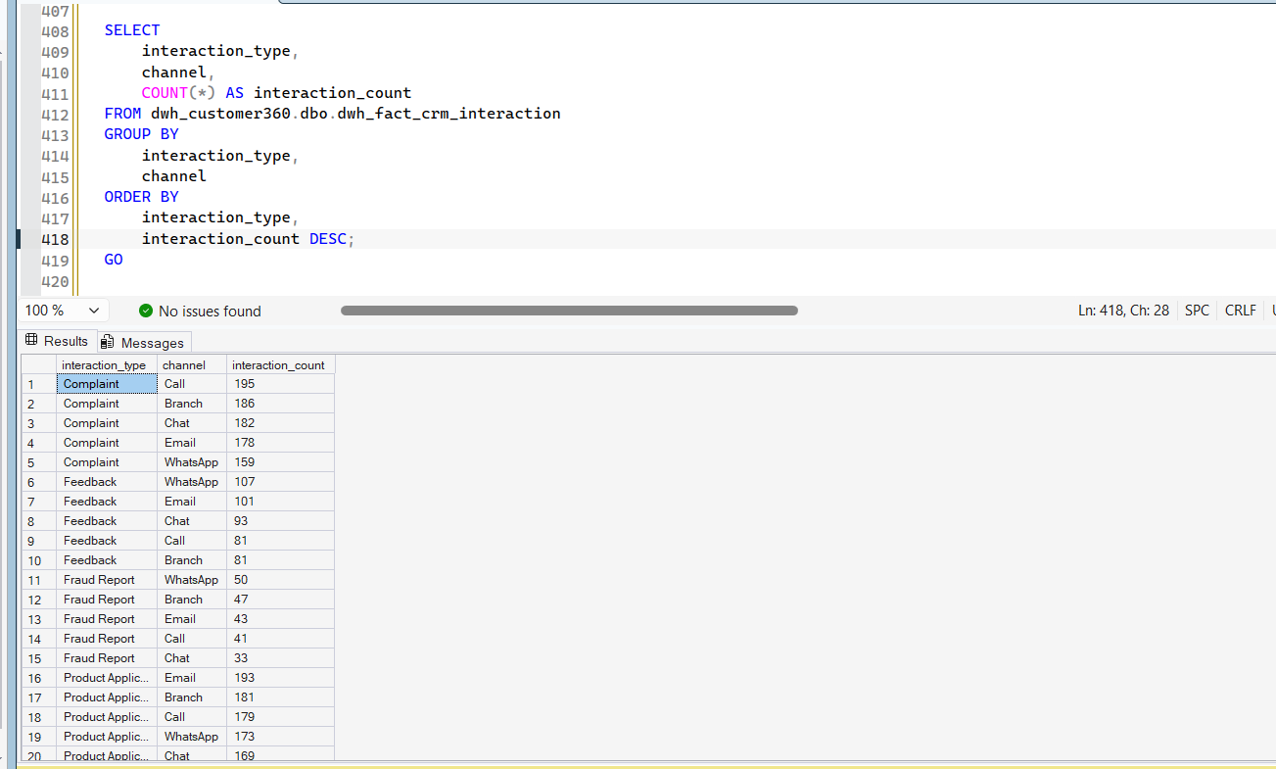
- What is the resolution rate (resolved_flag = Y) by channel? Which channel resolves the least, and could that be sample-size noise rather than a real difference?
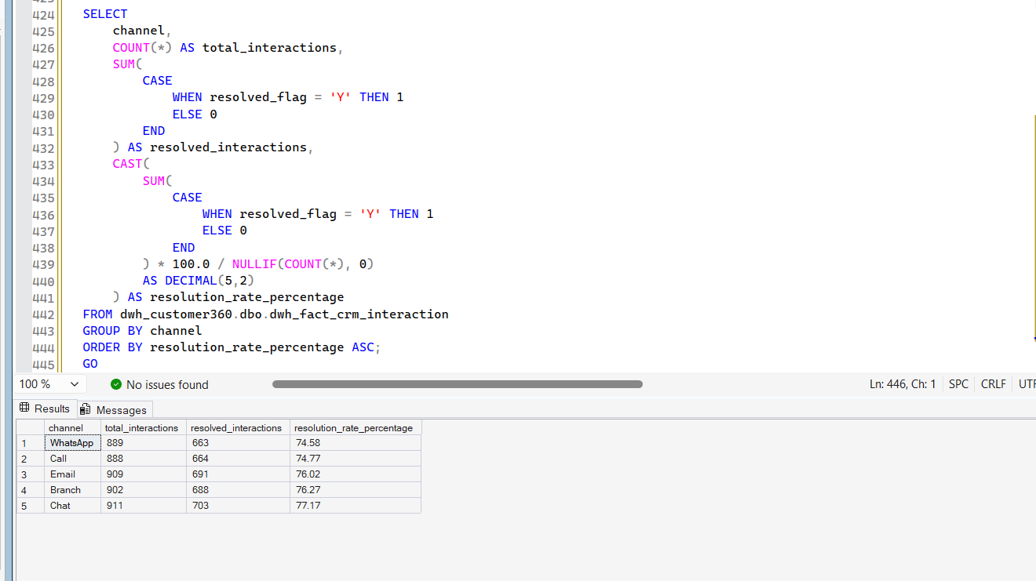

Combined / segmentation
- Segment customers into a small number of value tiers based on transaction activity (your choice of method, quartiles, fixed thresholds, etc.). Report the customer count and total transaction value per tier.
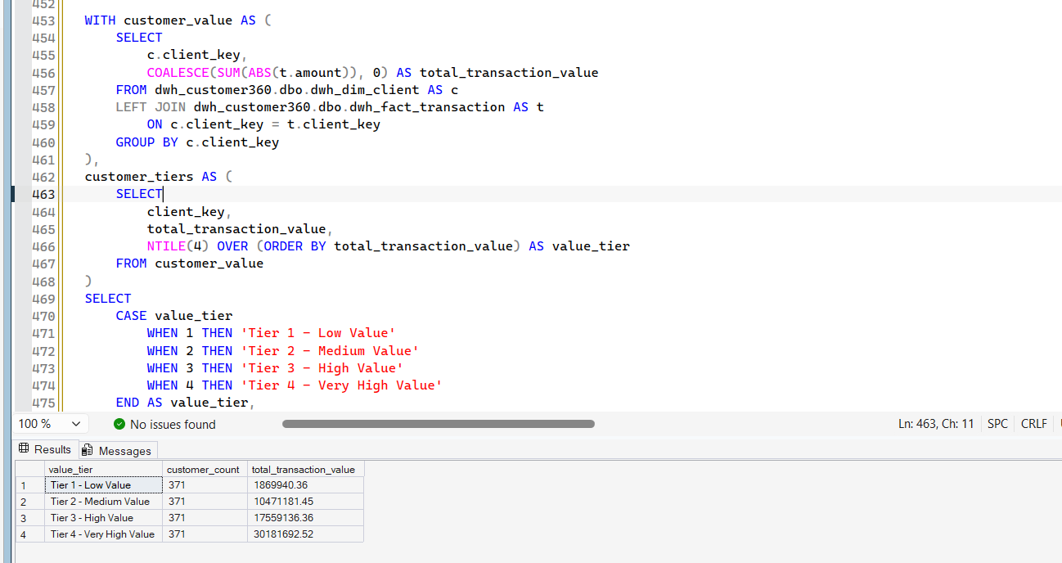
- Build a simple customer lifecycle segmentation (e.g. New / Active / At risk / Dormant) using signup date and activity recency. State your thresholds and justify them. Report the customer count per segment.
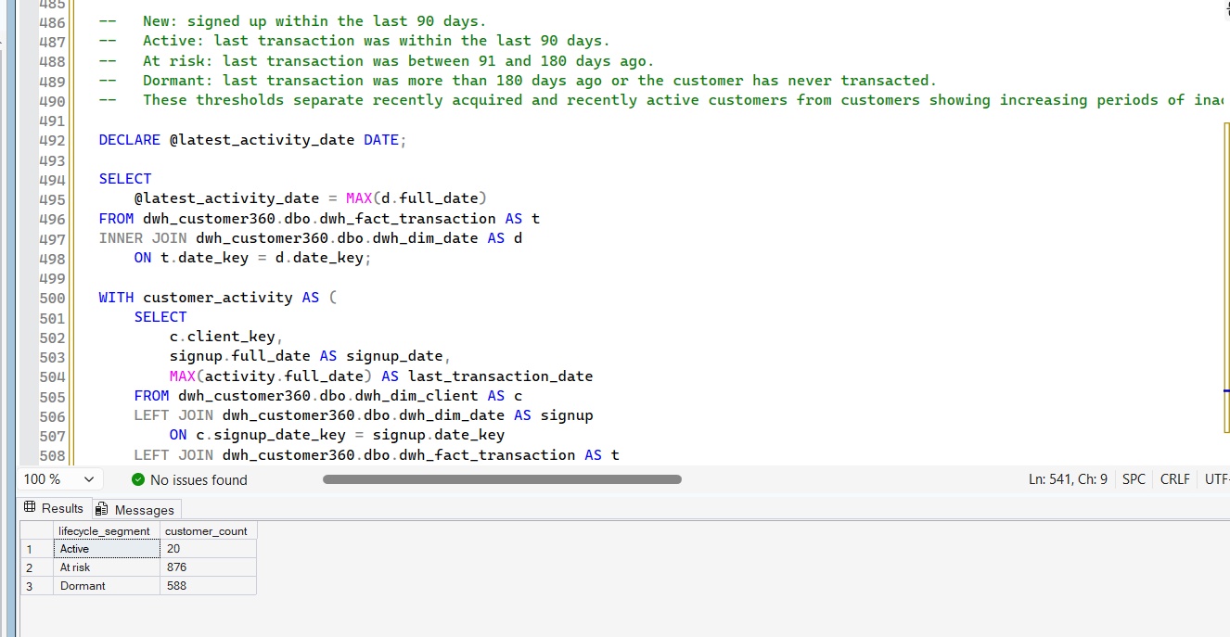
- Is there a relationship between number of CRM interactions and transaction value? (A simple grouped comparison is enough, this is not a statistics course.)
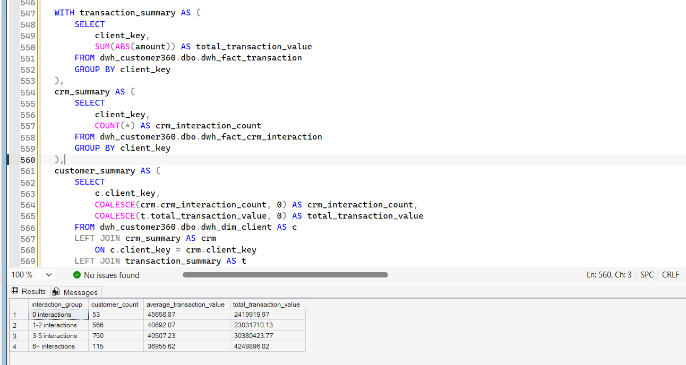

Stretch (optional, for interns who finish early)
- Build a month-over-month retention view: of customers active in month N, what percentage were still active in month N+1?
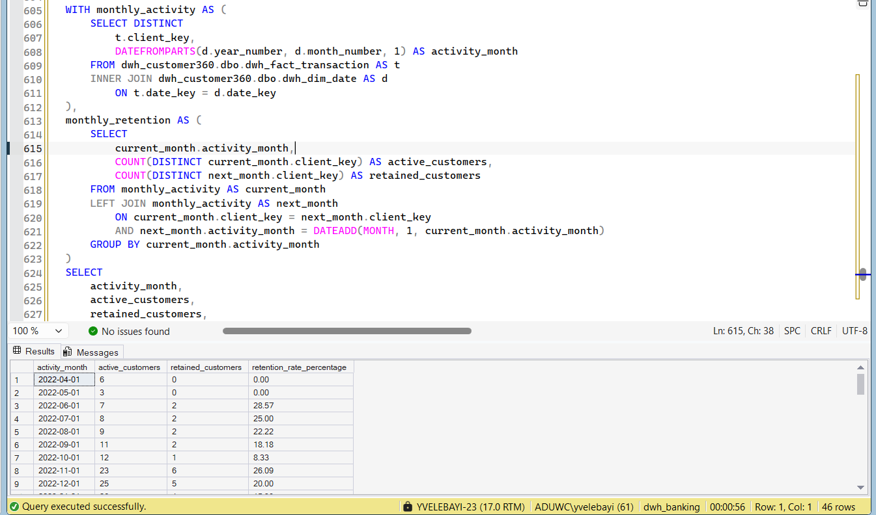
- Identify accounts with unusual transaction patterns (e.g. a sudden spike relative to the account's own history) and explain what additional data you'd want to confirm whether it's fraud.
