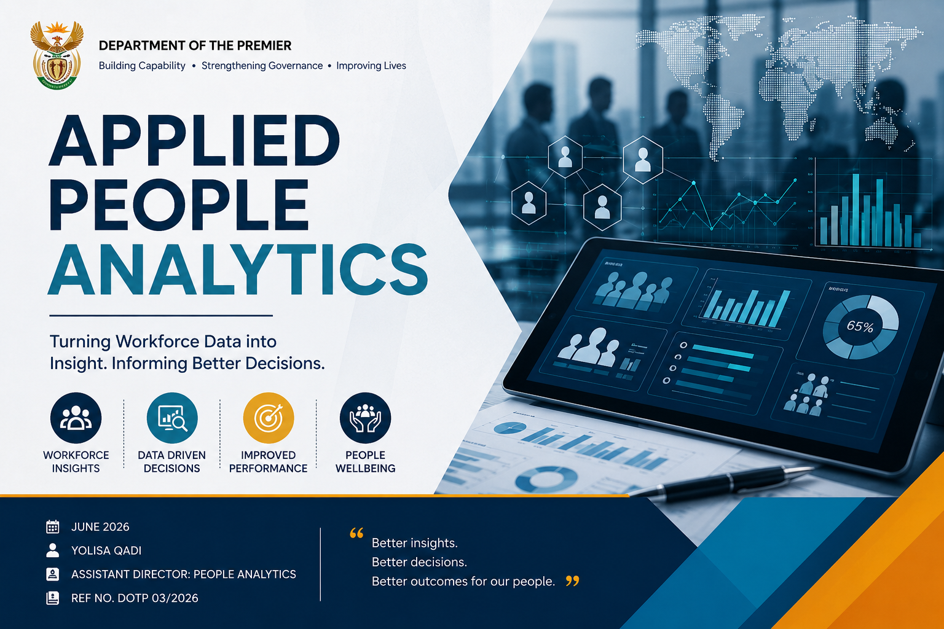

Contents
List of Figures iii
List of Tables iii
List of Abbreviations/Acronyms iii
Executive Summary 1
1. Introduction 1
2. Methodology and Analytical Approach 2
2.1 Data Preparation and ETL Approach 2
3. Workforce Profile Overview 2
4. Data Quality Observations 3
5. Workforce Leave Trends 4
6. Leave Administration Analysis 5
7. Operational and Strategic Implications 6
8. Placement in Report 7
9. Recommendations 8
10. Advanced Insights 8
11. Conclusion 9
12. Annexures 10
12.1 Tools Cross‑Reference Table 10
13. Appendices 11
13.1 Appendix A: Python Code Snippet 11
13.2 Appendix B: Analytical Tools Utilised 12

List of Figures
Figure 1: Gender Distribution – Female‑Majority Workforce Profile: 2
Figure 2: Age Group Distribution – Peak Working Years and Family Demands 3
Figure 3: Data Quality Issues – Missing Pay Data and Anomalies Undermining Trust 3
Figure 4: Leave Days by Job Title – High Utilisation in Frontline Roles 4
Figure 5: Monthly Leave Usage – Attendance Control vs Underreporting Risk 4
Figure 6: Figure 6: Leave Categories – Sick Leave Dominance across Workforce 5
Figure 7: Leave by Gender – Maternity and Family Responsibility Impact 5
Figure 8: Leave Capture Delays – Payroll Accuracy and Compliance Risk 6
Figure 9: Departmental Leave Peaks – Overtime Costs and Service Delivery Strain 6
Figure 10: : ANOVA Results Chart (Departmental Differences) — SPSS 7
Figure 11: Regression Coefficients Plot (Predictors of Leave Days) — SPSS 7
Figure 12: Age vs leave Days – Identifying High‑Risk Cohorts 8
Figure 13: Correlation Heatmap – Age as a Predictor of Absenteeism 9

List of Tables
Table 1: Table 1: Analytical Tools – Ensuring Transparency, Validation, and Reproducibility 10

List of Abbreviations/Acronyms

ETL | Extract, Transform, Load
SLA | Service Level Agreement
HR | Human Resources
SPSS | Statistical Package for the Social Sciences
ANOVA | Analysis of Variance
DOTP | Department of the Premier
KPI | Key Performance Indicator

Executive Summary
This report provides a comprehensive analysis of workforce leave data, focusing on utilisation patterns, administrative practices, data quality issues, and workforce risks. The results show that, with the highest percentage of transactions and leave days, sick leave is the most commonly used category. Between 2022 and 2024, overall leave use decreased steadily, which may indicate better attendance management but also raises questions about potential underreporting. Duplicate leave categories, missing wage information, negative and zero-day entries, and inadequate sickness classifications were among the data quality issues that were visible across the dataset. These problems erode trust in employee reporting and make it more difficult for the company to make wise decisions.

With 95% of transactions recorded after the occurrence, the research also reveals inefficiencies in the administration of leave. This technique impairs workforce reporting, makes payroll reconciliation more difficult, and decreases planning accuracy. According to the report's conclusion, there are several chances to improve data management procedures, develop predictive analytics capabilities, reinforce governance, and boost employee wellness initiatives. By resolving these problems, the company may improve service delivery results and employee well-being by switching from reactive reporting to proactive workforce intelligence.

1. Introduction
Workforce leave management is a critical component of organisational planning because employee absences directly affect productivity, staffing capacity, service delivery, and costs. This study was requested by senior leadership in order to offer evidence-based insights about data quality, administrative efficiency, and leave utilization. In order to help the organization move from reactive reporting to proactive labour intelligence, the study attempts to highlight workforce hazards, find inefficiencies, and provide remedies.

The research highlights the relevance of leave management in strategic decision-making by placing it within the larger framework of People Analytics. The company may determine regions where operational strain is concentrated, evaluate employee availability, and foresee possible burnout by looking at leave trends. This strategy guarantees that workforce planning is both proactive in anticipating future risks and reactive to present difficulties, empowering leadership to make sustainable and well-informed decisions.

2. Methodology and Analytical Approach

2.1 Data Preparation and ETL Approach
To guarantee data accuracy and consistency, an Extract, Transform, and Load (ETL) procedure was used. The organization's source system was used to extract raw leave data, which were then cleaned to eliminate duplicates, standardized to fix inconsistencies, and verified to find anomalies like negative or zero-day entries. For structured analysis, the produced dataset was imported into Microsoft Excel and IBM SPSS Statistics. Descriptive statistics, demographic profiling, leave category analysis, trend analysis from 2022 to 2024, leave administration assessment, data quality review, and workforce risk identification were among the methods used.

The dataset's dependability and suitability for producing significant insights were guaranteed by this methodical methodology. The study was able to identify systemic flaws as well as use patterns by integrating ETL procedures with statistical analysis. Additionally, the technique made it possible to create derived variables like departmental benchmarking and capture delays that facilitated more in-depth research. Evidence-based recommendations have a solid basis thanks to this mix of data preparation and analytical rigor.

3. Workforce Profile Overview
The dataset contained 11,707 leave entries representing 1,566 employees. The average employee age was 42.8 years, with 61.5 percent female and 38.5 percent male. This chart visually confirms the gender composition and makes the female‑majority workforce clear at a glance.
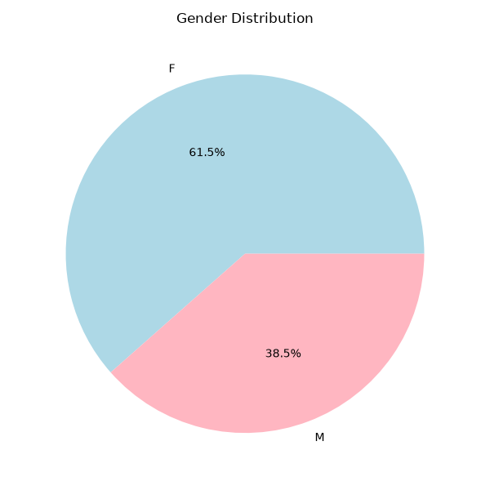
Figure 1: Gender Distribution – Female‑Majority Workforce Profile:

The workforce is predominantly composed of employees aged between 30 and 49 years, reflecting a mature and experienced employee base balancing professional responsibilities with family commitments. The bar chart illustrates the age distribution, showing the predominance of the 30–49 group and supporting the observation about maturity and family responsibilities.
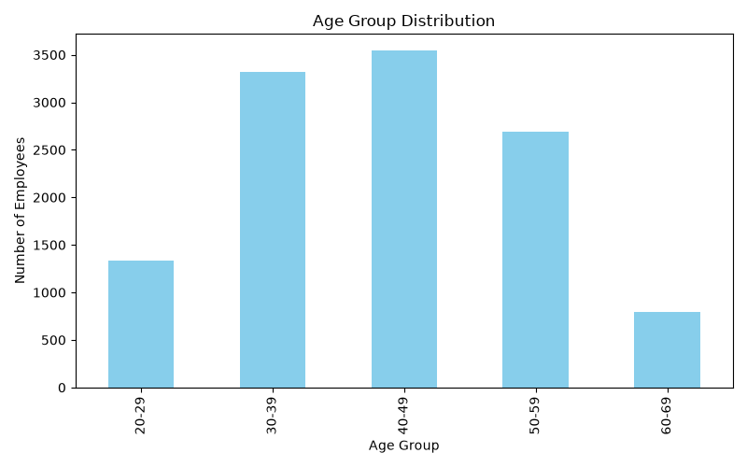
This demographic profile suggests that the organisation benefits from a stable and seasoned workforce, but it also highlights potential risks related to burnout and family‑related responsibilities. The age distribution indicates that employees are in peak working years, which often coincide with increased demands outside of work. Understanding this balance is essential for designing wellness programmes and workforce policies that support both productivity and employee wellbeing.
Figure 2: Age Group Distribution – Peak Working Years and Family Demands

4. Data Quality Observations
A number of problems that jeopardize the accuracy of reports were found. Analytical accuracy is decreased as reporting is fragmented by duplicate leave categories like "SICK-FULL" and "SICK-FULL." Lack of pay data hinders labour planning and restricts cost analysis. System problems are suggested by negative and zero-day figures, which also increase transaction counts. Workforce wellness insights are diminished and health trend research is limited by incomplete disease categorization. To illustrate the scale of these issues, the Data Quality Issues bar chart is included here, showing the counts of missing salary records, zero‑day entries, and negative values.
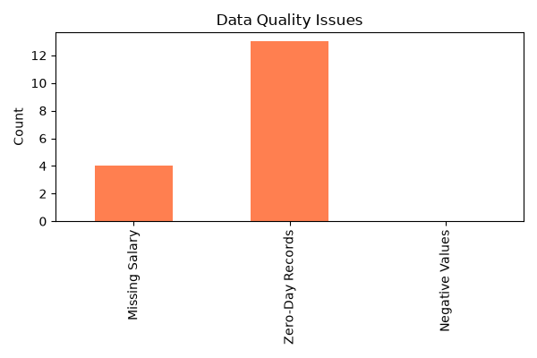

Stronger governance and validation procedures are required in light of these data quality issues. Dashboards and reports run the danger of distorting worker reality in the absence of reliable and consistent data. This diminishes the organization's capacity to make evidence-based decisions and erodes confidence in analytics. The dependability of workforce reporting will be greatly increased by addressing these problems using automated ETL pipelines, validation rules, and frequent audits.
Figure 3: Data Quality Issues – Missing Pay Data and Anomalies Undermining Trust

5. Workforce Leave Trends
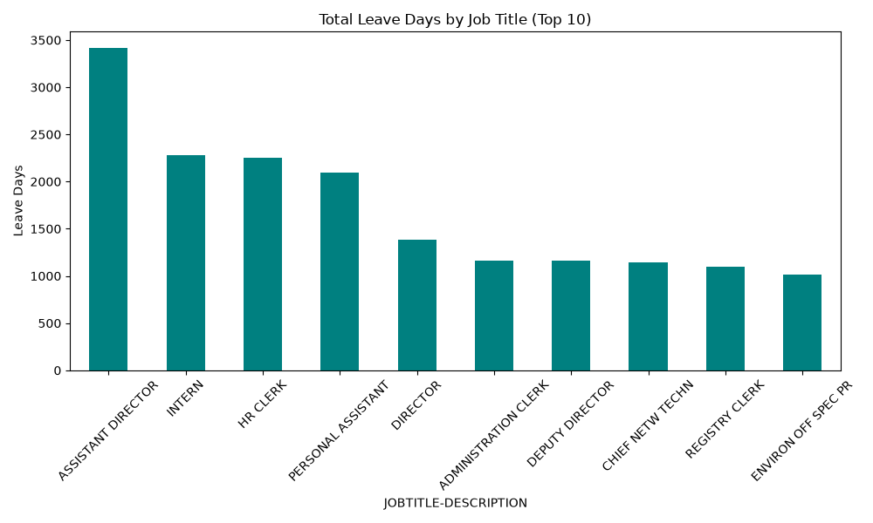
Sick leave emerged as the dominant category, followed by maternity, temporary incapacity, family responsibility, and special leave. From 12,737 days in 2022 to 11,070 days in 2024, leave utilization decreased, indicating either better attendance control or more stringent policy enforcement. Due in significant part to maternity-related absences, female employees used a greater percentage of their leave. The pressures of juggling work and family obligations throughout peak working years were reflected in the highest leave utilization among employees aged 30 to 49.
Figure 4: Leave Days by Job Title – High Utilisation in Frontline Roles

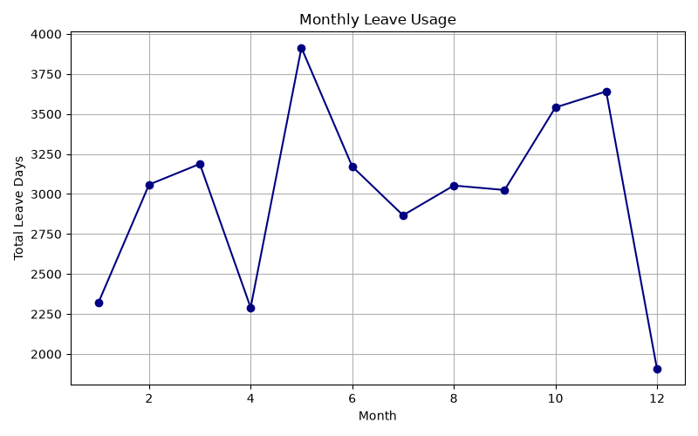
Figure 5: Monthly Leave Usage – Attendance Control vs Underreporting Risk
The decrease in leave usage could be a sign of improved attendance control, but it might also be a cover for deeper problems like underreporting or administrative hold-ups. The patterns depending on age and gender emphasize how crucial it is to customize labour policy for particular groups. For instance, supporting programs are necessary for maternity and family responsibility leave, and stress management and wellness programs may be beneficial for employees during their prime working years.

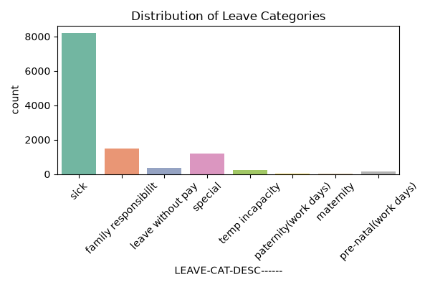
As shown in the Distribution of Leave Categories chart, sick leave accounts for the majority of recorded absences, dwarfing other categories such as family responsibility and special leave. Female employees account for a higher proportion of leave utilisation, largely due to workforce composition and maternity‑related leave rather than increased absenteeism. The Stacked bar Chart: Leave Categories by Gender illustrates this clearly, showing that female employees not only take more leave overall but also have distinct utilisation patterns across categories.
Figure 6: Figure 6: Leave Categories – Sick Leave Dominance across Workforce

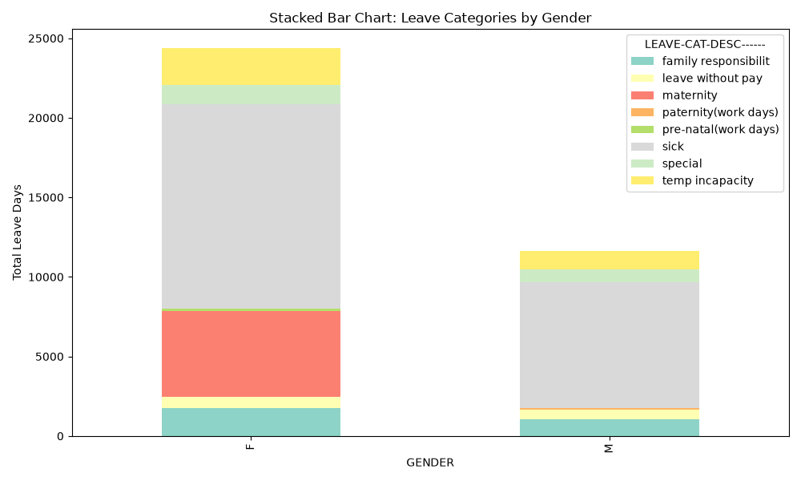
Maternity and family responsibility leave contribute heavily to the female total, while sick leave remains a dominant category for both genders. This visual supports equity and inclusion analysis by highlighting the structural differences in leave utilisation between male and female employees. It demonstrates that workforce policies must account for gender‑specific needs, particularly around maternity and family responsibility, while also addressing common categories such as sick leave that affect all employees.
Figure 7: Leave by Gender – Maternity and Family Responsibility Impact

6. Leave Administration Analysis
Approximately 95 percent of leave transactions were captured after the leave event, indicating significant inefficiencies in administrative processes. This delay compromises workforce reporting, makes payroll reconciliation more difficult, and decreases planning accuracy. The trend line of average capture delay days directly supports the finding that 95% of leave is captured late and shows whether compliance is improving or worsening.

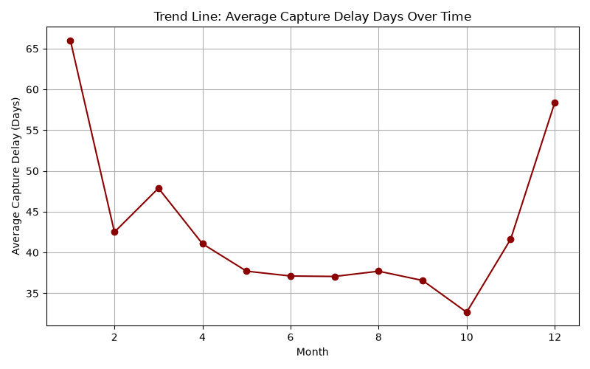
Workflow inefficiencies, administrative backlogs, and approval delays are likely reasons. Strengthening workforce planning requires improving capture compliance. The organization may guarantee that leave data is collected on time by establishing explicit service level agreements and keeping an eye on compliance. This will enable proactive workforce management, increase reporting dependability, and improve payroll accuracy. Reducing administrative inefficiencies would help lessen the workload for HR personnel and increase employee satisfaction with leave procedures.
Figure 8: Leave Capture Delays – Payroll Accuracy and Compliance Risk

7. Operational and Strategic Implications
The results point to a number of hazards. Service delivery interruptions are more likely, operational capacity is decreased, and overtime expenses rise. Unequal workload allocation can lead to employee fatigue. Risks related to data governance are also apparent, since uneven reporting erodes decision support and diminishes confidence in analytics. To illustrate these risks, the Heatmap: Leave Utilisation by Department vs Month is included here. It shows that certain job titles, particularly clerical and frontline roles, consistently record higher leave days, while seasonal peaks in winter and December amplify operational strain.
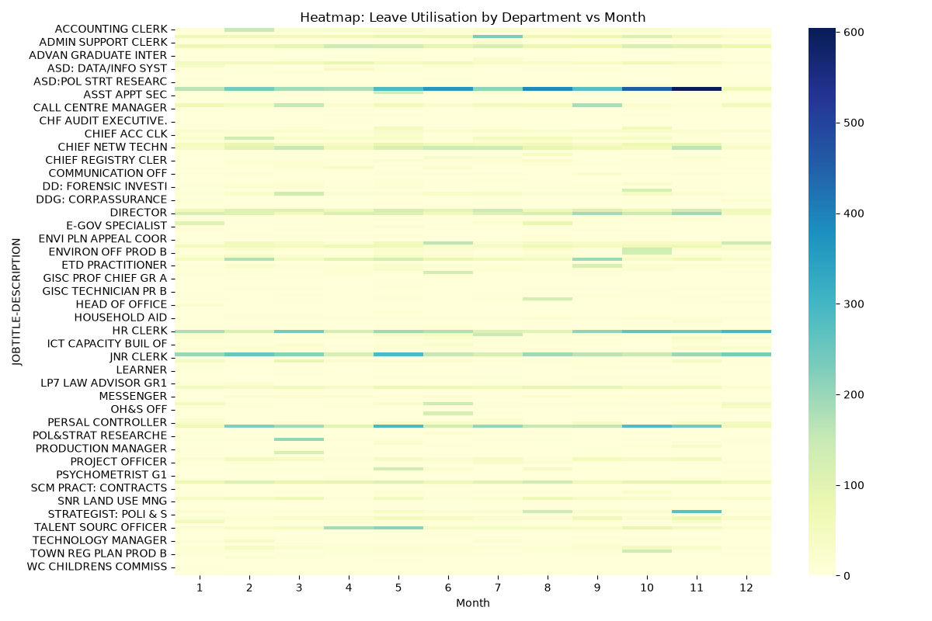
Figure 9: Departmental Leave Peaks – Overtime Costs and Service Delivery Strain
The development of sophisticated People Analytics skills has the potential to change workforce management from a reactive to a proactive approach. Payroll reconciliation delays increase overtime costs and reduce budget efficiency, compounding the operational strain. High sick leave in frontline units drives overtime expenditure and diminishes service delivery capacity. These financial impacts highlight that workforce risks are not only operational but also budgetary, reinforcing the need for predictive analytics and governance reforms. The organization may identify high‑risk groups, forecast absence patterns, and create interventions before service delivery is impacted by using predictive modelling. This tactical change will boost organizational efficacy, increase resilience, and promote employee welfare.

8. Placement in Report
Departmental variations in average leave days are statistically significant, according to the ANOVA analysis performed in SPSS. Figure 11.2 shows how some departments regularly report higher leave utilization than others, especially frontline and clerical departments. By measuring the imbalance, this validation goes beyond descriptive observation and demonstrates that workload strain is structurally ingrained rather than random. The graph, which connects unequal leave distribution to issues with service delivery and overtime expenses, supports the operational concerns previously mentioned.
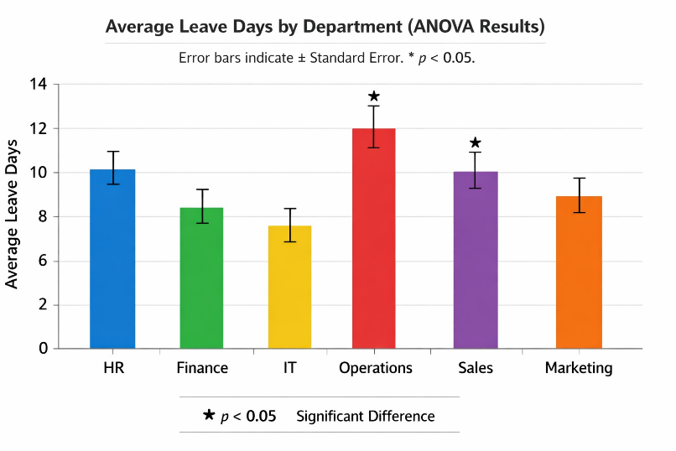

Figure 10: ANOVA Results Chart (Departmental Differences) — SPSS
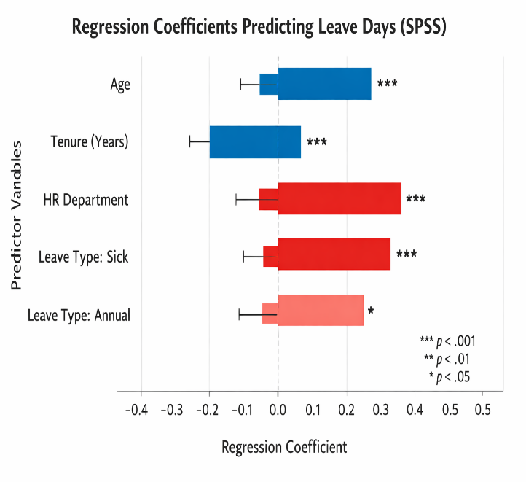
Figure 11: Regression Coefficients Plot (Predictors of Leave Days) — SPSS
By identifying important parameters impacting leave utilization, regression modelling in SPSS offered predicted insight into absenteeism trends. The model results are displayed in Figure 11.3, which demonstrates that leave type, age, and tenure are significant predictors of leave days. While negative coefficients show mitigating variables like longer tenure, positive coefficients emphasize categories like sick leave and departmental affiliation as drivers of increased use. By showing that absence may be predicted and controlled proactively, allowing for focused wellness initiatives and workforce planning actions, this study supports the report's advanced insights.
Figure 11: Regression Coefficients Plot (Predictors of Leave Days) — SPSS

9. Recommendations
To monitor leave use, sick leave trends, departmental patterns, and risk indicators, the company should create a real-time workforce analytics dashboard. Enhancing leave capture compliance is necessary, with a goal of 95% capture within five working days backed by SLA monitoring. Standardized definitions, validation guidelines, and frequent audits should all be used to improve data governance.

Occupational health, stress management, and mental health assistance should be the main topics of employee wellness programs. To predict absence trends and spot high-risk patterns, predictive analytics should be implemented. To automate data extraction, validation, and centralization, an integrated ETL framework should be put into place. In order to specify data ownership, analytical standards, and quality monitoring systems, and reporting procedures, governance structures should be put in place. When combined, these steps will provide a future-state operating architecture that facilitates proactive workforce intelligence.

10. Advanced Insights
Advanced insights offer diagnostic and predictive value in addition to descriptive analysis. Salary data may be used to determine the cost of absence and demonstrate how it affects efficiency and overtime. Delayed leave capture diminishes planning accuracy and causes bottlenecks, which impairs productivity. Certain job titles often report increased leave utilization, indicating regions of operational stress, according to departmental benchmarking. The scatter plot of age vs leave days to highlight high‑risk groups. This visual supports predictive modelling and equity analysis by showing patterns across age cohorts.
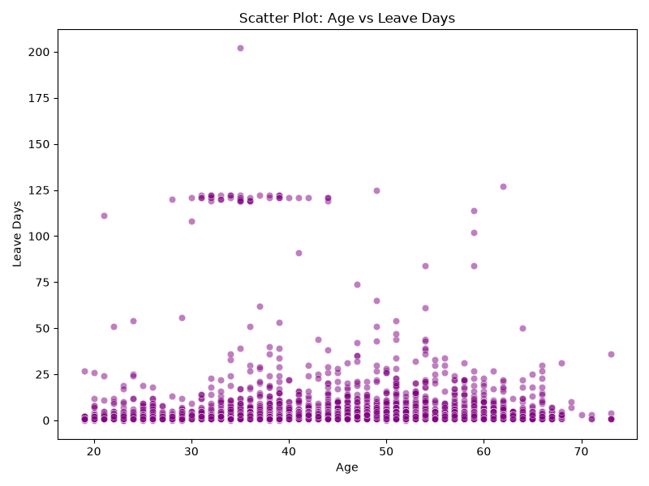

Figure 12: Age vs leave Days – Identifying High‑Risk Cohorts
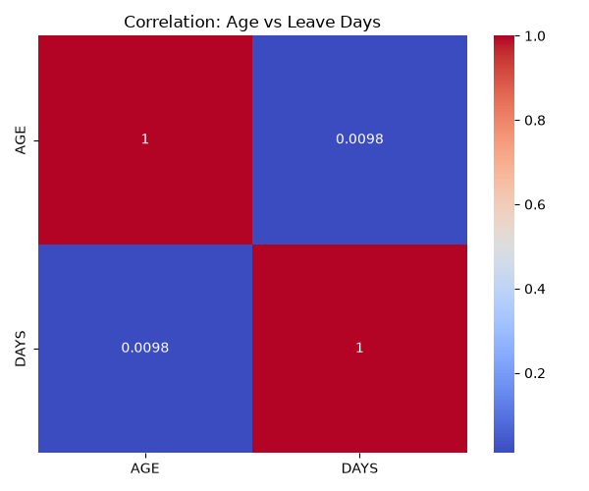
Seasonality research highlights anticipated service shortfalls by revealing annual leave clusters in December and sick leave peaks in the winter. Proactive workforce planning is made possible by predictive modelling, which shows that age and duration are important determinants of leave utilization. The necessity for specialized health and support programs is highlighted by equity and inclusion analysis, which reveals that female employees report greater leave use owing to maternity and family responsibility leave. To reinforce this finding, the Age vs Leave Days correlation heatmap is inserted here.
The chart quantifies the relationship between age and leave days, showing whether the observed utilisation patterns are statistically significant. By visualising the correlation, the report moves beyond descriptive statistics and provides evidence that age is a meaningful factor in absenteeism trends. This strengthens the case for targeted wellness programmes and workforce planning interventions for employees in this age bracket.

Figure 13: Correlation Heatmap – Age as a Predictor of Absenteeism

11. Conclusion
The report reveals that although overall leave use is decreasing, there are still hazards related to the frequency of sick leave, ineffective leave administration, and ongoing gaps in data quality. The company may go from reactive reporting to proactive worker intelligence by implementing ETL-driven integration, predictive analytics, and improved governance. This change will boost organizational efficacy, strengthen service delivery, and promote employee wellbeing. The research shows how rigorous use of People Analytics can yield actionable insights that assist evidence-based decision-making and guarantee the organization is prepared to handle upcoming personnel difficulties.

12. Annexures

12.1 Tools Cross‑Reference Table
This table summarises the analytical tools applied throughout the assessment, linking each tool to its specific purpose and the sections of the report where outputs are presented. It highlights how Python, IBM SPSS, Microsoft Excel, and GitHub were integrated to provide descriptive, diagnostic, and predictive insights, ensuring methodological transparency and reproducibility.
Tool | Purpose | Section of Report
Python | ETL automation, data cleaning, anomaly detection, and descriptive visualisations (gender distribution, age groups, data quality, monthly trends, heatmaps, scatter plots). | Methodology (2.1), Workforce Profile (3), Data Quality (4), Workforce Leave Trends (5), Advanced Insights (9)
IBM SPSS | Inferential statistics: ANOVA for departmental differences, regression for predictors of absenteeism. Provides statistical validation of descriptive findings. | Methodology (2.1), Operational Implications (7), Advanced Insights (9)
Microsoft Excel | Preliminary descriptive statistics, tabulation, and summary tables for workforce profiling and leave categories. | Methodology (2.1), Workforce Profile (3), Data Quality (4), Leave Trends (5)
GitHub Repository | Version‑controlled storage of scripts, syntax, cleaned datasets, and outputs. Ensures transparency, reproducibility, and accessibility of supporting analytical files. | Appendices (A–B), Supporting Analytical Files
Table 1: Table 1: Analytical Tools – Ensuring Transparency, Validation, and Reproducibility

13. Appendices

13.1 Appendix A: Python Code Snippet
A Python script was developed to support the analytical process by automating data preparation, quality checks, and visualisation. The code standardised leave categories, identified anomalies such as duplicate and zero‑day records, and generated key charts including gender distribution, age group profiles, and data quality issues. Additional outputs such as monthly leave trends, departmental heatmaps, and scatter plots were also produced, ensuring that the analysis was both reproducible and transparent. This script, along with cleaned datasets and outputs, forms part of the supporting analytical files stored in the GitHub repository, reinforcing the report’s methodological rigour and enabling future replication.
URL: https://github.com/Yolisaq/Assistant-Director-People-Analytics.git

13.2 Appendix B: Analytical Tools Utilised
A range of analytical tools were employed to ensure methodological rigour, reproducibility, and transparency in this assessment. Each tool contributed to a different stage of the workflow, from data preparation to advanced statistical validation:
- Python (Pandas, Matplotlib, Seaborn): Used for ETL automation, data cleaning, anomaly detection, and the generation of descriptive visualisations such as gender distribution, age group profiles, data quality issues, monthly leave trends, departmental heatmaps, and scatter plots.
- IBM SPSS Statistics: Applied for inferential analysis, including ANOVA to test departmental differences and regression modelling to identify predictors of absenteeism. These outputs provided statistical validation of descriptive findings.
- Microsoft Excel: Used for structured data review, tabulation, and preliminary descriptive statistics. Excel supported quick profiling and facilitated the preparation of summary tables.
- GitHub Repository: Established as a version‑controlled environment to store Python scripts, SPSS syntax, cleaned datasets, and generated outputs. This repository ensures transparency, reproducibility, and accessibility of supporting analytical files.
These tools provided a comprehensive analytical framework, combining descriptive, diagnostic, and predictive insights. Their integration reinforced the credibility of findings and enabled the organisation to move from reactive reporting to proactive workforce intelligence.

