

**Homework #12**

**01286121 Computer Programming**

**Software Engineering Program,**

**Department of Computer Engineering,**

**School of Engineering, KMITL**

By

68011278 Ananda Stallard

1.

Code:

abbreviations = {

"be": "b",

"because": "cuz",

"see": "c",

"the": "da",

"okay": "ok",

"are": "r",

"you": "u",

"without": "w/o",

"why": "y",

"see you": "cu",

"ate": "8",

"great": "gr8",

"mate": "m8",

"wait": "w8",

"later": "l8r",

"tomorrow": "2mro",

"for": "4",

"before": "b4",

"once": "1ce",

"and": "&",

"your": "ur",

"you're": "ur",

"as far as I know": "afaik",

"as soon as possible": "ASAP",

"at the moment": "atm",

"be right back": "brb",

"by the way": "btw",

"for your information": "FYI",

"in my humble opinion": "imho",

"in my opinion": "imo",

"laughing out loud": "lol",

"oh my god": "omg",

"rolling on the floor laughing": "rofl",

"talk to you later": "ttyl"

}

def textese(s):

text = s.lower()

for phrase, abbr in abbreviations.items():

if " " in phrase:

text = text.replace(phrase, abbr)

words = text.split()

for i in range(len(words)):

if words[i] in abbreviations:

words[i] = abbreviations[words[i]]

return " ".join(words)

def untextese(s):

reverse_abbreviation = {v.lower(): k for k, v in abbreviations.items()}

text = s.lower()

words = text.split()

for i in range(len(words)):

if words[i] in reverse_abbreviation:

words[i] = reverse_abbreviation[words[i]]

return " ".join(words)

abbreviated = textese("see you later, I will be right back as soon as possible and also, that's great")

print(f"Abbreviated sentence: {abbreviated}")

un_abbreviated = untextese(abbreviated)

print(f"Un-Abbreviated sentence: {un_abbreviated}")

Result:

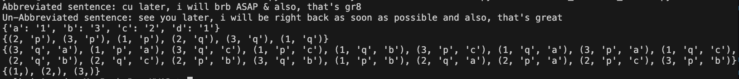

2.

Code:

def composite(d1, d2):

d3 = {}

for k, v in d1.items():

for i in d2:

if v == i:

d3[k] = d2[i]

return d3

dict1 = {'a': 'p', 'b': 'r', 'c': 'q', 'd': 'p', 'e': 's'}

dict2 = {'p': '1', 'q': '2', 'r': '3'}

new_dict = composite(dict1, dict2)

print(new_dict)

Result:



3.

Code:

def product(*args):

if not args:

return set()

if len(args) == 1:

return {(x, ) for x in args[0]}

first, *rest = args

rest_products = product(*rest)

cartesian = set()

for i in first:

for j in rest_products:

cartesian.add((i, *j))

return cartesian

s1 = set([1, 2, 3])

s2 = set(['p', 'q'])

s3 = set(['a', 'b', 'c'])

print(product(s1, s2))

print(product(s1, s2, s3))

print(product(s1))

Result:

