

**Homework #9**

**01286121 Computer Programming**

**Software Engineering Program,**

**Department of Computer Engineering,**

**School of Engineering, KMITL**

By

68011278 Ananda Stallard

1.

Code:

from tkinter import *

class KMITL_Phone:

def __init__(self):

window = Tk()

window.title("KMITL Phone")

self.message = StringVar()

frame1 = Frame(window)

frame1.grid(row=1, column=1, pady=10)

Label(frame1, textvariable=self.message).pack()

frame2 = Frame(window)

frame2.grid(row=2, column=1)

Button(frame2, text="1", command=lambda: self.add_digit("1")).grid(row=1, column=1)

Button(frame2, text="2", command=lambda: self.add_digit("2")).grid(row=1, column=2)

Button(frame2, text="3", command=lambda: self.add_digit("3")).grid(row=1, column=3)

Button(frame2, text="4", command=lambda: self.add_digit("4")).grid(row=2, column=1)

Button(frame2, text="5", command=lambda: self.add_digit("5")).grid(row=2, column=2)

Button(frame2, text="6", command=lambda: self.add_digit("6")).grid(row=2, column=3)

Button(frame2, text="7", command=lambda: self.add_digit("7")).grid(row=3, column=1)

Button(frame2, text="8", command=lambda: self.add_digit("8")).grid(row=3, column=2)

Button(frame2, text="9", command=lambda: self.add_digit("9")).grid(row=3, column=3)

Button(frame2, text="*", command=lambda: self.add_digit("*")).grid(row=4, column=1)

Button(frame2, text="0", command=lambda: self.add_digit("0")).grid(row=4, column=2)

Button(frame2, text="#", command=lambda: self.add_digit("#")).grid(row=4, column=3)

frame3 = Frame(window)

frame3.grid(row=3, column=1, pady=10)

Button(frame3, text="Talk", command=self.talk).grid(row=1, column=1, padx=5)

Button(frame3, text="<", command=self.backspace).grid(row=1, column=2, padx=5)

window.mainloop()

def add_digit(self, digit):

self.message.set(self.message.get() + digit)

def backspace(self):

self.message.set(self.message.get()[:-1])

def talk(self):

self.message.set("Dialing " + self.message.get())

KMITL_Phone()

Result:

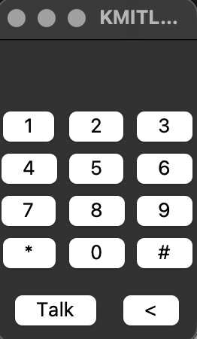 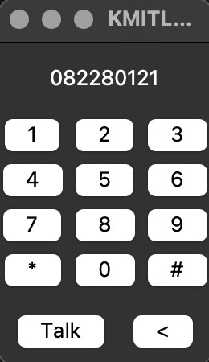

2.

Code:

from tkinter import *

from tkinter import ttk

class PhotoGalleryApp:

def __init__(self, root):

self.root = root

self.root.title("Photo Gallery App")

self.container = Frame(root)

self.container.pack()

self.frames = {}

for F in (MainMenu, Gallery, Import, Export, Settings):

page_name = F.__name__

frame = F(parent=self.container, controller=self)

self.frames[page_name] = frame

frame.grid(row=0, column=0, sticky="nsew")

self.show_frame("MainMenu")

def show_frame(self, page_name):

frame = self.frames[page_name]

frame.tkraise()

class MainMenu(Frame):

def __init__(self, parent, controller):

Frame.__init__(self, parent)

Label(self, text="Photo Gallery - Main Menu").pack(padx = 10, pady=20)

Button(self, text="Gallery", width=20, command=lambda: controller.show_frame("Gallery")).pack(padx = 10, pady=5)

Button(self, text="Import", width=20, command=lambda: controller.show_frame("Import")).pack(padx = 10, pady=5)

Button(self, text="Export", width=20, command=lambda: controller.show_frame("Export")).pack(padx = 10, pady=5)

Button(self, text="Settings", width=20, command=lambda: controller.show_frame("Settings")).pack(padx = 10, pady=5)

Button(self, text="Exit", width=20, command=controller.root.quit).pack(padx = 10, pady=5)

class Gallery(Frame):

def __init__(self, parent, controller):

Frame.__init__(self, parent)

Label(self, text="Gallery ").pack(padx = 10, pady=20)

Button(self, text="Back to Main Menu", command=lambda: controller.show_frame("MainMenu")).pack()

class Import(Frame):

def __init__(self, parent, controller):

Frame.__init__(self, parent)

Label(self, text="Import").pack(padx = 10, pady=20)

Button(self, text="Back to Main Menu", command=lambda: controller.show_frame("MainMenu")).pack()

class Export(Frame):

def __init__(self, parent, controller):

Frame.__init__(self, parent)

Label(self, text="Export").pack(padx = 10, pady=20)

Button(self, text="Back to Main Menu", command=lambda: controller.show_frame("MainMenu")).pack()

class Settings(Frame):

def __init__(self, parent, controller):

Frame.__init__(self, parent)

Label(self, text="Settings").pack(padx = 10, pady=20)

Button(self, text="Back to Main Menu", command=lambda: controller.show_frame("MainMenu")).pack()

root = Tk()

app = PhotoGalleryApp(root)

root.mainloop()

Result:

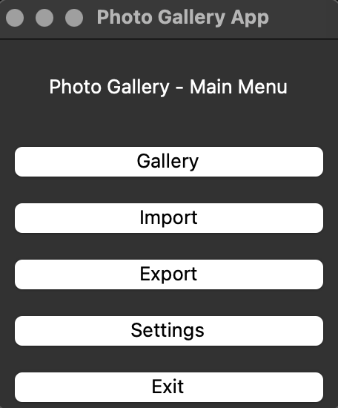 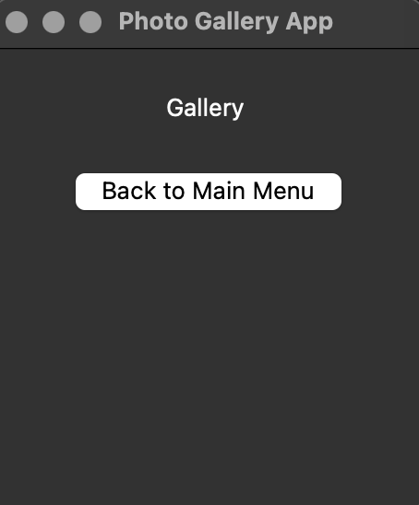

3.

Code:

from tkinter import *

Class circles:

def __init__(self):

window = Tk()

window.title("tk")

self.num = 0

self.canvas = Canvas(window)

self.canvas.pack()

self.canvas.bind("<Button-1>", self.add_circle)

self.canvas.bind("<Button-3>", self.remove_circle)

window.mainloop()

def add_circle(self, event):

self.num += 1

self.canvas.create_oval(event.x - 10, event.y - 10, event.x + 10, event.y + 10, tags = ("circle", f"circle{self.num}"))

def remove_circle(self, event):

ids = self.canvas.find_overlapping(event.x - 10, event.y - 10, event.x + 10, event.y + 10)

for i in ids:

self.canvas.delete(i)

circles()

Result:

