

**Homework #4**

**01286121 Computer Programming**

**Software Engineering Program,**

**Department of Computer Engineering,**

**School of Engineering, KMITL**

By

68011278 Ananda Stallard

Code:

name = input("Enter employee's name: ")

hours = float(input("Enter hours worked in a week: "))

pay_rate = float(input("Enter hourly pay rate: "))

federal_tax = float(input("Enter federal tax withholding rate: "))

state_tax = float(input("Enter state tax withholding rate: "))

gross_pay = hours * pay_rate

federal_deduction = gross_pay * federal_tax

state_deduction = gross_pay * state_tax

total_deduction = federal_deduction + state_deduction

net_pay = gross_pay - total_deduction

print(f"\nEmployee Name: {name}\nHours Worked: {hours}\nPay Rate: {pay_rate}\nGross Pay: {gross_pay:.2f}")

print("Deductions:")

print(f" Federal Withholding ({federal_tax * 100:.2f}%): {federal_deduction:.2f}")

print(f" State Withholding ({state_tax * 100:.2f}%): {state_deduction:.2f}")

print(f" Total Deduction: {total_deduction:.2f}")

print(f"Net Pay: {net_pay:.2f}")

Result:

2.

Code:

number = input("Enter a four digit number: ")

reversed = int(number[::-1])

print(reversed)

Result:

3.

Code:

import turtle

length = int(input("Enter the length of the star: "))

turtle.pensize(2)

turtle.speed(8)

for i in range(5):

turtle.pendown()

turtle.forward(length)

turtle.right(144)

turtle.penup()

turtle.hideturtle()

turtle.done()

Result:

(Length: 300)

4.

Code:

import turtle

radius = int(input("Enter the radius: "))

turtle.pensize(5)

turtle.speed(20)

turtle.hideturtle()

turtle.penup()

#Top row of rings

turtle.goto(-2.5 * radius, 0)

turtle.pendown()

turtle.color("blue")

turtle.circle(radius)

turtle.penup()

turtle.goto(0, 0)

turtle.pendown()

turtle.color("black")

turtle.circle(radius)

turtle.penup()

turtle.goto(2.5 * radius, 0)

turtle.pendown()

turtle.color("red")

turtle.circle(radius)

turtle.penup()

#Bottom row of rings

turtle.goto(-1.25 * radius, -radius)

turtle.pendown()

turtle.color("yellow")

turtle.circle(radius)

turtle.penup()

turtle.goto(1.25 * radius, -radius)

turtle.pendown()

turtle.color("green")

turtle.circle(radius)

turtle.penup()

turtle.done()

Result:

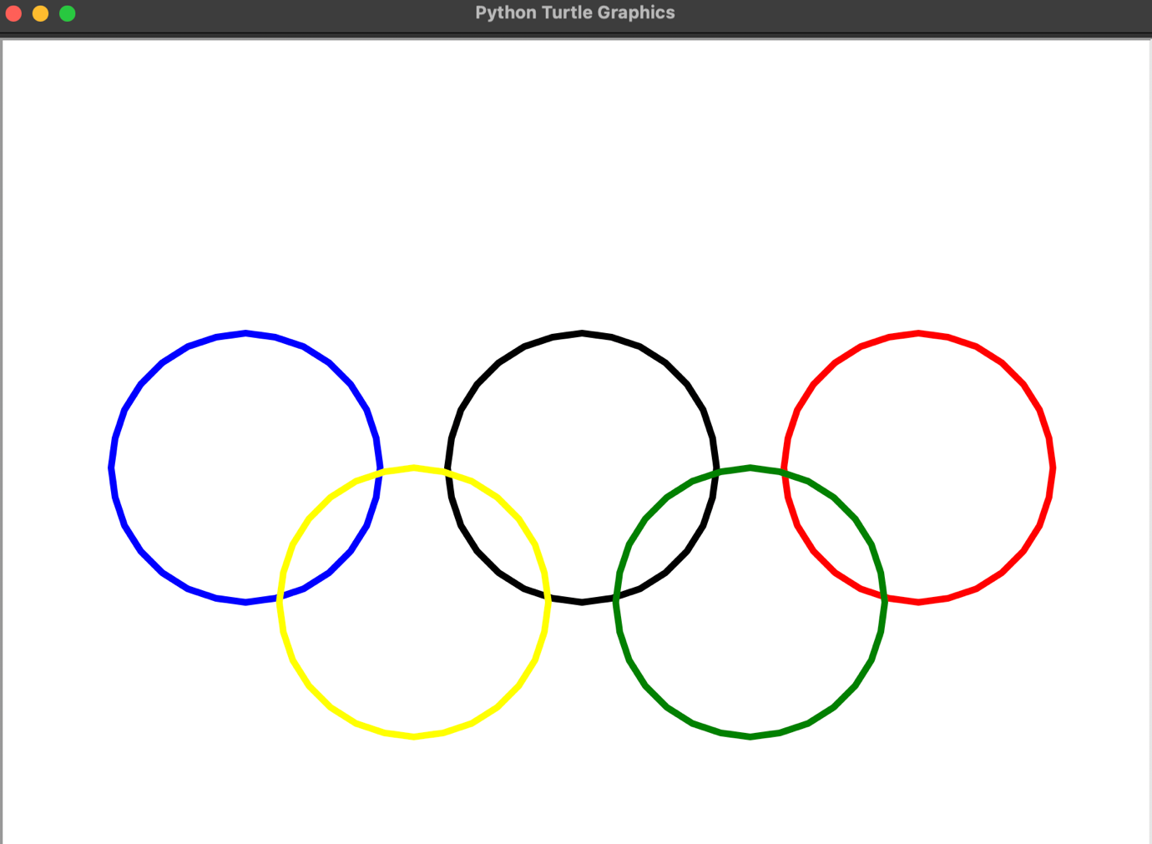

(Radius: 100)

5.

Code:

import turtle

p1x,p1y = input("Enter first point for triangle (x,y): ").split(",")

p2x,p2y = input("Enter second point for triangle (x,y): ").split(",")

p3x,p3y = input("Enter third point for triangle (x,y): ").split(",")

#Convert x, y points to floating point

p1x = float(p1x)

p2x = float(p2x)

p3x = float(p3x)

p1y = float(p1y)

p2y = float(p2y)

p3y = float(p3y)

area = 1/2 * abs(p1x * (p2y - p3y) + p2x * (p3y - p1y) + p3x * (p1y - p2y))

turtle.penup()

turtle.goto(p1x, p1y)

turtle.pendown()

turtle.goto(p2x, p2y)

turtle.goto(p3x, p3y)

turtle.goto(p1x, p1y)

turtle.penup()

turtle.goto((p1x + p2x + p3x)/3, -(p1x + p2y + p3y)/3)

turtle.write(f"Area: {area:.2f}")

turtle.hideturtle()

turtle.done()

Result:

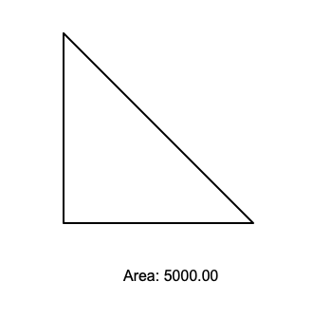

|Point 1: 0, 0|

|Point 1: 0, 100|

|Point 1: 100, 0|