CS331 Project 2

Haiqiang Zou

Student ID: 2717

Due Data: 4/22/2013

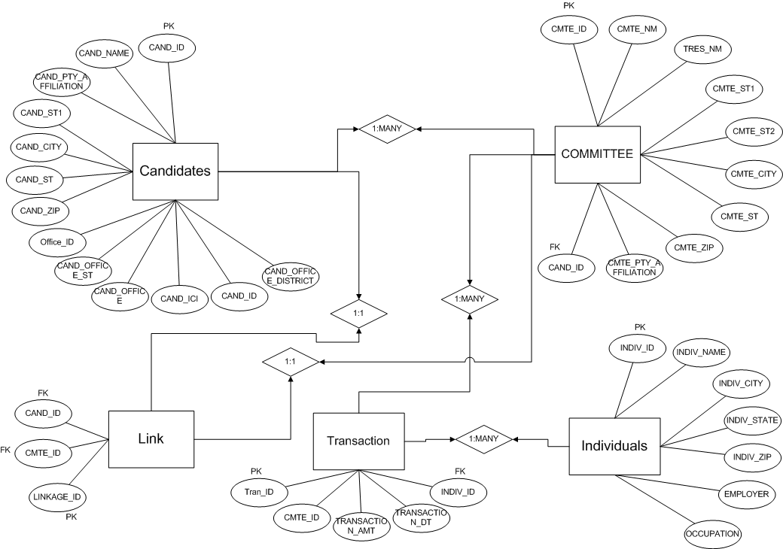

**QUESTIONS**

1. Identify contributions by banks or finance related occupations to each party. Use

a join and functions to create your output. Create three reports:

1. Contributions by party. Include only Democratic and Republican candidates. Display one row for Democratic and one row for Republican. Display party name, number of contributions and total contributions.
2. Identify top ten employers for Democrats. Display employer, number of contributions and total contributions. Display the employer with the highest total contributions first.
3. Identify top ten employers for Republicans. Display employer, number of contributions and total contributions. Display the employer with the highest total contributions first.

1a)

select cmte_Pty_affiliation, count(*) "Number of Contributions", sum(transaction_amt) "Total Contributions"

from transaction t, committee c, individuals i

where t.cmte_id = c.cmte_id and t.indiv_id=i.indiv_id and (CMTE_PTY_AFFILIATION='REP' or CMTE_PTY_AFFILIATION='DEM') and (occupation like '%BANK%' or occupation like '%FINAN%' or occupation like '%INVEST%'or occupation like '%BROKER%' or occupation like '%VENTURE%' or occupation like '%ECONO%' or employer like '%BANK%' or employer like '%FINAN%' or employer like '%INVEST%')

group by cmte_pty_affiliation;

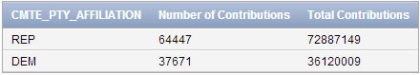

1b)

select employer, count(*) "Number of Contributions", sum(transaction_amt) "Total Contributions"

from individuals i, transaction t, committee c

where i.indiv_id=t.indiv_id and t.cmte_id=c.cmte_ID and cmte_pty_affiliation='DEM' and (occupation like '%BANK%' or occupation like '%FINAN%' or occupation like '%INVEST%'or occupation like '%BROKER%' or occupation like '%VENTURE%' or occupation like '%ECONO%')

group by employer

order by 3 desc;

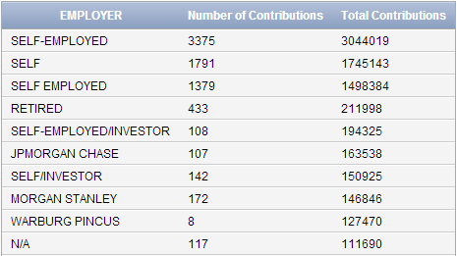

1C)

select employer, count(*) "Number of Contributions", sum(transaction_amt) "Total Contributions"

from individuals i, transaction t, committee c

where i.indiv_id=t.indiv_id and t.cmte_id=c.cmte_ID and cmte_pty_affiliation='REP' and (occupation like '%BANK%' or occupation like '%FINAN%' or occupation like '%INVEST%'or occupation like '%BROKER%' or occupation like '%VENTURE%' or occupation like '%ECONO%')

group by employer

order by 3 desc;

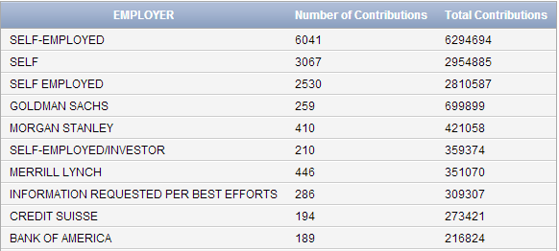

1. Identify the location of campaign contributions for the representative in your neighborhood. Display the city, state, number of contributions and total contributions. Output one row for each distinct city and state. Display the city with the highest contributions first.

select indiv_city, indiv_state, count(*) "Number of Contributions", sum(Transaction_amt) "Total Contributions"

from candidates ca, link l, transaction t, individuals i

where cand_city = 'NEW YORK' and CAND_ST = 'NY' and ca.cand_id = l.cand_id and l.cmte_id=t.cmte_id and t.indiv_id=i.indiv_id

group by indiv_city, indiv_state

order by 3 desc;

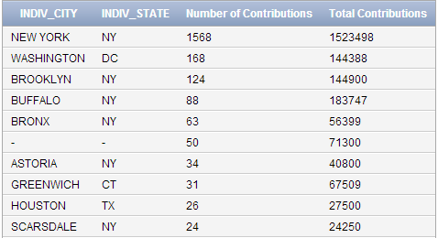

1. Identify party affiliation for contributors in your neighborhood. Include all candidates.
2. Display the party affiliation, number of contributions and total contributions. Display one row for each party. The party with the highest total contributions first will be displayed first.
3. Compare your neighborhood to Alaska. Display the party affiliation, number of contributions and total contributions. Display one row for each party. The party with the highest total contributions will be displayed first.

3a)

select cmte_pty_affiliation, count(*) "Number of Contributions", sum(Transaction_amt) "Total Contributions"

from individuals i, committee c, transaction t

where (indiv_city='FLUSHING' or indiv_zip='11355' or indiv_zip='11354' or indiv_zip='11356' or indiv_zip='11357') and indiv_state='NY' and i.indiv_id=t.indiv_id and t.cmte_id=c.cmte_id

group by cmte_pty_affiliation

order by 3 desc;

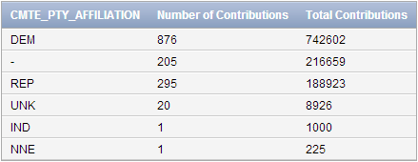

3b)

select cmte_pty_affiliation, count(*) "Number of Contributions", sum(Transaction_amt) "Total Contributions"

from individuals i, committee c, transaction t

where indiv_state='AK' and i.indiv_id=t.indiv_id and t.cmte_id=c.cmte_id

group by cmte_pty_affiliation

order by 3 desc;

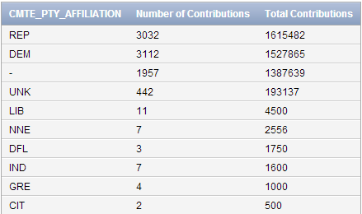

1. Identify campaign contributions by state for all candidates. Display the state, number of contributions, total contributions and average contributions. Display the state with the most contributions first. Output one row for each state.

select indiv_state, count(*) "Number of Contributions", sum(transaction_amt) "Total Contributions", round(avg(transaction_amt),2)

from individuals i, transaction t

where i.indiv_id=t.indiv_id

group by indiv_state

order by 2 desc;

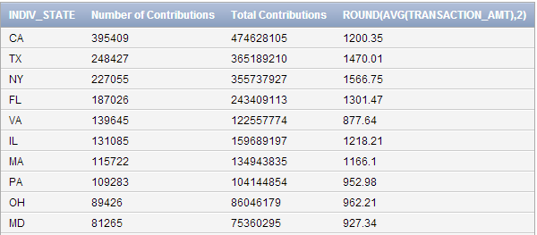

1. Identify zip codes with the most fund raising for candidates Obama and Romney. Display the zip code, number of contributions, total contributions and average contributions. Display the top five Democratic and top five Republican zip codes. Display the zip codes with the highest contributions first. Where are these zip codes? Use a nested select and functions to create your output.

Display the zip code, number of contributions, total contributions and average contributions.

select indiv_zip, count(*) "Number of Contributions", sum(transaction_amt) "Total Transaction", round(avg(transaction_amt),2) "Average Contributions"

from candidates ca, link l, transaction t, individuals i

where (ca.cand_name='"OBAMA, BARACK"' or ca.cand_name='"ROMNEY, MITT / RYAN, PAUL D. "') and ca.cand_id=l.cand_id and l.cmte_id=t.cmte_id and t.indiv_id=i.indiv_id

group by indiv_zip

order by 2 desc;

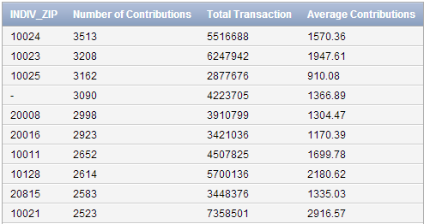

Display the top five Democratic and top five Republican zip codes

select *

from (select indiv_zip "Top 5 Democractic Zip", count(*) "Number of Contributions"

from individuals i, transaction t, committee c

where i.indiv_id=t.indiv_id and t.cmte_id=c.cmte_id and c.cmte_pty_affiliation='DEM'

group by indiv_zip

order by 2 desc)

where rownum<=5;

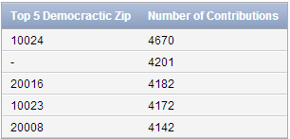

select *

from (select indiv_zip "Top 5 REP Zip", count(*) "Number of Contributions"

from individuals i, transaction t, committee c

where i.indiv_id=t.indiv_id and t.cmte_id=c.cmte_id and c.cmte_pty_affiliation='REP’

group by indiv_zip

order by 2 desc)

where rownum<=5;

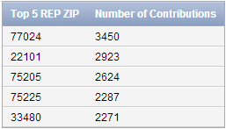

1. Identify the top ten campaign contributors for two candidates in the same race. Display the contributor name, employer, city, state, zip code, contribution amount and candidate name. Display the contributor with the highest total contributions first.

select indiv_name, employer, indiv_city, indiv_state, indiv_zip, sum(transaction_amt) "Total Contributions", cand_name

from candidates ca, link l, transaction t, individuals i

where (ca.cand_name='"OBAMA, BARACK"' or ca.cand_name='"ROMNEY, MITT / RYAN, PAUL D. "') and ca.cand_id=l.cand_id and l.cmte_id=t.cmte_id and t.indiv_id=i.indiv_id

group by indiv_name, employer, indiv_city, indiv_state, indiv_zip, cand_name

order by 6 desc;

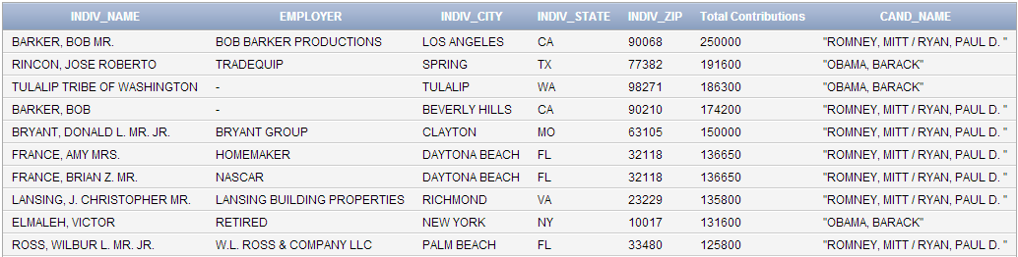

1. Identify the top ten college or university contributors for candidates Obama and Romney. Display the university/college name, number of contributions, total contributions and average contributions. Display the top five Democratic and top five Republican contributors. Display the university/college with the highest contributions first. Use a nested select and functions to create your output.

select employer, count(*) "Number of Contributions", sum(transaction_amt) "Total Transaction", round(avg(transaction_amt),2) "Average Contributions"

from transaction t, individuals i, link l, candidates ca

where i.indiv_id=t.indiv_id and t.cmte_id=l.cmte_id and l.cand_id=ca.cand_id and employer in (select employer

from individuals

where (employer like '%UNIVERSITY%' OR EMPLOYER LIKE '%COLLEGE%') and (ca.cand_name='"OBAMA, BARACK"' or ca.cand_name='"ROMNEY, MITT / RYAN, PAUL D. "'))

group by employer

order by 2 desc;

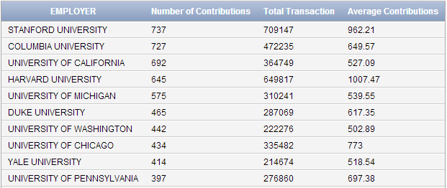

Display the top five Democratic contributors

select employer, count(*) "Number of Contributions", sum(transaction_amt) "Total Transaction", round(avg(transaction_amt),2) "Average Contributions"

from transaction t, individuals i, committee c

where i.indiv_id=t.indiv_id and t.cmte_id=c.cmte_id and c.cmte_pty_affiliation='DEM' and employer in(select employer

from individuals

where (employer like '%UNIVERSITY%' OR EMPLOYER LIKE '%COLLEGE%')

group by employer

order by 2 desc

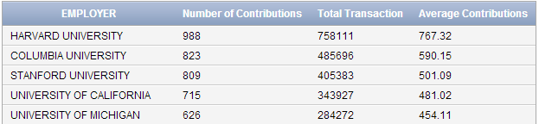

Display the top five Republican contributors

select employer, count(*) "Number of Contributions", sum(transaction_amt) "Total Transaction", round(avg(transaction_amt),2) "Average Contributions"

from transaction t, individuals i, committee c

where i.indiv_id=t.indiv_id and t.cmte_id=c.cmte_id and c.cmte_pty_affiliation='REP' and employer in(select employer

from individuals

where (employer like '%UNIVERSITY%' OR EMPLOYER LIKE '%COLLEGE%') )

group by employer

order by 2 desc

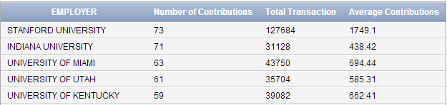

1. Identify the top five technology companies that contributed to candidates Romney and Obama. Create one report for each candidate. Display the company, number of contributions, total contributions and average contributions. Use a nested select and functions to create your report.

Obama

select employer,count(*) "Number of Contributions", sum(transaction_amt) "Total Contribution", round(avg(transaction_amt),2) "Average Contributions"

from candidates ca, link l,transaction t, individuals i

where ca.cand_name='"OBAMA, BARACK"' and ca.cand_id=l.cand_id and l.cmte_id=t.cmte_id and t.indiv_id=i.indiv_id and employer in (select employer

from transaction

where employer like '%TECHNOLOGY%' or employer like '%GOOGLE%' or employer like '%MICROSOFT%' or employer like '%APPLE%' or employer like '%ORACLE%' or employer like '%FACEBOOK%')

group by employer

order by 3 desc;

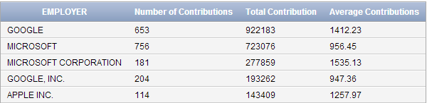

Romney

select employer,count(*) "Number of Contributions", sum(transaction_amt) "Total Contribution", round(avg(transaction_amt),2) "Average Contributions"

from candidates ca, link l,transaction t, individuals i

where ca.cand_name='"ROMNEY, MITT / RYAN, PAUL D. "' and ca.cand_id=l.cand_id and l.cmte_id=t.cmte_id and t.indiv_id=i.indiv_id and employer in (select employer

from transaction

where employer like '%TECHNOLOGY%' or employer like '%GOOGLE%' or employer like '%MICROSOFT%' or employer like '%APPLE%' or employer like '%ORACLE%' or employer like '%FACEBOOK%')

group by employer

order by 3 desc;

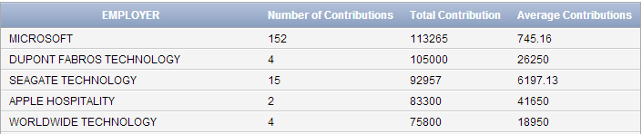

1. Identify small and large dollar contributions for candidates Obama and Romney. Display the number of contributions and total contributions of $100, $200, $250, $1000, $2000, $2500, $5000, $10000 for both candidates. Only display these eight dollar contributions on eight rows.

select transaction_amt, count(*) "Number of Contributions", sum(transaction_amt) "Total Contributions"

from transaction t, link l, candidates ca

where (t.transaction_amt='100' or t.transaction_amt='200' or t.transaction_amt='250' or t.transaction_amt='1000' or t.transaction_amt='2000' or t.transaction_amt='2500'or t.transaction_amt='5000' or t.transaction_amt='10000') and (ca.cand_name='"OBAMA, BARACK"' or ca.cand_name='"ROMNEY, MITT / RYAN, PAUL D. "') and t.cmte_id=l.cmte_id and l.cand_id=ca.cand_id

group by transaction_amt

order by 1 asc;

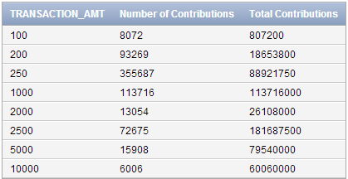

1. Identify if incumbents raise more money than challengers in New York. Display the candidate state, district, office, ici (challenger or incumbent), candidate name, number of contributions and amount of contributions. Order by districts. Display the incumbent first and challenger on the next line.

select cand_st, cand_office_district, cand_office, cand_ici, cand_name, count(*) "Number of Contribution", sum(transaction_amt) "Total Contribution"

from candidates ca, transaction t, link l

where cand_city='NEW YORK' and cand_st='NY' and (cand_ici='C' or cand_ici='I') and ca.cand_id=l.cand_id and l.cmte_id=t.cmte_id

group by cand_st, cand_office_district, cand_office, cand_ici, cand_name

order by 2 desc;

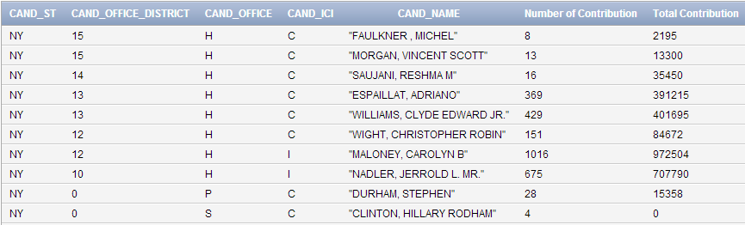

Display the incumbent first and challenger on the next line.

select cand_ici, count(*) "Number of Contribution", sum(transaction_amt) "Total Contribution"

from candidates ca, transaction t, link l

where cand_city='NEW YORK' and cand_st='NY' and (cand_ici='C' or cand_ici='I') and ca.cand_id=l.cand_id and l.cmte_id=t.cmte_id

group by cand_ici

order by 2 desc;

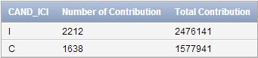

1. Identify if increased campaign contributions results in winning candidates. Review several states and discuss your findings.

New York Representative Incumbent - Bishop Timothy

select cand_name, count(*) "Number of Contributions", sum(transaction_amt) "Total Contributions"

from candidates ca, transaction t, link l

where ca.cand_st='NY' and cand_name='"BISHOP, TIMOTHY"' and ca.cand_id=l.cand_id and l.cmte_id=t.cmte_id

group by cand_name;



New York Representative Incumbent - Israel Steve

select cand_name, count(*) "Number of Contributions", sum(transaction_amt) "Total Contributions"

from candidates ca, transaction t, link l

where ca.cand_st='NY' and cand_name='"ISRAEL, STEVE J."' and ca.cand_id=l.cand_id and l.cmte_id=t.cmte_id

group by cand_name;



New York Representative Challenger - "LABATE, STEPHEN A"

select cand_name, count(*) "Number of Contributions", sum(transaction_amt) "Total Contributions"

from candidates ca, transaction t, link l

where ca.cand_st='NY' and cand_name='"LABATE, STEPHEN A"' and ca.cand_id=l.cand_id and l.cmte_id=t.cmte_id

group by cand_name;



New York Representative Challenger - "DEMOS, GEORGE"

select cand_name, count(*) "Number of Contributions", sum(transaction_amt) "Total Contributions"

from candidates ca, transaction t, link l

where ca.cand_st='NY' and cand_name='"DEMOS, GEORGE"' and ca.cand_id=l.cand_id and l.cmte_id=t.cmte_id

group by cand_name;



New Jersey Representative Incumbent - "ANDREWS, ROBERT E. MR."

select cand_name, count(*) "Number of Contributions", sum(transaction_amt) "Total Contributions"

from candidates ca, transaction t, link l

where ca.cand_st='NJ' and cand_name='"ANDREWS, ROBERT E. MR."' and ca.cand_id=l.cand_id and l.cmte_id=t.cmte_id

group by cand_name;



New Jersey Representative Incumbent - "LOBIONDO, FRANK A."

select cand_name, count(*) "Number of Contributions", sum(transaction_amt) "Total Contributions"

from candidates ca, transaction t, link l

where ca.cand_st='NJ' and cand_name='"LOBIONDO, FRANK A."' and ca.cand_id=l.cand_id and l.cmte_id=t.cmte_id

group by cand_name;



New Jersey Representative Challenger - "ROTHMAN, STEVEN R."

select cand_name, count(*) "Number of Contributions", sum(transaction_amt) "Total Contributions"

from candidates ca, transaction t, link l

where ca.cand_st='NJ' and cand_name='"ROTHMAN, STEVEN R."' and ca.cand_id=l.cand_id and l.cmte_id=t.cmte_id

group by cand_name;



New Jersey Representative Challenger - "SMITH, E DAVID"

select cand_name, count(*) "Number of Contributions", sum(transaction_amt) "Total Contributions"

from candidates ca, transaction t, link l

where ca.cand_st='NJ' and cand_name='"SMITH, E DAVID"' and ca.cand_id=l.cand_id and l.cmte_id=t.cmte_id

group by cand_name;



Florida Representative Incumbent - "ROONEY, TOM"

select cand_name, count(*) "Number of Contributions", sum(transaction_amt) "Total Contributions"

from candidates ca, transaction t, link l

where ca.cand_st='FL' and cand_name='"ROONEY, TOM"' and ca.cand_id=l.cand_id and l.cmte_id=t.cmte_id

group by cand_name;



Florida Representative Incumbent - "POSEY, BILL"

select cand_name, count(*) "Number of Contributions", sum(transaction_amt) "Total Contributions"

from candidates ca, transaction t, link l

where ca.cand_st='FL' and cand_name='"POSEY, BILL"' and ca.cand_id=l.cand_id and l.cmte_id=t.cmte_id

group by cand_name;



Florida Representative Challenger -"LONG, WILLIAM TODD"

select cand_name, count(*) "Number of Contributions", sum(transaction_amt) "Total Contributions"

from candidates ca, transaction t, link l

where ca.cand_st='FL' and cand_name='"LONG, WILLIAM TODD"' and ca.cand_id=l.cand_id and l.cmte_id=t.cmte_id

group by cand_name;



Florida Representative Challenger - "GUNTER, DAVID ALAN"

select cand_name, count(*) "Number of Contributions", sum(transaction_amt) "Total Contributions"

from candidates ca, transaction t, link l

where ca.cand_st='FL' and cand_name='"GUNTER, DAVID ALAN"' and ca.cand_id=l.cand_id and l.cmte_id=t.cmte_id

group by cand_name;



According to the data that we have on file for 2012, it shows that usually the incumbent gets a higher contribution and higher contribution does help the candidates in winning the election.

1. Compare contributions by occupation for two candidates. Create two reports. Display the occupation, number of contributions and total contributions for candidate A; number of contributions and total contributions for candidate B. Include only the following professions: attorney, physician, teacher, investor, banker and artist. Note, these professions can be referred to by different names. For instance, physicians can also be referred to as doctors; teachers/professors; artists/actors, actresses, writers, etc.

Candidate A – Obama

select occupation, count(*) "Number of Contributions", sum(transaction_amt) "Total Contributions"

from candidates ca, link l, transaction t, individuals i

where ca.cand_name='"OBAMA, BARACK"' and ca.cand_id=l.cand_id and l.cmte_id=t.cmte_id and t.indiv_id=i.indiv_id and (occupation='ATTORNEY' or occupation='PHYSICIAN' or occupation='DOCTOR' or occupation='TEACHER' or occupation='PROFESSOR' or occupation='INVESTOR' or occupation='BANKER' or occupation='ARTIST' or occupation='ACTOR' or occupation='ACTRESSES' or occupation='WRITER')

group by occupation

order by 2 desc;

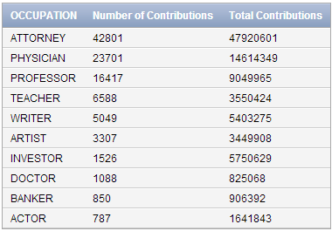

Candidate B – Romney

select occupation, count(*) "Number of Contributions", sum(transaction_amt) "Total Contributions"

from candidates ca, link l, transaction t, individuals i

where ca.cand_name='"ROMNEY, MITT / RYAN, PAUL D. "' and ca.cand_id=l.cand_id and l.cmte_id=t.cmte_id and t.indiv_id=i.indiv_id and (occupation='ATTORNEY' or occupation='PHYSICIAN' or occupation='DOCTOR' or occupation='TEACHER' or occupation='PROFESSOR' or occupation='INVESTOR' or occupation='BANKER' or occupation='ARTIST' or occupation='ACTOR' or occupation='ACTRESSES' or occupation='WRITER')

group by occupation

order by 2 desc;

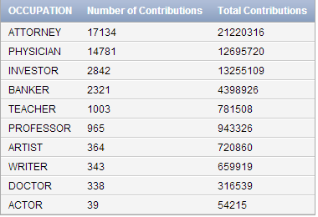

1. Identify incumbents in New York that raised more than $100,000 and did not receive contributions from lawyers. Display the candidate, district, state and office. Use a nested select or minus to create your output.

select cand_name, cand_office_district,cand_st, cand_office

from candidates

where cand_id not in (select ca.cand_id

from candidates ca, link l, individuals i, transaction t

where cand_st='NY' and cand_ici='I' and ca.cand_id=l.cand_id and l.cmte_id=t.cmte_id and t.indiv_id=i.indiv_id and (i.occupation='LAWYER' or i.occupation='ATTORNEY')

group by ca.cand_id

having sum(transaction_amt)>100000)

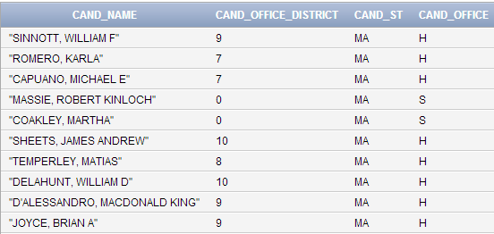

1. Identify neighborhoods in NYC where candidate Romney did not receive at least $5,000 in contributions. Display the city and zip code. Output one row for each city and zip code. Use a nested select or minus to create your output.

select indiv_city, indiv_zip

from individuals

where indiv_zip in(select indiv_zip

from candidates ca, link l, transaction t, individuals i

where ca.cand_name='"ROMNEY, MITT / RYAN, PAUL D. "' and ca.cand_id=l.cand_id and l.cmte_id=t.cmte_id and t.indiv_id=i.indiv_id and indiv_state='NY'

group by indiv_zip

having sum(transaction_amt)<5000);

