**Cairo University**

**Faculty of Computers and Artificial Intelligence Information Systems Department**

**Graduation Project Report**

**Etamn**

By

**Maram Ashraf Ahmed AlAzab 20200507**

**MennaTAllah Mohamed El Sharawy 20201178**

**Nervana Anwar Mansour 20200596**

**Omnya Alaa Korany 20200093**

**Salma Essam Mohamed Mohamed 20200777**

**Yomna Alaa Elsayed Aly Darwish 20200773**

**Under the Supervisors of:**

**Dr.  Ayman Elkilany**

**TA.  Dina Mohamed**

*Department of Information Systems, Faculty of Computers and Artificial Intelligence, Cairo University, Egypt*

                                                                   February 2024

**Abstract**

This research project is dedicated to developing an advanced electronic medical records system, aimed at addressing fundamental challenges in healthcare information management. The initiative is rooted in the essential need to enhance access to medical records, minimize medical errors, and empower patients in managing their health.

At its core, the project is a significant endeavor within healthcare technology, with a focus on revolutionizing electronic medical records. The goal is to transform the recording, accessing, and utilization of medical history, thereby making a substantial contribution to health informatics.

The healthcare landscape currently faces critical issues like restricted access to medical records, challenges in coordinating among different healthcare providers, and prevalent data errors. Such problems often result in treatment delays, unnecessary repeated tests, and the risk of medical errors.

To tackle these issues, our project adopts a user-centric design approach, prioritizing the needs of users and employing iterative development processes. It integrates innovative technologies such as blockchain for secure data management and provides multilingual support, catering to a diverse range of users. The system is designed to store a wide array of medical information, including X-rays, prescriptions, and lab tests, thus ensuring that both patients and healthcare providers have easy and quick access to essential health data.

The software features a user-friendly interface accessible to all age groups, offering a comprehensive approach to storing medical procedures. It also emphasizes a family-centric design for collaborative health management and employs robust security measures, including blockchain technology, for the secure storage of data. Additional features include health analysis tools for monitoring health progress and emergency access to vital health information.

**Table of Contents**

CHAPTER 1 INTRODUCTION 6

* 1. PROBLEM STATEMENT 6
  2. BACKGROUND AND MOTIVATION 7
  3. OBJECTIVES 7
  4. PROJECT SCOPE 8
  5. PROJECT LIMITATIONS 10
  6. PROJECT METHODOLOGY 10
  7. PROJECT REPORT OUTLINE 11
  8. PROJECT PLAN 12

CHAPTER 2 MARKET AND LITERATURE SURVEY 13

* 1. RELATED WORK 13

CHAPTER 3 SAFEKIDS ANALYSIS 20

* 1. REQUIREMENTS ANALYSIS 20
     1. FUNCTIONAL REQUIREMENTS 20
     2. NON-FUNCTIONAL REQUIREMENTS 21
  2. STAKEHOLDERS 21
  3. USE CASE MODEL 23
     1. USE CASE DESCRIPTION 24
  4. CLASS DIAGRAM 32
     1. SUBSYSTEMS 33
  5. SEQUENCE DIAGRAM 35
  6. SYSTEM ARCHITETURE 39

CHAPTER 4 ETAMN DESIGN AND IMPLEMENTATION 41

* 1. TECHNOLOGIES USED AND RESONS FOR CHOOSING THEM 41
  2. USER SCENARIO 42
     1. LOGIN SCREEN 42
     2. SIGN UP SCREEN 42
     3. MENU SCREEN 43
     4. UPLOAD SCREEN 44
     5. LAB TEST SCREEN 44
     6. SAVED SUCCESSFAULLY SCREEN 45
     7. UPLOAD PRESCRIPTION SCREEN 45
     8. UPLOAD MEDICINE IN PRESCRIPTION SCREEN 46
     9. NOTIFICATION SENT 46
     10. SHOW UPLOADS 47
     11. SHOW LAB TEST 47
     12. STORING MEDICINE 48
     13. USER ENTERS NAME OF MEDICINE OR UPLOAD MEDICINE IMAGE 48
     14. NOTIFICATION HISTORY SCREEN 49
     15. REPORT SCREEN 49
     16. PROFILE SCREEN 50
     17. EDIT INFO SCREEN 50
     18. ADD CHILD SCREEN 51
     19. CHANGE LANGUAGE 51
     20. SHOW QR CODE 52
     21. FELLING ILL SCREEN 52
     22. AVAILABLE DOCTORS SCREEN 53
     23. DOCTORS FILTER SCREEN 53
     24. AVAILABLE LABORATORIES SCREEN 54
     25. LABORATORIES SEARCH SCREEN  54
     26. LABORATORIES SIGN UP SCREEN 55
     27. LABORATORIES LOGIN SCREEN 55
     28. SHOWING REQESTS SCREEN 56
     29. DETAILD REQUEST SCREEN 56
     30. DOCTOR SIGN UP SCREEN 57
     31. SHOWING REQESTS SCREEN 57
     32. DETAILED SCREEN 58
     33. SCAN QR CODE 58

CHAPTER 5 ETAMN TESTING AND EVALUATION

5.1 ETAMN TESTING 59

5.2 ETAMN EVALUATION 63

CHAPTER 6 CONCLUSIONS AND FUTURE WORK

6.1 CONCLUSIONS 64

6.2 FUTURE WORK 64

**List of Figures**

Figure 1 Project Plan……………………………………………………………………………………12

Figure 2 Use Case Model………………………….……………………………………………………22

Figure 3 Class Diagram ………………………………………………………………………………...31

Figure 4.1 Subsystem ……...……………………………………………………………………………32

Figure 4.2 Subsystem ………...…………………………………………………………………………32

Figure 4.3 Subsystem ………...…………………………………………………………………………33

Figure 4.4 Subsystem ………...…………………………………………………………………………33

Figure 4.5 Subsystem ………...…………………………………………………………………………33

Figure 5 Sign in sequence……………………………………………………………………………….34

Figure 6 show profile sequence…………………………………………………………………………34

Figure 7 show report sequence……………………………………………………………………….…35

Figure 8 Upload prescription sequence…………………………………………………………………36

Figure 9 Storing medicine sequence…………………………………………………….………………37

Figure 10 System Architecture…………………...….………………………………………………….39

**List of Tables**

Table 1. Comparison of features in different medical apps 18

**List of Abbreviations**

|  |  |
| --- | --- |
| **Abbreviation** | **Meaning** |
| UCD | User-Centered Design |
| ERM | Electronic Medical Record |

**Chapter 1 Introduction**

Technology has brought about radical changes in health care, improving the accuracy of diagnoses and providing faster and safer access to medical information. Electronic medical records greatly enhance these improvements, as they reduce the chances of medical errors, facilitate coordination between various healthcare providers, and provide analytical tools for tracking health progress and identifying health patterns and trends.

Electronic medical records are a technical system that allows the storage, management, and exchange of individuals' health information in a digital manner. These records include the patient's medical history, test results, prescriptions, prescribed medications, and X-rays. The main importance of these records lies in improving the quality of health care by providing accurate, comprehensive, and updated information to patients.

Our project aims to develop an integrated electronic medical records system that makes it easier for individuals to track and manage their health history.

## **Problem Statement**

Issues in current systems of medical records Limited Access: Often times,

medical records are distributed among different health care providers and not readily

available to patients or other doctors.

Difficulty coordinating between care providers: Due to fragmented and non-standardized data, it is difficult for health care providers to get a complete picture of a patient’s health status, leading to delayed or repeated tests and treatments.

Data errors: Manual errors in data entry, or failure to update it, can lead to serious problems, such as incorrect diagnoses or prescribing inappropriate medications.

Enhancing healthcare: Improving electronic medical records is essential to enhancing the quality and efficiency of healthcare. By providing fast, secure access to accurate information, doctors can make better, faster decisions, and patients can receive more effective care.

Reducing medical errors: By improving the accuracy and availability of data, medical errors can be significantly reduced.

Patient self-empowerment: Providing patients with access to their medical records enhances their participation in managing their health and increases their health awareness.

## **Background and motivation**

Electronic medical records have roots dating back to the mid-20th century, when the need to store medical information in a more efficient and accurate manner began. With technological advances, these records have evolved from being simply information storage to integrated systems that provide analysis and support for healthcare decisions. In recent years, we have seen significant developments in this field, including integration with artificial intelligence and augmented reality technologies.

Our project comes to contribute to solving several problems that exist in the current health system.

First, it addresses the problem of limited and slow access to health information, which affects the speed and accuracy of medical decisions.

Second, it attempts to reduce medical errors resulting from mismanagement of medical records.

Third, it improves coordination between different healthcare providers, leading to improved overall patient care.

## **Objectives**

Improving the accuracy of medical records: developing a system that ensures high accuracy in recording and storing patients’ medical data.

Promoting ease of access to medical records: Ensuring that patients can access medical records easily and quickly.

Medical Decision Support: Helping doctors make informed medical decisions by providing a comprehensive analysis of a patient's historical health data.

Health crisis management: In health emergencies, doctors can quickly access medical records to understand the patient's condition and quickly provide appropriate treatment.

Improving self-understanding of health: Helping individuals better understand their health condition, promoting personal responsibility and health awareness.

Quick access in emergency situations: In emergency situations, paramedics can quickly access vital information, such as allergies and current medications.

Focus on privacy: ensuring that user data is protected and handled with complete security and confidentiality.

**1.4 Project Scope**

**Key Concept:**

The main objective of our project is to develop a comprehensive medical history record system. This includes meticulous documentation of diagnoses, medical prescriptions, X-ray results, surgeries, and details of lab tests. By employing blockchain technology, we establish an unalterable ledger of health data, providing an additional layer of trust and security. Through our commitment to data encryption, we prioritize safeguarding patients' confidential information, adhering to the highest standards of privacy and compliance.

**Audience:**

The target audience for the application encompasses a broad spectrum, including patients, individuals, men, women, families, and adults. The design and functionalities of the program aim to cater to the diverse needs and preferences of this varied user base.

**Main functionalities:**

* **User-Friendly Interface:** Recognizing the diversity within the audience, the application prioritizes a user-friendly interface to accommodate individuals of all ages. Whether it's children, adults, or the elderly, the design ensures accessibility and ease of use for everyone.
* **Medical Procedure Storage:** Allowing patients to store different types of medical procedures such as X-rays, surgeries, prescriptions, lab tests, and medicines, creating a comprehensive health history.
* **Accessible Features:** All functionalities are easily accessible, providing a seamless user experience.
* **Convenient Account Management:** Users can effortlessly access and edit their accounts.
* **variety options for data input**: The program supports data input through images or text, enhancing flexibility.
* **Multilingual Support:** Languages such as English and Arabic are supported to cater to a diverse user base.
* **Family-Centric Approach:** The application adopts a family-centric perspective by fostering a seamless connection between fathers, mothers accounts and their respective children accounts. This interconnected design aims to facilitate collaborative health management within the family unit.
* **Comprehensive Reports Section:** A dedicated area organizes surgery, X-ray, lab test, and prescription reports.
* **Robust Security Measures:** The application prioritizes the security of user data, implementing robust measures to safeguard personal and health information, ensuring a secure and confidential user experience.
* **Doctor and Clinical** **Laboratories Directory:** Providing a user-friendly directory for patients to access a comprehensive list of available doctors, categorized by different departments, and clinical laboratories. This feature offers informed decision-making for patients seeking medical assistance.
* **Notifications:** notifications section for:

1. patients to receive reminders for medications prescribed by their doctors in prescriptions.

* **Static Lab Test Storage:** The system utilizes static storage for lab tests, there are three predefined lab tests are stored: Lipid Panel (LDL, HDL, and Cholesterol), Electrolytes (Potassium, Chloride and Sodium), and CBC (Platelet count, Haematocrit and Haemoglobin).
* **Medical Verification Roles:** The role of doctors primarily involves the verification of prescriptions and the scheduling of surgeries. On the laboratory side, the focus is on the verification of laboratory tests.
* **QR Code:** Each patient has a QR code which leads to the show uploads page that shows all the medical information that the patent has uploaded within the app, this QR code then is scanned by the doctors to be able to access this medical information.

**1.5 Project Limitations**

1. **Technical Expertise Requirements:** The need for specialized technical expertise, both in blockchain development and healthcare information systems, may pose a limitation in terms of resource availability and potential learning curves.

2.**Lack of Resources for Prescription -Based Information:** The project faces limitations in acquiring and storing information from prescription due to resource constraints.

3. **Data Extraction Limitations:** The data obtained through the API may not achieve complete and accuracy of 100%. This limitation arises from the inherent challenge of converting all words in prescriptions to text. Variabilities in handwriting, and paper quality contribute to potential inaccuracies in the conversion process.

**1.6 Project Methodology**

In our project, we trying to solve problems focusing on understanding people and their needs. That’s the basis of user-centric design thinking or UCD.

UCD requires recognizing and learning about your users—the people using your product or interacting with your service now and in the future. The better you understand your users and their needs, the better you can design solutions fitting for them and contribute to creating a user-friendly interface.

**Here's how the UCD methodology could be used to develop this application:**

User- Centered Design (UCD) is employed in the development of an application through a series of iterative steps Here's a simplified overview of how UCD is typically used in application development:

1. **Research phase**

The basis of user-centric design is research. A team of designers uses many research strategies to understand the scope of the problem, the nuances of the task or tasks, and the user’s needs and goals.

2. **Concept phase**

User-centric design thinking Favors prototyping. When the design team comes up with a prototype concept, you can give valuable feedback and information to guide the research direction.

3. **Design phase**

Prototypes are created at a higher complexity level to refine the design to meet the user’s needs.

4. **Development phase**

This step involves the implementation of a well-defined and researched solution. It is a culmination of careful and detailed data collection to evaluate how successful the prototype has become.

5. **Launch phase**

The product is launched or "officially introduced" to the targeted user group and is no longer a prototype.

**1.7 Project Report Outline**

This outline provides a high-level structure for the project report and can be customized to fit the specific needs and requirements of the project. The purpose of each chapter is to provide a detailed and comprehensive overview of the different stages and aspects of the software development process, from the market and literature survey to the testing and implementation of the software system.

Here's the project report includes:

**Chapter 2 Market and Literature Survey**

**Chapter 3 Etamn Analysis**

**Chapter 4 Etamn Design and Implementation**

**1.8 Project Plan**

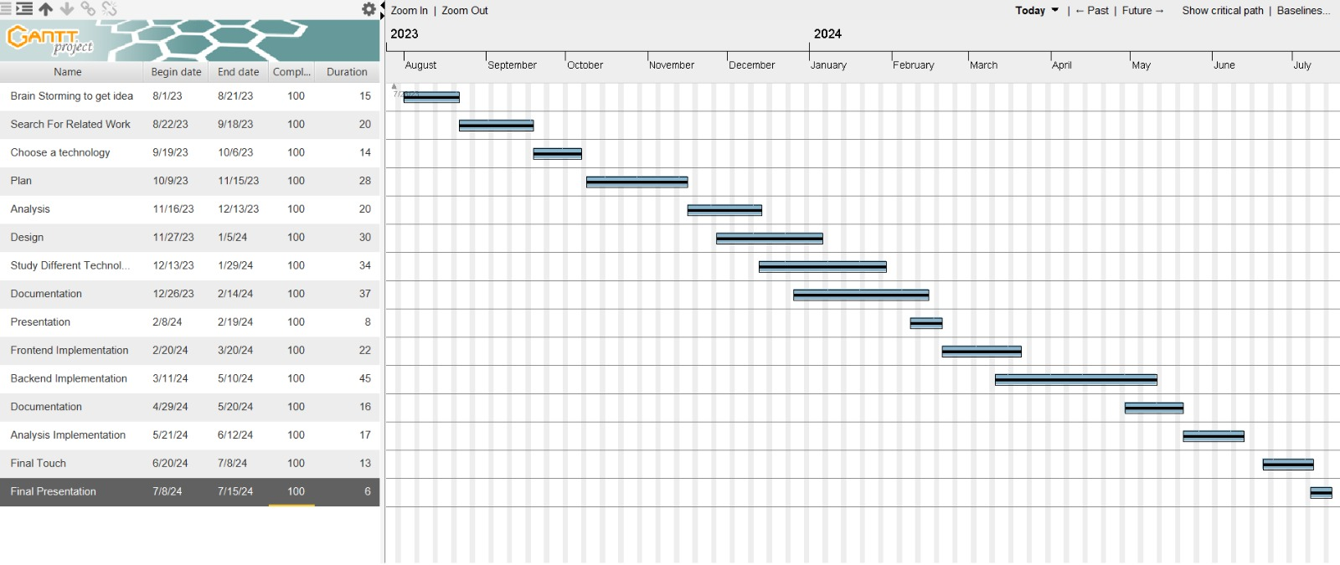

Figure 1 Project Plan

**Chapter 2 Market and Literature Survey**

**2.1 Related works**

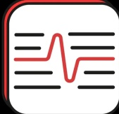**App Name: Clinical History**

**Description:**

Clinical History is an app that helps doctors to learn about a patient's health. It uses a list of questions to gather information about the patient's health, like what problems they have, their past health, family history, social history, and medication history. The app is designed to make sure doctors get all the important details. It can suggest possible health issues based on the answers given by the patient.

**Functionality:**

1. **Structured Questionnaire:** The app asks questions in a structured way, covering different parts of the patient's health.
2. **Save and Review:** Ability to save the patient's health details to look at them later.
3. **Identification of Common Causes:** It helps to find out what usually causes the patient's health problems.

**Limitations:**

1. **Data Accuracy**: Relies on users to input accurate and complete information, which may not always be the case.
2. **Language Issue:** The app is only available in one language, making it hard for people who speak other languages.

**Advantages:**

1. **Comprehensive History-Taking:** The app ensures doctors get a complete and organized understanding of a patient's health.
2. **Real-time Assistance:** It provides instant suggestions for health issues based on what the patient shares.
3. **Organized Record Keeping:** Doctors can keep a record of patient details for future reference.

**Disadvantages:**

1. **Privacy Concerns:** Storing sensitive health information digitally could raise concerns about data security and patient privacy, especially if proper safeguards are not in place.



**App Name: Ada – check your health**

**Description:**

Ada is an application designed for individuals to understand and track their symptoms, offering trusted medical guidance 24/7. Users can perform health checks for themselves and their relatives by answering simple questions about their health and symptoms. It utilizes an AI-driven questionnaire to provide personalized health assessment, suggesting potential causes and what the user could do next. Developed with input from doctors, Ada aims to provide quick and reliable health information from the convenience of one's home.

**Functionality:**

1. **Symptom Checks:** Users answer questions for personalized health assessments.
2. **Smart Results:** AI combines medical knowledge with intelligent technology for accurate results.
3. **24/7 Access:** Users can use the free symptom checker anytime and anywhere.
4. **Multilingual Support:** Supports assessments in seven languages

**Limitations:**

1. **Data Accuracy**: Relies on users to input accurate and complete information, which may not always be the case.

**Advantages:**

1. **Quick Assessment:** Users can get a quick assessment of their symptoms within minutes, enhancing accessibility to medical guidance.
2. **Privacy and Security:** Strict data regulations are applied to ensure user information is protected and kept private.
3. **Multilingual Support:** The app supports multiple languages, making it accessible to a diverse user base.

**Disadvantages:**

1. **Limited to Symptom Checks:** The app cannot provide a medical diagnosis and should not replace urgent care or professional medical advice.

**App Name: Medical ID**

**Description:**

A Medical ID application typically stores critical health information about an individual in a digital format. This information can be accessed quickly in case of emergencies, providing vital details to first responders or healthcare professionals.

**Functionality:**

1. **Emergency Information**: Users can input essential medical details such as allergies, medications, blood type, High, weight and emergency contacts.
2. **Accessibility:** The app enables quick access to these profiles directly from the lock screen, aiding first responders or medical staff during emergencies.
3. **Quick Response Codes:** Some apps generate QR codes that can be scanned to access medical information rapidly.

**Limitations:**

1. **Accessibility :** of medical information from the lock screen may pose privacy concerns if the device falls into unauthorized hands.
2. **Privacy Concerns:** Storing sensitive health data digitally may raise privacy concerns, and users need to ensure proper security measures are in place.

**Advantages:**

1. **Rapid Access:** Provides quick access to critical health information in emergencies.
2. **Customizable:** Users can input specific details relevant to their medical history.

**Disadvantages:**

1. **Limited Offline Access:** application may require an internet connection to access the information.
2. **Device Dependence:** Availability depends on the user having a compatible device.

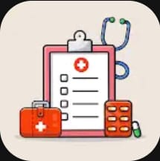**App Name: Medical Records-Health Logs**

**Description:**

Medical Records and Health Logs applications are designed to help individuals maintain a comprehensive record of their health-related information, including appointments, test results, and personal health metrics.

**Functionality:**

1. **Health Tracking**: Allows users to record and track health metrics such as weight, blood pressure, allergy and oxygen saturation.
2. **Appointment Reminders:** Provides features for scheduling and reminding users of medical appointments.
3. **Document Storage:** Allows users to upload and store documents such as test results and medical reports.

**Limitations:**

1. **Data Accuracy:** Relies on users to input accurate and complete information, which may not always be the case.
2. **Integration Challenges:** Integration with healthcare systems and interoperability can be challenging due to varying standards.

**Advantages:**

1. **Personalized Health Management:** Enables users to actively manage their health by tracking relevant information.
2. **Convenience:** Centralizes health information, reducing the need to carry physical documents.

**Disadvantages:**

1. **User Input Reliance:** Accuracy and usefulness depend on users consistently updating and maintaining the information.

|  |  |  |  |  |
| --- | --- | --- | --- | --- |
|  | **Clinical History** | **Ada – check your health** | **Medical ID** | **Medical Records-Health Logs** |
| **Multilingual Support** | Available in one language | available in seven languages | Available in one language"English" | Available in one language"English" |
| **Privacy and Security** | Data is not secured | Strict data regulations are applied | Access to the information is often controlled by the user, and it may require authentication. | Access to the records may be protected by usernames, passwords, or two-factor authentication. |
| **Accessibility** | limit accessibility for non-literate users | limit accessibility for non-literate users | Limited Offline Access | Easy to access at any time |
| **Advanced Analysis** | It doesn't do advanced analysis | Limited to Symptom Checks | Limited advanced analysis | Trend Analysis Allows users to track and analyze trends in their health data over time |
| **Accuracy** | Not accurate | Not accurate | Not accurate | Not accurate |

1. **Security Concerns:** Storing sensitive health data digitally may raise security and privacy concerns.

Table 1. Comparison of features in different medical apps

**Our Application:**

Our application differs from previous applications in several aspects. Firstly, it excels in user-friendliness, catering to both educated and non-educated users. Additionally, it enforces a strict policy against the entry of fictitious data; every piece of information must be authenticated usinga verified image from a medical source, such as diagnostic test results, prescriptions or medical imaging.

And have the following features:

1)”تحاليل” 2)”الروشته” 3)”الاعراض” 4)”الاشعه” 5) "الدواء"

**Chapter 3 Etamn Analysis**

**3.1 Requirement Analysis**

**3.1.1 Functional Requirements:**

* Medical Procedure Storage: Allowing patients to store different types of medical procedures such as X-rays, surgeries, prescriptions, lab tests, and medicines, creating a comprehensive health history.
* Doctor and Clinical Laboratories Directory: Providing a user-friendly directory for patients to access a comprehensive list of available doctors, categorized by different departments, and clinical laboratories. This feature offers informed decision-making for patients seeking medical assistance.
* Convenient Account Management: Users can effortlessly access and edit their accounts.
* variety options for data input: The program supports data input through images or text, enhancing flexibility.
* Multilingual Support: Languages such as English and Arabic are supported to cater to a diverse user base.
* Comprehensive Reports Section: A dedicated area organizes surgery, X-ray, lab test, and prescription reports.
* Medicine Notifications: Including a notifications section for patients to receive reminders for medications prescribed by their doctors and also when a doctor verifies their prescriptions.
* Family-Centric Approach: The application adopts a family-centric perspective by fostering a seamless connection between fathers, mothers accounts and their respective children accounts. This interconnected design aims to facilitate collaborative health management within the family unit.

**3.1.2 Non Functional Requirements:**

* USABILITY: The interface should be user-friendly and accessible to healthcare patients.
* RECOVERABILITY: Ensure the application includes features for easy data recovery, such as 'Forget Password' and blockchain integration.
* SECURITY: Use encryption of data during transition, Access controls and authentication mechanisms to protect sensitive information.
* AVAILABILITY: App should always be available and accessible to users.

**3.2 Stakeholders:**

* Users (Patients): These individuals, acting as end users, are typically aged 16 and above. They utilize the system to access their comprehensive medical history, allowing them to stay informed about their health status and past treatments. By having access to their medical records, patients can make more informed decisions about their healthcare.
* Doctors / Labs: Serving as essential end users, doctors and laboratories play a crucial role in the system. Their primary responsibility is to verify prescriptions or laboratory test results submitted from patients through using our app. This verification process ensures the accuracy and validity of medical information, ultimately contributing to the quality of patient care and treatment.
* Developers: Operating behind the scenes, developers are instrumental in bringing the system to life and maintaining its effectiveness. Their responsibilities encompass the entire software development lifecycle, from initial implementation to ongoing testing and maintenance. Developers work tirelessly to ensure that the system meets the needs of its users, addressing any bugs or issues that may arise and continuously improving its features and capabilities to enhance user experience and satisfaction.

**3.3 Use Case Model:**

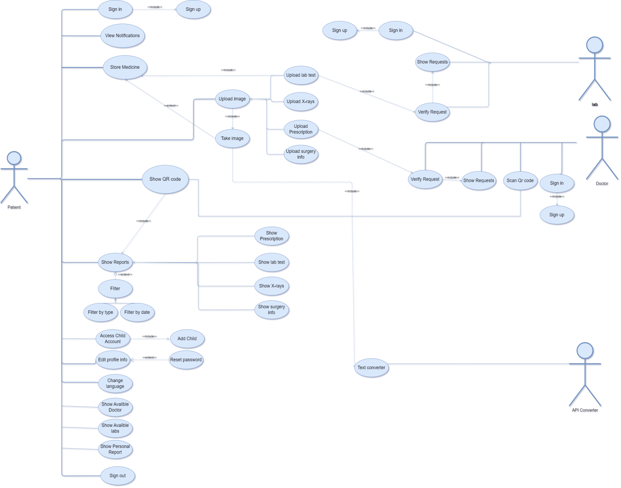

Figure 2 Use Case Model

**3.3.1 Use Case Description:**

|  |  |  |
| --- | --- | --- |
| Use Case ID: | 1 | |
| Use Case Name: | Sign in | |
| Actors: | Patient | |
| Pre-conditions: | Patient wants to see his medical record or add new information | |
| Post-conditions: | The system takes the Patient to main Page | |
| Flow of events: | **User Action** | **System Action** |
| 1- The Patient enter Sign in page. |  |
|  | 2- system ask patient to fill out the personal information (National ID and password). |
| 3- Patient fill out the personal information (National ID and password). |  |
|  | 4- System chick for the account. |
| 5- Patient enter main page. |  |
| Exceptions: | **User Action** | **System Action** |
| 1. The Patient enter Sign in page. |  |
|  | 1. system ask patient to fill out the personal information (National ID and password). |
| 1. Patient fill out the personal information (National ID and password). |  |
|  | 1. The system check for account and the password did not match. |
|  |  | 1. The system return message: “do you forget the password?”. |
|  | 6- Patient choose “forget password?” . |  |
|  |  | 7- System send code to his email. |
|  | 8- Patient enter the code and the new password. |  |
|  | 9- Patient enter submit. |  |
| Includes: |  | |
| Notes and Issues: | none | |

|  |  |  |
| --- | --- | --- |
| Use Case ID: | 2 | |
| Use Case Name: | Add child account | |
| Actors: | Patient | |
| Pre-conditions: | Patient has signed into his account and wants to add account for his child | |
| Post-conditions: | The system shows confirming message: “Child Has Been Saved Successfully” and Patient can access his child account from his account page | |
| Flow of events: | **User Action** | **System Action** |
| 1- Patient chooses to add new child from menu in his account page. |  |
|  | 2- system ask user to fill out the child information (name, National ID, date of birth, phone number, password and email). |
| 3- Patient fill out the child data. |  |
| 4- Patient enter submit. |  |
|  | 5- System add the child account to database. |
|  | 6- System display confirmation message: “Child Has Been Saved Successfully”. |
| 5- Patient enter account page and access child account. |  |
| Exceptions: | none | |
| Notes and Issues: | none | |

|  |  |  |
| --- | --- | --- |
| Use Case ID: | 3 | |
| Use Case Name: | Edit Profile Information | |
| Actors: | patient | |
| Pre-conditions: | The patient is logged into the system with a valid account.  The patient has permissions to access and modify their profile information. | |
| Post-conditions: | The patient's profile information is updated in the system.  Any changes are reflected immediately across the system and are visible the next time the profile is accessed. | |
| Flow of events: | **User Action** | **System Action** |
| 1- Patient selects the option to edit profile information. |  |
|  | 2- The system displays the current profile information in an editable format. |
| 3- Patient modifies the necessary fields, such as address, phone or age. |  |
|  | 4- The system validates new input for format and completeness. |
| 5-Patient submits the updated information. |  |
|  | 6-The system saves the changes, updates the patient's profile, and confirms the update to the patient. |
| Exceptions: | **User Action** | **System Action** |
| 1. If the patient enters invalid information (e.g., incorrect format for phone number). |  |
|  | 1. The system displays an error message and prompts for the correct format. |
| Includes: | none | |
| Notes and Issues: | none | |

|  |  |  |
| --- | --- | --- |
| Use Case ID: | 4 | |
| Use Case Name: | Upload Lab test | |
| Actors: | patient | |
| Pre-conditions: | The patient has a valid account and can log into the system.  The medical image to be uploaded is available on the patient's device.  The patient's device has a stable internet connection. | |
| Post-conditions: | The image is successfully uploaded and securely stored in the patient's electronic health record, and its data are extracted in the database.  The system provides confirmation to the patient. | |
| Flow of events: | **User Action** | **System Action** |
| 1- Patient selects the "Upload Image" option. |  |
|  | 2- The system displays the image upload interface. |
| 3- The patient will capture the medical image. |  |
|  | 4- The system verifies the image by confirming the source of the image. |
|  | 5- The system stores the image and its extracted data in the database and links it to the patient's electronic health record. |
|  | 6- The system guarantees that the data, once stored, is immutable and cannot be altered. |
|  | 7- The system initiates any analytical processes required for the image data. |
| Exceptions: | **User Action** | **System Action** |
| 1. If the image is in an unsupported format. |  |
|  | 1. The system displays an error message. |
| Includes: | none | |
| Notes and Issues: | none | |

|  |  |  |
| --- | --- | --- |
| Use Case ID: | 5 | |
| Use Case Name: | Show Reports | |
| Actors: | Patient | |
| Pre-conditions: | The patient chooses show reports | |
| Post-conditions: | The patient can see all his previous reports | |
| Flow of events: | **User Action** | **System Action** |
| 1-Patient asks to show old reports. |  |
|  | 2- System ask patient to choose the type of reports he need  (labs test, prescription, x-ray, surgery). |
| 3- Patient choose labs tests to show its reports. |  |
|  | 4- System retrieve all his past reports with that type with uploaded time and the classification of report based on the rest of the same type. |
| 5-Patient can choose to filter by uploaded time or the classification type. |  |
|  | 6- System retrieve all his past reports which satisfy that filter. |
| 7- Patient click on the image. |  |
|  | 8- System get the image of that report which patient was uploaded before. |
| Includes: | Patient logged in | |
| Notes and Issues: | none | |

|  |  |  |
| --- | --- | --- |
| Use Case ID: | 6 | |
| Use Case Name: | Store medicine | |
| Actors: | patient | |
| Pre-conditions: | The patient has a valid account and can log into the system.  The patient's device has a stable internet connection.  The patient has uploaded the prescription image. | |
| Post-conditions: | The Medicine's name or image is securely stored in the patient's electronic health record, and its data is extracted in the database. | |
| Flow of events: | **User Action** | **System Action** |
| 1- Patient selects the "Store Medicine" option. |  |
|  | 2- The system shows a screen that contains two options either to enter the medicine's name or to upload its picture |
| 3- Patient chooses the suitable option for him. |  |
| 4-Patient writes the dose of the medicine. |  |
|  | 5- The system stores either the image or the name of the medicine based on the patient's chosen option. It extracts medicine's data in the database and links it to the patient's electronic health record. |
|  | 6- The system ensures data encryption and protection during storage. |
|  |  | 7-System sends a notification to the patient at a specified time based on number of doses to remind him to take his medicine on time. |
| Exceptions: | **User Action** | **System Action** |
| 1. If the patient chose the image option and the image uploaded is in an unsupported format. |  |
|  | 1. The system displays an error message. |
| Includes: |  | |
| Notes and Issues: | none | |

**3.4 Class Diagram:**

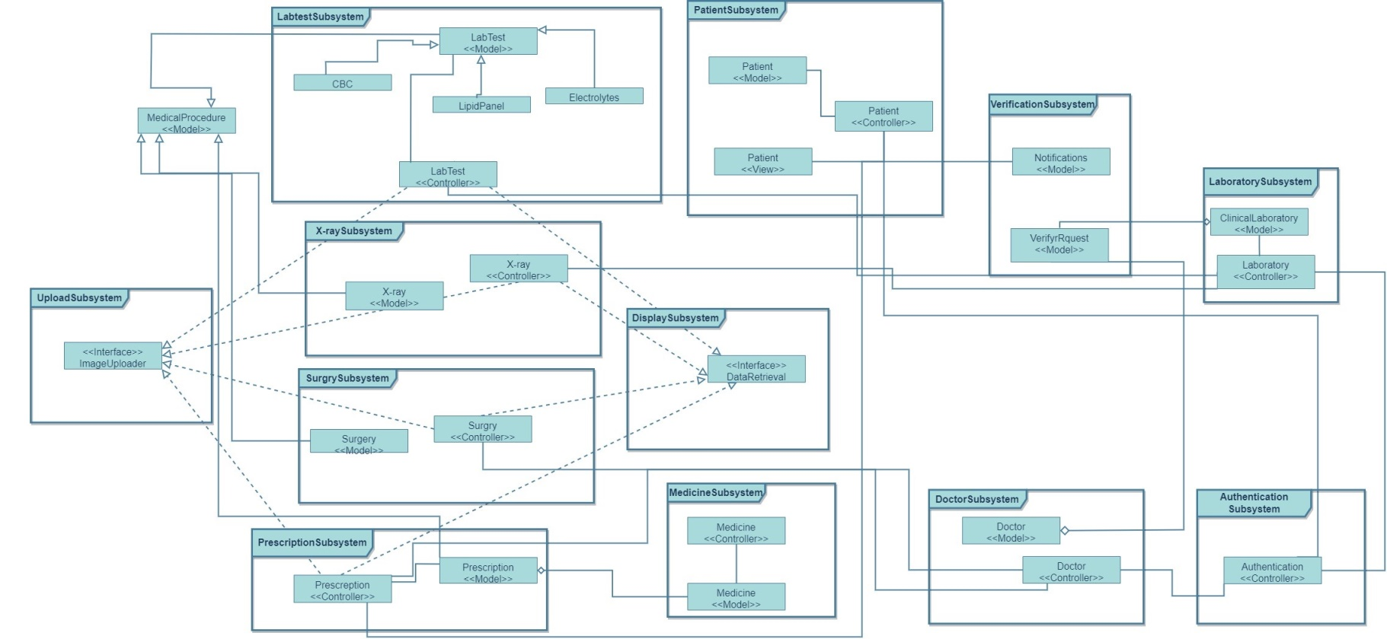

Figure 3 Class Diagram

**3.4.1 Subsystems :**

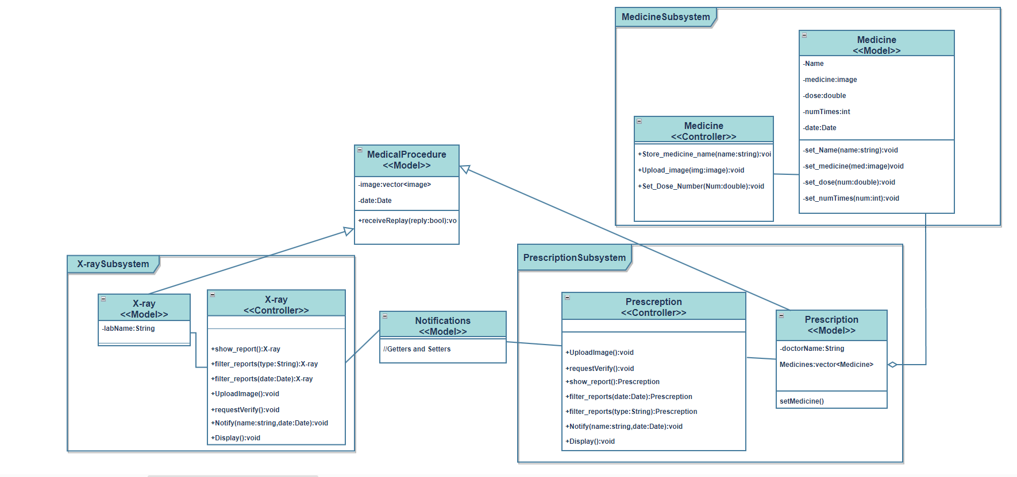

Figure 4.1 Subsystem

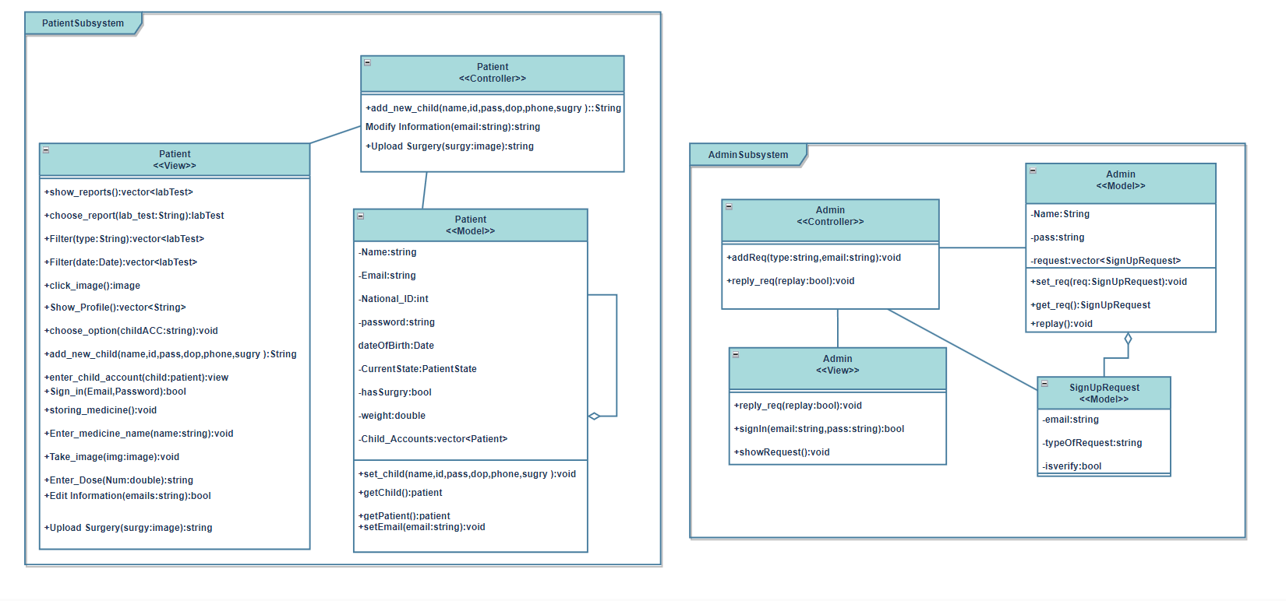

Figure 4.2 Subsystem

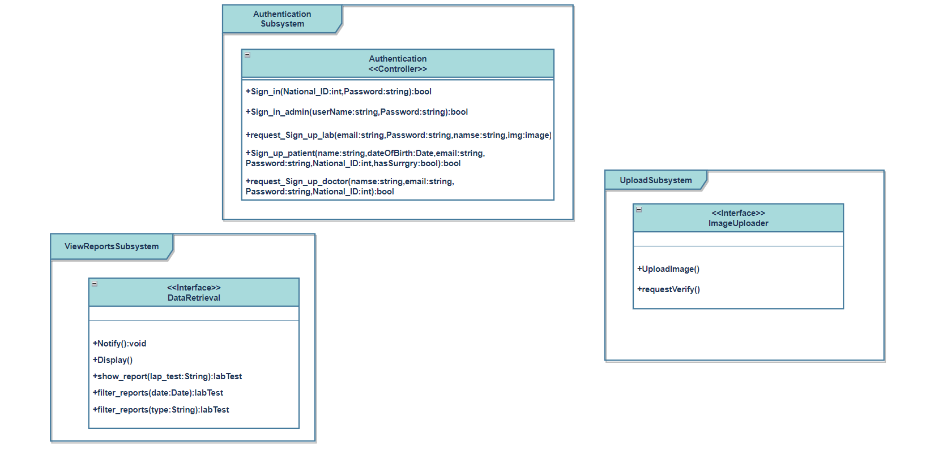Figure 4.3 Subsystem 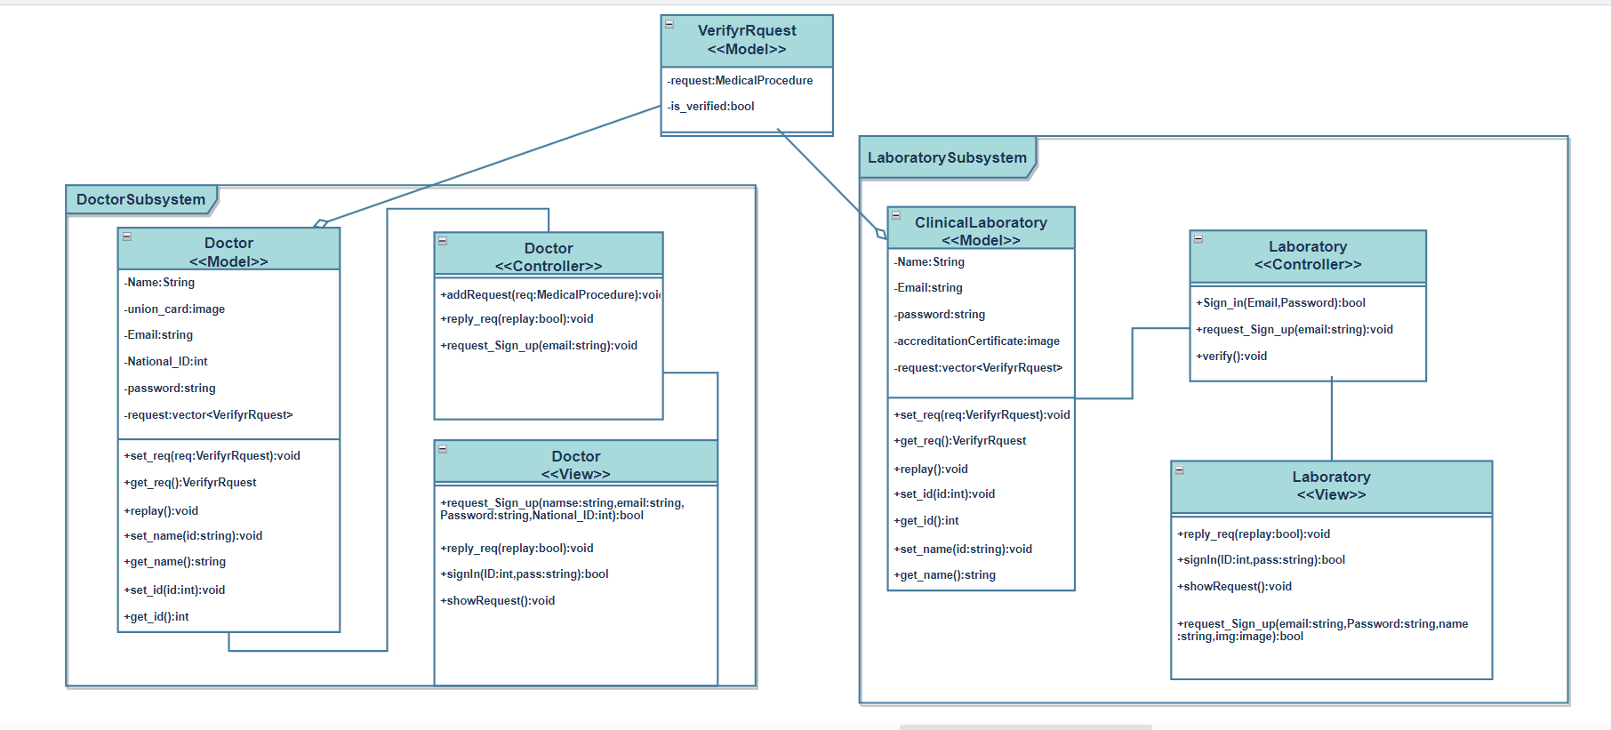 Figure 4.4 Subsystem 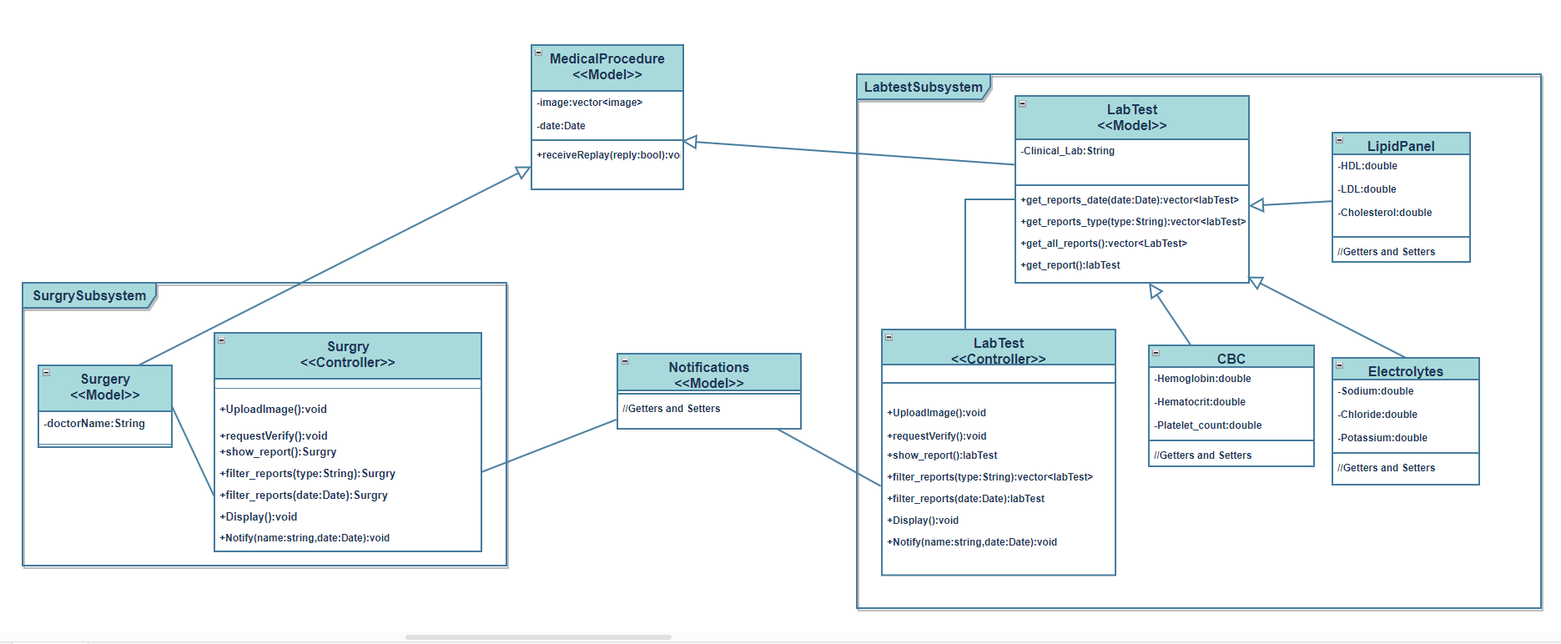 Figure 4.5 Subsystem

**3.5 Sequence Diagram:**

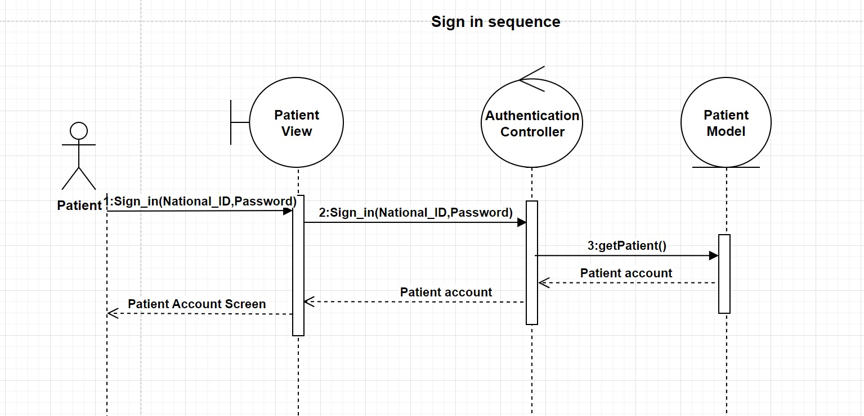Figure 5 Sign in sequence 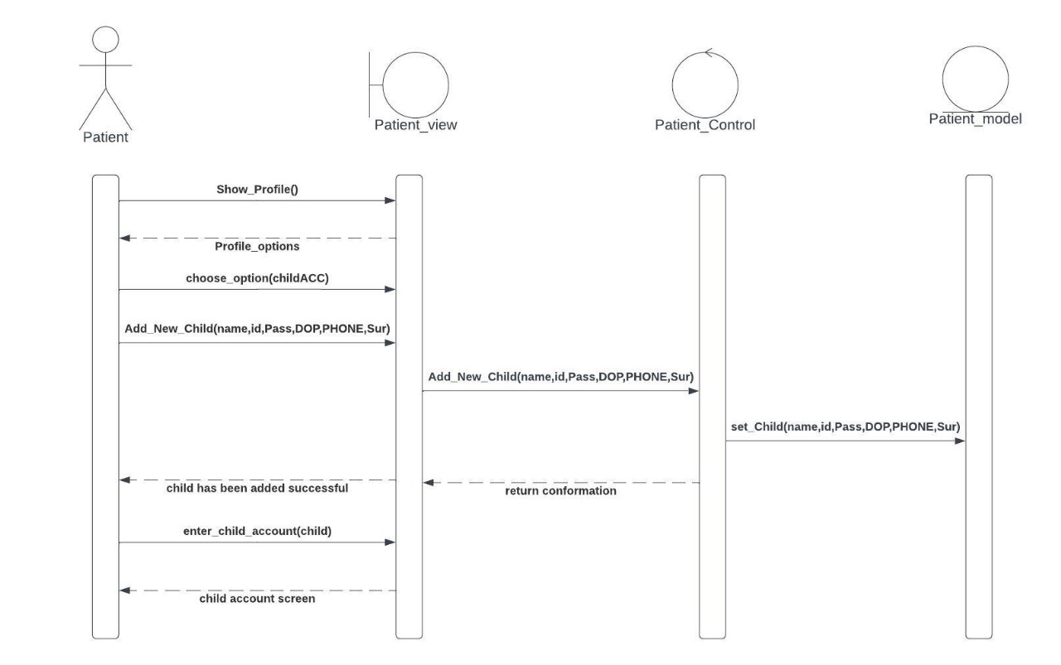 Figure 6 show profile sequence

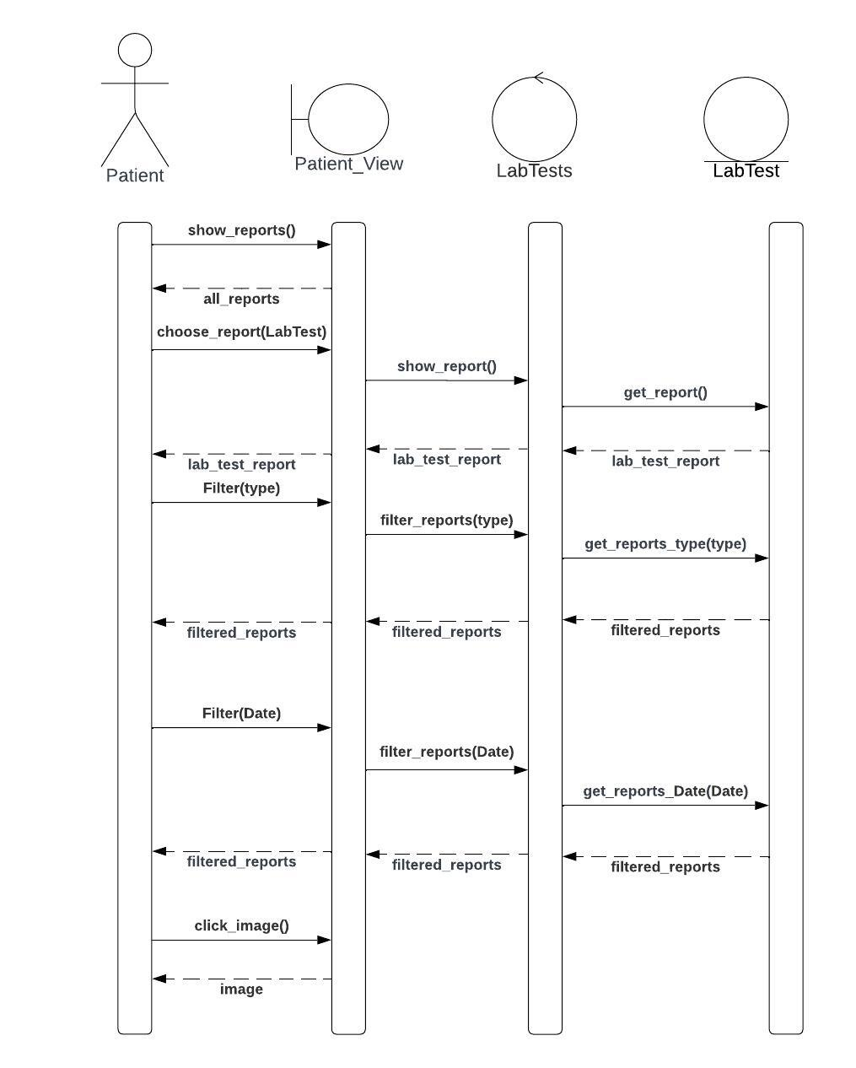Figure 7 show report sequence 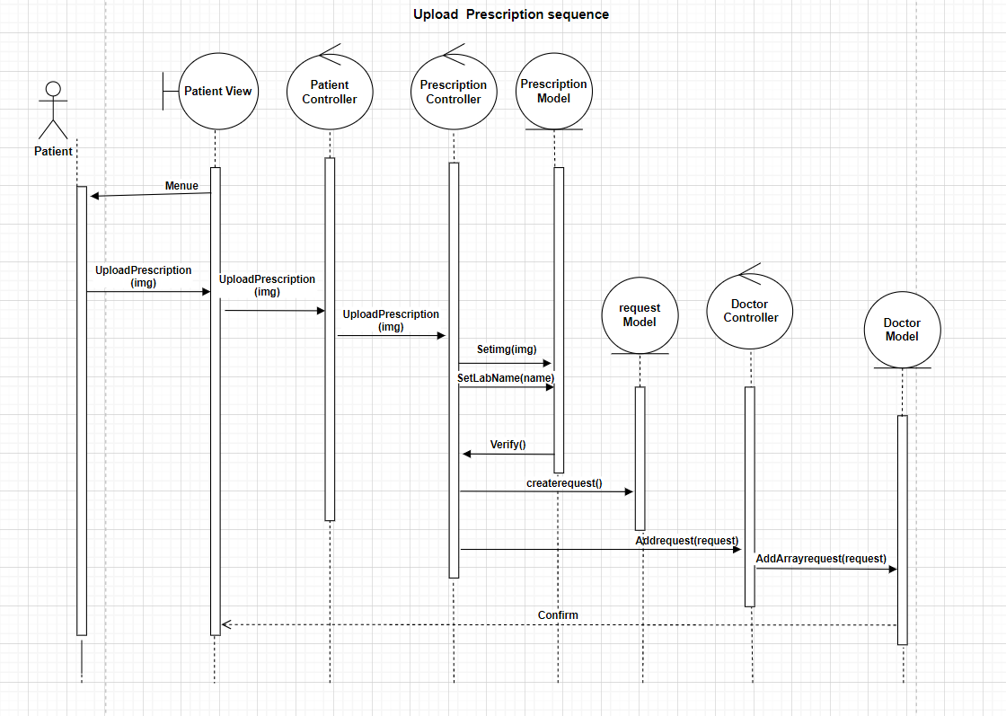

Figure 8 Upload prescription sequence 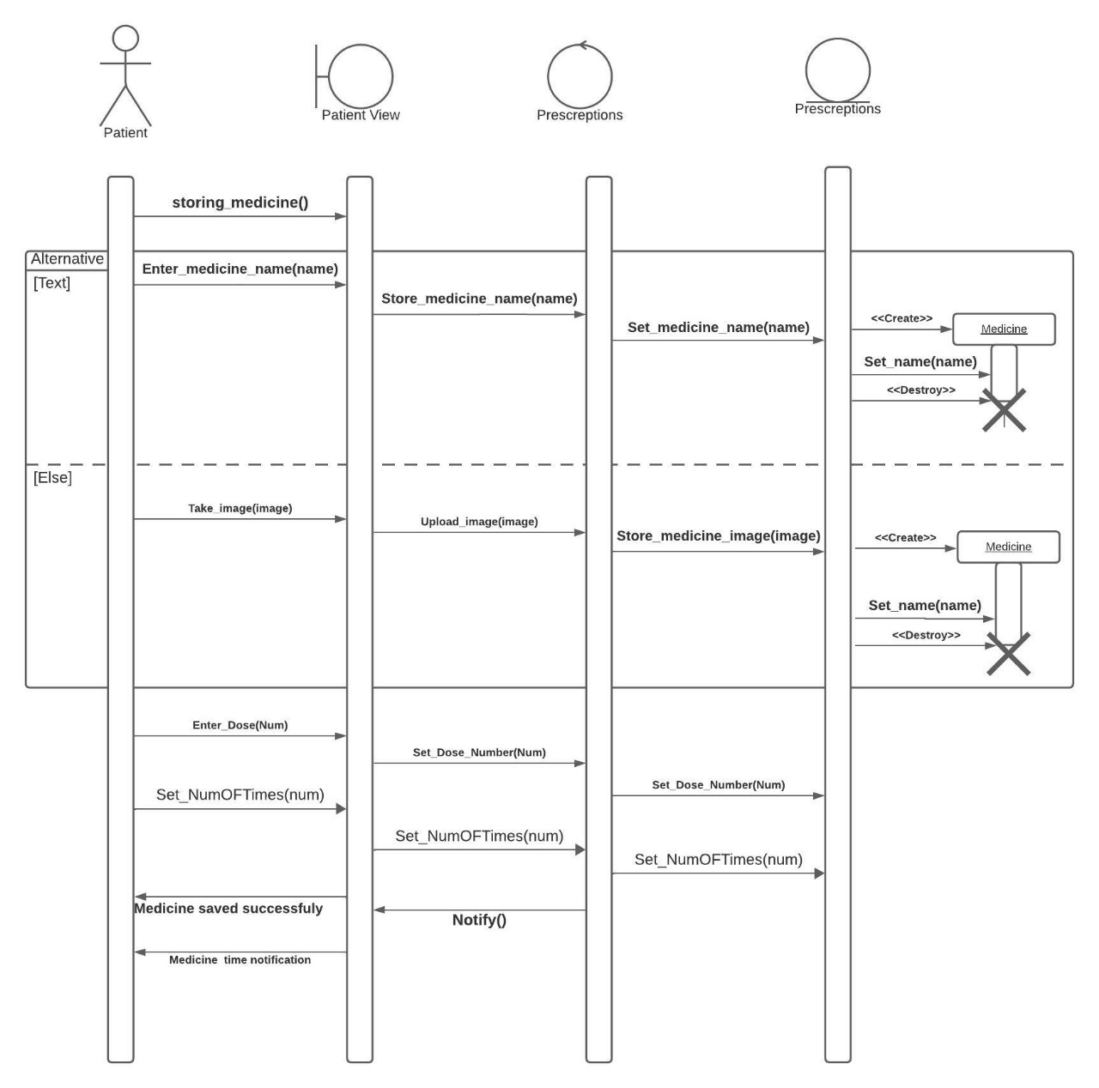

Figure 9 Storing medicine sequence

**3.6 System Architecture:**

In the design and development of our system, we have adopted a Layered Architecture, a proven design pattern that organizes the software system into distinct layers.

The key layers include:

1. **Presentation Layer:**

Positioned at the top of the architecture, the Presentation Layer is responsible for interacting directly with users. It manages the user interface, handles user interactions, and ensures a seamless and intuitive user experience.

1. **Application (or Business Logic) Layer:**

Serving as the intermediate layer, the Application Layer encapsulates the core business logic and rules of the system, manages application-specific functionalities like processing user input and enforcing business rules.

1. **Blockchain Layer:**

Retrieves data from the blockchain, such as transaction records, smart contract details, or any relevant information stored on the blockchain.

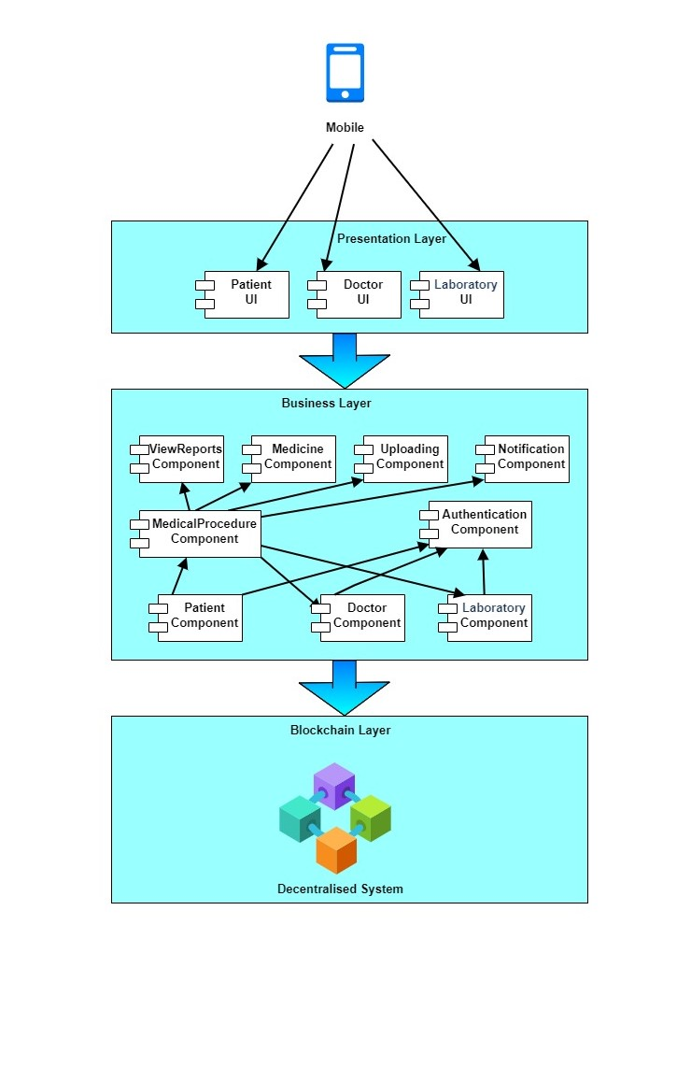

Figure 10 System Architecture

**Chapter 4 Etamn Design and Implementation**

The prototype was crafted using the Figma tool, streamlining our screen design process for the application. Unlike conventional design software, Figma enables seamless collaboration among team members, akin to Google Docs. This live collaboration feature fosters real-time feedback, iterative design refinement, and swift decision-making. Picture a design team seamlessly crafting a mobile app interface, effortlessly exchanging ideas and refining concepts together.

**4.1 Technologies used and reasons for choosing them:**

* **Flutter for front-end:**
* Single Codebase: Flutter utilizes a unified codebase to develop applications across various platforms including iOS, Android, web, and desktop. This approach offers future scalability, enabling seamless expansion from a mobile app to a web application. With Flutter's single codebase, transitioning between platforms is straightforward, significantly minimizing development time and resources in contrast to managing disparate codebases for each platform.
* Performance: Flutter apps are compiled directly to native ARM code (for mobile) or JavaScript (for web), resulting in high performance and smooth animations without the performance overhead of a JavaScript bridge.
* Platform Awareness: Flutter provides platform-specific APIs and widgets that allow developers to access platform-specific features and functionalities, ensuring a consistent user experience across different platforms while still leveraging each platform's unique capabilities.
* **Laravel Framework for back-end:**
* MVC Architecture: Laravel follows the Model-View-Controller (MVC) architectural pattern, which separates the application's logic, presentation, and data layers. This promotes code organization, maintainability, and scalability, making it easier to manage complex applications.
* Built-in Authentication and Authorization: Laravel provides built-in support for user authentication and authorization, including features like user registration, login, password reset, and role-based access control. This saves developers time and effort in implementing these common authentication mechanisms from scratch.
* **Blockchain for database:**
* Immutability: Once data is recorded on the blockchain, it cannot be altered or deleted. This feature ensures the integrity and transparency of the data, making it highly resistant to tampering or fraud.
* Security: Blockchain employs advanced cryptographic techniques to secure data and transactions, making it extremely difficult for unauthorized parties to access or alter the information. Additionally, the decentralized nature of blockchain networks enhances security by distributing data across multiple nodes and removing single points of vulnerability.
* Decentralization: Blockchain operates on a decentralized network of nodes, eliminating the need for a central authority or intermediary to manage and verify transactions. This decentralized architecture enhances security, as there is no single point of failure, and reduces the risk of data manipulation or censorship.

**4.2 User scenarios**

**4.2.1 Login screen:**

This is the login screen where users (considered as patient) can log in to their accounts through entering their national id and password. (the user can check the remember me option so that he doesn’t have to enter the login information every time he tries to login into his account as it will be saved).

**4.2.2 Sign Up screen:**

This is sign up screen, as if the user doesn’t have an account, he can sign up by entering the following information shown in the screen to create his new account. (the user can enter the surgeries he had before during sign up process).

**4.2.3 Menu screen:**

This is a menu options screen which shows the different features that the user can take advantage of, and it is shown once the user has logged into his account.

**4.2.4 Upload screen:**

Once the user clicks on the upload icon shown in Navbar he can start uploading his images whether it is related to

his lab tests, prescriptions, X-rays,

or surgery information.

**4.2.5 Lab Tests Screen:**

Here we are showing upload lab test scenario as an example to make it clear (x-rays and surgery information uploads goes same way).

**4.2.6 Saved Successfully Screen:**

If the user has chosen to save the image uploaded, then a message will be shown to the user telling him that the image has been saved successfully and he had two options whether to submit it and wait for the verification of laboratory or he can add another one.

**4.2.7 Upload Prescription Screen:**

This Screen scenario is a little bit different from others as the user has the option to enter the medicines written in the prescription uploaded and can enter the dose and number of times it should be taken to notify him by these medicines

or upload Prescription Image.

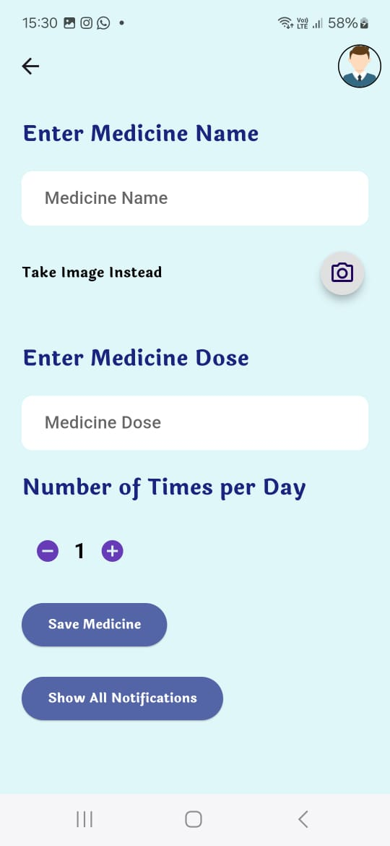**4.2.8 Upload Medicine in Prescription Screen:**

This screen shows the scenario of uploading medicine, which is written in prescription, as shown user can enter the medicine name or take photo of it, also enter the dose and number of times to take that medicine so that he can be notified then.

**4.2.9 Notification sent:**

Here it just shows how the notification of medicines appears and what does it contain,

(Example for clarification).

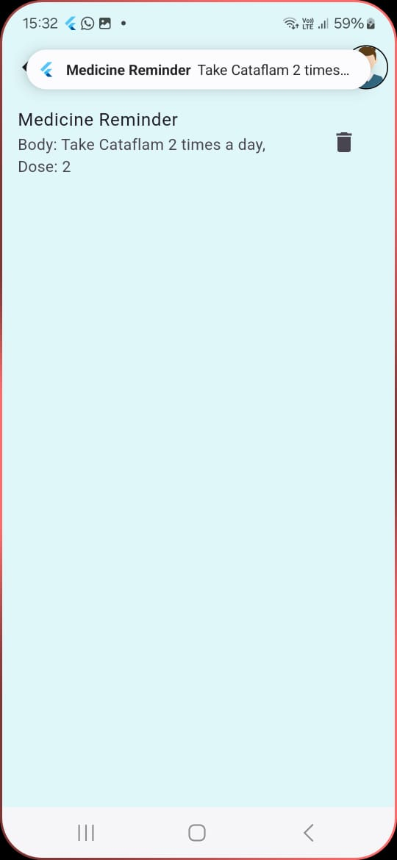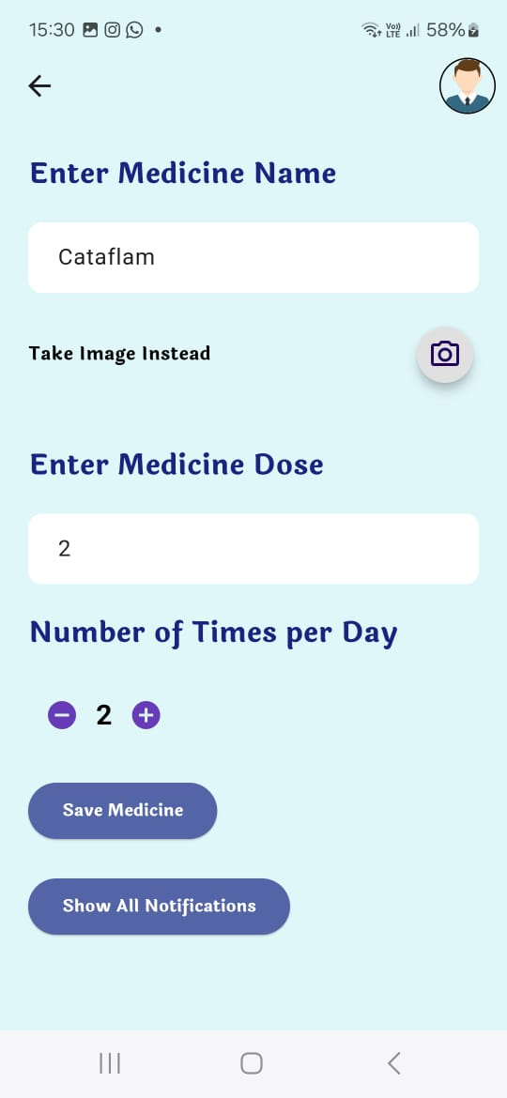

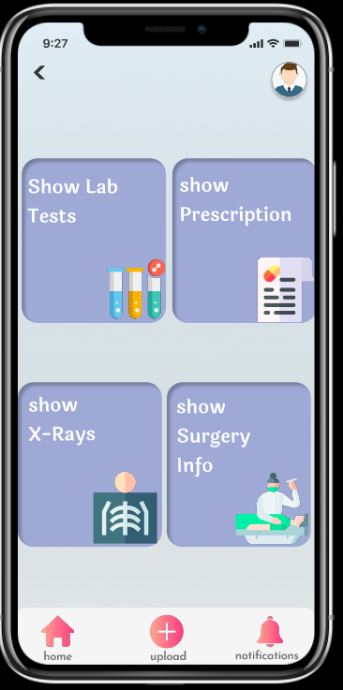

**4.2.10 Show Uploads:**

It is as a menu screen where the user can

choose to show the uploads of lab test,

prescriptions, X-rays, or surgery info (this shows

the photos which were uploaded before by the user).

**4.2.11 Show Lab Tests:**

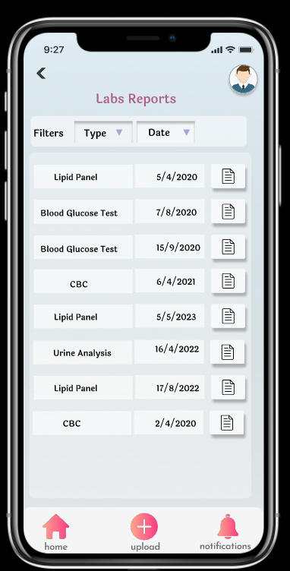

We will take here the lab test as an example

to show the scenario of showing uploads. (Prescription-rays

and surgery info goes by the same way).

As shown the user can filter his uploads whether

by the type or date.

**4.2.12 Storing medicine:**

Users can choose the storing medicine option from the menu. (He can store it either by entering the name of the medicine or take an image for that medicine).

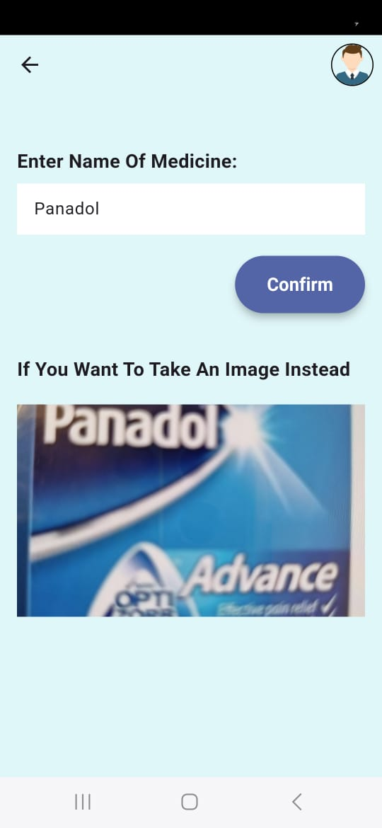

**4.2.13 User enters name of medicine or upload medicine image:**

As when user enters medicine name, he can click on confirm button, or he can take a photo for the medicine and upload it.

**4.2.14 Notification history screen:**

This screen shows the history of all

notifications that were sent to the user

during the whole day.

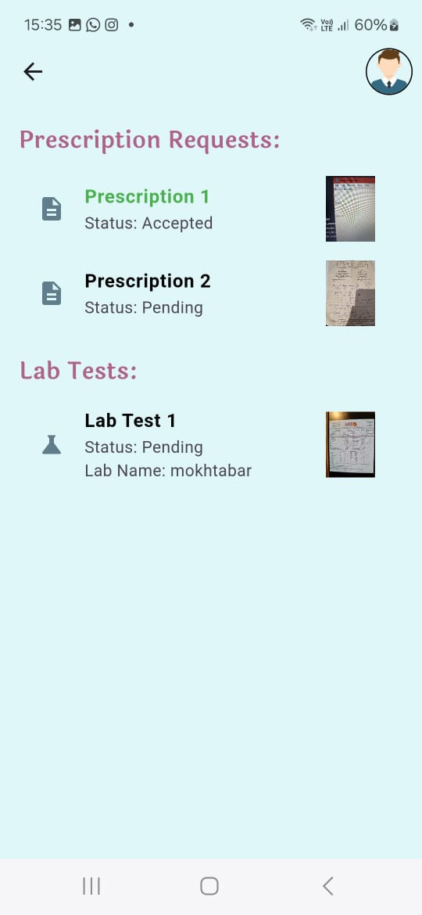

**4.2.15 Report Screen:**

This screen shows Prescriptions requests and lab test status whether they are accepted or not.

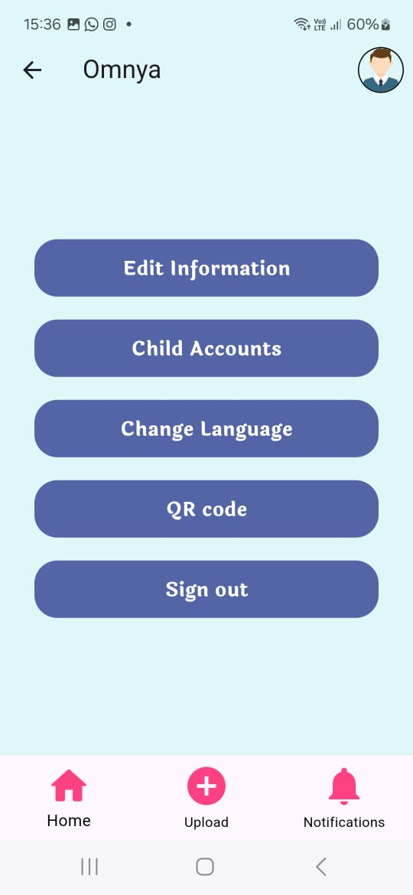

**4.2.16 Profile Screen:**

In the patient profile he can edit

his information, access his children accounts, sign out or

change the application language and show the QR code

for the doctor to scan.

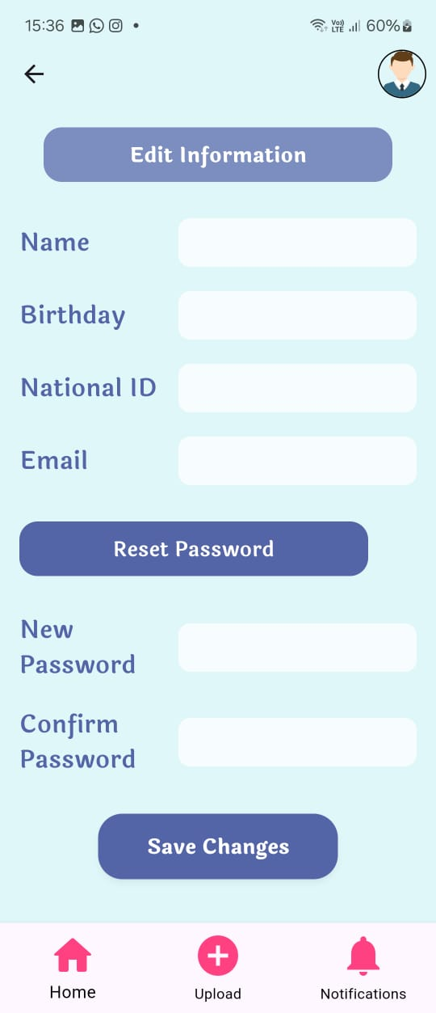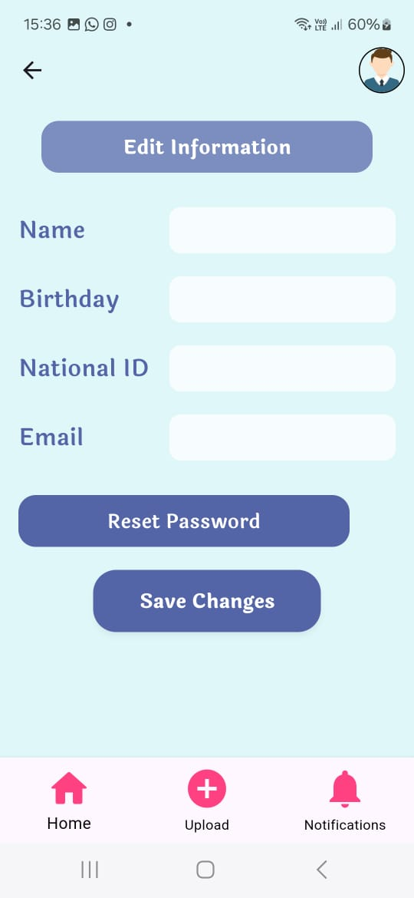

**4.2.17 Edit info Screen:**

This screen shows all patient information, and he can edit it or reset the password.

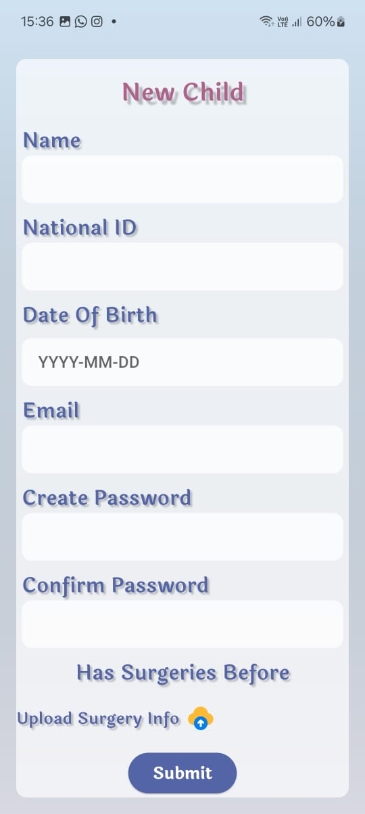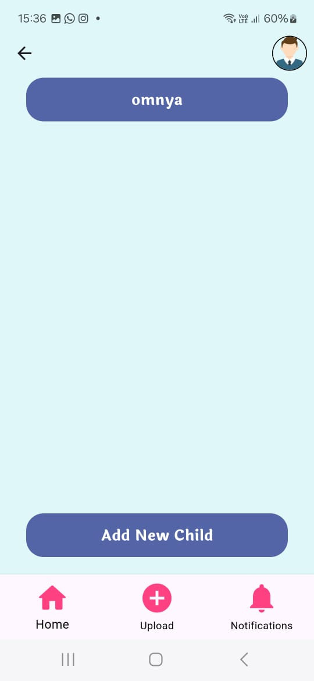

**4.2.18 Add Child Screen:**

The patient can add new child to his children accounts so he can manage his child account later.

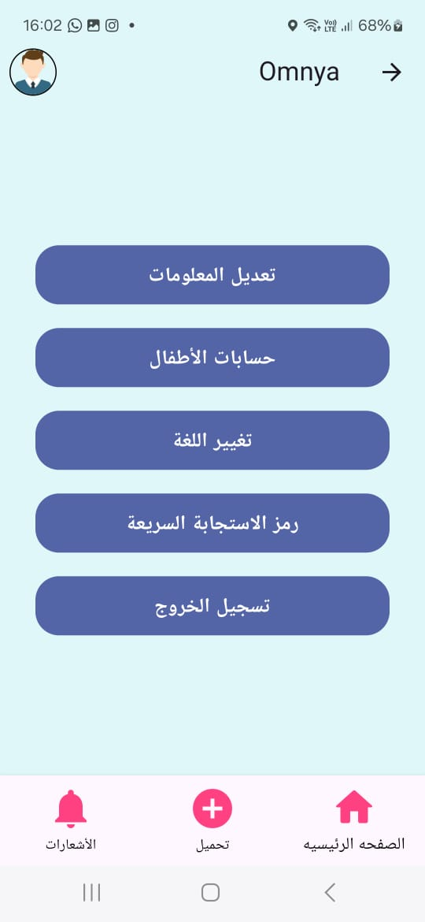**4.2.19 Change Language:**

This screen changes the language from English to Arabic

or vice versa.

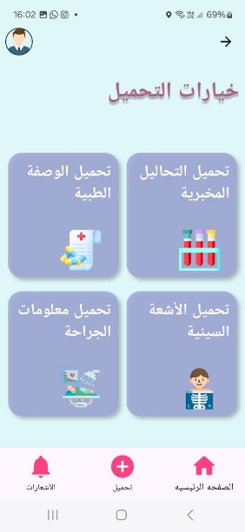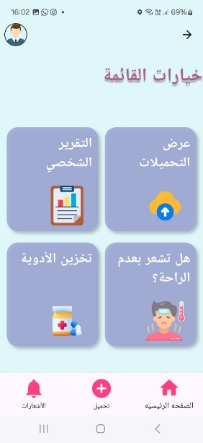

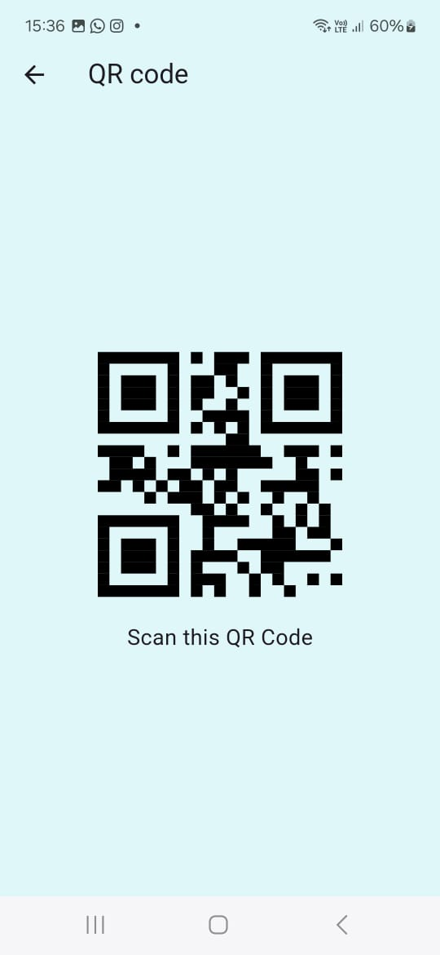

**4.2.20 Show QR Code:**

This screen shows the QR which will be

then scanned by the doctor.

**4.2.21 Felling ill Screen:**

This screen patient need when he fell ill and want

to know the available doctors and laboratories

that we support in our application.

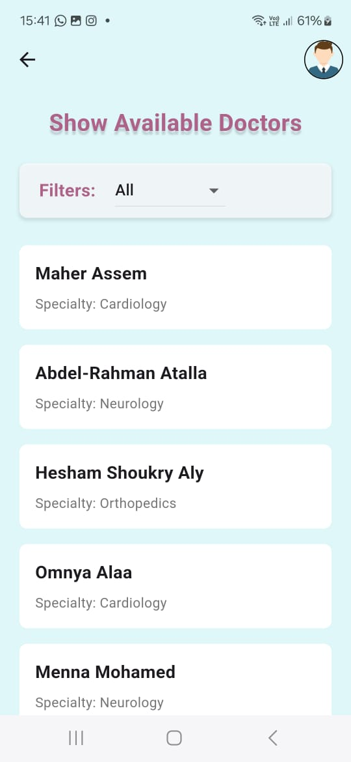

**4.2.22 Available Doctors Screen:**

In this screen we show all available doctors with

their name and departments.

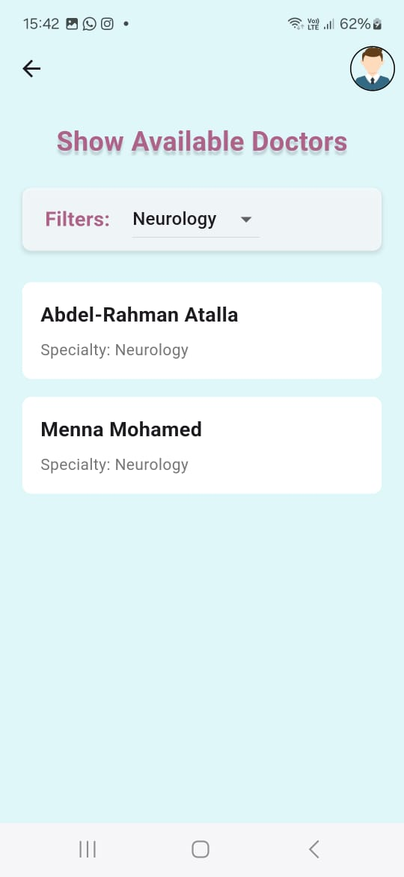

**4.2.23 Doctors Filter Screen:**

The patient can filter all doctors by specific department

and according to the chosen department a list of doctors

will be shown.

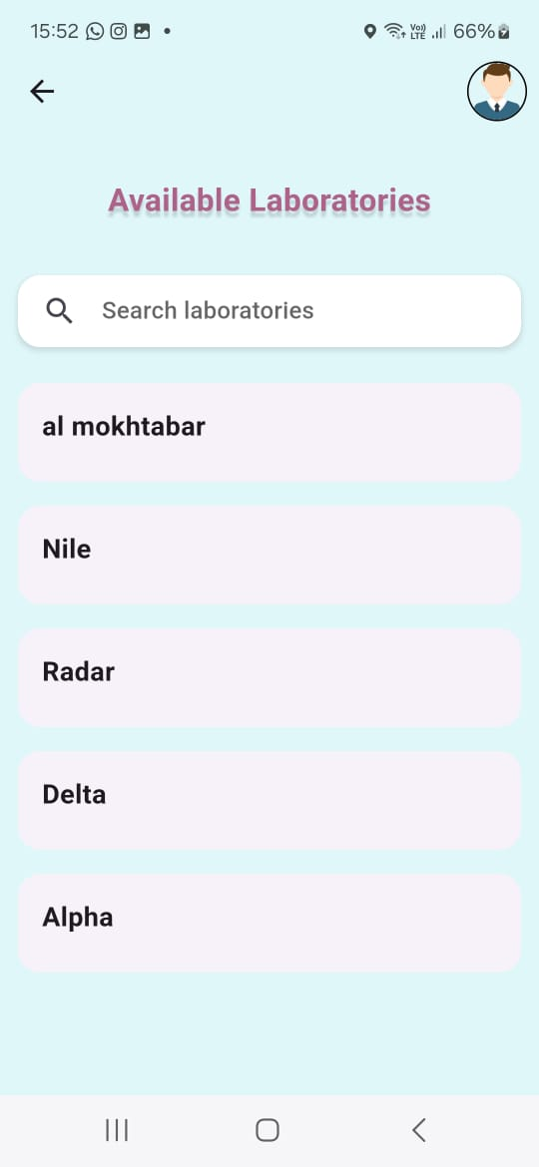

**4.2.24 Available Laboratories Screen:**

In this screen we show all available laboratories

with its name.

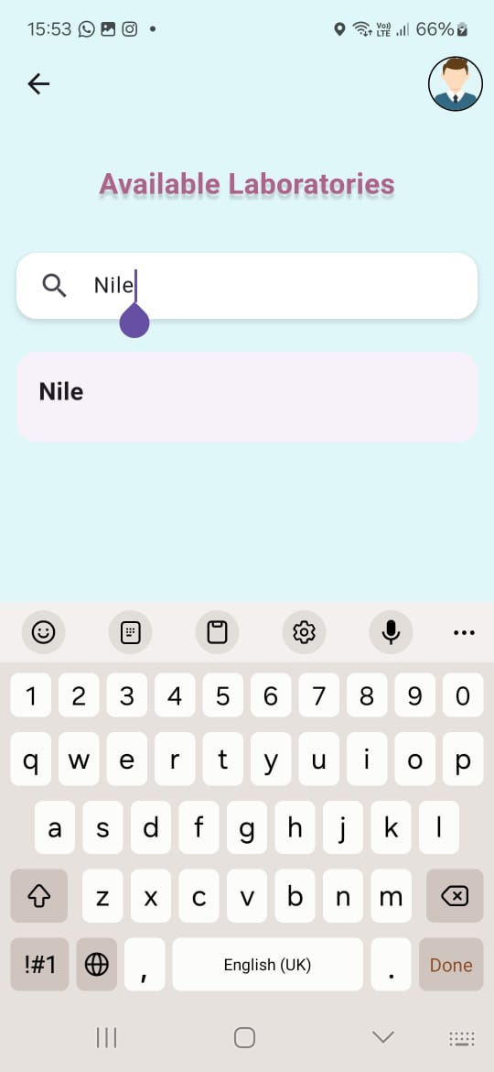

**4.2.25 Laboratories search screen:**

The patient can search in all Laboratories by specific name to know if we support this.

**LABORATORIES:**

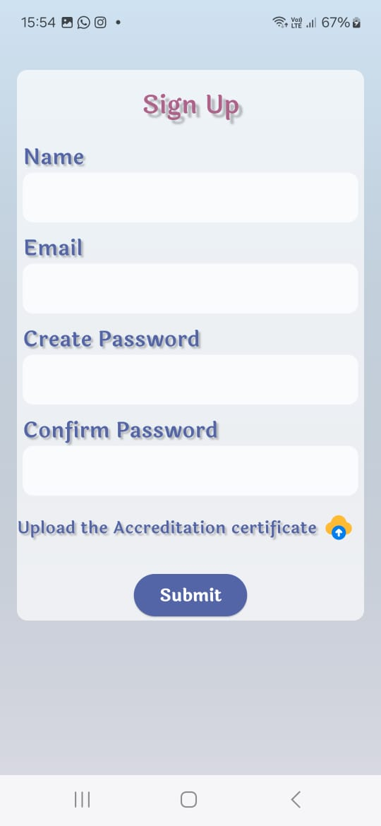**4.2.26 Sign up Screen:**

In this screen the laboratory can join us by filling in this sign-up form.

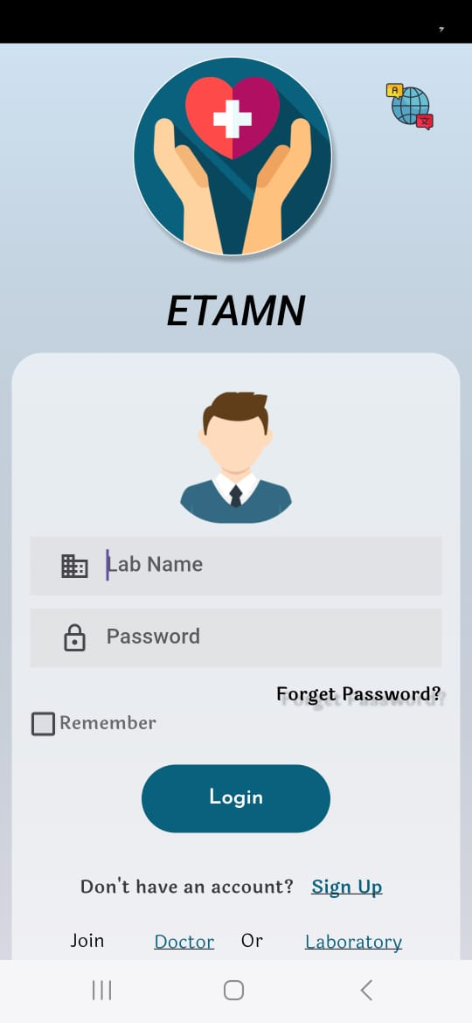

**4.2.27 Login Screen:**

In this screen the laboratory can login using its name and password.

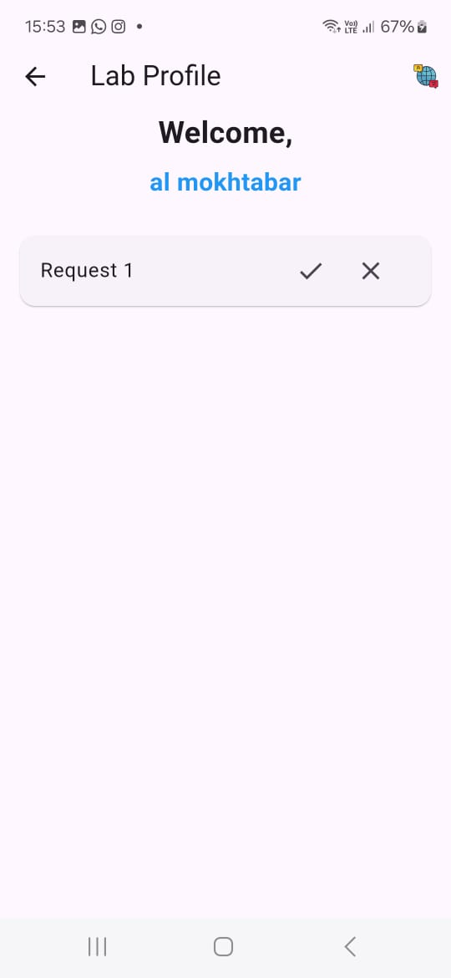

**4.2.28 Showing Requests Screen:**

This screen shows all pending request to approve or

reject by the laboratory.

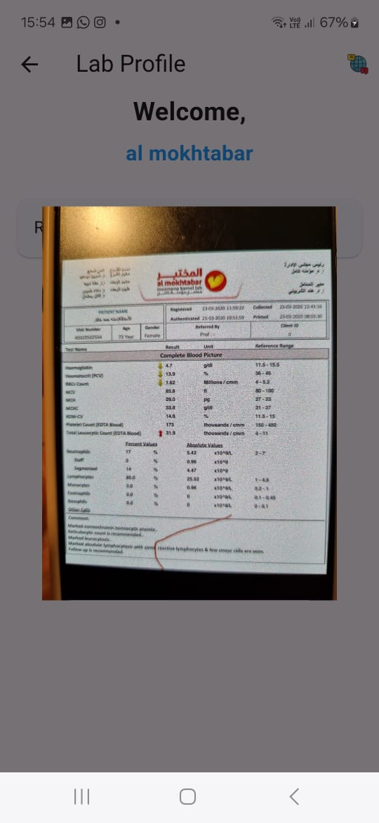

**4.2.29 Detailed request**

**Screen:**

This shows the lab test that

the patient uploaded and

it made in this laboratory to

he verifies or reject.

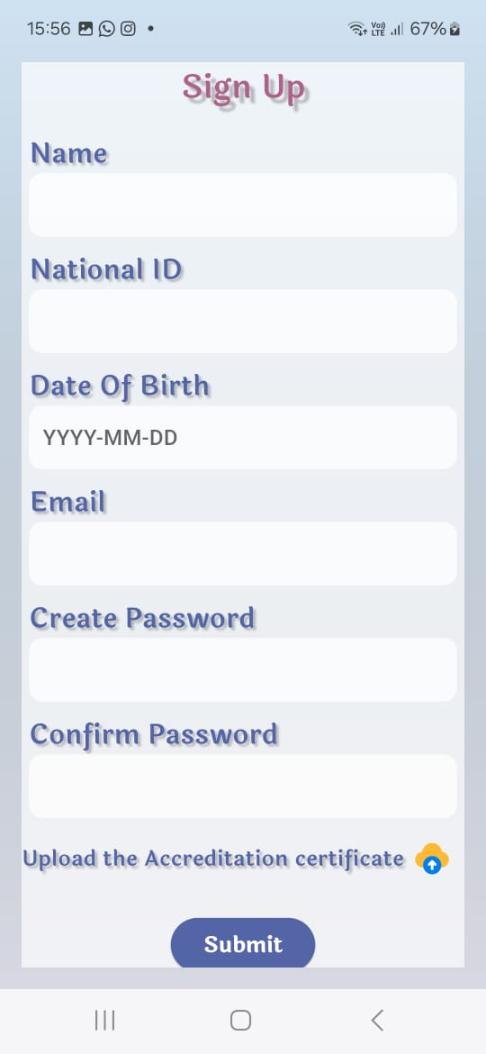**DOCTOR:**

**4.2.30 Sign Up Screen:**

In this screen the Doctor can join us by fill this sign-up form.

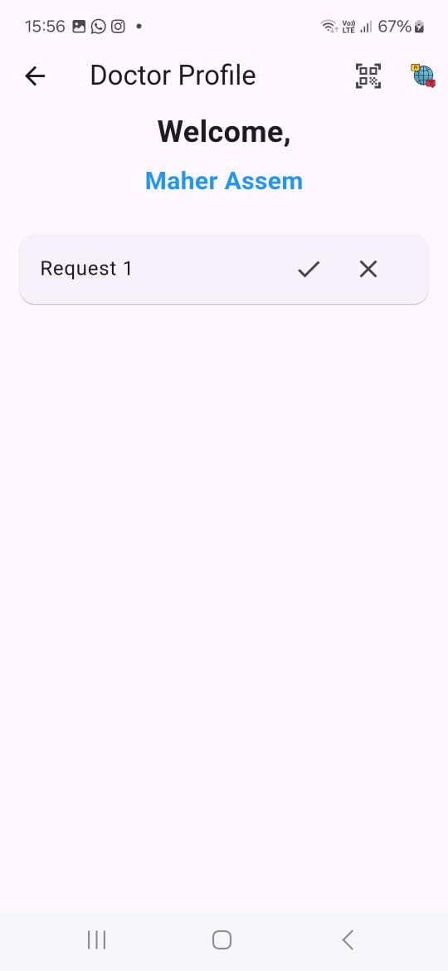

**4.2.31 Showing Requests Screen:**

This screen shows all pending request to approve or reject

by the doctor.

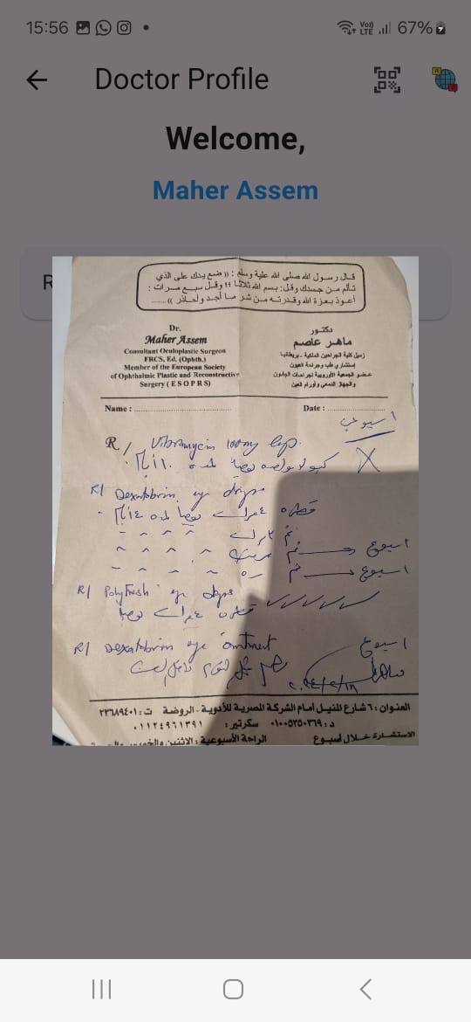**4.2.32 Detailed request Screen:**

This show the prescription that the patient uploaded, and it was

by that doctor to be verified or rejected.

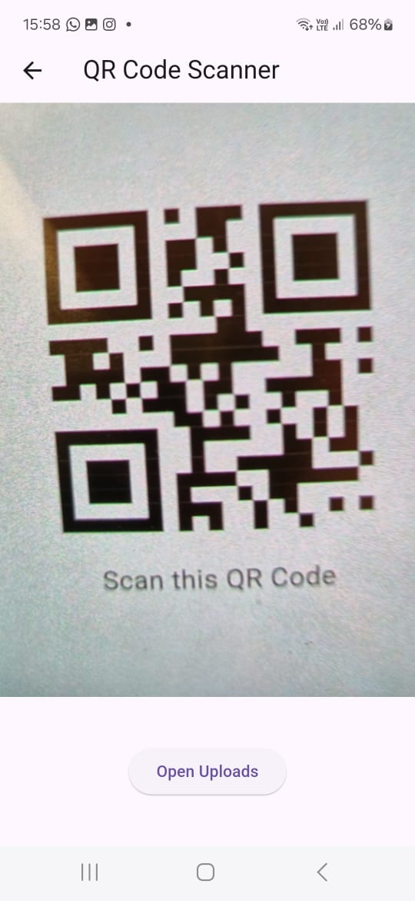

**4.2.33 Scan QR code:**

The doctor scans the QR code which is within the patient account ,where this qr code then goes to show uploads to let the doctors see the medical information of this patient.

**Chapter 5 Etamn Testing and Evaluation**

**5.1: Etamn Testing**

**1)Add Laboratory**

|  |  |
| --- | --- |
| **Test Case description** | Laboratories sign up on the application. |
| **Test Scenario** | The laboratory added successfully to data base |
| **Post** | http://127.0.0.1:8000/api/add-laboratory |
| **Test Data** | {  "id": 12345678912345,  "name": "Nile",  "imageHash": "9f86d081884c7d659a2feaa0c55ad015a3bf4f1b2b0b822cd15d6c15b0f00a08"  } |
| **Expected Result** | A success message and the data should be returned. |
| **Actual Result** | {“status”:”success”,  “data”{  "id": 12345678912345,  "name": "Nile",  "imageHash": "9f86d081884c7d659a2feaa0c55ad015a3bf4f1b2b0b822cd15d6c15b0f00a08"  }  } |
| **Processing Time and status code** | Time: 1260 ms  status code :200 OK |
| **Pass/Fail** | Pass |
| **Blockchain Before** |  |
| **Blockchain After** |  |

**2)Add Doctor**

|  |  |
| --- | --- |
| **Test Case description** | Doctor sign up on the application. |
| **Test Scenario** | The Doctor added successfully to data base |
| **Post** | http://127.0.0.1:8000/api/add-doctor |
| **Test Data** | {  "nationalId":23456423156386 ,  "name": "Maher Assem",  "email": "MaherAssem@gmail.com",  "password": "abcdefgh",  "dateOfBirth": "1980-05-06",  "certificateHash": "786556d081884c7d659a2feaa0c55ad015a3bf4f1b2b0b822cd15d6c15b0f00a08"  } |
| **Expected Result** | A success message and the data should be returned. |
| **Actual Result** | {“status”:”success”,  “data” {  "nationalId":23456423156386 ,  "name": "Maher Assem",  "email": "MaherAssem@gmail.com",  "password": "abcdefgh",  "dateOfBirth": "1980-05-06",  "certificateHash": "786556d081884c7d659a2feaa0c55ad015a3bf4f1b2b0b822cd15d6c15b0f00a08"  }  } |
| **Processing Time and status code** | Time: 1266 ms  status code :200 OK |
| **Pass/Fail** | Pass |
| **Blockchain Before** |  |
| **Blockchain After** |  |

**3)Add Patient**

|  |  |
| --- | --- |
| **Test Case description** | Patient sign up on the application. |
| **Test Scenario** | The Patient added successfully to data base |
| **Post** | http://127.0.0.1:8000/api/add-patient |
| **Test Data** | {  "nationalId" : 23523489463568,  "name": "yomna",  "dateOfBirth": "2002-08-05",  "email": "yomna@gmail.com",  "password": "gtrsewfe",  "hasSurgeriesBefore": "no"  } |
| **Expected Result** | A success message and the data should be returned. |
| **Actual Result** | {“status”:”success”,  “data” {  "nationalId" : 23523489463568,  "name": "yomna",  "dateOfBirth": "2002-08-05",  "email": "yomna@gmail.com",  "password": "gtrsewfe",  "hasSurgeriesBefore": "no"  } } |
| **Processing Time and status code** | Time: 1280 ms  status code :200 OK |
| **Pass/Fail** | Pass |
| **Blockchain Before** |  |
| **Blockchain After** |  |

**4)Upload Lab Test**

|  |  |
| --- | --- |
| **Test Case description** | The user upload a lab test on the application. |
| **Test Scenario** | Sent request to the laboratory and after accept request , the lab test added successfully to data base |
| **Post** | http://127.0.0.1:8000/api/addLabImg |
| **Test Data** | {  "nationalId": 34524276845629,  "img": "7j46d081884c7d659a2feaa0c55ad015a3bf4f1b2b0b822cd15d6c15b0f00a08",  "type": "lab-test"  } |
| **Expected Result** | A success message Your request has been successfully sent to the laboratory. |
| **Actual Result** | {“status”:”success”,  “data” {  "nationalId": 34524276845629,  "img": "7j46d081884c7d659a2feaa0c55ad015a3bf4f1b2b0b822cd15d6c15b0f00a08",  "type": "lab-test"  } } |
| **Processing Time and status code** | Time: 1260 ms  status code :200 OK |
| **Pass/Fail** | Pass |
| **Blockchain Before** |  |
| **Blockchain After** |  |

**5.2: Etamn Evaluation**

**Cost:** the project cost evaluation can include development costs, maintenance costs, and any other relevant expenses incurred during the project lifecycle. Since the provided documents do not specify these details, they will need to be estimated based on standard industry practices.

**Time Compared to Contemporary Systems:** Compared to contemporary systems, our project aims to reduce the time taken for various medical processes such as record retrieval, patient sign-up, and lab test uploads. The average processing times (approximately 1260 ms) for key operations indicate efficient performance.

**Environmental Impact:** The primary environmental impact of our project involves the reduction of paper usage by transitioning to electronic medical records. This shift contributes to a decrease in deforestation and waste generation associated with paper-based records. Additionally, the use of digital records reduces the carbon footprint related to the transportation and storage of physical documents.

**Social and Political Impact:** Our project has several social and political implications:

* **Social Impact**: The system improves patient access to medical records, leading to better health outcomes and increased patient empowerment. It also enhances the efficiency of healthcare providers, reducing the time and effort required to manage medical records.
* **Political Impact**: The implementation of secure electronic medical records aligns with global trends towards digital health records and can influence healthcare policies to support the adoption of similar technologies. It also sets a precedent for incorporating advanced technologies like blockchain in healthcare systems to ensure data security and integrity.

**Chapter 6 Conclusions and Future Work**

**6.1 Conclusions**

The advanced electronic medical records system developed in this project addresses several critical issues in healthcare information management. Our user-centric design, incorporating innovative technologies such as blockchain for secure data management and multilingual support, successfully enhances the accessibility and accuracy of medical records. By focusing on storing a wide array of medical information, including X-rays, prescriptions, and lab tests, we ensure that both patients and healthcare providers have quick and easy access to essential health data. This system minimizes medical errors and improves the coordination of healthcare services.

**Our project achieved its primary goals:**

1. **Enhanced Access to Medical Records:** The system allows patients and healthcare providers to access medical records efficiently, ensuring that vital information is available when needed.
2. **Minimized Medical Errors:** By centralizing and digitizing medical records, we reduce the chances of errors related to miscommunication or lost records.
3. **Empowered Patients:** Patients can manage their health data proactively, fostering better health management and decision-making.

**6.2 Future Work**

While the developed system has met its objectives, there are several areas for future improvement and research:

1. **Advanced Data Analytics:** Implementing advanced data analytics and machine learning algorithms could help predict health trends, personalize patient care, and provide actionable insights for healthcare providers.
2. **Integration with Wearable Devices:** Future versions of the system could integrate with wearable health devices to continuously monitor patient health metrics and provide real-time updates to their medical records.
3. **Enhanced Security Measures:** While blockchain provides robust security, ongoing research into emerging security technologies could further enhance data protection.
4. **Telemedicine Integration:** Adding telemedicine capabilities would allow healthcare providers to offer remote consultations, improving accessibility for patients in remote or underserved areas.
5. **User Interface Improvements:** Continuous feedback from users should be utilized to refine and improve the system's user interface, ensuring it remains intuitive and user-friendly.
6. **Regulatory Compliance:** Future work should include ensuring compliance with evolving healthcare regulations and standards to maintain the system's legality and trustworthiness.

These improvements will ensure that the system remains at the forefront of healthcare technology, continually adapting to meet the needs of patients and healthcare providers.