horizontal line

**Artificial Intelligence Course**

Markov Decision Processes

**5th January 2021**

|  |  |
| --- | --- |
| Name | ID |
| Toka Alaa | 14 |
| Nada Salama | 58 |
| Yomna Gamal El-Din | 63 |

# OVERVIEW

Consider the 3x3 world shown in the following figure:

The agent has four actions Up, Down, Right and Left. The transition model is: 80% of the time the agent goes in the direction it selects; the rest of the time it moves at right angles to the intended direction. A collision with a wall results in no movement.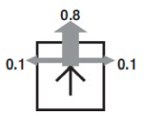

# Data Structure used

We implement a MDP class which contains

* States S
* Actions A
* Transitions P(s’|s,a) (or T(s,a,s’))
* Rewards R(s,a,s’) (and discount γ)
* Start state s0
* Policy

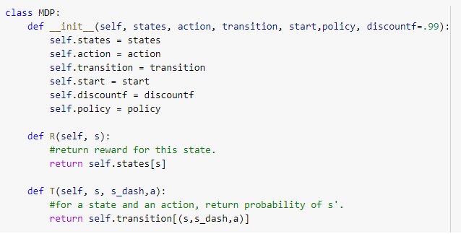

**Transitions** are a Dictionary, its key is a tuple consisting of (s, s’, a) and the value is the probability of that transition.

{(2, 1, -2): 0.8,

(2, 1, -1): 0.1,

(2, 1, 1): 0.1,

(2, 2, -2): 0.1,

(2, 2, 1): 0.8,

(2, 2, 2): 0.1,

(2, 3, -1): 0.1,

(2, 3, 1): 0.1,

(2, 3, 2): 0.8,

(2, 5, -2): 0.1,

(2, 5, -1): 0.8,

(2, 5, 2): 0.1,

(4, 1, -2): 0.1,

(4, 1, 1): 0.8,

(4, 1, 2): 0.1,

(4, 4, -2): 0.8,

(4, 4, -1): 0.1,

(4, 4, 1): 0.1,

(4, 5, -1): 0.1,

(4, 5, 1): 0.1,

(4, 5, 2): 0.8,

(4, 7, -2): 0.1,

(4, 7, -1): 0.8,

(4, 7, 2): 0.1,

(5, 2, -2): 0.1,

(5, 2, 1): 0.8,

(5, 2, 2): 0.1,

(5, 4, -2): 0.8,

(5, 4, -1): 0.1,

(5, 4, 1): 0.1,

(5, 6, -1): 0.1,

(5, 6, 1): 0.1,

(5, 6, 2): 0.8,

(5, 8, -2): 0.1,

(5, 8, -1): 0.8,

(5, 8, 2): 0.1,

(6, 3, -2): 0.1,

(6, 3, 1): 0.8,

(6, 3, 2): 0.1,

(6, 5, -2): 0.8,

(6, 5, -1): 0.1,

(6, 5, 1): 0.1,

(6, 6, -1): 0.1,

(6, 6, 1): 0.1,

(6, 6, 2): 0.8,

(6, 9, -2): 0.1,

(6, 9, -1): 0.8,

(6, 9, 2): 0.1,

(7, 4, -2): 0.1,

(7, 4, 1): 0.8,

(7, 4, 2): 0.1,

(7, 7, -2): 0.9,

(7, 7, -1): 0.9,

(7, 7, 1): 0.1,

(7, 7, 2): 0.1,

(7, 8, -1): 0.1,

(7, 8, 1): 0.1,

(7, 8, 2): 0.8,

(8, 5, -2): 0.1,

(8, 5, 1): 0.8,

(8, 5, 2): 0.1,

(8, 7, -2): 0.8,

(8, 7, -1): 0.1,

(8, 7, 1): 0.1,

(8, 8, -2): 0.1,

(8, 8, -1): 0.8,

(8, 8, 2): 0.1,

(8, 9, -1): 0.1,

(8, 9, 1): 0.1,

(8, 9, 2): 0.8,

(9, 6, -2): 0.1,

(9, 6, 1): 0.8,

(9, 6, 2): 0.1,

(9, 8, -2): 0.8,

(9, 8, -1): 0.1,

(9, 8, 1): 0.1,

(9, 9, -2): 0.1,

(9, 9, -1): 0.9,

(9, 9, 1): 0.1,

(9, 9, 2): 0.9}

**Actions** are 1→ Up, -1 → Down, 2→ right, -2 → Left

States are 1d array containing reward value for each state.

**The grid for us is like**

State number

|  |  |  |
| --- | --- | --- |
| 1 | 2 | 3 |
| 4 | 5 | 6 |
| 7 | 8 | 9 |

Reward values where r is [-3, 0, 3, 100]

|  |  |  |
| --- | --- | --- |
| r | -1 | 10 |
| -1 | -1 | -1 |
| -1 | -1 | -1 |

# 

# 

# 

# 

# Value Iteration

## Algorithm

## 

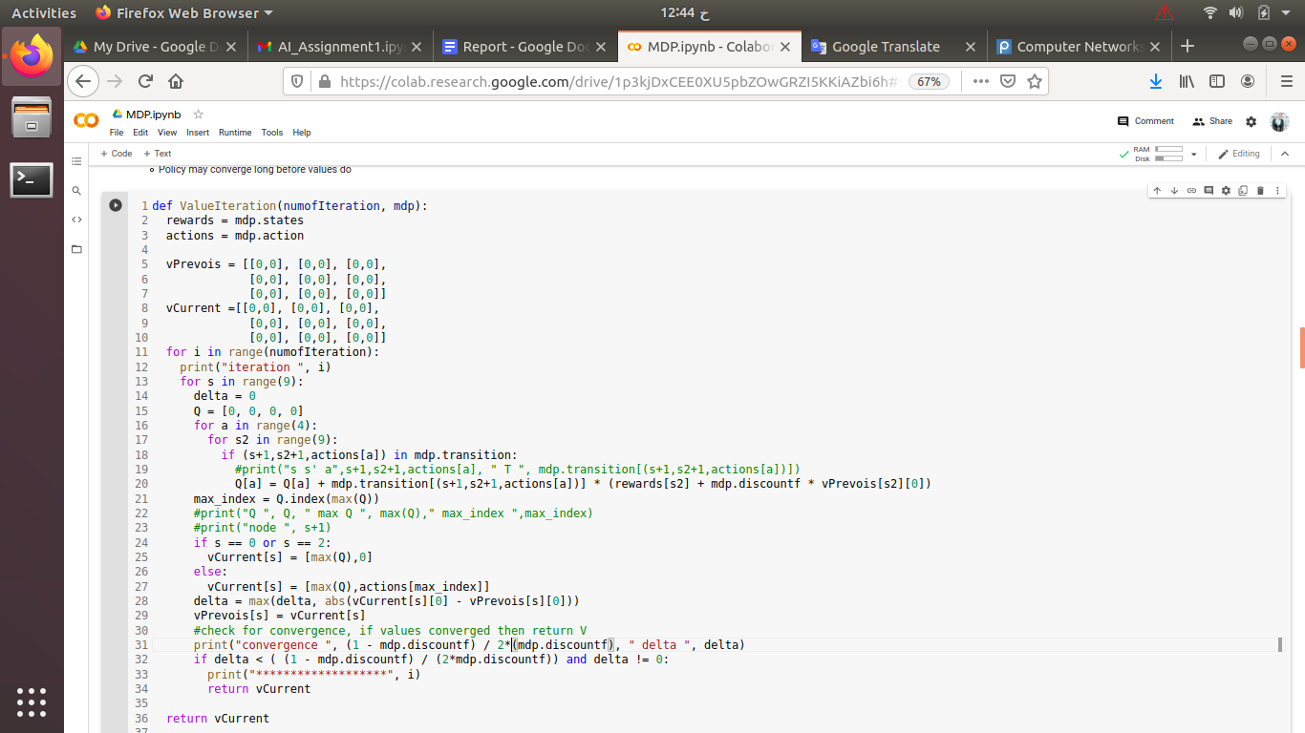

## Result Policy

### For r = 100

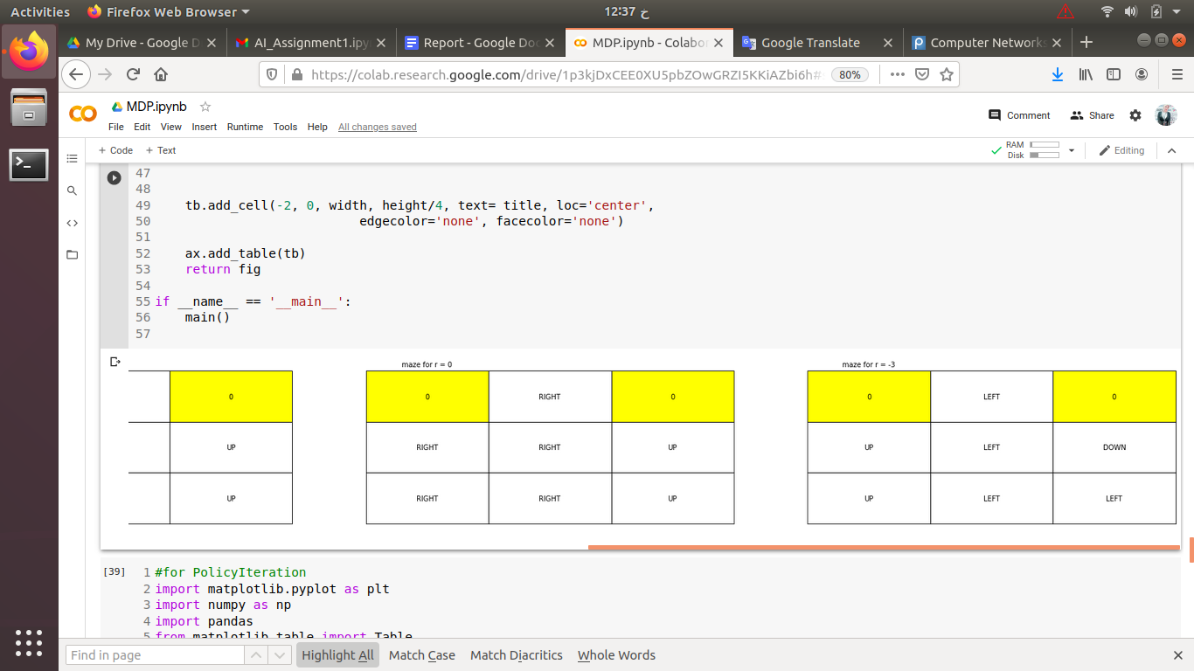

### For r = 3

### 

### For r = 0



### For r = -3

### 

# Policy Iteration

## Algorithm

* The idea as we take in lecture is

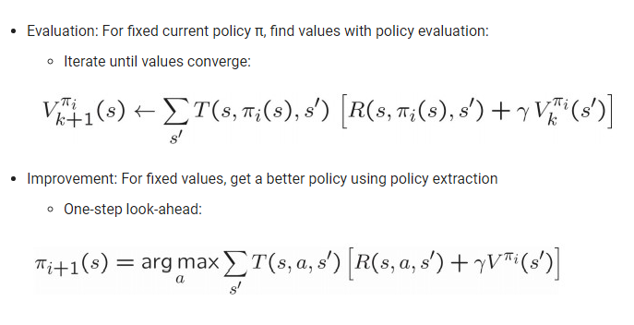

* The code consists of two parts, first one is the function of policy iteration which takes a MDP class and the number of iterations and returns the new policy that algorithm found.

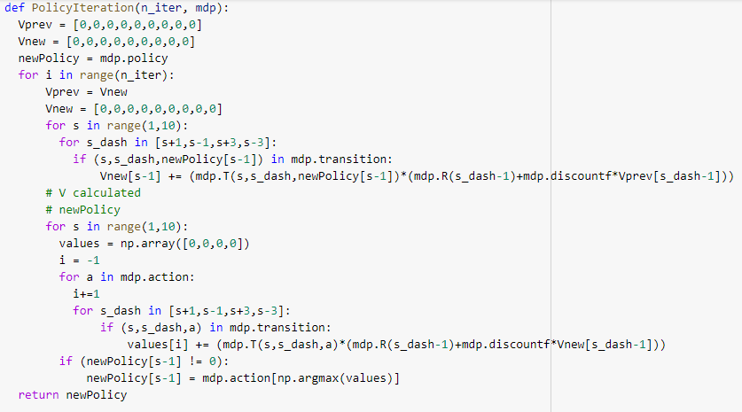

Second part is the code which runs this algorithm 4 times for each r value and print path from start point by the obtained policy.

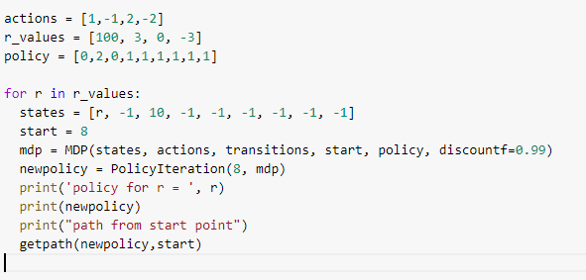

## Result Policy Without Early Stopping

### For r = 100

### 

### For r = 3

### 

### For r = 0

### 

### For r = -3

### 

## Result Policy With Early Stopping

### For r = 100 at iteration 3

### 

### For r = 3 at iteration 3

### 

### For r = 0 at iteration 2

### 

### For r = -3 at iteration 3

### 

