Agri-Vision Company Performance Report (2022–2023)


1. Executive Summary
Agri-Vision demonstrated strong performance across 2022–2023, achieving 6.5bn in sales, 2.3bn in total cost, and 4.2bn in profit with a 59.4% profitability ratio. Updated dashboard data indicates high product profitability and opportunities for improving quality control and production efficiency.

Sales Analysis Dashboard
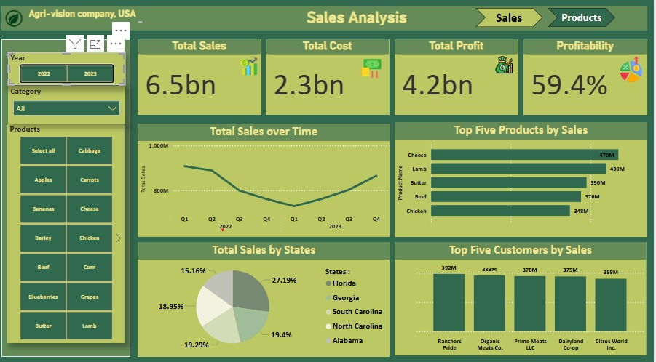

Products Analysis Dashboard
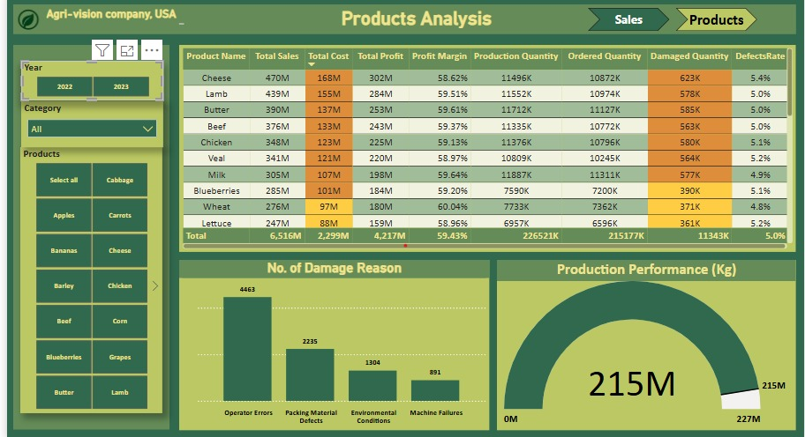

2. Financial KPIs (Corrected)
• Total Sales: 6.5bn
• Total Cost: 2.3bn
• Total Profit: 4.2bn
• Profitability: 59.4%

3. Sales Trend
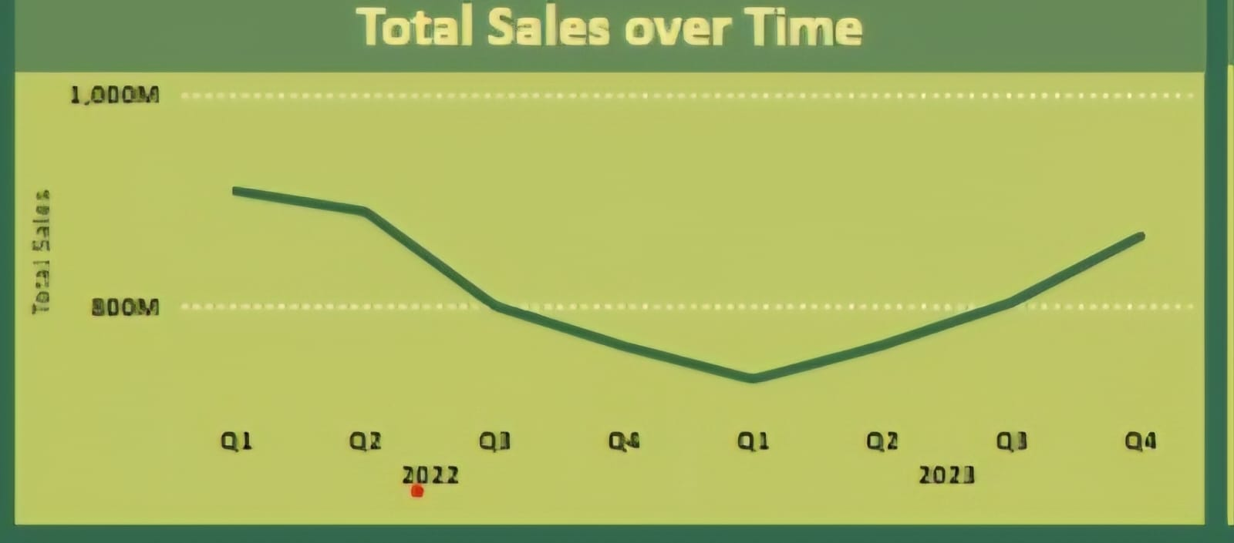
According to above chart we noticed that:
Q2–Q4 2022 decline followed by full recovery in 2023, peaking in Q4.

4. State-Level Sales Distribution

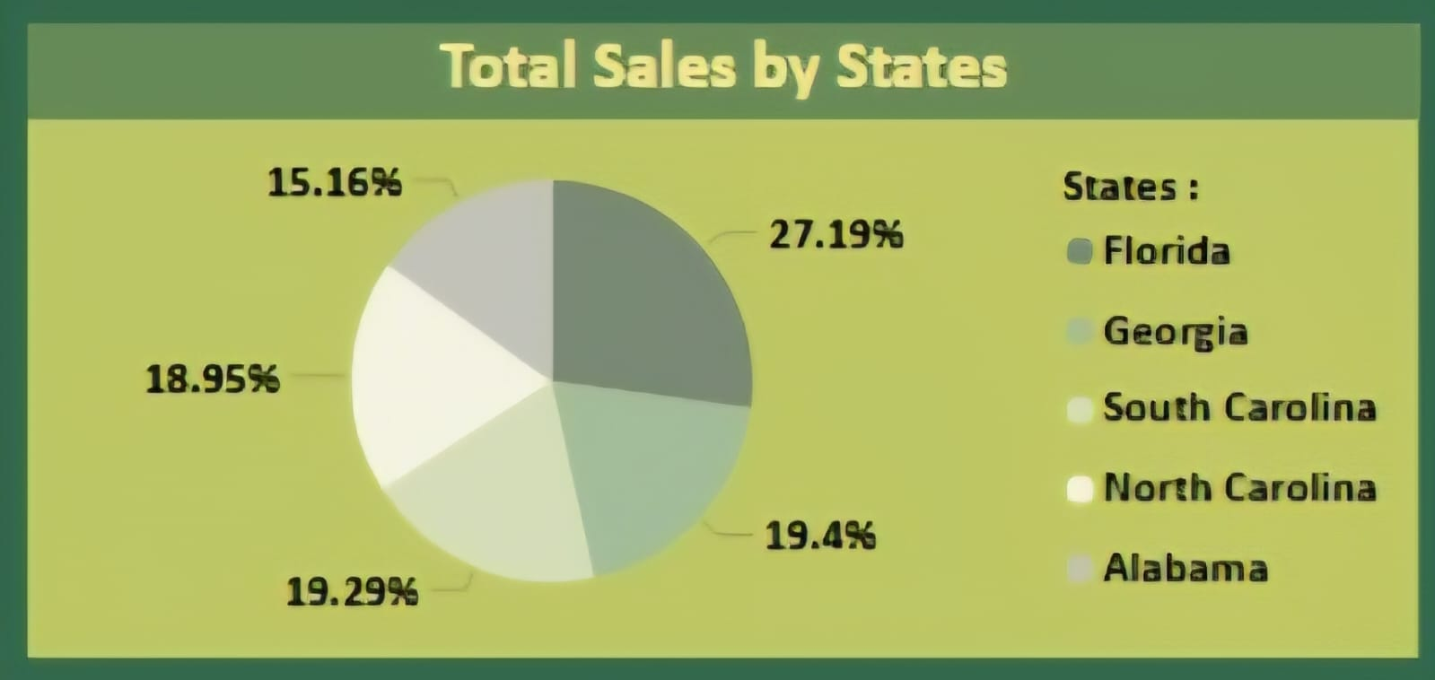
According to above chart we noticed that:
The leading state contributes 27.19% of total sales. The remaining four states range between 15.16% and 19.40%, showing a relatively balanced distribution.

5. Top Products by Sales
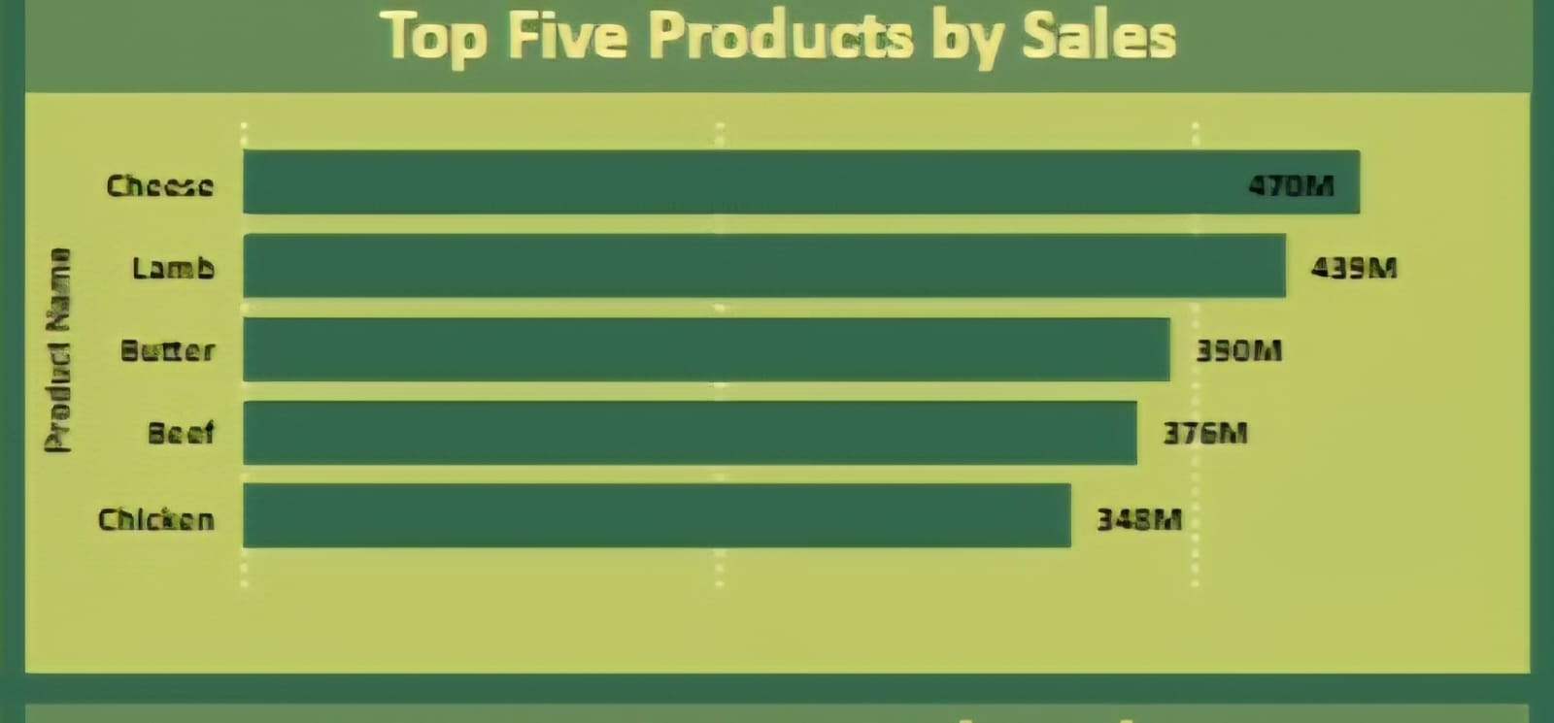
According to above chart we noticed that:
Cheese: 470M
• Lamb: 439M
• Butter: 390M
• Beef: 376M
• Chicken: 348M

6. Top Customers by Sales
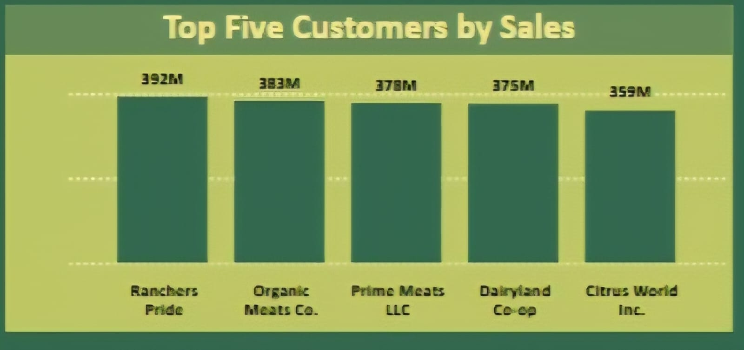
According to above chart we noticed that:
• Ranchers Pride: 392M
• Organic Meats Co.: 383M
• Prime Meats LLC: 378M
• Dairyland Co-op: 375M
• Citrus World Inc.: 359M

7. Product Portfolio Totals
• Total Sales: 6,516M
• Total Cost: 2,299M
• Total Profit: 4,217M
• Margin: 59.43%
• Production Quantity: 226,521K units
• Ordered Quantity: 215,177K units
• Damaged Quantity: 11,343K units (≈11.3M)
• Overall Defect Rate: 5.0%

8. Damage Reasons
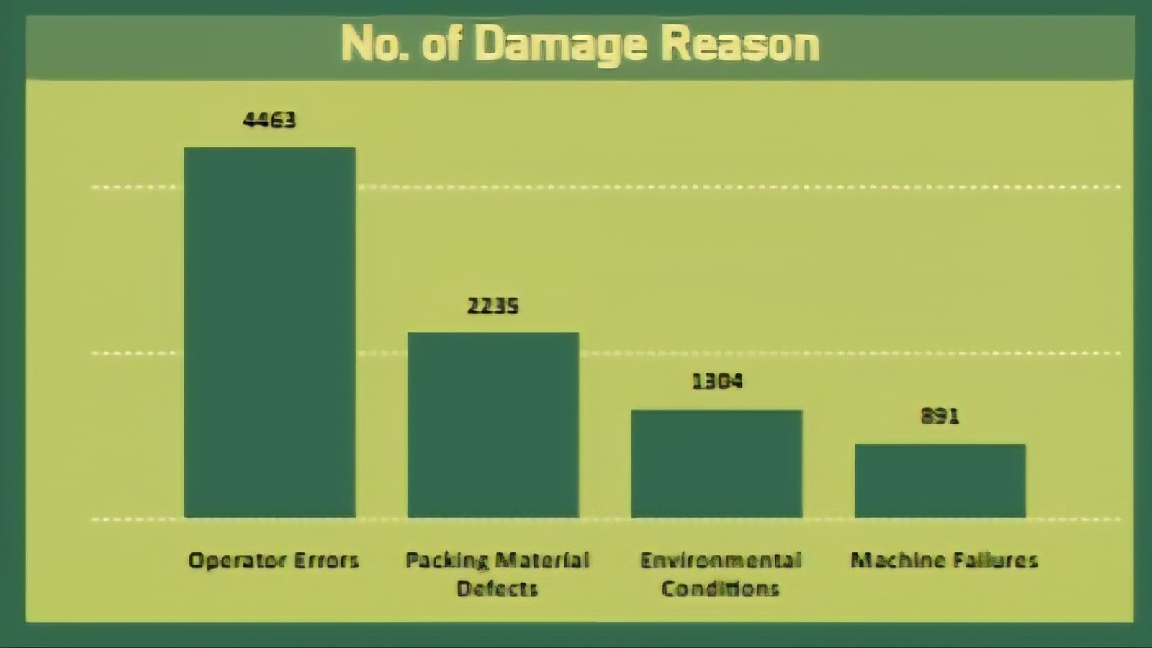
According to above chart we noticed that:
• Operator Errors: 4463
• Packing Material Defects: 2235
• Environmental Conditions: 1304
• Machine Failures: 891

9. Strategic Recommendations
• Reduce operator errors via targeted training.
• Improve packaging supplier quality.
• Expand presence in high-performing states.
• Boost production of profitable items like Cheese & Lamb.
• Reduce overproduction by improving forecasting models.
• Increase automation to lower defect rates.

10. Conclusion
Agri-Vision maintains strong financial and operational health. With updated and accurate figures, the company can focus on quality improvements, customer diversification, and production optimization.

Made by
1. Yomna Mohamed Mahrous Shalaby
2. Mohamed Hassan Mohamed Eisa
3. Mohamed Ahmed Abdel Hamid Mohamed
4. Ahmed Mahmoud Ahmed Ahmed
5. Hosam Gaafar El Bahariya
6. Asmaa Saeed Abdelaal Qasem

