Coding Challenge #1

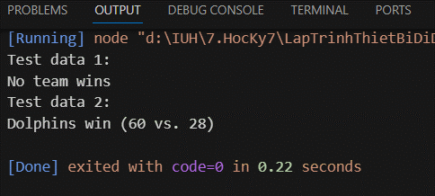

Coding Challenge #2

Coding Challenge #3

