Name: Yonas Tilahun Temesgen

Student Id | S1719046

Test Cases

Module: systems Programming

|  |  |  |  |  |
| --- | --- | --- | --- | --- |
| **Test case** | **Test case description** | **Expected results** | **Actual results** | **Pass/ Fail** |
| 1 | Display a simple text-based interactive menu | The menu should be displayed | As expected | pass |
| 2 | an exit option of the menu exits the client program | The client program should be terminated | As expected | pass |
| 3 | non-valid options prompt an error message | Please enter the right number | As expected | pass |
| 4 | Obtain student name and student ID from the server with server IP address | Display student name, ID, and server address | As expected | pass |
| 5 | Get 5 random numbers from the server | 5 random numbers displayed | As expected | Pass |
| 6 | Get “uname” information from the server | Information displayed | As expected | Pass |
| 7 | Obtain file names in the server current working directory | Display a list of files | As expected | Pass |
| 8 | Copy a file from a server | File copied | As expected | Pass |
| 8 | setup a signal handler | Show signal and terminate the program | As expected | Pass |

**Screenshots**

Test case 1

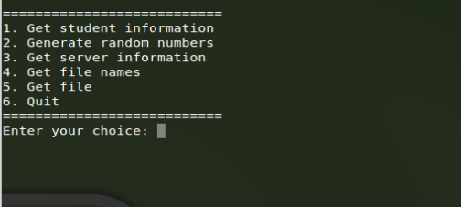

Test case 2

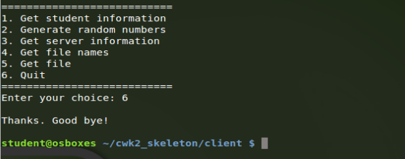

Test case 3

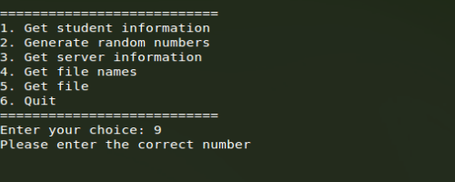

Test case 4

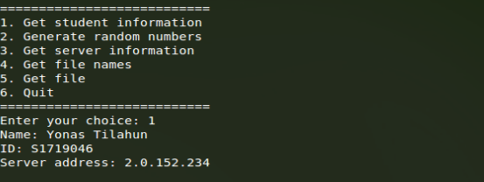

Test case 5

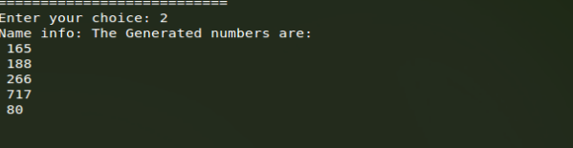

Test case 6

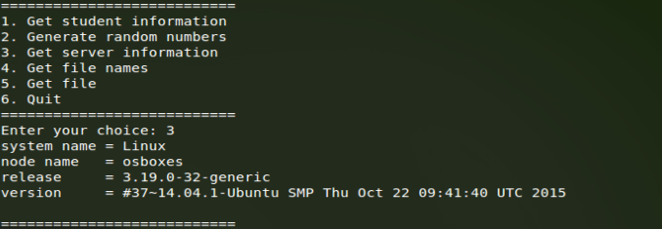

Test case 7

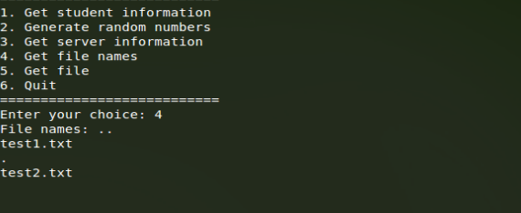

Test case 8

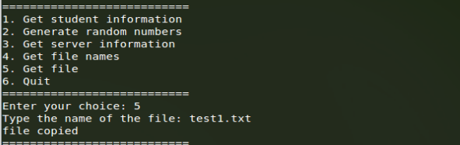

Test case 9

