Exercise :
The purpose of this exercise is to evaluate the divine proportion.
This number can be defined as the solution of equation:
Actually, its very value is:
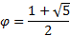
There are two ways to approximate this, using iterative processes:
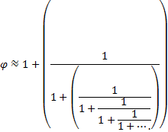

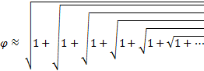

Write two procedures, each using one of the methods given before which computes the divine proportion to a certain accuracy.

