Exercise :
Gauss table is used statistics to assess the occurrence of a phenomenon characterized by a variable following a normal distribution.
Knowing that:
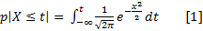

But, before going further, we can apply some transformation to this function to leave it simplified:
Knowing that:
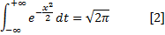
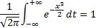
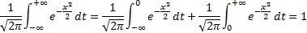
Being symmetric, we can state that:
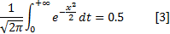
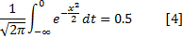
We can rewrite [1] as follows:
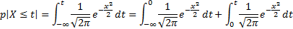
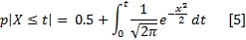

From now, we will refer to [5] for implementation.
Design a program that, when given a value t, returns p (X <= t). The result must be formatted to 5 decimals. Remember that when t is negative, we must return 1- p (X <= t).

