Exercise :
Integrate a function f between two points a and b is nothing but calculate the area under the curve of f between these two points.
This area can be approximated by a sum of trapezes of the same height p, being is a cutting of the interval [a, b]
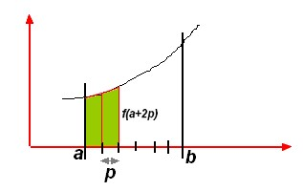.
Write a program which computes the integral of function f(x) = x^2, between two given bounds a and b.

