## 4.3 模型更新 Model Update

针对逃逸样本，我们采用两种抗攻击的方法来更新之前的模型，1.增加训练样本的个数,当训练样本达到一定的数量，就会避免数据过拟合，实现局部最优的情况；2.重新调整特征集也可以使检测率有所提高。

如果特征集已被攻击者利用，我们可通过改变特征集(dataset)，修改权值(feature)，或删除重要特征等操作，重新训练模型。如图2 所示，是模型训练后，按照特征重要性排序的前30个特征，我们可以看到count_font，count_javascript，size，count_obj，count_endobj这几个特征在分类中占有较多的权值，同时也是非常容易被攻击者利用，来对解析器和分类器进行逃逸，于是我们在训练时就删除了这几个特征，然后重新训练模型，预测结果如表7 所示。

For the evasion samples, we use two kinds of methods to update the above model. First, we increase the amount of training samples in order to avoid data overfitting and achieve the 局部最优 . The second one is to adjust the feature set to improve the detection rate.

If the feature sets are exploited by attackers, we can modify the datasets and weight of features, or delete important features in order to retrain this model. As shown in Figure 2, the top 30 features are sorted by the importance of features after model retraining. From Figure 2 we can find that features including count_font, count_javascript, size，count_obj，count_endobj account for more weights in the classification. They are really easy to be exploited by attackers to evade parser and classifier. Therefore, we delete these features and then retrain the model, outputting the prediction result shown in Figure 7.

图2 前30个重要特征分布图

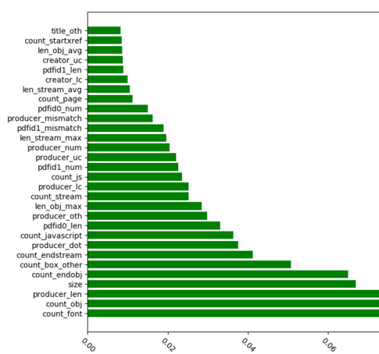

表7 是对前5个特征修改后的模型准确率。由表中可知，当分类器使用全部特征进行训练时，模型准确率高达99.82%。当我们将第一个重要的特征在训练的时候删去，检测率基本没有太大的波动，当减到count_endobj前5个特征时，模型准确率的波动可忽略不计。这也说明了我们的模型可以对抗一些基于特征的攻击，即使对手知道我们分类器使用的特征，模型同样可以达到99%的精度 。

Table 7 shows the detection accuracy of model after deleting the above 5 features. As shown in this table, when the classifier is trained by all features, the model accuracy rate is up to 99.82%. If we delete the first feature even the top five features, the rate is almost stable. That said, our model can confront the attacks based on these features. Despite attackers have the knowledge of features for training model, the accuracy rate can maintain at the level of 99%.

表7 对前5个特征依次删除后的模型准确率

Figure 7 Accuracy Rate of Model after deleting the top 5 features

|  |  |
| --- | --- |
| Feature delete train | 准确率 |
| None | 99.82% |
| count_font | 99.52% |
| count_javascript | 99.52% |
| Size | 99.64% |
| count_obj | 99.64% |
| count_endobj | 99.64% |

同时我们还通过对特征有效性（针对分类）进行研究来评估模型的鲁棒性。我们将模型的特征进行重要性排序，然后依次将最重要的特征逐一删减，并使用新特征集重新训练模型。图3是特征在不断自减时所对应的准确度曲线。从图中可知，当特征减少至100个时，重新训练后的模型准确率依然高达90%，这说明：

* 单个特征纵然权重高，当此类特征被删除时，模型准确度会下降，但降幅不大；
* “中等权重”特征的互相作用和叠加，可以使模型健壮，且抵消单个重要特征的缺失影响；
* “中等权重”特征能有效抵御通过改变特征数值的分类器逃逸攻击；

Besides, we assess the model robustness by the effectiveness of classification of features. First, we sequence the features based on their importance, and then delete the most important features one by one to create new feature sets which are used for model retraining. As shown in Figure 3, the curve represents the accuracy rate of model when features are deleted one by one. When the features are decreased to 100, the accuracy rate of retrained model still maintain at 90%. This demonstrates:

Despite the high weight of an individual feature, if it is deleted, accuracy rate of model declines moderately.

The interaction and superposition of “Medium Weight” can make the model robust, and reduce the effect causes by the deletion of individual important features.

“Medium Weight” can help to effectively prevent classification attack caused by modifying the value of feature.

图3 特征自减后的识别率（模型3）

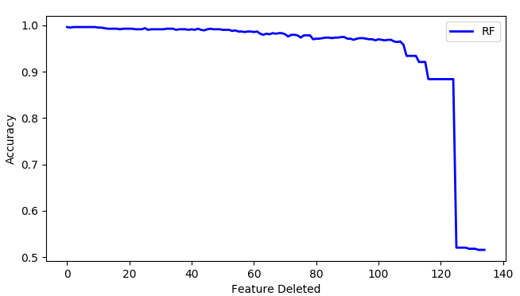

## 4.4 性能评估 Performance Assessment

为了评估模型的预测性能，我们把数据集随机分为训练（90％）和测试（10％）两部分，并采用10-Fold 交叉验证(Cross Validation)的方法来评估模型。 图4为ROC曲线图，由图可知，ROC曲线下的面积约为1，这表明模型具有良好的预测性能。~~模型准确度超过99％，与此同时误报率低于0.01％。~~

In order to assess the prediction performance of model, we divide dataset randomly into two categories including training (90%) and testing (10%) samples, and apply Cross Validation method to assess model. As shown in Figure 4, the area below ROC curve is about 1, which represent the good prediction performance of Model 3.

图4 ROC曲线图

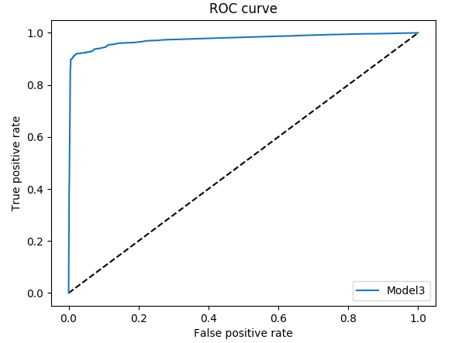

特征提取是最耗时的操作，因为它需要从硬盘加载所有的文件，并对文件进行逐个解析。于是我们将文件解析与训练分步处理，(特征集)作为中间结果保存。这样不仅可以减少CPU 内存占用，同时也可以使模型在训练时更为快速。对训练样本的解析（十万级别）共耗时约22分钟。表8 是模型使用不同算法之间的训练与预测时间对比，由表可知，使用随机森林算法的模型在此任务中不止有良好的准确率，并且预测时间也维持在秒级别。

Feature attraction is time-consuming because it needs to load all files and then parses them one by one. Therefore, we choose stepped processing: parsing files firstly, saving the feature sets extracted from the files, and then using feature sets for model training. In this way, CPU occupation can be reduced while training time of model can be much shorter. For example, it takes only about 22 minutes to parse the training samples at ten-thousand level. As shown in Figure 8, we compare training and prediction time as well as accuracy rate of Model 3 by applying different algorithm. The result shows that applying Random Forest Algorithm can achieve higher accuracy rate and short prediction time which maintain at second level.

表8 训练时间与预测时间

|  |  |  |  |
| --- | --- | --- | --- |
|  | 训练时间 | 预测时间 | 准确率 |
| Random Forest | 56s | 1s | 99% |
| Decision Tree | 4s | 1s | 97% |
| SVM | 58m 18s | 12s | 75% |