（0）（英文变中文）

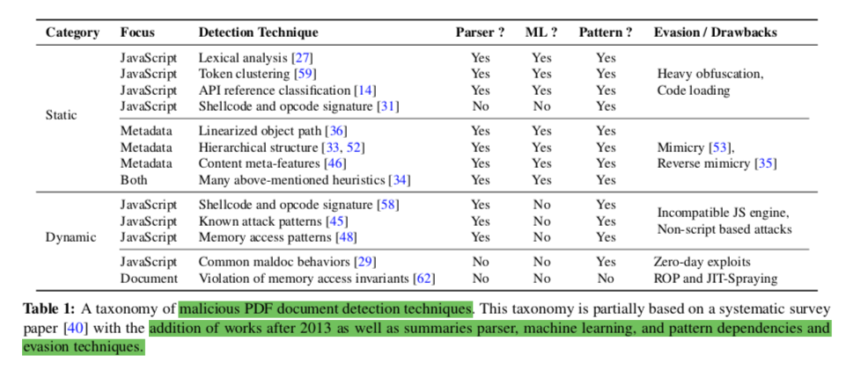

（1）

Lux0r [14] constructs two sets of API reference patterns found in benign and malicious documents, respectively, and uses this to classify maldocs.

[14]  IginoCorona, DavideMaiorca, DavideAriu, andGiorgioGiacinto. Lux0R: Detection of Malicious PDF-embedded JavaScript Code through Discriminant Analysis of API References. In *Proceedings of the Artificial Intelligent and Security Workshop (AISec)*, 2014.

Maiorca *et al*. [34] focuses on both JavaScript and metadata and fuses many of the above-mentioned heuristics into one procedure to improve evasion resiliency.

[34] DavideMaiorca, DavideAriu, IginoCorona, andGiorgioGiacinto. An Evasion Resilient Approach to the Detection of Malicious PDF Files. In *Proceedings of the International Conference on Information Systems Security and Privacy (ICISSP)*, 2016.

Reverse mimicry [35] attack, on the contrary, attempts to embed malicious content into a benign PDF by taking care to modify it as little as possible.

[35] DavideMaiorca,IginoCorona,andGiorgioGiacinto.Lookingat the Bag is not Enough to Find the Bomb: An Evasion of Structural Methods for Malicious PDF Files Detection. In *Proceedings of the 8th ACM Symposium on Information, Computer and Commu- nications Security (ASIACCS)*, Hangzhou, China, March 2013.

Mimicus [53] implements mimicry attacks and modifies existing maldocs to appear more like benign ones by adding empty structural and metadata items to the documents with no actual impact on rendering.

[53]  NedimSrndicandPavelLaskov.PracticalEvasionofaLearning- Based Classifier: A Case Study. In *Proceedings of the 35th IEEE Symposium on Security and Privacy (Oakland)*, San Jose, CA, May 2014.

[27]  Pavel Laskov and Nedim Srndic. Static Detection of Malicious JavaScript-Bearing PDF Documents. In *Proceedings of the Annual Computer Security Applications Conference (ACSAC)*, 2011.

[29]  DaipingLiu,HainingWang,andAngelosStavrou.DetectingMa- licious Javascript in PDF through Document Instrumentation. In *Proceedings of the 44th International Conference on Dependable Systems and Networks (DSN)*, Atlanta, GA, 2014.

[31] Xun Lu, Jianwei Zhuge, Ruoyu Wang, Yinzhi Cao, and Yan Chen. De-obfuscation and Detection of Malicious PDF Files with High Accuracy. In *Proceedings of the 46th Hawaii International Con- ference on System Sciences (HICSS)*, 2013.

[33] Davide Maiorca, Davide Ariu, Igino Corona, and Giorgio Giac- into. A Structural and Content-based Approach for a Precise and Robust Detection of Malicious PDF Files. In *Proceedings of the International Conference on Information Systems Security and Privacy (ICISSP)*, 2015.

[36] DavideMaiorca,GiorgioGiacinto,andIginoCorona.APattern Recognition System for Malicious PDF Files Detection. In *Pro- ceedings of the 8th International Conference on Machine Learning and Data Mining in Pattern Recognition (MLDM)*, 2012.

[40] NirNissim,AviadCohen,ChananGlezer,andYuvalElovici.De- tection of Malicious PDF Files and Directions for Enhancements: A State-of-the-art Survey. *Computers & Security*, October 2014.

[45] Florian Schmitt, Jan Gassen, and Elmar Gerhards-Padilla. PDF Scrutinizer: Detecting JavaScript-based Attacks in PDF Documents. In *Proceedings of the 10th Annual International Confer- ence on Privacy, Security and Trust (PST)*, 2012.

[46] Charles Smutz and Angelos Stavrou. Malicious PDF Detection using Metadata and Structural Features. In *Proceedings of the Annual Computer Security Applications Conference (ACSAC)*, 2012.

[48]  Kevin Z. Snow, Srinivas Krishnan, Fabian Monrose, and Niels Provos. ShellOS: Enabling Fast Detection and Forensic Analysis of Code Injection Attacks. In *Proceedings of the 20th USENIX Security Symposium (Security)*, San Francisco, CA, August 2011.

[52]  NedimSrndicandPavelLaskov.DetectionofMaliciousPDFFiles Based on Hierarchical Document Structure. In *Proceedings of the 20th Annual Network and Distributed System Security Symposium (NDSS)*, San Diego, CA, February 2013.（参考基准）

[58] Zacharias Tzermias, Giorgos Sykiotakis, Michalis Polychronakis, and Evangelos P. Markatos. Combining Static and Dynamic Anal- ysis for the Detection of Malicious Documents. In *Proceedings of the 4th European Workshop on System Security (EUROSEC)*, 2011.

[59] Cristina Vatamanu, Dragos ̧ GavriluT ̧, and Ra ̆zvan Benchea. A Practical Approach on Clustering Malicious PDF Documents. *Journal in Computer Virology*, June 2012.

[62] Carsten Willems, Felix C. Freiling, and Thorsten Holz. Using Memory Management to Detect and Extract Illegitimate Code for Malware Analysis. In *Proceedings of the Annual Computer Security Applications Conference (ACSAC)*, 2012.