Malicious Document Detection and Robust ML Model Construction

Abstract - With the rapid development of information technology, it has become increasingly more important to perform detection on malicious documents (e.g., PDFs). However, due to the diversity of document structures, attackers have gradually acquired a larger attack vector. In the research reported in this paper, we aim to construct a robust artificial intelligence (AI) document classifier both for industry and academia. Approximately 200,000 samples have been collected, and the AI model has been trained and optimized. The experimental results show that the accuracy of the model is as high as 99.82%, while the false-positive rate is as low as only 0.01%. Moreover, through the study of adversarial machine learning, the model has a certain capability to resist attacks and enjoys good robustness. Finally, we demonstrate that our model can be widely deployed in typical scenarios, such as in security products or mail servers.

Key Words: AI Security; Machine Learning; Maldoc Detection; Adversarial ML

Introduction
Cyber attackers are turning to document-based malware as suggested by many anti-virus (AV) vendors. Users are increasingly being warned more generally of the danger of executable files by browsers, email agents, or AV products, but documents such as PDFs are treated with much less caution and scrutiny because of the impression that they are static files and can do little harm.
However, over time, PDF specifications have changed. The added scripting capability makes it possible for documents to work in almost the same way as executable files, including their ability to connect to the Internet, run processes, and interact with other files/programs. The growth of content complexity gives attackers more weapons with which to launch powerful attacks and more flexibility to hide malicious payloads (e.g., encrypted files, files hidden in images, fonts, or Flash content) and evade detection.
A maldoc usually exploits one or more vulnerabilities in its interpreter to launch an attack. Unfortunately, given the increasing complexity of document readers and the wide library of component dependencies, attackers are presented with a large attack surface. New vulnerabilities continue to be found, with 137 published CVEs in 2015 and 227 in 2016 for Adobe Acrobat Reader (AAR) alone. The popularity of AAR and its large attack surface make it among the top targets for attackers. The collected malware samples show that many Adobe components have been exploited, including element parsers and decoders, font managers, and the JavaScript engine.
The continued exploitation of AAR along with the ubiquity of the PDF format makes maldoc detection a pressing problem, and many solutions have been proposed in recent years to detect documents bearing malicious payloads. These techniques can be classified into two broad categories: static and dynamic analysis.
Static analysis, or signature-based detection, parses the document and searches for indications of malicious content, such as shellcode or similarity to known malware samples. Dynamic analysis, or execution-based detection, runs the partial or entire document and traces malicious behaviors, such as vulnerable application programming interface (API) calls or return-oriented programming (ROP).
In the first half of this paper, we utilize machine learning (ML) techniques on document-specific attributes to identify embedded malware. Our approach addresses some of the shortcomings of existing techniques through the use of a broadly applicable mechanism to classify and characterize documents.
As part of our analysis, we show that while the use of documents as an exploitation vector can be an enabling mechanism for the attacker, it also provides additional detection opportunities. All of the data closely associated with malicious activities can be used to aid detection, regardless of whether the data utilized for detection are inherently malicious or not. The underlying premise and intuition of our study are that malicious documents do have similarities to other malicious documents; they also have dissimilarities to benign documents, regardless of the specific vulnerability exploited or the specific malware embedded in the document. We posit that features based on document structure and metadata are adequate for reliable document classification given that appropriate statistical methods are applied to these features. This ensemble classifier is also able to classify previously unseen variants.
Clearly, deployment of learning methods in any security-critical context requires that they can withstand potential attacks. The security of ML methods has been previously discussed from conceptual, methodical, and practical viewpoints. Typically, the security analysis of proposed learning-based techniques is carried out informally and is occasionally supported by experimental evaluation. From the practical perspective, the success of attacks against learning algorithms crucially depends on the amount of knowledge available to an attacker. Most of the previously reported successful attacks assume that the attacker has full knowledge of the learned model.
Still, it remains largely unclear what an attacker may learn about a learning-based method deployed “in the wild” and how this information can be exploited. To investigate this problem, we present the results of a case study we performed on a real learning-based model. For any submitted PDF file, the model provides a probabilistic estimate of its maliciousness. Our study addresses the case when an attacker attempts to evade detection by modifying the submitted PDF file so that its malicious functionality remains intact but the probabilistic score returned by the model is decreased.
To systematically explore the attacker’s options, we define an orthogonal set of evasion strategies reflecting various degrees of available knowledge. The general idea of our evasion technique is based on insertion of dummy content into PDF files that is ignored by PDF renderers but affects the computation of features. Once we can influence a subset of features, we develop algorithms for constructing attack instances. In the experiments, we evaluate the effectiveness of our strategies against our model.
In summary, this paper makes the following contributions:
- A new document dataset with 173,036 malicious files and 28,332 benign files.
- Identification of 133 useful and comprehensive static features for detection.
- A high accuracy rate of 99.82%, with a false positive rate of less than 0.01% for the learned model.
- Prediction time for single file maintains at a millisecond level.
- Development of an adversarial examples detection framework including adversarial example generation, robust model generation, and evasion detection.
- Presentation of a general model for practical assessment of the security of learning-based detection techniques; this model enables systematic exploration of various kinds of information leaks exploitable by an attacker and is applicable to systems that have a modifiable subset of features.
- We provide an open-source software framework for all experiments carried out in our study for independent verification and extension of our results.

Related Work
Existing malicious document detection methods can be classified broadly into two categories: dynamic and static analysis. In dynamic analysis, malicious documents are executed and examined in a specially created environment in order to capture the samples’ malicious behavior; in static analysis, the detection is carried out without code execution but with static scanning and examination for the header, binary-level N-gram of files, and others. In general, the advantages of static analysis are ease of deployment and good speed (but relatively low accuracy). Compared to static analysis, dynamic analysis, although suffering from low speed and intense resource consumption, exhibits the highest accuracy. Nowadays, both techniques have already had a large number of success stories. More advanced solutions along this line usually involve the hybrids of dynamic and static detection methods (see Maiorca et al. [9] for details). A summary of existing methods is presented in Table1.

Table 1. Taxonomy of malicious PDF document techniques partially based on platform diversity [8] with the addition of works after 2016 as well as summaries parsers, ML, and pattern dependencies.
Category | Focus | Detection | Work | Year | External Parser? | ML? | Discrepancy?
Static | JavaScript | Lexical analysis [5] | PJScan | 2011 | Y | Y | Y
Static | JavaScript | Token clustering [12] | Vatamanu et al. | 2012 | Y | Y | Y
Static | JavaScript | API reference classification [7] | Lux0r | 2014 | Y | Y | Y
Static | JavaScript | Shellcode and Opcode Sig [13] | MPScan | 2013 | N | N | N
Static | Metadata | Linearized object path [11] | PDF Malware Slayer | 2012 | Y | Y | Y
Static | Metadata | Hierarchical structure [1] | Srndic et al. | 2013 | Y | Y | Y
Static | Metadata | Content meta-features [24] | PDFrate | 2012 | Y | Y | Y
Static | Both | Many heuristics combined [8] | Maiorca et al. | 2015 | Y | Y | Y
Static | Both | Many heuristics combined [9] | Maiorca et al. | 2016 | Y | Y | Y
Dynamic | JavaScript | Shellcode and Opcode Sig [15] | MDScan | 2011 | Y | N | N
Dynamic | JavaScript | Known attack patterns [16] | PDF Scrutinizer | 2012 | Y | N | N
Dynamic | JavaScript | Memory access patterns [17] | ShellOS | 2011 | Y | N | Y
Dynamic | JavaScript | Common Maldoc behaviors [18] | Liu et al. | 2014 | N | N | Y
Dynamic | JavaScript | Platform-independent tap- point identification [20] | Tap point | 2016 | N | N | Y
Dynamic | Memory | Violation of invariants [19] | CWXDetector | 2012 | N | N | N
 | OS | Platform diversity [21] | PlatPal | 2017 | Y | N | Y

From Table 1, we can conclude that the main focus of static analysis is JavaScript or file metadata. Typical detection techniques include Shellcode and Opcode Sig–based MPScan [13], and structure- and content-based classification [9]. However, dynamic analysis mainly focuses on extracting the JavaScript Snippet from the file and running them directly to enable malicious behavior detection. Typical work in this line includes behavior-based analysis [20] and platform diversity-based analysis [21].

We can also see from Table1 that all but three methods use either open-source or home-grown parsers and assume their capability. However, Carmony et al. [20] shows that these parsers are typically incomplete and make oversimplified assumptions in regard to where JavaScript can be embedded. This leads to one of the most important questions in this research: Is the external parser robust or not? This is because the design and implementation of these kinds of external parsers are usually simple without being designed to be secured; in this case, only a little effort is needed for the successful evasion of malicious malware. This kind of attack is called “parser-confusion attacks” by Carmony et al. [20].
An important conclusion can be drawn from Table 1, namely that ML, in general, is fit for static rather than dynamic analysis. We are not aware of a paper on dynamic analysis that considers ML, while ML has been the “default standard” in nearly all static analysis papers. Typical ML work here includes PDFRATE [24] and PDF Malware Slayer [11]. Nearly all of the aforementioned works claim that their classifiers can attain high accuracy in resource-intensive environments, but seldom mention the security of their deployed ML models, much less the need for a comprehensive study of adversarial ML. This raises serious doubts about the effectiveness of classifiers based on superficial features in the presence of adversaries. An attack exploiting this vulnerability is mentioned in Xu et al. [14], one that can automatically produce evasive maldoc variants. Here, for each iteration and for every sample, operations like addition, deletion, and replace with respect to the PDF structure tree is performed via genetic-programming-like operations. During the entire process, the malicious behavior of the sample should remain exactly the same, but the ability to confuse and evade the classifier is stronger at each iteration. This kind of attack is called a “classifier evasion attack” by Xu et al. [14].
An implicit assumption is that structural/behavioral discrepancies exist between benign and malicious documents and such discrepancies can be observed. Since the document must follow a public format specification, commonalities (structural or behavioral) are expected in benign documents. If a document deviates largely from the specification or the common patterns of benign samples, it is more likely to be a malicious document. In other words, a hyper-plane should always be found and posited in a high-dimensional feature space to clearly separate the malicious and benign samples. However, this assumption does not hold if we can answer the following research questions:
- Can we evade the classifier by adding, deleting, or replacing content of the malicious PDF files while still keeping the malicious behaviors of files?
- Can we still evade the classifier by gradually adding malicious content to the benign PDF?
The work of Srndic et al. [4], starting with malicious files, has answered the first question, which refers to what is called a “mimicry attack.” Maiorca et al. [10], starting with benign files, has answered the second question, which refers to what is called a “reverse mimicry attack.” Both works show how a malicious document can systematically evade detection.

In summary, for attacking an external parser, the current technique is called a “parser-confusion attack.” For attacking ML models, the current technique is called an “automatic classifier evasion attack.” For the assumed detectable discrepancy, the existing attack is called “Mimicry and Reverse Mimicry.”

There is no doubt that the above-mentioned attacks have raised significant challenges to the security of ML models, extending to the entire framework. Therefore, in this paper, we propose not only some approaches that can achieve high accuracy, but also a truly secure, robust, and working model under our effective defense strategies.

ML Model Design and Implementation
Here, we present a ML-based framework for detecting malicious documents. The dataset used in our experiment contains 200,000 samples, including all formats of PDF files. We mainly parse the content and structure of these files and select features with good classification performance, and then classify the extracted features by using a ML method. The experimental results reveal that, based on the extracted features and the classification method used, the accuracy rate of our model is over 99%, with a false positive rate of less than 0.01%.

3.1 Dataset
The PDF dataset, a total of 201,368 samples, is divided into two categories: 28,332 benign samples and 173,036 malicious samples. Among these samples, 156,035 are downloaded from VirusShare, with a size of 6.8 GB, 9,000 benign samples from the Contagio dataset, and 2,026 from Sogou and Baidu (two Chinese search engines).
We use VirusShare as the source to generate 7,000 adversarial samples that are used in testing in the experiment.
In addition, we obtain the open-source dataset from mimicus, which is used for assessing PDFRATE [4]. This dataset contains 20,000 balanced samples, with 5,000 benign and 5,000 malicious subsamples of the Contagio dataset, 5,000 benign samples obtained from Google, as well as 5,000 malicious samples downloaded from VirusTotal.

3.2 Feature Extraction
Effective methods for extracting features are based on structure, metadata, content, and JavaScript (JS). The experimental results reveal that structure-based features perform well in classification. We calculate the average value of each feature in the dataset and find that the average values of some features in benign and malicious samples are different.
Features such as count_font and count_box: There are several objects like font and box contained in the benign samples as a PDF file mainly uses these objects for description. However, malicious files do not aim at describing information; instead, they run the malicious code embedded in the file to launch the attack.
Features such as count_page_obj and count_obj: Generally, there are many more obj in benign files than in malicious files. When calculating the number of obj in the same page, those in a malicious file are twice as many as in a benign file. Thus, if the number of obj in the same page increases sharply, the file is likely to be malicious.
Features such as count_endobj and count_endstream: In benign files, endobj refers to the end of an object. Yet, a maldoc seldom contains endobj and endstream, for which it aims at confusing the parser to make it fail to obtain the entire object when parsing the malicious file, or fail to parse the malicious documents that can then evade detection successfully. This is the common evasion against the parser.
Features such as count_js: The main tactic of the malicious document is to embed JS code in the file to execute malicious behaviors. In this way, there are many more JS codes contained in a maldoc than in a benign file.
Features such as count_acroform_obs: AcroForm is introduced in PDF Specification 1.2, which is to collect information from users via interaction. The form can display, capture, and edit data. Moreover, it can conduct dynamic interactions between the interactive and editable forms that contain characteristics like dynamic calculation and verification and the forms generated by servers and filled in by machines. With these characteristics, the form is vulnerable to obscuration and encryption by the attacker. As a result, the value of AcroForm in a malicious sample is usually double that of a benign sample.

Table 2. Average value comparison of features in benign and malicious files.
Feature | Benign file | Malware file
count_font | 14.64 | 0.55
count_acroform_obj | 700 | 1400
count_box_a4 | 12001 | 200
count_box_legal | 395040 | 0
count_box_letter | 7291529 | 866773
count_box_other | 32.18 | 1.74
count_box_overlap | 1000 | 0
count_endobj | 95.80 | 9.68
count_endstream | 30.43 | 3.78
count_page_obj | 8001 | 16003
count_image_large | 110711 | 400
count_image_med | 465247 | 6401
count_image_small | 915892 | 12002
count_image_total | 36.56 | 0.30
count_image_xlarge | 300 | 0
count_image_xsmall | 21.64 | 0.11
count_js | 0.71 | 1.01
count_obj | 100.96 | 12.01
count_objstm | 1.57 | 0.15

Classification Algorithm
First, we classify the collected files by extracted features, and use these files as the training dataset. The random forest (RF) algorithm used performs well during classification, with high effectiveness and a low false positive rate. Moreover, the algorithm is easy to use and can classify data rapidly. The output of the RF classification method is a result ensemble of a multitude of decision trees that is constructed from a randomly selected subset of training data. That said, RF is an ensemble classifier applying the technique of bagging training data. Each node in a decision tree is constructed based on a randomly selected subset of features, as well as the best split at each node, which is determined by the training data for that node. Finally, the classification result is determined by the votes of each tree.
One of the important components of an artificial intelligence (AI) engine is the algorithm. We select and compare several algorithms with good performance, including KNN, NNET, RF, and SVM. After multiple training and classification experiments, we have found that the RF algorithm demonstrates high detection accuracy, low false-positive rate and latency, good robustness, and good resolvability. Therefore, we choose RF as our default algorithm. After more than 100 experiments, the accuracy rate of RF tends to be a stable value even if the features change.

Table 3. Comparison of algorithm accuracy rate.
SVM | NNET | KNN | RF
75.23% | 82.41% | 97.12% | 99.64%

3.4 Model Construction

The proposed ML-based method of detecting a malicious document includes the following steps, as shown in Figure 1:
1. Feature Extraction. This is a basic pre-processing step, which parses the structure, content, and metadata in PDF files and then conducts vector computation on these objects, finally extracting them as a two-dimensional feature set. These features can be trained and classified in the ML-based model.
2. Learning and Classification. We select 80% of the data randomly for training and then save the trained model. Later, we use 20% of the files for prediction and classification to calculate information such as the accuracy rate and false positive rate.
Figure 1. Basic ML framework.
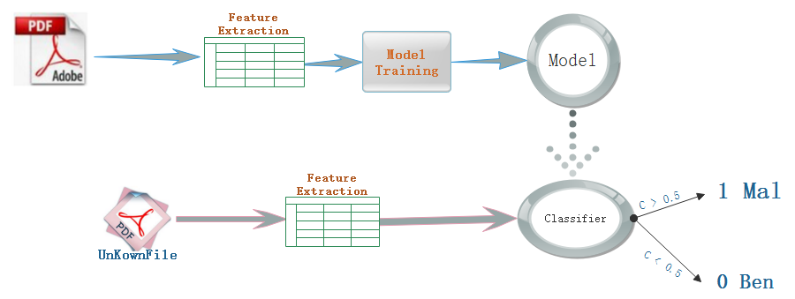
During the experiment, we update the model for four times. The initial one (Model 1) uses peepdf as the parser to extract features. After computation and quantization, these features can be used for ML-based training and prediction. We extract 133 features that contain static attributes of structure (count_font, size, count_startxref), content (title_oth, subject_lc), and metadata (producer_oth, producer_len). We classify these extracted features via RF as it has higher accuracy. However, problems do exist, namely only half the files can be parsed if we use peepdf. Therefore, we reselect another parser, mimicus [2], which helps handle the parsing failure caused by structural defects or obscuration. By using mimicus, all the data can be parsed and features can be extracted.
To train Model 2, we initially use a balanced dataset for training and prediction. The balanced dataset include 20,000 malicious and 20,000 benign samples selected randomly from the entire dataset. In addition, we use mimicus to extract features from the beginning of training of Model 2 and finally extract 135 features in total. The main algorithm used is RF. After parameter tuning, the detection rate of Model 2 throughout multiple tests increases and remains at 99.99%, with a decreased false positive rate of 0.012%.
We use a new sample dataset at a 10,000 level to retrain the model, with a training time of only 56 s by utilizing a quad-core CPU with 4 GB of RAM. We then test Model 2 using 20,000 samples, and the accuracy rate still remains at 99.81% with a false-positive rate of 0.086%. From these experiments, we have learned that when the dataset is increased to a 10,000 level, the accuracy drops by 0.18%, because the costs of file classification and code embedding increase along with the increase in dataset size. As a result, the robustness and security of the model should be considered; we discuss this issue in the next section.

Adversarial Analysis
ML classifiers are increasingly used in detecting malicious data. However, if the models are deployed online, attackers may evade them by using data manipulation. Such attacks have been studied in previous works, in which it was assumed that attackers have full knowledge of the deployed classifier. In practice, this assumption is rarely made, especially for systems deployed online. Knowledge of the deployed classifier can be obtained from all kinds of sources. In our experiment, we use a real, deployed model (our Model 2) as a test case to verify the effectiveness of classifier evasion.
We build a system for practical evasion strategies and adapt several evasion algorithms for practical application scenarios. Our experiment results reveal that the detection accuracy of Model 2 decreases sharply even if it is exposed to simple attacks. In addition, we studied some potential prevention strategies against classifier evasion. The experimental results show that two techniques can improve the robustness of a model when facing such attacks: (1) increasing the size of the dataset used for model training, and (2) applying different feature sets to retrain the model. In the Discussion, we analyze some potential techniques to strengthen the robustness of learning-based systems against adversarial data manipulation.

4.1 Sample Evasion
Here, we discuss adversarial learning in particular scenarios. Specifically, we suppose that an attacker has obtained some information of a known model, such as extracted features and the algorithm applied by the model. If the attacker knows more about the model, the evasion sample designed by the attacker can evade the model more easily. We mainly refer to the methods proposed by Smdic [4] to conduct evasion attacks against the learning-based model. The four scenarios are the following:
- F (feature): In this scenario, only feature sets can be used by the adversary.
- FT (feature and training): In this scenario, the adversary can utilize the knowledge of a target classifier training dataset, except for the known features.
- FC (feature and classifier): The adversary knows feature sets and some details about the classifier, such as its type, parameters, or the specific implementation.
- FTC (all of the above): The adversary can evade the target classifier if the adversary knows all the information about the classifier components. In this case, the adversary can fully reproduce an online classifier, submitting the attack results only when a sufficiently good evading sample has been found.

We use 2,000 malicious samples, which are highly scored by the classifier, as the original samples to generate variants that can evade PDFrate and still remain malicious. We then use these variants to attack Model 2. As shown in Table 4, this attack has a great effect on Model 2; in the FC scenario, the detection accuracy rate of Model 2 is only 2.92%, which means that more than 90% of malicious documents can evade the classifier successfully after variation.
Based on the above scenarios, we construct another model, Model 3, by modifying features and sample sets, with an increased training dataset size of 200,000 samples. This updated training set includes some new variants, such as some variants generated by mimicry attack and reverse mimicry attack methodologies. As shown in Table 4, when Model 3 is attacked by the tactics used in the above four scenarios, its detection accuracy rate is higher than that of Model 2, as shown in Table 4.

Table 4. Different attack scenarios and accuracies.
Scenario | Evasive variants | Model 2 accuracy | Model 3 accuracy
F | 2157 | 71.18% | 96.71%
FC | 240 | 2.92% | 12.50%
FT | 4196 | 84.25% | 96.76%
FTC | 600 | 15.83% | 18.71%

4.2 Case Study
For the variation, we select some typical samples to conduct a case study. For example, we select a file with CVE ID (CVE-2013-0641) that can execute any code remotely by exploiting the vulnerability. We apply the methodologies in the above four scenarios to vary the selected samples and then check the VT reports of these samples and their variants. The VT reports (see Table 5) show that original samples can be detected by 61 detection engines, within which 33 engines can identify the malicious information. Yet after variation, only 60 engines can detect these variants and 22 engines are able to identify their malicious information.

Table 5. VT detection results of generated new malware.
File_HASH | Source | F | FC | FT | FTC
00ba5c43b1cec186c634c24ac21982d3  cve-2013-0641 | 33/61 | 22/60 | 23/60 | 22/60 | 22/60

As most PDF detection engines are based on structure and content, once we modify the structure and content, such as adding some objects of benign samples, or modify the file size, the malicious file can evade the classifier. We compare the files before and after variation. As shown in Table 6, variation includes modifying the size and content of metadata, adding the number of count_javascript and some content of keywords that are objects in a benign sample, and upgrading the file version from 4.0 to 7.0. After variation, the sample remains malicious, while 10 classifiers have already failed to detect the malicious code in this file.

Table 6. Comparison of generated new malware features.
Feature | Source | Evasive
author_lc | 0 | 6
author_len | 0 | 14
author_uc | 0 | 6
count_javascript | 1 | 6
createdate_ts | -1 | 650616173
createdate_tz | -1 | 10020
moddate_ts | -1 | 482083775
keywords_lc | 0 | 4
keywords_len | 0 | 7
producer_lc | 0 | 8
producer_len | 0 | 19
version | 4 | 7

4.3 Model Update
For the evasion samples, we use two methods to update the model. The first method increases the number of training samples in order to avoid data overfitting and achieve the local optimum. The second adjusts the feature set to improve the detection rate.
If the feature sets are exploited by attackers, we can modify the datasets by, e.g., modifying the weight of features or by deleting important features in order to retrain the model. In Figure 2, the top 30 features are sorted by the importance of features after Model 3 is trained. We can see from the figure that features like count_font, count_javascript, size, count_obj, and count_endobj account for more weight in the classification. These features are really easily exploited by attackers to evade both parser and classifier. Therefore, we delete these features and then retrain Model 3, outputting the prediction result shown in Figure 7.

Figure 2. Top 30 features distribution.
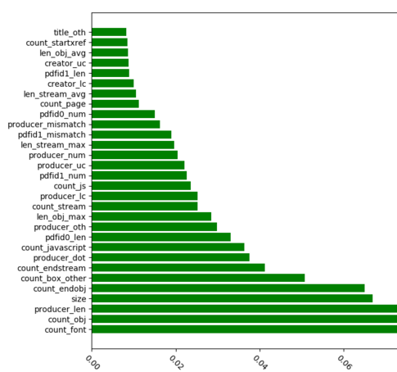

Table 7 shows the detection accuracy of Model 3 after deleting the above-mentioned five features. As shown in the table, when the classifier is trained by all features, the accuracy rate of the model reaches 99.82%. If we delete the first feature, or even the top five features, the rate is almost stable. That said, our model can confront the attacks based on these features. Despite attackers having the knowledge of features for the training model, the accuracy rate can maintain a level of 99%.
Figure 7. Accuracy rate of model after deleting the top five features.
Features deleted from training set | Accuracy rate
none | 99.82%
count_font | 99.52%
count_javascript | 99.52%
Size | 99.64%
count_obj | 99.64%
count_endobj | 99.64%

In addition, we assess the model robustness by measuring the effectiveness of the classification of features. First, we sequence the features based on their importance, and then delete the most important features one by one to create new feature sets to use for model retraining. In Figure 3, the curve represents the accuracy rate of the model when features are deleted one by one. When the features are decreased to 100, the accuracy rate of the retrained model still remains at 90%. This demonstrates the following:
- Despite the high weight of an individual feature, if it is deleted, the accuracy rate of the model decreases moderately.
- The interaction and superposition of “medium weight” can make the model robust and reduce the effect caused by the deletion of individual important features.
“Medium weight” can help effectively prevent classification evasion caused by modifying the value of features.
Figure 3. Detection accuracy rate when features are deleted.
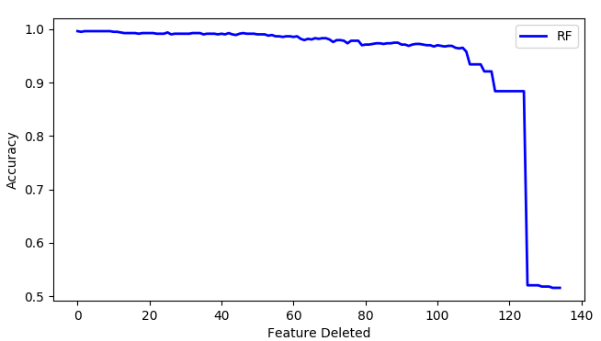

4.4 Performance Assessment
In order to assess the prediction performance of the model, we divide the dataset randomly into two categories, training (90%) and testing (10%) samples, and apply a cross- validation method to assess the model’s performance. As shown in Figure 4, the area below the ROC curve is approximately 1, which represents the good prediction performance of Model 3.
Figure 4. ROC curve.
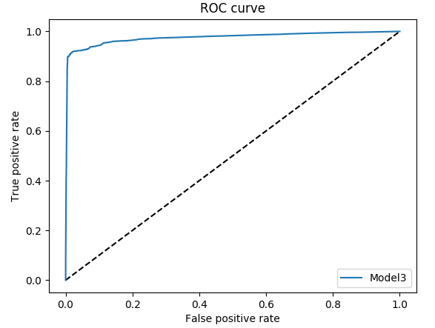
Feature extraction is time consuming because it must load all files from disk and then parse them one by one. Therefore, we choose stepped processing: parsing files first, saving the feature sets extracted from the files, and then using these feature sets for model training. In this way, CPU overhead can be reduced while the training time of model can be much shorter. For example, it takes only approximately 22 min to parse the training samples at a 10,000 level. As shown by the results plotted in Figure 8, we compare the training and prediction times, as well as accuracy rate, of Model 3 by applying different algorithms. The results show that applying the RF algorithm can achieve a higher accuracy rate and a short prediction time of 1 s.
Table 8. Training and prediction time comparison.
 | Training time | Prediction time | Accuracy rate
RF | 56 s | 1 s | 99%
DT | 4 s | 1 s | 97%
SVM | 58 m, 18 s | 12 s | 75%

Application: Bluedon AI Firewall

According to the design principle of modulation, we regard the AI-based maldoc detector as an independent detection module that can be easily integrated in security products, such as a next-generation firewall. An interesting question is: How Bluedon manages to apply AI technology seamlessly to a 30-year-old security product?

In the current development of network and gateway security products, the capability of performing malicious file scanning effectively and efficiently at layer7 (the network application layer) is the international standard. The industry has strict demands on this product feature; that is, a good detection module should include (1) millisecond latency for single-file detection, and (2) 99% accuracy while maintaining a FP rate of less than 0.01%.

The reason behind the demand for low latency is obvious: Since a security module is sequentially placed into a working pipeline, high latency will lead to an increased packet drop rate and occasionally data loss. This is strictly forbidden for security devices. In the past few years, with the rapid development of malware, the former industry best practice—the pattern -matching engine—has gradually been used less and less in mainstream security applications. There are two main reasons for this: (1) In order to meet the requirement of high detection accuracy, a large number of security analysts are needed for pattern writing, which is a manual process that has not scaled at all; and (2) considering the fast-growing size of core databases, the time for core operation–pattern matching grows exponentially. These conditions have inspired us to discover a better engine rooted in AI.

By 2018, we managed to integrate our AI maldoc detector into a firewall, in the hope of replacing the old engine. Although both the old and new engines are static-analysis-based engines, the improvement of shifting from the old to the new AI engine has been tremendous. First, the AI engine does not need to be updated frequently because it can detect previously unencountered malware effectively for years. According to our experiment results, the average update frequency for our AI engine is half a year, which is longer if compared to the 2-week period of the old pattern-matching engine. Moreover, the AI-based engine enjoys low resource consumption in execution. According to our study, during the phase of model prediction, the AI engine can only consume as much as a one-third of CPU and 50% of memory. The CPU portion of consumption is mainly due to computations, such as feature extraction and confidence-score computation. The memory portion of consumption is mostly due to the fact that an AI-based model must be sited entirely in main memory for prediction.

In the context of a firewall, different actions are triggered based on the probability and reasons that output is generated from the AI maldoc detection module. For instance, if the output probability is greater than a certain threshold of 0.9, this indicates that the AI module has high confidence that this document is malicious. Then, a blocking operation is triggered, the connection is dropped, and an alert is raised for further investigation. If the output probability is less than a certain threshold of 0.1, this indicates that the AI module has high confidence that this document is benign, and then the connection is allowed and monitored as normal by default.

The truly interesting part arises when the output probability is in the range 0.1–0.9. When this happens, we by default upload the samples to our Threat Intelligence (TI) Cloud where multiple dynamic analyses will be performed by Sandbox, Threat Intelligence, and Security Teams. According to our heuristics in a typical usage scenario, 95% of the files are processed inline while approximately 5% of the files are uploaded. Dynamic analysis from our TI cloud plays a great complementary role in the static analysis method inline. By combining the two engines, we can now completely provide end users with a more advanced, AI-enabled security solution. We have made our cloud service a subscription service and freely open to the research community.

Conclusions
In this paper, we introduce the design and implementation of a PDF file classifier based on machine learning (ML). Our experimental results reveal that the classifier can achieve a detection accuracy of greater than 99% and has a false-positive rate of less than 0.01%. In addition, compared with a rules-based model, the time and space performance of CPU and memory are improved significantly.
We use a great amount of effort to study the proposed AI-based security application and at the same time give equal weight to the security of the ML model itself. Specifically, we complete the following work: 1) simulation of a scenario in which attackers change the malicious samples (such as by modifying the value of features) to confuse the classifier and then evade it and 2) designing our classifier to conduct self-revision by retraining the model and eliminating the features that have been previously exploited by attackers to maintain the ML model’s robustness.
A learning-based classifier is an important research topic in fields such as social engineering and malware analysis. In the future, we plan to focus on and progress in the following areas:
- Malicious PDF file detection based on deep learning.
- Optimization of the static and dynamic analysis engines.
- Analysis of more file formats, such as Microsoft Office formats, including .docx, .pptx, and others.

