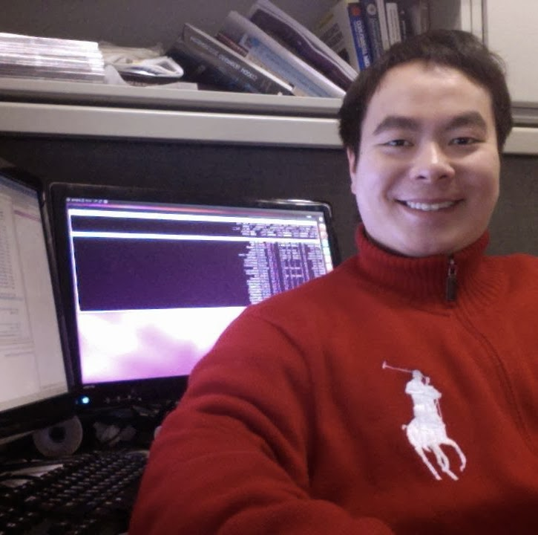 **Wei Jiang**

**Email:** [weijiang2009@gmail.com](mailto:weijiang2009@gmail.com)

**Cell:** +86 18802014980

**Personal Web:** [**https://weijiang2009.github.io/**](https://weijiang2009.github.io/)

**Wechat:** wei_jiang_2009

**Github:** [**https://www.github.com/weijiang2009**](https://www.github.com/weijiang2009)

**Brief –** My name is Wei Jiang, a 32-years old tech people from Guangzhou, China. Previously, I have been in Los Angeles, New York City, Shenzhen and Guangzhou for education, work and research. My current interest lies in the fields of Artificial Intelligence and Data Analysis.

**Skill Set –**

* Research in many different AI models such as regression, decision trees, classification and clustering
* Engineering work in how to apply AI technology to the fields of computer security, web search engine and social networks
* Research in the architecture of search engine, the tradeoff between performance and quality
* Familiar with data science tools including Office Suite, Python & R, Java & Scala, notebooks etc
* Familiar with big data analytics tools such as Hadoop, HBase, Elastic, Spark etc
* Familiar with basic algorithms & data structure
* General understanding of research & development process of intelligent hardware such as UAV, modular robotics, embedded systems
* Strong communication skills and native listening, speaking, reading and writing in English, Mandarin and Cantonese
* Strong problem solving and project management capability

**Working Experience 1 – Senior Researcher, Bluedon**

2017, 01 – Present, Guangzhou

Objective & Key Results：

1. Research in the intersection of Computer Security & Privacy & Machine Learning
2. AI & Security Products Lifecycle / Project Management
3. OKR Settings & Planning & Coordination
4. Management of the AI engineering & research team for 20 people
5. Deliver the AI innovations in different domains in enterprise value chain
6. Working with third-party providers or internal AI expert, business and functional managers to create the use case of AI adoption
7. Output around 10 production-ready AI models, around 20 research reports in world-known recognized conferences with related teams



**Working Experience 2 – Data Scientist, Howpay**

2015, 11 – 2016, 12, Shenzhen

Objectives & Key Results:

* Conduct research in the context of machine learning, model construction and data analysis
* **O**: Apply classification technique to billion-scale document collection for unrelated content removal such as Ad words and images
* **KR**: Output 2 production-ready supervised learning classification models and evaluate the model effectiveness & efficiency using about 10 practical metrics. Generate around 20 comprehensive data analysis reports. 1 unique pipeline for ‘document purification’ has been found.
* **O**: Apply clustering technique to medium size document collection for LDA topic discovery & exploration
* **KR**: Construct 1 EM framework and train 1 mixed Gaussian model and 1 LDA topic model separately. The model has been evolved and improved 15 times due to the interaction between the model and the data. Conduct quantitative analysis on both single data sample and the whole dataset in order to evaluate the predictability and explain ability of the model. This piece of work set the foundation and provide the research prototype for the following research work.
* **O**: Apply NLP technique for Chinese word tokenization / segmentation
* **KR**: Design and implementation of 1 Chinese word tokenization / segmentation visualization/modification tool. The major design goal of this tool is for human tagging optimization. Preliminary result shows that the average number of natural language sentence (100 words on average) tagging performance has increased from 300 to 1000 per hour. This work set the foundation for later cloud service such as search & recommendation system.



**Working Experience 3 – Product Manager, DJI**

2015, 05 – 2015, 11, Shenzhen

Objective & Key Results:

1. Strategic overall planning for the Matrice drone product line including documentation, function analysis and open protocol / standard design
2. Design and implementation of research prototypes for drones

**Working Experience 4 – Researcher, New York University**

2011, 09 – 2015, 03, New York City & Shanghai

Objective & Key Results:

* Conduct research in the field of information retrieval, web search engine and data mining
* **O**: Research in different kinds of static inverted index pruning techniques in information retrieval system
* **KR**: Only preserving 5% of the size of the original index while no significant search result decrease has been observed
* **O**: Research in different kinds of inverted index tiering technique
* **KR**: The overall query throughput of the system has increased by 80%; The overall query latency of the system has decreased by 10%; No significant search result decrease has been observed

**Education Background –**

**University of Southern California**

Viterbi School of Engineering, Computer Science Department

* **Master**, Computer Science, 2009, 09 – 2011, 05
* Los Angeles, CA, USA
* GPA: 3.7 / 4.0
* Courses: Machine Learning, Data Mining, NLP, Distributed Systems, Robotics



**Guangdong University of Technology**

School of Engineering, Computer Science Department

* **Bachelor**, Compute Science, 2005, 09 – 2009,05
* Guangzhou, GD, China
* Score: 88/100 Rank: 4/800
* Courses: Algorithms, Data Structure, OS, Database

**Patents –**

( Note: The Inventors of the following granted patents are: Wei Jiang, Lifeng Jiang, Yuanlie He and Yongquan Yu )

* **Non-current transformer type power-frequency weak-current electromagnetism signal sensor**

CN 201425627 Y [Google Patent Link](https://patents.google.com/patent/CN201425627Y/en)

* **Indoor wall-buried wire non-destructive detection instrument**

CN 101539637 A [Google Patent Link](https://patents.google.com/patent/CN101539637A/en)

* **Power-frequency feeble-current electromagnetic signal sensor of non-current transformer type**

CN 101539636 A [Google Patent Link](https://patents.google.com/patent/CN101539636A/en)

* **Indoor wall-embedded wire nondestructive detector**

CN 201425626 Y [Google Patent Link](https://patents.google.com/patent/CN201425626Y/en)

**Papers –**

* **Improved Methods for Static Index Pruning**

with J.Rodriguez, T.Suel.

in Proceedings of IEEE BigData, 2016

* **What, Where and When: Geotemporal Text Search in Twitter**

with S.Nepomnyachiy, B.Gelley, T.Minkus.

in Proceedings of Geographic Information Retrieval, 2014

* **AI based Windows Malware Detection Engine at scale** (Under submission)

with Deyuan, 2017

* **Bluedroid: The AI based APK Malware Detection Engine** (Under submission)

with Guobin, 2018

* **AI based malicious document detection**

with Fengjiao

in Netinfo Security, August, 2018

**Referee –** (**Disclosed upon request**)